Guidelines on Band and Carrier Aggregation in fixed point-to-point systems
approved 2 October 2020
ECC Report 320

Executive summary
Band and Carrier Aggregation (BCA) approach, has been introduced recently in point-to-point fixed service systems. Its practical implementation in term of frequency band options and antenna arrangements affects the characteristics of the overall link connection performance in terms of hop length and the balance of capacity versus availability.
The scope of this report is to identify a possible implication of the adoption of the BCA approach that may have on a traditional licence procedure to provide suggestions to the relevant administration.
This Report provides a general concept and definitions of BCA and the benefit of the implementation of BCA. Some examples of BCA provide possible configurations of aggregated channels in different frequency bands and their typical applications.
For one example with the frequency bands 18 GHz and 80 GHz, the overall link performance with both frequency bands in terms of capacity level and associated availability has been analysed based on each frequency band link performance. During normal propagation condition the capacity could reach 7 Gb/s, during fading periods the lower frequency bands are used with limited capacity.
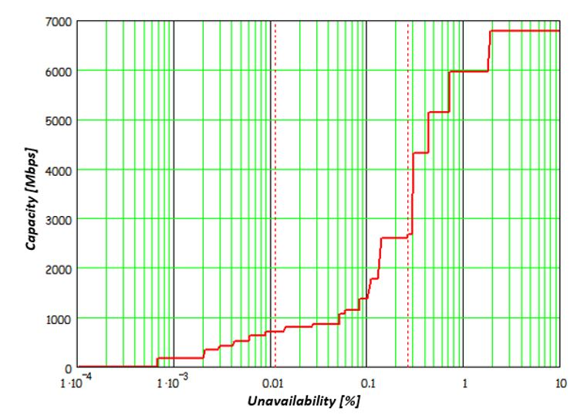
Figure 1: Example of capacity vs availability with BCA of 18 GHz and E-band
Four key points are identified in this Report:
- Mandatory minimum link availability target in planning procedures:
The highest BA band should be planned only from the interference point of view, while its availability should be considered as "best effort".
- Impact of an ATPC range imposed in the licensing conditions:
It is expected that the highest BCA band will operate at its lowest modulation schemes and at its highest transmitter power level towards reaching its best, even if poor, availability level. A minimum ATPC range may be not applicable.
- Dual-Band antenna requirements:
Where dual band antennas are concerned, the characteristics of the antenna are expected to comply different ETSI classes for both bands.
- Minimum link length:
The lowest band considered in a BCA, may not respect the rule of some administrations in regards to the minimum link length. Exception for BCA may have to be considered when BCA is concerned.
It should be noted that intermodulation between carriers of BCA is not an issue under the condition highlighted in section 3.2.

TABLE OF CONTENTS

0 Executive summary 2
1 Introduction 5
2 Definitions 6
3 Band and Carrier Aggregation background 7
3.1 concept and definitions 7
3.2 Intermodulation 9
3.3 BCA General implementation and benefits 10
3.4 Examples of BCA 12
3.4.1 General case: Channels in the same or closed frequency bands 12
3.4.2 Band aggregation in medium microwave frequency bands 13
3.4.3 Microwave and mmW band aggregation 13
4 Band and Carrier Aggregation operational impact 14
4.1 Basic concepts 14
4.2 Link planning example: case of e-band and medium microwave band 14
5 Implications for frequency coordination and possible regulatory background (licensing) 18
5.1 Basic concept 18
5.2 Mandatory minimun Link availability target in planning procedures 18
5.3 Impact of an ATPC range imposed in the licensing conditions 18
5.4 Dual-Band antenna requirements 18
5.5 Minimum link length 19
6 Technological advancements related to Band and Carrier Aggregation 20
7 Conclusions 24
ANNEX 1: List of References 25

LIST OF ABBREVIATIONS

Abbreviation | Explanation
3G | 3rd Generation mobile systems
4G | 4th Generation mobile systems
5G | 5th Generation mobile systems
ACM | Adaptive Coding and Modulation
ATPC | Automatic Transmit Power Control
BA | Band Aggregation
BCA | Band and Carrier Aggregation
CA | Carrier Aggregation
C/I | Carrier to Interference ratio
CEPT | European Conference of Postal and Telecommunications Administrations
EC | European Community
ECC | Electronic Communications Committee
e.i.r.p. | Equivalent Isotopically Radiated Power
ETSI | European Telecommunication Standards Institute
FM | Fade Margin
HS | Harmonised Standard
ITU-R | International Telecommunication Union – Radiocommunication Sector
KPI | Key Performance Indicator
MMSS | Maximum Modulation Scheme Sustainable
NDF | Net Filter Discrimination
P-P | Point to Point
QAM | Quadrature Amplitude Modulation
QoS | Quality of Service
QPSK | Quadrature Phase Shift Keying
R&TTE | Radio and Telecommunications Terminal Equipment
RSL | Receiver Signal Level
RTPC | Remote Transmit Power Control
TCO | Total Cost of Ownership
XPIC | Cross polar interference cancellation

Introduction
Combining multiple frequency bands over the same radio link could offer several benefits, beyond the throughput increase, leading to more efficient use of available spectrum.
Band and Carrier Aggregation (BCA) could be implemented through different arrangements, depending on the application. Some new considerations in terms of network design apply since the propagation aspects can be very different for the different spectrum aggregated. The overall BCA network often offers multiple capacity levels with different availability.
The result is a payload with steps in term of capacity/availability like the concept of adaptive modulation. However, BCA is providing more steps than adaptive modulation in one frequency band.
Finally, new approaches to implement BCA have been adopted by microwave manufacturers, including multiband antennas and single physical transceivers able to cope with multiple carriers/channels, and from different frequency bands. Possible impacts of these new approaches on the coordination process and the interference situation has to be identified.

Definitions

Term | Definition
Adaptive modulation | A technology (referred in ETSI standard [1] as “Mixed-mode”) in which the modulation formats are dynamically changed (errorless for the relevant payload fraction) according the propagation conditions. This permits to design a link with a defined availability for a uniquely predefined modulation format (the “reference mode”) and having the payload capacity enhanced during good propagation time and reduced during abnormally adverse propagation.
ATPC  (Automatic Transmit Power Control)  BCA | Range of transmit attenuation dynamically variable with the propagation effects. Total range(s), activation threshold(s) and attenuation dynamics may also be software programmable.  Band and carrier aggregation system (BCA): a combination of channels operating in different (e.g. 6 GHz plus 18 GHz or 38 GHz plus 80 GHz) bands carrying an overall packet payload capacity over the same link.
Bandwidth adaptive | A technology similar to Adaptive modulation where, while keeping the modulation format constant, the capacity is changed through the dynamic increase/decrease of the occupied bandwidth. This is mostly used in highest frequency bands where higher modulations index are not practical.
Max Modulation Scheme Sustainable | The highest modulation format stably supported during clear sky propagation conditions.
Reference mode | Where adaptive modulation systems are concerned, corresponds to the reference modulation format used for identifying the equipment parameters needed for the link coordination with the predefined availability objective (i.e. Spectrum mask, Nominal output power for defining the licensed e.i.r.p. and BER threshold for deriving the nominal link fade-margin, Co-channel and adjacent channel C/I for deriving the NFD.  When bandwidth adaptive systems are concerned, the reference mode and its equipment parameters and availability objective correspond to the maximum bandwidth occupancy situation.
Reference modulation | The modulation format used for the reference mode.
RTPC  (Remote Transmit Power Control) | Range of static transmit attenuation used for software programmable setting of the e.i.r.p. required for the link in the license conditions.

Band and Carrier Aggregation background

concept and definitions
Band and Carrier Aggregation is a new technology that has recently become popular in the mobile backhaul arena to better meet the requirements of the new backhaul network.
BCA is a relatively new concept enabling efficient use of the spectrum through smart aggregation, over a single physical link, of multiple frequency channels (in the same or different frequency bands).
ETSI is using both following wordings “channel aggregation” and "carrier aggregation".
The use of "Carrier Aggregation" in ETSI EN 302 217-1 [1] and ETSI GR mWT 015 [4] is referring to the case when a single radio stream (single radio emission in an assigned channel) is obtained by two separate signals merged before being sent to the antenna.
The use of "Channel Aggregation" in ETSI EN 302 217-1 and ETSI GR mWT 015 refer to the case when a single radio equipment is able to transmit/receive two different signals under two assigned channels. Substantially, ETSI “channel aggregation” is a special physical implementation of the general concept of BCA.
For the scope of this Report, the two terms "Channel Aggregation" and "Carrier Aggregation" will be used without any distinction for BCA.
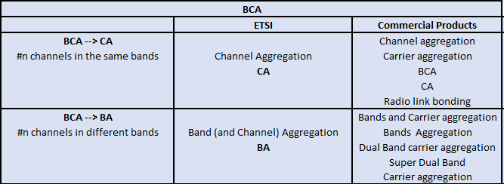
Considering what is on the market today, many different formulations are used indicating BCA, targeting different commercial products. The table below provides a non-exhaustive view considering the two possible main BCA sub-cases, Carrier Aggregation (CA) and Band Aggregation (BA).
Figure 1: Band and Carrier Aggregation uses
The simplest example of BCA is the traditional 2+0 system. The general logical scheme of the BCA includes a "carrier aggregation engine" and different physical radio channels.
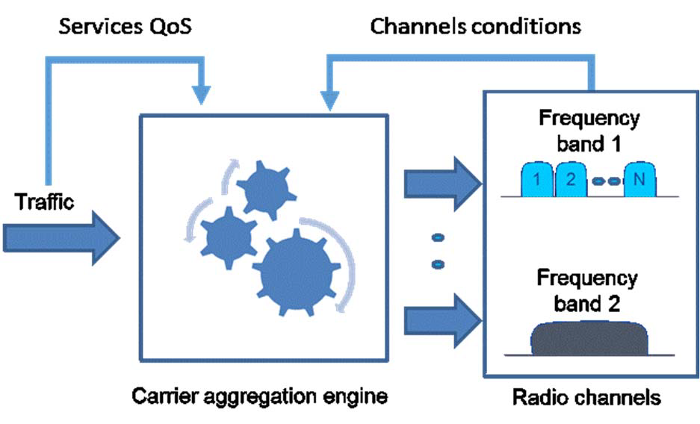
Figure 2: BCA - General concept
BCA benefits are obtained when the BCA is able to re-route the different traffic flows adaptively across the different channels, adjusting the quality of service (QoS) with each frequency band propagation conditions.
Channels used under BCA can be different in terms of:
- Bands and size;
- Capacity and latency (according to the adopted radio profile or modulation scheme);
- Availability - due to different frequency band and/or different results due to how the link is designed (performance obtained taking into account antenna gain, system gain, etc.);
- Fixed or adaptive modulation scheme adopted;
- License scheme - subject to interference-free operation or not.
BCA can be seen as an additional technique used to increase capacity in the wireless domain compared to the traditional approaches such as adaptive modulation, XPIC or packet compression.
From a payload perspective, BCA appears as a single carrier connection using a large channel and with large adaptive modulation steps. The following figure illustrates how capacity can be transported as a function of availability time:
- the first figure shows as an example two single cases, the first at 18 GHz with ACM up to 4096 QAM and CS=56 MHz and the second at 80 GHz with ACM up to 128 QAM and CS=250 MHz;
- the second figure shows the effects of BCA combining the two streams, from payload standpoint, into a single logical one.
The width of the steps in these pictures is always kept the same for simplicity even if in reality this is not the case. The relative positions between the 18 GHz case and 80 GHz case may be different case by case, producing different final results.
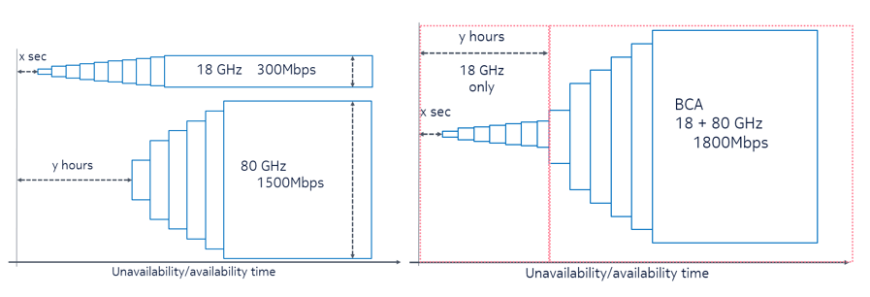
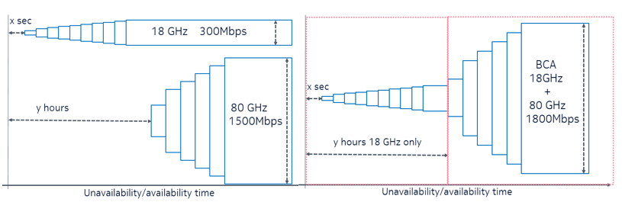
Figure 3: BCA effects on payload vs availability
BCA can be considered also as a new way to use the frequency spectrum more efficiently by adapting the frequency spectrum portions as far as possible to the payload needs.
For most of the different BCA use cases, the link budget design may produce different results to those obtained in traditional cases without BCA. This will depend on how the traffic is distributed across all the channels, and it is therefore highly correlated to the implementation of the proprietary carrier aggregation engine.
Adaptive modulation link budget, based on the concept of reference modulation [1], is an evolution that provides large degrees of flexibility. Examples of possible BCA options are: different frequency bands, different channel size and numbers, different antenna gain and equipment system gain.

Intermodulation
Intermodulation happens for the same physical phenomenon (mixing of two signals in a non linear device), but is in general seen as two different aspects, in FS context:
- Intermodulation (coming from presence of spectral components) within a single RF channel : it affects all “traditional amplifiers”, transferring one single RF channels by its input to the output port towards the antenna, increased by the amplifier gain and taking account of nonlinearity (3d, 5th, nth order). Main contribution (2F-f) generates an increase of power inside the RF channel or just outside (up to 1 first adjacent channels) and compliance with the TX spectrum mask of the HS is mandatory.
- Intermodulation coming from the mixing two (or more) different RF channels.
In case of a generic channel aggregation equipment, both channels are within the same RF band, which is covered by of a common amplifier (flat zone of the transfer function). Example is the case of two adjacent RF channels.
For this case, in addition to the interference of case 1 for each RF channel, there is a need to control the (2F-f) intermodulation products (and the higher order) of the two channels. Interference is generated, below the lower and above the upper signal, at a distance equal to separation of the two channels. It is covered by the HS (and the ERC Recommendation 74-01 [3]), so proper design has to be made in order to be compliant with the relevant harmonised standards [2].
In cases of BCA (2 channel systems), where the two channel belong to different RF bands, no active device receives as input the addition of the two RF channels, since they belong to different RF bands and no practical amplifier can be built with so wide BW. Each RF amplified receives only the RF channel belonging to its frequency range.
The mixing of RF signals is not possible in the active devices and just happens in passive parts of the systems (mechanical parts of antenna reflector) or in the air itself.
This case is topologically similar to previous systems, using branching lines to bring several RF channels to the same antenna, where the reference to intermodulation levels lower that -110 dBm was used.
This case is not distinguishable, in the air, from a normal station used currently, where two RF different signals with the same characteristics of those transmitted by the BCA are transmitted by two completely different equipment, using two antennas or single dual polarized antenna.

BCA General implementation and benefits
Efficient exploitation of BCA of payload lies in the multidimensional set of performances in terms of capacities vs availability.
Mobile backhaul/fronthaul and fixed broadband access applications could adjust the network transport to the evolving capacities vs availability demand.
The following table is a high-level summary of the max reference channel bandwidth in the different frequency bands allocated to fixed service.
A given P-P radio link is designed to use the most appropriate frequency band for the application need. On one hand, lower frequency bands allow generally longer range. On the other hand, the lower frequency bands have in general narrower channel sizes.
Therefore, low-frequency bands (usually up to 11-13 GHz) are commonly used for long haul applications (rural or islands connectivity) with multiple channels system; medium-frequency bands are used for sub-urban use cases and higher bands are used for urban scenarios and short links.
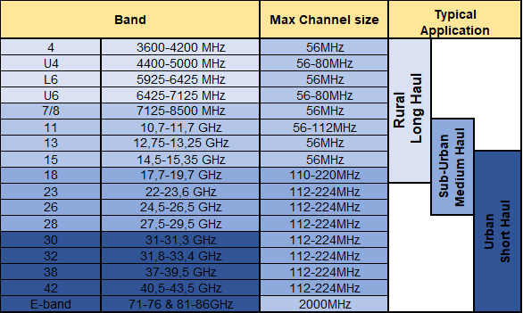
Figure 4: Microwave frequency bands
Typically, BCA coupling would be made in the same frequency range or same applications (i.e. long + medium haul, medium + short haul or short + short haul).
BCA can enable new scenarios, through aggregation of different frequency bands.
BCA benefits when aggregating different bands are:
- Enabling an increased channel granularity combining small channels into one larger carrier, thus:
  - to meet the real capacity needs in terms of the main KPIs. (capacity/coverage/availability/ latency);
  - to enable a single big pipe (e.g. 1 or more Gbps) to replace multiple narrow channels;
  - improving efficiency in the spectrum usage by using all available narrow band channels of spectrum.
- Enabling the use of wider channels using multiple continuous channels or grooming surrounding channels;
- limit the redundancy need of traffic flows to ensure protection.
One of the most used BCA case today is the aggregation of millimetre-wave channels with microwave channels achieving the objective of designing a relatively long link (7-10 km) with high capacity offering high availability for high-priority services and less availability for lower-priority services.
As an example: if an operator needs to increase the transport throughput on already-deployed links which are using a single frequency band. this operator could decide:
- to use a channel in an adjacent band which is not used (Carrier aggregation);
- to use a channel in a higher frequency band, if high level of availability is not required.
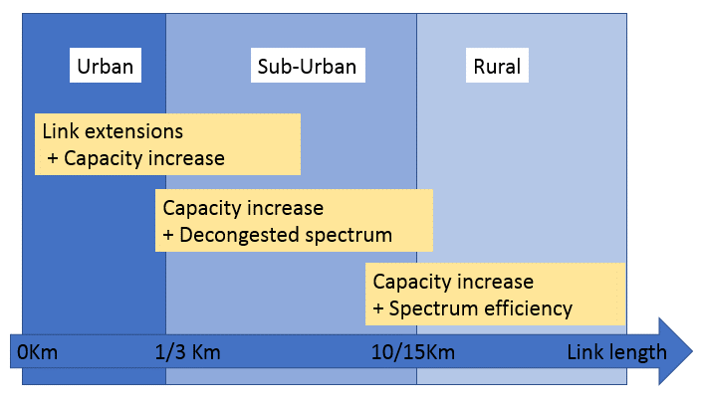
Additionally, to increase the capacity over a single physical link, BCA could also enable the different scenarios summarised in the following diagram with regard to link length and scenarios (rural, suburban, and urban):
Figure 5: BCA in different deployment scenarios
For instance, the aggregation of microwave and mmW frequency bands could allow the use of mmW bands (usually constrained by propagation effects) in the suburban environment.

ExampleS of BCA
BCA is mainly applicable to mobile backhaul/ fronthaul application and to wireless transport in general.
These use cases applicable to BCA are described below.

General case: Channels in the same or closed frequency bands
The most common use case is the use of two or more channels in the same frequency band. The adoption of channels with different sizes, or channels designed for different objectives, capacity/availability/latency, may produce some benefits in changing the link working conditions according to the actual traffic volume.
Carrier aggregation in low microwave frequency bands (long haul application).
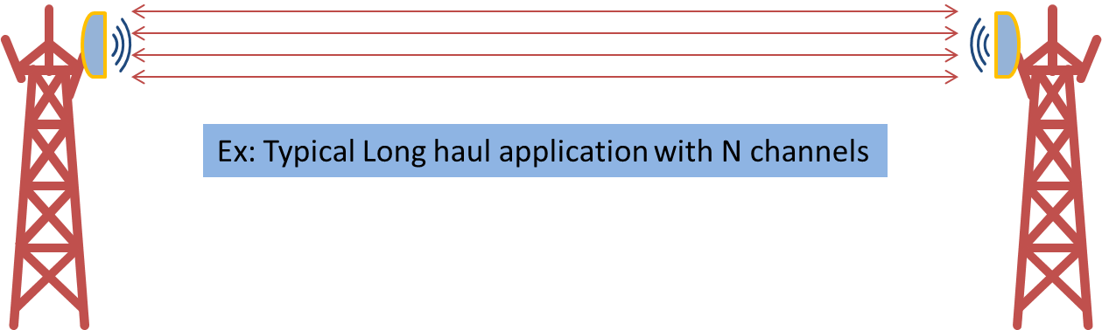
Figure 6: BCA long haul up to 13 GHz
In long haul transport, the aggregation of multiple RF channels to be transmitted by means of a single antenna over a link can be in the same frequency band or in different frequency bands. A typical use case when two bands are used, is the aggregation of 7 and 11 GHz.

Band aggregation in medium microwave frequency bands
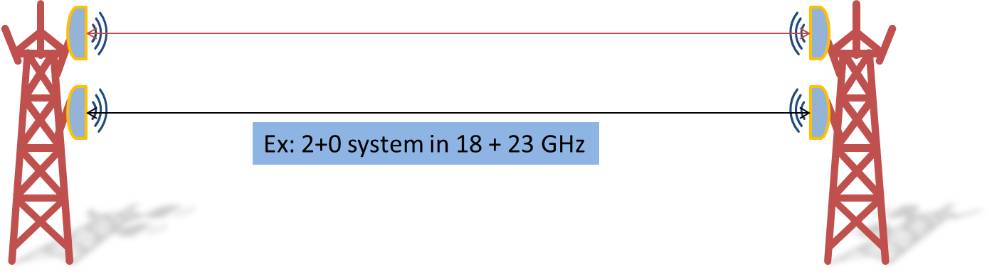
Figure 7: BCA medium haul: from 13 to 42 GHz
Channels in medium microwave frequencies can be aggregated over the same or different bands, in order to increase capacity. In many cases, in fact, the required bandwidth cannot be found in a single band: a given operator might not have a sufficient number of channels in a given band to reach the required capacity.
For this specific case, single wide-band antennas, able to cover two or more adjacent bands are being studied.

Microwave and mmW band aggregation
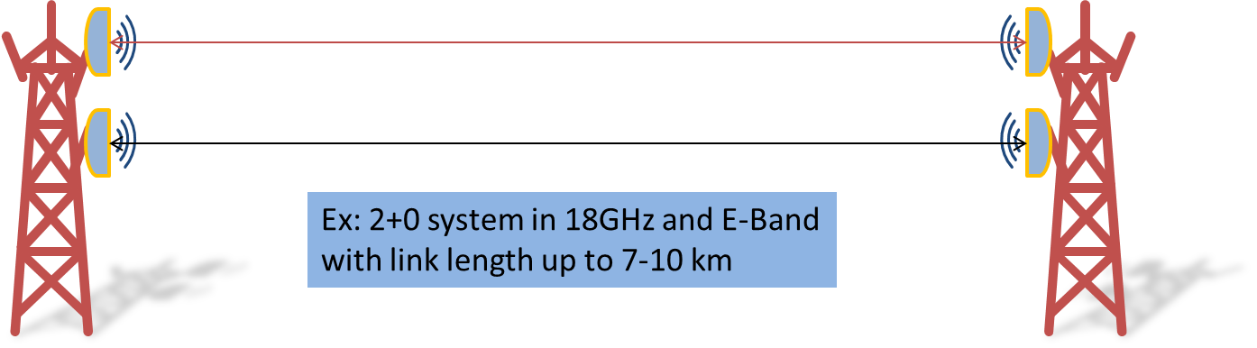
Figure 8: BCA microwave plus millimetre wave
This case covers at least two different scenarios:
- mmW in addition to high microwave bands, for instance of 28 GHz + 80 GHz. Capacity has the highest priority, not hop length aspects nor the critical availability;
- mmW in addition to medium microwave bands. In such cases, the microwave band would comply the most critical services at highest availability, while the mmW band would be used for high data applications for the majority of time.
The most interesting combination is between microwave in the range 15-23 GHz (main bands used to cover distances up to 7-10 km) with E-Band, due to single bi-band antennas are available on the market.

Band and Carrier Aggregation operational impact

Basic concepts
In most of the cases, the BCA link should be designed on link availability / fade margin concept like for traditional links. When the BCA is considering two or more channel in the same frequency band similar availability can be obtained mainly by playing on antenna gain, PTx level/RTPC.
ECC Report 198 " Adaptive modulation and ATPC operations in fixed point-to-point systems - Guideline on coordination procedures" [5] concludes that only the “reference modulation” of an adaptive modulation systems is used for the coordination process under the assumptions made in that report.
The case of BCA in microwave and mmW needs to be further considered due to:
- Frequency band are so different reflecting in different the propagation conditions;
- Radio system, including antennas, performs differently;
- Channels size may be different.

Link planning example: case of e-band and medium microwave band
As an example of link planning, the greater gap case is considered where E-Band and a medium microwave band are concerned.
In this case, it is assumed, that the low-frequency band will provide the whole capacity at the highest availability required. This principle is not always applicable,
This example uses a 56 MHz channel with XPIC (frequency reuse) at 18 GHz and a 1000 MHz channel at 80 GHz with ACM.
The following figure draws the channels sizes' proportion and the 18 GHz duplexer space, (80 GHz duplexer space is not displayed)

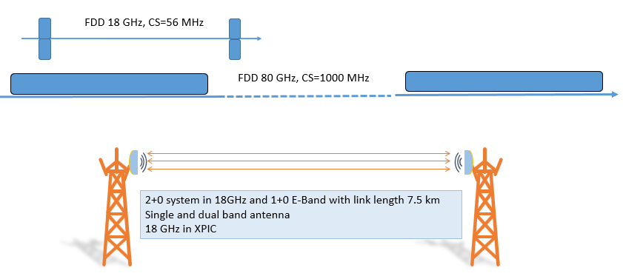
Figure 9: BCA example of a link design
With the aim of showing a practical example of BCA link planning, the following parameters, representative of an actual deployment, have been selected
Link characteristics:
- Hop length 7.5 km;
- Rain rate zone 42 mm/h.

Frequency resources available:
- 1x 56 MHz channel @ 18 GHz;
- 1x 1000 MHz channel @ 80 GHz.

Radio system:
- Single bi-band antenna 38 dBi @18 GHz and 50 dBi @ 80 GHz;
- System @ 18 GHz able to perform XPIC & ACM till 4096 QAM;
- System @ 80 GHz able to ACM till 128 QAM;
- System gain considered: Average commercial product: according to ETSI White Paper No. 15, table 3 [4].
The most common requirements, to be fulfilled today by a backhaul use case are no longer only capacity level and relevant availability, but a set of capacities levels with different availabilities, matching the expected payload requirements. For simplicity, the required latency performance aspects are not considered here.
Payload requirements:
  - 650 Mbps @ 99.99%;
  - 1500 Mbps @ 99.7%;
  - 3500 Mbps @ best effort.
Planning starts with the radio system operating at the lower frequency. The 18 GHz connection is then designed to satisfy the payload requirements a).
The design method follows the usual link budget methods as in ETSI TR 103 103 [7] and ECC Report 198 [5].
The obtained results:
- It is necessary to use XPIC to exploit the 56 MHz channel two times at 18 GHz to be able to reach the capacity at the availability level requested. The reference modulation has to be 256 QAM offering a capacity of more than 350 Mbit/s for each stream with 99.99% availability and the above requirement a) is therefore fulfilled.
Additional capacity/availability steps are also available with ACM. Figure 10 shows that the 18 GHz is at 4096 QAM (substantially 364/365 days/year) provides an additional capacity of about 150 Mbps, to the 350 Mbps supplied with 256 QAM in the same frequency band.
Considering payload requirements b) and c), part of these requirements can be fulfilled by the additional capacity provide by the 18 GHz.
The obtained results:
- Figure 10 (right side) shows the results: The QPSK profile, at its PTx max, provides more than 1 500 Mbit/s at 99.7% availability and with ACM, an additional ≈4000 Mbit/s at best effort conditions, hence fulfilling the requirements.
- The link in the 80 GHz is designed with a reference modulation equal to QPSK and with a target availability of 99.7% or less.
Figure 10 also indicates that:
- The maximum modulation scheme sustainable at 18 GHz is 4096 QAM (>7 dB of Fade Margin (FM);
- The max modulation scheme sustainable at 80 GHz is 128 QAM (>10 dB of FM).
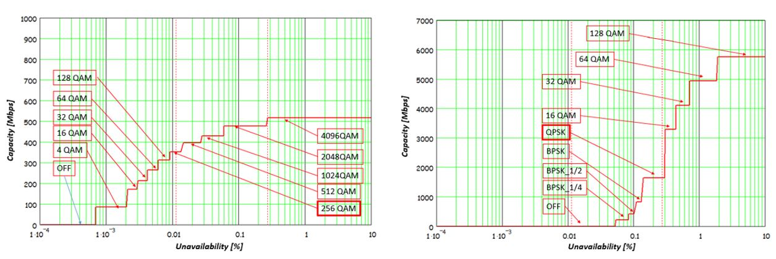Figure 10: Capacity vs availability at 18 GHz (left) and 80 GHz (right)
Depending on different links characteristics and the differences in fade margin that could be experienced, the highest modulation schemes is not always applicable.
To manage this aspect, the Maximum Modulation Scheme Sustainable (MMSS) is defined as the working point able to provide the maximum level of capacity under clear sky propagation conditions.
The results obtained in the example of Figure 10, are as following:
- the left chart shows the capacity vs. unavailability for a single channel at 18 GHz with ACM and MMSS=4096 QAM. The link is designed for 128 QAM as a reference modulation at 99.99% availability;
- the right chart shows the capacity vs. unavailability for an 80 GHz link with ACM and MMSS= 128 QAM. QPSK is assumed as reference modulation at 99.7% availability.
In case of a longer link or of challenging rain rate zones, availability could be less than 99.7% for the same capacity. This may have an impact on regulatory aspects, when a minimum level of availability is requested.
Figure 11 presents the results of the overall link performance with the frequency bands 18 GHz and 80 GHz in the example.
Figure 11: Capacity vs availability with BCA of 18 GHz and E-Band
For this specific case, the link can provide:
- A capacity level of about 700 Mbps (2x350 Mbps due to XPIC) with an availability of 99.99% (0.01% unavailability): 80 GHz channels are not used;
- Significant increase in capacity can be provided starting to use of the 80 GHz channels with unavailability of less than 99.95% (with less than 0.05% unavailability/year);
- A capacity level around 2500 Mbps could be provided;
- For 364/365 days/year, it is expected to be able to provide a capacity level exceeding 2500 Mbps corresponding to an availability better that 99.7% (0.3% unavailability) when considering the joint contribution from the two bands;
- A capacity level close to 7 Gbps is expected to be provided for an availability of 98%.
The example of this section assumed that:
- Propagation events and their effects over the two frequency bands are always correlated and connected. (18 GHz/56 MHz plus 80 GHz/1 GHz).
- The carrier aggregation engine is common for all channels and able to distribute/re-route the traffic over multiple radio channels, exploiting "early warning" messages from radio, to be errorless. Static traffic assigned will jeopardize the result significantly.
For this specific case, the RTPC functionality is not enabled and the ATPC is being used just for adapting PTx to the actual modulation scheme in the E-Band frequency. The link reference modulation is QPSK and therefore the spectrum emission mask to be considered is QPSK (ETSI Class2).

IMPLICATIONS FOR FREQUENCY COORDINATION AND POSSIBLE REGULATORY BACKGROUND (LICENSING)

Basic concept
Introducing the BCA concept in the regulatory landscape will require a more holistic view in which two or more aggregated channels are seen as a single pipe with combined performance in terms of both QoS and spectrum efficiency. This fact should be taken into account when establishing a regulatory and licensing framework for BCA assignment.
Four points have been identified as worthy of consideration:
- Mandatory minimum link availability targets in planning procedures;
- Impact of an ATPC range imposed in the licensing conditions;
- Dual-band antenna requirements;
- Minimum link length

Mandatory minimun Link availability target in planning procedures
Most administrations use various automated planning tools that require a set of input parameters, including the link availability. Typically, the link availability is a fixed value used nationwide for all links (e.g. 99.99%). In case of BCA, when the band distance is relatively large (e.g. 15/38 GHz + 80 GHz bands), that availability cannot be used for the two bands, but only for the lower one; moreover, in such BCA situations, the higher-band channel should be planned only from the interference point of view, while its availability should be considered as "best effort". This may require some updating to the current planning tools and/or licensing forms.

Impact of an ATPC range imposed in the licensing conditions
In all BCA cases, especially when two different frequency bands are concerned as r medium microwave and mmW carrier aggregation, the use of ATPC for the highest frequency band may become challenging and limit the full BCA exploitation.
For instance, for the above example the E-Band should be engineered to work 100% of the time at its maximum feasible PTx (therefore without the ATPC) in order to obtain the best results. Using the ATPC to fix the receiver signal level (RSL) at a given value (e.g. -50 dBm) may imply the loss of complete capacity by limiting the MMSS. High modulation schemes may have a receiver threshold even higher than RSL. Therefore, the ATPC use should be carefully analysed/studied case by case because it may pose limitations or even jeopardize the BCA adoption.

Dual-Band antenna requirements
Dual-band antennas are commonly available on the market for many combinations of frequencies. The antenna dimensions are constrained by the highest band, maximum gain generally exceeding 50 dBi.
Antenna RPEs are generally different between the two bands. It is expected that both bands may comply different ETSI classes.
The antenna will be aligned using lower frequency bands, with lower gain, therefore adjusted with the higher frequency bands signal.
Lower frequency signal will be also beneficial.

Minimum link length
Some administrations dealing the use of higher frequencies bands to implement short links, have defined a rule, usually described by a table that imposes a minimum distance associated with each frequency band. In the specific case under discussion of the BCA, there could be cases, such as for example the 15 GHz with 80 GHz, where this rule does not allow the implementation of links shorter than 6-8 km because 15 GHz not applicable in this range. Exception for BCA may have to be considered when BCA is concerned.

Technological advancements related to Band and Carrier Aggregation
Microwave backhaul antenna solutions using multiple carriers below to different bands were mainly addressed by two separate antennas. The Dual-band microwave antenna technology is a recent opportunity for offering low footprint to the wind, reducing bad effects impacting the structure and the link performance.
This section is dealing with the dual-band antenna configuration.
The E-Band frequency bands in conjunction with 15-38 GHz is then considered below. Dual-band antennas can be designed using different kinds of technology, such as: micro strip antennas with dual access, large bandwidth corrugated horns, spiral antennas. Nevertheless, for backhaul applications, high gain antennas are required. Conventional backhaul applications use almost only axial parabolic antenna technology and more recently dual-reflector antennas, such as the Cassegrain antenna. The addition of a second reflecting surface offers additional possibilities for achieving highest performance in radiation efficiency, high lobe discriminations in order to comply with the class 3 or class 4 ETSI requirements.
Parabolic antenna technology remains the only one candidate for the dual band backhaul solutions. For time being, no other high-performance technologies have been identified. Dual-band antenna solutions will maintain the same performance, such as the quality of the radiation pattern, met by existing conventional backhaul networks. The antenna gain should be also in the same range as with the current single-band antenna in order to keep the same distance of the microwave links. In order to achieve this target, different key technological issues should be addressed.
Multisource feed technology is suitable for the parabolic illumination to achieve the dual band antenna configuration.
However, the integration of multi-sources causes a large mask effect especially in E-Band where the physical dimension difference become significant compared to the wavelength. The aperture blockage (Figure 12) impacts not only the antenna gain, but also the side lobes and thus making the compliance to ETSI Class 3 difficult. The lower is the frequency of the first band, the more difficult the compliance to the ETSI standard is.

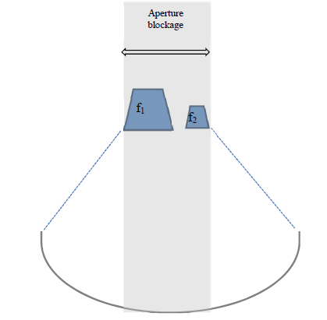
Figure 12: Feed blockage effect
Although radome is supposed to be only a protective part of the antenna system, it is a key element for the antenna radiation quality and especially it impacts the side lobes of the radiation pattern. The antenna radome material should be selected to be as much as possible radio-electrically transparent. However, addressing this challenge is more difficult when the material needs to cover 1 or 2 frequency octaves.
Another technological issue could be the isolation between the bands to limit cross-talk inference. Good isolation between the E-Band and the medium microwave frequency band should be achieved to limit the interference on the radio aggregation systems.
The possible combination of frequency bands for a dual-band, commercial, parabolic antenna, are presented is figure 13. The selected urban short-haul frequency bands in this instance are the aggregation of the E-Band and 38 GHz with a 2ft antenna diameter. It is assumed that the radome is fully transparent whatever the frequencies. The ETSI class 3 performance can be achieved both in E-Band and in 38 GHz.
The dual-band configuration impacts the gain in the example of less than 2 dB compared to single-band antennas. In the example, it is also assumed discrimination due to isolation of more than 25 dB between the E-Band and 38 GHz.
For the installation, a dual band antenna does not differ from one single band antenna leading to reduce by one antenna.
At E-Band and 23 GHz with a 2 ft antenna diameter, isolation between the E-Band and 23 GHz could be better than 33 dB.
Figure 13 reports for information, current possible combinations of bands in a single 2 feet dual-band antenna (excluding 6 GHz where at least 3 feet is needed). Other pairing could be different for other devices.
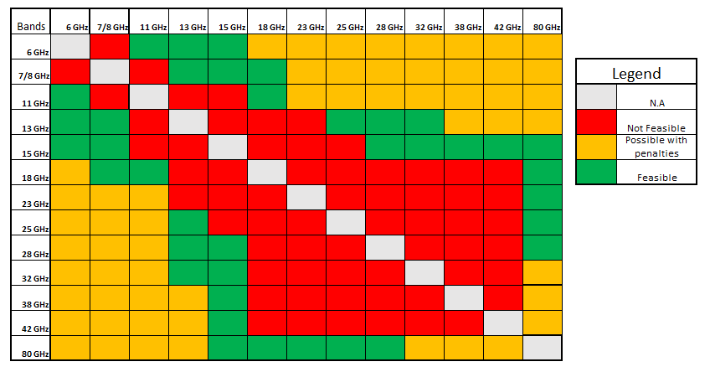
Figure 13: Dual band antenna - Possible frequency bands pairing
Advance in antenna design allows now to include the following features:
- The second polarisation for one of the two bands, usually the lower one;
- Wide band coverage, allowing three even four band antenna.
Dual band antenna may be a way to optimising the TCO in particular if integrated antenna.
Some examples are provided including BCA with two carriers (E-Band and 18 GHz), three carriers (E-Band and two 18GHz carriers) and four carriers (two E-Band carriers and two 18 GHz carriers).
Wind-load on antennas infrastructure, antenna radiation pattern local antenna regulation, have to be looked in detail in a case by case basis (e.g. Union of Swiss Shortwave Amateurs, “Building permit for antennas” [8], Radio Society of Great Britain: “Planning matters” [9] and Radio Frequency Systems: “Introducing DragonSkin™ UL 2196-Certified Standalone Coaxial Cable from RFS”[10]).
Commercially BCAs are currently available with dual carrier system implemented with a single antenna and single transceiver. When the two carriers are inside the same frequency band, the preferred arrangement is frequency reuse leveraging the XPIC. When the two carriers operate on different frequency bands, a dual band antenna is needed. Next picture depicts that CA and BA systems could have no physical appearance.
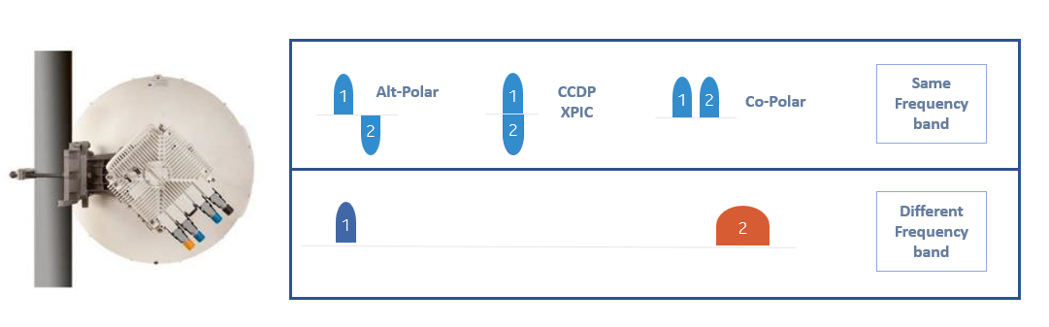
Figure 14: A possible physical appearance of BCA with two channels arrangement
BCA approach could reduce the overall system volume.
Figure 15 shows a commercial solution implementing BCA with four carriers/channels. Two carriers @ E-Band in XPIC with 1 GHz channel size and two carriers @ 18 GHz in XPIC with 56 MHz channel size.
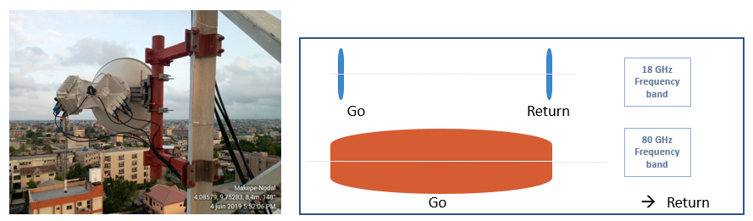
Figure 15: Actual BCA installation
Figure 16 is a picture extracted from the APT Report: “FWS link performance under severe weather conditions No. APT/AWG/REP-81” [11], where the effects the wind are analysed in case of two antennas mounted on a pole showing the advantage for the use of a single dual band antenna to the structure's stability and consequently to the link performance.
Having only one antenna may also reduce the visual impact.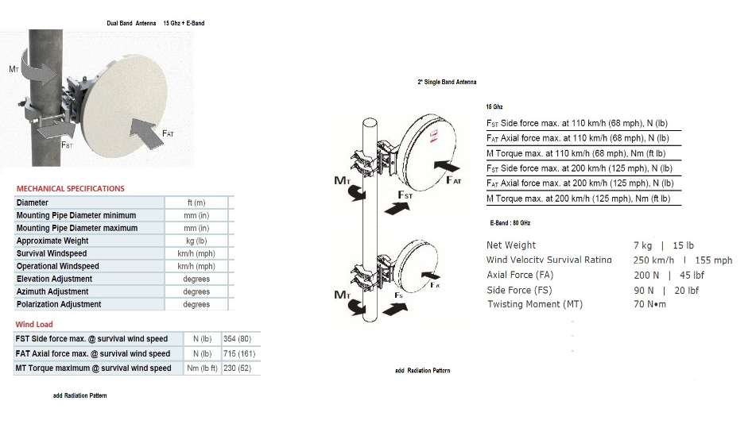
Figure 16: Wind effects of two antenna on the same pole
More information about the impact of wind on link performance are today under investigation and preliminary results can be found in the recent ATP report “AWG study on models for FWS link performance degradation due to wind” [9] currently under consideration by ETSI.

Conclusions
A view of the Band and Carrier Aggregation (BCA) approach in point-to-point systems was described, including why BCA is used as well as its practical implementation.
The Report contains significant, detailed examples where BCA is used and on case-by-case basis, how the links are designed and for which target values.
The specific case of Band Aggregation (BA) has been identified, i.e. where the two bands are separated in frequency by a large margin (e.g.: 18 GHz and E-Band). This is considered to be the only case needing special attention because the coordination process of the higher band may differ from the practice for traditional frequencies.
In most of these specific BA cases, the highest band is required to operate over hop lengths that well exceed the usual span addressed by a link in this band. The link budget for the highest band usually leads the radio to operate with the lowest modulation scheme and with the maximum available transmit power, resulting in performance at low availability levels, in some cases, may even be less than 99.9%.
This operation of the higher band would not impact the other links nearby from a spectral emission point of view assuming that it does not exceed the spectrum mask of the chosen modulation scheme, usually the lowest, and the corresponding licensed e.i.r.p. In the case of ACM, this lower modulation is assumed as the "reference modulation" of the system.
The report identified the possible implications of the adoption of BCA in a common licence procedure. For all the identified points, the report provides suggestions on how to proceed.
Lastly, some discussion is offered on the minimum antenna class necessity with regard to dual band antennas, mainly taking into account current technological constraints.
Four key points are identified in this Report:
- Mandatory minimum link availability target in planning procedures:
The highest BA band should be planned only from the interference point of view, while its availability should be considered as "best effort".
- Impact of an ATPC range imposed in the licensing conditions:
It's expected that the highest BCA band will operate at its lowest modulation schemes and at its highest transmitter power level towards reaching its best, even if poor, availability level. A minimum ATPC range may be not applicable.
- Dual-Band antenna requirements:
Where dual band antennas are concerned, the characteristics of the antenna are expected to comply different ETSI classes for both bands.
- Minimum link length:
The lowest band considered in a BCA, may not respect the rule of some administrations in regard to the minimum link length. Exception for BCA may have to be considered when BCA is concerned.

It should be noted that intermodulation between carriers of BCA is not an issue under the condition highlighted in section 3.2.
- List of References

- ETSI EN 302 217-1 (V3.1.1) (05-2017): "Fixed Radio Systems; Characteristics and requirements for point-to-point equipment and antennas; Part 1: Overview, common characteristics and system-independent requirements"
- ETSI EN 302 217-2: “Fixed Radio Systems; Characteristics and requirements for point-to-point equipment and antennas; Part 2: Digital systems operating in frequency bands from 1,3 GHz to 86 GHz; Harmonised Standard for access to radio spectrum”
- ERC Recommendation 74-01 ‘Unwanted emissions in the spurious domain’ as Amended in May 2019
- ETSI GR mWT 015: "Frequency Bands and Carrier Aggregation Systems; Band and Carrier Aggregation" https://www.etsi.org/deliver/etsi_gr/mWT/001_099/015/01.01.01_60/gr_mWT015v010101p.pdf
- ECC Report 198: “Adaptive modulation and ATPC operations in fixed point-to-point systems - Guideline on coordination procedures”, approved May 2013
- ETSI White Paper No. 15: mmWave Semiconductor Industry Technologies: Status and Evolution (September 2018)
https://www.etsi.org/images/files/ETSIWhitePapers/etsi_wp15ed2_mmWave-Semiconductor_Technologies_FINAL.pdf
- ETSI TR 103 103: "Fixed Radio Systems; Point-to-point systems; ATPC, RTPC, Adaptive Modulation (mixed-mode) and Bandwidth Adaptive functionalities; Technical background and impact on deployment, link design and coordination"https://www.etsi.org/deliver/etsi_tr/103100_103199/103103/01.01.01_60/tr_103103v010101p.pdf
- Union of Swiss Shortwave Amateurs, “Building permit for antennas” https://www.uska.ch/dienstleistungen/technik/nis-berechnungen
- Radio Society of Great Britain: “Planning matters” https://rsgb.org/main/operating/planning-matters/
- Radio Frequency Systems: “Introducing DragonSkin™ UL 2196-Certified Standalone Coaxial Cable” from RFS
https://www.rfsworld.com
- APT REPORT on FWS Link Performance under severe weather conditions, Edition: April 2018
No. APT/AWG/REP-81

