Sharing and compatibility implications of high capacity P-P Fixed systems using a single channel merging two adjacent channels with the same total bandwidth

approved 2 October 2020

ECC Report 319

# Executive summary

The increasing demand for high capacity in communication networks, whose most recent expression is given by the development of the 5G ecosystem, requires an improvement in backhaul connectivity that nowadays is ensured in over 50% of worldwide deployments by wireless radio links (ETSI White Paper No. 25) [1].

In order to improve capacity on a Fixed Service radio link several options are available, leveraging on one side on higher spectral efficiency (high order modulations, XPIC, MIMO) and on another side on wider spectrum (wide channel bandwidth, BCA).

The publication of several updated ECC Recommendations (listed in the below table) which allow wider channel bandwidths (i.e. up to 112 MHz or 220/224 MHz, doubling the previous maximum size available) for FS in the spectral range between 10 and 40 GHz goes in this direction.

Table 1: ECC Recommendations with double max channel bandwidth

|  |  |  |
| --- | --- | --- |
| ECC Recommendation | Title | Link to docDB |
| [ERC/REC 12-03](https://www.ecodocdb.dk/document/816) | ERC Recommendation of 1994 on harmonised radio frequency channel arrangements for digital terrestrial fixed systems operating in the band 17.7 GHz to 19.7 GHz, amended 29 May 2019 | <https://docdb.cept.org/document/816> |
| [ERC/REC 12-06](https://www.ecodocdb.dk/document/819) | ERC Recommendation of 1996 on preferred channel arrangements for fixed service systems operating in the frequency band 10.7-11.7 GHz, amended 5 February 2010 and amended 29 May 2019 | <https://docdb.cept.org/document/819> |
| [ERC/REC/(01)02](https://www.ecodocdb.dk/document/856) | ERC Recommendation of 2001 on preferred channel arrangement for fixed service systems operating in the frequency band 31.8-33.4 GHz, revised 5 February 2010 and amended on 29 May 2019 | <https://docdb.cept.org/document/856> |
| [T/R 12-01](https://www.ecodocdb.dk/document/867) | Recommendation T/R of 1991 on preferred channel arrangements for fixed service systems operating in the frequency band 37.0-39.5 GHz, latest revised 5 February 2010 and amended on 29 May 2019 | <https://docdb.cept.org/document/867> |
| [T/R 13-02](https://www.ecodocdb.dk/document/869) | Recommendation T/R of 1993 on preferred channel arrangements for fixed service systems in the frequency range 22.0-29.5 GHz, revised 15 May 2010 and amended 29 May 2019 | <https://docdb.cept.org/document/869> |

This Report analyses the possible implications of using a single wide channel merging two adjacent channels with the same total bandwidth in terms of interference, both in band (sharing) and out of band (compatibility).

The study shows that the possible increase of emitted RF power in some frequency ranges close to the used channels, generated by the adoption of the wide channels, compared to the use of narrow channels, is compliant with the standardisation and regulatory framework in force (ETSI EN 302 217-2 [3] and ERC Recommendation 74-01 [4]).

Conclusions for the in-band case: considering that ETSI masks and spurious emission levels are used for link planning and interference assessment purposes, it is assumed that major problems may not be expected by the adoption of new proposed wide channels.

Conclusions for the out-of-band case: due to the presence of duplexer filter and considering also the decrease of power spectral density due to the adoption of wide channel in real equipment, it is assessed that the raise of interference by the use of wide channels merging two adjacent channels could be managed to avoid performance degradation of applications belonging to services allocated outside of the FS band (or of the equipment operating band) compared to a situation in which narrower channels are used.

The analysis in this Report is made over a single channel of 56 MHz. Conclusions are considered valid also for transition from 112 to 224 MHz, due to the similarities of equipment requirements and transmission masks.

TABLE OF CONTENTS

0 Executive summary 2

1 Introduction 6

2 Definitions 7

3 Equipment and link considerations 8

3.1 Power levels 8

3.2 Fade margin 8

3.3 Spectral efficiency 9

3.4 Site Footprint 9

3.5 Energy efficiency 10

3.6 Channel use rights related aspects 10

4 Evaluation of interference 11

4.1 Impact of merging two adjacent channels on in band interference 12

4.1.1 Assumptions 12

4.1.2 Power levels and conditions 12

4.1.3 Additional considerations 15

4.1.4 Analysis for the in band case 16

4.2 Impact of merging two adjacent channels on out of band interference 16

4.2.1 Analysis for the out of band case 20

4.3 Additional considerations for in band/out of band interference 20

5 Conclusions 21

ANNEX 1: Information about 2019 update of ERC Recommendation 74-01 22

ANNEX 2: List of References 23

LIST OF ABBREVIATIONS

|  |  |
| --- | --- |
| Abbreviation | Explanation |
| ACM | Adaptive Coding and Modulation |
| ATPC | Automatic Transmit Power Control |
| BCA | Band and Carrier Aggregation |
| BW | Bandwidth |
| CEPT | European Conference of Postal and Telecommunications Administrations |
| CS | Channel Spacing |
| DF | Duplexer Filter |
| ECC | Electronic Communications Committee |
| e.i.r.p. | Equivalent Isotropic Radiated Power |
| FS | Fixed Service |
| MIMO | Multiple Input Multiple Output |
| OOB | Out Of Band emission |
| Ptx | Transmitted power |
| QAM | Quadrature Amplitude Modulation |
| RF | Radio Frequency |
| RTPC | Remote Transmit Power Control |
| TX | Transmitter |
| XPIC | Cross Polar Interference Cancellation |

# Introduction

Answering to the demand for high capacity networks, ECC published in May 2019 the update of some ECC Recommendations for Fixed Service (FS) in the frequency range from 10 to 40 GHz.

In the below table, the new upper limits for channel bandwidths are summarised.

Table 2: Maximum channel bandwidth according to updated ECC Recommendations

|  |  |  |  |  |
| --- | --- | --- | --- | --- |
| Band | Duplex spacing | Old max.. channel width | New max.. channel width | ECC Recommendation |
| 11 GHz | 530 MHz  490 MHz | 56 MHz  56 MHz | 112 MHz  112 MHz | REC 12-06 |
| 18 GHz | 1010 MHz | 110 MHz | 220 MHz | REC 12-03 |
| 23 GHz | 1008 MHz | 112 MHz | 224 MHz | T/R 13-02 |
| 28 GHz | 1008 MHz | 112 MHz | 224 MHz | T/R 13-02 |
| 32 GHz | 812 MHz | 112 MHz | 224 MHz | REC (01)02 |
| 38 GHz | 1260 MHz | 112 MHz | 224 MHz | T/R 12-01 |

This technical Report analyses the possible implications of using a single channel instead of two adjacent channels with the same total bandwidth in terms of interference, both in band (sharing) and out of band (compatibility).

# Definitions

|  |  |
| --- | --- |
| Term | Definition |
| Basic channel | RF channel of given BW. |
| Wide channel | RF channel built merging two adjacent basic channels (2*BW wide). |
| "Slope" range | Frequency range between the wide channel edge and the beginning of the floor of the wide channel TX mask. |
| "Boundary" range | Frequency range between the end of the slope range and the frequency Fd[1] above which the general spurious limit of -50 dBm/MHz is applied to the wide channel. Note that Fd is not defined for emission frequency > 21.2 GHz. This range is further divided in a "Far1" range and a "Far2" range. |
| "Far1" range | Frequency range between the end of the slope range and the TX mask limit of the wide channel. |
| "Far2" range | Frequency range between the end of Far1 range and the end of boundary range. |
|  | More details about these definitions can be found in section 4 (Figure 3) and in Annex 1. |

# Equipment and link considerations

## Power levels

Depending on the wide RF frequency range addressed by the proposal and also considering the spread of equipment and solutions implemented by manufacturers, it is difficult to establish a relation between frequency range and expected output power from RF amplifier (Ptx), although it is known that Ptx tends to decrease with increasing frequency.

FS equipment are expected to cover an output power range at a level that just permits to offer the service, with the expected quality, over the specific link or within the cell area.

Output power ranges foreseen by FS for the various frequency ranges are reported in Recommendation ITU-R F.758 [2], intended to provide system parameters and considerations in the development of criteria for sharing or compatibility between digital fixed wireless systems in the fixed service and systems in other services.

In practical deployments a maximum level of 30 dBm and above is reported for frequency ranges up to about 15 GHz, decreasing to 20 dBm and below for frequencies above 21 GHz, depending on modulation order.

Such levels need to be considered in the estimation of possible interference (see section 4).

In real equipment, in principle, there is a trend to retain the same level of output power for same modulation, no matter of channel size, due to the linearity required by the modulation itself, implying a specific back-off.

So, in general, same level of power is expected by the equipment, in case of wide channel or single channel, for same modulation.

As a consequence in real case the level of emission corresponding to the transmission of two consecutive single channels transmitted by two different equipment at some level is 3 dB higher than the level of the emission by a wide channel using same frequency range and transmitted by one equipment.

## Fade margin

For most links, planning procedure provides for nominal e.i.r.p. lower than the maximum available. Thus operating usually with reduced power through ATPC still allows to comply with the required error performance objectives over the same link.

Even in longer hops where maximum power is needed and for which larger antenna is not practical, the 3 dB higher fade margin required by the wide channel might be managed in ACM equipment by reducing of one step the reference mode of modulation (e.g. from 256 to 128 QAM). This would only reduce (e.g. by about 15%) the high quality traffic (e.g. the one with the usual 99.99% availability). However, this will not impair the available peak traffic, but only slightly reduce the availability of each capacity level, as shown in the below figure.



Figure 1: Example of enhancing fade margin by 3 dB through ACM reference mode

## Spectral efficiency

The spectral efficiency of a wide channel is expected to be the same as that offered by a couple of adjacent narrow channels with same total bandwidth, since the transition zone needed between the two narrow channel spectra is compensated by the longer transition skirts of the wide channel.

An example of comparison at same modulation and filter roll off is shown in the below figure.



Figure 2: Example of single and double channel spectrum masks with same modulation and filtering

## Site Footprint

The use of a single equipment in place of different separate equipment constitutes a big benefit in terms of wind load on poles, pole size, visual impact, cabling and other site related aspects.

## Energy efficiency

The use of a single equipment in place of different separate equipment allows to achieve a significant advantage in terms of power consumption.

## Channel use rights related aspects

The possibility to implement a new link is subject to a specific link planning and interference analysis, whether this analysis is undertaken by a central Authority or left to frequency user, depending on license type. Based on this analysis, the use of frequency is possible or not, independently of the channel size.

The decision to add wide channels to already existing ones in the specified Recommendations is fully in line with similar actions already undertaken in the past, and in the same line, the possibility of having these additional channels added to the ones currently available does not restrict the use of already existing channels, nor gives any obligation to any administration to use this channels.

On the contrary, it gives the possibility to cope with challenging needs of high capacity management by proper equipment and channels, when the conditions are right to use them.

# Evaluation of interference

In order to evaluate the potential impact when two adjacent channels of same size are replaced by a single channel of double nominal BW, Figure 3, drawn as example for 56 MHz basic channel, can be used as a reference. The two basic channels are shown (56 MHz width each), in addition to the wide channel (112 MHz width), using the RF spectrum masks according to ETSI EN 302 217-2 [3] to represent TX emission.

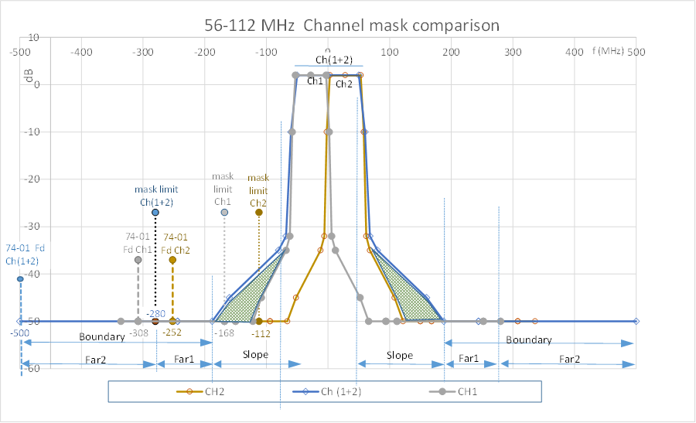

Figure 3: Spectrum masks and relevant points for wide (112 MHz) channel and single (2 x 56 MHz) channels

Comparison shows that the two main differences, potentially contributing to different interference emission, consist in:

* Larger extension of the RF spectrum mask of wide channel outside the channel BW (represented by grey triangle areas in Figure 1).

In this Report, these regions will be referred to as "slope"; they extend from channel edge to the beginning of mask floor of the wide channel mask, where the increase of emissions due to the wide channel is mainly associated to the wider sides of the RF spectrum mask of the wide channel.

* Further position of the border between the out of band emission and the spurious domain.

In this Report, these regions will be referred to as "boundary"; following ERC Recommendation 74-01 [4], two different subranges can be identified: the first, up to mask limit of wide band channel (OOB border), is indicated as "far1"; the second, up to the frequency above which the general spurious limit of -50 dBm /MHz is applied to the wide channel (see ERC Recommendation 74-01, Figure 1/Table 4, frequency Fd), is indicated as "far2". Above this point, no difference exists between emissions.

The different intervals and points or relevance to this Report are represented in Figure 3. More details are given in Annex 1.

## Impact of merging two adjacent channels on in band interference

### Assumptions

Possible implications of the doubling of the channel BW on other services sharing the band with FS with same priority, for channels ≥ 28 MHz, imply considering a potential variation of interfering level in a limited frequency range, centred on the new wide channel centre frequency.

Main part of this section addresses the "boundary" region, whilst the "slope" region is considered in section 4.1.3.

In order to facilitate analysis, the following assumptions apply:

* Transmitted signal: a transmitted signal is simulated using the masks derived from ETSI EN 302 217-2 v. 3.1.1 [3], tab 3f, classes 5LA/8A, note 2 (50 dBc floor), for 56 and 112 MHz (worst theoretical case – real cases always better);
* The normalizing factor (10 log (XX/1 MHz)) used is the channel BW (56 or 112 MHz);
* In-band mask level = normalised power density (Pout - 10 Log BW) level raised by +2 dB -same as TX output mask;
* Ptx: total power at the output of TX side of equipment (Figure 9, point A), before duplexer filter;
* The same output power is used for wide channel and each single channel (see section 3.3).

In section 4.1.3 further adaptation to current assumptions is introduced, before conclusions in section 4.1.4.

Since the analysis takes into account the spurious emission limit, figures in following sections consider the two cases of frequency ranges respectively lower and higher than 21.2 GHz, as for ERC Recommendation 74-01; for frequency > 21.2 GHz the limit of -30 dBm/MHz is used; for frequency ≤ 21.2 GHz two spurious limits are considered (see more details in Annex 1):

* -50 dBm/100 kHz (-40 dBm/MHz) is the limit valid between the OOB border f1=2.5*CS (MHz) and Fd=min[5*CS; 500] (MHz);
* -50 dBm/MHz is the limit valid above Fd=min[5*CS; 500] (MHz).

Note that in case Fd < f1 (true for 224 MHz channels) only -50 dBm/MHz limit applies.

The diagrams used in the next sections are drawn with the power spectral density (dBm/MHz) on y-axis versus frequency (MHz). In order to avoid duplicating each figure and leveraging on the symmetry of the ETSI RF masks [x], the situation for f ≤ 21.2 GHz is represented in the left part of the spectrum and the situation for f > 21.2 GHz is represented in the right part of the spectrum. Frequency ranges where the unwanted emissions from the wide channel are lower than from the single channels are shadowed in green, whilst where they are higher, they are shadowed in red.

In case that the two channels are transmitted by two single equipment, the overall level of the spurious emissions could add up to 3 dB in the RF ranges where both emissions are same value. In case the single emissions are close to the limit, the combined emission can exceed the limit of the wide channel which is transmitted by a single equipment.

Limit case (both emissions at -50 dBm/100 kHz) is reported in figures of section 4.1.2, where relevant, (for output levels up to about 30 dBm), by means of red dashed lines labelled as "sp1+sp2".

Case A and B (Figure 4 and Figure 5) have a different behaviour than case C (Figure 6), because note 3 in table 4 in ERC Recommendation 74-01 applies and the limit of the spurious emission of ‑50 dBm/100 kHz should be reduced to the actual level of the mask floor.

### Power levels and conditions

Depending on power level, different conditions may occur due to the different interference levels generated by channels with specified BW and double size channels in same frequency ranges.

Three specific conditions have been used for this study, under the assumptions specified in section 4.1.1:

* 1. Output Power level = 17.5 dBm, corresponding to spectrum mask floor = -50 dBm/MHz (general spurious emission limit of ERC Recommendation 74-01 for f ≤ 21.2 GHz)
  2. Output Power level = 27.5 dBm, corresponding to spectrum mask floor = -50 dBm/100 kHz (spurious emission limit of ERC Recommendation 74-01 for f ≤ 21.2 GHz and up to fd from the carrier)
  3. Output Power level = 37.5 dBm, corresponding to spectrum mask floor = -30 dBm/MHz (spurious emission limit of ERC Recommendation 74-01 for f > 21.2 GHz).

Condition A): Ptx = 17.5 dBm

For all frequencies : interference level from wide channel is lower than from single channel in "far1"and "far2" and the absolute level is within respective limits (-50 dBm/MHz for f ≤ 21.2 GHz and -30 dBm/MHz for f > 21.2 GHz), so no further consideration is necessary. This situation is shown in Figure 4.

Same conclusions also applies to power levels below this value:



Figure 4: Case of Ptx = 17.5 dBm

Condition B): Ptx = 27.5 dBm

For frequency ≤ 21.2 GHz: interference level from wide channel is lower than from single channel in "far1" and higher in "far2"; however the absolute level is within -50 dBm/100 KHz in all "boundary": the power level is therefore within the permitted values in this range.

For frequency > 21.2 GHz: the wide channel interference in "far1" is lower than the level generated by the narrow channel; the power level is below the permitted values in this range.

Figure 5 shows a representation of this situation.

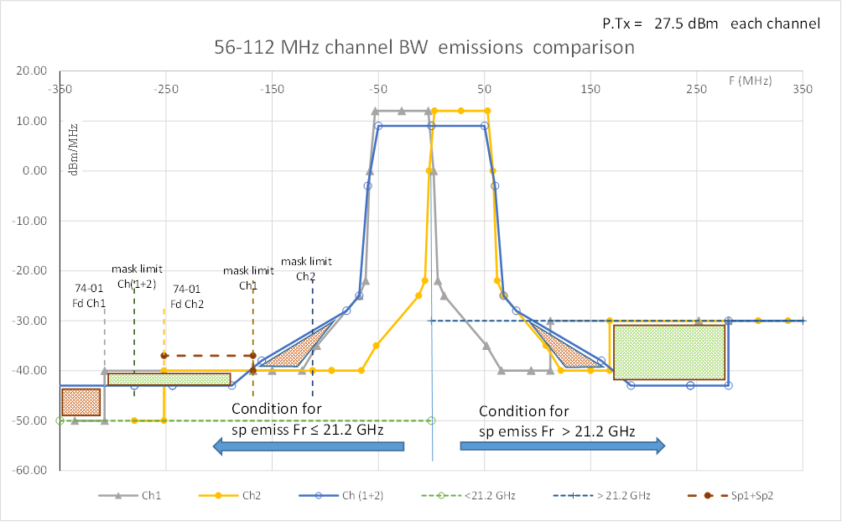

Figure 5: Case of Ptx = 27.5 dBm

Condition C): Ptx = 37.5 dBm

For frequency ≤ 21.2 GHz: interference level from wide channel is higher than from single channel: in "far1" the level is higher than -50 dBm/100 KHz, while in "far2" it is equal to the limit; in any case the power level is inside the permitted values in this range.

For frequency > 21.2 GHz: the wide channel interference in "far1" is lower than the level generated by the narrow channel; the power level is below the permitted values in this range.

Figure 6 shows a representation of this situation:



Figure 6: Case of Ptx = 37.5 dBm

Note that for power levels exceeding this value, the behaviour is the same; in particular, if level is raised by more than 3 dB, the interference level of the wide channel in "far1", for frequency > 21.2 GHz, exceeds the level of narrow channel, as well as the limit of -30 dBm/MHz.

It should be noted, however, that this condition is not met by practical applications, where output levels are much lower (see Recommendation ITU-R F.758 [2]). For frequencies up to 21.2 GHz, the behaviour is the same as for Condition C).

Figure 7 shows an example with Ptx > 37.5 dBm (according to upper limit in RR art. 21 sect. 21.5):

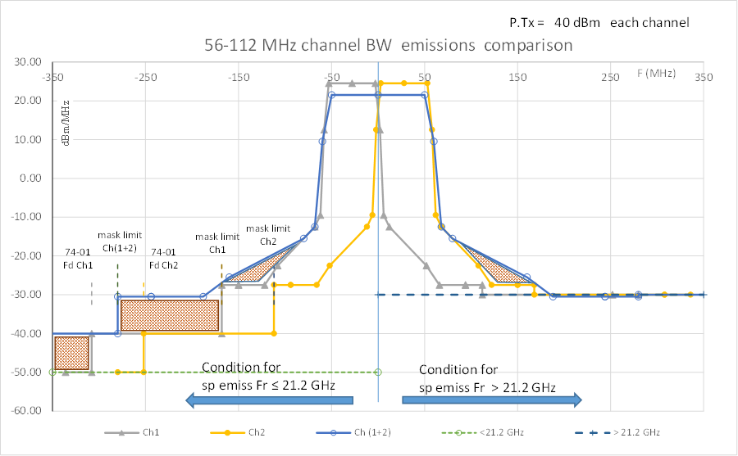

Figure 7: Case of Ptx = 40 dBm

### Additional considerations

In order to better evaluate the effect of using a wide channel, especially in the “slope” range, further considerations are useful.

In line of principle, the spurious emission level coming from the addition of contributions of single channels could raise up to 3 dB in some region of the "Tx mask floor".

Such a situation is shown in Figure 8:



Figure 8: Additional considerations applied, example for f > 21.2 GHz

Moreover, most links used today, due to the network evolution, are significantly shorter than the “limit” links, and ACM and ATPC are used to reduce interference and maximize traffic. Maximum power is used only when long link is concerned and so, in most cases, this level is required during adverse propagation conditions only; this implies that, for a great percentage of time (close to 99.XX%), the interference generated in band is significantly lower than the one computed for nominal level.

### Analysis for the in band case

As possible additional point of confidence, no major concerns have been received till now from field coming from the application of same philosophy of “wide channel” in the past, in cases that 56 or 112 MHz channels have been derived by merging two half size already existing adjacent channels.

Conclusions for the in-band case: considering that ETSI masks and spurious emission levels are used for link planning and interference control purposes, unless there is some need to know more detail of devices for some specific reason, it is assumed that no major problems can be met by the adoption of new proposed wide channels.

## Impact of merging two adjacent channels on out of band interference

Figure 9 shows the basic architecture of a FS equipment, where TX and RX parts are combined by means of a duplexer filter (DF) to an antenna port. Reference points are shown, according to block diagram and terminology of ETSI EN 302 217 series.

DF is needed to isolate the RX from the TX. Usually at least 70 dB of isolation are required between TX and its relevant RX at duplexer distance. Due to the similarities between channel arrangements schemes, considerations in this section are transversal to all frequency bands.

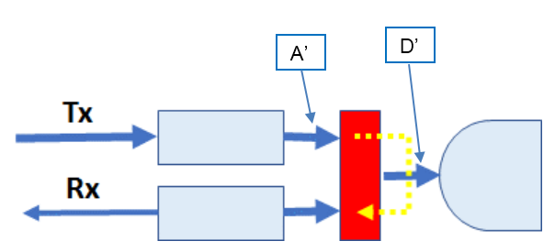

Figure 9: Basic equipment architecture with duplexer filter

In Figure 10 and Figure 11, the measured performance of a DF is shown (the example is in 11 GHz band) in terms of attenuation (dB) versus frequency (GHz). An attenuation of 15-20 dB at about 100 MHz from the lower band limit is shown.

Due to the need of isolation, duplexer characteristics are expected to be quite similar in the out of band, no matter the frequency range analysed. As a consequence, the conclusions expressed in this document are considered appropriate for all frequency ranges where addition of wide channels are proposed.

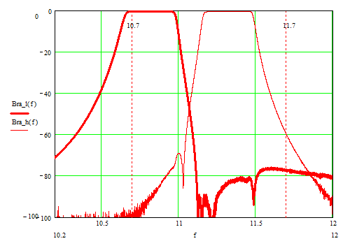

Figure 10: Duplexer filter

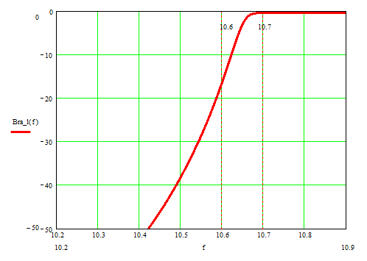

Figure 11: Zoom over duplexer filter edge

Figure 12 shows a general illustration of RF aspects of a generic equipment, where the following diagrams are shown:

* Hypothetical transmitted signal in worst conditions, at TX amplifier output (Figure 9, point A’). Ptx=32 dBm – blue/grey masks for 112/56 MHz CS, continuous line;
* DF transfer function – brown, dashed line;
* Transmitted signal after DF and before antenna, from the equipment (, Figure 9, point D’) – green dashed line, drawn for both single and wide channel cases;
* "boundary" and "slope" ranges;
* Spurious emission limits for frequencies ≤ 21.2 GHz and > 21.2 GHz.

Uppermost channels only are considered, closer to the upper edge of the channel plan / equipment tunability range.

Possible increase of interference in adjacent bands is assumed to be roughly independent of channel BW, since the low frequency side of channels number 1 is assumed to be close to the channel edge by a similar amount for 112, 56 and 28 MHz channel spacing.

In any case, the result is not significantly affected by the real differences.



Figure 12: Duplexer filtering effect

The above figure shows the duplexer filtering effect on a hypothetical TX signal, having as a shape the ETSI TX mask and the emission limits (worst case) outside the occupied band.

Due to the isolation needed from duplexer and the corresponding significant attenuation outside the RF band, it can be seen that the filtering effect plays a significant role not only in the “boundary” range, but, for wide channel BW, also in the “slope” range, such as the resulting power spectral density is significantly below the level of the spurious emission limit, which is normally used for compatibility towards other services situated outside the band allocated to FS, for frequencies at 70/80 MHz from the channel edge.

As example, Figure 13 shows the same situation for the 28 and 56 MHz cases for frequencies < 21.2 GHz. Here the dashed blue line represents the emission limit according to ERC Recommendation 74-01 [4].

It can be seen that the interference control due to the DF, which is a fixed mechanical filter, increases with increasing channel BW.

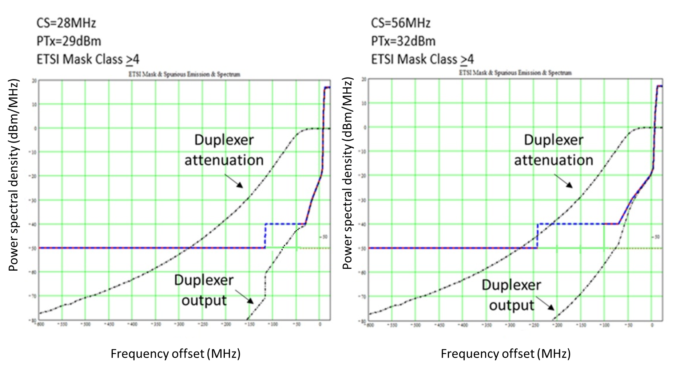

Figure 13: 28 MHz (left) and 56 MHz (right) channels – worst case

(please note that the zero frequency point is the border of the allocated band and not the center of the channel)

In the slope range of the spectrum there is a zone where the emission of the wide channel would exceed the emission of the single channel as a consequence of scaling between different channel size, which could produce a potential interference, as already noted in previous sections and as already seen in the past with the previous channel doublings.

### Analysis for the out of band case

Due to the presence of duplexer filter and considering also the decrease of power spectral density due to the adoption of wide channel in real equipment, it is assessed that the raise by the use of wide channels merging two adjacent channels could be managed to avoid performance degradation of applications belonging to services allocated outside of the FS band (or of the equipment operating band) compared to a situation in which narrower channels are used. .

## Additional considerations for in band/out of band interference

In order to properly evaluate the possible interference effects when using a single channel merging two adjacent channels with the same total bandwidth, the following general considerations, applicable to both in-band and out of band, have to be taken into account:

1. A possible increase of emission power outside the wide channel band is theoretically possible but it should be noted that real equipment is likely to have better performance.
2. Such increase of the current spurious emission is within limits of ERC Recommendation 74-01 [4].
3. Due to ATPC, maximum power level is just used in adverse propagation conditions.
4. The need to retain the same output power in case of use of wide channels, reducing the power spectral density, automatically reduces most possible interference towards other band or adjacent channel users.
5. The power levels associated to real signals are lower than the ones assumed in this Report, due to the need for real spectra to comply with the masks and limits with some margin.
6. The use of wider CS reduces the number of overall emissions due to the reduced number of TX equipment.

# Conclusions

In order to answer the continuously growing request for capacity, new FS equipment with advanced capabilities is available or near to be developed by the industry. Among the possible new capabilities RF channels of wide band, up to 112 / 224 MHz, have been provided by industry, according to market needs.

The study shows that the possible increase of emitted RF power in some frequency ranges close to the used channels, generated by the adoption of the wide channels, compared to the use of narrow channels, is compliant with the standardization and regulatory framework in force (ETSI EN 302 217-2 [3]and ERC Recommendation 74-01 [4]).

Conclusions for the in-band case: considering that ETSI masks and spurious emission levels are used for link planning and interference assessment purposes, it is assumed that major problems may not be expected by the adoption of new proposed wide channels.

Conclusions for the out-of-band case: due to the presence of duplexer filter and considering also the decrease of power spectral density due to the adoption of wide channel in real equipment, it is assessed that the raise of interference by the use of wide channels merging two adjacent channels could be managed to avoid performance degradation of applications belonging to services allocated outside of the FS band (or of the equipment operating band) compared to a situation in which narrower channels are used.

The analysis in this Report is made over a single channel of 56 MHz. Conclusions are considered valid also for transition from 112 to 224 MHz, due to the similarities of equipment requirements and transmission masks.

1. Information about 2019 update of ERC Recommendation 74-01

In versions of ERC Recommendation 74-01 before the amendment of 29 May 2019, the limit for spurious emission levels in FS for frequencies < 21.2 GHz was -50 dBm/MHz.

This limit was originated more than 20 years ago, based on old equipment, unable to offer any flexibility of use (old analogue / first generation digital equipment, allowing fixed frequency, modulation, power, capacity), and margins to comply with this limit have been progressively eroded, following the wide request for continuously increased equipment flexibility. Such limit is felt today as an obstacle for the development of new even extended functionalities required from the market (wider channel BW, energy efficiency and channel aggregation).

Technical evidence was given that a relaxation of at least 10 dB was possible with negligible effects towards in band and out of band services (FS itself or others) and this new criteria was introduced into the revision of ERC Recommendation 74-01 published on 29 May 2019 [2].

The limit for FS spurious emission of -50 dBm/100 kHz (-40 dBm/MHz) is applicable to a limited frequency range, covering up to the minimum between 5*CS and 500 MHz each side of centre frequency, in line with an approach already agreed for Mobile Service. Above this range -50 dBm/MHz limit applies.

In case of CS = 224 MHz only the limit for FS spurious emission of -50 dBm/MHz is applicable. However in this case the power spectral density is significantly lower than with narrower channels.

The below table summarise the frequency range for spurious emission in different FS channel sizes, given that:

f1 = boundary between OOB domain (f<f1) and spurious domain (f>f1), upper limit of ETSI spectrum mask:

* For CS < 500 MHz, f1 = 2.5*CS (MHz) (ITU-R F.1191);
* For CS ≥ 500 MHz, f1 = 500 + 1.5*CS (MHz) (ITU-R SM.1539).

Fd = boundary between ranges in which reference BW for spurious measurement is 100 kHz (f<Fd) and 1 MHz (f>Fd):

* Fd = min [5*CS; 500] (MHz) (ERC Recommendation 74-01).

Table 3: Frequency ranges for spurious emission

|  |  |  |
| --- | --- | --- |
| CS (MHz) | f1 (MHz) | Fd (MHz) |
| 28 | 70 | 140 |
| 56 | 140 | 280 |
| 112 | 280 | 500 |
| 224 | 560 | NA (Note 1) |
| Note 1: only the limit for FS spurious emission of -50 dBm/MHz is applicable. | | |

It is worthwhile to be noted that no change to the spurious limit of -30 dBm/MHz, valid for frequencies higher than 21.2 GHz, was introduced in the updated ERC Recommendation 74-01. In this case Fd is not defined.

1. List of References
2. ETSI White Paper No. 25: “Microwave and Millimetre-wave for 5G Transport”
3. Recommendation ITU-R F.758: “System parameters and considerations in the development of criteria for sharing or compatibility between digital fixed wireless systems in the fixed service and systems in other services and other sources of interference”
4. ETSI EN 302 217-2: “Fixed Radio Systems; Characteristics and requirements for point-to-point equipment and antennas”
5. ERC Recommendation 74-01: “Unwanted Emissions in the Spurious Domain”, latest amendment on 29 May 2019

1. See ERC Recommendation 74-01