Sharing studies assessing short-term interference from Wireless Access Systems including Radio Local Area Networks (WAS/RLAN) into Fixed Service in the frequency band 5925-6425 MHz
approved 21 May 2020
ECC Report 316

Executive summary
In this Report, two studies are presented which expand upon the studies carried out in ECC Report 302 by assessing the possible short-term interference impact of the WAS/RLANs onto point-to-point Fixed Service (FS) links:
- Site-general Monte Carlo analysis;
- Site-specific sensitivity analysis on LPI deployment assumptions based on radio coverage.
A combination of low power indoor (LPI) WAS/RLANs operating at power levels up to 200 mW and outdoor Very Low Power (VLP) portable WAS/RLANs up to 25 mW is used in the studies
Clutter loss lower than 5 dB (corresponding to $P_{CLUT}=0.001\%$ for distances larger than 1 km) has not been considered in this analysis. In particular, line of sight cases using only free space propagation model for distances larger than 1 km have not been considered.

Results of the site-general Monte Carlo analysis
Site-general Monte Carlo simulations have been performed using from 10 to 30 million events to assess whether the short-term criterion is met when WAS/RLAN indoor and VLP WAS/RLAN outdoor devices are both in operation simultaneously. For the low FS antenna heights scenario, this Monte Carlo simulation removed any WAS/RLAN with an unrealistic physical placement (as explained in ANNEX 2:). The studies have considered, amongst other parameters, a high-density populated environment corresponding to large cities.
The performed sensitivity analysis has shown that the results are sensitive to assumptions on population density and the difference of antenna heights between FS Rx and WAS/RLAN.
Results from a large number of Monte Carlo events show that the percentage of events for which the short-term threshold (I/N = 19 dB) is not exceeded for more than $4.5⋅{10}^{-4}$% (which was used as a proxy for short-term protection criterion) for the studied combinations of FS antenna heights, population densities, and WAS/RLAN deployment.
Various VLP outdoor percentages of WAS/RLAN deployment show no effect on the overall interference impact.
The simulations carried out used space- and time-based distributions for calculating a percentage of interference. Therefore, results are in terms of time-space percentage and not in terms of time percentage only. This should be taken into account in the interpretation of results.

Results of the site-specific sensitivity analysis on LPI deployment assumptions based on radio coverage
Simulations have shown that the size of the area from where a WAS/RLAN may create interference to the FS receiver is sensitive among others to the clutter loss, building entry loss, WAS/RLAN height and position (relative to FS main beam). For the WAS/RLAN RF activity factor of 2%, it should be noted that for the combinations where some positions depict the exceedance of the short-term threshold I/N = 19 dB, this interference may be created for more than $4.5⋅{10}^{-4}$% of the time in any month (for errored seconds); the probability of this occurring has not been studied.

TABLE OF CONTENTS

0 Executive summary 2
1 Introduction 6
2 Technical Characteristics of WAS/RLAN and FS in the Band 5925-6425 MHz 7
2.1 Technical Characteristics of low power indoor (LPI) and Very Low Power (VLP) WAS/RLANs in the band 5925-6425 MHz 7
2.2 WAS/RLAN antenna height statistics 8
2.3 FS System Parameters and Assumptions 8
3 Methodology Used in Sharing Studies 9
4 Short-Term Interference Assessment from WAS/RLAN into FS 10
4.1 Introduction 10
4.2 Site-general Monte Carlo Analysis 10
4.2.1 Technical characteristics of WAS/RLAN in the band 5925-6425 MHz for the purpose of this study 10
4.2.1.1 VLP WAS/RLAN use case and associated peak e.i.r.p. 10
4.2.1.2 WAS/RLAN deployment model and density 10
4.2.1.3 WAS/RLAN antenna height distribution 12
4.2.1.4 WAS/RLAN bandwidth distribution and associated e.i.r.p. 13
4.2.2 Technical characteristics of FS in the band 5925-6425 MHz for the purpose of this study 15
4.2.3 Methodology and approach considered 15
4.2.3.1 Methodology 15
4.2.3.2 Interference criterion 15
4.2.3.3 Path loss calculation 16
4.2.3.4 Fresnel zone 16
4.2.3.5 WAS/RLAN height and distance removal algorithm for FS heights of 25 m 17
4.2.4 Simulation results 17
4.2.4.1 Simulation scenarios 17
4.2.4.2 Results for simultaneous indoor and outdoor operation 18
4.2.5 Summary of the site-general Monte Carlo analysis 22
4.3 Sensitivity analysis on LPI deployment assumptions applying a static methodology based on radio coverage 22
4.3.1 Simulation results 23
4.3.1.1 Effect of building entry loss 23
4.3.1.2 Effect of clutter loss 25
4.3.1.3 Effect of WAS/RLAN antenna height 27
4.3.2 Summary of sensitivity analysis on LPI deployment assumptions 28
5 Conclusions 29
ANNEX 1: List of References 30
ANNEX 2: Analysis on the exceedance of the I/N from Monte-Carlo Simulation 31
ANNEX 3: Statistics for buildings heights and WAS/RLAN antenna heights 36

LIST OF ABBREVIATIONS

Abbreviation |  | Explanation
ATPC |  | Automatic Transmitter Power Control
AR/VR |  | Augmented and Virtual Reality
BEL |  | Building Entry Loss
BL |  | Body Loss
BW |  | Bandwidth
CF |  | Conversion factor
CDF |  | Cumulative Distribution Function
CEPT |  | European Conference of Postal and Telecommunications Administrations
C/I | Carrier to interferer ratio
C/(I+N) | Carrier to interference plus noise ratio
DP |  | Degradation of Performance
ECC |  | Electronic Communications Committee
e.i.r.p. | Effective isotropically radiated power
ES |  | Errored Second
FFM |  | Flat Fade Margin
FS |  | Fixed Service
FSPL | Free Space Path Loss
I/N | Interferer to noise ratio
ITU | International Telecommunication Union
LOS |  | Line of sight
NF |  | Noise Floor
NLOS |  | Non line of sight
pdf |  | Probability Density Function
PP |  | Point-to-point
QAM | Quadrature amplitude modulation
RLAN |  | Radio Local Area Networks
Rx |  | Receiver
SES |  | Severely Errored Seconds
SNR |  | Signal to noise ratio
SRTM |  | Shuttle Radar Topography Mission
STA |  | Wi-Fi Station
Tx |  | Transmitter
VLP |  | Very Low Power
WAS |  | Wireless Access Systems

Introduction
In this Report, studies have been performed to assess short-term interference protection of point-to-point Fixed Service (FS) from WAS/RLAN indoor only deployments as well as from potential outdoor WAS/RLAN portable devices operating with power levels significantly lower than those for indoor uses. This Report complements ECC Report 302 [2], which contains sharing and compatibility studies between WAS/RLAN systems and existing incumbent systems in the 5925-6425 MHz band and adjacent bands, in line with the EC Mandate to CEPT to study feasibility and identify harmonised technical conditions for wireless access systems including radio local area networks in the 5925-6425 MHz band [1].
The studies presented here include parametric inputs, parameters and distributions, which are detailed in ECC Report 302, and cover sharing scenarios taking into account models of year 2025 for WAS/RLAN deployments from that Report and additional considerations on several parameters such as WAS/RLAN antenna heights and densities. The studies attempt to quantify and qualify the risk of exceeding short-term interference criteria assessed in terms of I/N threshold.
Two studies are presented:
- Site-general Monte Carlo analysis;
- Site-specific sensitivity analysis on LPI deployment assumptions based on radio coverage.

Technical Characteristics of WAS/RLAN and FS in the Band 5925-6425 MHz

Technical Characteristics of low power indoor (LPI) and Very Low Power (VLP) WAS/RLANs in the band 5925-6425 MHz
Wireless Access Systems including Radio Local Area Networks (WAS/RLANs) represent the primary broadband wireless access technologies used for wireless internet access. WAS/RLAN systems are used to provide coverage in a range of locations, from commercial and residential premises to transport hubs, hospitals, sports stadiums, shopping centres, hotels, cafes, etc... WAS/RLAN systems are also being used to provide internet connections within enterprise, commercial and industrial premises, with many organisations now moving to wireless industrial solutions to increase the flexibility of production and distribution.
WAS/RLAN devices used in various applications will have different power levels and technologies. For the 6 GHz band, it is intended to introduce indoor enterprise access points (APs)/small cells, indoor consumer APs/small cells and indoor high-performance gaming APs. They are referred to as low power indoor (LPI) devices.
The Very Low Power device (VLP) category is used for short-range WAS/RLAN applications that cover personal area networks. Devices operating under the VLP category are expected to be used for connecting peripheral devices to smartphones, tethering, in-vehicle entertainment, and short-range video streaming. These devices would mostly be portable, battery powered and have small physical size.
Very Low Power portable battery-operated device category is expected to enable a hand-held or wearable client device class. VLP devices will provide connectivity to client devices when located outside of locations that contain low power indoor access points. Example outdoor use cases include short range personal area networks for Automotive, such as improved vehicle to driver interface, and Augmented and Virtual Reality (AR/VR) applications in education, medicine, training, defence, remote presence, gaming, and more generally, next generation human – computer interaction.
The bandwidth distribution for the VLP category is assumed to be the same as that of other 6 GHz devices considered in ECC Report 302 [2] and given in Table 12 thereof. A fixed body loss of 4 dB is applied to VLP devices when performing sharing studies. As in ECC Report 302, an omni-directional antenna model is used for analysis of VLP.
Two assumptions have been used concerning the number of VLP devices assumed to be operating outdoors:
- 1% of the total number of WAS/RLAN devices (as a baseline study), where most of the deployment was assumed to be indoor access point, reflecting a scenario where the use of 6 GHz for wearable device connectivity remains negligible and where these VLP devices are replacement of part of the initial amount of small cells/client devices;
- A sensitivity analysis, where the percentage of VLP devices varies from 2% to 5%.
A WAS/RLAN activity factor of 2% as adopted in ECC Report 302 for LPI applications is considered in the studies as a general framework. The results of this sensitivity analysis may also be used to take account of situations where the activity factor would be higher for VLP than the 2% considered for LPI.
In order to obtain the power levels and distribution, all devices are assumed to be client-like devices with a maximum e.i.r.p. of 25 mW. Using the antenna pattern given in Figure 93 of ECC Report 302 for the indoor/outdoor client device category and using the 25 mW maximum transmit power, the VLP e.i.r.p. power distributions as shown in Table 1 can be obtained.
Table 1: WAS/RLAN power distribution for the VLP use case
Power level e.i.r.p. | 25 mW | 12.5 mW | 3.25 mW
Percentage of VLP devices with the power level shown above | 6.93% | 45.71% | 47.36%

The e.i.r.p. distribution for indoor WAS/RLAN devices is presented in Table 2. This distribution was generated from ECC Report 302 (Table 8) by:
- first summing the indoor and outdoor percentages for each power,
- then, truncating the powers at maximum 200 mW by aggregating all percentages related to powers higher than 200 mW to the 200 mW level.
The e.i.r.p. distribution for outdoor VLP devices is also shown in Table 2. Using different granularities in the power distributions assumed for outdoor and indoor devices has a consequence that some power levels are dedicated to outdoor usage only.
Table 2: LPI/VLP outdoor power distributions
Tx e.i.r.p. Power | 200  mW | 100  mW | 50  mW | 25  mW | 13  mW | 12.5  mW | 3.25  mW | 1  mW | Total
Indoor | 9.81% | 6.24% | 26.01% | 0% | 52.31% | 0% | 0% | 5.63% | 100%
Outdoor | 0% | 0% | 0% | 6.93% | 0% | 45.71% | 47.36% | 0% | 100%

WAS/RLAN antenna height statistics
Two different WAS/RLAN height distributions are used in the studies:
- one is according to the WAS/RLAN height statistics used in ECC Report 302 and
- the other one is according to the antenna height distribution given in ANNEX 3:.

FS System Parameters and Assumptions
Unless specified otherwise, the FS system parameters and assumptions as outlined in ECC Report 302 are used.

Methodology Used in Sharing Studies
In this Report, only the methodology based on I/N = 19 dB not exceeded for more than $4.5⋅{10}^{-4}$% of the time in any month (for errored seconds) [10] has been used to evaluate the fixed-service short-term criterion.

Short-Term Interference Assessment from WAS/RLAN into FS

Introduction
This section contains the results of two studies of the short-term interference from WAS/RLANs to FS links:
- A Monte Carlo analysis assessing short-term interference from low power indoor (LPI) WAS/RLANs and very low power (VLP) WAS/RLAN portable devices for a site-general scenario in a dense urban environment;
- Site-specific sensitivity analysis on LPI deployment assumptions based on radio coverage.

Site-general Monte Carlo Analysis

Technical characteristics of WAS/RLAN in the band 5925-6425 MHz for the purpose of this study

VLP WAS/RLAN use case and associated peak e.i.r.p.
Based on Table 1 and the work done for ECC Report 302 [2], the use case of Very Low Power was further refined as summarised in Table 3. The three different weights of VLP e.i.r.p. (%) come from the antenna design of the E-plane antenna pattern of the WAS/RLAN as reported in ANNEX 1 of ECC Report 302.
Table 3: Outdoor VLP WAS/RLAN e.i.r.p. and associated weights
Parameter | Value |  |  | Notes
VLP e.i.r.p. levels (mW) | 25 | 12.5 | 3.25 | Based on 6 dB reduction of Client/STA powers in Table 7 of ECC Report 302
VLP e.i.r.p. levels (dBm) | 14.0 | 11.0 | 5.1
VLP Body Loss (dB) | 4 |  |  | Same as in ECC Report 302, STA body loss (all devices)
VLP e.i.r.p. levels (including Body Loss) (dBm) | 10.0 | 7.0 | 1.1
Weight of VLP e.i.r.p. (%) | 6.93 | 45.71 | 47.36 | Twice the Client/STA percentages in Table 7 of ECC Report 302
The e.i.r.p. distribution for indoor WAS/RLAN devices is presented in Table 4.
Table 4: e.i.r.p. distribution for indoor WAS/RLAN devices
Indoor power (mW)  (Body loss included) | 200 | 100 | 50 | 13 | 1 | 40 | 20 | 5 | Total
Indoor percentage | 9.81 | 4.39 | 13.76 | 39.63 | 5.62 | 1.85 | 12.25 | 12.69 | 100.0%

WAS/RLAN deployment model and density
The simulation area is a circle where a single FS receiver station is in the centre. The circle contains a specific density of population: 20000 inhabitants/km2 and 2000 inhabitants/km2 have been used for this study. A population density of 20000 inhabitants/km2 is equivalent to the city centre of Paris. Table 5 provides clarification on how the VLP devices deployment is derived and highlights the overview of the difference with the WAS/RLAN deployment studied in the ECC Report 302. The simulations in this section are based on the baseline scenario of 1% outdoor VLPs (see Section 2.1). An additional sensitivity analysis is also assessed for 2%, 3%, 4% and 5% VLP outdoor and it is not representative of anticipated actual outdoor use. This high percentage is included only to show the minimal impact VLP devices will have on incumbent services.
Table 5: VLP WAS/RLAN devices deployment
Parameter | Value | Notes
Weight of VLP portable outdoor devices (%) | 1% of total devices | Percentages of VLP outdoor of 2%, 3%, 4% and 5% are used only for sensitivity analysis and they are not representative of anticipated outdoor use
Total weight of indoor devices | 99%
Based on the total number of devices that are simultaneously transmitting, the WAS/RLAN deployment model is summarised in Table 6 (i.e. similar methodology as per ECC Report 302). Three categories of WAS/RLAN deployment were considered as in ECC Report 302: Low, Mid and High deployment. A bandwidth overlap factor of 21.25% as in ECC Report 302 was considered.
Table 6: Summary of the VLP WAS/RLAN deployment model as per ECC Report 302
 | Low | Mid | High
Wireless devices operating in licence exempt spectrum (remainder operating in licence spectrum) | 90%
Busy Hour factor | 50% | 62.7% | 62.7%
6 GHz factor (6 GHz / (6 GHz + 5 GHz +2.4 GHz)) | 48.17%
Market Adoption factor (6 GHz capable devices) | 25% | 32% | 50%
RF Activity factor per person (i.e. duty cycle) | 1.97%
Bandwidth overlap factor (as per ECC Report 302) | 21.25 %
Instantaneously transmitting WAS/RLAN devices per km² for a population density of 20000 inhabitants/km² (dense urban scenario) | 4.54 | 7.28 | 11.38
Equivalent number of instantaneously transmitting WAS/RLANs used in the simulations (5 km radius) | 356 | 572 | 894
Instantaneously transmitting WAS/RLAN devices per km² for a population density of 2000 inhabitants/km² (urban scenario) | 0.454 | 0.728 | 1.14
Equivalent number of instantaneously transmitting WAS/RLANs used in the simulations (5 km radius) |  |  | 89.4

Table 7: Typical WAS/RLAN system for the frequency range 5925-6425 MHz
Parameter | Value
Centre frequency (MHz) | 5985 (=5945 (edge of the band) + 40 (half bandwidth))
Channel spacing and receiver noise bandwidth (MHz) | 20, 40, 80, and 160 MHz as per ECC Report 302
Antenna peak gain (dBi) | 0
Antenna pattern | Omni-directional in all directions
Antenna height (m) | See Table 8
Polarisation mismatch (assuming aggregate cases) | Random polarisation as in ECC Report 302
e.i.r.p. | See Table 3 and Table 4

WAS/RLAN antenna height distribution
The outdoor and indoor WAS/RLAN antenna height distributions have been used as described in ECC Report 302 (see Table 8 and Table 9).
To show the impact of the indoor WAS/RLAN antenna height distribution on the results, a height distribution of a large city (with more than 50000 and 100000 households) has also been used as described in ANNEX 3: and shown in Table 9.
Table 8: WAS/RLAN outdoor height distribution (ECC Report 302)
Building story | Height (m) | Probability (%)
1 | 1.5 | 95.00
2 | 4.5 | 2.00
3 | 7.5 | 2.00
4 | 10.5 | 0.50
10 | 28.5 | 0.50

Table 9: WAS/RLAN indoor height distribution (ANNEX 3:, ECC Report 302 - urban case)
Floor | Height (m) | >100k | >50k | ECC 302
ground | 1.5 | 24.66 | 35.14 | 77.85
1 | 4.5 | 20.36 | 24.74 | 17.85
2 | 7.5 | 14.05 | 13.40 | 2.85
3 | 10.5 | 11.27 | 9.31 | 0.52
4 | 13.5 | 9.19 | 6.24 | 0.36
5 | 16.5 | 7.52 | 3.78 | 0.24
6 | 19.5 | 5.56 | 2.91 | 0.16
7 | 22.5 | 3.88 | 2.16 | 0.09
8 | 25.5 | 2.41 | 1.50 | 0.05
9 | 28.5 | 1.10 | 0.92 | 0.02

WAS/RLAN bandwidth distribution and associated e.i.r.p.
The WAS/RLAN bandwidth distribution is assumed the same as in ECC Report 302 (i.e. 20, 40, 80, 160 MHz). The bandwidth distribution and its associated e.i.r.p. are summarised in Table 3 and Table 4.
The resulting bandwidth distribution and its associated e.i.r.p. for VLP outdoor is summarised in Table 10 and for WAS/RLAN devices operating indoor in Table 11.
Table 10: Bandwidth distribution and associated e.i.r.p. for VLP WAS/RLAN outdoor simulation
VLP e.i.r.p. levels (mW) | 25 |  |  |  | 12.5 |  |  |  |  | 3.25
Channel bandwidth (MHz) | 20 | 40 | 80 | 160 | 20 | 40 | 80 | 160 | 20 |  | 40 | 80 | 160
WAS/RLAN device percentage (%) | 10 | 10 | 50 | 30 | 10 | 10 | 50 | 30 | 10 |  | 10 | 50 | 30
Bandwidth conversion factor (dB)  Note 1 | 0 | -1.25 | -4.25 | -7.25 | 0 | -1.25 | -4.25 | -7.25 | 0 |  | -1.25 | -4.25 | -7.25
Power (PTx) (dBm) | 14 | 14 | 14 | 14 | 11 | 11 | 11 | 11 | 5.1 |  | 5.1 | 5.1 | 5.1
Percentage associated to the power (%) | 6.92 | 6.92 | 6.92 | 6.92 | 45.7 | 45.7 | 45.7 | 45.7 | 47.36 |  | 47.36 | 47.36 | 47.36
PTx+CF_BW (dBm) | 14 | 12.75 | 9.75 | 6.75 | 11 | 9.75 | 6.75 | 3.75 | 5.1 |  | 3.85 | .85 | -2.15
PTx+Body loss +CF_BW (dBm) | 10 | 8.75 | 5.75 | 2.75 | 7 | 5.75 | 2.75 | -0.25 | 1.1 |  | -0.15 | -3.15 | -6.15
Combined percentage (%) | 0.692 | 0.692 | 3.46 | 2.076 | 4.57 | 4.57 | 22.85 | 13.71 | 4.736 |  | 4.736 | 23.68 | 14.208
Note 1: A bandwidth conversion factor is introduced to take into account only the overlapping portion of transmitted power. It is applied if the bandwidth of the WAS/RLAN device is greater than the 30 MHz bandwidth of the FS channel. It is calculated as follows: 10log(BW_FS/BW_RLAN)

Table 11: Bandwidth distribution and associated e.i.r.p. for indoor simulation
Power Level (mW, BL incl) |  | Power Level (PTx) BL incl. (dBm)) |  | Channel bandwidth (MHz) | Device perc. (%) | BW conversion factor  (dB) (CF_BW): |  | Percentage associated to the power (%) |  | PTx+CF_BW (dBm) | Combined perc. (%)
200 | 23 |  | 20 |  | 10 | 0 | 9.81 |  | 23.00 |  |  | 0.98
 |  |  | 40 |  | 10 | -1.25 | 9.81 |  | 21.75 |  |  | 0.98
 |  |  | 80 |  | 50 | -4.25 | 9.81 |  | 18.75 |  |  | 4.91
 |  |  | 160 |  | 30 | -7.25 | 9.81 |  | 15.75 |  |  | 2.94
100 | 20 |  | 20 |  | 10 | 0 | 4.39 |  | 20.00 |  |  | 0.44
 |  |  | 40 |  | 10 | -1.25 | 4.39 |  | 18.75 |  |  | 0.44
 |  |  | 80 |  | 50 | -4.25 | 4.39 |  | 15.75 |  |  | 2.20
 |  |  | 160 |  | 30 | -7.25 | 4.39 |  | 12.75 |  |  | 1.32
50 | 17 |  | 20 |  | 10 | 0 | 13.76 |  | 17.00 |  |  | 1.38
 |  |  | 40 |  | 10 | -1.25 | 13.76 |  | 15.75 |  |  | 1.38
 |  |  | 80 |  | 50 | -4.25 | 13.76 |  | 12.75 |  |  | 6.88
 |  |  | 160 |  | 30 | -7.25 | 13.76 |  | 9.75 |  |  | 4.13
13 | 11 |  | 20 |  | 10 | 0 | 39.63 |  | 11.00 |  |  | 3.96
 |  |  | 40 |  | 10 | -1.25 | 39.63 |  | 9.75 |  |  | 3.96
 |  |  | 80 |  | 50 | -4.25 | 39.63 |  | 6.75 |  |  | 19.8
 |  |  | 160 |  | 30 | -7.25 | 39.63 |  | 3.75 |  |  | 11.8
1 | 0 |  | 20 |  | 10 | 0 | 5.62 |  | 0.00 |  |  | 0.56
 |  |  | 40 |  | 10 | -1.25 | 5.62 |  | -1.25 |  |  | 0.56
 |  |  | 80 |  | 50 | -4.25 | 5.62 |  | -4.25 |  |  | 2.81
 |  |  | 160 |  | 30 | -7.25 | 5.62 |  | -7.25 |  |  | 1.69
40 | 16 |  | 20 |  | 10 | 0 | 1.85 |  | 16.00 |  |  | 0.19
 |  |  | 40 |  | 10 | -1.25 | 1.85 |  | 14.75 |  |  | 0.19
 |  |  | 80 |  | 50 | -4.25 | 1.85 |  | 11.75 |  |  | 0.93
 |  |  | 160 |  | 30 | -7.25 | 1.85 |  | 8.75 |  |  | 0.56
20 | 13 |  | 20 |  | 10 | 0 | 12.25 |  | 13.00 |  |  | 1.23
 |  |  | 40 |  | 10 | -1.25 | 12.25 |  | 11.75 |  |  | 1.23
 |  |  | 80 |  | 50 | -4.25 | 12.25 |  | 8.75 |  |  | 6.13
 |  |  | 160 |  | 30 | -7.25 | 12.25 |  | 5.75 |  |  | 3.68
5 | 7 |  | 20 |  | 10 | 0 | 12.69 |  | 7.00 |  |  | 1.27
 |  |  | 40 |  | 10 | -1.25 | 12.69 |  | 5.75 |  |  | 1.27
 |  |  | 80 |  | 50 | -4.25 | 12.69 |  | 2.75 |  |  | 6.35
 |  |  | 160 |  | 30 | -7.25 | 12.69 |  | -0.25 |  |  | 3.81

Technical characteristics of FS in the band 5925-6425 MHz for the purpose of this study
The technical characteristics of point-to-point (PP) Fixed Service (FS) links are derived from ECC Report 302, which refers to Recommendation ITU-R F.758 [3] and Report ITU-R F.2346 [4]. Other deliverables describing typical deployment of FS stations in the 6 GHz band were also referenced including Recommendations ITU-R F.383-9 [5], F.384-11 [6], F.699-7 [7] and F.1245-2 [8].
The technical characteristics of PP FS links are summarised in Table 12 for the 5925-6425 MHz range.
Table 12: Typical System for PP FS systems for the frequency range 5925-6425 MHz
Parameter | Value
Centre frequency (MHz) | 5960 (=5945 (edge of the band) + 15[(half bandwidth))
Channel spacing and receiver noise bandwidth (MHz) | 30
Feeder/multiplexer loss (dB) | 1.3 (it is being deduced from the antenna peak gain of the FS)  (Type 2 of Table 17 of ECC Report 302 is assumed)
Effective Antenna peak gain (dBi) | 37.4 dBi = 38.7 dBi - 1.3 dB (Antenna peak gain – Feeder loss) (Type 2 of Table 17 of ECC Report 302 is assumed)
Antenna diameter (m) | 1.8 m
Antenna pattern | Recommendation ITU-R F.1245 specified for aggregate interference
Antenna height (m) (Rx) | 25 m, 55 m, 110 m (values from ECC Report 302)
Receiver noise figure (NF) typical (dB) | 5
Receiver Noise floor (dBm) | -94 (= -173.97 + 10log10(BW in Hz) +NF)
Protection requirement (dB) | Long-term:  I/N = −10 dB (Recommendation ITU-R F.758: Table 4) not exceeded for more than 20% of time  Short-term:  I/N = +19 dB not exceeded for $4.5⋅ {10}^{-4}$ % (Recommendation ITU-R SF.1650-1 [10])

Methodology and approach considered

Methodology
A Monte Carlo simulation was used to generate I/N results. 10 million events were simulated for outdoor only and outdoor+indoor simulation respectively. This high amount of statistics is necessary for Monte Carlo analysis to be able to find the percentage of events exceeding the short-term criteria. In some scenarios where larger samples of data were needed, 30 million events were simulated.
The simulation platform used is SEAMCAT and it has been modified to take into account the Fresnel zone as described section 4.2.3.4.

Interference criterion
For short-term interference criterion, an I/N of 19 dB is considered as shown in Table 12. This means that for a noise floor of -94 dBm, the maximum tolerable interference is -75 dBm.

Path loss calculation
The WINNER model [12] has been used up to 1 km, where the first 40 m is upper bounded by free space model [13]. For distances farther than 1 km, Recommendation ITU-R P.452-16 [9] with clutter loss (Recommendation ITU-R P.2108-0 [11]) is used. This is summarised in Table 13.
Table 13: Propagation models
Horizontal Distance | Propagation Model | For Indoor only | Clutter
$$0 m≤ d< 40 m$$ | Free space | ITU-R P.2109 [14]  (70% traditional, 30% modern, uniform distribution of probability from 1 to 99%) | not applicable
$40 m≤ d<1000 m$ | WINNER model  (Urban Macrocell C2) | ITU-R P.2109  (70% traditional,  30% modern,  uniform distribution of probability from 1 to 99%) | LOS and NLOS ratio probability determination is inherent to the WINNER model
$$d≥ 1000 m$$ | Recommendation ITU-R P.452-16  (time percentage: uniform distribution from 0.001% to 50%) | ITU-R P.2109  (70% traditional,  30% modern,  uniform distribution of probability from 1% to 99%) | ITU-R P.2108-0  (Location percentage: uniform distribution from 0.001% to 99%)

Fresnel zone
The simulation takes care of the Fresnel zone for the WАS/RLAN positioned within 200 m.
From FS planning a rule of thumb is that the first Fresnel zone must be 60% clear of obstructions from the major axis of the first Fresnel ellipsoid [15]. It is also assumed that there will be no WAS/RLAN on top of a roof. Therefore a 5 m clearance in addition to the Fresnel zone has been applied.
The clearance from the building is illustrated in Figure 1 and its formula can be described as follows: any WAS/RLAN within 200 m of the FS that is within 0.6r + 5 m of the major axis of the first Fresnel ellipsoid will have its height reduced by 0.6r + 5 m below the Fresnel ellipsoid major axis.
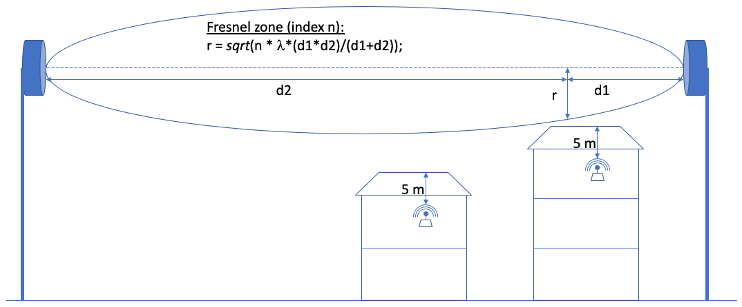
Figure 1: Illustration of the clearance from the Fresnel zone and the building roof and walls

WAS/RLAN height and distance removal algorithm for FS heights of 25 m
Analyses of results for FS heights of 25 m exceeding the short-term probability criterion revealed an unrealistic positioning for single WAS/RLAN devices, which can cause this exceedance. In ANNEX 2:, one of these analyses is described in detail.
A correction for those unrealistically positioned devices has been performed afterwards, only for the scenario with a FS height of 25 m as follows:
- In a radius of 20 m around the FS antenna, there will be no WAS/RLAN device;
- In a radius of 200 m, there will be no WAS/RLAN devices placed higher than 10.5 m.
This algorithm is assumed to give a more realistic model of building heights in the vicinity of a FS antenna.

Simulation results

Simulation scenarios
This study shows the simultaneous impact of indoor and VLP outdoor WAS/RLAN devices onto the FS receiver. Table 14 presents a summary of the scenarios that have been considered.
The overall results are shown in terms of the inverse CDF of the I/N to be able to assess the short-term interference criterion.
Table 14: Summary of the simulation scenarios
Scenario | Description | Remarks
Scenario 1 | density of inhabitants/km²: 20000  WAS/RLAN deployment: High (Table 6)  (9 devices outdoors, 885 devices indoors)  FS height: 55 m  WAS/RLAN height distribution: Table 8  Share of outdoor devices: 9/894 = 1.01%
Scenario 2 | density of inhabitants/km²: 20000  WAS/RLAN deployment: High (Table 6)  (9 devices outdoors, 885 devices indoors)  FS height: 110 m  WAS/RLAN height distribution: Table 8  Share of outdoor devices: 9/894 = 1.01% | FS antenna height increased in comparison with Scenario 1
Scenario 3 | density of inhabitants/km²: 20000  WAS/RLAN deployment: High (Table 6)  (9 devices outdoors, 885 devices indoors)  FS height: 110 m  WAS/RLAN height distribution 2: ANNEX 3: (Table 2, > 100k households)  Share of outdoor devices: 9/894 = 1.01% | WAS/RLAN height distribution from ANNEX 3: used in comparison with Scenario 2
Scenario 4 | density of inhabitants/km²: 20000  WAS/RLAN deployment: Low (Table 6)  (4 devices outdoors, 352 devices indoors)  FS height: 110 m  WAS/RLAN height distribution 2: ANNEX 3: (Table 2, > 100k households)  Share of outdoor devices: 4/356 = 1.12% | Low WAS/RLAN deployment used in comparison with Scenario 3
Scenario 5 | density of inhabitants/km²: 2000  WAS/RLAN deployment: High (Table 6)  (1 device outdoors, 88 devices indoors)  FS height: 25 m  WAS/RLAN height distribution: Table 8  Share of outdoor devices: 1/89 = 1.12% | FS antenna height decreased and lower population density in comparison with Scenario 1
Scenario 6 | density of inhabitants/km²: 2000  WAS/RLAN deployment: High (Table 6)  (1 device outdoors, 88 devices indoors)  FS height: 55 m  WAS/RLAN height distribution: Table 8  Share of outdoor devices: 1/89 = 1.12% | FS antenna height increased in comparison with Scenario 5
Scenario 7 | density of inhabitants/km²: 20000  WAS/RLAN deployment: Low (Table 6)  (4 devices outdoors, 352 devices indoors)  FS height: 110 m  WAS/RLAN height distribution: Table 8  Share of outdoor devices: 4/356 = 1.12% | Low WAS/RLAN deployment used in comparison with Scenario 2
Scenario 8 | density of inhabitants/km²: 2000  WAS/RLAN deployment: High (Table 6)  FS height: 25 m  WAS/RLAN height distribution: Table 8  Share of outdoor devices: 1/89 = 1.12%  Share of outdoor devices: 2/89 = 2.25%  Share of outdoor devices: 3/89 = 3.37%  Share of outdoor devices: 4/89 = 4.49%  Share of outdoor devices: 5/89 = 5.62% | VLP deployment: 1% to 5% as sensitivity analysis  ILP deployment: 99% to 95% as sensitivity analysis

Results for simultaneous indoor and outdoor operation
For all scenarios the high WAS/RLAN deployment numbers derived from Table 6 have been used, except for scenarios 4 and 7, which used the low deployment numbers for comparison purpose.
Figure 2 presents the inverse CDF of the I/N values on the FS antenna. A population density of 20000 inhabitants/km² is assumed as well as a minimum FS antenna height of 55 m, considering such a population density. It can be seen that for one of the highest populated areas the short-term criterion is met. The sensitivity analysis for different antenna heights shows a diminishing I/N margin for decreasing FS antenna heights. Simulations are not to be interpreted for the long-term criterion because constant population density is assumed, which in reality is not the case.

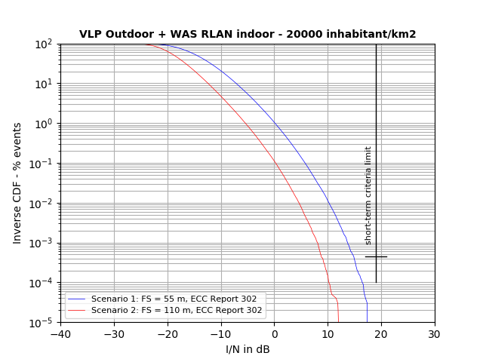
Figure 2: Results for a population density of 20000 inhabitants/km²- Sensitivity for FS height
Figure 3 presents results for a population density of 2000 inhabitants/km² taking into account the removal of unrealistic WAS/RLANs as described in Section 4.2.3.5 for FS antenna height of 25 m. Raw data is presented in ANNEX 2:. Regarding this value of population density, minimum FS antenna heights of 25 m are assumed to be realistic. It can be seen that the short-term criterion is just met. The sensitivity analysis for different antenna heights shows a diminishing I/N margin for decreasing FS antenna heights. The results for the FS height of 25 m are obtained using 30 million iterations in Monte Carlo simulations.
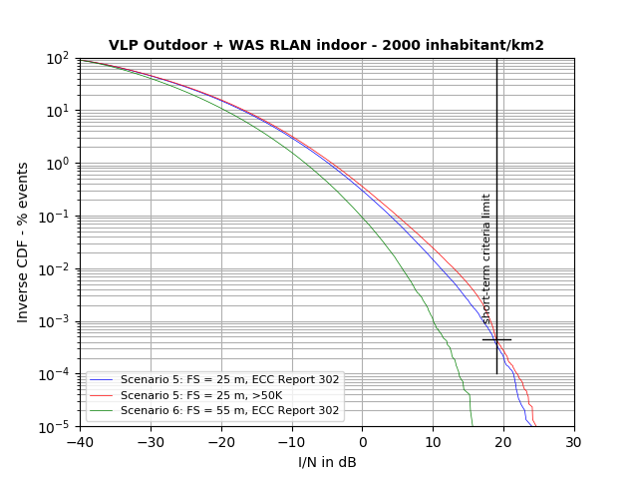
Figure 3: Results for a population density of 2000 inhabitants/km²- Sensitivity for FS height
Figure 4 presents a sensitivity analysis for FS antenna heights of 55 m regarding different values of population densities. Curves from Figure 2 and Figure 3 have been reused to show the sensitivity for a single FS antenna height for different population densities.
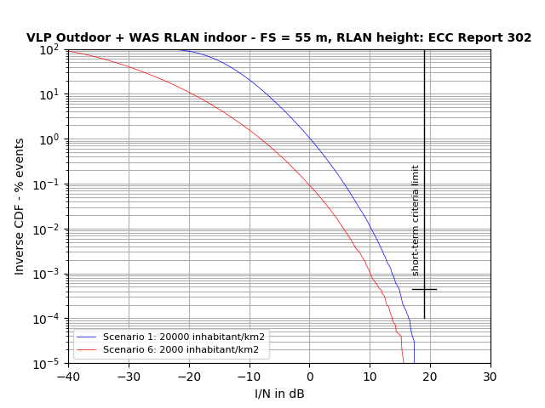
Figure 4: Results for FS height of 55 m - Sensitivity for population density
Figure 5 presents a sensitivity analysis for FS antenna heights of 110 m for different values of WAS/RLAN height deployments and WAS/RLAN number deployments. The alternative distribution for WAS/RLAN device heights for a site of a large city (with more than 100000 households, ANNEX 3:) has been analysed. The vertical separation (difference in antenna heights) between a Fixed Link Rx and WAS/RLAN is an important parameter for the results. The effect of a low WAS/RLAN deployment in comparison with the high deployment is also shown.

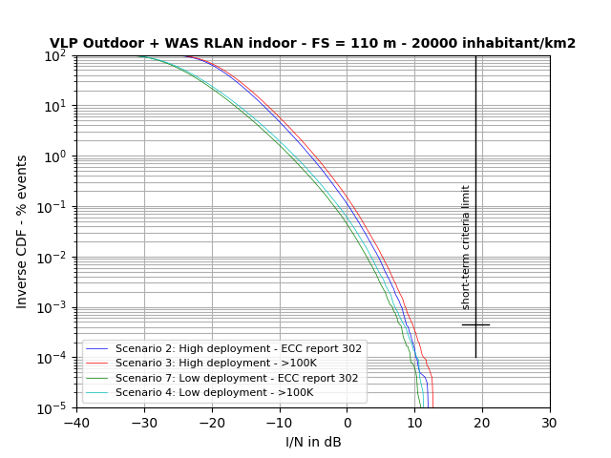
Figure 5: Results for FS height 110 m - Sensitivity for WAS/RLAN height distribution
Figure 6 presents the effects of the percentage of VLPs for simultaneous indoor and outdoor operation with 30 million events for scenario 8, i.e. FS of 25 m, high WAS/RLAN deployment and a population of 2000 inhabitants/km2. Scenario 8 was selected, where several percentages of VLP WAS/RLAN penetration have been considered as depicted in Table 5, i.e. VLP with 1%, 2%, 3%, 4%, 5% and the associated LPI. The percentages of outdoor VLP larger than 1% are for sensitivity analysis purposes only and are not representative of anticipated actual outdoor use. They are included only to show the minimal impact VLP devices will have on incumbent services.
Figure 7 shows a zoom of Figure 6 at $4.5⋅{10}^{-4}$ level. It can be seen that for 1% to 5% of VLP outdoor, the short-term criterion is respected. Various VLP percentage of deployment shows no effect to the overall interference impact.
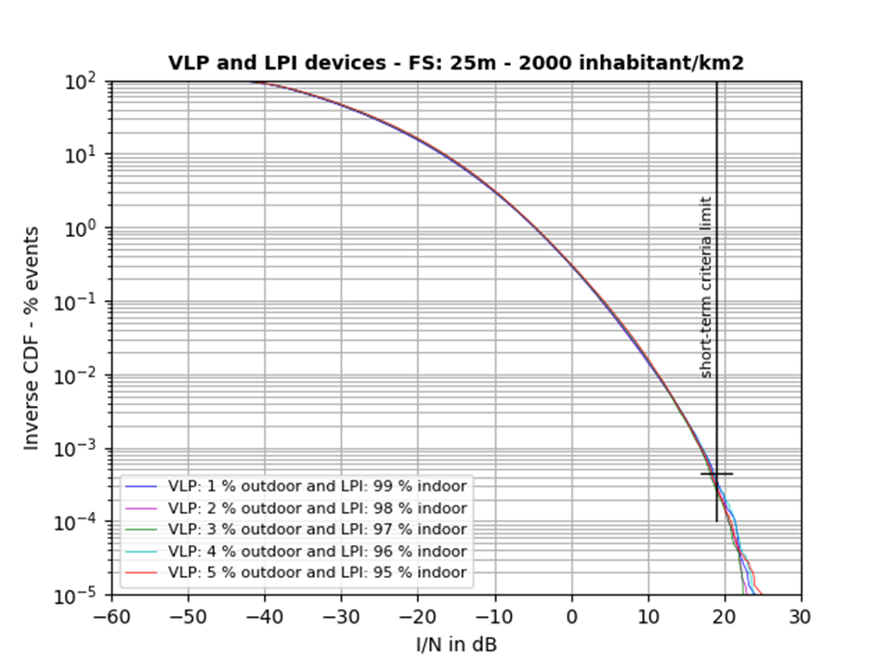
Figure 6: Outdoor and indoor simulation for various VLP percentage deployment outdoor
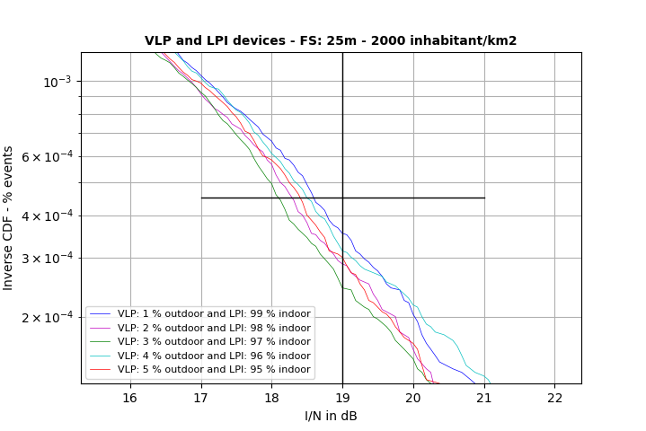
Figure 7: Zoom of Figure 6 - Outdoor and indoor simulation for various VLP and ILP percentage
Note that increasing the simulation radius beyond 5 km has no material impact on meeting the short-term interference criterion. The impact from devices being far away from the FS receiver is negligible for the assessment of the short-term criterion.

Summary of the site-general Monte Carlo analysis
Site-general Monte Carlo simulations have been performed using from 10 to 30 million events to assess whether the short-term criterion is met when WAS/RLAN indoor and VLP WAS/RLAN outdoor devices are both in operation simultaneously. The studies have considered, amongst other parameters, a high-density populated environment corresponding to large cities.
Results are sensitive to assumptions on population density and the difference of antenna heights between FS Rx and WAS/RLAN.
Results from large number of Monte Carlo events show that the short-term interference criterion is met for the studied combinations of FS antenna heights and population densities. Various VLP outdoor percentages of deployment show no effect to the overall interference impact.
It has to be noted that the simulations carried out used space- and time-based distributions for calculating a percentage of interference. Therefore, results are in terms of time-space percentage and not in terms of time percentage only. This has to be taken into account in the interpretation of results.

Sensitivity analysis on LPI deployment assumptions applying a static methodology based on radio coverage
This section presents a sensitivity analysis that quantifies the impact of propagation parameters (such as the building entry loss and the clutter loss) but also the WAS/RLAN heights on the fixed service short-term criterion exceedance. This analysis is presented as a snapshot of a static approach that takes into account only the interference created by a single active WAS/RLAN, the aggregate WAS/RLAN effect is not taken into account.
The used methodology is the same as the one described in section 6.4.3.1 (ECC Report 302) [2]. The simulated WAS/RLAN e.i.r.p. corresponds to 200 mW/20 MHz. The used propagation model is according to Recommendation ITU-R P.452-16 [9], with a terrain profile according to Shuttle Radar Topography Mission (SRTM) data 3 arcsecond. In addition to that, a clutter loss according to Recommendation ITU-R P.2108 [11] is added. The building entry loss is according to Recommendation ITU-R P.2109 [14]. A polarisation mismatch of 1.5 dB (for single entry interference) is also considered in the link budget.
The analysed FS link corresponds to “Link 2" from the Study C on FS in ECC Report 302 (Table 34). The link parameters are summarised in Table 15 and Figure 8.
Table 15: Link configuration
 | Station A |  |  |  |  | Station B |  |  |  |  | Length  (km)
Parameter | Lat° | Long° | h(m) | Ele° | Az° | Lat° | Long° | h(m) | Ele° | Az°
Link 2 (Dijon) | 47.322 | 5.063 | 22 | 0.3 | 206.5 | 47.136 | 4.926 | 26.5 | -0.3 | 26.5 | 23.2

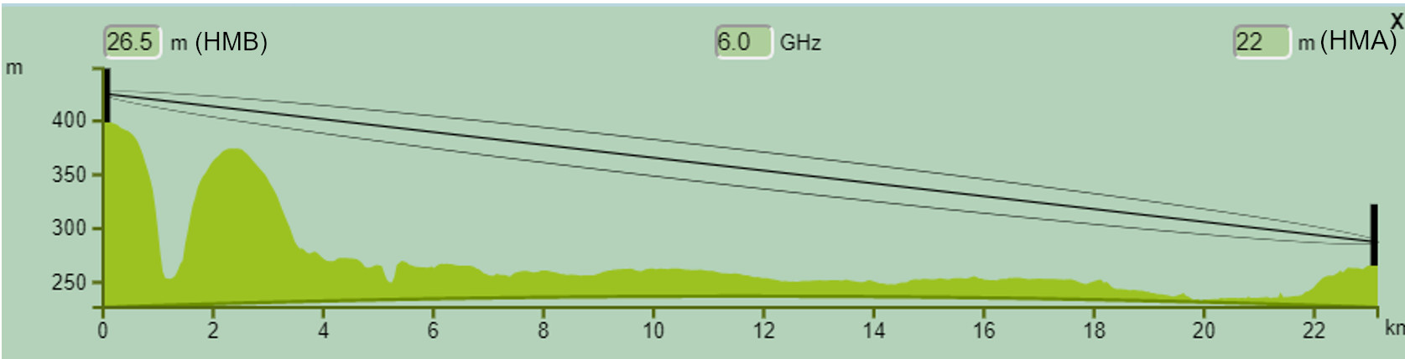
Figure 8: Path profile along the studied FS link
Below, $P_{PL}$ designates the probability that losses are not exceeded for a given time percentages used as an input for Recommendation ITU-R P.452-16. $P_{CLUT}$ designates the probability of location associated with Recommendation ITU-R P.2108 (terminal clutter loss). Finally, $P_{BEL}$ designates the probability associated with Recommendation ITU-R P.2109 (Building entry loss).

Simulation results

Effect of building entry loss
A first analysis assessed the effect of building entry loss on the short-term interference criterion exceedance by varying the probability as input to Recommendation ITU-R P.2109. The results are shown in Figure 9 for fixed values of $P_{PL}=20\%$ and $P_{CLUT}=10\%.$ For $P_{BEL}=50\%$, the area of interference is restricted to the close vicinity of the FS receiver (less than 50 m) where no buildings exists. For $P_{BEL}=10\%$, this area becomes bigger covering few houses in the neighbourhood first rows (see the zoom in Figure 9 on the right). Finally, decreasing $P_{BEL}$ to 1% adds a narrow beam along the FS boresight of 400 m length, stopping 1 km away from the FS receiver.
When considering a weighted BEL (70% Traditional, 30% thermally efficient), the area of potential interference becomes smaller, with a maximum interference distance up to 765 m (see Figure 10).
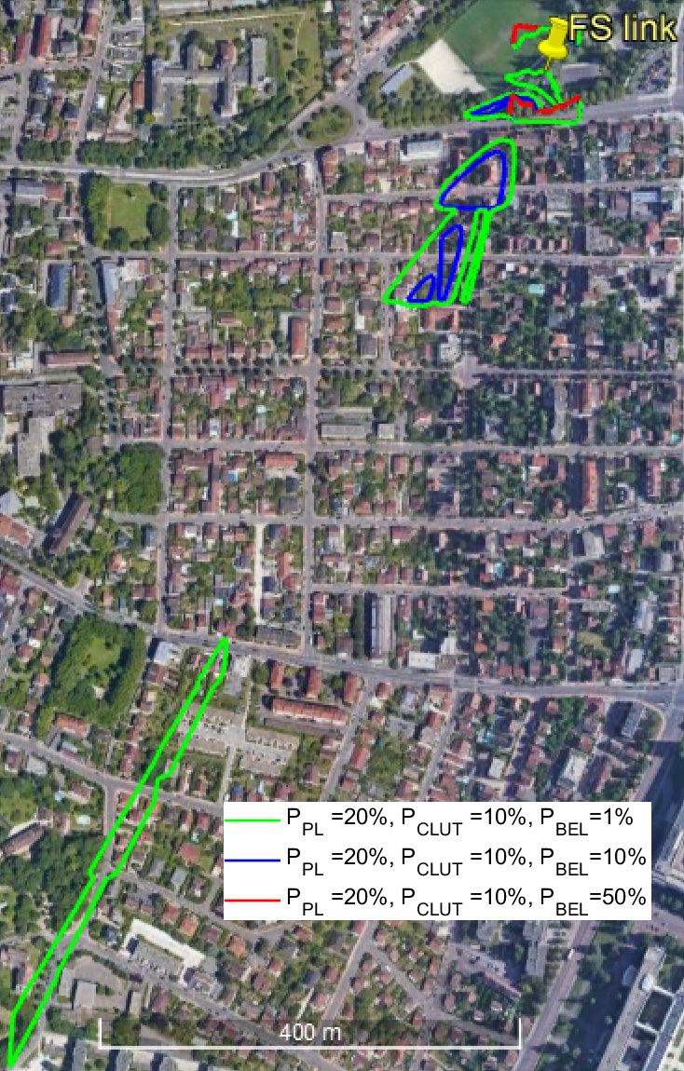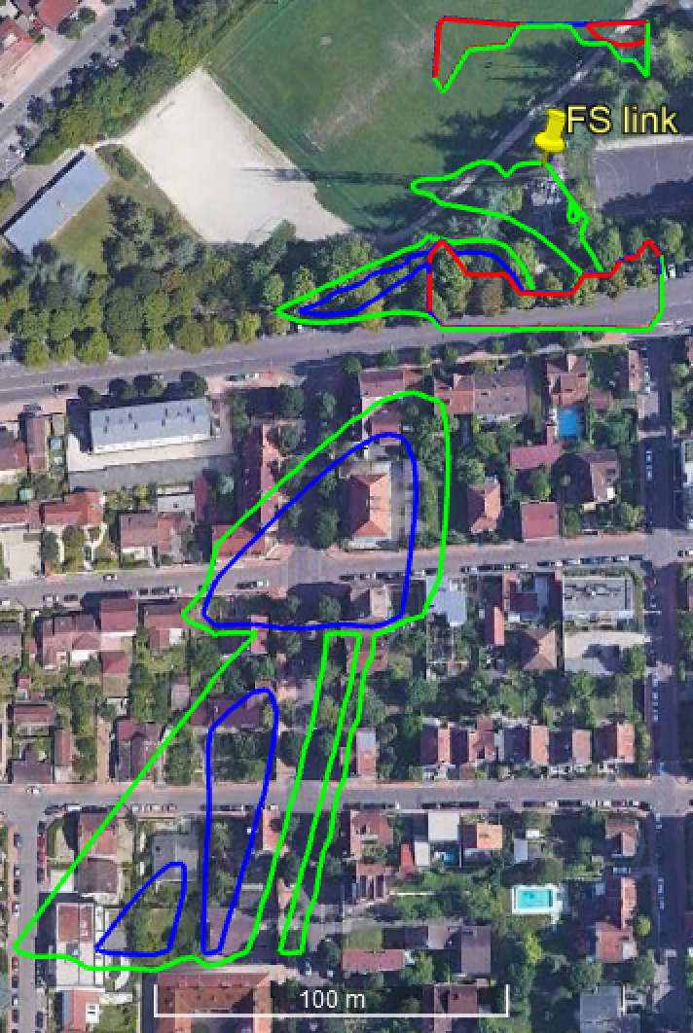
Figure 9: I/N contour for 19 dB value and higher for different building entry loss values (Traditional).
Left: all the simulated area, Right: zoom in the vicinity of the FS link.
WAS/RLAN power =200 mW, WAS/RLAN height =1.5 m
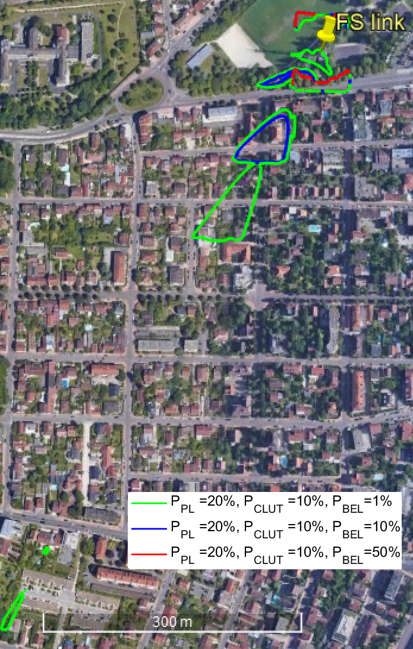
Figure 10: I/N contour for 19 dB value and higher for different Building entry loss values
(weighted: 70 % Traditional, 30% Thermally efficient).
WAS/RLAN power =200 mW, WAS/RLAN height =1.5 m

Effect of clutter loss
A second analysis assessed the effect of clutter loss on the short-term interference criterion exceedance by varying the probability as input to Recommendation ITU-R P.2108. The results are shown in Figure 11, for fixed values of $P_{PL}=20\%$ and $P_{BEL}=10\%$ (Traditional). For $P_{CLUT}=10\%$, the area of interference is restricted to the close vicinity of of the FS receiver covering few houses (see the zoom in Figure 11 on the right). For $P_{CLUT}=1\%$, this area covers a first spot wider than the one for $P_{CLUT}=10\%$, this area is measured approximatively to be 13200 m², plus two narrow beams of 450 m and 500 m length each. The farthest interference point is situated at 1900 m from the FS receiver. Finally, decreasing $P_{CLUT}$ to 0.1%, increases the size of the closest interference area, the farthest interference point in that case reaches 2.9 km distance from the FS receiver. Clutter loss lower than 12.3 dB (corresponding to $P_{CLUT}=0.1\%$ and distances larger than 1 km) has not been considered in this analysis.
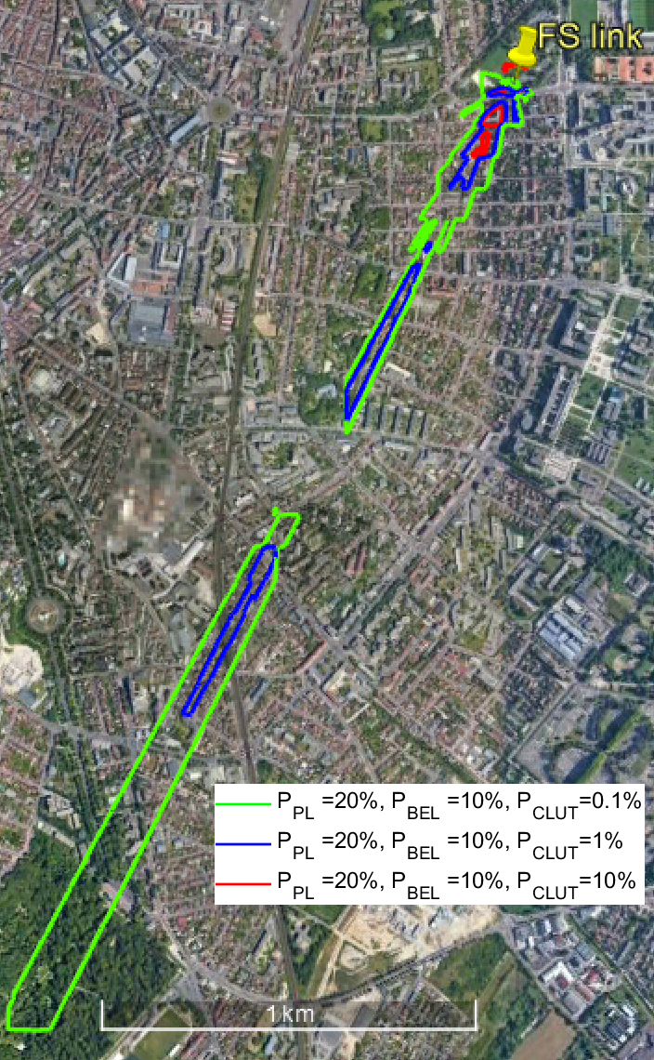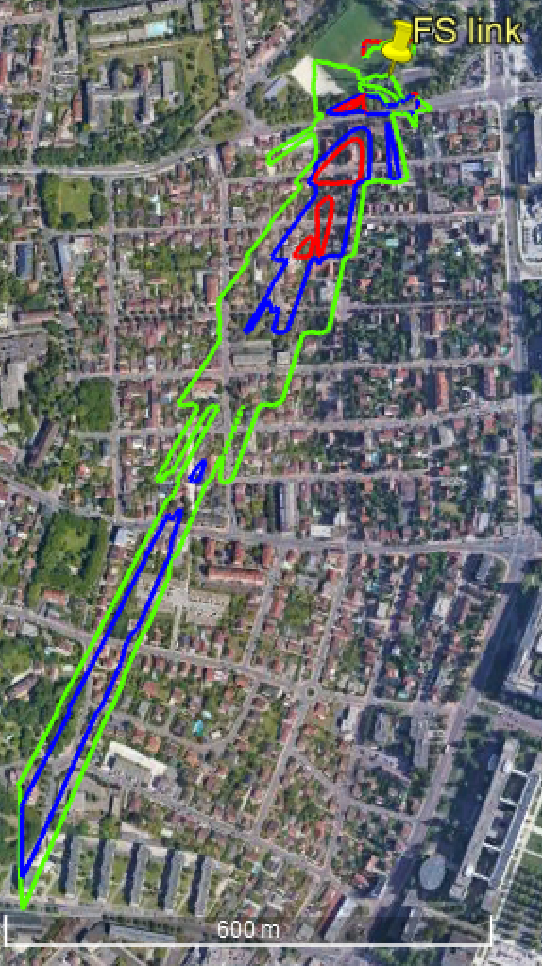
Figure 11: I/N contour for 19 dB value and higher for different clutter loss values.
Left: all simulated area, Right: zoom in the vicinity of the FS link.
WAS/RLAN power =200 mW, WAS/RLAN height =1.5 m.
Figure 12 shows the same results when considering a weighted BEL (70% Traditional, 30% thermally efficient), as observed in Section 4.3.1.1, the area of interference is reduced again, noting a maximum interference point situated at 1.9 km instead of 2.9 km.
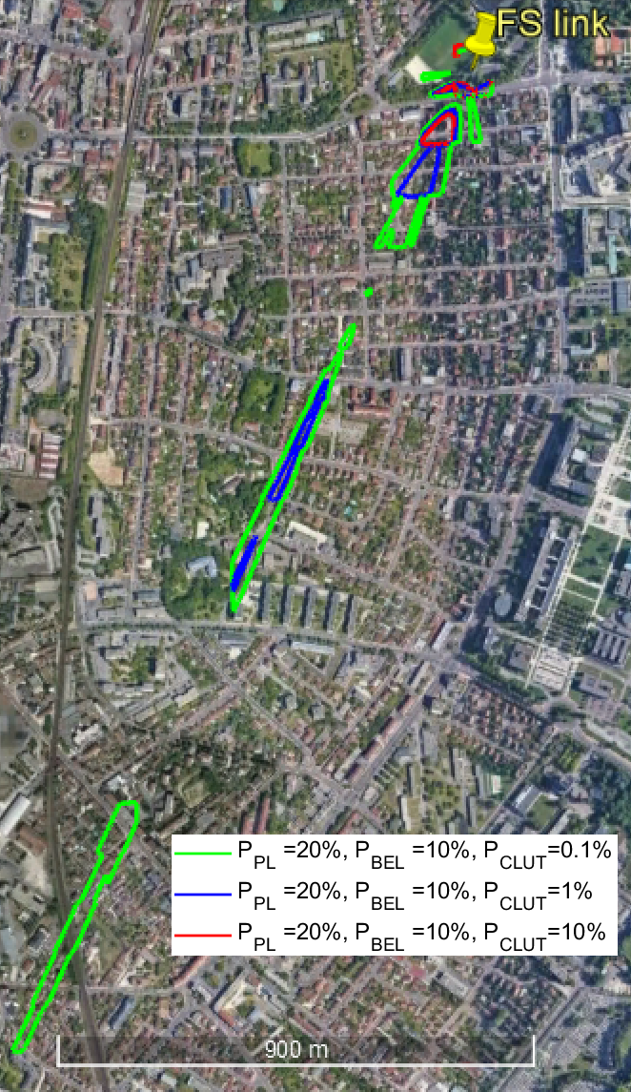
Figure 12: I/N contour for 19 dB value and higher for different clutter loss values.
BEL weighted: 70 % Traditional, 30% Thermally efficient.
WAS/RLAN power =200 mW, WAS/RLAN height =1.5 m.

Effect of WAS/RLAN antenna height
By fixing $P_{PL}=20\%$ and $P_{BEL}=1\% \left(Traditional\right) and$ $P_{CLUT}=1\%$, two WAS/RLAN antenna height were studied (1.5 m and 7.5 m). The results show that, even though no impact was observed on the farthest interference point (2.9 km), the interference area is wider for higher antenna height. In particular the beam does not cut between 1050 m and 1380 m due to the fact that the signal does not suffer from the path profile obstruction when the interferer is situated at 7.5 m. Clutter loss lower than 16.9 dB (corresponding to $P_{CLUT}=1\%$ and distances larger than 1 km) has not been considered in this analysis.

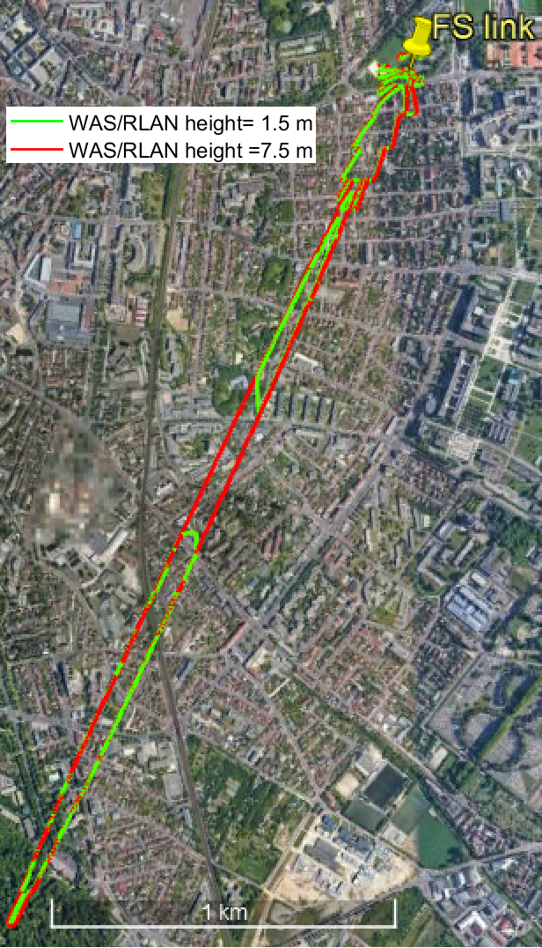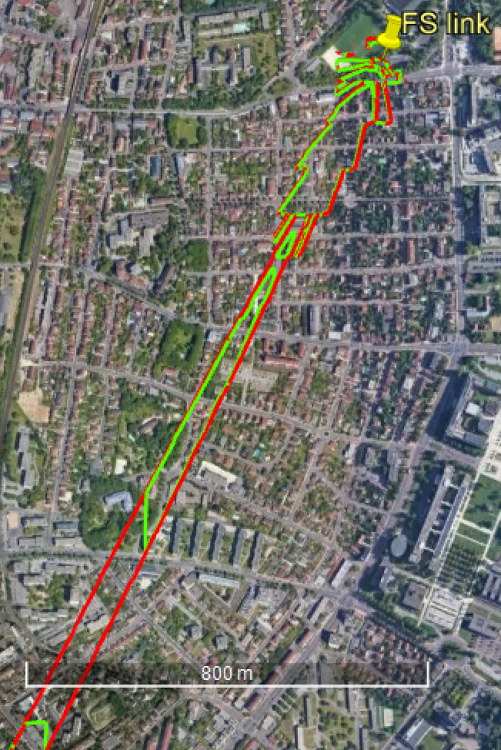
Figure 13: I/N contour for 19 dB value and higher for WAS/RLAN height =1.5 m and 7.5 m.
Left: all simulated area, Right: : zoom in the vicinity of the FS link. $P_{CLUT}$=1%, $P_{BEL}$=1% and $P_{PL}$=20%.

Summary of sensitivity analysis on LPI deployment assumptions
Simulations have shown that the size of the area from where WAS/RLAN may create interference to the FS receiver is sensitive among others to the clutter loss, building entry loss, WAS/RLAN height and position (relative to FS main beam). For the WAS/RLAN RF activity factor of 2%, it has to be noted that for the combinations where some positions depict the exceedance of the short-term threshold I/N = 19 dB, this interference may be created for more than $4.5⋅{10}^{-4}$% of the time in any month (for errored seconds).

Conclusions
In this Report, two studies are presented which expand upon the studies carried out in ECC Report 302 by assessing the possible short-term interference impact of the WAS/RLANs onto point-to-point Fixed Service (FS) links:
- Site-general Monte Carlo analysis;
- Site-specific sensitivity analysis on LPI deployment assumptions based on radio coverage.
A combination of low power indoor (LPI) WAS/RLANs operating at power levels up to 200 mW and outdoor Very Low Power (VLP) portable WAS/RLANs up to 25 mW is used in the studies.
Clutter loss lower than 5 dB (corresponding to $P_{CLUT}=0.001\%$ for distances larger than 1 km) has not been considered in this analysis. In particular, line of sight cases using only free space propagation model for distances larger than 1 km have not been considered.

Results of the site-general Monte Carlo analysis
Site-general Monte Carlo simulations have been performed using from 10 to 30 million events to assess whether the short-term criterion is met when WAS/RLAN indoor and VLP WAS/RLAN outdoor devices are both in operation simultaneously. For the low FS antenna heights scenario, this Monte Carlo simulation removed any WAS/RLAN with an unrealistic physical placement (as explained in Annex 2). The studies have considered, amongst other parameters, a high-density populated environment corresponding to large cities.
The performed sensitivity analysis has shown that the results are sensitive to assumptions on population density and the difference of antenna heights between FS Rx and WAS/RLAN.
Results from a large number of Monte Carlo events show that the percentage of events for which the short-term threshold (I/N = 19 dB) is not exceeded for more than $4.5⋅{10}^{-4}$% (which was used as a proxy for short-term protection criterion) for the studied combinations of FS antenna heights, population densities, and WAS/RLAN deployment.
Various VLP outdoor percentages of WAS/RLAN deployment show no effect on the overall interference impact.
The simulations carried out used space- and time-based distributions for calculating a percentage of interference. Therefore, results are in terms of time-space percentage and not in terms of time percentage only. This should be taken into account in the interpretation of results.

Results of the site-specific sensitivity analysis on LPI deployment assumptions based on radio coverage
Simulations have shown that the size of the area from where a WAS/RLAN may create interference to the FS receiver is sensitive among others to the clutter loss, building entry loss, WAS/RLAN height and position (relative to FS main beam). For the WAS/RLAN RF activity factor of 2%, it should be noted that for the combinations where some positions depict the exceedance of the short-term threshold I/N = 19 dB, this interference may be created for more than $4.5⋅{10}^{-4}$% of the time in any month (for errored seconds); the probability of this occurring has not been studied.

- List of References
- European Commission, Mandate to CEPT to study feasibility and identify harmonized technical conditions for wireless access systems including radio local area networks in the 5925-6425 MHz band for the provision of wireless broadband services, Brussels, December 2017
- ECC Report 302: “Sharing and compatibility studies related to Wireless Access Systems including Radio Local Area Networks (WAS/RLAN) in the frequency band 5925-6425 MHz," May 2019. Available: https://www.ecodocdb.dk/document/10170
- Recommendation ITU-R F.758: "System parameters and considerations in the development of criteria for sharing or compatibility between digital fixed wireless systems in the fixed service and systems in other services and other sources of interference"
- Report ITU-R F.2326: "Sharing and compatibility study between indoor International Mobile Telecommunication small cells and fixed service stations in the 5 925-6 425 MHz frequency band"
- Recommendation ITU-R F.383-9: "Radio-frequency channel arrangements for high-capacity fixed wireless systems operating in the lower 6 GHz (5 925 to 6 425 MHz) band"
- Recommendation ITU-R F.384-11: "Radio-frequency channel arrangements for medium- and high- capacity digital fixed wireless systems operating in the the 6 425-7 125 MHz band"
- Recommendation ITU-R F.699-7: "Reference radiation patterns for fixed wireless system antennas for use in coordination studies and interference assessment in the frequency range from 100 MHz to 86 GHz"
- Recommendation ITU-R F.1245-2: "Mathematical model of average and related radiation patterns for point-to-point fixed wireless system antennas for use in interference assessment in the frequency range from 1 GHz to 86 GHz"
- Recommendation ITU-R P.452-16: "Prediction procedure for the evaluation of interference between stations on the surface of the Earth at frequencies above about 0.1 GHz".
- Recommendation ITU-R SF.1650-1: "The minimum distance from the baseline beyond which in-motion earth stations located on board vessels would not cause unacceptable interference to the terrestrial service in the bands 5 925-6 425 MHz and 14-14.5 GHz".
- Recommendation ITU-R P.2108-0: "Prediction of Clutter Loss".
- P. Kyösti, J. Meinilä, L. Hentilä, X. Zhao, T. Jämsä, C. Schneider, M. Narandzić, M. Milojević, A. Hong, J. Ylitalo, V.-M. Holappa, M. Alatossava, R. Bultitude, Y. d. Jong and T. Rautiainen, "IST-4-027756 WINNER II D1.1.2 V1.2, WINNER II Channel Models, Part I: Channel Models," 2008. Available: https://www.cept.org/files/8339/winner2%20-%20final%20report.pdf
- Recommendation ITU-R P.525-3: “Calculation of free-space attenuation”
- Recommendation ITU-R P.2109-0: “Prediction of building entry loss”
- H. R. Anderson (2003): Fixed broadband wireless system design, John Wiley & Sons Ltd, Chichester, UK

- Analysis on the exceedance of the I/N from Monte-Carlo Simulation
  - Description
A detailed analysis of the intermediary results of Section 4.2 shows that the short-term interference limit is exceeded when WAS/RLANs are placed in unrealistic physical locations.
Figure 14 shows that when excluding WAS/RLAN devices creating I/N > 19 dB from the simulation that are deployed in a manner that is unrealistic using a WAS/RLAN height and distance removal algorithm, the short-term interference limit is respected.
WAS/RLAN position on the ground with respect to the FS receiver is denoted as (x,y) and its height above the ground as z.
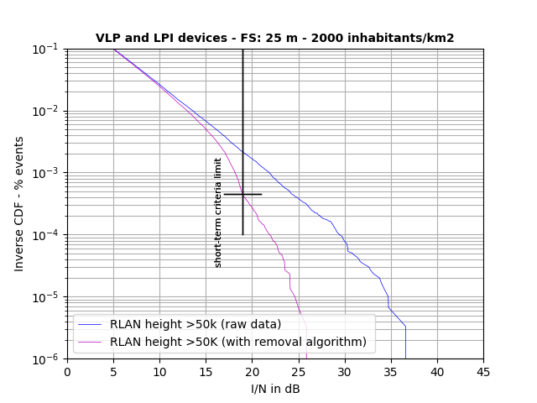
Figure 14: I/N results for a city with more than 50k household WAS/RLAN height with and without the height and distance removal algorithm
  - Analysis
Simulations with 30 million iterations were run to take into account different WAS/RLAN height distributions (as in ANNEX 3:) for scenario 5 as in Section 4.2.4 (i.e. 99% LPI and 1% VLP, 89 devices in total).
Figure 15 presents the I/N results generated for two cases “ECC Report 302” (i.e. indoor urban) and “>50K”. Short-term interference is predominantly caused by WAS/RLAN devices located within 200 m of the FS station.
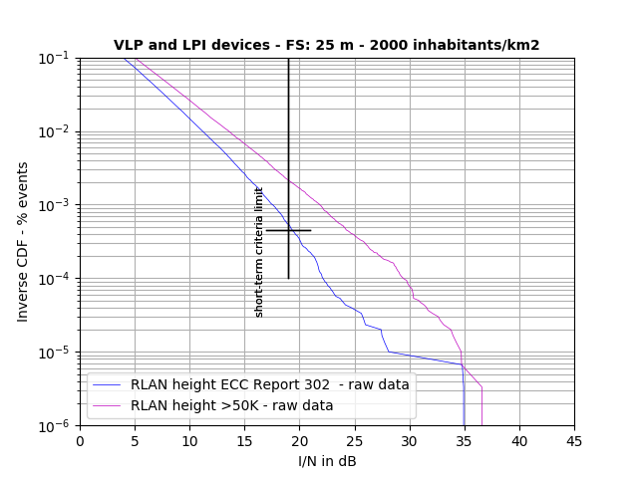
Figure 15: I/N results for the “ECC Report 302 (indoor urban)” and “>50K” (raw data)
The results of Figure 15 show that for a FS antenna height of 25 m and a density of 2000 inhabitants/km2, the WAS/RLAN antenna height placed as high as 28.5 m within 200 m of the FS link will affect the short-term interference criterion. However, this is not a realistic deployment scenario neither for a FS link nor for a WAS/RLAN device as the investigation of the (x,y,z) position of the WAS/RLANs with respect to the FS and its influence on the overall results will be demonstrated.
The intermediary results such as (x,y) position and the height of the WAS/RLANs that were identified to cause an I/N > 19 dB are investigated in the following two steps.
  - WAS/RLAN Height investigation
The first step analysed the distribution of the WAS/RLAN antenna heights (99% LPI indoor and 1% VLP outdoor). Figure 15 presents the number of WAS/RLANs with their respective heights that are contributing to the exceedance of the short-term limit for the cases “ECC Report 302” and “>50K” households. It shows that with the proposed heights, the WAS/RLANs primarily contributing to the exceedance of the short-term interference limit have heights higher than 10.5 m (i.e. 4th floor and above).

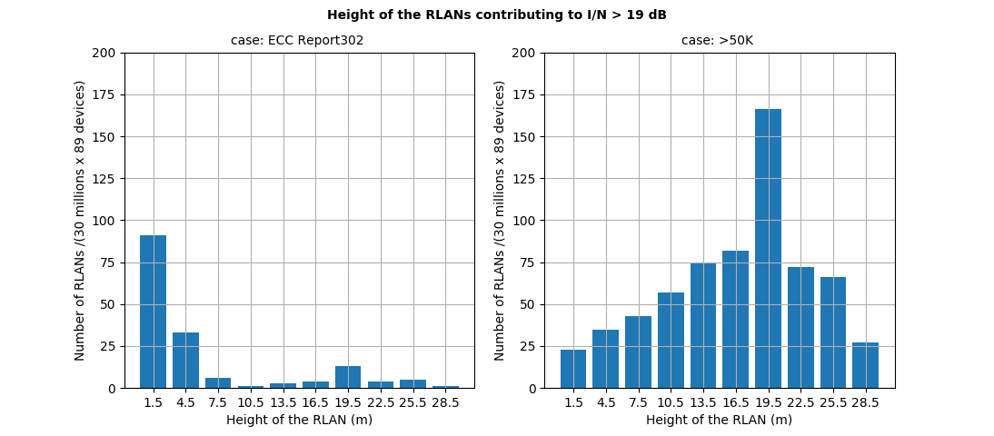
Figure 16: Investigation of the height of WAS/RLAN contributing to the exceedance of the short-term threshold of I/N = 19 dB for case “ECC Report 302” and “>50K”
  - WAS/RLAN distance investigation
The second step of the analysis looked at the geographical location of these WAS/RLANs for these two cases: “<2.5K” and “>50K” households.
Figure 17 (a) presents the WAS/RLANs that cause the I/N>19 dB for the “ECC Report 302” households and (b) the “>50K”. The graphics represents the (x,y) coordinates (in metre) of the WAS/RLANs with a colour-bar map representing the height (z) in metre of these WAS/RLANs. The FS station is indicated by a black star.
For the cases a) and b), the results show that the WAS/RLAN devices on the lower floors are gathering around the FS within a circle of 40 m. For the upper floors, two effects are noticeable: a) some of the WAS/RLANs are gathering around the FS station (similarly as for the lower floors), and b) WAS/RLANs of maximum height of 19.5 m are stretched along the line of the narrow beam of the FS antenna pattern. This limitation in the height of 19.5 m is due to the Fresnel zone algorithm that was applied to the simulation.
Such example of positioning in (x,y,z) of the WAS/RLANs do not represent realistic deployment condition.
A generic Monte Carlo simulation does not account for real life deployment since it is a statistical tool. WAS/RLANs are placed in unrealistic locations in the vicinity of the FS mast.
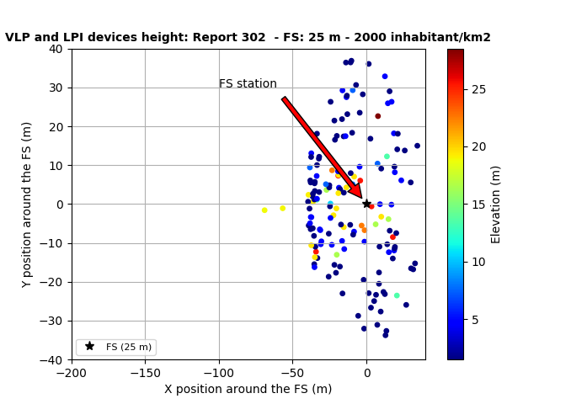
(a)
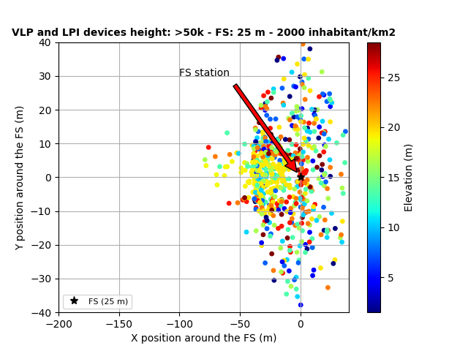
(b)
Figure 17: Investigation of the height of WAS/RLAN contributing to the exceedance of the short-term criterion for case (a)“ECC Report 302” and (b) “>50K”
  - WAS/RLAN Height and distance removal algorithm
A WAS/RLAN height and distance removal algorithm was developed to remove WAS/RLANs that would not be deployed from the simulation. Figure 18 presents an illustration of the algorithm performed on the data.
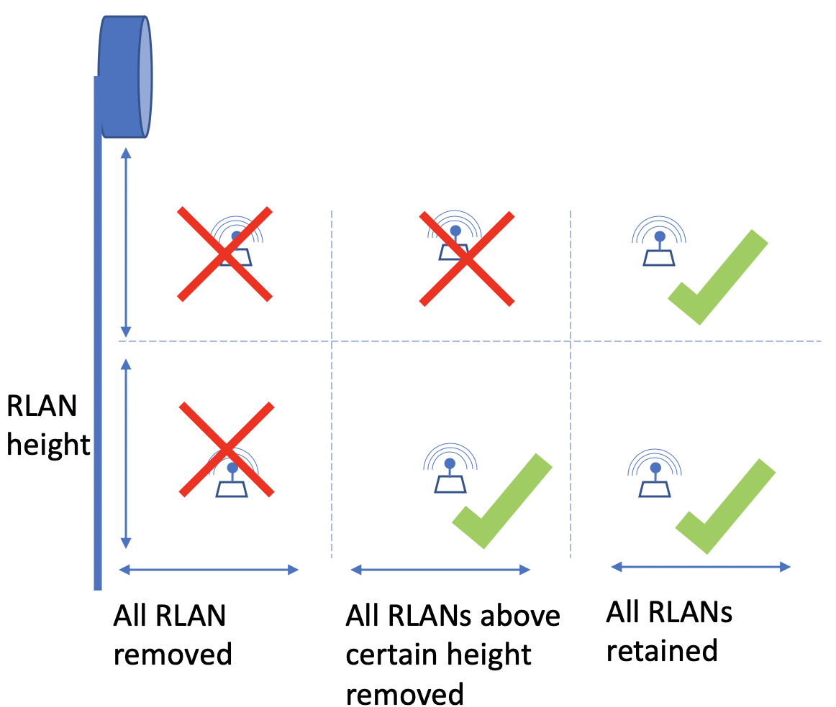
Figure 18: Example of a “WAS/RLAN Height and distance removal” algorithm
Figure 19 presents, as an example, the I/N results after applying the WAS/RLAN Height and distance removal algorithm. First, all WAS/RLANs within 20 m of the FS and WAS/RLANs within 200 m higher than 10.5 m were removed from the data set. The short-term interference criteria is met. This demonstrates that when excluding WAS/RLAN devices creating I/N > 19 dB from the simulation that are deployed in a manner that is unrealistic, the short-term interference limit is respected.
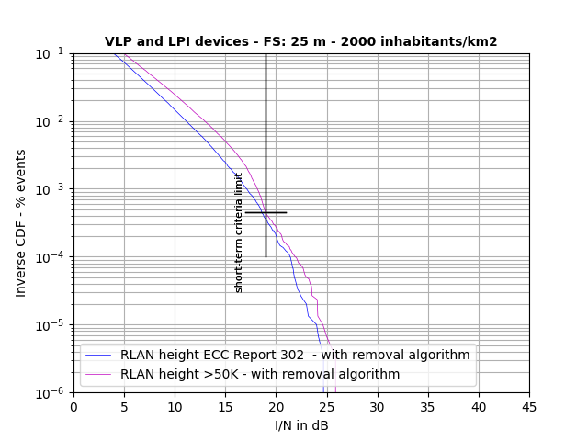
Figure 19: I/N results with removal algorithm (all WAS/RLANs within 20 m irrespective of height are removed and WAS/RLANs higher than 10.5 m and up to 200 m are removed)
- Statistics for buildings heights and WAS/RLAN antenna heights
Statistics were available in France on the distribution of households over building heigths and are considered as representative of European building heights.
Table 16: Buildings statistics according their number of floors
 | Individual (0-1 floors) | 1-4 floors | 5-8 floors | 9 and +
Cities >100k households | 86 | 333 | 471 | 110
Cities >50k households | 208 | 491 | 210 | 92
Cities >25k households | 260 | 418 | 226 | 96
Cities >10k households | 334 | 428 | 160 | 78
Cities >5k households | 465 | 391 | 100 | 44
Cities <2.5k households | 630 | 316 | 42 | 12
Cities <2.5k households | 801 | 184 | 13 | 2
Rural | 912 | 78 | 8 | 2
It is necessary to know the distribution of households floors before using the formula of ECC Report 302
(WAS/RLAN on 1st Floor Probability = 1 Story Building Probability + 2 Story Building Probability/2 Floors … +10 Story Building Probability/10 Floors).
Since the distribution of households over building heights is known, the distribution of antenna heights can be easily derived, using the same formula as in ECC Report 302 (i.e. in a building of x floors, uniform distribution of WAS/RLAN over floors). The following assumptions were made:
- For individual house, it is assumed that 50% of WAS/RLAN will be on story 0 and 50% on floor 1;
- For 1-4 story and 5-8 story it is assumed that building heights will be uniform among 1 to 4 and 5 to 8 story respectively;
- For 9 and +, it is assumed that all buildings are only 9 story.
This leads to the following Table 17 (case of a city with more than 100k households for example):
Table 17: Height distribution for >100k households
Floor | % of households in a building of X floors
ground | 4.3
1 | 12.6
2 | 8.3
3 | 8.3
4 | 8.3
5 | 11.8
6 | 11.8
7 | 11.8
8 | 11.8
9 | 11.0
This leads to the distribution of WAS/RLAN height over the floors as in Table 18.
Table 18: WAS/RLAN height probabilities for the cases described above in %
Floor | Height (m) | >100k | >50k | >25k | >10k | >5k | >2.5k | <2.5k | Rural | ECC 302
ground | 1.5 | 24.66 | 35.14 | 36.95 | 41.74 | 49.22 | 58.08 | 66.18 | 71.03 | 77.85
1 | 4.5 | 20.36 | 24.74 | 23.95 | 25.04 | 25.97 | 26.58 | 26.13 | 25.43 | 17.85
2 | 7.5 | 14.05 | 13.40 | 12.23 | 11.34 | 9.46 | 6.88 | 3.80 | 1.66 | 2.85
3 | 10.5 | 11.27 | 9.31 | 8.75 | 7.78 | 6.20 | 4.25 | 2.27 | 1.01 | 0.52
4 | 13.5 | 9.19 | 6.24 | 6.13 | 5.10 | 3.76 | 2.27 | 1.12 | 0.52 | 0.36
5 | 16.5 | 7.52 | 3.78 | 4.04 | 2.96 | 1.80 | 0.69 | 0.20 | 0.13 | 0.24
6 | 19.5 | 5.56 | 2.91 | 3.10 | 2.30 | 1.39 | 0.52 | 0.14 | 0.10 | 0.16
7 | 22.5 | 3.88 | 2.16 | 2.29 | 1.72 | 1.03 | 0.37 | 0.10 | 0.07 | 0.09
8 | 25.5 | 2.41 | 1.50 | 1.59 | 1.22 | 0.72 | 0.24 | 0.06 | 0.04 | 0.05
9 | 28.5 | 1.10 | 0.92 | 0.96 | 0.78 | 0.44 | 0.12 | 0.02 | 0.02 | 0.02

For the Monte-Carlo simulation, the first 40 m assumes a Free Space propagation model and the Winner model is used from 40 m to 1 km.
http://reseaux-chaleur.cerema.fr/wp-content/uploads/2008_Extrait_etude_CDC_Boucle_locale_optique___donnees_sur_le_parc_immobilier_francais.pdf

