Sub-assignment and number hosting - Implementation models, rights of use and obligations for E.164 numbers across the electronic communications supply chain
approved 27 May 2020
ECC Report 311

Executive summary
There are different models for the assignment of E.164 numbering resources and their implementation across the electronic communications supply chain and these models have evolved, in quantity and complexity, since market liberalisation to support competition and efficient use.
The most common model (the "Base Model") involves the primary assignment of a block of numbers to an Electronic Communications Service Provider (ECSP) with its own Electronic Communications Network (ECN). This block of numbers is provisioned on the network and individual numbers from this block are then assigned, on a secondary basis, to end users via a contract (i.e. subscriber) as part of an Electronic Communications Service (ECS) offering. In this model there is no ambiguity as to the rights and obligations of both parties. For example, it is very clear who has obligations related to supporting legal interception and number portability.
This Report studies models that are different from the "Base Model", in which E.164 numbering resources are assigned and implemented across the electronic communications supply chain. Chapter 4 of the Report describes five models of assignment and implementation that are in use today and focuses on those models using sub-assignment and number hosting particularly if transparency may become an issue for regulatory supervision.
Chapter 5 then outlines measures that could be implemented to increase transparency. It should be noted that the application of any of these measures, including how they would apply retrospectively, would require careful consideration before implementation. The measures identified are:
- Restrictions on the number of levels of sub-assignment;
- Implementation of a notification procedure for any numbering resources that are sub-assigned or hosted on another network; and
- Implementation of a database containing information on sub-assignment and number hosting that can be accessed by the Numbering Plan Administrator (NPA) or provided by the NPA.
The Report recognises that there are some benefits of allowing sub-assignment of numbers and number hosting including more efficient numbering plan management, increased market competition due to lower market entry costs and reduced time to market.
However, sub-assignment and number hosting has its challenges, in particular because there are more entities in the supply chain. If national numbering regulations only foresee the "Base Model", as described in Chapter 4, the practical implementation of sub-assignment and number hosting can become complex since it could not always be transparent to which entities the rights and obligations apply. Therefore, this longer supply chain should be addressed at national level so that it is clear which rights and obligations apply to each entity in the supply chain and so that the NPA has the information it needs to ensure compliance with the regulations.
The measures proposed to increase transparency on sub-assignment and number hosting outlined in this Report should be considered in this regard.

TABLE OF CONTENTS

0 Executive summary 2
1 Introduction 5
2 Definitions 6
3 Scope of report 7
4 Assigning and implementing numbers on electronic communications networks 8
4.1 Base model: Primary and secondary assignment 8
4.2 Sub-assignment 9
4.3 Number hosting 10
4.4 Combination of sub-assignment and number hosting 10
5 Measures to increase transparency 12
5.1 Restrictions on sub-assignment 12
5.2 Notification or Approval procedure 12
5.3 Information database 12
6 Obligations and regulatory supervision 13
6.1 Legal interception 13
6.2 Number portability and the provision of number information for directory enquiry services 13
6.3 Regulatory intervention when an ECSP/ECNO ceases operations 13
6.4 CallinG Line Identity (CLI) integrity and emergency services-related obligations 14
6.5 databases with number assignment data 14
7 Current approaches to sub-assignment and number hosting 16
7.1 Approaches to sub-assignment 16
7.2 Approaches to number hosting 16
8 Conclusions 17

LIST OF ABBREVIATIONS

Abbreviation | Explanation
CEPT | European Conference of Postal and Telecommunications Administrations
CLI | Calling Line Identity
ECC | Electronic Communications Committee
ECN | Electronic Communications Network
ECNO | Electronic Communications Network Operator
ECS | Electronic Communications Service
ECSP | Electronic Communications Service Provider
EECC | European Electronic Communications Code
GNSS | Global Navigation Satellite Systems
MNO | Mobile Network Operator
MVNE | Mobile Virtual Network Enabler
MVNO | Mobile Virtual Network Operator
NRA/CA | National Regulatory Authority or other Competent Authority (referred to in this document as NPA)
NPA | Numbering Plan Administrator
NPDB | Number Portability Database
PSAP | Public Safety Answering Point

Introduction
There are different models for the assignment of E.164 numbering resources and their implementation across the electronic communications supply chain and these models have evolved, in number and complexity, since market liberalisation to support competition and efficient use. The most common model (the "Base Model") involves the primary assignment of a block of numbers to an Electronic Communications Service Provider (ECSP) with its own Electronic Communications Network (ECN). This block of numbers is provisioned on the network and individual numbers from this block are then assigned, on a secondary basis, to end users as part of an Electronic Communications Service (ECS) offering. In this model it is clear to the National Regulatory Authority or other Competent Authority (NRA/CA), here indicated as Numbering Plan Administrator (NPA), who the number blocks are assigned to and who they are being used by. There is no ambiguity as to the rights and obligations of both parties. For example, it is very clear who has obligations related to supporting legal interception and number portability.
For certain market players, particularly new market entrants it might be a commercial business decision to approach a third party who offers a wholesale service providing network access and/or access to numbering resources since they may not require a high volume of numbers at the outset of its operations.
This Report studies different models in which E.164 numbering resources are assigned and implemented across the electronic communications supply chain. In particular, some of the concepts and different variations of the sub-assignment of numbers and number hosting are examined. The objective of the Report is to identify different models where transparency becomes an issue for regulatory supervision and to identify possible options to address these issues.

Definitions
These definitions only apply in the context of this Report. At the national or European level different definitions for these concepts may exist.

Term | Definition
Primary assignment | The assignment of numbering resources by the NPA to an eligible applicant (i.e. primary assignee) who receives the right of use of the resources under specified conditions in an administrative decision.
Sub-assignment | The assignment of numbering resources by an assignee to another entity that is not an end user.
Secondary assignment | The assignment of numbering resources by an assignee to an end user who receives the right of use of the resources under specified conditions in a contract.
Direct assignment | The assignment of numbering resources by the NPA to an end user who receives the right of use of the resources under specified conditions in an administrative decision.
Number hosting | The implementation of an assignee`s numbering resources on an ECNO's network to enable connectivity for the assignee`s end users.

Scope of report
The objective of the Report is to describe and analyse some of the concepts and different variations of the assignment of E.164 numbers and some of the models that exist for the practical implementation of those numbers on public Electronic Communications Networks (ECNs), in particular sub-assignment and number hosting. To achieve this objective, each model is examined and the rights and obligations of each party in the supply chain regarding the use of the numbers are assessed. The Report then analyses those models where transparency may become an issue for regulatory supervision. The sub-assignment can be realised under specified conditions in a contract between entities and/or under specified conditions in an administrative decision from the NPA. In a country where the NPA is not involved in the sub-assignment process, transparency is reduced, as it may be unclear to which entity the numbers are sub-assigned to, which network they are provisioned on and which entity is providing the service to the end user. Therefore, there may be a lack of clarity regarding the obligations of each party. Following this analysis, some conclusions are drawn and options identified to improve transparency in order to ensure that all rights and obligations related with numbers are always met.
Another situation where transparency may become an issue for regulatory supervision is where number hosting is offered by many Electronic Communications Network Operators (ECNOs) to ensure that an entity with an assigned numbering block, but without its own network, can have those numbers provisioned on a network with interconnection to other networks to allow full end-to-end connectivity. For example, VoIP operators, and some mobile virtual network operators (MVNOs), may rely on number hosting to ensure interconnectivity of their services with those of other operators/providers.
It is also important to make the distinction between the sub-assignment of numbers from the transfer of a block of numbers from the primary assignee to another ECSP (which will become the primary assignee). The transfer of a block of numbers is between the primary assignee and another ECSP, which is always performed under the supervision of the NPA. Broken down into individual legal steps, the transfer consists of a return by the primary assignee and a new assignment by the NPA. The transfer of a block of numbers is covered by national and European legislation.
When an end user exercises its right to continue using its telephone number when changing provider, the number is ported from the end user's existing ECSP to the new ECSP. Number portability reduces barriers to switching and makes it easier for new entrants to challenge existing market positions.
The concepts of number transfer and number portability, as methods to move numbers between providers ,are therefore outside of the scope of the Report. Also, the situation where individual numbers are assigned to end users through direct assignment (for example freephone numbers in some countries) is also outside of the scope of this Report as no transparency issues arise.

Assigning and implementing numbers on electronic communications networks
Before the introduction of competition, the electronic communications market was dominated by large monopolistic market players with their own networks. These market players provided a vertically integrated service to their end users as they owned and operated all the elements of the network, the back office systems required to manage it and they provided services on it exclusively. As smaller market players began to enter the market different business models emerged and the ecosystem for assigning and implementing numbers became quite complex.
This chapter describes some of the different models of assigning and implementing numbers. There may be differences among CEPT countries on which models are permitted from a regulatory point of view. There may also be one or more entities (e.g. ECNOs and ECSPs) involved in the process, in particular for sub-assignment and number hosting. It is not intended to provide an exhaustive description of each and every model. Instead, the aim is to aid understanding how transparency around the supervision of the numbers reduces as the complexity of the business model increases.
In some of the following models it is important to distinguish between the network level and the service level to understand the relationship between the different market players. For example, at the service level, conditions regarding the designation of service for which the number shall be used, number portability, provision of public directory subscriber information and information about the person or entity that subscribed to the service. At the network level, obligations such as legal interception and the provision of caller location information for emergency calls.

Base model: Primary and secondary assignment
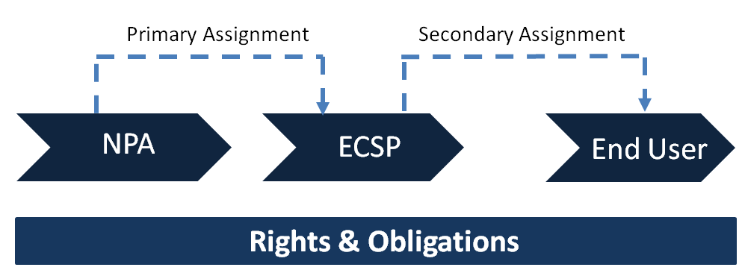
Figure 1: Base Model - Primary and secondary assignment
Figure 1 above describes the Base Model, where the NPA assigns a block of numbers to an ECSP, denoted as the primary assignment. A secondary assignment takes place when a number (or numbers) is made available to the end user along with the provision of a service. In this model, it is clear to the NPA who is responsible for fulfilling the obligations associated with the numbers (e.g. provide access to emergency services, support number portability and legal interception etc.). The ECSP is listed in the NPA's numbering database as the assignee and it can be easily contacted if problems arise.

Sub-assignment
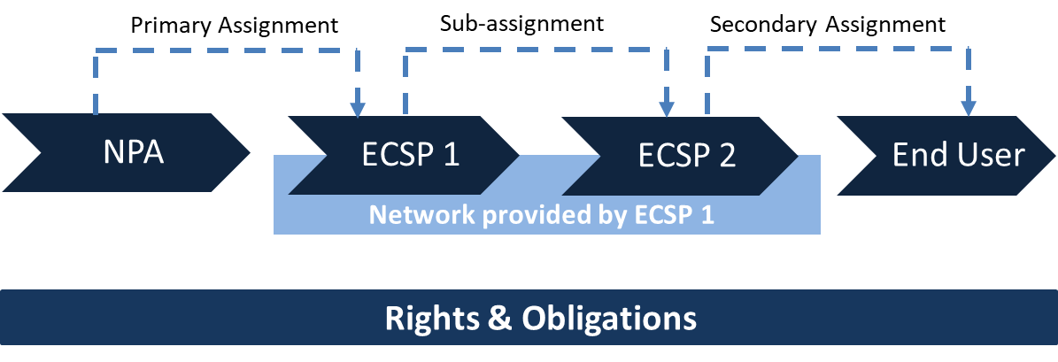
Figure 2: Sub-assignment with a single network
Figure 2 above describes sub-assignment. The NPA assigns a block of numbers to an ECSP - (ECSP 1) - which has its own network infrastructure and provides wholesale services to other ECSPs. ECSP 1 makes an agreement to provide numbers and network resources to ECSP 2 and so numbering resources of ECSP 1 are sub-assigned to ECSP 2. ECSP 2 then makes a secondary assignment of a number (or numbers) to its end user along with the provision of a service. An example of sub-assignment is when a Mobile Network Operator (MNO) or a Mobile Virtual Network Enabler (MVNE) sub-assigns numbers to a Mobile Virtual Network Operator (MVNO) who uses the network infrastructure of the MNO/MVNE.
In this model, the ECSPs' obligations, regarding the sub-assigned numbers, are less transparent if the responsibilities of ECSP 1 and ECSP 2 are unclear. ECSP 1 is listed in the NPA's database as being responsible for the numbers but the service is provided and some numbers are assigned to end users by ECSP 2. A question may arise whether the responsibilities are moved or shared between ECSP 1 and ECSP 2 and this issue may become even more complex when there are multiple levels of sub-assignment (i.e. from ECSP 2 to ECSP 3 and so on).
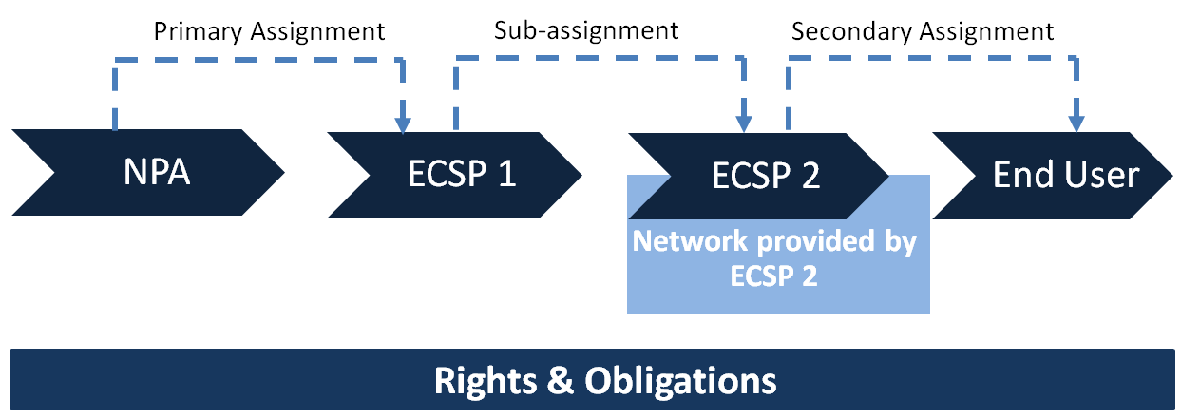
Figure 3: Sub-assignment with multiple networks
A further model of sub-assignment is where the sub-assignee (ECSP 2) has its own network and consequently the network is not provided by ECSP 1 but by ECSP 2, as described in Figure 3 above. In this model, the issues raised in the previous model remain but at the network level (routing), since the numbers are implemented in the network of ECSP 2, there could be some problems. This will depend on how the other ECNOs perform the routing. If the ECNOs have to implement in their networks the routing towards the sub-assigned numbers to ECSP 2, this could be a problem that has to be taken into account, particularly if there is any limitation in the number of digits that can be analysed during the routing of the communications.
In conclusion, the fact that there could be more than one model for the sub-assignment could lead to a greater complexity. For example, where the legal interception should be performed may depend on the model of the sub-assignment.

Number hosting
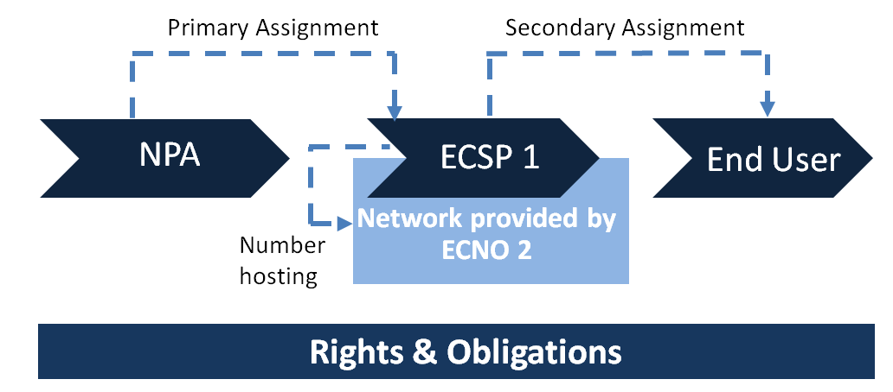
Figure 4: Number hosting
In Figure 4 above, the NPA makes a primary assignment to ECSP 1, but ECSP 1 does not have its own network. Therefore, it enters an agreement with a hosting network provider, ECNO 2, who agrees to host ECSP 1's primary assignment of numbers. In this model a secondary assignment of a number is made to the end user by ECSP 1 along with a network service provided using network resources from ECNO 2.
Directive (EU) 2018/1972 of the European Parliament and of the Council of 11 December 2018 establishes the European Electronic Communications Code (EECC). The EECC foresees scenarios whereby an NPA may also grant rights of use for numbering resources from the national numbering plans for the provision of specific services to undertakings other than providers of electronic communications networks or services. In such cases, it would be highly likely that these undertakings would require the services of number hosting providers.

Combination of sub-assignment and number hosting
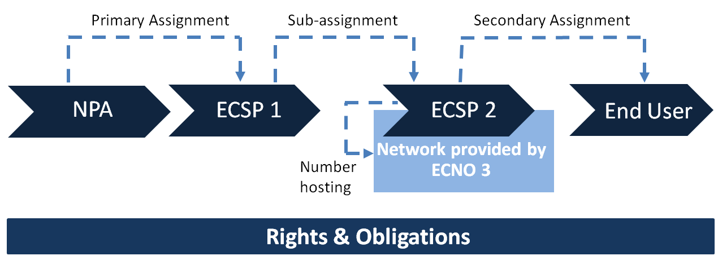
Figure 5: Combination of sub-assignment and number hosting
In Figure 5 above, the NPA makes a primary assignment to ECSP 1. ECSP 1 sub-assigns part of its assigned numbering resources to ECSP 2, without the constraint of using its own network. ECSP 2 enters into an agreement with ECNO 3 to have its numbers hosted on ECNO 3's network. ECSP 2 is then in a position to offer services to its end users and it provides a service to the end user using network resources provided by ECNO 3 along with the secondary assignment of a number from ECSP 1. One can see from the illustration that this business model is quite complex and from a supervisory perspective, difficult to determine which entities in the supply chain are responsible for which obligations. When there are multiple levels of sub-assignment the situation is further exacerbated.

Measures to increase transparency
Based on the models presented in Chapter 4, some measures to increase transparency are identified in this chapter in cases where sub-assignment is permitted. The application of any of the below-mentioned measures, including how they would apply retrospectively, would require careful consideration before implementation. For example, implementing notification procedures or information databases will have an administrative and/or financial burden for NPAs and market players.

Restrictions on sub-assignment
Limiting the number of levels of sub-assignment to one level could help ensure that transparency is more easily maintained in the supply chain.

Notification or Approval procedure
An obligation could be imposed by the NPA on primary assignees (or sub-assignees if the restriction of paragraph 5.1.1 is not applied) to notify the NPA when, or request an approval before, it sub-assigns numbering resources. In cases of number hosting, an obligation could be imposed on the primary assignee or sub-assignee to notify the NPA of the network on which its assigned numbering resources are hosted.

Information database
A database containing information on which entities have been sub-assigned numbers and on which networks assigned numbers are hosted would assist NPAs to monitor the market and ensure compliance with the regulatory framework. Such a database could be either centralised or distributed. It could be maintained by the NPA, by market players or by a third party vendor. It could be accessible by the NPA, by market players or by the public depending on the type of information maintained.

Obligations and regulatory supervision
There are benefits and drawbacks to allowing sub-assignment of numbers and number hosting.
On the one hand, NPAs typically assign numbers in block sizes of 10 000 or higher, although in some cases there are primary assignments of blocks of 100 and 1 000 numbers. Smaller operators or new market entrants may not need large blocks and sub-assignment offers a more efficient and less expensive alternative.
In the case of geographic numbers, where there are specific ranges for each geographic area, the sub-assignment may lead to more efficient use of numbering resources. To further increase the efficient use of the numbering resources a threshold for additional sub-assignments can be defined. This would mean that a sub-assignee would need to demonstrate efficient use of existing sub-assigned numbers before requesting a further sub-assignment. However, it is recognised that this would be difficult for the NPA to supervise in practice.
With number hosting, ECSPs who do not have their own network can greatly reduce their cost and time to market. Specialised number hosting service providers now advertise services where it is promised that all regulatory obligations will be fulfilled allowing the ECSP to focus on building their brand and end user base.
On the other hand, the drawbacks of allowing sub-assignment and number hosting are mainly related to a possible risk of lack of transparency which can make it difficult for regulatory authorities to perform their supervisory role. Sub-sections 6.1 to 6.4 describe the regulatory obligations and 6.5 describes the different databases which contain numbering assignment information necessary for enabling supervision.

Legal interception
Some regulatory obligations can be supervised by simply knowing the network that handles the numbers. If we consider the models described in Chapter 4 (such as those depicted in Figures 3, 4 and 5) where the network that provides the service to the end user (more precisely the network that handles the numbering resources) is different from the primary assignee, the NPA is often not informed thereby making the task of regulatory supervision more challenging and time consuming. This lack of transparency could lead to a situation where a request for legal interception is made to an ECSP or ECNO where the communication in question does not originate and/or terminate and consequently law enforcement authorities have to issue a new request after the correct ECNO has been identified. This can cause unnecessary delay in a situation where effective law enforcement requires swift action.

Number portability and the provision of number information for directory enquiry services
Number portability and the provision of number information for directory enquiry services can be efficiently supervised only if the NPA has sufficient knowledge of all the operators involved in the relevant implementation aspects which includes both the primary and secondary assignee.

Regulatory intervention when an ECSP/ECNO ceases operations
When an ECSP withdraws from the market the NPA might intervene to ensure that the ECSP's end users continue to have a service. In some instances, the numbering ranges are transferred to another ECSP or end users are advised to port their numbers to other ECSPs. This process can be seamless when there is advanced warning and complete transparency on who the numbering assignee is and on what network the numbering resources are provisioned. When the concerned numbering resources have been sub-assigned or number hosted on an ECNO the situation can be quite challenging and further exacerbated when the ECSP's withdrawal from the market is abrupt (e.g. in the case of bankruptcy).
When an ECSP with a primary assignment of numbering resources with its own network withdraws from the market abruptly all operations cease and the NPA may intervene to ensure that the numbering resources are transferred or ported. When those numbers are sub-assigned along with access to the primary assignee's network, the ECSP with the sub-assignment may also experience service disruption for its end users and the NPA may need to intervene. If the primary assignee does not have a network and has entered into an agreement with a number hosting provider it is possible that its end users may still have service for a period even if the primary assignee withdraws from the market abruptly. This is also the case even if the NPA withdraws the primary assignment. This situation is a challenging one for the NPA to deal with given the lack of transparency it has on the entities in the supply chain and their respective obligations.
Similar issues may arise when an ECNO ceases operations.

CallinG Line Identity (CLI) integrity and emergency services-related obligations
There are also obligations and/or end users' rights whose supervision may depend both on the ECSP that makes a secondary assignment of the numbering resources to the end user and on the network that handles these numbering resources (see Figure 5 in Chapter 4). Examples include the supervision of the obligations and user's rights on CLI, CLI integrity, access to emergency services and the provision of caller location information for emergency calls.
When a complaint is made to the NPA, it may not be able to make a direct link between the assigned number and the ECSP, in the case of sub-assignment, or know which network the number is provisioned on, in the case of number hosting. The information that is needed for supervision is often fragmented and located within different actors in different parts of the supply chain. The location of this critical information is discussed in more detail in the following section.

databases with number assignment data
Chapter 4 describes how numbers are implemented and provisioned in the supply chain. Number assignment data is stored in the databases of NPAs, but also in databases managed by primary assignees, sub-assignees and number hosting providers. This paragraph analyses what kind of information on numbering assignments is stored and where. The NPA manages the national numbering plan database and information about the numbering block such as the assignee name, the assignment date, a numbering category (designation according to the numbering plan) and an assignment/license ID/decision is maintained and is normally publicly available. These databases do not always contain data related to the type of assignee (network and/or service provider) and the secondary assignee. For this kind of information other databases need to be consulted.
The Number Portability Databases (NPDB) were established in most CEPT Countries to facilitate ECSPs and ECNOs, both fixed and mobile, to meet their number portability obligations. The NPDB contains data to facilitate service provider switching and to support efficient routing and/or increased tariff transparency. In most CEPT countries the NPDB is not managed by the NPA but is maintained by the industry (e.g. an association of ECNOs/ECSPs).
Emergency services need to know the location of emergency callers. For fixed telephone networks, emergency caller location information is primarily based on static subscriber data which the end user provided during the subscription to the service (i.e. an installation address). For mobile services this is an area where mobile cell ID or cell sector ID is primarily used. The location data needs to be provided by the ECNO with a radio network. With mobile phones enabled for Global Navigation Satellite Systems (GNSS) location data can also be provided directly from the mobile handset to the emergency services. A lack of clarity and transparency on which party in the supply chain could and should provide location information for emergency services stems to a large extent from the technological developments in electronic communications.
Telephone directories for numbering information or telephone book functionality contain subscriber data based on the secondary assignment from the ECSP to the end user. In most CEPT countries the telephone directory database is not managed by the CEPT administration but maintained by an external entity. The ECNO which hosts a particular number could not provide subscriber data in all models described in Chapter 4.
Functions for collecting telephone and internet data are managed by governmental organisations in some countries. These organisations can supply personal data associated with IP addresses, telephone numbers and e-mail addresses to law enforcement authorities when needed to support investigations. With this data, law enforcement authorities can trace suspects of criminal activities. In most CEPT countries the NPA assigning numbers is not the same organisation as that which provides such functions.

Current approaches to sub-assignment and number hosting
This chapter summarises different approaches to sub-assignment and number hosting in CEPT countries.

Approaches to sub-assignment
There is no harmonised approach governing sub-assignment in Europe. In some countries, sub-assignment is explicitly allowed, while in a few other countries it is explicitly forbidden. In some countries where it is allowed, it is allowed to one level of sub-assignment only and in other countries the NPA must be notified of the sub-assignment. There are also differences regarding the obligations associated with the assignment of numbers. In some countries they follow with the sub-assignment, in other countries they remain with the primary assignee while in other countries the responsibilities are shared. The quantity of sub-assigned numbers is also different; some countries allow any quantity while others can impose a minimum amount.
There is broad agreement that sub-assignment does happen even if the practice is not provided for in regulation and it causes problems for transparency in the supervision of the obligations associated with the numbers.

Approaches to number hosting
Again, there is no harmonised approach governing number hosting in Europe and in most cases the practice is not explicitly allowed or explicitly forbidden in regulation. There is broad agreement that number hosting does happen and the NPA is not aware of the practice in most cases.
In some countries, the primary assignee must demonstrate that they have a network, or an agreement to use a network, before they can be assigned certain categories of numbers. When such agreements change, e.g. when the primary assignee enters into another agreement with another network to host the numbers, it is common that the NPA is not notified. Where there is a combination of sub-assignment and number hosting, the NPA is not notified of the arrangements in almost all cases.

Conclusions
At time of publication of this Report, there is no harmonised approach to regulating sub-assignment and/or number hosting in Europe.
However, there are some benefits to allowing sub-assignment of numbers and number hosting including more efficient numbering plan management, lower market entry costs and reduced time to market.
Section 4.1 of this document describes a "Base Model" for assigning numbers which is based on the assumption that there is a direct relationship between the NPA and the primary assignee and between the primary assignee and the secondary assignee. The rights and obligations of each party are clear.
A consequence of sub-assignment and number hosting is that there are more entities in the supply chain. If national numbering regulations are based on the "Base Model" their practical implementation can become complex as it is not always transparent as to which entities rights and obligations apply.
This longer supply chain should be addressed at national level so that it is clear which rights and obligations apply to each entity in the supply chain and so that the NPA has the information it needs to ensure compliance with the regulations.
The measures to increase transparency on sub-assignment and number hosting outlined in Chapter 5 should be considered in this regard.

Or an individual number in the case of an assignment of a short code to an undertaking.
Or an individual number e.g. in the case of an assignment of a short code to an assignee.

