Evaluation of receiver parameters and the future role of receiver characteristics in spectrum management, including in sharing and compatibility studies

approved 31 January 2020

ECC Report 310

ECC Report 310

# Executive summary

There has been a regulatory change in Europe with the introduction of the Radio Equipment Directive (RED), 2014/53/EU[1] [1], which became fully applicable to radio products being placed on the market from 13 June 2017. The RED explicitly includes receivers, which as well as transmitters must make effective and efficient use of spectrum, meaning a receiver should have a level of performance that allows it to operate as intended and protects it against the risk of harmful interference, in particular from shared or adjacent channels. To support this ETSI develops Harmonised Standards which include receiver parameters and characteristics providing a minimum set of conformance requirements[2].

There are several experiences in CEPT administrations and examples in CEPT/ECC studies where receiver performance was found to be a limiting factor for co-existence between radio services and systems. The reports have resulted in different outcomes. In some of these cases, co-existence was deemed unfeasible, or restrictions were put on the transmitter (power restrictions guard bands etc). In several cases, improvement of receiver performance may have improved the sharing and compatibility outcomes. Going forward, CEPT/ECC should consider the feasibility of stipulating improved receiver performance, where it is found to be a limiting factor in sharing and compatibility studies. CEPT/ECC should provide information on the necessary receiver performance improvements to ETSI for consideration in Harmonised Standards under the Radio Equipment Directive. Additionally, CEPT administrations can pursue improved receiver performance into Harmonised Standards through their participation in ETSI. It is also important that receiver performance should be specified in Harmonised Standards with a sufficient level of resilience from the outset in order to achieve satisfactory sharing and compatibility outcomes. This will minimise the need to remediate receivers already deployed and in use noting that Harmonised Standards only cover products at the time they are placed on the market.

This Report identifies which receiver parameters are critical for most sharing and compatibility studies. It is observed that parameters such as selectivity and/or blocking are commonly included in a large number of Harmonised Standards, but other parameters are less common. Some receiver parameters are not readily available in some standards at this point in time. Some standards do not provide enough information for sharing and compatibility studies.

When conducting sharing and compatibility studies, receiver parameters should first be based first on ECC deliverables, ETSI Harmonised Standards, ITU-R Recommendations, or other CEPT information or studies. Information about receiver performance sourced from vendors, held by regulators, or results of relevant measurements carried out on equipment can also be used.

Some areas of improvement for receiver performance are identified in Chapter 9 “Conclusions”.

ECC should consider the development of a Recommendation addressing receiver resilience to adjacent frequency use (e.g. blocking and selectivity) based on the analysis in this Report. Such a Recommendation should focus on areas that are relevant for sharing and compatibility between different systems.

TABLE OF CONTENTS

0 Executive summary 2

1 Introduction 9

2 Definitions 10

2.1 Main definitions 10

2.2 Additional definitions 12

3 Importance of receiver performance in sharing and compatibility 14

3.1 CEPT/ECC studies and receiver performance 15

3.2 Summary of observations and findings in previous CEPT/ECC Reports 15

3.3 Previous ECC deliverables generally on receiver performance 15

3.4 Limits and typical receiver performance considerations 16

3.5 Future ECC Recommendation on receiver performance 17

4 General principles of receivers and characterisation 18

4.1 Description of the receiving system 18

4.2 Characterisation of receiver parameters 21

4.2.1 Receiver noise floor 21

4.2.2 Sensitivity 22

4.2.3 Linearity 22

4.2.4 Dynamic range 22

4.2.5 Protection ratio 22

4.2.6 Selectivity 22

4.2.6.1 Adjacent channel selectivity 23

4.2.7 Blocking and overloading 26

4.2.7.1 Blocking (receiver blocking response) 27

4.2.7.2 Overloading 29

4.2.7.3 Intermodulation rejection 31

4.2.8 Spurious response rejection 35

5 Role of receiver parameters in sharing and compatibility studies 36

5.1 General considerations on receiver parameters 36

5.2 Critical receiver parameters for sharing and compatibility studies 37

6 Sources of information on the receiver performance of equipment 38

6.1 The RED, receiver parameters and limits used in ETSI Harmonised Standards 38

6.1.1 ETSI Guide EG 203 336 V1.1.1 (2015-08) 39

6.1.2 Receiver parameters included in RED Harmonised Standards 40

6.2 Additional ETSI definitions of radio parameters 40

7 Additional consideration of receivers in sharing and compatibility studies 42

7.1 Methodology for dealing with coexistence of systems of unlike bandwidth and different technologies 42

7.1.1 Different bandwidths for interferer and victim 42

7.1.1.1 Co-channel interferer and victim receiver bandwidth 42

7.1.1.2 Adjacent and offset interferer and victim receiver bandwidth 44

7.1.2 Different technologies 45

7.1.3 Enhanced Sharing mechanisms 45

7.2 Modelling of receiver parameters in SEAMCAT 46

7.2.1 SEAMCAT background 46

7.2.2 Receivers in generic SEAMCAT systems 46

7.2.2.1 Blocking 46

7.2.2.2 Intermodulation 48

7.2.2.3 Overloading 49

7.2.3 Receivers in cellular SEAMCAT systems 50

8 receiver measurements of common digital systems 52

8.1 Introduction 52

8.2 Description of general measurement setups and measured parameters 52

8.3 Summary of measured receiver performance 52

8.3.1 RLAN 53

8.3.1.1 General information 53

8.3.1.2 Adjacent channel selectivity 55

8.3.1.3 Blocking 55

8.3.1.4 Overloading immunity 56

8.3.1.5 Intermodulation immunity 56

8.3.1.6 Analysis of the measurement results in comparison with ETSI Harmonised Standards 57

8.3.2 DECT 58

8.3.2.1 General Information 58

8.3.2.2 Sensitivity 58

8.3.2.3 Selectivity curve 59

8.3.2.4 Adjacent channel rejection 60

8.3.2.5 Blocking 61

8.3.2.6 Overloading immunity 61

8.3.2.7 Intermodulation immunity 62

8.3.2.8 Analysis of the measurement results in comparison with ETSI Harmonised Standards 63

8.3.3 Tetrapol 63

8.3.3.1 Sensitivity 63

8.3.4 TETRA 63

8.3.4.1 Sensitivity 64

8.3.4.2 Analysis of the measurement results in comparison with ETSI Harmonised Standards 64

8.3.5 GSM-Rail 900 UE 64

8.3.5.1 Sensitivity 65

8.3.5.2 Selectivity 65

8.3.5.3 Adjacent channel selectivity 65

8.3.5.4 Overloading immunity 66

8.3.5.5 Intermodulation immunity 66

8.3.5.6 Analysis of the measurement results in comparison with ETSI Harmonised Standards 67

8.3.7 DCF77 79

8.3.7.1 General Information 79

8.3.7.1 Sensitivity 80

Selectivity 80

8.3.7.2 Overloading 80

8.3.8 GPS 81

8.3.8.1 General information 81

8.3.8.2 Sensitivity 82

8.4 Overall findings from the measurements 88

9 Conclusions 90

ANNEX 1: Analysis of previous CEPT/ECC reports 92

ANNEX 2: Receiver parameters Measurement Concept applied in this report 108

ANNEX 3: list of receiver parameters found in ETSI Harmonised standards 112

ANNEX 4: information on the blocking requirements for receivers 113

ANNEX 5: Comparative analysis of definitions of parameters in some etsi standards 120

ANNEX 6: TECHNICAL BACKGROUND FOR DERIVING RECEIVER SELECTIVITY FROM KNOWN ACS AND BLOCKING CHARACTERISTICS OF THE RECEIVER 129

ANNEX 7: Example of derivation of a SEAMCAT blocking mask 132

ANNEX 8: Receiver threshold for adaptive spectrum sharing techniques 134

ANNEX 9: List of References 138

LIST OF ABBREVIATIONS

|  |  |  |  |  |  |  |  |  |  |  |  |  |  |  |  |  |  |  |  |  |  |  |  |  |  |  |  |  |  |  |  |  |  |  |  |  |  |  |  |  |  |  |  |  |  |  |  |  |  |  |  |  |  |  |  |  |  |  |  |  |  |  |  |  |  |
| --- | --- | --- | --- | --- | --- | --- | --- | --- | --- | --- | --- | --- | --- | --- | --- | --- | --- | --- | --- | --- | --- | --- | --- | --- | --- | --- | --- | --- | --- | --- | --- | --- | --- | --- | --- | --- | --- | --- | --- | --- | --- | --- | --- | --- | --- | --- | --- | --- | --- | --- | --- | --- | --- | --- | --- | --- | --- | --- | --- | --- | --- | --- | --- | --- | --- |
| |  |  | | --- | --- | | Abbreviation | Explanation | | ACIR | Adjacent Channel Interference Ratio | | ACLR | Adjacent Channel Leakage Ratio | | ACS | Adjacent Channel Selectivity | | ADC | Analogue to Digital Converter | | AFA | Adaptive Frequency Agility | | ATPC | Automatic Transmit Power Control | | BCBSEL | Receiver Channel Bandwidth Integrated selectivity | | **BER** | Bit Error Rate | | CDMA | Code Division Multiple Access | | CEPT | European Conference of Postal and Telecommunications Administrations | | **CGC** | Complementary Ground Component | | **DAA** | Detect and Avoid | | **DCR** | Direct Conversion Receiver | | DDC | Digital Down Conversion | | DFS | Dynamic Frequency Selection | | **DSP** | Digital Signal Processer | | **DSP** | Digital Signal Processing | | DTT | Digital Terrestrial Television | | DVB-T | Digital Video Broadcasting - Terrestrial | | e.i.r.p. | Equivalent Isotropically Radiated Power | | ECC | Electronic Communications Committee | | EN | European Standard | | ETSI | European Telecommunication Standards Institute | | E-UTRA | Evolved Universal Terrestrial Radio Access | | FDD | Frequency Division Duplex | | FM | Frequency Modulation | | FOS | Frequency Offset Selectivity | | GFSK | Gaussian Frequency Shift Keying | | GMSK | Gaussian Minimum Shift Keying | | GSM | Global System for Mobile Communications | | GSM-R | Global System for Mobile Communications - Railway | |  |

|  |  |
| --- | --- |
| Abbreviation | Explanation |
| IEEE | Institute of Electrical and Electronic Engineers |
| IF | Intermediate Frequency |
| **ILR** | Interference Leakage Ratio |
| IMT | International Mobile Telecommunications |
| ITU | International Telecommunication Union |
| ITU-R | International Telecommunication Union - Radiocommunication Sector |
| LBT | Listen-Before-Talk |
| **LNA** | Low Noise Amplifier |
| LO | Local Oscillator |
| LTE | Long Term Evolution |
| **MES** | Mobile Earth Station |
| MFCN | Mobile/Fixed Communications Networks |
| MSR | Multi Standard Radio |
| **MSS** | Mobile Satellite Services |
| N | Receiver noise floor |
| NF | Noise Figure |
| NFD | Net Filter Discrimination |
| NZIF | Non-Zero Intermediate-Frequency |
| OFDM | Orthogonal Frequency Division Multiplexing |
| OFDMA | Orthogonal Frequency Division Multiple Access |
| OoB | Out-of-Band |
| PAPR | Peak-to-Average Power Ratio |
| PEP | Peak Envelope Power |
| PMSE | Programme Making and Special Events |
| PR | Protection Ratio |
| PSD | Power Spectral Density |
| QAM | Quadrature Amplitude Modulation |
| R&TTE | Radio and Telecommunications Terminal Equipment Directive |
| RED | Radio Equipment Directive |
| RF | Radio Frequency |
| **RIR** | Receiver Interference Ratio |
| RLAN | Radio Local Area Network |
| RMS | Root Mean Square |
| RR | Radio Regulations |
| SE | Spectrum Engineering |
| **Abbreviation** | **Explanation** |
| SEAMCAT | Spectrum Engineering Advanced Monte Carlo Analysis Tool |
| SEM | Spectrum Emission Mask |
| SINAD | Signal to Interference Noise and Distortion |
| SINR | Signal to Interference plus Noise Ratio |
| SIR | Signal to Interference Ratio |
| SNR | Signal to Noise Ratio |
| SRD | Short Range Devices |
| SSB | Single Sideband Modulation |
| TDD | Time Division Duplex |
| TDMA | Time Division Multiple Access |
| TETRA | Terrestrial Trunked Radio |
| TPCBS | Transmit Power Control |
| TRPUE | Total Radiated Power |
| UMTS | Universal Mobile Telecommunications System |
| WAS | Wireless Access System |
| WLAN | Wireless Local Area Network |
| WRC | World Radiocommunication Conference |

# Introduction

The characteristics of the receiver play an important role in sharing and compatibility between radio services/systems. There has been a regulatory change in Europe with the introduction of the Radio Equipment Directive (RED), 2014/53/EU[3] [1], which became fully applicable to radio products being placed on the market from 13 June 2017. The RED explicitly includes receivers[4] which, as well as transmitters, must make effective and efficient use of spectrum, meaning a receiver should have characteristics that allow it to operate as intended and to protect it against the risk of harmful interference, in particular from shared or adjacent channels. To support this Directive, ETSI has developed a set of Harmonised Standards which specify receiver parameters and providing a minimum set of conformance requirements[5].

The demand for spectrum is driven by both existing and new services, systems and applications. Efficient spectrum usage requires that characteristics and necessary performance of both the transmitter and receiver be taken into account in sharing and compatibility between radio services, systems and applications. Receiver characteristics are as important as transmitter characteristics. Improving receiver characteristics is one of the options to achieve compatibility.

This Report examines existing literature and Harmonised Standards under the RED, analyses different receiver parameters and presents the results of a series of measurements for some receivers. It also presents various definitions, different receiver architectures and a mathematical model describing the behaviour of the receiver front-end. Its aim is to help ECC to identify the relevant receiver parameters to be used in sharing and compatibility studies.

# Definitions

## Main definitions

|  |  |
| --- | --- |
| Term | Definition |
|  |  |
| **Adjacent Channel Interference Ratio (ACIR)** | The ratio of the in-channel interference power on an adjacent channel frequency to the interference power received by the victim receiver. |
| **Adjacent Channel Leakage power ratio (ACLR)** | The ratio of the (nominally rectangular) filtered mean power centred on the assigned channel frequency to the similarly filtered mean power centred on an adjacent channel frequency. |
| **Adjacent Channel Selectivity (ACS)** | A measure of the receiver ability to receive a wanted signal at its assigned channel frequency in the presence of an unwanted adjacent like-channel signal. It is most often defined as the ratio of the receiver filter attenuation on the adjacent channel frequency to the receiver filter attenuation on the assigned channel frequency (normally a positive number in dB). ACS is typically used in systems operating on channelised bands. |
| **Blocking** | A measure of the receiver capability to receive a wanted signal without exceeding a given degradation due to the presence of an unwanted signal at any frequency other than those of the spurious responses or of the adjacent channels and it is defined as the maximum interfering signal level expressed in dBm reducing the specified receiver sensitivity by a certain number of dBs (desensitisation). |
| **Channel bandwidth** | The bandwidth of the channel assigned to the emission of the service. |
| **Desensitisation** | Reduction in the signal to noise ratio of the receiver or a reduction in the effective sensitivity in the presence of an interfering signal, given in dB. It corresponds to the ‘noise rise’ due to the interfering signal. |
| **Frequency Offset Selectivity (FOS)** | A measure of the receiver ability to receive a wanted signal at its assigned channel frequency in the presence of an unwanted adjacent signal at a given frequency offset from the centre frequency of the assigned channel. It is most often defined as the ratio of the receiver filter attenuation on the offset frequency to the receiver filter attenuation on the assigned channel frequency (normally a positive number in dB).  FOS is of general use for any mixed wanted and unwanted signal situation. |
| **Interference Leakage Ratio (ILR)** | The ratio of the (nominally rectangular) filtered mean power centred on the assigned channel frequency to the similarly filtered mean power centred on a given frequency offset. |
| **Interference to Noise Ratio (INR)** | The ratio, generally expressed in decibels, of the power of the interfering signal to the power of noise, evaluated in specified conditions at a specified point of a transmission channel. |
| **Linearity** | Linearity is a measure of how directly proportional the output signal is to the input, this may be complicated to measure in a completed receive system. Non-linearity is likely to result in overloading and intermodulation. |
| **Noise  (radio frequency noise)** | A time-varying electromagnetic phenomenon having components in the radio-frequency range, apparently not conveying information and which may be superimposed on, or combined with, a wanted signal (Recommendation ITU-R P.372 [64]). |
| **Overloading (interference level threshold)** | The level expressed in dBm of interfering signal, above which the receiver begins to lose its ability to discriminate against interfering signals at frequencies differing from that of the wanted signal (i.e. the onset of strong non-linear behaviour). Therefore, above the overloading threshold (Oth) the receiver will behave in a non-linear way but does not necessarily fail immediately depending on the receiver and interference characteristics. |
| **Permissible interference (RR 1.167)** | Observed or predicted interference which complies with quantitative interference and sharing criteria contained in the Radio Regulations or in ITU-R Recommendations or in special agreements as provided for in the Radio Regulations. |
| **Protection Ratio (Radio frequency)** | The minimum value of the wanted-to-unwanted signal ratio, usually expressed in decibels, at the receiver input, determined under specified conditions such that a specified reception quality of the wanted signal is achieved at the receiver output (RR 1.1.70). Usually, protection ratio (PR) is specified as a function of the frequency offset between the wanted and interfering signals over a wide frequency range. |
| **Receiver Bandwidth (B)** | The bandwidth of the receiver that determine the amount of thermal noise affecting the signal detection and consequently the SNR. |
| **Receiver Interference Ratio (RIR)** | The ratio of the in-channel interference power on a given frequency offset to the interference power received by the victim receiver. |
| **Receiver noise floor (N)** | The total noise power at the receiver including the effect of thermal noise and the receiver noise figure. |
| **Receiver sensitivity** | The minimum wanted input signal or field strength at the nominal frequency of the receiver able to produce a minimum specified output performance (e.g. SINAD and BER). |
| **Signal-to-Interference plus Noise Ratio (SINR)** | The ratio, generally expressed in decibels, of the power of the wanted signal to the total power of the interfering signal and noise, evaluated in specified conditions at a specified point of a transmission channel. |
| **Signal-to-Interference Ratio (SIR)** | The ratio, generally expressed in decibels, of the power of the wanted signal to the power of the interfering signal, evaluated in specified conditions at a specified point of a transmission channel. |
| **Signal-to-Noise Ratio (SNR)** | The ratio, generally expressed in decibels, of the power of the wanted signal to the power of noise, evaluated in specified conditions at a specified point of a transmission channel. |

## Additional definitions

|  |  |
| --- | --- |
| Term | Definition |
| **Adjacent Channel Interference (ACI)** | Interference caused by extraneous power from a signal on an adjacent channel. |
| **Adjacent Channel Rejection (ACR)** | A measure of the capability of the receiver to receive a wanted signal without exceeding a given degradation due to the presence of an unwanted signal (interferer) either in the first or second adjacent channel. It is expressed as the ratio, in dB, of the level of the unwanted signal to the level of the wanted signal, at the receiver input. |
| **Co-channel rejection** | A measure of the capability of the receiver to receive a wanted modulated signal without exceeding a given degradation due to the presence of an unwanted modulated signal, both signals being at the nominal frequency of the receiver. It is expressed as the ratio, in dB, of the level of the wanted signal to the level of the unwanted signal, at the receiver input (also called co-channel protection ratio). |
| **Compatibility** | Where two or more radio frequency users can operate on either the same or adjacent frequencies without causing each other an unacceptable level of degradation or harmful interference. |
| **Intermodulation Free Dynamic Range (IFDR)**  **Spurious Free Dynamic Range (SFDR)** | The range, expressed in dBm, between the least discernible signal and the level in which two or more signals do not produce (intermodulation) products that cannot be separated from the wanted signal. |
| **Intermodulation response rejection** | A measure of the capability of the receiver to receive a wanted modulated signal, without exceeding a given degradation due to the presence of two or more unwanted signals with a specific frequency relationship to the wanted signal frequency. It is expressed as the maximum interfering signal mean power (dBm) for a given wanted signal level. |
| **LO phase noise** | Local oscillator (LO) Phase noise is the spreading of the LO’s signal in the frequency domain as a result of the phase jitter introduced by thermal and flicker/pink noise in the generating circuit. |
| **Minimum detectable signal (Least discernible signal)** | The minimum wanted signal level, expressed in dBm, that can be distinguished from the receiver noise assuming no other signals are present; which is called the least discernible signal, typically for some high sensitivity applications (e.g. earth observation or radio astronomy applications). |
| **Net Filter Discrimination (NFD)** | The ratio, generally expressed in decibels, between the level of interference of the adjacent channel interference (i.e. at antenna port) and its residual level after all RF, IF and Baseband filter chain (see Recommendation ITU-R. F.746 [54]). |
| **Sharing** | Where two or more concurrent radio frequency users can operate in the same frequency band while compatibility is achieved. |

# Importance of receiver performance in sharing and compatibility

Both transmitter and receiver parameters have an impact on the spectrum efficiency. Previously sharing and compatibility studies have focused on transmitters but receivers are also critically important. If a receiver has inability to attenuate adjacent signals, improvements to transmitter unwanted emission performance will not improve sharing and compatibility outcomes.

A generic example of the impact of an adjacent interfering transmitter and victim receiver on the reception of a wanted signal is given in Figure 1. It can be seen from this that the receiver and transmitter both contribute to the occurrence of interference.



Figure 1: Impact of an interfering transmitter and a victim receiver on the reception of wanted signals

The example in Figure 1 demonstrates that ACS and ACLR are ratios of spectral power density integrals; and the most significant components of both will impact the reception of the wanted signal. There should be a balance between the resilience to interference of the receiver, described by ACS, and the effects of interference from the transmitter, described by ACLR, in order to avoid one of them being the dominant factor in a compatibility scenario.

There have been several cases where receiver characteristics have played an important role in compatibility scenarios. Some recent examples of issues experienced by CEPT administrations where improving receiver characteristics enhance the compatibility between existing and new services are the following:

* Digital Terrestrial Television receiver performance and compatibility and susceptibility to 800 MHz MFCN;
* 2700-2900 MHz Aeronautical Primary Surveillance Radars receiver performance and susceptibility to 2600 MHz MFCN and conversely, improvement of the radar receiver selectivity, limitations of unwanted emissions and co-ordination requirements (e.g. frequency and/or geographical separations) were also identified as part of the possible mitigation techniques;
* 900 MHz GSM-R receiver performance and susceptibility to MFCN.

## CEPT/ECC studies and receiver performance

Some examples of CEPT/ECC Reports where receiver characteristics have played an important role in compatibility scenarios are summarised below. More detailed analyses are presented in ANNEX 1:. The summary below is not exhaustive and focuses on some scenarios related to receiver performance.

## Summary of observations and findings in previous CEPT/ECC Reports

In the new European regulatory environment (Radio Equipment Directive) there is an increased emphasis on receivers, and receiver performance is a critical element in achieving compatibility. Receiver performance was a factor for compatibility in the different CEPT/ECC Reports analysed. The different studies had different proposals and outcomes on how to address the receiver performance. These studies show why receiver performance is important and how improving performance at the earliest possible stage could result in better sharing and compatibility outcomes. The studies are summarised below:

**Compatibility between 900 MHz GSM-R and LTE/WiMAX:** CEPT Report 41 [42] identified issues with GSM-R receivers but considered coexistence could be achieved without restrictions/mitigations on the receiver as the issue was being rectified by standardisation bodies. Later reports (ECC Report 162 [43] and ECC Report 229 [13]) then noted interference problems and identified mitigations/co-ordination procedures to minimise the interference issues and not unduly restrict use of the adjacent band.

**Compatibility between 800 MHz DTT receivers and UMTS/LTE:** CEPT Report 30 [4] found that interference could occur to television reception through the adjacent channel selectivity (ACS) performance of the television receiver.ECC Reports 138 and 148 derived protection criteria based on performance of DTT receivers and then suggested that this information should be used by administration seeking to protect DTT.

**Compatibility between 1800 MHz PMSE and GSM/LTE:** ECC Report 191 [7], proposed restrictions/mitigations on the transmit power of PMSE close to the band edges. ECC Report 191 did not consider in detail the feasibility of improving receiver performance as a mitigation. While it is difficult to say if this would have improved the outcomes, it would have been beneficial to study this in the Report.

Compatibility between 2500 MHz CGC and LTE: ECC Report 165 [8] proposed restrictions/mitigations for the transmit power of CGC which precluded it (compatibility was not feasible). ECC Report 165 did not consider the feasibility of improving receiver performance as a mitigation. While it is difficult to say if this would have improved the outcomes, it would have been beneficial to study this in the Report.

**Compatibility between 1500 MHz LTE and MSS:** ECC Report 263 [10] reinforced by ECC Report 299 [11], found that MSS terminal performance were the limiting factor and proposed mitigations to improve the receiver blocking performance of MSS terminals, this information was liaised to ETSI and is still a work in progress. As complement to ECC Report 263, ECC Report 299 addresses proportionate solutions for currently operating maritime and aeronautical MESs that do not meet this blocking requirement.

## Previous ECC deliverables generally on receiver performance

The impact of receiver standards on spectrum management (ECC Report 127 [12])

ECC Report 127 [12], published in 2008, conducted a broad analysis on the impact of receiver performance on spectrum management. The Report covered regulatory issues, receiver parameters in regulations/standards, coexistence, compatibility and experiences with interference due to receiver performance. Some of the content in the report relating to regulations and standards may now be surpassed by the introduction of the Radio Equipment Directive [1] which explicitly included receivers and became mandatory on 13 June 2017. The Report revealed that there were several cases where it would have been possible to make a significant difference to spectrum management outcomes through better receiver performance. The Report made several conclusions and recommendations, many of which are relevant to this Report.

The most relevant conclusions are:

*“2 Receiver parameters are a crucial element of co-existence calculations and thus in spectrum management.*

*3. Carefully chosen values for receiver parameters should be available for compatibility studies.*

*4. Field surveys are necessary in many cases to determine the actual performance of receivers.*

*5. Significant enhancement of receiver performance in one respect (for example sensitivity) can come at the expense of underperformance in another. Under those circumstances co-existence assumptions can be prejudiced.”*

The most relevant recommendations are:

*“1 In general, there is always a case in introducing new services, (and in managing existing ones) to identify what are the appropriate receiver parameter limit values, and to consider the best mechanism.*

*2. Identify the set of receiver parameters that could be introduced in standards on a case by case basis in Harmonised Standards and/or in regulation.”*

Specification of reference receiver performance parameters (ECC Recommendation (02)01 [14])

ECC Recommendation (02)01, published February 2002, provides the following recommendations:

"

1. that the reference receiver performance parameters given in Annex 1 to this recommendation should be used by CEPT administrations as the basis for planning the radio spectrum and for radio compatibility and sharing analysis;
2. that CEPT administrations make reference to the reference receiver performance parameters given in Annex 1 to this recommendation for the purpose of making decisions on investigating and resolving interference complaints;
3. that, for the purposes of recommends 2) above, CEPT administrations should recognise receiving equipment as either:

radio equipment which complies with reference receiver performance parameters as defined in the relevant recognised standards; or

other radio equipment for which interference complaints would, in principle, not be investigated."

Annex 1 of ECC Recommendation (02)01 provides a list of reference receiver performance parameters to be considered for spectrum planning and investigation of interference for onsite paging and commercially available amateur radio equipment. It was the intention that the list would be updated to include other equipment for which receiver parameters are not included in ETSI Harmonised Standards or in any ECC deliverable.

ECC Recommendation (02)01 was developed in 2002 and only a limited range of equipment was taken into account. Since 2002, there have been a number of developments and the situation has changed. One of these developments was introduction of the Radio Equipment Directive [1] which explicitly included receivers.

## Limits and typical receiver performance considerations

When conducting sharing and compatibility studies the limits for receiver parameters contained in ETSI Harmonised Standards should be used as a starting point, because it is expected that all equipment (i.e.100%) should conform to these minimum requirements.

It is expected that there will be a distribution of equipment performance better than the limit where some equipment may be close to the limit and others may have a margin. This is due to the fact that manufacturers need to ensure that the ETSI HS limits are met for all stated conditions. However, using conformance limits in studies may lead in some cases to imposing undue constraints on other systems. When coexistence cannot be demonstrated with the conformance limits from ETSI HS, or when ETSI HS limits are not available, additional studies could be conducted by looking at typical receiver performance. Information on typical performance of the concerned device could be sourced from technical documentation from vendors, material already held by national regulators or it could be sourced from a series of measurements where relevant (see examples in chapter 8). It is noted that some documentation might only give single values for receiver performance which results in a binary pass/fail assessment of interference (e.g. conformance limits).  Measurements of equipment can be used to give a more realistic understanding of the impact of the interferer based on the signal strength and type of the interferer. This is particularly true for interference cases not directly covered in the technical documentation.

## Future ECC Recommendation on receiver performance

ECC has produced ECC Recommendations on limits for unwanted emissions in the out-of-band and spurious domains from radio equipment (ECC Recommendation (02)05 [17] and ERC Recommendation 74-01 [18]), and which applies constraints on the transmitter in order to increase the effectiveness of use of the spectrum. ECC Recommendation (19)02 [61] provides “Guidance and Methodologies when considering typical unwanted emissions in sharing/compatibility studies“. Additionally, ITU-R has produced Recommendations on unwanted emissions in the out-of-band and spurious domains (Recommendations ITU-R SM.1541 [19] and ITU-R SM.329 [20]). These ITU-R Recommendations are based on the assumption that the receiver should have sufficient performance not to be affected by transmissions in adjacent bands, particularly due to the blocking phenomena. ECC could now consider the development of a recommendation addressing receiver resilience to adjacent and non-adjacent frequency use (e.g. blocking and selectivity). This Recommendation should focus on areas that are relevant for sharing and compatibility between different systems. Two possible examples were discussed (one or both of these could be done):

* Example 1: Develop a Recommendation which would be on a similar principle as for ECC Recommendation (02)05 [17] and ERC Recommendation 74-01 [18] which address the case of transmitter emissions;
* Example 2: Develop Recommendations on how to define the receiver requirements and the types of receiver parameters to include in standards.

Further studies would be required to develop such a recommendation and there would be a number of challenges that need to be addressed. As a second step, development of a recommendation equivalent to ECC Recommendation (19)02 could also be considered.

# General principles of receivers and characterisation

## Description of the receiving system

Different receiver architectures are used today. Figure 2, Figure 3, Figure 4, Figure 5 and Figure 6 depict five common receiver architectures in a simplified manner. In practice, each of the architectures presented here would include a more complex (and in some cases simplified) architecture depending on the operating frequency and the required operational characteristics. In most cases, digital design is extensively used as far as the current technology permits.

One of the most common traditional receivers is the superheterodyne receiver which requires a large number of discrete elements such as filters. Architectures such as Zero IF and Low IF lend themselves to more integrated approaches with fewer external components. More integrated approaches allow almost the entire receiver to be fabricated in silicon, so that it can be manufactured in large volumes. Each receiver architecture has different characteristics, limitations and associated relevant receiver specifications. The relevant test methods depend on the receiver architecture.

In Figure 2 a superheterodyne receiver with a single IF is depicted. In practice this architecture is also used for high end receivers with multiple IF stages and local oscillators (LO). In this architecture the band filtered received signal is first converted to an intermediate frequency and then filtered and amplified. In a further stage the filtered signal is converted to baseband either by another mixer or a direct digital down converter implemented in an analogue to digital converter (ADC) and digital signal processer (DSP). Two main impairments are directly related to this architecture: LO phase noise and spurious response/image rejection.

The amount of LO phase noise depends on the number of IF stages and thus the number and quality of the LOs. Any received signal at an offset of the LO frequency equal to the IF frequency falls directly in the IF passband and generates interference. These image products may cause additional desensitisation and blocking. Moreover, if the LO generates harmonic signals, these could mix with these products generating spurious signals which may degrade the receiver performance.



Figure 2: Superheterodyne receiver architecture

* The wanted signal frequency is fwanted=fLO+fIF ( or fLO-fIF);
* Images are located at fimage=fLO-fIF (or fLO+fIF);
* Spurious responses are located at fspur(x) =fLO(harmonic x)±fIF.

In applications where high integration is needed (e.g. SRD) the Direct Conversion receiver (DCR) or traditional zero-IF receiver is often used. Several variations exist and this type of receiver is shown in Figure 3, where only the analogue part of the receiver is shown.

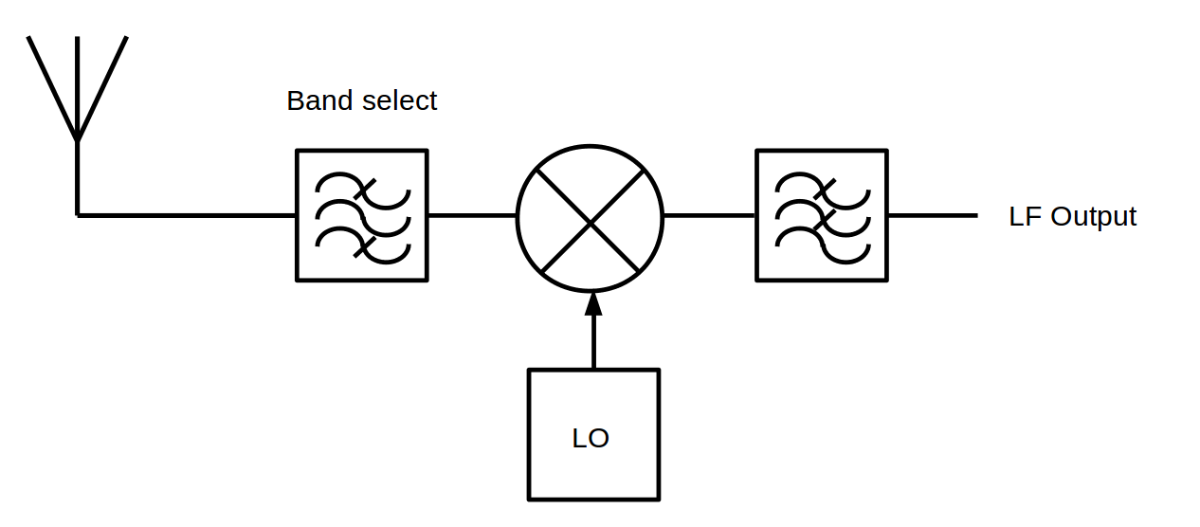

Figure 3: Direct Conversion Receiver (DCR) simplified architecture (analogue components only)

This receiver, also called the “homodyne” receiver, has no IF filter. The input signal is down-converted to baseband (fc = 0 Hz) and there is no need to perform image rejection, since the wanted signal is the image of itself, but spurious responses may still be present. Only a single LO is needed. Drawbacks of this design are oscillator leakage and associated impaired sensitivity. Another issue is desensitisation and low selectivity since there is only a bandpass filter as the frequency selective component in this design. DCRs can also generate LO radiation since the bandpass filter doesn’t block the LO signal and the receiver is typically a single chip design.

DCRs exhibit a DC (direct current voltage) component in the spectral centre, or at the edge, of the down-converted output, depending on filtering, where the received signal equals the LO frequency. This is caused by LO leaking through the input of the mixer and mixing with itself, with the additional contributions of emitted and re-received LO signals. DC removal techniques are usually present in such receivers.

Figure 4 shows two simplified variations of the concept - a traditional down converter (analogue part of architecture) with added ADC and DSP and a direct digital down converting (DDC) receiver, where the Rx frequency can be directly handled by the ADC and followed by a DSP.

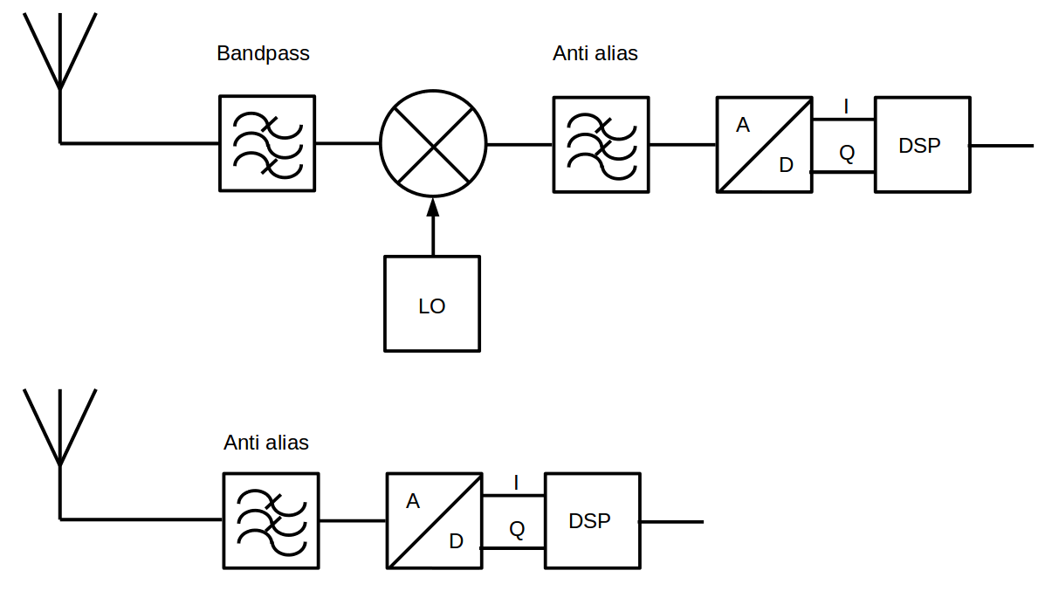

Figure 4: Direct Conversion Receiver (DCR) simplified architecture with digital processing

The maximum operating frequency of the DDC receiver depends on the bandwidth of the ADC. A technique called under sampling is also used. In this process down converting and sampling is performed at the same time. This method may make the receiver susceptible to interference at specific frequencies outside the reception bandwidth.

Figure 5 shows a more detailed schematic of a digital Zero-IF receiver. It implements a quadrature down-converter as still found in many larger communication systems. These types of down-converters may exhibit crosstalk between the I and Q branches which degrade the receiver performance, particularly in multichannel configurations.

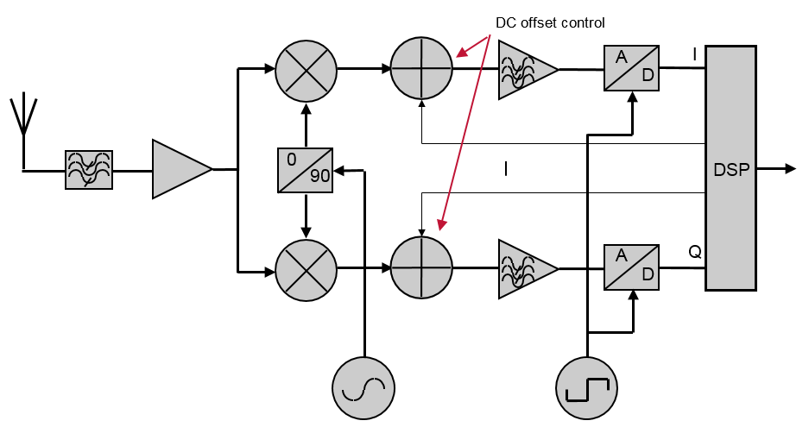

Figure 5: Zero IF receiver architecture

In receiver systems for applications with well-determined channellisation schemes such as cellular networks and fixed links it makes sense to perform channellisation at an early stage in the receiver. In older designs this was done using a splitter and a bank of downconverters, and in later designs using a DSP. The drawback of such a scheme is the inflexibility or in case of chanellisation the need for wideband ADC. Polyphase filtering is more flexible in this aspect, Figure 6 shows such a receiver. A polyphase filter is basically a set of independent DSP down converters.

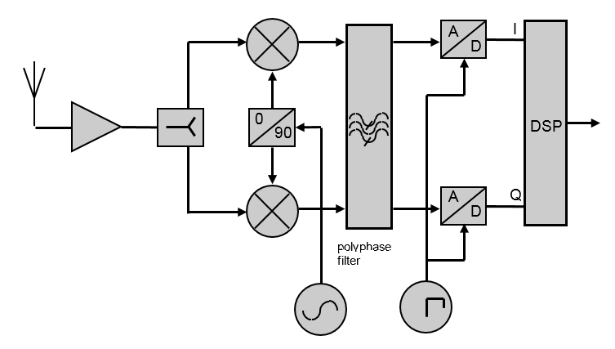

Figure 6: Low IF receiver with polyphase filter architecture

The benefit of digital designs is that selectivity may be achieved in the DSP. The DSP also combines the digital demodulation function and the associated receiver signal shaping filter (matched filter), which has similar shaping to the transmitter, thus minimising interference being the most selective for adjacent/nearby interfering signals. This filter provides additional rejection to adjacent signals. The DSP in the receive chain can provide a significant contribution to the Adjacent Channel Selectivity.

Digital designs however have specific disadvantages. All components in a digital chain have a resolution in bits and the instantaneous dynamic range of the receiver is a direct function of this resolution (dynamic range = 6 x number of bits in dB) and each extra bit comes at additional complexity in the design. At the time this Report was published, many simple digital receivers have only 8 or 10 bit resolution (48-60 dB theoretical, 40-50 dB practical dynamic range) and a variable gain amplifier to compensate for this. The discrete steps of an ADC also introduce non-linearities that particularly have an effect on sinusoidal input signals. Traditional testing methods therefore may not be suitable for these receiver designs.

## Characterisation of receiver parameters

The definitions and mathematical relationships in this section aim at describing the behaviour of a receiver.

The radio frequency performance of a receiver is characterised by a number of different receiver parameters. Each one of these parameters describes how the receiver behaves in particular scenarios. Together the parameters characterise the behaviour and performance of the receiver. Characterisation of the receiver is important for understanding how it behaves in the presence of interference and in sharing and compatibility scenarios. It is important that receiver parameters are controlled and quantified to minimise the risk of radio receivers being subject to harmful interference.

### Receiver noise floor

Every radio receiver is subject to a noise floor that can be described using the following equation and expressed in dB:



Where:

* $N$ = Receiver noise floor;
*  = Boltzmann constant in Joules per Kelvin (1.381×10-23);
*  = Temperature in degrees Kelvin (for common terrestrial radio receivers, 290 K can be used);
*  = Receiver bandwidth in Hertz;
*  = thermal noise in dBW;
*  = Noise Figure in dB.

The noise figure (NF) is the ratio of the additional noise generated by different stages of the receiver to the thermal noise in the input of the receive. It is expressed in dB and calculated by using the following equation:



Where:

* = Noise factor;
*  =Signal to noise at the input of the receiver expressed in linear domain;
*  =Signal to noise at the output of the receiver expressed in linear domain (i.e. the SNR seen by the demodulator circuit).

Typical noise figures range from around 2 dB to 10 dB depending on the receiver. The noise figure is important to consider in sharing and compatibly studies as it is part of defining the noise floor of the receiver and relates to sensitivity. It should be noted that for some radio systems the noise figure is taken into account as a noise temperature.

### Sensitivity

Sensitivity is the minimum wanted input signal or field strength at the nominal frequency of the receiver able to produce a minimum specified output performance (e.g. SINAD and BER). A better sensitivity (i.e. lower absolute level) means a receiver can suitably detect lower level signals. On the other hand, this can also result in being sensitive also to unwanted signals at low levels that then must be more efficiently eliminated or attenuated by the selectivity of the receiver.

### Linearity

Linearity is important in receiver’s design but could be complicated to measure in a complete receive system. Non-linearity in a receiver’s internal circuitry gives rise to performance limitations. For instance, it may affect the receiver overloading and intermodulation performance. A linearity figure is normally expressed as second and third order intercept points (IP2 and IP3) in dBm or dBc. The linearity characterisation is provided in some Harmonised Standards in terms of intermodulation performance, particularly for amplifiers and repeaters. In some cases, other parameters such as blocking (in normal interference scenarios) and overloading (in the presence of strong interference signals) provide an overall receiver performance combining selectivity and linearity impairment effects to the receiver; therefore, in general, separate knowledge of linearity is not normally necessary.

### Dynamic range

Dynamic range is the range between the highest and lowest signal strengths over which the receiver can operate as intended. The lower end of this range is normally the sensitivity of the receiver. The upper end of a receiver dynamic range determines how strong a received signal can be before signal quality degradation due to overloading. Automatic RF gain control allows a receiver to adjust the level of a received signal as it appears at the receiver signal processing and demodulation stages. It can also be used to improve the receiver dynamic range and provide protection against overloading. Receivers with a high dynamic range can have good sensitivity and discern weak signals while being able to handle strong signals. In general, receivers with high dynamic range and appropriately designed selectivity would be resilient to strong interfering signals, provided the Automatic Gain Control (AGC) capture effect can be avoided.

Receivers with high dynamic range are necessary for applications where the distance to the transmitter is highly variable and not known in advance.

AGC is generally necessary to allow the receiver to work properly over the specified dynamic range. The correct operation of the AGC depends on the design of the receiver, like for instance the location of the variable gain modules and of the filtering elements in the receiver chain. There are generally several possible design solutions for AGC implementation, which in consequence is not standardised. The presence of an interfering signal generated by the OOBE of the interfering transmitter may affect the operation of the AGC, which may increase the impact of the interfering signal on the receiver.

### Protection ratio

The protection ratio is the minimum value of the wanted-to-unwanted signal ratio, usually expressed in decibels, at the receiver input, determined under specified conditions such that a specified reception quality of the wanted signal is achieved at the receiver output (RR - Art. 1 § 1.170). Usually, the protection ratio (PR) is specified as a function of the frequency offset between the wanted and interfering signals over a wide frequency range. The co-channel protection ratio is where the interferer is incident within the bandwidth of the wanted signal on the same frequency. The adjacent channel protection ratio is where the interferer and the wanted signal are on adjacent frequencies.

### Selectivity

Selectivity is a measure of the ability of the receiver to reject unwanted signals in adjacent frequency ranges. A number of elements (e.g. filters and active circuits in the receive chain) contribute to the overall selectivity in modern digital receivers and it is not easily tested as a "stand-alone" function.

The receiver selectivity (specifically its effect on the performance degradation of the wanted signal in the presence of interference at certain frequency separations) can be effectively estimated from other easily measured characteristics, typically ACIR, ACLR and blocking, as described in the following sections and in ANNEX 6:, by using the formula below:



Where:

* FOS: Frequency Offset Selectivity
* *RIR*: Receiver Interference Ratio at offset frequency;
* *ILR*: Leakage Power Ratio of the interfering signal at offset frequency.

*RIR* and *ILR* can be expressed as follows:





Where:

* *I*: Interfering signal power measured in its bandwidth;
* *Ir*: Interfering signal power received by the victim receiver (total power measured in the receiver channel bandwidth);
* *IOOB*: Interfering signal out-of-block or out-of-band power falling into the victim receiver bandwidth.

The most common application of the frequency offset selectivity concept is identified as adjacent channel selectivity as described below where RIR and ILR are substituted by the appropriate ACIR and ACLR respectively.

#### Adjacent channel selectivity

The adjacent channel selectivity (ACS) of a receiver, expressed in dB, is most often defined as the ratio of the receiver filter attenuation on the adjacent channel frequency to the receiver filter attenuation on the assigned channel frequency. However, it is not solely characterised by the physical attenuation of the filter, but takes account of the shape of the overall receiver filter chain (convolution of the impulse responses of all the filters used in cascade in the receiver). ACS is a virtual attenuation representing the overall response of the receiver to an interfering signal in the adjacent band. For example, two receivers of different design with the same physical receiver filter may have different ACS.

Consequently, ACS cannot be directly measured. Nevertheless, it can be calculated according to Recommendation ITU-R BT.1368 as follows:



Where:

* *ACIR*: Adjacent Channel Interference Ratio;
* *ACLR*: Adjacent Channel Leakage Power Ratio of the interfering signal.

This is a specific case of Equation

ACIR can be calculated from the measured co-channel and adjacent channel protection ratios (PR), evaluated at the same predefined degradation of performance (e.g. with same receiver desensitisation M), of the receiver under test. If the co-channel and adjacent channel I/C ratios of the receiver (at the same receiver desensitisation) as well as the ACLR of the interfering signal are known:



Note that:

* the co-channel and adjacent channel PR of the receiver as well as the ACLR of the interfering signal values are needed to calculate the ACS of the receiver;
* in modern digital telecommunications radio systems (i.e. using tight roll-off shaping and a linear transmit chain), ACIR is practically equivalent to the Net Filter Discrimination (NFD) which may be extended to any wanted and interfering frequency separation; see ANNEX 5: for more details;
* if ACLR >> ACIR, then ACS = ACIR ≅ NFD.

It is also important to note that the term ACS used in some ETSI Harmonised Standards does not have the same meaning as the term ACS used in this Report (see ANNEX 5:). The term ACS used in those Harmonised Standards is equivalent to the measured adjacent channel I/C ratio of the receiver under test and would more appropriately be referred to as Adjacent Channel Rejection (ACR).

Nevertheless, ACS as defined in this Report can also be calculated from the adjacent channel I/C ratio (with a specific receiver desensitisation M), if the C/N ratio of the receiver as well as the ACLR of the interfering signal are known and the interfering signal BW is comparable to the wanted signal BW, by the following steps:

1. Calculate ACIR as described below:



1. Use equation to calculate ACS.

In the absence of the co-channel I/C and C/N ratios of the receiver, Report ITU-R M.2039 [56] defines “ACS relative”, which is described in Equation .



Where:

* *Iadj* (dBm): acceptable adjacent interfering signal level for a specific desensitisation (M);
* *N* (dBm): noise floor of the receiver; (see section 4.2.1)
* *M* (dB): receiver desensitisation defined for the ${(I/C)}_{adj}$ test.

Here, it is worth comparing ACS calculated from Equation with ACS relative calculated from Equation .

From Equation :



For a receiver desensitisation of M dB:



Now by replacing Iadj (dBm) - N(dBm) in Equation with ACIR (dB) + M (dB):



Where:



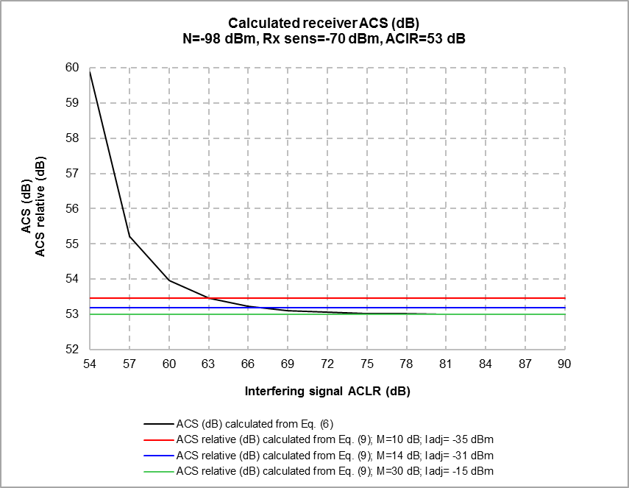

Figure 7: Calculation of ACS from Equations and

Figure 7 shows the comparison of ACS calculated from Equation with ACS relative calculated from Equation or equivalently from Equation . Note that there is a simplification in Equation compared with Equation . Equation does not take into account the ACLR of the interfering signal and thus it underestimates ACS for low and medium ACLR values. Consequently, it would be more appropriate to calculate ACS from Equation when the interfering signal ACLR is relatively large compared to the victim receiver ACS. For high ACLR and M values Equation is equivalent to Equation as shown in Figure 7.

Please also note that “Receiver sensitivity” is not in the equations related to Figure 7; it is a reference for quantifying the typical C/I expected. In addition note that, from Equation , with the assumed values of N and ACIR in Figure 7, the value of M-Iadj = 45 dB remains constant for each ACSrelative calculation.

Finally, it is important to note that:

* Some ETSI Standards provide direct ${(I/C)}_{co-ch} and {(I/C)}_{adj-ch}$ tests; if needed ACS can be derived from the above equations. From those I/C tests it is also possible to calculate ACS;
* In a number of ETSI Standards, the term ACS is used in different ways and the required tests could mislead the reader towards ACS values different from the above concept; therefore, ACS values in the standards should be carefully considered in order to use them correctly in sharing and compatibility studies.

To explore this subject further, ANNEX 5: shows similar mathematical considerations using graphical examples and analyses of ACS values in a number of ETSI Standards to give a correct understanding.

### Blocking and overloading

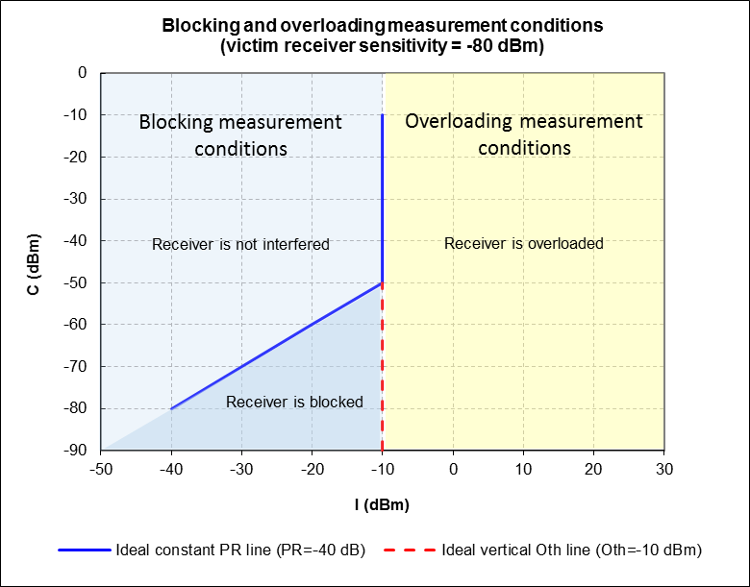

Figure 8: Receiver blocking and overloading measurement ranges

Blocking and overloading of a receiver are two different phenomena and should not be confused. Figure 8 shows the C(I) curve of an ideal receiver with a protection ratio (PR) of -40 dB and an overloading threshold (Oth) of -10 dBm.

In this example, it can be seen that:

* if the interfering signal level is lower than -10 dBm, the receiver operates in its linear range and consequently, it is interfered (desensitised) with by the interfering signal if and only if the C/I ratio is lower than its PR;
* while, if the interfering signal level is higher than -10 dBm, the receiver front-end is fully overloaded and consequently, it is unable to receive anything at all, independent of the wanted signal level.

The blocking response of the receiver cannot be measured under “Overloading” measurement conditions. Consequently, it should not be measured at wanted signal levels more than 30 dB above the receiver sensitivity, depending on the receiver.

Conversely, the overloading threshold of a receiver cannot be measured under “Blocking” measurement conditions. Consequently, the overloading threshold of the receivers should be measured at a wanted signal levels more than 30 dB above the receiver sensitivity, depending on the receiver.

For most existing mobile and broadcasting systems, the blocking response of the receivers is measured at a wanted signal level equal to the receiver sensitivity +3 dB to +16 dB depending on the system configuration. At such wanted signal levels, most of the receivers operates in their linear range and are interfered (desensitised) with by the interfering signal only and only if the C/I ratio is lower than their PR.

Overloading threshold measurements have recently been introduced in the European Harmonised Standard ETSI EN 303 340. In this Harmonised Standard, the overloading threshold is measured at a wanted signal level above the receiver sensitivity +42 dB.

Blocking and overloading phenomena are described in detail in the following sections.

#### Blocking (receiver blocking response)

Blocking refers to the reduction of the receiver sensitivity, thus the degradation of its performance, in the presence of an interfering signal; the frequency offset of the interfering signal within a certain offset frequency range; should generally cover a relatively large range of frequencies around the wanted signal. The reduction of the sensitivity of the receiver is called “desensitisation”.

The blocking response is measured at a given wanted signal level with a modulated or unmodulated interfering signal at a frequency offset with respect to the wanted signal. For example, if the receivers blocking level for a 3 dB receiver desensitisation needs to be measured, it would then be necessary to set the wanted signal level at a level equal to the receiver sensitivity +3 dB. The interfering signal level is set at a suitably lower level (e.g. 10 dB lower than the wanted signal level). Then, the interfering signal level is increased by steps of 1 dB up to the level that again causes the receiver performances to degrade up to its sensitivity reference performance. Finally, for the sake of testing accuracy, the interfering signal level is decreased by 1 dB and its level is noted. This level expressed in dBm is the receiver blocking response.

Note that the protection ratio (PR) of a receiver can easily be calculated from its measured blocking levels as follows:



The degradation of the performance of a receiver due to an interfering signal above its blocking response is not necessarily due to the nonlinearity of the receiver LNA.

The gain compression effect of the interfering signal can be expressed as follows:

* $y={a_{1}A}_{c}\cos{ω_{c}t}+a_{3}\frac{3}{2}A_{I}^{2}A_{c}\cos{ω_{c}t}$ (see Section 4.2.7.3)
* $=\left(1+a_{3}\frac{3}{2}A_{I}^{2}\right)A_{c}\cos{ω_{c}t}$, with a1=1

$=\left(1+KA_{I}^{2}\right)A_{c}\cos{ω_{c}t}$

$=C_{f}A_{c}\cos{ω_{c}t}$

Where

* $A_{c}\cos{ω_{c}t}$: useful signal
* $A_{I}\cos{ω_{c}t}$: interfering signal
* $C_{f}$: LNA gain compression factor

Cf is due to the third-order non-linearity of the receiver LNA and can be expressed as

For the sake of simplicity, the “gain compression” effect of the receiver LNA can be considered in isolation. The effective carrier to interference plus noise ratio C/(I+N) (or signal to interference plus noise ratio SINR) at the LNA output can be expressed as:



Where:

* *C*: carrier power (W);
* *Cf*: LNA gain compression factor (0<Cf<1);
* *I*: interfering signal power (W);
* FOS: receiver selectivity at a given frequency offset (>1);
* *N*: noise power (W);
* *CLNA*: carrier power at the output of the LNA;
* *ILNA*: interfering signal power at the output of the LNA.

Cf is due to the third-order non-linearity of the receiver LNA and can be expressed as



with:





Now, suppose that N is negligible due to the high wanted signal level used in the measurement. Then, the protection ratio of the receiver can be expressed as:



Then



The above equation implies that unless the level of the interfering signal is high enough to strain the receiver LNA to operate in its nonlinear region, the desensitisation is due to the interfering signal level converted by the receiver IF/baseband filter into an equivalent co-channel interfering signal power. Consequently, when the blocking response of a receiver is being measured, if the interfering signal level is not too high to overload the receiver, the protection ratio (PR) of the receiver which is operating in its linear range (normal operation conditions) is simply measured.

Finally, C can be written as a function of I as follows:



Note that in the case of an ideal linear radio receiver (*Cf* =1) C(I) can be expressed as follows:



Figure 9 shows the measured and theoretical C(I) curves of a radio receiver with PR=-35 dB and FOS=53 dB calculated by using Equation . The value of *K* is not known and thus has been adjusted to fit the theoretical C(I) curve to the measured one.

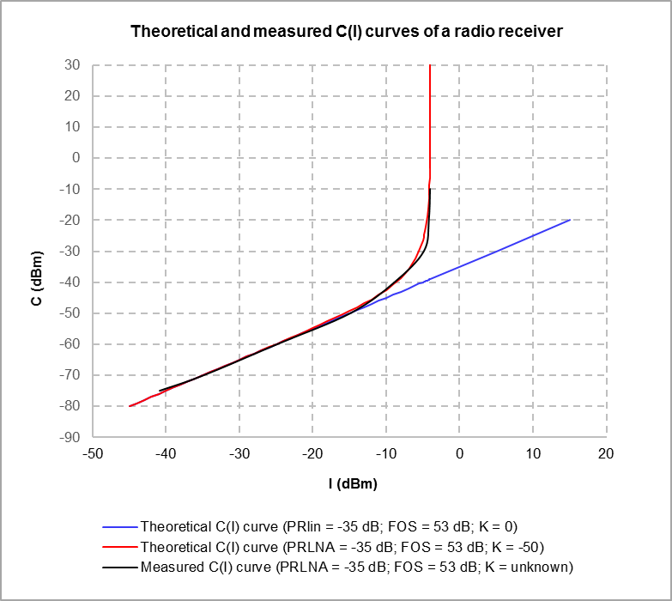

Figure 9: Theoretical and measured C(I) curves of a receiver

The Figure 9 above shows that if the interfering signal level is higher than -10 dBm, the overloading threshold of the receiver which is operating in its nonlinear range is simply measured.

“Blocking” of a receiver cannot be measured under “Overloading” measurement conditions. Consequently, the blocking response of the receivers should not to be measured at a wanted signal levels above the receiver sensitivity +30 dB depending on the receiver.

#### Overloading

Overloading occurs when the receiver front-end is fully overloaded by a strong off channel interfering signal[6]. This results in the degradation of the PR of the receiver due to the “gain compression” and “noise increase” caused respectively by the third-order and second-order nonlinearities of the receiver LNA. The receiver selectivity also affects the overloading threshold level. In such case the interfering signal level expressed in dBm is called the «Overloading threshold» of the receiver.

When the receiver front-end is fully overloaded the receiver may become “blind” and thus unable to receive anything at all. Additionally, beyond the overloading threshold the receiver is interfered with by the interfering signal independent of the wanted signal level, as explained in Figure 8.

The C(I) as well as PR(C) curves of a receiver can be used to analyse its performance for different wanted and interfering signal levels. They clearly show the degradation of the PR of the receiver due to the overloading of its front-end.

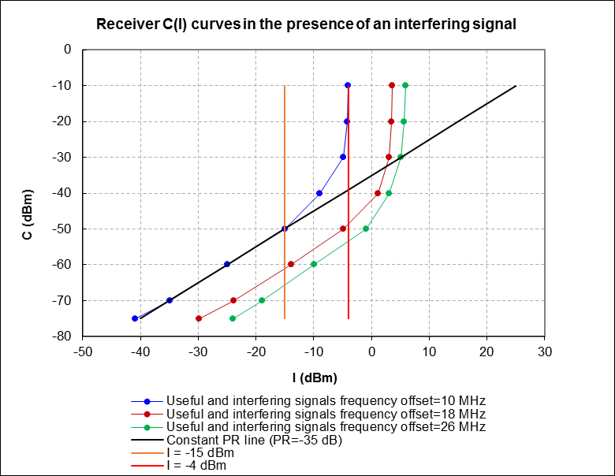

Figure 10: C(I) curves of a radio receiver

Figure 10 shows the C(I) curves of a radio receiver for three different wanted and interfering signal frequency offsets. The unity slope black line represents the C(I) curve of an ideal perfectly linear receiver (not generating any second, third, or higher order nonlinearities to distort the wanted signal). Such an amplifier does not exist in practice.

Here, comparing the blue line with the black unity slope line shows that, for an offset of 10 MHz, the receiver operates in its linear range up to an interfering signal level of -15 dBm (vertical orange line) for a wanted signal level of -50 dBm (PR=-35 dB). The linear behaviour of the receiver is perfectly explained by Equation (Cf = 0 dB). Note that the wanted signal level of -50 dBm corresponds to the receiver sensitivity + 30 dB (-50 dBm=-80 dBm + 30 dB). Clearly, under these conditions, the receiver is interfered with (desensitised) by the interfering signal only and only if the C/I ratio is lower than its PR.

Beyond the interfering signal level of -15 dBm the receiver front-end starts to get slightly overloaded. This results in the degradation of the PR of the receiver. When the interfering signal level reaches -4 dBm (vertical red line) the receiver is fully overloaded. This level is called the "Overloading threshold" of the receiver. The PR of the receiver tends to infinity.

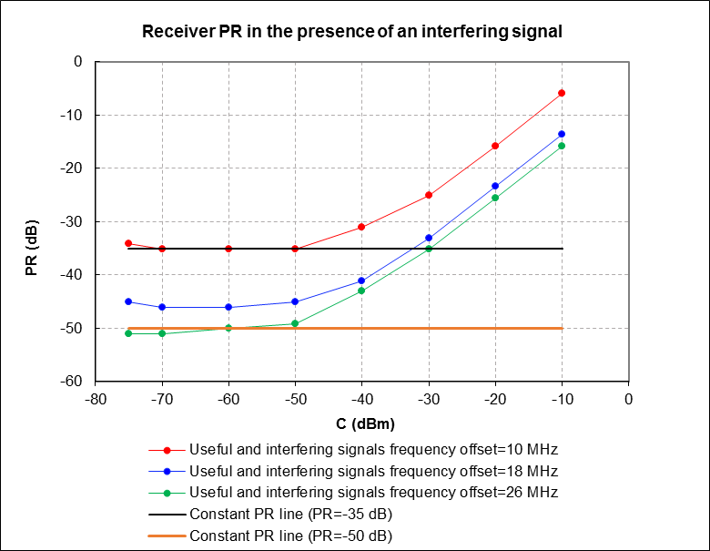

Figure 11: Degradation of the PR of the receiver due to the overloading of its front-end

The PR(C) curves presented in Figure 11 also clearly show the degradation of the PR of the receiver due to the overloading of its front-end. However, the determination of the overloading threshold from these curves is not explicit. The “overloading threshold” of a receiver cannot be measured under “blocking” measurement conditions, because the full receiver front-end overloading occurs in the presence of relatively high interfering signal levels. Consequently, the overloading threshold of the receiver should be measured at a wanted signal level equal to the receiver sensitivity + 30 dB to + 60 dB, depending on the system configuration.

#### Intermodulation rejection

The Intermodulation phenomenon arises from non-linearity of the amplifier in the receiving chain. The theoretical output signal of the amplifier can be described in a simplified form by a power series expansion:



Where:

* x is the input signal,
* $a_{0}$ is the DC offset of the amplifier,
* $a_{1}x$ is the wanted output, while $a_{2}x^{2}$ and $a_{3}x^{3}$ are second and third order nonlinear terms of the polynomial.

These terms generate harmonic and intermodulation products. Intermodulation products are due to the mixing of two or more interfering signals present at the input of the receiver amplifier. Intermodulation products are often called intermodulation distortions (IMD). Analysis of the output signal for more than two input signals can become very complex, consequently it is a common practice to limit the analysis to only two input signals.

When considering, for the sake of simplicity, only two signals at the amplifier input:



the third order nonlinear term becomes:



By using the trigonometric identities  and :



The above equation shows amplitude offset at the fundamental frequencies $f_{1}$ and $f_{2}$, third-order harmonics and third-order IMD. The terms of interests are:



These two terms are also produced by the amplifier according to Equation when there are three signals at the amplifier input:



Where:

* $f_{0}$ is the wanted signal centre frequency and
* $f_{1}$ and $f_{2}$ are two interfering signals centre frequencies.

$f_{0}$, $f_{1}$ and $f_{2}$ being 880 MHz, 890 MHz and 900 MHz respectively, Figure 12 shows the third-order IMD generated by the receiver amplifier and their impact on the wanted signal.

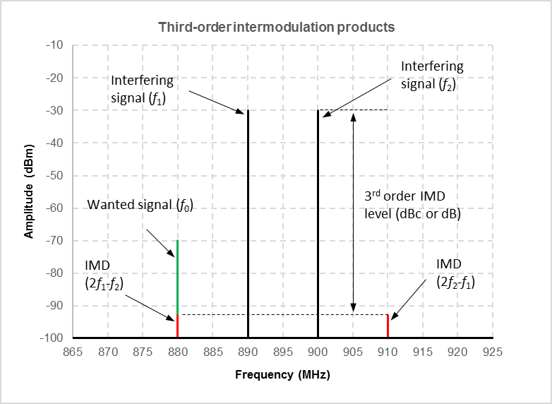

Figure 12: Generation of intermodulation products

In this example, as shown in Figure 12, the third-order IMD frequency $2f_{1}-f_{2}$ is equal to the useful signal frequency $f_{0}$ and consequently it is a co-channel interference that may affect the receiver performance. Second-order products (and higher order even number products) can be ignored. Higher order odd number products may also have an impact on the receiver, but not as significant as third-order products.

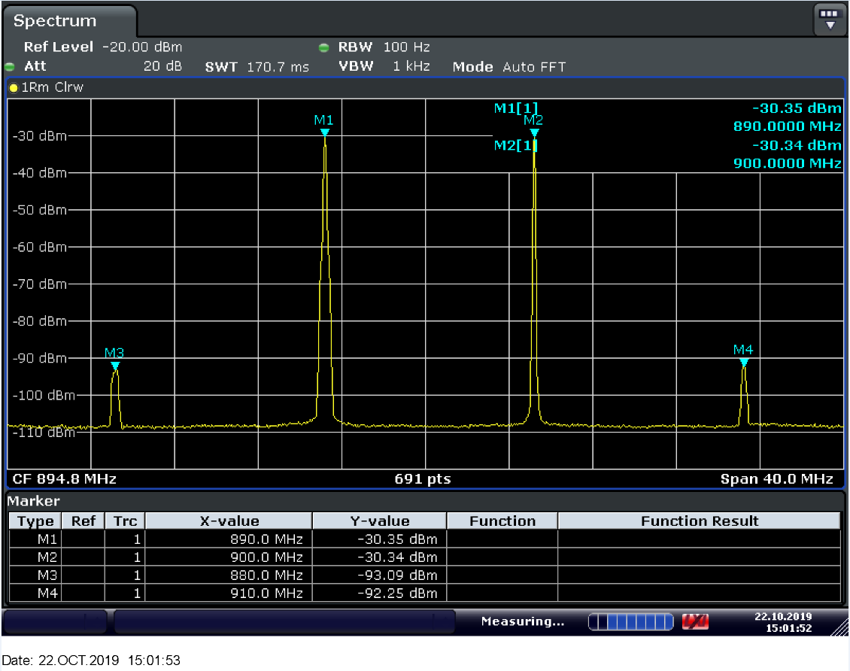

Figure 13: Measured third-order intermodulation products (spectrum analyser plot)

Figure 13 shows the third-order IMD generated by an LNA. The input signals are two modulated carriers (BW≈200 kHz) centred at 890 and 900 MHz respectively in line with the above example.

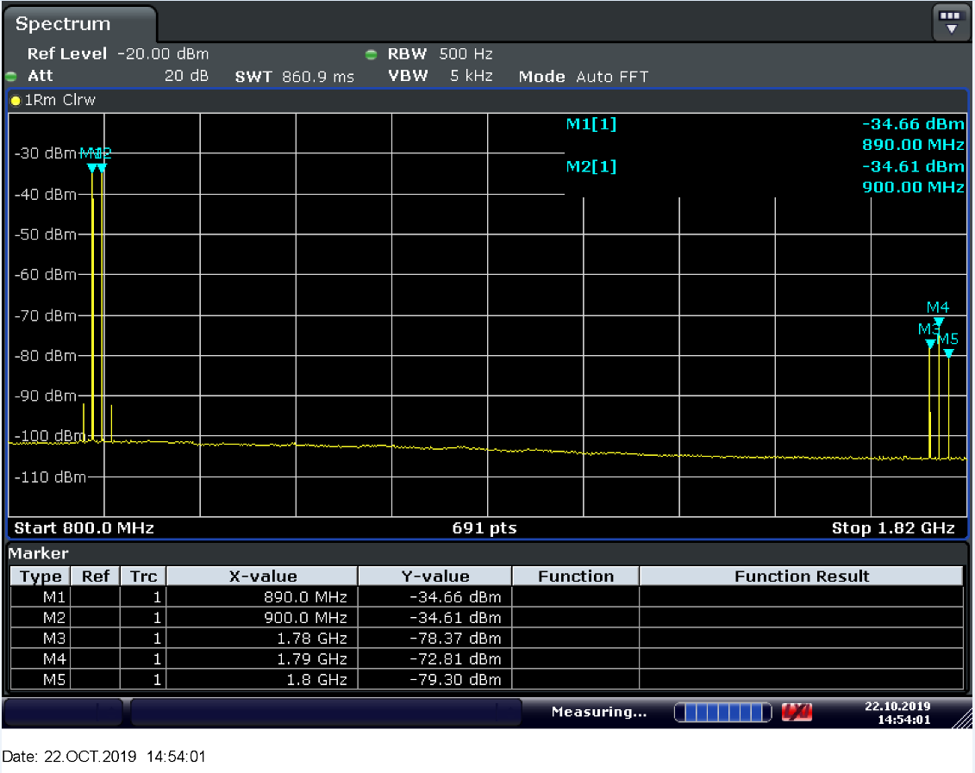

Figure 14: Measured third-order intermodulation products (spectrum analyser plot)

Figure 14shows the second harmonics, the second-order and third-order IMD of the modulated carriers (890 and 900 MHz), these harmonics and IMD are generated by the LNA (see Table 1).

Table 1: Measured harmonics and intermodulation products

|  |  |  |  |
| --- | --- | --- | --- |
| Component | Formula | Frequency (MHz) | Reference from Figure 14 |
| Carrier 1 | f1 | 890 | M1 |
| Carrier 2 | f2 | 900 | M2 |
| 2nd harmonic | 2f1 | 1780 | M3 |
| 2nd harmonic | 2f2 | 1800 | M5 |
| 2nd order IMD | f1+f2 | 1790 | M4 |
| 2nd order IMD | f2-f1 | 10 | - |
| 3rd order IMD* | 2f1-f2 | 880 | - |
| 3rd order IMD | 2f2-f1 | 910 | - |
| * Not shown in Figure 14 | | | |

The intermodulation response rejection is often measured with a wanted signal at the assigned channel frequency and two interfering signals with identical levels, which have a specific frequency relationship to the wanted signal, coupled to the receiver antenna input. It is expressed as the maximum interfering signal mean power (dBm) above which the receiver cannot meet the required intermodulation performance. Interfering signals may be two CW signals, a CW signal and a modulated signal or two modulated signals.

### Spurious response rejection

Spurious response rejection is the capability of the receiver to receive a wanted modulated signal without exceeding a given degradation due to the presence of an unwanted modulated signal at any other frequency, at which a response is obtained. Spurious responses are caused by harmonics and/or mixing products of internal oscillators, which can lead to a sensitivity reduction on certain frequencies.

It should be noted that, those frequencies, if any, are generally identified as those unable to respect a more severe blocking requirement (see 4.2.7.1).

# Role of receiver parameters in sharing and compatibility studies

## General considerations on receiver parameters

For sharing and compatibility between systems and services[7] one of the most important receiver parameter is the receiver selectivity. Generally, improving the receiver selectivity may improve the overall performance of the receiver from a coexistence point of view and makes it resilient to adjacent channel/band interference. Note that in most of the standards and specifications the receiver selectivity is implicitly defined by defining the ACS and blocking response of the receiver.

Another important parameter is the receiver linearity. Non-linearity in a receiver internal circuits give rise to performance limitations (e.g. it may affect the receiver overloading and intermodulation performance).

Receiver sensitivity may also have an impact on sharing and compatibility. But it would be very difficult to quantify this impact and to decide on the level of receiver sensitivity to improve sharing and compatibility.

Using the example of sensitivity, where a receiver is more sensitive than that expected in the environment in which it is designed to operate - and as documented in the relevant ETSI Standard, this is likely to make the real receivers in the field more vulnerable to interference than necessary and assumed in sharing and compatibility studies based on the ETSI Standard limit. On the same or overlapping frequencies the receiver will be particularly sensitive to very low levels of interference. For adjacent frequency ranges such higher sensitivity levels, not matched by suitable selectivity, influence blocking and adjacent performance levels of the receiver making it vulnerable to interference from signals in adjacent bands. This can be particularly problematic in a shared spectrum environment.

The co-channel PR defines the degree of resilience of the receiver to the co-channel interference as well as to unwanted emissions falling into the receiver channel from the adjacent channel interfering signal. It is mostly used as reference for frequency reuse of the same channel/band by different services. However, the co-channel PR is not heavily dependent on the receiver design. It is a system parameter which depends mainly on the modulation schemes and error correction codes used. This PR can be used to calculate the adjacent channel selectivity of the receiver.

In conclusion, high receiver selectivity combined with good linearity and low co-channel PR should improve sharing and compatibility. Nevertheless, care should be taken when defining the requirements for receiver parameters because most of them are interdependent. Each receiver parameter may have a different impact on the overall receiver performance. Actually, each receiver parameter value is a trade-off with other parameters value and ideally these should be in balance to achieve a good overall receiver performance. One of the conclusions of ECC Report 127 [12] stated that “Significant enhancement of receiver performance in one respect (for example sensitivity) can come at the expense of underperformance in another.

From a sharing and compatibility point of view, the focus is usually on introducing new services and systems, and protection of incumbents as appropriate. The main objective of the sharing and compatibility studies is to assess whether incumbent services would be affected by interference from the new service. In order to do this assessment, the characteristics of the incumbent service must be accurately simulated in the studies. Overly pessimistic assumptions on the incumbent receiver performance may lead to a negative result in a case where coexistence would be possible. On the other hand, if the assumptions are too optimistic, the risk of interference will be underestimated.

## Critical receiver parameters for sharing and compatibility studies

While all receiver parameters may be needed to fully characterise a given receiver, certain parameters are more important than others when considering compatibility, sharing and efficient use of spectrum. Previously ECC has predominately focused on particular receiver parameters in its sharing and compatibility studies. ANNEX 1: analyses several CEPT/ECC Reports and found that receiver blocking, selectivity, intermodulation and overload performance were the most important parameters in those studies. It is likely that these will remain key parameters for most future sharing and compatibility studies.

Different receiver parameters may have different importance depending on the study being conducted. The parameters generally considered necessary for most sharing and compatibility studies are:

* Co-channel protection ratio – important for in-band sharing studies and relates to the signal to noise and interference ratio. It also permits to calculate the frequency offset selectivity of the receiver from its blocking response;
* Adjacent channel selectivity/frequency offset selectivity– particularly important where the adjacent channel/band edge is being considered. Information on this parameter may not be readily available for non-channelised systems;
* Receiver blocking - particularly important when there is a frequency separation greater than two adjacent channels.

It should be noted that additional parameters not listed above may need to be known or derived for specific studies. For example:

* Receiver sensitivity is not considered to be a critical standalone parameter for sharing and compatibility studies, because it can be calculated from the NF and SNR of the receiver: Rxsens = NF + SNR. However, a reference sensitivity needs to be known for a correct understanding of the specified levels for other parameters such as blocking and overloading;
* Overloading threshold was identified as being important for some specific cases where receivers have a wide band front-end RF stage and operate in the presence of strong interfering signals (e.g. DTT), but it was not identified as being critical for most sharing studies.

Table 2: Summary of relationship between receiver parameters used in sharing and compatibility studies, parameters from technical documentation and protection criteria

|  |  |  |
| --- | --- | --- |
| Parameter to specify in the study | Parameter needed from the technical documentation | Related protection criteria (for a predefined, acceptable desensitisation) |
| Receiver noise floor (N) | Noise figure (NF) | I/N, (N+I)/N, (C+I)/N |
| Signal to interference plus noise ratio (SINR) | Receiver noise floor (N), Signal to noise ratio (C/N or SNR) or Co-channel rejection ratio | C/Ico-ch or C/(N+ Ico-ch) |
| Sensitivity | Receiver noise floor (N) and C/N | (C+I)/N, (N+I)/N |
| Frequency offset selectivity (FOS) | Frequency offset rejection, including adjacent channel rejection; spurious response rejection | C/Iadj-ch, C/IFO and blocking response |
| ACS | Adjacent channel rejection | C/Iadj-ch |
| Blocking | Frequency offset rejection | C/IFO and blocking response |
| Overloading | Frequency offset rejection | Overloading threshold |
| Intermodulation (IM) | Linearity | IM rejection |

# Sources of information on the receiver performance of equipment

When ECC working groups and project teams are conducting sharing and compatibility studies, they will need to decide what receiver parameters are important for the study and they will need to source suitable information on the equipment. Information can come from several sources. Receiver parameters should be based first on limits defined in ECC deliverables and ETSI Harmonised Standards, if available. Harmonised Standards set out minimum requirements, i.e. conformance limits[8], that receivers have to meet and cover a wide range of equipment. CEPT and ECC working groups may complement the information as appropriate by additional relevant sources of information. These information sources include:

* ECC deliverables
* ITU-R Recommendations
* Other relevant CEPT information or previous studies;
* ETSI Technical reports/specifications;
* Other technical specifications and standards;
* Information sourced from vendors;
* Information already held by regulators;
* Results of relevant measurements carried out on equipment samples.

Measurements of some receivers have been undertaken for this ECC Report and are presented in Chapter 8. This information could also be used by ECC groups, where relevant, when undertaking sharing and compatibility studies. The concept of receiver parameter measurement can be found in ANNEX 2:.

## The RED, receiver parameters and limits used in ETSI Harmonised Standards

The European Radio Equipment Directive (RED), 2014/53/EU [1], was published in the Official Journal of the European Union (OJEU[9]) on 22 May 2014, and repealed the Radio and Telecommunications Terminal Equipment Directive (R&TTE) 1999/5/EC [2]. The RED is fully applicable to all radio products being placed on the European Market from 13 June 2017. Changes include a wider scope than the R&TTE Directive, and the RED explicitly includes receivers. The ‘essential requirements’ of the RED relating to spectrum use have also been clarified to promote more efficient use of the radio spectrum, particularly by receivers. Recitals 10 and 11 from the RED state:

* *“In order to ensure that radio equipment uses the radio spectrum effectively and supports the efficient use of radio spectrum, radio equipment should be constructed so that: in the case of a transmitter, when the transmitter is properly installed, maintained and used for its intended purpose it generates radio waves emissions that do not create harmful interference, while unwanted radio waves emissions generated by the transmitter (e.g. in adjacent channels) with a potential negative impact on the goals of radio spectrum policy should be limited to such a level that, according to the state of the art, harmful interference is avoided; and, in the case of a receiver, it has a level of performance that allows it to operate as intended and protects it against the risk of harmful interference, in particular from shared or adjacent channels, and, in so doing, supports improvements in the efficient use of shared or adjacent channels.”;*
* *”Although receivers do not themselves cause harmful interference, reception capabilities are an increasingly important factor in ensuring the efficient use of radio spectrum by way of an increased resilience of receivers against harmful interference and unwanted signals on the basis of the relevant essential requirements of Union harmonisation legislation”.*

Harmonised Standards written by ETSI which are cited in the OJEU are one way[10] to conform with the essential requirements of the RED (presumption of conformity). Essential requirements are high level objectives described in European Directives. The purpose of the Harmonised Standards is to translate those high-level objectives into detailed technical specifications.

The receiver parameters and performance limits included in RED Harmonised Standards should reflect the state of the art for the equipment that it applies to. The receiver should have a sufficient level of performance that allows it to operate as intended and protects it against the risk of harmful interference, in particular from shared or adjacent channels, and, in so doing, supports improvements in the efficient use of shared or adjacent channels. For sharing and compatibility studies Harmonised Standards provide a minimum requirement for receiver performance. The general assumption is that all equipment will meet the limits in the relevant Harmonised Standard and therefore it sets the minimum performance.

The RED is a tool for administrations to ensure that the receivers have an adequate level of performance. In addition, under the Memorandum of Understanding (MoU[11]) between CEPT ECC and ETSI, the ECC may advise the European Commission and ETSI on the requirements for the effective use of the radio frequency spectrum. It is also noted that the ETSI Rules of Procedure [55] states that “ETSI shall take into consideration all the applicable CEPT spectrum sharing conditions”. The procedure for co-operation between ETSI and ECC as defined in the Annex of the MoU should be followed. In practice this may mean that the outcomes of CEPT work may result in improvements to the requirements for receiver performance in Harmonised Standards when consensus is achieved between ECC and ETSI.

### ETSI Guide EG 203 336[12] V1.1.1 (2015-08)

This guide (ETSI EG 203 336 [16]) provides advice to Technical Bodies/Committees within ETSI. It outlines a number of receiver parameters to characterise the receiver and that should be considered for inclusion in Harmonised Standards. The parameters are presented in the table below.

Table 3: Receiver parameters from ETSI Guide ETSI EG 203 336 V1.1.1

|  |
| --- |
| Receiver parameter |
| Sensitivity |
| Co-channel rejection |
| Selectivity  (Adjacent channel) |
| Blocking |
| Spurious response rejection |
| Intermodulation |
| Dynamic Range |
| Reciprocal mixing |
| Desensitisation |

The parameters in the guide are intended to be an exhaustive list (as much as possible) of realistic situations which radio systems might be subject to. However, it should be noted that a number of them might be an alternative to each other or redundant (e.g. Spurious response rejection is often covered by blocking when there is no need of either relaxing or improving the blocking figure at specific frequencies).

### Receiver parameters included in RED Harmonised Standards

A survey of the receiver parameters found in the 152 Harmonised Standards (some of which are transmit only) cited in the OJEU [21] in September 2018 compared with EG 203 336 [16] was conducted in this report, the summary of this survey is found in Table 4. It was observed that receiver blocking, and selectivity are the most common parameters contained in Harmonised Standards. It should be noted that in some cases, some parameters might have been excluded because they are encompassed by other parameters.

Table 4: Survey of receiver parameters from ETSI Guide ETSI EG 203 336 [16] in Harmonised Standards

|  |  |  |  |  |  |  |  |  |  |  |
| --- | --- | --- | --- | --- | --- | --- | --- | --- | --- | --- |
|  | Sensitivity | Co-Channel Rejection | Selectivity | Blocking | Spurious response | Intermodulation | Dynamic Range | Reciprocal mixing | Desensitisation | Overloading[13] |
| Number of Harmonised Standards containing the parameter | 55 | 29 | 91 | 99 | 41 | 39 | 3 | 0 | 14 | 1 |

The requirements for receiver found in ETSI Harmonised cited in the OJEU [21] are useful to ECC groups conducting compatibility studies as they set a minimum expectation on receiver performance. As seen in the previous section, blocking is one of the most common receiver parameters defined in Harmonised Standards. Table 31 (Annex 4) gives an overview of the blocking limits found in some ETSI Harmonised Standards.

## Additional ETSI definitions of radio parameters

There are also some older additional definitions on receiver parameters in ETSI TR 103 265 [36] which presents all definitions found in most ETSI Standards and information on how all these definitions were gathered. Other relevant ETSI documents are:

* ETSI TR 102 914 V1.1.1 (2009-01): Technical report on aspects and implications of the inclusion of receiver parameters within ETSI standards, Annex A: Definitions of receiver parameters found in ETSI Harmonised Standards under article 3.2 of the R&TTE Directive [38];
* ETSI TR 102 137 V1.3.1 (2019-11): Use of radio frequency spectrum by equipment meeting ETSI standards. An excel table is provided with search function for searching standards for equipment operating in a specified frequency band; [39]
* ETSI EG 202 150 V1.1.1 (2003-02): ETSI Guide on "Common Text" for Application Forms/Short Equipment Description Forms, AP-1_v104: Common text for EQUIPMENT DESCRIPTION FORM FOR TESTING and ETSI TR 100 0TT-1 V1.0.4 (2002-12) Test Report Form for "in-house testing" to <EN [40].

Recently ,ETSI produced the following technical specification relevant to receiver parameters and interference handling. This has not been analysed or reviewed by CEPT/ECC:

* TS 103 567 V1.1.1 (2019-09): “Requirements on signal interferer handling” [41];

# Additional consideration of receivers in sharing and compatibility studies

## Methodology for dealing with coexistence of systems of unlike bandwidth and different technologies

### Different bandwidths for interferer and victim

The following sections present a general method for dealing with different bandwidths for the interferer and victim. It may be more accurate to use a realistic receiver mask based on more detailed information (e.g. measurements) or make assumptions of the characteristics of the filters in the receiver.

#### Co-channel interferer and victim receiver bandwidth

In the case of co-channel interference, if the bandwidths of the victim receiver and the interfering transmitter are fully overlapping and when the interfering transmitter bandwidth is equal to or less than the victim receiver bandwidth as shown in Figure 15 (when the bandwidths are equal) and Figure 16 (when the bandwidths are not equal). Those figures assume a rectangular shape for both the interfering transmitter and the victim receiver masks, therefore, when the bandwidths are equal:



Where:

* *I*: Interfering signal power measured in its bandwidth at the input of the receiver, before any filtering (e.g. at antenna port);
* *Ir*: Interfering signal power received by the victim receiver.

It should be noted that, in general, when the real response is not rectangular, the result is not perfect and Ir is slightly lower than I.



Figure 15: Transmitter and receiver masks where bandwidths are equal



Figure 16 Transmitter and receiver masks where the receiver bandwidth is wider

If the victim receiver bandwidth is fully covered by the interfering transmitter bandwidth that is greater than the victim receiver bandwidth as shown in Figure 17, then the interfering signal power received by the victim receiver is:



Where:

* *BWr*: Victim receiver bandwidth;
* *BWt*: Interfering signal bandwidth.

Compared to the equal bandwidths case the assumed rectangular mask may give a discrepancy compared to the actual interference level.

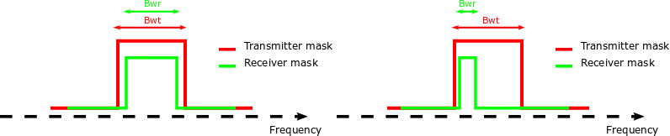

Figure 17 Transmitter and receiver masks where the transmitter bandwidth is wider

If the bandwidths of the victim receiver and the interfering transmitter are partially overlapping as shown in Figure 18, then the interfering signal power received by the victim receiver is:



Where:

* ${BW}_{r}∩{BW}_{t}$: Intersection of the victim receiver and the interfering transmitter bandwidths (i.e. in general it is the integral of the interfering power density after the relevant receiver selectivity transfer function and is often coincident with the FOS concept (or the NFD concept detailed in Annex A5.7).

In general, this formula is valid also for any frequency offset between the interfering transmitter and the victim receiver..



Figure 18: Transmitter and receiver masks where the bandwidths are partially overlapping

#### Adjacent and offset interferer and victim receiver bandwidth

Note that, as elsewhere mentioned in this Report, it is impractical for ETSI Standards to provide a direct receiver selectivity mask; however, when other receiver parameters such as ACIR, ACS, ACLR, blocking can be found (or easily calculated with the formulas provided in section 4.2.6.1), the methodology given in ANNEX 6: may provide a suitable approximation for the receiver selectivity.

When transmitter and receiver bandwidths are equal and on the same channel raster

In the case of adjacent channel interference, the adjacent channel leakage ratio (ACLR) and the adjacent channel selectivity (ACS) values provide the relevant information to calculate the power of the interfering signal received by the victim receiver. ACLR allows to estimate the interfering signal unwanted emissions power falling into the receiver bandwidth. ACS allows to estimate the interfering signal power received after being attenuated by the receiver filters as shown in Figure 19.

The interfering signal power received by the victim receiver is:

 (in the linear domain)

For the first adjacent channels:



For the second adjacent channels:



For channels at a frequency separation higher than the second adjacent channel where the value of ACS is considered to be fairly high:





Figure 19: Transmitter and receiver masks where bandwidths are equal and on the same channel raster

When transmitter and receiver bandwidths are different or not on the same channel raster

In this case, the interfering signal leakage ratio (ILR) and frequency offset selectivity (FOS) values provide the relevant information to calculate the power of the interfering signal received by the victim receiver. ILR allows estimation of the interfering signal unwanted emissions power falling into the receiver bandwidth. FOS allows estimation of the interfering signal power received after being attenuated by the receiver filters as shown in Figure 20.

The interfering signal power received by the victim receiver is:

 (in the linear domain)



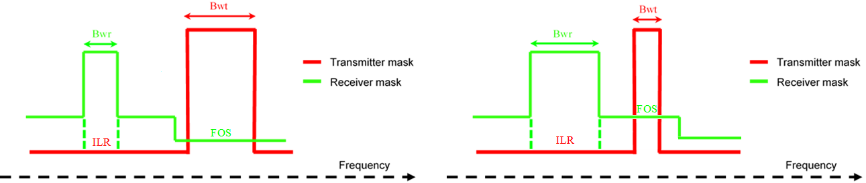

Figure 20: Transmitter and receiver masks where bandwidths are different or not on the same channel raster

It is noted that there may be other cases than those shown in Figure 18 where FOS may be difficult to derive.

### Different technologies

Heterogeneous technologies operating in the same or neighbouring bands can present challenges for studies. Such situations could be studied case by case depending of the specific performance of the system requiring appropriate characterisation of the device under consideration meaning that tests may be required. In any case, the methodology described for the different bandwidths can be used for determining the amount of interference power received (Ir) from the total interference power (I) at the input of the receiver (see section ).7.1.1). It should also be noted that receiver performance is defined for specific interfering signals at specific frequency offsets. If the actual interfering signal has different characteristics from those interfering signals (e.g. different peak to average ratio) or a different frequency offset from the victim receiver channel, then the selectivity values derived from standards may not directly apply.

As the systems approach one another (in the frequency domain) the detail of the leakage of the transmitter (ACLR) and receiver filter response (ACS) overlap one another and the compatibility of the two systems can become less predictable. If such a situation arises in an investigation, then it is incumbent on investigators to carefully characterise both the interfering and victim systems in a laboratory in order for this to be studied and modelled / simulated (e.g. suitable profiles to be entered in SEAMCAT).

Where SEAMCAT is used, once this receiver and transmitter characterisation work is completed and the data entered into SEAMCAT – which treats the interfering signals as a concatenation of narrow band signals – it would be instructive to bring the two systems together (in the frequency domain), calculate their predicted protection ratio by looking for the step in the SEAMCAT translation function as a function of blocking response level, and compare that to the actual results achieved in the laboratory.

### Enhanced Sharing mechanisms

SRD regulations provide spectrum for testing some new technologies and, by their very nature, demonstrate ways in which spectrum can be shared between different technologies and applications thereby achieving improved spectrum efficiency. Aspects of receiver design particular to SRD regulations are shown in Annex 8.

## Modelling of receiver parameters in SEAMCAT

### SEAMCAT background

SEAMCAT (Spectrum Engineering Advanced Monte Carlo Analysis Tool)[14] is a statistical simulation software tool developed by CEPT for sharing and compatibility studies. Full details are provided in the SEAMCAT User Manual (ECC Report 252 [37]) and the online documentation[15].

SEAMCAT calculates interference differently for 2 types of systems:

1. “Generic” systems, where probability of interference to any radio system can be modelled based on specified interference criteria (C/(N+I), C/I, (N+I)/N or I/N). The following receiver parameters are modelled: blocking, overloading and intermodulation. The effects of these can be modelled separately, in combination with each other or in combination with interference due to transmitter unwanted emissions
2. “Cellular” systems, including link-level modelling of CDMA, OFDMA and IMT-2020 networks, where interference is calculated as degradation in the bit-rate of the network based on user-specified link-level mapping of SINR to throughput. In this case “Blocking/ACS” is the main receiver parameter modelled. The effects of blocking and unwanted emissions are combined to calculate the impact of interference.

The following sections describe how the main receiver parameters are modelled for both types of systems.

Note the use of the following terms:

* ILT: Interfering link transmitter
* VLR: Victim link receiver

The examples and equations in the following sections are simplified to focus on a single interfering link between two systems at different frequencies. The full calculation algorithms are provided in ECC Report 252.

### Receivers in generic SEAMCAT systems

#### Blocking

The level of interference determined by the interferer’s transmit power, the antenna gains and propagation loss, is further decreased due to the receiver blocking performance for a given interferer/victim frequency separation.

In SEAMCAT generic systems the term “blocking” is used to refer to this effect at any frequency offset, and therefore does not distinguish between blocking and ACS. It should be noted that this differs from the definitions outlined in section 2.1 of this Report. Additionally, in SEAMCAT the blocking calculation excludes the victim receiver’s own bandwidth – in this region only unwanted emissions are considered, whereas in measurements it is not possible to separate the two effects. This is illustrated in the following figure.

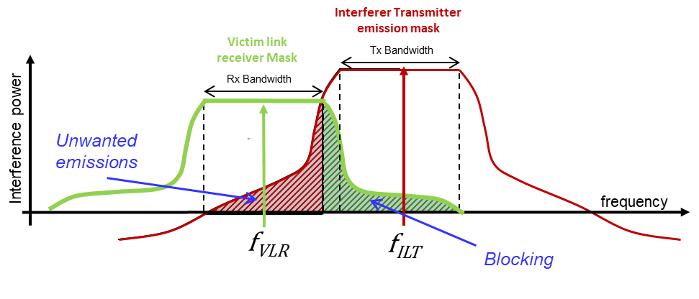

**Figure 21: Illustration of the blocking of the victim link receiver (i.e. total emission power of ILT reduced by the blocking attenuation (selectivity) function of the VLR**

Interference due to blocking is calculated in SEAMCAT according to:



Where:

* ${iRSS}_{blocking(dBm) }$ is the interfering received signal strength due to blocking (in dBm);
* $P_{rx\left(dBm\right)}$ is the interference power at the receiver input (in dB);
* ${a_{VLR}(∆f)}_{(dB)}$ is the blocking attenuation at a given frequency offset due to the selectivity of the receiver filter (in dB).

There are 3 optional modes to specify the blocking attenuation ($a_{VLR}(∆f)$) according to a mask input by the user (${mask}_{VLR}(∆f)$:

1. **User defined**: the blocking attenuation is equal to the user specified mask values in dB:



1. **Protection ratio**: the user specifies positive values of protection ratio (I/C) in dB (e.g. measurements or values from standards), and SEAMCAT calculates the blocking attenuation by comparing with the interference criteria according to:



1. **Sensitivity**: the user specifies a maximum power level in dBm and SEAMCAT calculates the blocking attenuation by comparing this with the receiver sensitivity ${sens}_{VLR(dBm)}$ and the interference criteria according to:



In the equations above ${C/{(N+I)}}_{(dB)}$, ${{(N+I)}/N}_{(dB)}$ and ${I/N}_{(dB)}$ are the user specified interference criteria.

The following figure illustrates the combination of factors in the Protection Ratio and Sensitivity modes.

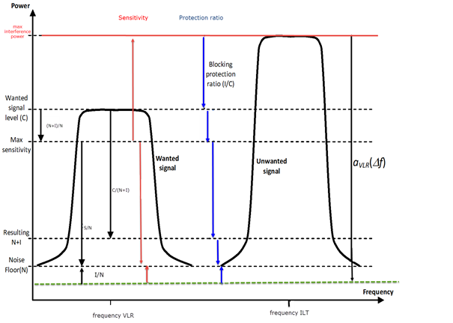

Prx

iRSSblocking

**Figure 22: Illustration of the blocking of the victim link receiver (i.e. total emission power of ILT reduced by the blocking attenuation (selectivity) function of the VLR for the Sensitivity and Protection Ratio modes**

The calculated value of  is compared against the specified interference threshold to determine if blocking occurs.

For example, if  is -95 dBm, the receiver noise floor N is -90 dBm, and the selected interference criterion is I/N = -6 dB, then the achieved I/N (due to blocking) is calculated as:



As this is higher than the interference criterion threshold then interference due to blocking occurs in this scenario.

It is possible to calculate the effect of blocking separately or in combination with the effect of unwanted emissions to obtain an understanding of the total impact of interference and also the dominant cause of interference (i.e. the unwanted emissions of the transmitter or the selectivity of the receiver)

#### Intermodulation

The intermodulation interference, i.e. the power of third order intermodulation products from at least 2 different interfering systems, reduced by the intermodulation attenuation function of the VLR, can be used in interference calculations in SEAMCAT.

An intermodulation rejection response $L_{imr}$ can be specified as a relative attenuation or an absolute level. If an absolute level is specified it is converted into a relative attenuation as follows:



For the case of relative attenuation, specified as a constant value within the bandwidth of the VLR, the interference due to intermodulation from different interfering systems is calculated as follows:



For $f_{j}≥f_{i}$:



For $f_{j}<f_{i}$:





Where:

* is the interfering received signal strength at the receiver input from interferer *x* (in dBm);
*  is the intermodulation rejection response at frequency offset $∆f$ (in dB);
* is the intermodulation product for a pair of interferers $i$ and $j$ (in dBm);
* is the total intermodulation product for $n$ interferers (in dBm);
* other parameters are as defined in section 7.2.2.1 above-

#### Overloading

Interference due to overloading can be calculated as follows:



Where:

*  is the interfering received signal strength due to overloading (in dBm);
*  is the interference power at the receiver input (in dBm);
*  is a user specified receiver filter mask (in dB).

The value of  is compared with a user-specified overloading threshold (which can be constant or frequency offset dependent) to determine if interference occurs.

### Receivers in cellular SEAMCAT systems

In cellular systems (CDMA, OFDMA and IMT-2020), receiver selectivity is modelled using the “Blocking/ACS” input.

If the input mask is specified using positive values it is effectively equivalent to the user-defined mode for blocking in generic systems, as described in section 7.2.2.1 above.

For positive values the blocking response in SEAMCAT can be calculated by the following equation:



For 3GPP cellular systems with:

Desensitisation  = 6 dB

dB

 (-108 dBm = thermal noise over 4.5 MHz)

 = the out-of-band interfering signal at the base station antenna connector

 = the in-band interfering signal at the base station antenna connector

Further explanation can be found in the SEAMCAT documentation.

Alternatively, the user may specify the mask in negative values in dBm, which SEAMCAT converts to relative attenuation according to the following method:



Where:

*  is the calculated blocking attenuation at frequency offset $∆f$ (in dB);
*  is the user specified blocking level at frequency offset $∆f$ (in dBm);
*  is the user specified ‘standard desensitisation’ (in dB) –i.e. the desensitisation for which the blocking level is specified in the standard;
* is the user-specified ‘target’ interference to noise ratio (in dB)– i.e. the criteria for which the blocking attenuation is to be calculated;
* is the receiver noise floor (in dBm).

Similarly to generic systems, blocking and ACS are combined in a single frequency offset dependent mask function, and the calculation of  is the same as outlined above in section 7.2.2.1.

However, in cellular systems the subsequent calculations are different in that the contributions due to blocking and unwanted emissions are summed in order to evaluate a single value of external interference power. It is not possible in this case to evaluate interference due to unwanted emissions and blocking separately[16].



Where:

* is the total external interference power due to unwanted emissions and blocking (in milliwatts);
*  is the interfering received signal strength due to blocking (in milliwatts);
*  is the interfering received signal strength due to unwanted emissions (in milliwatts).

The resulting SINR is then calculated according to:



Where:

*  is the total signal to interference plus noise ratio (in dB);
*  is the received signal strength of the wanted signal (in dBm);
* is the intra-system interference due to other cells in the network (in milliwatts);
* is the receiver noise floor (in milliwatts).

The calculated SINR is then compared against a lookup table to determine the resulting capacity/bitrate of the link.

# receiver measurements of common digital systems

## Introduction

Measurement of equipment is one way to characterise the performance of a receiver for sharing and compatibility studies. In addition to ITU-R or CEPT deliverables, Harmonised Standards or technical specifications, measurements allow to further characterise the receiver performance. In particular, Harmonised Standards contain requirements that all equipment shall meet and do not provide the full picture of all existing equipment performance in use on the market.

The measurements in this section are compared with ETSI Standards where possible. It is noted that the comparison with ETSI Standards and specifications may not match because Standards use a pass/fail criterion whereas these measurements use a failure/performance criterion. Some of the criteria used in ETSI Standards cannot be evaluated as this is only accessible to the manufacturer for production purposes. Some of the measurements also use a different measurement setup compared with measurement methods in the standards/specifications and measurement uncertainties may be different and these may not represent all receivers operating in all conditions for the mentioned services.

The following sections present measurements of common digital systems.

## Description of general measurement setups and measured parameters

Where possible, the following receiver parameters have been measured for some common digital systems:

* Sensitivity;
* Selectivity curve;
* Adjacent channel selectivity;
* Blocking;
* Overloading immunity;
* Intermodulation immunity.

Due to practical constraints (e. g. no access to internal test points), the above parameters could only be measured by assessing the overall performance. Apart from the pure RF circuity in the receiver, this may also include influences due to software implementation.

The general approach was as follows:

* Define a failure (performance) criterion as a threshold from undistorted to interfered state;
* Establish an undistorted connection between the device under test (DUT) and a reference transmitter;
* Feed the unwanted (interfering) signal(s) from the reference transmitter into the DUT with increasing unwanted signal level until the failure point is reached.

The detailed measurement procedure and typical setups are described in Annex 2.

## Summary of measured receiver performance

The measurements conduced were on the following equipment types:

* RLAN;
* DECT;
* TETRAPOL;
* TETRA;
* GSM-R;
* DTT Receivers;
* DCF 77;
* GPS.

### RLAN

#### General information

The relevant RF properties of the measured 2.4 GHz RLAN system are:

* Frequency range: 2400-2483.5 MHz
* Number of channels: 13
* Channel spacing: 5 MHz
* Bandwidth (OBW): 16 MHz
* Encoding: OFDM
* Modulation:QPSK/QAM (adaptive)
* Access/Duplex: TDMA / TDD
* IEEE standard: 802.11g

The relevant RF properties of the measured 5 GHz RLAN system are.

* Frequency range: 5150-5350 MHz
* Number of channels: 8
* Channel spacing: 20 MHz
* Bandwidths (OBW): 16, 33 and 67 MHz
* Encoding: OFDM
* Modulation: QPSK/QAM (adaptive)
* Access/Duplex: TDMA / TDD
* IEEE standards: 802.11n/a/h

The relevant Harmonised Standards for 2.4 and 5 GHz RLAN are EN 300 328 [23] and EN 301 893 respectively. [24]. Reference receiver parameters for RLAN systems are defined in ETSI ES 202 131.

A total of 16 RLAN devices deploying 13 different RLAN chips have been measured. Both 2.4 and 5 GHz ranges were tested.

Table 5: Measured RLAN device types

|  |  |  |  |
| --- | --- | --- | --- |
| Number of devices | Rx-Number | Device Type | Frequency Range(s) |
| 2 | Rx1, Rx3 | PCI express cards | 2.4 and 5 GHz |
| 1 | Rx6 | USB Wi-Fi adapter | 2.4 GHz |
| 3 | Rx2, Rx8, Rx9 | USB Wi-Fi adapters | 2.4 and 5 GHz |
| 1 | Rx10 | Wi-Fi-LAN adapter | 2.4 and 5 GHz |
| 3 | Rx4, Rx5, Rx11 | Wi-Fi Routers and Access Points | 2.4 and 5 GHz |
| 2 | Rx12 | Wi-Fi Routers and Access Points | 2.4 GHz |
| 1 | Rx13 | 4G Wi-Fi Gateway | 2.4 and 5 GHz |
| 3 | Rx14, Rx15, Rx16 | Smartphones | 2.4 and 5 GHz |

The wanted signals in the 2.4 GHz range were on channel 1 (2402-2422 MHz) with a bandwidth of 20 MHz. In the 5 GHz range, channel 36 (5170-5250) with a bandwidth of 80 MHz was used. Receivers 9, 10, 11 and 16 only supported 40 MHz bandwidth (5170-5210 MHz).

For the tests, a constant data transfer from a reference device to the device under test (DUT) was established and its speed was measured. The failure or performance criterion was a consistent drop of the maximum undistorted data transfer rate or a connection loss.

ETSI ES 202 131 [34] uses a frame error rate of 10% at a PSDU length of 1000 bytes as a performance criterion. Since this parameter could not be measured for readily available equipment, it may be more or less critical than the performance criterion used for these measurements.

Devices with external antenna connector were measured in conducted mode, those without an external antenna connector were measured in a G-TEM cell.

Not all parameters could be measured for all devices. This was sometimes due to a strange behaviour of the DUT (e. g. not being able to recover from an interference situation), or due to the limited interfering power available (especially for DUTs measured in the TEM cell).

The summary of the measurement results is presented in the following subsections.

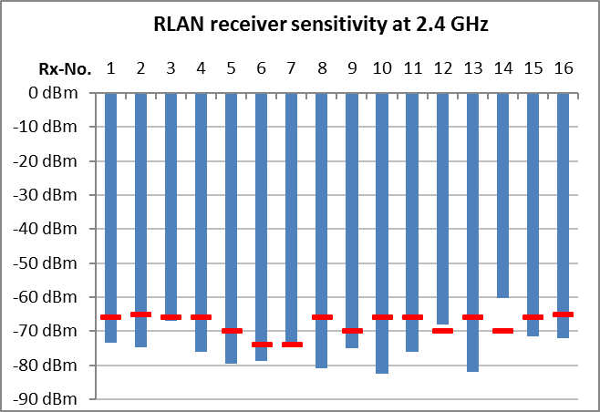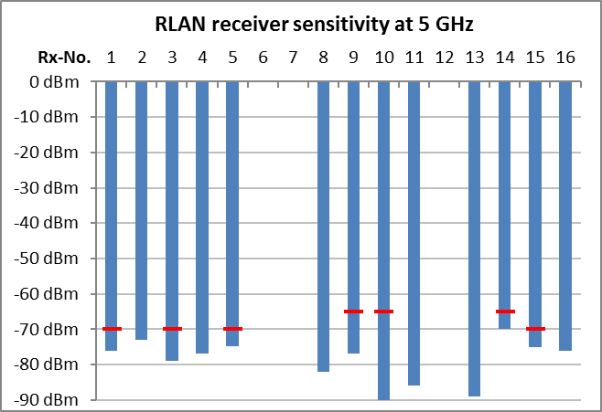

Figure 23: Measured RLAN receiver sensitivity

The levels in Figure 23 are average burst levels (RMS during an active RLAN burst), measured over the whole bandwidth of the wanted signal (20, 40 or 80 MHz).

It was not possible to compare the measured sensitivity levels with Harmonised Standards EN 300 328 and EN 301 893 [24] as these do not contain sensitivity values. Instead, the red lines in Figure 19 indicate the corresponding values from ETSI ES 202 131 [34]. Sensitivity values in this standard are dependent on the gross data rate supported by the modulation parameters. The net data rates that have been measured for the different receivers are assumed to be one class below the gross data rates. Example: Rx 1 had a measured net data rate of 43 Mbit/s in the 2.4 GHz band. Table 8 of ETSI ES 202 131 has sensitivity values for IEEE 802.16a and 802.16h systems for 36 and 48 Mbit/s respectively. In that case, the value for 48 Mbit/s of -66 dBm was taken. The latest version of ETSI ES 202 131 was from 2003 and does not contain values for IEEE 802.11n systems. This is the reason why no requirements could be obtained for some Rx in the 5 GHz band.

#### Adjacent channel selectivity

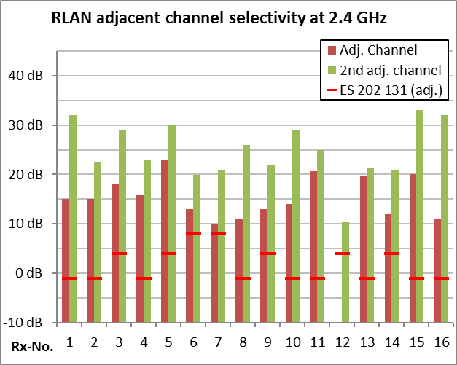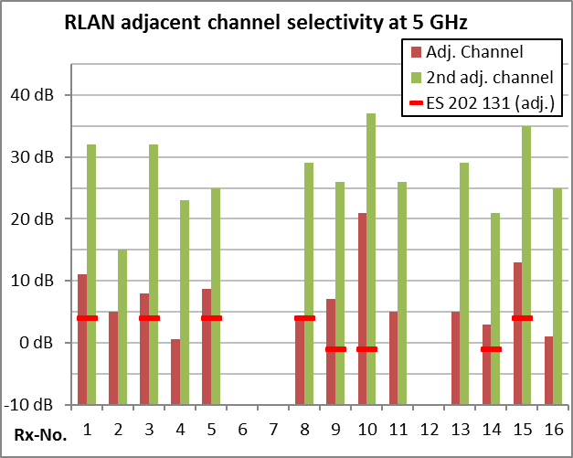

Figure 24: Measured adjacent channel selectivity for RLAN devices

The y-axis in Figure 24 is the difference in RMS burst levels between wanted and an unwanted signal with a bandwidth of 20 MHz placed in adjacent RLAN channels (channel spacing of 20 MHz was assumed).

It was not possible to compare the measured adjacent channel selectivity levels with Harmonised Standards EN 300 328 [23] and EN 301 893 [24] as these do not contain adjacent channel selectivity values. Instead, the red lines indicate the corresponding values from ETSI ES 202 131 [34] for the adjacent channel. Selectivity values in this standard are dependent on the gross data rate supported by the modulation parameters. The net data rates that have been measured for the different receivers are assumed to be one class below the gross data rates. The latest version of ETSI ES 202 131 was from 2003 and does not contain values for IEEE 802.11n systems. This is the reason why no requirements could be obtained for some Rx in the 5 GHz band.

#### Blocking

The standard offset between wanted and unwanted frequencies for this measurement was 25 MHz for the 2.4 GHz range and 110 MHz for the 5 GHz range (all relative to centre frequencies).

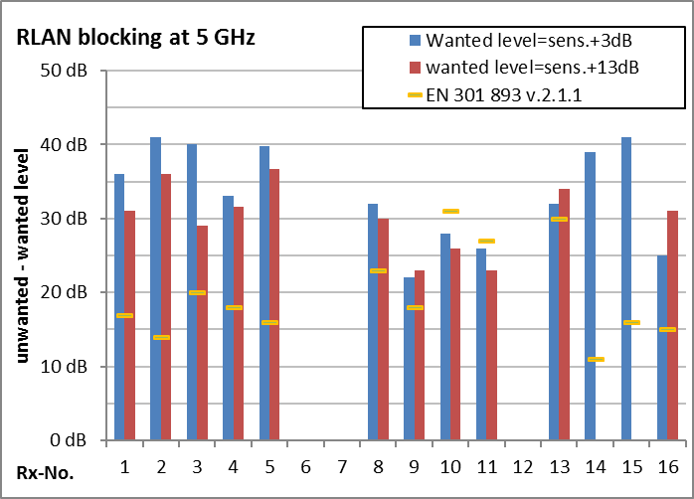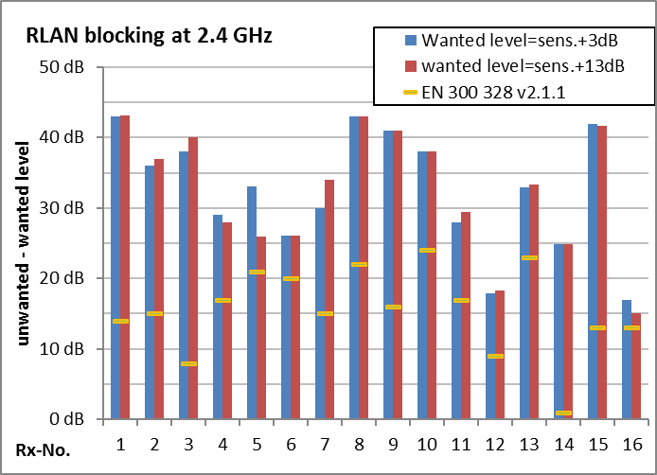

Figure 25: Measured blocking of RLAN receivers for standard frequency offsets

All levels in Figure 25 are average burst levels over the whole signal bandwidth.

For some receivers blocking was also measured with higher separations between wanted and unwanted frequencies.

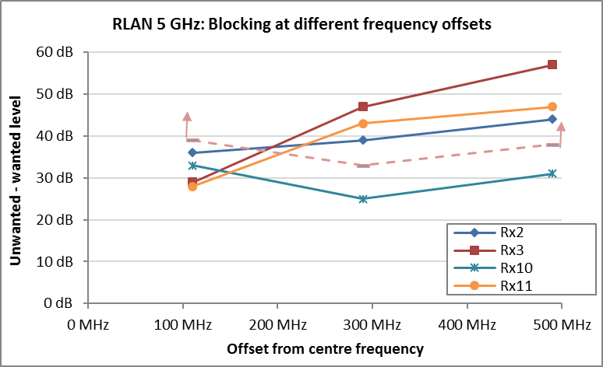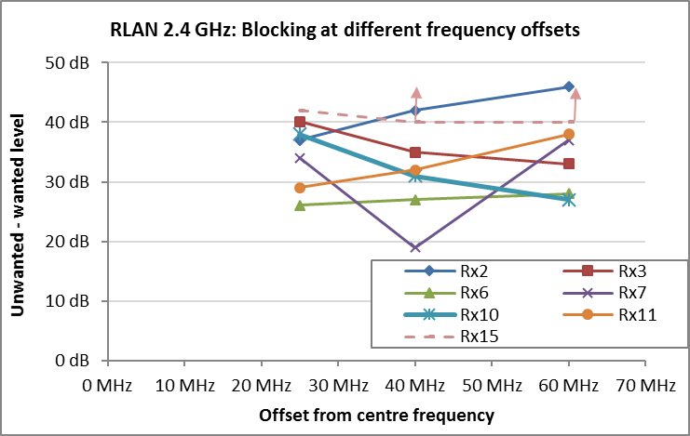

Figure 26: Measured blocking of RLAN receivers for different frequency offsets

The y-axis in Figure 26 denotes the difference between wanted and unwanted average burst level over the whole signal bandwidth.

Blocking levels in EN 300 328 [23] and EN 301 893 [24] are specified as absolute unwanted signal levels, measured at a wanted signal level that is 6 dB above sensitivity. This would result in different blocking rejection requirements for every tested device.

#### Overloading immunity

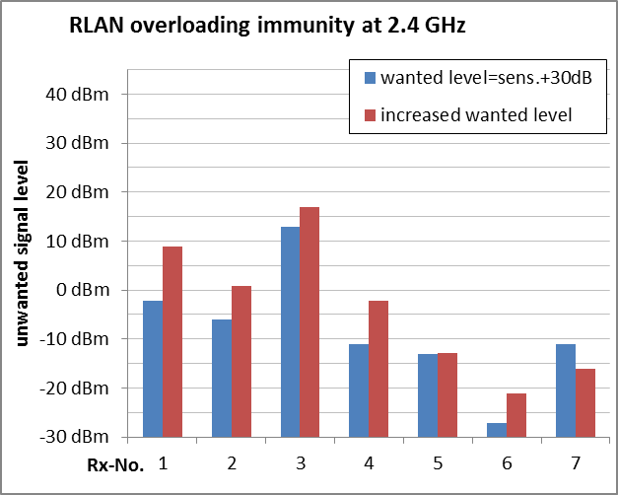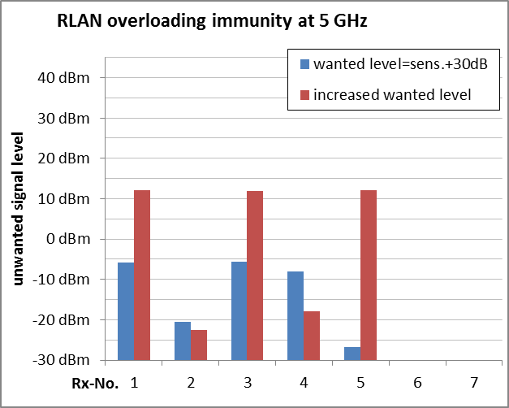

Figure 27: Measured overloading immunity of RLAN receivers

True overloading was only proven for receivers 5 and 7 (2.4 GHz range) and receivers 2 and 4 (5 GHz range). All other receivers could manage with higher unwanted signal levels if the wanted signal level was increased, which means they were initially not yet overloaded. In these cases, blocking may have been the dominating effect.

ETSI EN 300 328 [23], EN 301 893 [24] and ES 202 131 [34] do not contain values for overloading immunity.

#### Intermodulation immunity

Measurement of the intermodulation immunity was only possible for DUTs with external antenna connectors due to the limited available unwanted signal level.

The unwanted signal frequencies were placed at least 20 MHz away from the edge of the wanted channel in a way that they produce a third order IM product fully inside the wanted channel.

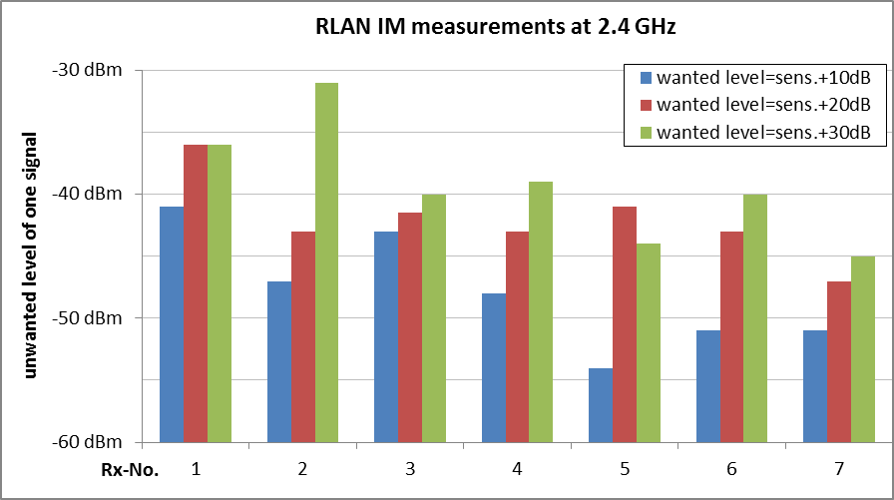

Figure 28: Measured intermodulation immunity for 2.4 GHz RLAN receivers

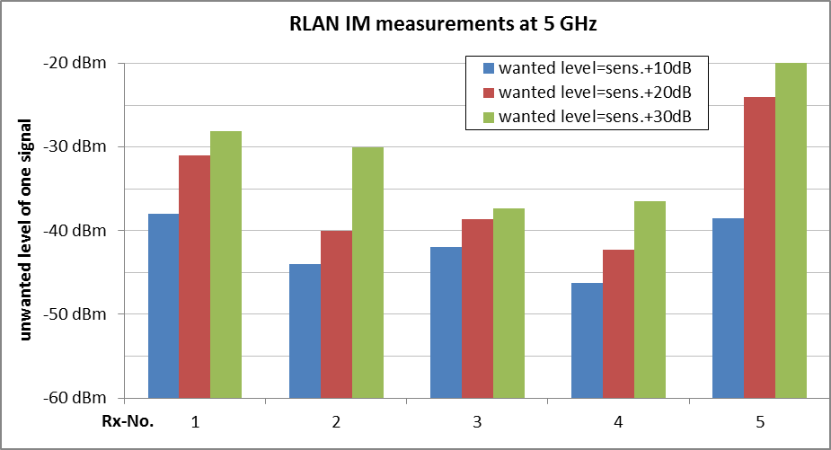

Figure 29: Measured intermodulation immunity for 5 GHz RLAN receivers

The levels presented in Figure 28 and Figure 29 are the RMS levels of each of the two unwanted signals producing the intermodulation components, measured over the whole bandwidth, so the total unwanted energy seen by the receiver is 3 dB higher.

ETSI EN 300 328 [23], EN 301 893 [24] and ES 202 131 [34] do not contain values for intermodulation immunity.

#### Analysis of the measurement results in comparison with ETSI Harmonised Standards

The measurements show that most of the tested receivers outperform the requirements of the ETSI ES 202 131 [34] typically by 5 to 10 dB. For 2.4 GHz RLAN the measured blocking values outperformed the ETSI EN 300 328 [23]) limits by as much as 30 dB but in one case only 4 dB. For 5 GHz RLAN the measured blocking values outperformed the ETSI EN 301 893 [24] limits by as much as 28 dB but in one case the limit was exceed by 3 dB. However, it must be noted that the ETSI performance criterion is different from the one used for the measurements, and that the difference between gross and net data rates could only be estimated. This, together with the measurement uncertainty, may be the reason why some receivers did not seem to meet the relevant ETSI Harmonised Standards.

### DECT

#### General Information

The relevant RF properties of the DECT system are:

* Frequency range: 1880-1900 MHz (Europe);
* Number of channels: 10;
* Channel spacing: 1.728 MHz;
* Bandwidth (OBW): 1.15 MHz;
* Modulation: GFSK;
* Access/Duplex: TDMA/TDD.

The relevant ETSI Harmonised Standard is EN 301 406 [65] which gives the receiver performance requirements. The standard generally refers to EN 300 175-2 [66] for the limits specific to receiver performance.

A total of 21 DECT devices were selected as “device under test” (DUT). They are numbered as Rx1P/F through Rx15P/F in this section. The “P” behind an Rx number denotes a portable part (PP, handset), whereas an Rx number followed by “F” denotes a fixed part (FP, base station). The same Rx number for portable and fixed parts is used in case of a pre-configured, matching pair. Because none of the DECT devices had external antenna connectors, all DUTs were measured in a G-TEM cell.

The performance or failure criterion was the point where an active voice call was dropped.

The highest channel in the European DECT band (1897.344 MHz) was selected as the frequency of the wanted signal.

#### Sensitivity

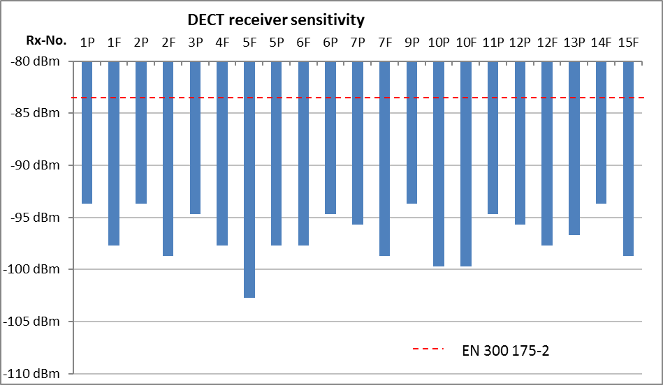

Figure 30: Measured receiver sensitivity

The levels given in Figure 30 are average burst levels (RMS level during the burst), measured over the whole signal bandwidth. The ETSI limit was taken from EN 301 406 [65] which refers to EN 300 175-2 [66], Section 6.2. It should be noted, however, that this value is based on a more critical BER value that could not be measured on readily available devices.

#### Selectivity curve

The measurements were performed with an unmodulated carrier as the unwanted signal. There are no specific requirements in EN 301 406 [65] for selectivity so the ETSI limit was taken from EN 300 175-2 [66], Section 6.4, Table 4. Although it is labelled “Receiver interference performance”, the values also contain co-channel interferers and can therefore be used as a measure of selectivity by normalization. It should be noted, however, that the ETSI limits are based on a more critical BER value that could not be measured on readily available devices.

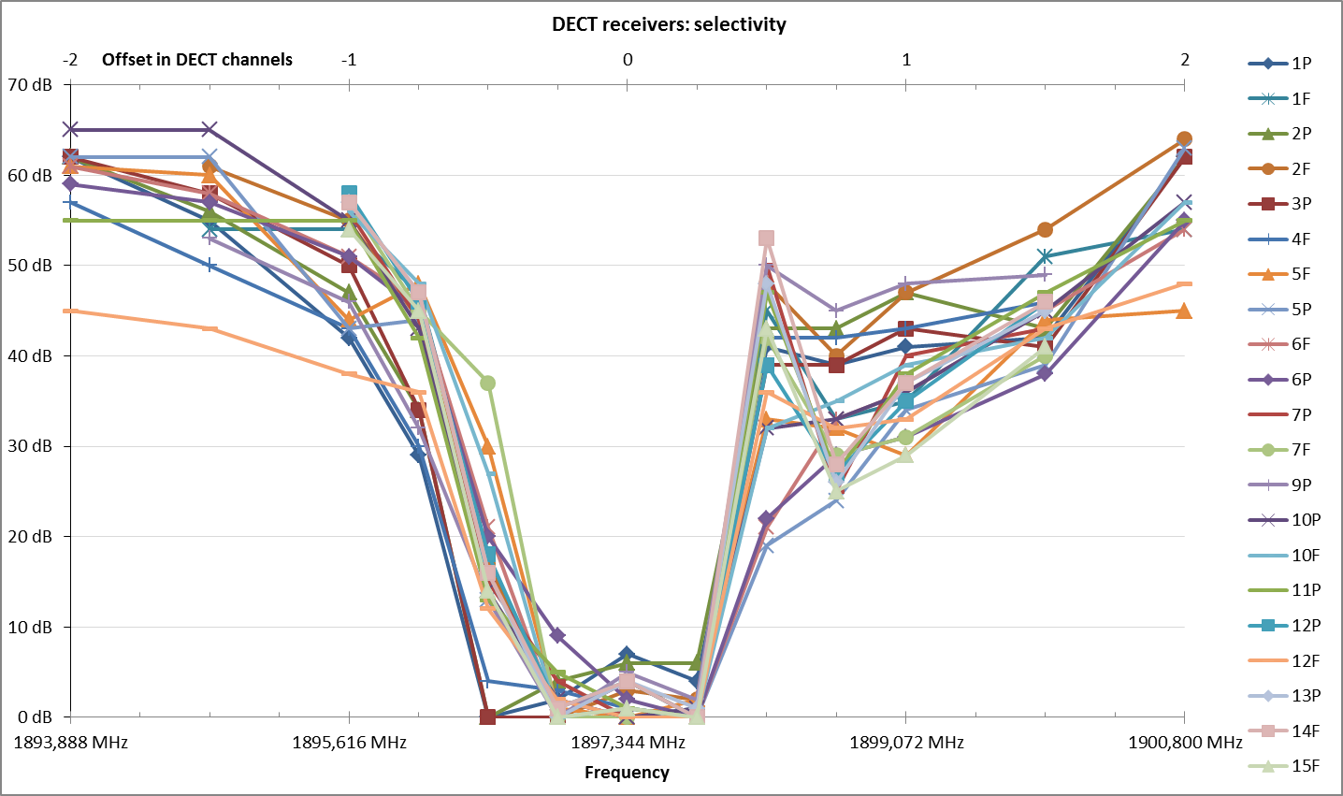

Figure 31: Measured selectivity curve of DECT receivers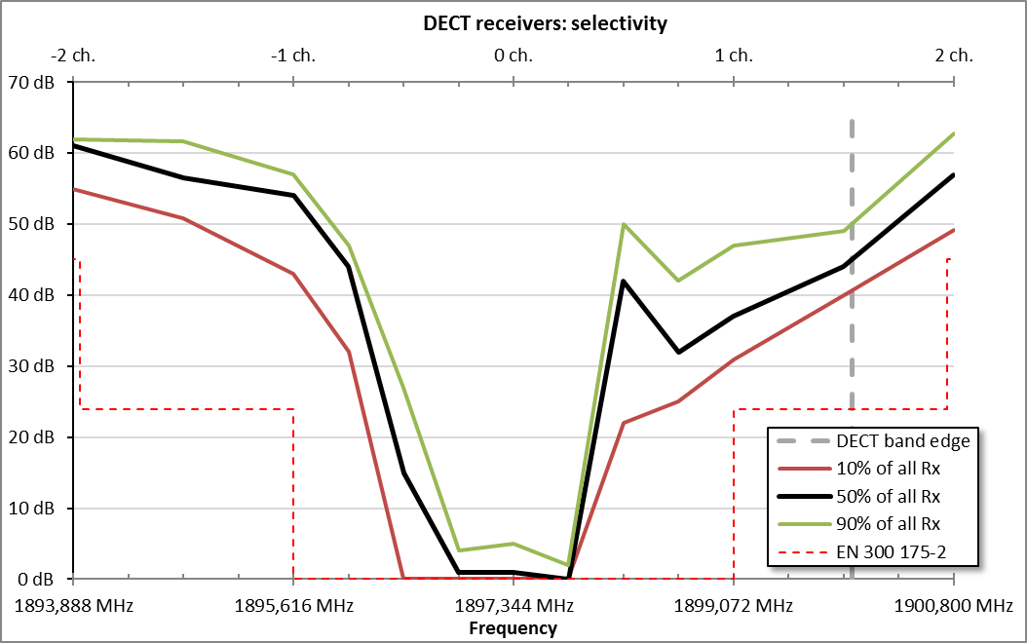

Figure 32: Statistical evaluation of measured selectivity curves

#### Adjacent channel rejection

The measurements were performed with an unwanted DECT signal in adjacent channels occupying all time slots to ensure that the time slot of the wanted signal was always affected. There are no specific requirements in ETSI EN 301 406 [65] for selectivity and the ETSI limits were taken from ETSI EN 300 175-2 [66], Section 6.4, Table 4. It should be noted, however, that these values are based on a more critical BER value that could not be measured on readily available devices.

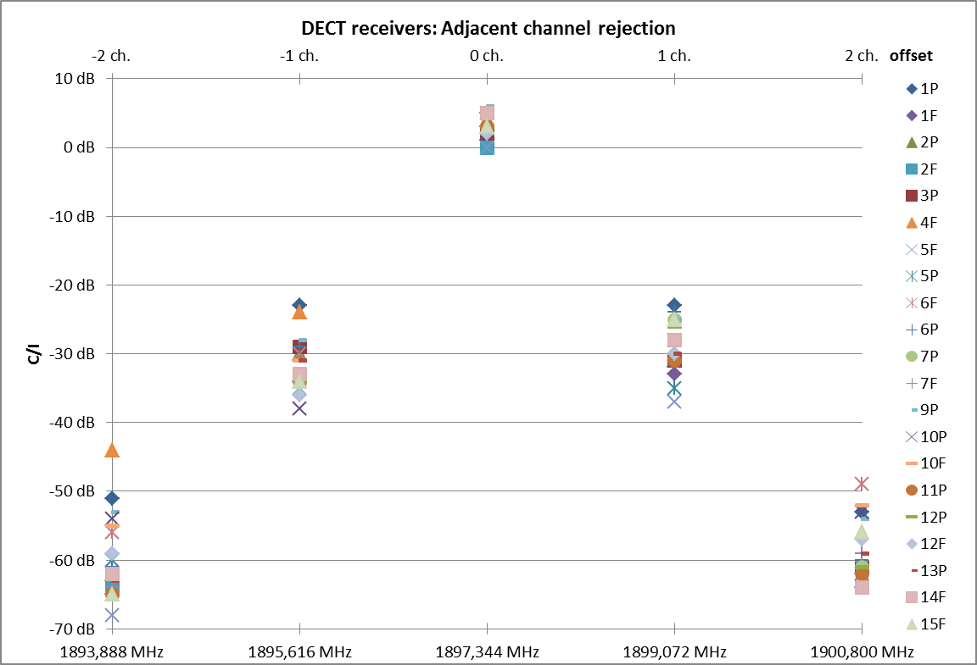

Figure 33: Measured adjacent channel rejection of DECT receivers

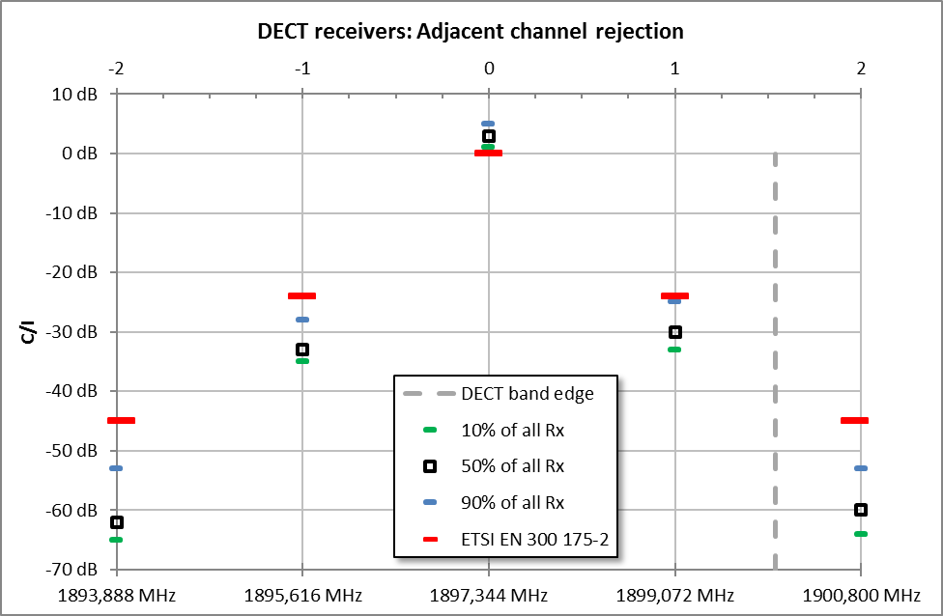

Figure 34: Statistical evaluation of DECT adjacent channel rejection

The C/I values in Figure 33 and Figure 34 are the difference between average burst levels (RMS levels during the burst) measured over the whole signal bandwidth.

#### Blocking

Blocking was measured at two different wanted signal levels with an unmodulated carrier at an offset of 6.344 MHz from the centre frequency of the wanted signal. The ETSI limit was taken from EN 301 406 [65] which refers to EN 300 175-2 [66], Section 6.5.1, Table 5 for interfering frequency offsets > 6 MHz, normalised to a wanted signal level of -80 dBm. It should be noted, however, that this value is based on a more critical BER value that could not be measured on readily available devices.

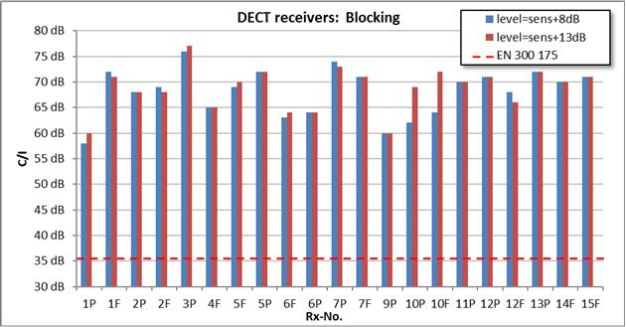

Figure 35: Measured Blocking of DECT receivers

Table 6: Statistical evaluation of blocking results

|  |  |
| --- | --- |
| Percentile of receivers | Blocking (rejection) |
| EN 300 175-2 [66] | 37 dB |
| 10% of all Rx | 64 dB |
| 50% of all Rx | 70 dB |
| 90% of all Rx | 72 dB |

Except for Rx 10P and 10F, the results show blocking as the dominating interference effect. Rx 10P and 10F may have some regulating gain control built in because the C/I increases by the same amount as the wanted signal level.

#### Overloading immunity

True overloading effects could not be measured due to the limited available unwanted signal level. It could, however, be concluded that overloading of the DECT receivers may occur only at interfering signal levels higher than +5 dBm.

#### Intermodulation immunity

The unwanted signals for this measurement were an unmodulated carrier at 1890.432 MHz and a DECT signal occupying all time slots at 1883.520 MHz. These signals create a third order IM product in the centre of the wanted channel at 1987.344 MHz.

The ETSI limit was taken from EN 301 406 [65] which refers to EN 300 175-2 [66], Section 6.6 where it is specified for a wanted signal level of -80 dBm. It should be noted, however, that this value is based on a more critical BER value that could not be measured on readily available devices.

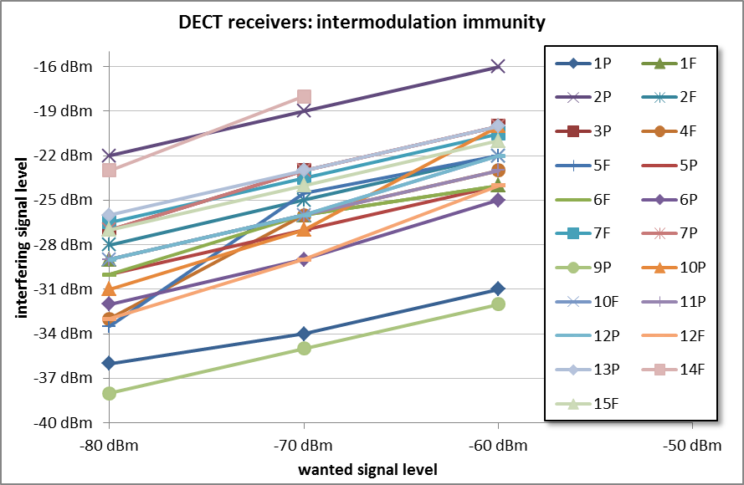

Figure 36: Measured intermodulation immunity of DECT receivers

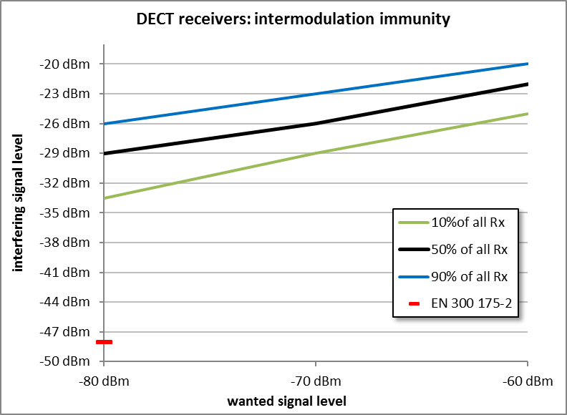

Figure 37: Statistical evaluation of DECT IM immunity measurements

A 3 dB increase of unwanted level when the wanted level is raised by 10 dB proves that intermodulation is the dominating effect.

The Y-axis in Figure 28 and Figure 29 specifies the RMS burst level of each of the unwanted signals, so the total unwanted energy seen by the receiver is 3 dB higher.

#### Analysis of the measurement results in comparison with ETSI Harmonised Standards

Although ETSI EN 301 406 [65] contains limits for some receiver parameters and ETSI EN 300 175-2 [66] contains limits for other receiver parameters, they are of limited use when comparing them with the measurement results, because the limits in these ETSI standards are defined based on a BER < 10-3. While this may be a usable criterion for manufacturers during production, it cannot be evaluated on readily available equipment because it requires a measurement point inside the equipment.

Nevertheless, the measured equipment outperformed almost all ETSI limits. One exception is the co-channel C/I (see Figure 32 at 1897.344 MHz) where the ETSI limit is slightly exceeded by all DUTs. This may mean that the ETSI criterion is more restrictive than the criterion of dropped calls used for these measurements. The other extreme is the blocking where even the poorest DUT outperforms the ETSI limit by about 27 dB.

### Tetrapol

The relevant RF properties of this communication system are:

* Frequency range: 380-450 MHz;
* Channel spacing: 12.5 kHz;
* Bandwidth (OBW): 7 kHz;
* Modulation: π/4 DQPSK;
* Access/Duplex: FDMA/FDD-

As TETRAPOL is a propriety standard, there are no relevant ETSI Harmonised Standards or other documents specifying receiver parameters.

Four different receivers were measured (3 handsets and one base station). The occurrence of unrecoverable audio packets during an active voice connection was used as the failure (performance) criterion.

#### Sensitivity

Table 7: Sensitivity of the measured Tetrapol receivers

|  |  |
| --- | --- |
| Rx | Sensitivity |
| 1 (handset) | -124 dBm |
| 2 (handset) | -125 dBm |
| 3 (handset) | -125 dBm |
| 4 (base station) | -125 dBm |

### TETRA

The relevant RF properties of this communication system are:

* Frequency range: 380-450 MHz;
* Channel spacing: 25 kHz;
* Bandwidth (OBW): 21 kHz;
* Modulation: GMSK;
* Access/Duplex: TDMA/FDD.

Three different receivers were measured (2 handsets and one base station). The occurrence of unrecoverable audio packets during an active voice connection was used as the failure (performance) criterion.

#### Sensitivity

Table 8: Sensitivity of the measured Tetra receivers

|  |  |  |
| --- | --- | --- |
| Rx | Sensitivity  Network Mode | Sensitivity Direct Mode |
| 1 (handset) | -106 dBm | -112 dBm |
| 2 (handset) | - | -115 dBm |
| 3 (base station) | -115 dBm | - |

#### Analysis of the measurement results in comparison with ETSI Harmonised Standards

The relevant ETSI EN 300 394-1 specifies different sensitivities for TETRA receivers under normal and extreme operating conditions. The static sensitivity of a base station under normal operating conditions is specified as -115 dBm which is exactly the value of the measured base station sensitivity. The equivalent requirement for sensitivity of a mobile/portable TETRA receiver is -112 dBm which was reached by Rx1 and outperformed by 3 dB by Rx2.

### GSM-Rail 900 UE

The GSM-R system is used for internal communication of railway operators, including those for safety services.

The relevant RF properties of this system are:

* Frequency range: 918-925 MHz (UE receive band);
* Channel spacing: 200 kHz;
* Bandwidth (OBW): 250 kHz;
* Modulation: GMSK;
* Access/Duplex: TDMA/FDD.

Three different UE receivers to be installed in locomotives were tested. The design of Rx2 is equal to the that of standard GSM user equipment. Therefore, the results of this receiver may be taken to assess GSM UE performance as well. Rx1 was designed especially for GSM-Rail application with the aim to specifically suppress signals above 925 MHz.

A drop of the reported RxQual to level 4 was used as the failure criterion. This is also the point where the first degradations of the subjective audio quality are noticeable.

Receiver requirements for different parameters are contained in ETSI EN 301 511 [62], which refers to relevant sections of ETSI TS 151 010-1 [67] which in turn refers to 3GPP TS 05.05 [68] and ETSI TS 102 933-2 [69].

#### Sensitivity

Table 9: Sensitivity of the measured GSM-R receivers

|  |  |
| --- | --- |
| Rx | Sensitivity |
| 1 | -108 dBm |
| 2 | -107 dBm |
| 3 | -109 dBm |
| 3GPP TS 05.05 [68] | -104 dBm |

#### Selectivity

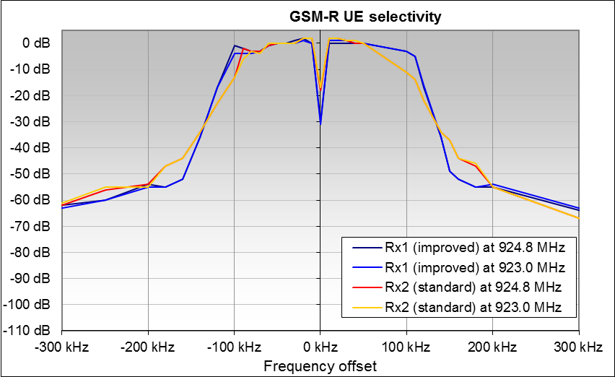

Figure 38: Selectivity of the measured GSM-R receivers

#### Adjacent channel selectivity

The unwanted signal for this measurement was a GSM signal with all time slots occupied to ensure that in any case the wanted time slot is affected.

ETSI EN 301 511 [62] gives limits for adjacent channel rejection, the values for these limits are given in ETSI TS 151 010-1 [67] and TS 102 933-2 [69] through reference and are equal to the limits defined in 3GPP TS 05.05 [68].

Table 10: Protection ratio of the measured GSM-R receivers

|  |  |  |  |
| --- | --- | --- | --- |
| offset | Rx1 C/I | Rx2 C/I | 3GPP TS 05.05 |
| 0.0 MHz (co-channel) | 5 dB | 7 dB | 9 dB |
| 0.2 MHz (adjacent channel) | -15 dB | -14 dB | -9 dB |
| 0.4 MHz (second adjacent channel) | -57 dB | -56 dB | -41 dB |
| 0.6 MHz (third adjacent channel) | -70 dB | -71 dB | -49 dB |

All levels given in Table 10 are average burst levels (RMS levels during the burst) over the whole signal bandwidth.

#### Overloading immunity

The unwanted signal for this measurement was an unmodulated carrier places 400 kHz (2 GSM channels) above the wanted centre frequency. Only the standard GSM-R receiver using a typical GSM 900 chipset has been measured.

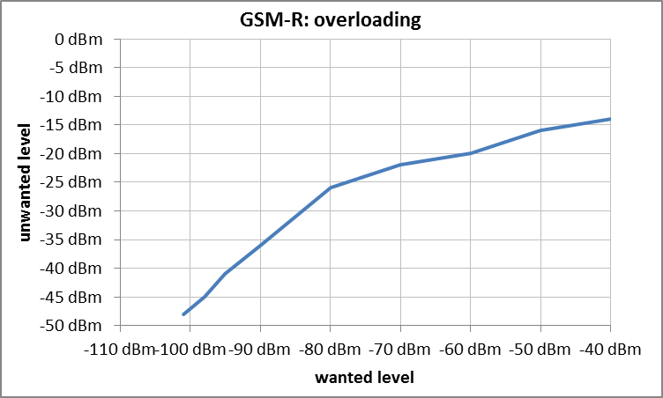

Figure 39: Overloading measurement of a typical GSM-R UE receiver

ETSI EN 301 511 [62] and TS 145 005 [63] do not specify overloading requirements.

#### Intermodulation immunity

The unwanted signals for this measurement were GSM signals with all time slots occupied at frequencies 13.8 MHz and 27.6 MHz above the wanted centre frequency. These signals created a third order IM product at the centre of the wanted channel. Only the standard GSM-R receiver using a typical GSM 900 chipset has been measured.

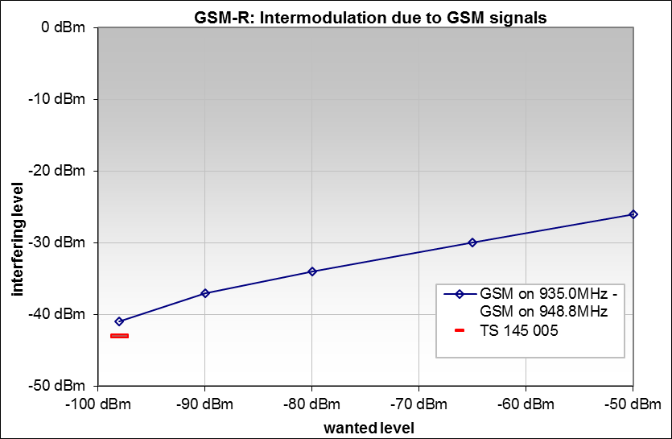

Figure 40: Intermodulation immunity of a typical GSM-R UE receiver

The red line indicates the requirement from ETSI EN 301 511 [62] and ETSI TS 145 005, Section 5.3.1 [63].

#### Analysis of the measurement results in comparison with ETSI Harmonised Standards

The measurements show that the measured GSM-R receivers outperform the requirements of ETSI TS 145 005 [63]. The sensitivity of these receivers is 4-5 dB better and intermodulation immunity about 3 dB. Depending on the frequency offset, their selectivity against signals on other GSM channels is up to about 20 dB better than the standard requirement.

* + 1. **Digital Terrestrial Television Receivers**

*8.2.6.1 General information*

A total of 12 different DTT receivers (DVB-T2/T receivers) were tested, eight of them being brad-new receivers available on the European market at the time of the development of this Report.

The most important radio parameters of these receives were measured in the presence of an LTE interfering signal for four different frequency offsets. The corresponding frequency offsets and LTE interfering signal ILR values, measured in the 8 MHz DTT channel, are presented in Table 12.

**Table 11: LTE interfering signal and DTT wanted signal channelling configurations and LTE** I**LR**

|  |  |  |  |  |  |  |  |  |
| --- | --- | --- | --- | --- | --- | --- | --- | --- |
| **LTE Interfering**  **signal** | **LTE fc**  **(MHz)** | **LTE**  **channel**  **BW (MHz)** | **DTT**  **channel** | **DTT fc**  **(MHz)** | **DTT**  **channel**  **BW (MHz)** | **LTE-DTT frequency**  **offset (MHz)** | **LTE-DTT**  **guard band**  **(MHz)** | **LTE ILR**  **in DTT CH**  **(dB/8 MHz)** |
| LTE 400 BS | 465 | 5 | 21 | 474 | 8 | -9 | 2.5 | 67 (Note 1) |
| LTE 700 PPDR UE(Note 4) | 700.5 | 5 | 48 | 690 | 8 | 10.5 | 4 | 65 (Note 2) |
| LTE 700 SDL | 740.5 | 5 | 48 | 690 | 8 | 50.5 | 44 | 87 (Note 3) |
| LTE 700 BS | 763 | 10 | 48 | 690 | 8 | 73 | 64 | 87 (Note 3) |
| Note 1 ILR: ACLR=67 dB=60 dBm-(-7 dBm), see ECC Decision(16)02 [70]  Note 2 ILR: ACLR=65 dB=23 dBm-(-42 dBm), see ECC Decision(15)01 [71]  Note 3 ILR: ACLR=87 dB=64 dBm-(-23 dBm), see ECC Decision(15)01 [71]  Note 4: This configuration is only envisaged in France | | | | | | | | | |

The measured (or calculated) DTT receiver parameters are:

* Sensitivity;
* Signal to noise ratio (S/N or C/N);
* Noise factor - calculated;
* Blocking response;
* Overloading threshold (Oth);
* Protection ratios - calculated;
* Frequency offset selectivity (FOS) - calculated.

Note that the frequency offset selectivity (FOS) of the receivers has been calculated according to the method defined in section 4.2.3.

The relevant RF parameters of the DTT system as well as the interfering LTE system are presented in Table 12 and Table 13.

Table 12: DTT system parameters

|  |  |  |
| --- | --- | --- |
| Parameter | Value | Comments |
| Centre frequency (MHz) | 474 and 690 | Channels 21 and 48 |
| Channel bandwidth (MHz) | 8 MHz |  |
| **DVB-T2** **(configuration envisaged in France):** | | |
| Tx/Rx configuration | SISO |  |
| Receiver bandwidth: | 7.768 |
| Modulation: | 256 QAM |
| FFT size: | 32k ext |
| Coding rate: | 3/5 |
| Guard interval: | 1/32 (112 µs) |
| Pilot profile: | PP4 |
| # OFDM symbols/Frame: | 60 |
| Throughput per multiplex: | 34.271 Mbps |
| Spectral efficiency: | 4.41 bits/s/Hz |
| Theoretical C/N (dB): | 18 dB | Gaussian channel |
| **DVB-T** **(configuration used in France):** | | |
| Receiver bandwidth: | 7.61 MHz |  |
| Modulation: | 64 QAM |
| FFT size: | 8k ext  Non-Hierarchical |
| Coding rate: | 3/4 |
| Guard interval: | 1/8 (112 µs) |
| Throughput per multiplex: | 24.882 Mbps |
| Spectral efficiency: | 3.27 b/s/Hz |
| Theoretical C/N (dB): | 18 | Gaussian channel |
| Content | HD video streams |  |
| Wanted signal levels used (dBm) | -70, -58, -50, -40, -35 and -25 | In order to properly determine the C(I) curve of the receiver |

Table 13: LTE system parameters

|  |  |  |  |
| --- | --- | --- | --- |
| **Parameter** | **Value** | | **Comments** |
| **BS** | **UE** |
| Centre frequency (MHz) | 465, 740.5 and 763 | 700.5 | For four different DTT-LTE frequency offsets |
| Channel bandwidth (MHz) | 5/10 | 5 |  |
| Modulation | OFDMA | SC-FDMA |  |
| Number of RB used | 25 | 25 |  |
| Max Tx power (dBm/5 MHz) | 60 | 23 | 17-19 dBm was used for tests (Note 1) |
| 3GPP E-UTRA Operating Band number | 72 and 67 | 68 | For BS fc = 465 MHz and 740.5 MHz respectively |
| Transmission mode | Continuous | Discontinuous | DT:   * duration of transmission 1 ms; * period of transmission 10 ms. |
| Note 1: These LTE signal generator outputs were resulted in a maximum interfering signal level of 9-10 dBm at the DTT receiver input. | | | |

*8.2.6.2 Device tested*

The information on the tested DVBT2/T receivers is presented in Table 14.

Table 14: Tested DVB-T/T2 receivers

|  |  |  |
| --- | --- | --- |
| **Reference** | **Date of**  **purchase** | **Comments** |
| TV1 | 2018 | TV DVB-T/T2/HEVC; UHD HDR (HDR 10, HLG) compatible - low-end equipment |
| TV2 | 2018 | TV DVB-T/T2/HEVC; DVB-T2/HEVC compatible - low-end equipment |
| TV3 | 2018 | TV DVB-T/T2/HEVC; UHD HDR (HDR 10, HDR 10+) compatible - low-end equipment |
| TV4 | 2014 | TV DVB-T/T2/MPEG4 (UHD) |
| TV5 | 2014 | TV DVB-T/T2/MPEG4 (Full HD) |
| TV6 | 2014 | TV DVB-T/T2/MPEG4 (Full HD) |
| TV7 | 2014 | TV DVB-T/T2/MPEG4 (Full HD) |
| TV8 | 2018 | TV DVB-T2/HEVC (UHD) - low-end equipment |
| TV9 | 2018 | TV DVB-T2/HEVC (UHD/HDR) - low-end equipment |
| TV10 | 2018 | TV DVB-T2/HEVC (UHD) - mid-range equipment |
| STB1 | 2018 | Set-top box DVB-T/T2/HEVC (UHD) - low-end equipment |
| STB2 | 2018 | Set-top box DVB-T/T2/HEVC (HD) - low-end equipment |

* + - 1. *Measurement results*

The results of these measurements are presented in the following sections in Table 15 to Table 20.

* + - 1. *Performance of DTT receivers under Gaussian channel conditions*

Table 15: Performance of DTT receivers under Gaussian channel conditions

|  |  |  |  |  |  |  |  |  |  |  |  |  |
| --- | --- | --- | --- | --- | --- | --- | --- | --- | --- | --- | --- | --- |
| **DTT fc = 474 MHz** | | | | | | | | | | | | |
| **DVB-T2 receivers** | | | | | | | | | | | | |
|  | TV1 | TV2 | TV3 | TV4 | TV5 | TV6 | TV7 | TV8 | TV9 | TV10 | SB1 | SB2 |
| Sensitivity (dBm) | -83.2 | -84 | -83.4 | -82.7 | -83.3 | -83.6 | -84.2 | -83.9 | -83 | -83.7 | -84.7 | -83 |
| C/N (dB) (Note 1) | 17.5 | 17.4 | 18 | 17.8 | 17.7 | 17.7 | 17.6 | 17.7 | 17.5 | 17.7 | 17.6 | 17.8 |
| NF (dB)  (Note 2) | 4.5 | 3.8 | 3.8 | 4.7 | 4.2 | 3.9 | 3.4 | 3.6 | 4.7 | 3.8 | 2.9 | 4.4 |
| **DVB-T receivers** | | | | | | | | | | | | |
|  | TV1 | TV2 | TV3 | TV4 | TV5 | TV6 | TV7 | TV8 | TV9 | TV10 | SB1 | SB2 |
| Sensitivity (dBm) | -84.7 | -85.5 | -84.6 | -84.1 | -83.9 | -85.3 | -85.1 | -85.0 | -84.4 | -84.8 | -86.1 | -84.2 |
| C/N (dB) (Note 1) | 16.4 | 16.3 | 16.6 | 16.7 | 17.5 | 16.6 | 16.6 | 16.4 | 16.5 | 16.7 | 16.4 | 16.6 |
| NF (dB) (Note 2)(2) | 4.1 | 3.4 | 4 | 4.4 | 3.8 | 3.3 | 3.5 | 3.8 | 4.3 | 3.7 | 2.7 | 4.4 |
| Note 1: Measured at a wanted signal level of -70 dBm  Note 2: NF (dB) = sensitivity (dBm) – (C/N) (dB)+ 105.2 | | | | | | | | | | | | |

Table 16: Performance of DTT receivers under Gaussian channel conditions

|  |  |  |  |  |  |  |  |  |  |  |  |  |
| --- | --- | --- | --- | --- | --- | --- | --- | --- | --- | --- | --- | --- |
| **DTT fc = 690 MHz** | | | | | | | | | | | | |
| **DVB-T2 receivers** | | | | | | | | | | | | |
|  | TV1 | TV2 | TV3 | TV4 | TV5 | TV6 | TV7 | TV8 | TV9 | TV10 | SB1 | SB2 |
| Sensitivity (dBm) | -83.5 | -83.9 | -84 | -82.8 | -83.3 | -83.4 | -83.9 | -83.9 | -82.7 | -83.2 | -83.1 | -84.3 |
| C/N (dB) (Note 1) | 17.6 | 17.5 | 17.6 | 17.8 | 17.7 | 17.8 | 17.7 | 17.7 | 17.6 | 17.7 | 17.7 | 17.7 |
| NF (dB) (Note 2) | 4.1 | 3.8 | 3.6 | 4.6 | 4.2 | 4 | 3.6 | 3.6 | 4.9 | 4.3 | 4.4 | 3.2 |
| **DVB-T receivers** | | | | | | | | | | | | |
|  | TV1 | TV2 | TV3 | TV4 | TV5 | TV6 | TV7 | TV8 | TV9 | TV10 | SB1 | SB2 |
| Sensitivity (dBm) | -85 | -84.9 | -85 | -84.2 | -84 | -84.8 | -85.3 | -85.4 | -83.1 | -84.3 | -85.3 | -84.3 |
| C/N (dB) (Note 1) | 16.3 | 16.3 | 16.5 | 16.8 | 17.5 | 16.7 | 16.7 | 16.4 | 16.6 | 16.7 | 16.5 | 16.6 |
| NF (dB) (Note 2) | 3.9 | 4 | 3.7 | 4.2 | 3.7 | 3.7 | 3.2 | 3.4 | 5.5 | 4.2 | 3.4 | 4.3 |
| Note 1: Measured at a wanted signal level of -70 dBm  Note 2: NF (dB) = sensitivity (dBm) – (C/N) (dB)+ 105.2 | | | | | | | | | | | | |

* + - 1. *Performance of DTT receivers under Gaussian channel conditions in the presence of an LTE (5 MHz) interfering signal*

Table 17: Performance of DTT receivers under Gaussian channel condition in the presence of an LTE (5 MHz) BS interfering signal (Imax= 9.5 dBm)

|  |  |  |  |  |  |  |  |  |  |  |  |  |
| --- | --- | --- | --- | --- | --- | --- | --- | --- | --- | --- | --- | --- |
| **DTT fc = 474 MHz, LTE fc = 465 MHz (**I**LR=67 dB/8 MHz), LTE-DTT frequency Offset = -9 MHz** | | | | | | | | | | | | |
| **DVB-T2 receivers** | | | | | | | | | | | | |
|  | TV1 | TV2 | TV3 | TV4 | TV5 | TV6 | TV7 | TV8 | TV9 | TV10 | SB1 | SB2 |
| PRco-ch (dB) (Note 1) | 18 | 15 | 15 | 15 | 15 | 15 | 18 | 15 | 15 | 14 | 15 | 15 |
| PRfreq-offset (dB) | -42 | -46 | -42 | -44 | -47 | -47 | -47 | -47 | -54 | -42 | -51 | -47 |
| Blocking response (dBm) (Note 1) | -27.5 | -23.5 | -28.5 | -25.5 | -21.5 | -22.5 | -22.5 | -24.5 | -15.5 | -27.5 | -18.5 | -22.5 |
| Oth (dBm) | 5 | 2.5 | 5 | N/A | -2.5 | -2.5 | -18 | 0 | 3 | 2.5 | -15 | -7 |
| FOS (dB) (Note 2) | 61.0 | 62.3 | 57.5 | 59.7 | 63.7 | 63.7 | 69.3 | 63.7 | N/A | 56.4 | 72.9 | 63.7 |
| **DVB-T receivers** | | | | | | | | | | | | |
|  | TV1 | TV2 | TV3 | TV4 | TV5 | TV6 | TV7 | TV8 | TV9 | TV10 | SB1 | SB2 |
| PRco-ch (dB)(Note 1) | 17 | 16 | 16 | 16 | 18 | 16 | 17 | 16 | 16 | 16 | 17 | 17 |
| PR freq-offset (dB) | -44 | -46 | -42 | -45 | -48 | -48 | -48 | -48 | -55 | -43 | -51 | -48 |
| Blocking response (dBm)(1) | -26.5 | -23.5 | -28.5 | -24.5 | -21.5 | -21.5 | -21.5 | -23.5 | -14.5 | -26.5 | -18.5 | -21.5 |
| Oth (dBm) | 3.5 | 2.5 | 5 | N/A | -4 | -3 | -15 | 1 | 2.5 | 2.5 | -13 | -6 |
| FOS (dB)(2) | 62.3 | 63.7 | 58.6 | 62.3 | 72.9 | 67.0 | 69.3 | 67.0 | N/A | 59.7 | N/A | 69.3 |
| 1. Measured at a wanted signal level of -70 dBm  2. Calculated according to the method described in Section 4.2.6.1 | | | | | | | | | | | | |

Table 18: Performance of DTT receivers under Gaussian channel condition in the presence of an LTE (5 MHz) UE interfering signal (Imax= 10.3 dBm)

|  |  |  |  |  |  |  |  |  |  |  |  |  |
| --- | --- | --- | --- | --- | --- | --- | --- | --- | --- | --- | --- | --- |
| **DTT fc = 690 MHz, LTE fc = 700.5 MHz (**I**LR=65 dB/8 MHz), LTE-DTT frequency Offset = 10.5 MHz** | | | | | | | | | | | | |
| **DVB-T2 receivers** | | | | | | | | | | | | |
|  | TV1 | TV2 | TV3 | TV4 | TV5 | TV6 | TV7 | TV8 | TV9 | TV10 | SB1 | SB2 |
| PRco-ch (dB) (Note 1) | 6 | 6 | 8 | 4 | 4 | 4 | 9 | 5 | 6 | 5 | 5 | 5 |
| PR freq-offset (dB) | -49 | -45 | -49 | -46 | -19 | -45 | -45 | -21 | -51 | -48 | -50 | -48 |
| Blocking response (dBm) (Note 1) | -20.7 | -24.7 | -20.7 | -24.7 | -49.7 | -24.7 | -24.7 | -40.7 | -18.7 | -22.7 | -19.7 | -21.7 |
| Oth (dBm) | 5 | -0.5 | 4 | 10.3 | N/A | 2.5 | -9 | N/A | N/A | -0.5 | -13 | -4.5 |
| FOS (dB) (Note 2) | 55.3 | 51.1 | 57.5 | 50.1 | 23.0 | 49.1 | 54.2 | 26.0 | 57.5 | 53.2 | 55.3 | 53.2 |
| **DVB-T receivers** | | | | | | | | | | | | |
|  | TV1 | TV2 | TV3 | TV4 | TV5 | TV6 | TV7 | TV8 | TV9 | TV10 | SB1 | SB2 |
| PRco-ch (dB) (Note 1) | 16 | 16 | 16 | 18 | 19 | 17 | 16 | 16 | 17 | 17 | 17 | 17 |
| PR freq-offset (dB) | -45 | -40 | -46 | -43 | -18 | -44 | -42 | -44 | -47 | -44 | -44 | -44 |
| Blocking response (dBm) (Note 1) | -25.7 | -29.7 | -23.7 | -26.7 | -51.7 | -26.7 | -27.7 | -26.7 | -23.7 | -25.7 | -25.7 | -25.7 |
| Oth (dBm) | 3.5 | -1.5 | 3 | 8.5 | N/A | -2 | -12 | -2 | N/A | -2.5 | -14.5 | -8.5 |
| FOS (dB) (Note 2) | 62.3 | 56.4 | 63.7 | 62.3 | 37.0 | 62.3 | 58.6 | 61.0 | 67.0 | 62.3 | 62.3 | 62.3 |
| Note 1: Measured at a wanted signal level of -70 dBm  Note 2: Calculated according to the method described in Section 4.2.6 | | | | | | | | | | | | |

Table 19: Performance of DTT receivers under Gaussian channel condition in the presence of an LTE (5 MHz) SDL interfering signal (Imax= 8.7 dBm)

|  |  |  |  |  |  |  |  |  |  |  |  |  |
| --- | --- | --- | --- | --- | --- | --- | --- | --- | --- | --- | --- | --- |
| **DTT fc = 690 MHz. LTE fc = 740.5 MHz (**I**LR=87 dB/8 MHz). LTE-DTT frequnecy Offset = 50.5 MHz** | | | | | | | | | | | | |
| **DVB-T2 receivers** | | | | | | | | | | | | |
|  | TV1 | TV2 | TV3 | TV4 | TV5 | TV6 | TV7 | TV8 | TV9 | TV10 | SB1 | SB2 |
| PRco-ch (dB) (Note 1) | 19 | 15 | 17 | 16 | 16 | 16 | 19 | 15 | 15 | 15 | 16 | 16 |
| PRfreq-offset (dB) | -55 | -50 | -56 | -51 | -55 | -57 | -54 | -56 | -59 | -51 | -59 | -55 |
| Blocking response (dBm) (Note 1) | -15.3 | -20.3 | -14.3 | -19.3 | -13.3 | -13.3 | -15.3 | -14.3 | -9.3 | -19.3 | -10.3 | -14.3 |
| Oth (dBm) | 8 | 7.5 | 7 | N/A | 0 | 0.5 | -8 | 7 | N/A | 7.5 | -9.5 | -1.5 |
| FOS (dB) (Note 2) | 74.2 | 65.0 | 73.2 | 67.0 | 71.1 | 73.2 | 73.2 | 71.1 | 74.2 | 66.0 | 75.3 | 71.1 |
| **DVB-T receivers** | | | | | | | | | | | | |
|  | TV1 | TV2 | TV3 | TV4 | TV5 | TV6 | TV7 | TV8 | TV9 | TV10 | SB1 | SB2 |
| PRco-ch (dB) (Note 1) | 18 | 17 | 17 | 17 | 19 | 17 | 18 | 17 | 17 | 17 | 17 | 17 |
| PR freq-offset (dB) | -56 | -51 | -57 | -52 | -57 | -58 | -55 | -57 | -61 | -52 | -60 | -56 |
| Blocking response (dBm) (Note 1) | -12.3 | -19.3 | -13.3 | -18.3 | -13.3 | -12.3 | -14.3 | -13.3 | -8.3 | -17.3 | -9.3 | -14.3 |
| Oth (dBm) | N/A | 8.7 | N/A | 8.7 | 0 | 1.5 | -7 | 7.5 | N/A | 7.5 | -8.5 | -0.5 |
| FOS (dB) (Note 2) | 74.2 | 68.1 | 74.2 | 69.1 | 76.4 | 75.3 | 73.2 | 74.2 | 78.6 | 69.1 | 77.5 | 73.2 |
| Note 1: Measured at a wanted signal level of -70 dBm  Note 2: Calculated according to the method described in Section 4.2.6 | | | | | | | | | | | | |

* + - 1. *Performance of DTT receivers under Gaussian channel conditions in the presence of an LTE (10 MHz) interfering signa*

Table 20: Performance of DTT receivers under Gaussian channel condition in the presence of an LTE (10 MHz) BS interfering signal (Imax= 9 dBm)

|  |  |  |  |  |  |  |  |  |  |  |  |  |
| --- | --- | --- | --- | --- | --- | --- | --- | --- | --- | --- | --- | --- |
| **DTT fc = 690 MHz, LTE fc = 763 MHz (**I**LR=87 dB/8 MHz), LTE-DTT frequency Offset = 73 MHz** | | | | | | | | | | | | |
| **DVB-T2 receivers** | | | | | | | | | | | | |
|  | TV1 | TV2 | TV3 | TV4 | TV5 | TV6 | TV7 | TV8 | TV9 | TV10 | SB1 | SB2 |
| PRco-ch (dB) (Note 1) | 18 | 18 | 18 | 19 | 19 | 19 | 18 | 18 | 18 | 18 | 18 | 19 |
| PRfreq-offset (dB) | -57 | -51 | -58 | -52 | -57 | -60 | -53 | -58 | -61 | -51 | -61 | -57 |
| Blocking response (dBm) (Note 1) | -13 | -18 | -12 | -18 | -12 | -9 | -13 | -13 | -8 | -20 | -9 | -12 |
| Oth (dBm) | N/A | 8 | N/A | N/A | 1 | 2 | -7 | N/A | N/A | 6 | -8 | 0 |
| FOS (dB) (Note 2) | 75.3 | 69.1 | 76.4 | 71.1 | 76.4 | 79.7 | 71.1 | 76.4 | 79.7 | 69.1 | 79.7 | 76.4 |
| **DVB-T receivers** | | | | | | | | | | | | |
|  | TV1 | TV2 | TV3 | TV4 | TV5 | TV6 | TV7 | TV8 | TV9 | TV10 | SB1 | SB2 |
| PRco-ch (dB) (Note 1) | 17 | 17 | 17 | 17 | 18 | 17 | 17 | 17 | 17 | 17 | 17 | 17 |
| PR freq-offset (dB) | -57 | -52 | -59 | -53 | -57 | -61 | -53 | -59 | -62 | -53 | -62 | -58 |
| Blocking response (dBm) (Note 1) | -12 | -17 | -11 | -17 | -12 | -7 | -12 | -11 | -7 | -17 | -8 | -11 |
| Oth (dBm) | N/A | 8 | N/A | N/A | 1 | 2 | -7 | N/A | N/A | 7 | -7 | 0 |
| FOS (dB) (Note 2) | 74.2 | 69.1 | 76.4 | 70.1 | 75.3 | 78.6 | 70.1 | 76.4 | 79.7 | 70.1 | 79.7 | 75.3 |
| Note 1: Measured at a wanted signal level of -70 dBm  Note 2: Calculated according to the method described in Section 4.2.6 | | | | | | | | | | | | |

* + - 1. *Analysis of the measurement results in comparison with ETSI Harmonised Standards*

Statistical analyses of the measurement results were carried out. The results of the analyses have been compared with the DTT receivers technical conformance requirements defined in ETSI EN 303 340 [22]. The outcome of this analysis should be interpreted with caution due to the low number of receivers used in this statistical analysis (12 DTT receivers).

For a clear understanding of the analyses, it is important to note that:

* The xth percentile value of a set of values is the value below which x % of the values are found;
* DTT receivers technical conformance requirements are defined for a limited number of DVB-T2/T configurations in ETSI EN 303 340. Consequently, the comparison of all the measurement results with those requirements is not possible;
* DTT receivers C/N values are note defined in ETSI EN 303 340. Nevertheless, the C/N values of 19 dB and 15 dB are assumed respectively for DVB-T2 (256-QAM, CR=2/3) and DVB-T (64-QAM, CR=2/3) in Annex F of the EN. However, the C/N value of 15 dB for DVB-T (64-QAM, CR=2/3) seems to be too low. A C/N value of 16 or 17 dB would probably be more realistic;
* DTT receivers co-channel PR values are note defined in ETSI EN 303 340. The C/N values of 19 dB and 15 dB are used instead of co-channel PR in the analyses;
* The ACS in ETSI EN 303 340 is equivalent to the measured I/C ratio. For comparison with the FOS values calculated from the measurement results, FOS values have been calculated from the C/N, adjacent channel PR and ACLR values presented in ETSI EN 303 340. The calculations were carried out according to the method defined in section 4.2.3 of this Report.

The results of the statistical analyses are presented in Figure 41 to Figure 47 in the following sections

* + - 1. *Performance of DTT receivers under Gaussian channel conditions in the absence of an interfering signal.*

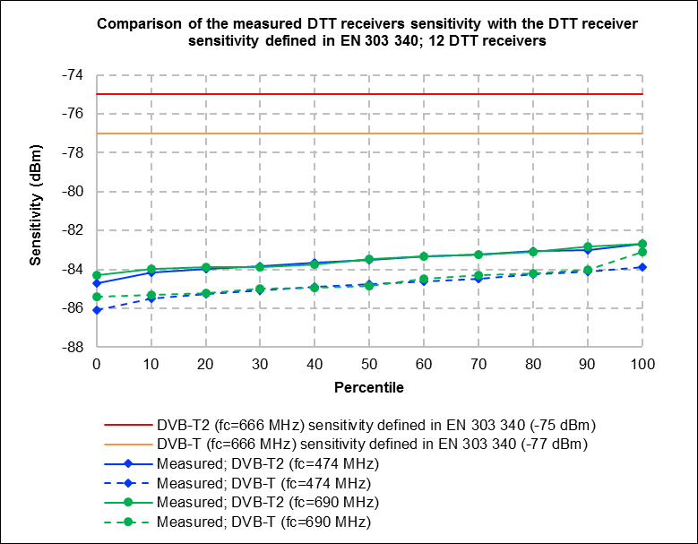

**Figure 41: Measured DTT receiver sensitivity**

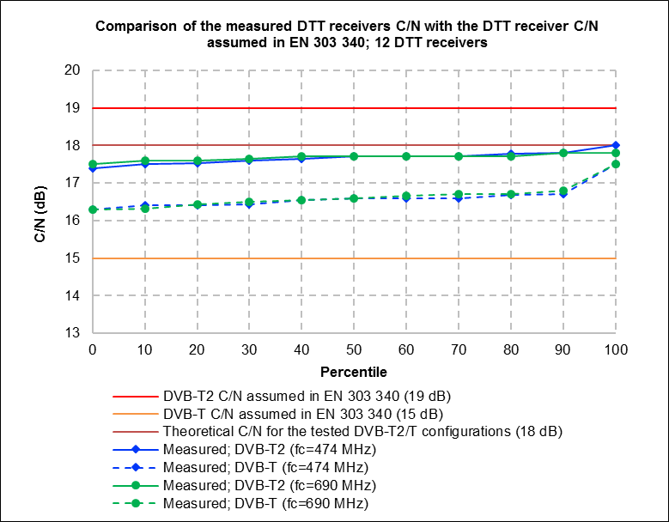

**Figure 42: Measured DTT receivers carrier to noise ratios**

* + - 1. *Performance of DTT receivers under Gaussian channel conditions in the presence of an LTE interfering signal for different LTE-DTT frequency offsets*

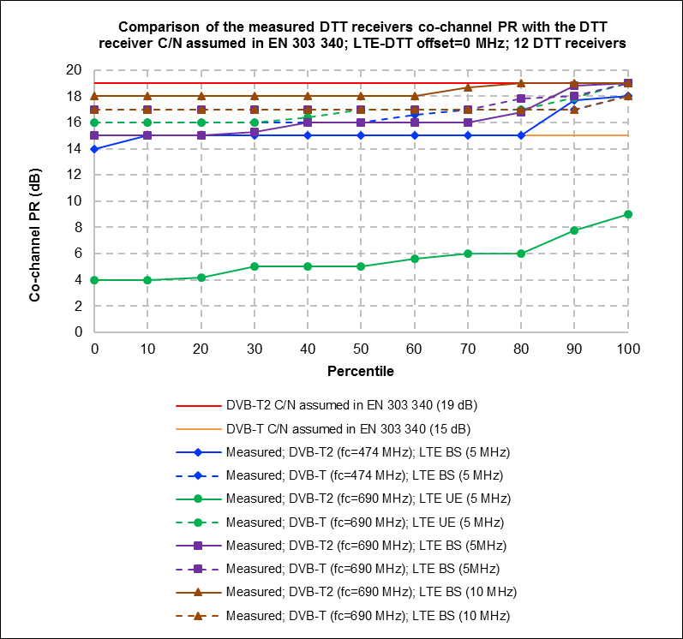

**Figure 43: Measured DTT receivers co-channel protection ratios**

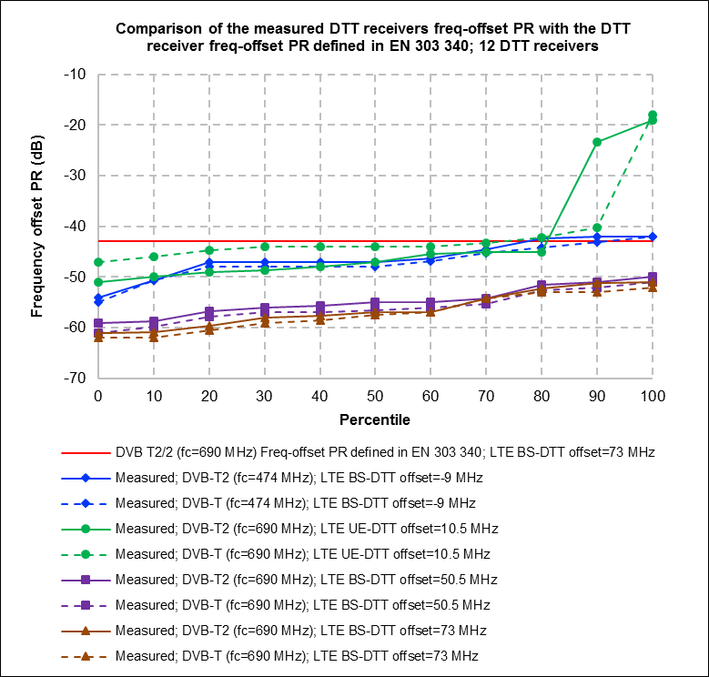

**Figure 44: Measured DTT receivers frequency offset protection ratios**

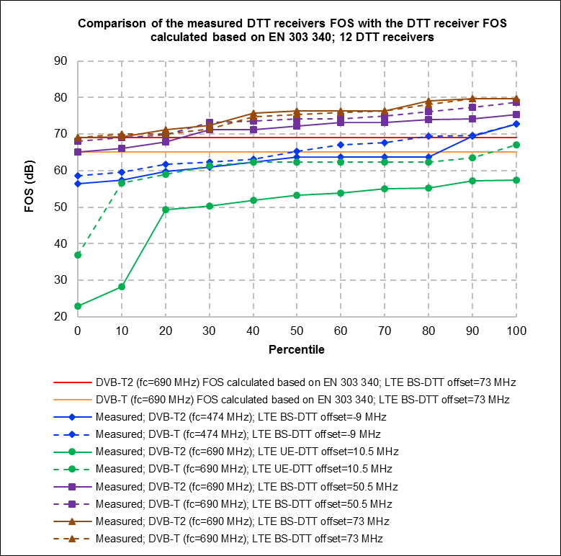

**Figure 45: Measured DTT receivers blocking responses**

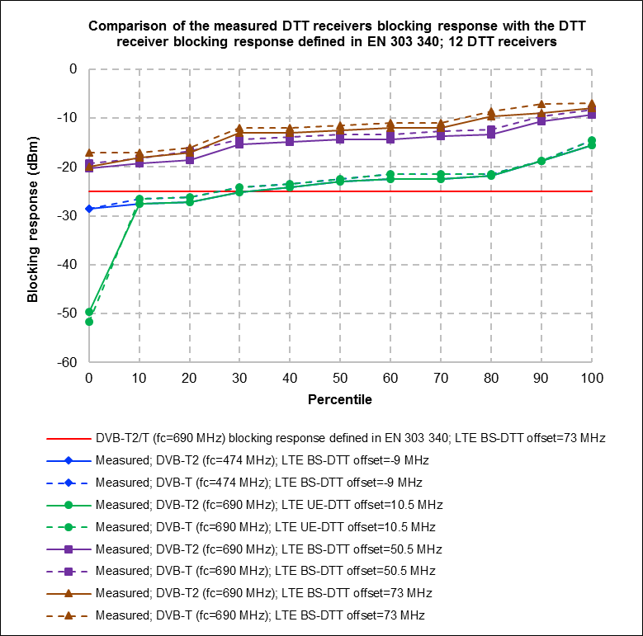

**Figure 46: Measured DTT receivers overloading thresholds**

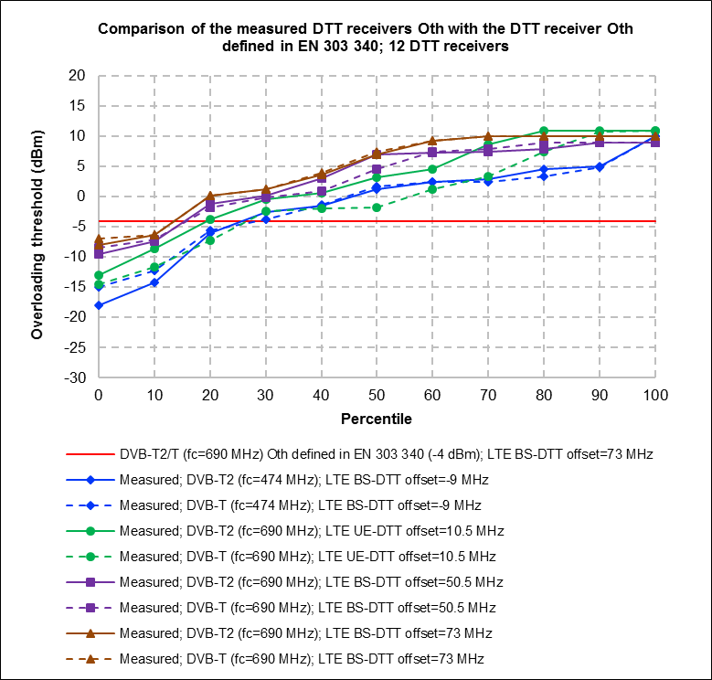

Figure 47: Calculated DTT receivers frequency offset selectivity

*8.2.6.8 Conclusion*

A total of 12 different DTT receivers (DVB-T2/T) were tested. Measurement results show that:

* Sensitivity, FOS, frequency offset PR and blocking responses of measured DTT receivers are respectively 6-9 dB, 2-14 dB, 8-19 dB and 5-18 dB better than the values defined in harmonised standard ETSI EN 303 340 [22];
* Concerning overloading threshold only two of the tested receivers have an overloading threshold lower than the limit defined in ETSI EN 303 340.

### DCF77

#### General Information

DCF77 is the standard frequency and time signal used in Western Europe. The transmitter is located in Mainflingen (Germany). The dedicated range is around 1000 km where an average wanted signal strength of 50 dBµV/m can be expected. The relevant RF properties of the DCF77 system are:

* Frequency: 77.5 kHz;
* Modulation: A1A.

There is no relevant ETSI Standard specifying performance criteria for DCF77 receivers.

A total of 11 different watches and clocks were selected as “device under test” (DUT). They are numbered as Rx1 through Rx11 in this section.

Table 21: Devices that were measured

|  |  |  |
| --- | --- | --- |
| Rx | Type | Remarks |
| 1 | Reference receiver | 19” rack receiver to provide reference frequency |
| 2 | Table clock |  |
| 3 | Wall clock |  |
| 4 | Weather station |  |
| 5 | Wrist watch | Designed to use other time signals alternatively |
| 6 | Alarm clock |  |
| 7 | Alarm clock |  |
| 8 | Mini clock module |  |
| 9 | Table clock | needed at least 59 dBµV/m to synchronise |
| 10 | Alarm clock |  |
| 11 | Wrist watch |  |

Because none of the devices had external antenna connectors, all DUTs were measured in a shielded anechoic chamber. The wanted signal was radiate d from a magnetic loop antenna at 10 m from the DUTs. The unwanted signal was an unmodulated carrier supplied through a Helmholtz Coil centred around the DUTs.

The performance or failure criterion was the inability to read the time signal after initialisation of the devices.

#### Sensitivity

For the sensitivity test, the DUTs were oriented in a direction towards the wanted signal so that the reception was optimal.

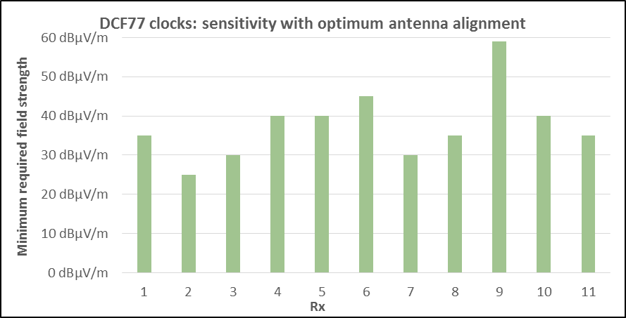

Figure 48: DCF77 sensitivity

#### Selectivity

Since DCF77 operates only on one discrete frequency, there are not channel widths and channel steps defined. Instead of adjacent channel selectivity, the frequency offset selectivity curve was measured. The wanted signal level for this measurement was 50 dBµV/m.

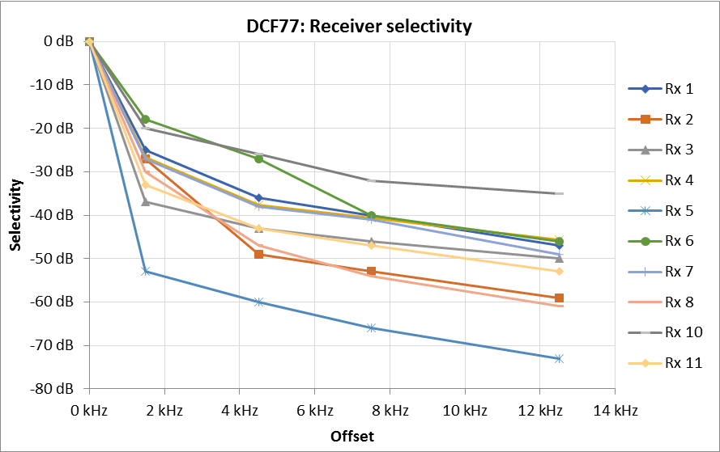

Figure 49: DCF77 frequency offset selectivity

#### Overloading

Because of the limited available unwanted signal level, the DUTs could only be exposed to a maximum field strength of 126 dBµV/m. Only Rx 5 showed indications of overloading at this level.

### GPS

#### General information

The relevant RF properties of the measured GPS system are:

* Frequency (L1-signal): 1575.42 MHz;
* Number of channels: 1;
* Bandwidth: 15 MHz;
* Modulation: BPSK;
* Access: CDMA with 1.023Mchips/s;
* Receive level: -125 to -130 dBm (assumed).

The relevant ETSI Standard for GPS is ETSI EN 303 413 [72].



Figure 50: GNSS upper L-bands

A total of 11 GPS devices of different types were tested.

Table 22: Measured GPS receivers

|  |  |
| --- | --- |
| No. | Type |
| Rx1 | usb receiver |
| Rx2 | hand-held GPS |
| Rx3 | car navigation |
| Rx4 | smartphone |
| Rx5 | smartphone |
| Rx6 | smartphone |
| Rx7 | smartphone |
| Rx8 | smartphone |
| Rx9 | smartphone |
| Rx10 | smartphone |
| Rx11 | smartphone |

It can be assumed that many GPS receivers can also decode signals from other GNSS systems such as Beidou, Galileo and GLONASS. In that case, the receiver bandwidth may be higher than necessary to decode only the GPS L1 signal.

The wanted signal was taken from a GPS signal generator that produced signals from four satellites well above the horizon. For the majority of the tests, the performance criterion used was the ability to maintain tracking of all four already acquired satellites (“tracking” criterion). The level to acquire satellites and establish a location fix after a start of the receiver is higher (“fix” criterion). This level was only determined for sensitivity measurements.

Because none of the measured receiver provided access to an external antenna, all measurements were performed in radiated mode while the receiver was placed inside a G-TEM cell with calibrated RF characteristics.

#### Sensitivity

In order to keep the necessary measurement effort within reasonable borders, a warm-start scenario was chosen. This means the EUT has established a connection to the simulated satellite signals recently, is synchronised to the GPS time, has information about the satellites’ ephemeris and a rough estimate of the device’s position and speed. The wanted GPS level was increased in steps of 1 dB until the exact position was established (“fix” criterion). Then, the GPS level was decreased until at least one of the four satellites could no longer be decoded (“tracking” criterion).

For each device, the orientation inside the G-TEM cell providing best sensitivity was determined and individually kept throughout the whole measurement series.

The ETSI EN 303 413 [72] does not contain sensitivity requirements.

The following table and figure show the results of the sensitivity measurements.

Table 23: Sensitivity of the GPS receivers

|  |  |  |
| --- | --- | --- |
| No. | Fix | Tracking |
| Rx1 | -136 dBm | -144 dBm |
| Rx2 | -147 dBm | -155 dBm |
| Rx3 | -140 dBm | -148 dBm |
| Rx4 | -140 dBm | -147 dBm |
| Rx5 | -128 dBm | -133 dBm |
| Rx6 | -139 dBm | -144 dBm |
| Rx7 | -138 dBm | -146 dBm |
| Rx8 | -143 dBm | -149 dBm |
| Rx9 | -139 dBm | -143 dBm |
| Rx10 | -135 dBm | -142 dBm |
| Rx11 | -133 dBm | -139 dBm |

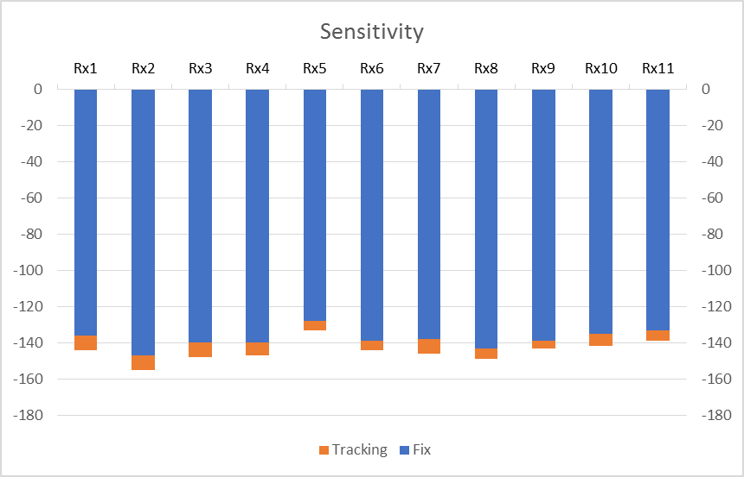

Figure 51: Sensitivity of the GPS receivers

Observations:

Real GPS signals on the earth’s surface produce typical receiver input levels between -125 to -130 dBm which could be handled by all tested devices. It is apparent that most receivers have a sensitivity between ‑130 and ‑140 dBm for the ‘fix’ criterion. Performance regarding the ‘tracking’ criterion is subject to similar variation. Best performance was shown by Rx2, a hand-held GPS device. On the other extreme, the smartphone labelled Rx5 is known for its poor GPS performance.

* + - 1. *Selectivity*

Since there is only one specific L1 frequency (no channellisation plan), there is no defined “adjacent channel rejection”. Measurements of the frequency offset selectivity curve and adjacent band selectivity were therefore combined.

ETSI EN 303 413 [72] specifies only 5 different interfering frequencies for adjacent band performance. To provide a higher frequency resolution for the selectivity curve, a total of 12 offset frequencies were measured.

An FM modulated signal evenly spreading its energy in a bandwidth of 1.04 MHz was used as the interfering signal. The wanted GPS level was set to 3 dB above the measured receiver sensitivity for the “tracking” criterion. Then the interfering signal was increased in steps of 1 dB until at least one of the four satellites could no longer be decoded. Both wanted and unwanted signals were combined by a directional coupler in the feeder line to the G-TEM cell with the GPS receiver.

The measured unwanted signal levels at the failure point (“tracking” criterion) were normalised to the interfering signal level at exactly the wanted frequency of 1575.42 MHz. This could be assumed as the point at which the receiver has its highest sensitivity. The difference between this reference level and the failure levels at other frequency offsets is a measure for the receiver selectivity.

The following figure shows the normalised results of the selectivity measurement. The “non-filled” dots at the end of some selectivity curves (e. g. Rx 3 at 1526.4 MHz) indicate levels where the EUT could not yet be interfered. This means that the actual selectivity at these frequency offsets is higher than indicated in Figure 52

It should be noted that the “limit line” from ETSI EN 303 413 is specified for a different performance criterion (degradation of S/N0 ≤ 1 dB at a wanted signal level of -128.5 dBm) than the “tracking” criterion used for these receiver measurements. It can therefore not accurately be normalised in the same way as the selectivity curves of the measured receivers and should be used as a rough indication only.

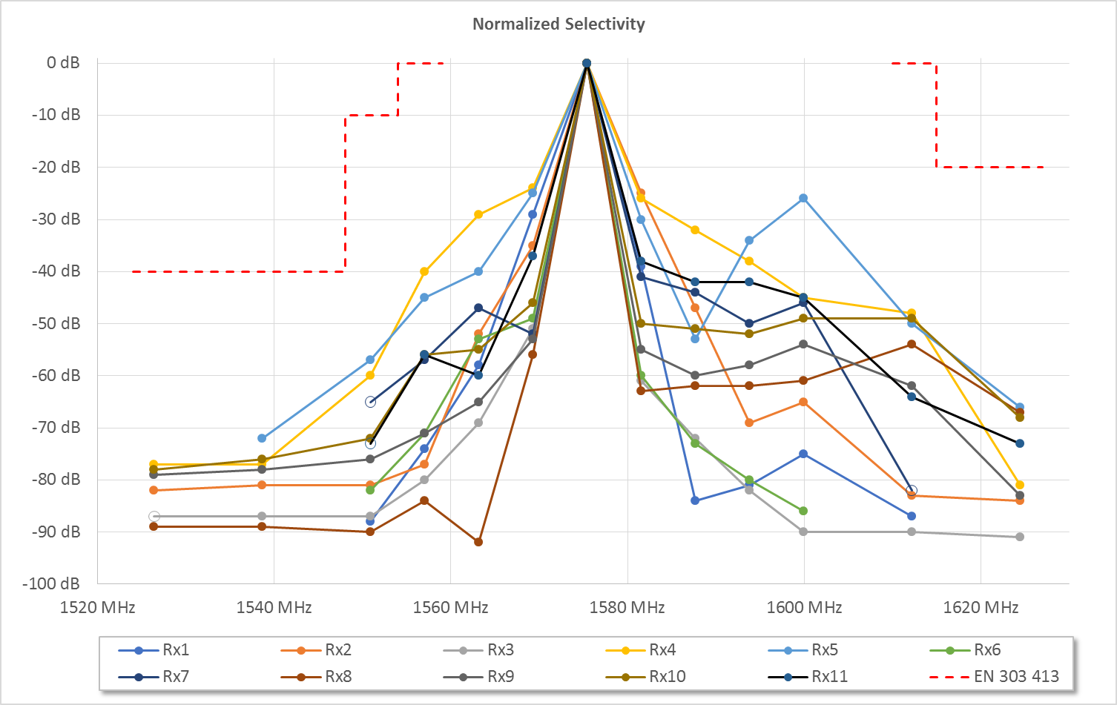

Figure 52: Measured frequency offset selectivity of the GPS receivers

Observations:

There is a considerable spread in selectivity between the EUTs, especially in the offset range up to -20 and +40 MHz. The best overall selectivity was shown by Rx 3. The selectivity of Rx 4 is up to 40 dB poorer.

The selectivity of many EUTs is not symmetric. It is often better towards the lower band edge. This may be due to the fact that some devices also support the GLONASS system with the same RF front-end as used for GPS and Galileo.

* + - 1. *Blocking and overload*

The setup to measure blocking and overload of the receivers was equal to the setup shown in Figure 57 in Annex 2. According to the agreed measurement concept the wanted signal levels for the blocking measurement was set to 3 dB and 13 dB above the measured sensitivity.

Wanted levels for overload measurements according to the measurement concept would have been 30 and 50 dB above sensitivity. These levels could never be reached in real environments and would render this measurement unrealistic by definition. However, during the blocking measurements, some receivers showed signs of overloading at the higher wanted signal levels.

The ETSI EN 303 413 definition of the RNSS band includes the frequencies used for Beidou, GLONASS and Galileo, covering 1559 to 1610 MHz. The test points in its adjacent channels at 1554 and 1615 MHz are greatly supressed by the selectivity of the receiver as shown in the previous measurement. The interfering CW signal for blocking was placed at 1625.42 MHz, fulfilling the ETSI requirement for out-of-band emissions of a 2+ channel distance for GPS (but not for Galileo, Beidou or GLONASS).

The measurement procedure was similar to the one used for selectivity measurements (see section above). The “tracking” criterion was used for this measurement.

The following table and figure show the result of this measurement. The difference between wanted and unwanted signal levels is stated for each of the two wanted signal levels as C/I. The underlined results in the table point out cases where the interfering signal level indicated could not yet produce a failure. These cases are marked with a “non-filled” dot in the table.

Table 24: Blocking and overload measurement results - GPS level = sensitivity + 3 dB

|  |  |  |  |  |
| --- | --- | --- | --- | --- |
| Rx No. | Wanted level | Interfering level | C/I | probable effect |
| 1 | -141 dBm | -13 dBm | 128 dB | blocking |
| 2 | -152 dBm | -14 dBm | 138 dB | blocking |
| 3 | -145 dBm | -10 dBm | 132 dB | - |
| 4 | -144 dBm | -20 dBm | 124 dB | Overloading |
| 5 | -130 dBm | -26 dBm | 104 dB | blocking |
| 6 | -141 dBm | -19 dBm | 122 dB | Blocking |
| 7 | -143 dBm | -10 dBm | 133 dB | - |
| 8 | -146 dBm | -40 dBm | 106 dB | Overloading |
| 9 | -140 dBm | -13 dBm | 127 dB | Blocking |
| 10 | -139 dBm | -19 dBm | 120 dB | Blocking |
| 11 | -136 dBm | -10 dBm | 126 dB | - |

Table 25: Blocking and overload measurement results - GPS level = sensitivity + 13 dB

|  |  |  |  |  |
| --- | --- | --- | --- | --- |
| Rx No. | Wanted level | Interfering level | C/I | probable effect |
| 1 | -131 dBm | -10 dBm | 121 dB | - |
| 2 | -142 dBm | -10 dBm | 132 dB | - |
| 3 | -135 dBm | -10 dBm | 122 dB | - |
| 4 | -134 dBm | -19 dBm | 115 dB | Overloading |
| 5 | -120 dBm | -20 dBm | 100 dB | Overloading |
| 6 | -131 dBm | -10 dBm | 121 dB | - |
| 7 | -133 dBm | -10 dBm | 123 dB | - |
| 8 | -136 dBm | -40 dBm | 96 dB | Overloading |
| 9 | -130 dBm | -10 dBm | 120 dB | - |
| 10 | -129 dBm | -10 dBm | 119 dB | - |
| 11 | -126 dBm | -10 dBm | 116 dB | - |

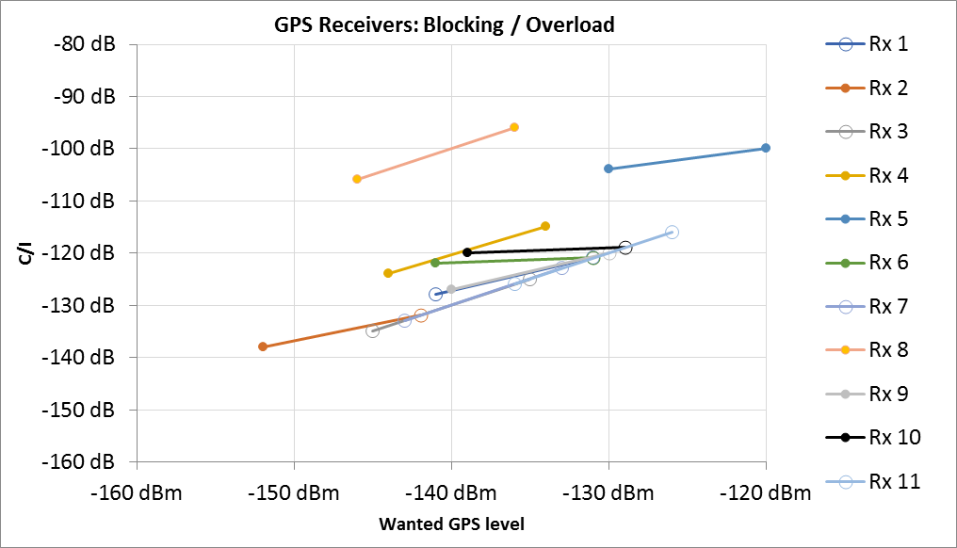

Figure 53: Blocking and overload measurement results

Observations:

* If blocking is the dominating effect, the C/I for both wanted signal levels should be equal. This was not the case for any receiver;
* If overloading is the dominating effect, the interfering level should be equal for both wanted signal levels. This was the case for Rx 4 and Rx 8;
* In cases where the increase of interfering level is between 0 and 10 dB, it was assumed that the receiver is overloaded at the higher wanted signal level and desensitised at the lower wanted level. This was the case for Rx 5;
* In cases where the receiver could not be interfered when supplied with the higher wanted signal level it must be assumed that the dominating effect is blocking. This was the case for Rx 1, 2, 6, 9 and 10;
* Receivers 3, 7 and 11 could not be interfered with by any unwanted signal level up to -10 dBm.

ETSI EN 303 413 [72] does not contain requirements for blocking and overload performance.

* + - 1. *Intermodulation immunity*

For measurement of the IM immunity, the following two interfering signals were used:

1. Unmodulated carrier at 1850 MHz
2. FM modulated, 1 MHz wide signal at 2124.58 MHz

These signals produce a third order intermodulation product at the wanted GPS frequency. Both IM signals had the same level.

The wanted GPS level was adjusted to 3 dB above the measured sensitivity for the “tracking” criterion.

For the receivers showing interference, the measurement was repeated with a wanted signal level increased by 10 dB. If intermodulation is actually the dominating interference effect, it could be expected that the interfering level necessary to reach the failure point increases by 3 dB when the wanted signal level is raised by 10 dB. If the receiver could not be interfered with by this raised wanted signal level, intermodulation at the lower wanted signal level was proven by switching off one of the two interfering signal generators and verifying that the receiver recovered again.

The following table and figure show the results of the intermodulation immunity measurements. The yellow underlined values are cases where the receiver could not be interfered with by the indicated IM level.

Table 26: Intermodulation measurement results - GPS level = sensitivity + 3 dB

|  |  |  |  |
| --- | --- | --- | --- |
| Rx No. | GPS level | Interfering level | C/I |
| 1 | -141 dBm | -23 dBm | 118 dB |
| 2 | -152 dBm | -18 dBm | 134 dB |
| 3 | -145 dBm | -18 dBm | 124 dB |
| 4 | -144 dBm | -19 dBm | 125 dB |
| 5 | -130 dBm | -18 dBm | 112 dB |
| 6 | -141 dBm | -20 dBm | 121 dB |
| 7 | -143 dBm | -18 dBm | 125 dB |
| 8 | -146 dBm | -18 dBm | 128 dB |
| 9 | -140 dBm | -18 dBm | 122 dB |
| 10 | -139 dBm | -18 dBm | 121 dB |
| 11 | -136 dBm | -18 dBm | 118 dB |

Table 27: Intermodulation measurement results - GPS level = sensitivity + 13 dB

|  |  |  |  |
| --- | --- | --- | --- |
| Rx No. | GPS level | Interfering level | C/I |
| 1 | -131 dBm | -20 dBm | 111 dB |
| 2 | -142 dBm | -18 dBm | 124 dB |
| 3 | -135 dBm | -18 dBm | 114 dB |
| 4 | -134 dBm | -18 dBm | 116 dB |
| 5 | -120 dBm | -18 dBm | 102 dB |
| 6 | -131 dBm | -18 dBm | 113 dB |
| 7 | -133 dBm | -18 dBm | 115 dB |
| 8 | -136 dBm | -18 dBm | 118 dB |
| 9 | -130 dBm | -18 dBm | 112 dB |
| 10 | -129 dBm | -18 dBm | 111 dB |
| 11 | -126 dBm | -18 dBm | 108 dB |

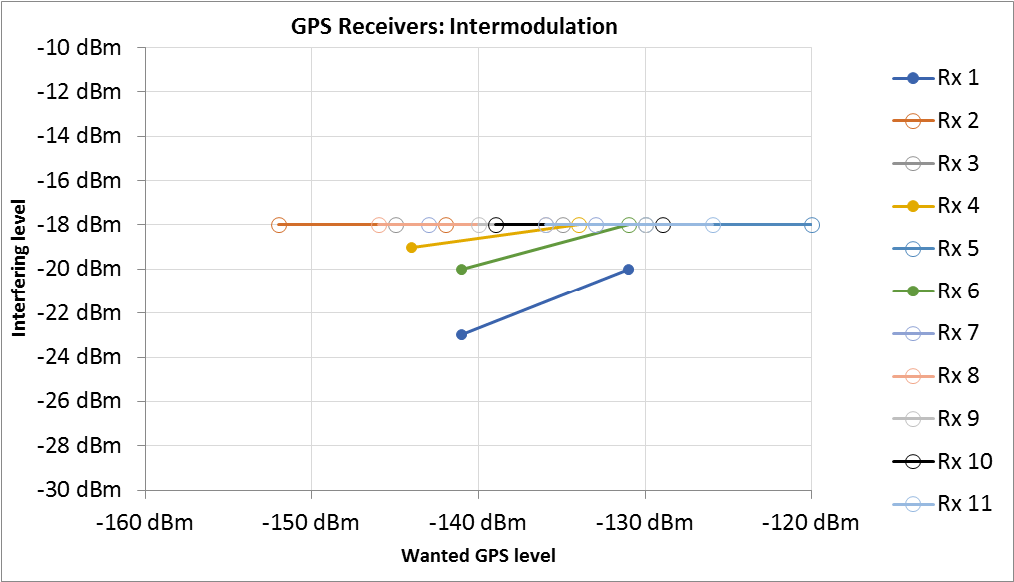

Figure 54: Intermodulation measurement results

Observations:

* Intermodulation could only be measured for Rx 1, 4 and 5. The other receivers could withstand more than -18 dBm interfering level without being affected by IM.

ETSI EN 303 413 [72] does not contain requirements for intermodulation performance.

* + - 1. *Analysis of the measurement results in comparison with ETSI Harmonised Standards*

The measurements have shown a high spread of selectivity between the receivers tested. This may be because some receivers also support other GNSS systems such as Beidou, Glonass or Galileo, which operate on slightly different frequencies. Those receivers must have a wider bandwidth than the receivers only designed for GPS.

Overloading and intermodulation do not seem to be problematic even in the presence of very strong interfering signals.

Comparison of the performance with requirements of the relevant ETSI Standard is difficult because the performance criterion used in ETSI EN 303 413 could not be evaluated using readily available GPS equipment. Furthermore, the standard only contains requirements for selectivity and not for any of the other receiver parameters tested.

## Overall findings from the measurements

The measurements conducted in this Report give information on how receivers would behave in the presence of some types of interference. When available, these are analysed and compared with ETSI Harmonised Standards. Where information is not available in Harmonised Standards, other ETSI standards and specifications are used, but in some cases no information is available at all. ETSI Harmonised Standards contain a limited set of parameters whereas other ETSI standards and specifications may contain additional information. Manufacturers applying ETSI Harmonised Standards, shall meet the limits whereas the limits in other ETSI standards and specifications are voluntary.

These measurements show that for some receiver parameters, there is a gap of a few dB to about 20-30 dB compared to the limits specified in ETSI Harmonised Standards and other ETSI standards and specifications. However, there are some measurements where some receiver parameters did not meet the ETSI limits. In some of these cases, this could be due to the parameter being voluntary because it is not in the Harmonised Standard, or it could be due to the different measurement setup and method.

The following was observed for the measured receivers:

* **Sensitivity:** Measured sensitivity was generally better than limits given in standards (where specified);
* **Selectivity/adjacent channel selectivity:** Measured selectivity/adjacent channel selectivity of all receivers is better than standards (where specified) apart from a couple of cases;
* **Blocking:** The measured blocking performance is better than standards (where specified) apart from a couple of cases;
* **Overloading immunity:** For some of the measurements performed, it was difficult to generate an unwanted signal that was strong enough to cause overloading in the receiver. The measured overloading performance is generally better than the standards (where specified) apart from some cases;
* **Intermodulation immunity:** Measured intermodulation performance is better than standards (where specified).

# Conclusions

There are several experiences in CEPT administrations and examples in CEPT/ECC studies where receiver performance was found to be a limiting factor for co-existence between radio services and systems. The reports have resulted in different outcomes. In some of these cases, co-existence was deemed unfeasible, or restrictions were put on the transmitter (power restrictions guard bands etc). In several cases, improvement of receiver performance may have improved the sharing and compatibility outcomes. Going forward, CEPT/ECC should consider the feasibility of stipulating improved receiver performance, where it is found to be a limiting factor in sharing and compatibility studies. CEPT/ECC should provide information on the necessary receiver performance improvements to ETSI for consideration in Harmonised Standards under the Radio Equipment Directive. Additionally, CEPT administrations can pursue improved receiver performance into Harmonised Standards through their participation in ETSI. It is also important that receiver performance should be specified in Harmonised Standards with a sufficient level of resilience from the outset in order to achieve satisfactory sharing and compatibility outcomes. This will minimise the need to remediate receivers already deployed and in use noting that Harmonised Standards only cover products at the time they are placed on the market.

The following parameters are generally critical for most sharing and compatibility studies noting that additional parameters not listed below may be required for future or specific studies. These parameters are also consistent with previous CEPT/ECC studies and it is likely that these same parameters will remain important for future studies:

* Co-channel protection ratio;
* Adjacent channel selectivity / frequency offset selectivity;
* Receiver Blocking.

It was observed that parameters such as selectivity and blocking are commonly included in a large number of Harmonised Standards, but other parameters are less common.

Some parameters are not readily available in standards and at this point in time and some standards may not provide enough information for sharing and compatibility studies. If these parameters are needed for a particular sharing and compatibility study they will need to be obtained. If certain receiver parameters are important in sharing and compatibility studies, it is likely that these are important in Harmonised Standards to adequately characterise the receiver.

When conducting sharing and compatibility studies, receiver parameters should first be based first on ECC deliverables, ETSI Harmonised Standards, ITU-R Recommendations, or other CEPT information or studies. Information about receiver performance sourced from vendors, held by regulators, or results of relevant measurements carried out on equipment can also be used.

Care needs to be taken when dealing with coexistence of unlike systems and there is always going to be a challenge when assessing the impact of varying bandwidths when the necessary parameters on receiver performance cannot be directly derived from technical documentation (e.g. Harmonised Standards). These studies will need to be done on a case by case basis. It would be sensible to supplement this with measurements.

The Report has identified the following areas of improvement for receiver performance:

1. When CEPT/ECC conducts sharing and compatibility studies and identifies that interference may occur and the receiver performance is the limiting factor, improving receiver performance should be considered as a possible mitigation, noting that a number of other mitigation techniques may also be considered.
2. Complete and accurate information on receiver performance is important to understand how a receiver behaves in the presence of an interferer. It is noted that a full sharing and compatibility study may need additional information on receivers than the parameters currently provided in some ETSI Harmonised Standards.
3. Receiver parameters such as selectivity and blocking need to be referenced to a clearly defined reference sensitivity in order to allow a full understanding of these parameters.
4. Where there is a large gap between representative measured levels and conformance limits for receiver parameters, further investigations may be required to determine if this gap could be reduced

ECC should consider the development of a Recommendation addressing receiver resilience to adjacent frequency use (e.g. blocking and selectivity) based on the analysis in this Report. Such a Recommendation should focus on areas that are relevant for sharing and compatibility between different systems.

1. Analysis of previous CEPT/ECC reports

This annex analyses several previous CEPT/ECC Reports where receiver characteristics were considered in the study. Many of these reports looked at several different compatibility scenarios and when necessary frequency or geographical separations. This analysis is not exhaustive and only focuses on some scenarios where receiver characteristics have played a predominant role in the compatibility scenario and where improvements to the receiver may have been beneficial. The studies analysed were the following:

* CEPT Report 41 [42], ECC Reports 162 [43] and ECC Report 229 [13] (Compatibility between 900 MHz GSM-R and LTE/WiMAX);
* CEPT Report 30 [4], ECC Report 138 [5] and ECC Report 148 [6] (Compatibility between 800 MHz DTT receivers and UMTS/LTE);
* ECC Report 191 [7] (Compatibility between 1800 MHz PMSE and GSM/LTE);
* ECC Report 165 [8] (Compatibility between 2500 MHz CGC and LTE);
* ECC Report 174 [9] (Compatibility between 2600 MHz MFCN and Radars in the band 2700-2900 MHz);
* ECC Report 263 [10], ECC Report 299 [11] (Compatibility between 1500 MHz LTE and MSS).

In addition, ECC Report 127 [12] on the impact of receiver standards on spectrum management [12] was analysed and summarised below. This Report did not contain a specific compatibility study but a general analysis of receivers, including ECC experiences in compatibility studies with regard to receivers.

* 1. Summary of observations and findings in previous CEPT/ECC Reports

All of the different CEPT/ECC Reports analysed found that receiver performance was the limitation in achieving compatibility. The different studies had different proposals and outcomes on how to address the receiver performance. This is summarised below:

**Compatibility between 900 MHz GSM-R and LTE/WiMax:** CEPT Report 41 [42] identified issues with GSM-R receivers but considered coexistence could be achieved without restrictions/mitigations on the receiver as the issue was being rectified by standardisation bodies. Subsequent, ECC Reports (ECC Report 162 [43] and ECC Report 229 [13]) noted interference problems and identified mitigations/co-ordination procedures to minimise the interference issues and not unduly restrict use of the adjacent band.

**Compatibility between 800 MHz DTT receivers and UMTS/LTE:** CEPT Report 30 [4] found that interference could occur to television reception through the adjacent channel selectivity (ACS) performance of the television receiver.ECC Reports 138 [5] and 148 [6] derived protection criteria based on performance of DTT receivers and suggested that this information should be used by administration seeking to protect DTT.

Compatibility between 1800 MHz PMSE and GSM/LTE: ECC Report 191 [7], proposed restrictions/mitigations on the transmit power of PMSE close to the band edges. ECC Report 191 did not consider in detail the feasibility of improving receiver performance as a mitigation. While it is difficult to say if this would have improved the outcomes, it would have been beneficial to study this in the Report.

Compatibility between 2500 MHz CGC and LTE: ECC Report 165 [8] proposed restrictions/mitigations for the transmit power of CGC which precluded it (compatibility was not feasible). ECC Report 165 did not consider the feasibility of improving receiver performance as a mitigation. While it is difficult to say if this would have improved the outcomes, it would have been beneficial to study this in the Report.

**Compatibility between 1500 MHz LTE and MSS:** ECC Report 263 [10] found that MSS terminal performance were the limiting factor and proposed mitigations to improve the receiver blocking performance of MSS terminals, this information was liaised to ETSI and is still a work in progress. As complement to ECC Report 263, ECC Report 299 [11] addresses proportionate solutions for currently operating maritime and aeronautical MESs that do not meet this blocking requirement.

The receiver parameters that were considered in the above studies are:

* Receiver selectivity/adjacent channel selectivity (all studies);
* Receiver blocking (all studies);
* Intermodulation performance (compatibility between 900 MHz GSM-R and LTE/WiMAX);
* Overload performance (compatibility between 800 MHz DTT receivers and UMTS/LTE).

The two predominant receiver parameters limiting coexistence seem to be receiver selectivity/ACS and blocking. It is likely that these two parameters (not limited to) will remain key parameters for future sharing and compatibility studies. Intermodulation and overload performance parameters were used in two separate studies, these are important for wide band receivers particularly in areas of high interfering signal strength.

**Did studies overestimate or underestimated interference?**

In CEPT Report 41 [42] compatibility between 900 MHz GSM-R and LTE/WiMAX may have underestimated the scale of the compatibility issues with GSM-R receivers. The report did clearly identify the receiver performance issues and noted that there was work underway in ETSI and 3GPP to update standards. However, it seemed to take longer than expected to resolve issues and for improved receivers being available on the market. GSM-R systems operating at minimum sensitivity added to the problem. Also, it seemed that the problem perpetuated with the growth of both GSM-R networks and MFCN networks. Ultimately the issues were resolved with a combination of receiver improvements and co-ordination.

Reports on compatibility between 800 MHz DTT receivers and UMTS/LTE (CEPT Report 30 [4], ECC Reports 138 [5] and 148 [6]) are likely to have overestimated the compatibility issues related to DTT receivers and in practice there were very few compatibility issues. Other reports studying compatibility between 1800 MHz PMSE and GSM/LTE(ECC Report 191 [7]) and compatibility between 2500 MHz CGC and LTE (ECC Report 165) may have also overestimated interference caused by receiver performance. This could be because they made conservative assumptions taking parameters from conformance standards and using conservative protection criteria. However, it is difficult to make a judgement on if it was an overestimate or if the analysis was exact.

**Would improvements to receiver performance have changed the outcome?**

For the studies in many of these reports, making improvements to the receiver performance could have made a difference to the outcomes in the studies and the proposed mitigations. Many of these reports predate the introduction of the Radio Equipment Directive [1] which explicitly included receivers and became mandatory on 13 June 2017. As a result, ETSI Harmonised Standards have been updated to include receiver parameters. It is noted that improving the limits for receiver performance through Harmonised Standards could now be a mechanism/mitigation that was not previously available.

The studies (CEPT Report 41 and ECC Reports 162 and 229) on compatibility between 900 MHz GSM-R and LTE/WiMAX identified the issues with GSM-R receiver performance and also noted that ETSI and 3GPP were updating standards. However, there was already an installed base of GSM-R receivers and the availability of new better performing receivers seemed to take some time. If new better performing GSM-R receivers were made available shortly after the problem was identified, then this would have prevented the problem from perpetuating, particularly with the growth of both GSM-R networks and MFCN. It also could have reduced the scale of remediation required on the existing installed base of GSM-R equipment. The issues could clearly be minimised with improvements to receiver performance but there would have been a benefit from the improvements being made earlier to reduce the scale of the problem.

The studies on compatibility between 1500 MHz LTE and MSS (ECC Report 263) clearly identify the issues with MSS receiver blocking performance and identified that improvement of this mitigates/reduces interference issues. Action was also taken to advise ETSI of its findings for consideration in Harmonised Standards under the Radio Equipment Directive. This is still a work in progress but it clear that improvements to receiver performance were a benefit in this case. Making these improvements in a timely manner will be important to reduce the scale of the issues in the future.

The studies that looked at compatibility between 800 MHz DTT receivers and LTE (CEPT Report 30) identified issues with ACS as being potentially limiting factors in compatibility. However, the reports did not identify improvements to receiver performance as a mitigation. At a later stage a Harmonised Standard was written under the Radio Equipment Directive that did make improvements to the receiver performance of new equipment. Clearly there would have been a benefit and a different outcome in these studies if DTT receiver performance were improved.

The reports studying compatibility between 1800 MHz PMSE and GSM/LTE (ECC Report 191) and 2500 MHz CGC and LTE (ECC Report 165) did not consider the feasibility of improving receiver performance as a mitigation. While it is difficult to say if this would have improved the outcomes, it could have been beneficial to assess this in the reports.

Table 28: Summary of the observations and findings in CEPT/ECC Reports

|  |  |  |  |  |
| --- | --- | --- | --- | --- |
| Report | Receiver parameters that limited compatibility | Overestimated or underestimated interference? | Would improvements to receiver performance have changed the outcome? | Work conducted before or after implementation of the RED? |
| CEPT Report 41 [42]  ECC Report 162 [43]  ECC Report 229 [13]  (Compatibility of GSM-R and LTE/WiMAX) | GSM-R receiver Blocking and intermodulation | Early reports may have underestimated the scale of interference | Yes, improvements to receiver performance minimise the issue. There would have been a benefit to improving new equipment early to minimise issues | Before |
| CEPT Report 30 [4]  ECC Report 138 [5]  ECC Report 148 [6]  (Compatibility between DTT receivers and LTE) | DTT receiver Adjacent Channel Selectivity, Selectivity and Overload | CEPT Report 30 overestimated interference as there have been few compatibility issues | Yes, but improvements to receiver performance were not identified as mitigation technique. | Before |
| ECC Report 191 [7] (Compatibility between PMSE and GSM/LTE) | GSM/LTE receiver blocking | Not clear but likely to have overestimated | Not clear but considering improvements as a mitigation would have been beneficial | Before |
| ECC Report 165 [8] (Compatibility between CGC and LTE) | UMTS receiver blocking | Not clear, but likely to have overestimated | Not clear but considering improvements as a mitigation may have been beneficial | Before |
| ECC Report 263 [10] (Compatibility between LTE and MSS)  ECC Report 299 [11] | MSS receiver blocking | Not clear, too early to say | Yes, improvement can be made to blocking performance and ETSI currently have work underway to do this. Proportionate solutions for currently operating MESs that do not meet the new blocking requirement. | During/After |

* 1. CEPT Report 41, ECC reports 162 and 229 (Compatibility between 900 MHz GSM-R and LTE/WiMax) [42] [43] [13]

CEPT/ECC produced several reports which studied compatibility between Public Mobile Networks (now called Mobile/Fixed Communications Networks – MFCN) and GSM-R in the 900 MHz band. The analysis in this Report only looks at the latest reports published. Following the introduction and growth of MFCN, GSM-R operators noticed/reported operational limitation because of interference. It was found that interference was caused by the blocking and intermodulation performance of GSM-R receivers particularly where they were operated at minimum sensitivity. GSM-R receivers were subsequently improved in voluntary industry standards and then later reflected in a Harmonised Standard under the RED covering new equipment. For existing equipment, co-ordination and remediation receivers may be needed where filters need to be installed or equipment needs to be replaced.

* + 1. CEPT Report 41: “Compatibility between LTE and WiMAX operating within the bands 880-915 MHz/925-960 MHz and 1710-1785 MHz/1805-1880 MHz (900/1800 MHz bands) and systems operating in adjacent bands” [42]

Extract from the executive summary:

Table 29: Extract from CEPT Report 41 Executive Summary

|  |  |  |
| --- | --- | --- |
| Section of Report for further details | Band/Scenario (interferer >victim) | Summary Result |
| 4 | 880 MHz/925 MHz  LTE/WiMAX to GSM-R | In general, there isno need of an additional guard band between LTE/WiMAX900 and GSM-R whatever the channellisation or bandwidth considered for LTE/WiMAX900. ECC Report 096 [73] concludes that a carrier separation of 2.8 MHz or more between the UMTS carrier and the nearest GSM-R carrier is sufficient. For LTE/WiMAX900, the frequency separation between the nearest GSM-R channel centre frequency and LTE/WiMAX channel edge should be at least 300 kHz (at least 200 kHz between channel edges) |
| 4.2 | 925 MHz - LTE/WiMAX BS to GSM-R MS | For some critical cases (e.g. with high located antenna, open and sparsely populated areas served by high power LTE/WiMAX BS close to the railway tracks, which would lead to assumption of possible direct line of sight coupling) the MCL calculations demonstrate that coordination is needed for a certain range of distances (up to 4 km or more from railway track) when the GSM­R signal is close to the sensitivity level.  In order to protect GSM-R operations, LTE/WiMAX operators should take care when deploying LTE/WiMAX in the 900 MHz band, where site engineering measures and/or better filtering capabilities (providing additional coupling loss in order to match the requirements defined for the critical/specific cases) may be needed in order to install LTE/WiMAX sites close to the railway track when the LTE/WiMAX network is using the channel adjacent to the GSM-R band. The deployment criteria of the GSM-R network such as the field strength level at the GSM-R cell edge could be also strengthened in order to improve the immunity of the GSM-R network towards the emissions from other systems. |
| 4.2 | 880 MHz – GSM-R MS to LTE/WiMAX BS | It is beneficial to activate GSM-R uplink power control, especially for the train mounted MS, otherwise the impact on LTE/WiMAX capacity could be important when the LTE/WiMAX network is using the 10 MHz of spectrum adjacent to the GSM-R band. However, it has to be recognised that this is only applicable in low speed areas as elsewhere the use of uplink control in GSM-R will cause significantly increased call drop out rates.  Another solution would be to introduce a higher frequency separation between the GSM-R channel and the 900 MHz allocation by allowing transmission in the extended GSM-R band. However, this solution should be counter-balanced by the potential impact onto the upper part of the 900 MHz allocation. Due to the blocking response profile of LTE, the base station deployed above 890 MHz may also suffer from desensitization due to E-GSM-R BS emissions. |
| 4.3 | 915 MHz - LTE/WiMAX MS to E-GSM-R MS  (CEPT has recently adopted amendments to ECC Decisions (02)05 on GSM-R and (04)06 on wideband PMR/PAMR. The amended Decisions provide a possibility for GSM-R extension (E-GSM-R) into the bands 873-876 MHz and 918-921 MHz on a national basis under the PMR/PAMR umbrella). | The LTE/WiMAX UE transmitting power is relatively limited, at 23 dBm. In reality, mobile terminals rarely emit a maximum power of 23 dBm (in 90% of cases they would emit 14 dBm or less. By considering that the minimum coupling loss between UE and E-GSM-R BS is relatively large (80 dB is used in ECC Report 082 [74] between UE and BS in rural area) compared to the MCL between LTE/WiMAX BS and GSM-R Train Mounted MS, and since the UE is moving, the interference from LTE/WiMAX UE to E-GSM-R MS should not lead to interference. For detailed analysis of interference between LTE/WiMAX UE to E-GSM-R MS, Monte-Carlo simulations should be performed; this is not covered in this Report. |
| 4.3 | 915 MHz - E-GSM-R BS to LTE/WiMAX BS  (CEPT has recently adopted amendments to ECC Decisions (02)05 on GSM-R and (04)06 on wideband PMR/PAMR. The amended Decisions provide a possibility for GSM-R extension (E-GSM-R) into the bands 873-876 MHz and 918-921 MHz on a national basis under the PMR/PAMR umbrella). | The worst interference case is the interference from E-GSM-R BS to LTE/WiMAX BS.  The interference from E-GSM-R BS operating at frequencies above 918 MHz may cause receiver desensitization and blocking of LTE/WiMAX900 BS operating below 915 MHz. The specifications of the GSM-R BTS characteristics in the expected extension band are assumed to be the same as those of GSM-R in the primary band.  It is assumed the GSM-R BTS for extension band will be designed to protect efficiently the upper part of the uplink 900 MHz band, in particular the spurious emissions will be aligned to the spurious emissions as currently defined to protect the 900 MHz receive band. The main challenge would be to achieve this level in a 3 MHz offset instead of a 6 MHz frequency offset. However, as it would not be sufficient to prevent blocking of LTE/WiMAX base stations, the utilization of interference mitigation techniques should be assessed in order to protect efficiently LTE/WiMAX900 BS. |
| 5.2 | 915 MHz - LTE/WiMAX MS to PMR/PAMR MS | The LTE/WiMAX UE transmitting power is relatively small, at 23 dBm. In reality, mobile terminals rarely emit a maximum power of 23dBm (in 90% of cases they would emit 14 dBm or less. By considering that the minimum coupling loss between UE and PMR/PAMR BS is relatively large (80 dB is used in ECC Report 082 between UE and BS in rural area) compared to the MCL between LTE/WiMAX BS and GSM-R Train Mounted MS, and since the UE is moving, the interference from LTE/WiMAX UE to PMR/PAMR MS should not lead to interference. For detailed analysis of interference between LTE/WiMAX UE and PMR/PAMR MS, Monte-Carlo simulations should be performed; this is not covered in this Report.  The worst interference case is the interference from PMR/PAMR BS to LTE/WiMAX BS (see next section). |
| 5.5 | 915 MHz - PMR/PAMR BS to LTE/WiMAX BS | The interference from PMR/PAMR (CDMA PAMR, TETRA, TAPS) BS operating at frequencies above 915 MHz will cause receiver desensitisation of LTE/WiMAX900 BS operating below 915 MHz. In order to protect LTE/WiMAX900 BS, the utilisation of interference mitigation techniques is necessary:   1. Reduced PMR/PAMR BS Tx power; 2. Spatial separation by coordination between operators; 3. External filters applied to the PMR/PAMR BS; 4. Sufficient guard band between the 900 MHz mobile allocation and the first PMR/PAMR channel in use.   It is more likely that a combination of these interference mitigation techniques should be used in order to ensure the compatibility of LTE/WiMAX900 operating below 915 MHz and PMR/PAMR (CDMA PAMR, TETRA, TAPS) operating above 915 MHz. |
| 6 | 960 MHz - LTE/WiMAX BS to DME/L-DACS | The LTE and WiMAX BS masks for the 900 MHz bands are aligned with the UMTS900 mask for all the LTE/WiMAX channelisation bandwidth available and are expected to have similar characteristics in terms of average power. Similarly, the protection criteria of LTE and WiMAX terminals is aligned with that of UMTS, and hence the conclusions regarding interference between UMTS and DME/L-DACS should be applicable to the scenarios involving LTE/WiMAX on one side and DME/L-DACS on the other side, for the same signal bandwidth.  When considering LTE/WiMAX with higher carrier bandwidth (> 5 MHz), the compatibility results should be improved. With a large number of interferers with lower bandwidths (<5 MHz), the aggregate interference from LTE would increase. However, it is not expected that LTE will be deployed with lower bandwidth. Bandwidth different from 5 MHz for LTE/WiMAX has not been addressed in detail.  The results of the studies are as follows:   1. L-DACS2 airborne transmitters will not cause any interference to LTE/WIMAX terminals, when the distance between the aircraft and an outdoor LTE/WIMAX terminal is greater than 8.6 km, with a L-DACS2 transmitting frequency of 960.1 MHz. For a L-DACS2 transmitting frequency of 96.6 MHz, this distance becomes 6.5 km. The limiting factor is currently the selectivity of the LTE/WIMAX UE; 2. L-DACS2 ground stations could cause desensitization to LTE/WIMAX terminals at a distance up to 17.5 km, depending on the propagation characteristics in the area considered and L-DACS2 ground station antenna height, with a L-DACS 2 transmitting frequency of 960.1 MHz. For a L-DACS2 transmitting frequency of 962.6 MHz, this distance becomes 14.7 km. The limiting factor is currently the selectivity of the LTE/WIMAX UE; 3. No interference from LTE/WIMAX base stations to DME airborne receivers is expected above 972 MHz. Below 972 MHz some interference, in the order of 3 to 4 dB, may occur at low altitudes for the mixed-urban case; 4. L-DACS airborne receivers are no more sensitive to interference than DME; 5. LTE/WIMAX base station transmissions may cause interference to L-DACS ground stations, if these stations are deployed in the lowest part of the band, and if the L-DACS TDD option is selected, in the order of 17 to 25 dB, depending on the distance from the ground station to the nearest base station. If the FDD (L-DACS-1) option is chosen and the associated ground stations receive at frequencies far above 960 MHz, then the interference from LTE/WIMAX base stations to these ground stations would be alleviated.   CEPT Report 42 [75] gives results on the compatibility between UMTS and DME/L-DACS2. Those results have been extended to the compatibility between LTE/WiMAX and DME/L-DACS, based on the similarities between UMTS on one side and LTE/WiMAX on the other side.  For additional information, see CEPT Report 42, especially with respect to mitigation techniques. |
| 7 | 960 MHz - LTE/WiMAX BS to MIDS MS | To avoid any interference on each MIDS frequency the protection distance between LTE/WiMAX900 base station and MIDS stations should be up to 2 km accordingly when the MIDS receiver is placed in the direction of the LTE/WiMAX base station antenna that corresponds to the worst-case situation.  However, the protection should be reduced if the real unwanted emission level of the equipment is better than specified. For the worst case situation (the MIDS receiver is placed in the direction where the LTE/WiMAX base station antenna gain is maximum), to fully protect MIDS without any protection distance, the unwanted emission level should be:   * 21 dB better than specified in the 970-1000 MHz band; * 17 dB better than specified in the 1000-1206 MHz MIDS band (corresponding to the 1-12.75 GHz spurious band); * For other azimuths of antenna, the separation distance and the additional filtering requirements decrease.   However, a performance degradation of the MIDS can be tolerated: this corresponds to interference on the first 11 MIDS channels (ranging from 969 to 999 MHz). Consequently, if there is an additional isolation of 17 dB above 1 GHz no additional separation distance is required to protect the MIDS receiver for the worst case situation (the MIDS receiver is placed in the direction where the LTE/WiMAX base station antenna gain is maximum).  Information put forward by some manufacturers about the performance of a typical LTE/WiMAX900 base station shows that the practical level of unwanted emission provides isolation considerably higher than that required (17dB). Indeed, the interference criteria would be met already at 980 MHz or even lower. It should be noted that the study did not take into account the regulatory status of JTIDS/MIDS, which operates in the band 960-1215 MHz under the conditions of provision 4.4 of the Radio Regulations [3]. |
| 8 | 1880 MHz. LTE/WiMAX BS to DECT BS/MS | It can be concluded that the interference created by the LTE/WiMAX1800 system would be similar to the interference created by GSM1800.  No guard band is therefore required between LTE/WiMAX1800 and DECT allocations, provided that DECT is able to properly detect interference on closest DECT carriers F9-F7 and escape to more distant carriers F6-F0 within 1880-1900 MHz  LTE/WiMAX1800 macro-cells can be deployed in the same geographical area in coexistence with DECT which is deployed inside of the buildings, as the interference between DECT RFP and PP and macro-cellular LTE/WiMAX1800 BS and UE is not a problem;  When pico-cellular LTE/WiMAX1800 BS is deployed inside of the building in coexistence with DECT RFP and PP deployed in the same building indoor area, some potential interference is likely to exist from indoor pico-cellular LTE/WiMAX1800 BS to DECT if they are placed too close and they are operating in the adjacent channel at 1880 MHz. |
| 9 | 1710 MHz. LTE/WiMAX MS to METSAT Earth station receivers | The METSAT Earth stations have been adjacent to GSM1800 for many years, and they have not experienced interference from GSM MS transmissions. It is believed that the interference from LTE/WiMAX UE to METSAT Earth Stations operating in adjacent frequency band is unlikely to be a problem. |
| 10 | 1785 MHz. Radio microphone to LTE/WiMAX BS | It can be considered that the proposed guard band of 700 kHz in ERC Report 063 [57] and ERC Recommendation 70-03 [58] for the protection of GSM1800 is sufficient for protecting LTE/WiMAX1800 BS receivers. This assumes that the radio microphone maximum transmitting power is limited to 13 dBm (20 mW) for hand held microphones and 17 dBm (50 mW) for body-worn microphones, as recommended in ERC Report 63 and ERC Recommendation 70-03. |
| 11 | 1710 MHz/1785 MHz/1805 MHz. LTE/WiMAX BS to fixed service | Compatibility between UMTS and Fixed Services operating in co-frequency and adjacent bands was studied and reported in ERC Report 065 [60] and ERC Report 064 [59] . As described in these two ERC Reports, the critical interference scenarios are between UMTS BS and Fixed Service stations. It is thought that these Reports are also applicable to LTE/WiMAX.  The Fixed Service frequency range is adjacent to LTE/WiMAX1800 UL at 1710 MHz and 1785 MHz. The potential interference, if any, will be between Fixed Service and LTE/WiMAX1800 BS at 1805 MHz. The interference analysis method used in the two ERC Reports can be used to derive the coordination distance, that is the separation distance between LTE/WiMAX BS and Fixed Service stations as a function of frequency separations between LTE/WiMAX base station and Fixed service station, as an interference prevention solution, as described in ERC Reports 064 and 065. |

* + 1. ECC Report 162: “Practical mechanism to improve the compatibility between GSM-R and Public mobile networks and guidance on practical coordination” [40]

Extract from the executive summary:

*“Recently some GSM-R operators have noticed operational limitations caused by interferences to their networks from public mobile networks emissions. Coordination carried out between public mobile networks and GSM-R operators in some countries shows that there exist some remedies to alleviate these interferences.*

*In the future, the number of interference cases may increase, due to the expected growth of GSM-R network deployment and the potential growth of public mobile networks.*

*Moreover, public mobile networks may suffer from GSM-R mobile station emissions when deployed in adjacent frequencies and in geographical close vicinity.*

*This Report focuses on the coexistence between public mobile networks operating in the 900 MHz band and GSM-R networks operating both in the GSM-R band (876-880 MHz/921-925 MHz) and the E-GSM-R band (873-876 MHz/918-921 MHz).*

*Several scenarios have been identified as relevant whereas most of them have already been studied in CEPT (ECC Reports 096 and 146 and CEPT Report 41). Consequently, the existing results have been taken into account with complements added for some of them. Several scenarios between public mobile networks and GSM-R have been studied in detail in this Report in particular those involving E-GSM-R.*

*This Report provides guidance to improve the coexistence between GSM-R and public mobile networks and describes potential mitigation techniques which may be considered by national administrations and/or operators on both sides to address interference cases between GSM-R and public mobile networks on a local/regional/national basis.*

*It should be noted that the list of measures is not exhaustive and that additional spectrum engineering techniques may be considered on a case-by-case basis. Applying a single one of the measures may not be sufficient in all cases but rather a combination of methods.*

*In addition, preventive methods to avoid interference situations between GSM-R and public mobile networks can be applied on a national/regional basis. Interoperability and continuity of GSM-R service shall be ensured from one country to another one, as well as public operators' licence obligations have to be fulfilled.*

*In general, the use of mitigation techniques should be limited to the cases necessary in order to avoid undue constraints on both networks and facilitate an efficient use of spectrum.”*

* + 1. ECC Report 229 : “Guidance for improving coexistence between GSM-R and MFCN” [13]

Extract from the executive summary:

*“Measurement campaigns performed during 2013-2014 concluded that current GSM-R receivers are affected by intermodulation products generated from a wideband signal such as UMTS/LTE, two narrowband signals such as GSM, or a combination of wideband and narrowband signals. Wideband signals can impact the whole GSM-R downlink frequency range. UMTS, LTE/5 MHz and LTE/10 MHz have similar interference potential.*

*In order to sustainably mitigate interferences due to blocking and intermodulation, the standard for GSM-R radios has been improved with respect to the receiver characteristics and published in June 2014 as ETSI TS 102 933-1 v1.3.1. GSM-R radios compliant with this new specification are robust against MFCN emissions in the E-GSM band.*

*Field tests carried out in the UK clearly showed the improvements achieved by the radio module vendors. They result from the use of a built-in filter function which prevents the creation of IM3 products inside the GSM-R RF-frontend and the improvement of the linearity of the receiver chain.*

*As a certain period of time is needed to implement GSM-R radios with improved performance in all trains within Europe, a transition period should be defined in which additional mitigation measures are required to avoid GSM-R interferences, such as coordination/cooperation between MFCN and GSM-R operators.*

*Before and during the transition period, the coordination/cooperation process is intended to avoid/mitigate issues related to intermodulation or blocking. Nevertheless, improved receivers may still be impacted by MFCN out-of-band (OOB) emissions falling into the receiving band of the GSM-R radio. Thus, the process is also intended to prevent interference from MFCN OOB emissions before, during and after the transition period. Visibility and exchange of information between the stakeholders shall remain after the transition period to prevent any further issues.*

*The process is described in section 7 and can be adapted to meet national needs; it remains a national decision, noting that there are existing processes in use in some CEPT countries. The process is to be used proactively for existing, new and modified sites as well as reactively for resolving actual interference cases.*

*Changes at the GSM-R radio equipment such as incorporation of a filter at trains (in front of cab radios or EDORs) or exchange of radio modules, as well as changes on the MFCN network side, are expensive and time consuming.*

*The coordination volume and effort should be kept as low as possible for all involved parties; otherwise the ability to rollout both MFCN and GSM-R could be jeopardised. Furthermore, the risk of interference should be evaluated from the occurrence probability and the severity of its consequences on railway operation. Therefore, a pre-filtering of critical zones is suggested to be conducted before detailed coordination is triggered.*

*This Report also includes in its section 5.1 a calculation method that gives the maximum MFCN OOB level below 924.9 MHz and anywhere at 4m above the rail tracks, which should trigger the proactive coordination process. It should take into account national GSM-R parameters.*

*To support the technical analysis, a single agreed technical tool could be developed. It would allow GSM-R and MFCN operators, as well as the spectrum regulator, to use the same tool, thus avoiding mutual misunderstandings. The report recommends the usage of a common tool, e.g. SEAMCAT, which is an interference assessment tool and not a network planning tool.”*

* 1. CEPT Report 30, ECC Report 138, andECC Report 148 (Compatibility between 800 MHz DTT receivers and UMTS/LTE)

CEPT Report 30 - *“The identification of common and minimal (least restrictive) technical conditions for 790 - 862 MHz for the digital dividend in the European Union”* [4] covered compatibility between mobile systems and television receivers. It concluded:

“*Compatibility of ECN base stations with high power terrestrial broadcasting*

Simulations over a range of scenarios indicate that the fraction of locations in which a TV receiver may suffer unacceptable levels of interference (failure rate) does not improve significantly with a reduction in the ECN BS BEM baseline below 0 dBm/(8 MHz), based on typical measured values for ACS and on a range of high e.i.r.p. of the base station (≥59 dBm/10 MHz). However, for lower e.i.r.p. levels, this fraction of locations in which a TV receiver may suffer unacceptable levels of interference (failure rate) shows significant improvement with a reduction in the ECN BS BEM baseline.

The different set of studies realised so far show that the impact of interference cannot be arbitrarily reduced through a reduction of the BS out-of-block (OoB) emission alone due to finite TV receiver selectivity. Therefore, other mitigation mechanisms (beyond the BEM baseline level) would ultimately be required if the protection delivered by the BEM only is considered insufficient by an administration, e.g. by means of additional measures at the national level”

ECC Report 138 - “Measurements on the performance of DVB-T receivers in the presence of interference from the mobile service (especially from UMTS)” [5] was aimed to assist administrations seeking to protect their broadcasting services in the band 470-790 MHz from interference generated by UMTS services in the band 790-862 MHz. It concluded:

"In general, protection ratios showed a decrease in values (from -31 to -67 dB for the base station interference and from -5 to -55 dB for the user equipment interference) as the frequency offset increases. However, the protection ratio in the image channel is similar to the one in the third adjacent channel. The overloading threshold shows only small variations with frequency offset.

At equal frequency offsets the impact of user equipment interference into DVB-T receiver is considerably higher than the one from the base station, the effect being linked to the use of transmit power control. In particular, the latter increases the required protection ratio by 12-26 dB and decreases the overloading threshold detected by 7-11 dB depending on the frequency offset.

The results may be used by administrations seeking to protect their broadcasting services from interference generated by UMTS services in the band 790-862 MHz”

ECC Report 148 [6]- “Measurements on the performance of DVB-T receivers in the presence of interference from the mobile service (especially from LTE)” [6] aimed to assist administrations seeking to protect their broadcasting services in the band 470-790 MHz from interference generated by LTE in the band 790-862 MHz and was complementary to ECC Report 138. It concluded:

“This report presents the results of measurements to assess the performance of DVB-T receiver in terms of measured carrier-to-interference protection ratios and overloading thresholds in the presence of a single interfering LTE signal. In total, 81 DVB-T receivers (set top boxes, television set integrated receivers, USB sticks, mobile receivers available on the market in 2009), which are considered to be typical DVB-T receivers, have been tested against LTE interference in a Gaussian channel environment (6 receivers were measured also in a time-variant Rayleigh transmission channel). These receivers are implementing either conventional can-type tuners or silicon-based tuners. Interference in co-channel, first adjacent channel and beyond has been considered. Values for the measured protection ratios and overloading thresholds have been statistically calculated at the 10th, 50th and 90th percentile for all the receivers tested.

Amongst the most noticeable results is the wide range of performance of individual receiver depending on the nature of the LTE uplink signal. Some preliminary indications show that, amongst other, it may be related to the way the Automatic Gain Control of the DVB-T receiver is designed in some specific receivers. Industry is investigating further this matter.

The results may be used by administrations seeking to protect their broadcasting services from interference generated by LTE downlink or uplink transmissions in the band 790-862 MHz.”

Observations:

1. CEPT Report 30 [4]underlines that “The different set of studies realised so far show that the impact of interference cannot be arbitrarily reduced through a reduction of the BS out-of-block (OoB) emission alone due to finite TV receiver selectivity. Therefore, other mitigation mechanisms (beyond the BEM baseline level) would ultimately be required if the protection delivered by the BEM only is considered insufficient…”.
2. ECC Report 138 [6] underlines that “The overloading threshold shows only small variations with frequency offset. At equal frequency offsets the impact of user equipment interference into DVB-T receiver is considerably higher than the one from the base station, the effect being linked to the use of transmit power control.”

Note that the findings of these reports emphasise the importance of the receiver selectivity in compatibility between services. However, improvements to receiver characteristics were not considered as a mitigation.

* 1. ECC Report 191 Adjacent band compatibility between MFCN and PMSE audio applications in the 1785-1805 MHz frequency range [7]

Extract from the executive summary:

* + 1. BEM[17] proposal for PMSE audio applications in the frequency band 1785-1805 MHz

Table 30: BEM for hand-held microphone

|  |  |  |  |
| --- | --- | --- | --- |
|  | **Frequency range** | **Hand-held e.i.r.p.** | **Reasoning** |
| OOB | < 1785 MHz | -17 dBm/(200 kHz) | LTE UE spectrum emission mask |
| Restricted frequency range | 1785-1785.2 MHz | 4 dBm/(200 kHz) | Blocking of GSM BS |
|  | 1785.2-1803.6 MHz | 13 dBm/channel |  |
|  | 1803.6-1804.8 MHz | 10 dBm/(200 kHz) (note 1) | Slow increase of LTE UE selectivity |
| Restricted frequency range | 1804.8-1805 MHz | -14 dBm/(200 kHz) | Blocking of GSM UE |
| OOB | > 1805 MHz | -37 dBm/(200 kHz) | OOB calculation, in line with ERC Recommendation 74-01 |
| Note 1: with a limit of 13 dBm/channel | | | |

Table 31: BEM for body-worn microphone

|  |  |  |  |
| --- | --- | --- | --- |
|  | **Frequency range** | **Body-worn e.i.r.p.** | **Reasoning** |
| OOB | < 1785 MHz | -17 dBm/(200 kHz) | LTE UE spectrum emission mask |
|  | 1785-1804.8 MHz | 17 dBm/channel |  |
| Restricted frequency range | 1804.8-1805 MHz | 0 dBm/(200 kHz) | Blocking of GSM UE |
| OOB | > 1805 MHz | -23 dBm/(200 kHz) | OOB calculation (note 1)* |
| Note 1: For the body-worn case the body loss is 14 higher than for the hand-held case, therefore the -23 dBm for body-worn is equivalent to -37 dBm for hand-held. | | | |

* 1. ECC Report 165: “OMPATIBILITY STUDY BETWEEN MSS complementary ground component operating in THE BANDS 1 610.0-1 626.5 MHz AND 2 483.5-2 500.0 MHz and OTHER SYSTEMS in the same bands or in adjacent bands” [8]

Extract from the executive summary:

*“For the frequency band 2483.5-2500 MHz:*

1. *Compatibility between CGC BS operating in the band 2483.5-2500 MHz and IMT above 2500 MHz is difficult, deploying CGC BS as cellular network layout is not possible based on the coexistence conditions from CEPT Report 19:*

*The main interference mechanism is the IMT BS adjacent band selectivity and blocking, in order to protect IMT uplink reception above 2500 MHz, CGC BS transmit power at the BS output should be limited to -10.5 dBm in the frequency range 2495-2500 MHz with a 100 m separation distance, in a macro cellular environment. Since this is not feasible, a restriction of CGC operations to the band 2483.5-2495 MHz is therefore required.”*

* 1. ECC Report 174: ”Compatibility between 2600 MHz MFCN and Radars in the band 2700-2900 MHz” [9]

Extract from the executive summary:

*“Two interference effects of potential mutual interference have been studied:*

* ***Blocking****: where a signal outside of the nominal receiver bandwidth causes the victim receiver to experience an increased noise level or go into compression, thus producing non-linear responses;*
* ***Unwanted emissions****: where the unwanted emissions (OOB and spurious) of the interfering transmitter fall into the receiving bandwidth of the victim receiver.*

***Impact from mobile systems into radars:***

*Blocking:*

* *Studies have shown that additional isolation depending on the separation distance would be required between the mobile service base station and the radar. As an example, for a separation distance of 1 km this additional required isolation is in the order of 20-60 dB depending on the radar characteristics such as antenna height, gain, radiation patterns, radar frequency and bandwidth, number and size of mobile blocks, etc. The actual impact should be determined on a case-by-case basis. Currently, it is planned in a number of administrations to address this issue by improving the radar adjacent band rejection capability through enhancing receiving chains where needed;*
* *It should be noted that the non-linear responses could be dominant for some radar frequencies compared with other effects;*
* *In addition, studies have shown that the blocking effect from mobile service terminals operating in accordance with the FDD band-plan (in the 2500-2570 MHz band) is not considered to be a problem and no additional isolation is required for this case.*

*Unwanted Emissions:*

* *Based on the assumption that unwanted emissions of mobile equipment are -30 dBm/MHz[18] in the band 2700-2900 MHz, studies have indicated that there would be a need for an additional isolation depending on the separation distance between the two services. As an example, for a separation distance of 1 km, this additional isolation would be in the order of 30-45 dB for the base station and 15-20 dB for the mobile service terminal depending on the radar characteristics such as antenna height, gain, radiation patterns, etc.*

***Impact from radar into mobile systems:***

*Blocking:*

* *The additional isolation due to blocking of mobile receivers by radar in-band emissions was not assessed in such details, but by comparison with the impact of radar unwanted emissions. Two different cases were addressed:*

*In-band blocking which refers to a situation of interference that is not attenuated by the duplex filter, i.e. reaches the LNA without being filtered within LTE band.*

*Out-of-band blocking refers to the case when the interference falls outside of LTE band, but it could be within the pass band of the duplex filter.*

* *In cases where the radar unwanted emissions (OoB and/or spurious) attenuation is lower than 78 dBc, in-band blocking to the LTE BS becomes the dominant factor and this blocking level can only be improved accordingly through additional receiver rejection;*
* *In cases where the radar unwanted emissions (OoB and/or spurious) attenuation are above 78 dBc, the LTE BS out of band blocking effect becomes dominant and should be improved accordingly. The out-of-band blocking of user terminal equipment may also be problematic for radar frequencies close to the mobile band, due to the lack of duplexer suppression of the radar interference;*
* *However, the real FDD BS receiver blocking performance is much better than the minimum requirements of in-band & out of band blocking levels defined in the standard due to the duplexer which protects the BS receiver reception (2500-2570 MHz) against its own emission (2620-2690 MHz).*

*Unwanted Emissions:*

* *The results for radar unwanted emissions apply only to LTE systems. Results for other mobile systems may be substantially different, as the analysis relies on very detailed aspects of system characteristics.*
* *Based on the assumption that unwanted emissions of radars are at the regulatory limit contained in ERC Recommendation 74-01 which depends on the radar type and characteristics, studies have shown that there would be a need for additional isolation depending on the separation distance. As an example, based on a separation distance of 1 km, a limit in the spurious domain of -60 dBc and limited to the impact of the radar antenna main beam, the additional isolation needed would be in the order of 75-95 dB to protect the base station and 40-65 dB to protect the terminal equipment. It is recognised that such isolation cannot be fulfilled by additional filtering of radars only.*
* *When the mobile service equipment is within the side lobe of the radar, the required additional isolation would instead be 40-60 dB for BS and 10-30 dB for terminal. It should be noted that 60 dBc attenuation is only valid if there is sufficient separation in frequency between interferer and victim. Otherwise, the attenuation may be as low as 40 dBc instead.*
* *Measurements of some radars indicate that the level of unwanted emission falling into the band 2500-2690 MHz may be much lower than the above mentioned limit and hence the impact may be less severe than the results based on the regulatory levels. Additionally, the intermittent aspect of the interference due to the radar antenna sweeping pattern may limit its impact on the mobile equipment, although a degradation of the quality of service would still be expected in vicinity of radars. The studies related to the latter effect have not been completed.*

*Possible Mitigation Techniques*

*The following is a non-exhaustive list of possible mitigation techniques:*

* *Improvement of the receiver selectivity, in particular for radars, which would help solve the blocking of radars by the mobile service;*
* *Reduce unwanted emissions of radar transmitters;*

*Measured examples of the spectral masks would indicate that the radars are, in practice achieving better than the regulatory limit and hence the impact may be less severe than the results based on the regulatory levels would indicate.*

* *Reduce unwanted emissions of mobile service transmitters;*

*Measured examples, in isolation, (see annex 4) would indicate that mobile service equipment (i.e. base station and user terminal) are in practice better that the regulatory limit (-30 dBm/MHz limit specified in the appropriate EN for mobile equipment operating in these bands). Based on these measurement results it looks like no additional isolation may be needed with at least some existing production equipment;*

*With regard to the base station, if necessary, more stringent unwanted emissions limits above 2.7 GHz may be achieved by introducing additional filtering on a case-by case basis, when appropriate at a national level. This approach has been chosen by some administrations;*

*With regard to the user terminal, the additional isolation cannot be achieved by introducing additional filtering on a case-by-case basis and can only be achieved through harmonised approach.*

* *Reduced power from the mobile service base station;*

*This solution may only be used in some specific instances with base stations near a radar station;*

* *Site specific deployment, e.g.;*

*avoid mobile service base station antennas pointing towards radars (both in azimuth and elevation);*

*take advantage of natural shielding that terrain and buildings provide.*

* *Increase of the distance separation between radar and stations of the mobile service;*

*Increase of the frequency separation;*

*This will enable a further reduction of spurious emissions from mobile service transmitters, which may be considerably lower at e.g. 2730 MHz than at 2700 MHz;*

*The risk of out-of-band emissions from a radar falling into the mobile service spectrum is reduced, and additional suppression of spurious emissions is simplified”.*

* 1. ECC Report 263 and ECC Report 299 (Compatibility between 1500 MHz LTE and MSS)
     1. ECC Report 263: “Adjacent band compatibility studies between IMT operating in the frequency band 1492-1518 MHz and the MSS operating in the frequency band 1518-1525 MHz” [10]

Extract from the executive summary:

*“The results of the simulations show that there will be some interference irrespective of the selected frequency separation.*

*With the assumed values for IMT e.i.r.p. and OOBE and current values of MES receiver blocking, the interference at 1 MHz frequency separation is high from both IMT OOBE and MES receiver blocking. However, at frequency separations of 3 MHz and 6 MHz the interference from IMT OOBE is reduced but the interference due to receiver blocking remains high for current MESs.*

*The report also examines the impact of a number of methods for mitigation of interference including a reduction in the IMT OOBE (these values have been used in the report for the analysis) and a future expectation for the MES receiver blocking characteristics. When the future expectations for MES receiver blocking is also taking into consideration, the interference is reduced to similar levels as for IMT OOBE interference (for frequency separations of 3 MHz and 6 MHz).*

*There may be a need to provide protection for MES at seaports and airports, and hence there may be a need to apply other mitigation techniques to IMT BSs in the vicinity of seaports and airports for the frequencies at the top end of the 1492-1518 MHz frequency band to avoid harmful interference to MESs.*

*Based on the final results of compatibility studies, it is concluded that:*

* *The minimum in-band blocking characteristic for land mobile earth stations receivers from a 5 MHz broadband signal interferer (LTE) operating below 1518 MHz shall be −30 dBm above 1520 MHz[19];*
* *The base station unwanted emission limits e.i.r.p. for a broadband signal interferer (LTE) operating below 1518 MHz shall be −30 dBm/MHz above 1520 MHz. This figure is 10 dB more stringent than ECC Decision (13)03 due to a different service in the adjacent band.*

*It is noted that the IMT block ends at 1517 MHz".*

* + 1. ECC Report 299: “Measures to address potential blocking of MES operating in bands adjacent to 1518 MHz (including 1525-1559 MHz) at sea ports and airports” [11]

Extract from the executive summary:

*“To minimise any potential blocking of next generation MES receivers, CEPT concluded in ECC Report 263 that the minimum in-band blocking characteristic for land mobile earth station receivers from a 5 MHz broadband signal interferer (LTE) operating below 1518 MHz shall be −30 dBm above 1520 MHz, noting that the IMT block ends at 1517 MHz. The same blocking requirement as used for land mobile is assumed for next generation maritime and aeronautical MESs. This Report also addresses proportionate solutions for currently operating maritime and aeronautical MESs, that do not meet this blocking requirement.*

*This Report has considered proportionate solutions that CEPT members could implement to address potential blocking of L-band maritime and aeronautical MES receivers in specific areas or locations. This Report has identified certain maritime and aeronautical applications that administrations may wish to take into account in determining airports and seaports for application of the proportionate measures. Regarding maritime operations, administrations may choose to provide protection based on GMDSS services, which operate in the band 1530-1544 MHz, noting that this may also protect other maritime MSS operations outside this band if used at the same seaports.  Regarding aeronautical operations, administrations may choose to provide protection based on AMS(R)S services, which operate in the band 1525-1559 MHz, noting that this may also protect other aeronautical MSS operations outside this band if used at the same airports.  If administrations also provide protection of MSS applications which are operating outside the GMDSS/ AMS(R)S bands, this may require protection measures at additional seaports/airports, but the pfd values recommended in this Report remain unchanged.*

*Each national administration will decide which areas or locations require protection and how to do so, e.g. by using options outlined in Section 5 of this Report if suitable to their national circumstances.”*

* 1. ECC report 127 "The impact of receiver standards on spectrum management" [12]

Extract from the executive summary:

*“The study has revealed several cases where it would have been possible to make a significant difference to an outcome in spectrum management if the treatment of receiver performance, and particularly the application of receiver parameters, had been different. Historically the extent of technical benefit or disadvantage has not been quantified, and so the evidence available to this study is very limited in how it can be used. In particular, there is a lack of available impact analysis to determine whether and to what extent an alternative approach or alternative receiver parameters would have given a net economic benefit.*

*Improvements in technology allow for opportunities to improve spectrum management. This will be helped at a later stage if standards can play a role in licensing and/or consumer expectation when a service is first launched, in order to manage legacy protection issues at a later stage.*

*Nevertheless, the study has revealed sufficient cases to suggest that the role of receiver parameters in standards and their related consideration in spectrum engineering should receive greater prominence in order to promote more efficient use of the spectrum, including maximising economic and social welfare. Without further study it is difficult to prescribe in detail what regime and approach would be most effective. The depth of study required to evaluate every possible option and all their variations could be out of proportion to the accrued benefits, not least because of the delays to decision making which may be implied by a more complex process. There is also the consideration that such estimates of benefit can be decidedly speculative.*

*The study makes recommendations of principles which could be introduced, or applied with increased vigour, to how receiver performance is specified and regulated, or information made available to consumers. The recommendations are of necessity very general and further study - itself a recommendation of the report - would be needed to turn these into more precise proposals”.*

1. Receiver parameters Measurement Concept applied in this report
   1. General measurement considerations

The objective of receiver measurements is to determine the failure point of the receiver in the presence of an interference. A failure criterion, which is also called performance criterion, is used to define the difference between “interfered” and “not interfered” states of the receiver.

In some cases, the parameter measured as the performance criteria in the relevant ETSI Standard was used. In other cases, a failure criterion that could be readily observed was used.

Examples are:

* Ability to synchronize to the data stream;
* Ability to log on to a radio network;
* Ability to establish a connection;
* Ability to keep an existing connection alive;
* Degradation of audio or video quality;
* Increasing number of requests to repeat transmitted information (ARQ systems).

Usually, in digital systems the first occurrence of degradation in any quality parameter is very close to the point of total system failure or synchronisation loss. This is mainly due to the error correction deployed in almost all digital systems. The difference in interference levels for first performance degradation and synchronisation loss is only a few dB. This is especially true in measurements of effects such as intermodulation and overloading. Due to this behaviour, the exact definition of the failure criterion (as well as the ability to measure it) is often not so important. In many cases, a simple go/no-go test was used as the failure criterion.

If the receiver has an external antenna input, the wanted and interfering signals are fed into the receiver via an RF cable. This allows reproducible results and accurate measurements of signal levels. Furthermore, it ensures that no other (external) signals influence the measurement results.

If the receiver has a built-in antenna only, it is placed inside a G-TEM cell where the RF field is homogeneous. If possible, field tests are avoided, but they may be necessary for receivers not fitting into the G-TEM cell or stationary systems that have to be measured on-site.

Wanted and interfering signals are fed into the receiver via a combining network. In most cases this is a directional coupler.

For systems requiring bidirectional communication in order to function (e. g. mobile phone systems) it may be necessary to split both RF directions by means of circulators in order to adjust levels for up and downlink separately.

Unwanted emissions of the interfering signals falling into the wanted channel were suppressed by means of band pass or notch filters. Spectral shape and unwanted emissions of these signals are recorded with high dynamics.

The measurement setup depends on:

* The RF system (analogue or digital);
* The link requirement (unidirectional or bi-directional);
* The type of receiver (built-in antenna or external antenna connector);
* The receiver parameter to be measured (see section 4).

The following sections show typical measurement setups. They are only examples based on the different aspects listed above.

* 1. Sensitivity measurements

Figure 55 shows a typical receiver sensitivity measurement setup for digital cellular phones equipped with a built-in antenna. Uplink and downlink signals are generated by means of a base station simulator with separate transmitter and receiver RF connectors.

uplink

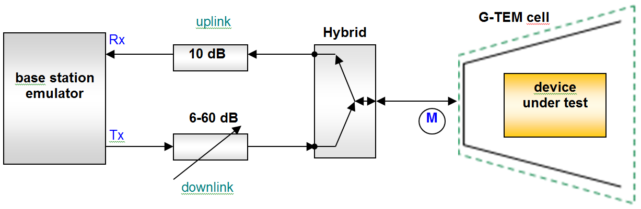

Figure 55: Example setup to measure receiver sensitivity

The signal received by the cellular phone is measured at point “M”. The antenna factor of the G-TEM cell (difference between RF level at measurement point M and field strength inside cell) is measured a-priori.

* 1. Selectivity / Adjacent channel selectivity measurements

Figure 56 shows a typical receiver selectivity measurement setup for a bi-directional data link. The receiver under test has an external antenna connector. A commercial transmitter is used as the counterpart for the connection. BER measurements are not possible, so the failure criterion is the ability to establish a connection.

Signal   
Generator (2)

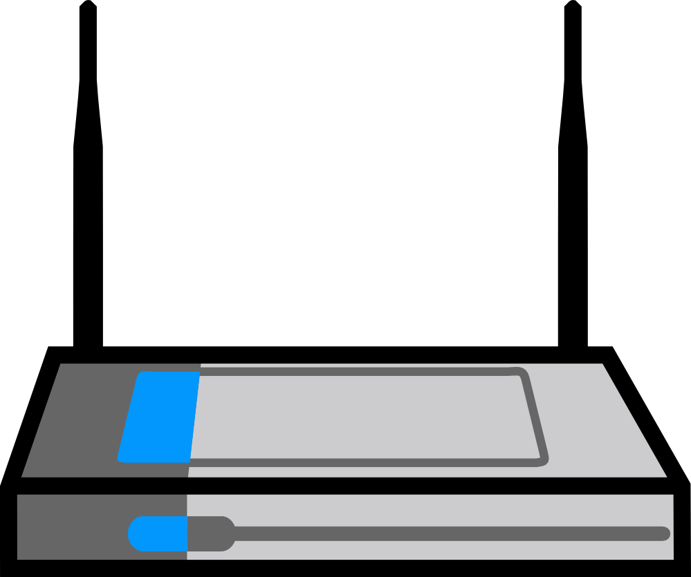

20dB

50dB

Filter

Fwanted



**1**

**2**

Wanted signal

Interferer

Device under test

Directional coupler

Counterpart

Figure 56: Example setup to measure receiver selectivity

For interfering frequencies inside or near the wanted channel, the filter is bypassed (switch position 2). For higher frequency offsets, the filter supresses undesirable sideband emissions and broadband noise from the signal generator to influence the result. The filter could be a notch tuned to the wanted frequency, or a bandpass/highpass/lowpass filter that passes the interfering frequency and blocks the wanted frequency.

* 1. blocking and Overloading measurements

Figure 57 shows a typical receiver overloading measurement setup for a unidirectional data link (e. g. broadcast receiver). The receiver under test has an external antenna connector. A test transmitter is used to provide the wanted signal. The BER or picture failure can be used respectively as objective and subjective failure criterion.

Signal   
Generator (2)

20dB

50dB

Filter

Fwanted

Wanted signal

Interfering signal

Device under test

Directional coupler

Signal   
Generator (1)



Figure 57: Example setup to measure overloading and desensitization

The filter suppresses undesirable sideband emissions and broadband noise from the interfering signal generator. It could be a notch tuned to the wanted frequency, or a bandpass/highpass/lowpass filter that passes the interfering frequency and blocks the wanted frequency.

* 1. Intermodulation measurements

Figure 58 shows a typical receiver intermodulation measurement setup for a unidirectional data link (e.g. PMR, TETRA). The receiver under test has an external antenna connector. A commercial transmitter is used to provide the wanted signal. BER measurements are not possible, so the failure criterion is the beginning of degradation of the audio signal. This is monitored aurally. It is most easy to detect audio degradation when a sine wave (e. g. 1 kHz tone) is transmitted. This signal can be generated by an audio signal generator.

20dB

50dB

Filter

Fwanted

Wanted signal

Interfering signals

Device under test

Directional coupler

Signal   
Generator (2)

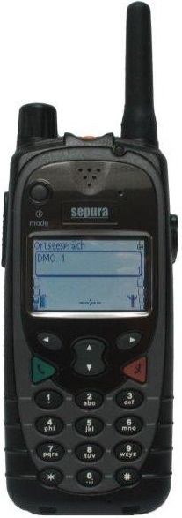

Signal   
Generator (1)

Combiner

Circulator

CW

mod. signal



Sine wave audio signal

Figure 58: Example setup to measure receiver intermodulation

The circulators isolate the two interfering signal generators from each other and thus prevent the interfering signals generators producing undesirable intermodulation products. The filter suppresses undesirable sideband emissions, broadband noise and remaining intermodulation products from the interfering signal generators. It could be a notch tuned to the wanted frequency, or a bandpass/highpass/lowpass filter that passes the interfering frequency and blocks the wanted frequency.

1. list of receiver parameters found in ETSI Harmonised standards

The following contains a list of ETSI Harmonised Standards listed in the Official Journal on of the European Union for Article 3(2) of 2014/53/EU on 14/09/2018 and indicates the receiver parameters they contain.



1. information on the blocking requirements for receivers

In Table 31, the term "in-band" means inside the whole band allocated to a specific radio service or application; consequently, "out-of-band" means a range outside that allocated band (e.g. adjacent bands).

Table 32: Blocking requirements for receivers observed in ETSI RED Harmonised Standards

(14 September 2018)

|  |  |  |  |  |  |
| --- | --- | --- | --- | --- | --- |
| Technology | In-band/out-of-band ∆ Frequency | Blocking Limit (dBm) | Interfering signal type | Wanted Signal level (dBm) | Protection ratio |
| Digital Terrestrial Television Receivers (ETSI EN 303 340 V1.1.2) **[22]** | | | | | |
| DVB-T | In-band | -25 dBm | 10 MHz LTE (fully loaded) | -71 dBm | - 46 dB |
| DVB-T2 | In-band | -25 dBm | 10 MHz LTE (fully loaded) | -69 dBm | - 44 dB |
| 2.4 GHz Wide Band Data Transmission systems (ETSI EN 300 328 V2.1.1) **[23]** | | | | | |
| 2.4 GHz RX  Category 1 | In-band to <±20 MHz | -53 dBm | CW | Pmin + 6 dB  (-76 dBm to  -59 dBm see note 1) | - 23 dB to 6 dB |
|  | >±20 MHz | -47 dBm | CW | Pmin + 6 dB  (-76 dBm -  -59 dBm see  note 1) | -29 dB to -12 dB |
| 2.4 GHz RX  Category 2 | In-band to <±20 MHz | -57 dBm | CW | Pmin + 6 dB  (-76 dBm -  -59 dBm see note 1) | -23 dB to -6 dB |
|  | >±20 MHz | -47 dBm | CW | Pmin + 6 dB  -76 dBm to  -59 dBm see note 1) | -29 dB to -12 dB |
| 2.4 GHz RX  Category 3 | In-band to <±20 MHz | -57 dBm | CW | Pmin + 12 dB  (-70 dBm to  -53 dBm see note 1) | -13 dB to 4 dB |
|  | >±20 MHz | -47 dBm | CW | Pmin + 12 dB  (-70 dBm to  -53 dBm see note 1) | -23 dB to -6 dB |
| **5 GHz RLAN (ETSI EN 301 893 V2.1.1) [24]** | | | | | |
| With radar detection | In-band to <±50 MHz | -53 dBm | CW | Pmin +6 dB (-76 dBm to -59 dBm see note 1) | -26 dB to -6 dB |
|  | >±150 MHz | -47 dBm | CW | Pmin (-76 dBm to -59 dBm see note 1) | -29 dB to -12 dB |
| Without radar detection (slave only) | In-band to <±50 MHz | -59 dBm | CW | Pmin + 6 dB (-76 dBm to -59 dBm see note 1) | -17 dB to 0 dB |
|  | >±150 MHz | -53 dBm | CW | Pmin + 6 dB (-76 dBm to -59 dBm see (note 1) | -23 dB to -6 dB |
| L-Band MES (ETSI EN 301 444 V2.1.2) **[25]** | | | | | |
| L-band MES | >±10 MHz | -40 dBm | CW | Not clear |  |
| Non Specific Short Range devices 25-1000 MHz ETSI EN 300 220 **[26]** | | | | | |
| Non Specific SRD  Category 3:  Minimum Rx requirement in EN 300 220-2 v3.1.1 | ±2 MHz from Operating channel edges Fhigh and Flow±2 MHz | -80 dBm | CW | Sensitivity + 3 dB |  |
| ±10 MHz from Operating Channel edges Fhigh and Flow±10 MHz | -60 dBm | CW | Sensitivity + 3 dB |  |
| ±5% of Centre Frequency or ±15 MHz whichever is the greater | -60 dBm | CW | Sensitivity + 3 dB |  |
| Non Specific SRD Category 2  Minimum Rx requirement in   * ETSI EN 300 220-2 v3.2.1 [27] * ETSI EN 300 220-4 V1.1.1 [28]   ETSI EN 300 220-3-2 v1.1.1 [29] | ±2 MHz from Operating channel edges Fhigh and Flow±2 MHz | -69 dBm | CW | Sensitivity + 3 dB |  |
| ±10 MHz from Operating Channel edges Fhigh and Flow±10 MHz | -44 dBm | CW | Sensitivity + 3 dB |  |
| ±5% of Centre Frequency or ±15 MHz whichever is the greater | -44 dBm | CW | Sensitivity + 3 dB |  |
| Non Specific SRD Category 1.5  Minimum Rx requirement in  ETSI EN 300 220-3-1 v2.1.1 [30] | ±2 MHz from Operating channel edges Fhigh and Flow±2 MHz | -43 dBm | CW | Sensitivity + 3 dB |  |
| ±10 MHz from Operating Channel edges Fhigh and Flow | -33 dBm | CW | Sensitivity + 3 dB |  |
| ±5% of Centre Frequency or ±15 MHz whichever is the greater±10 MHz | -33 dBm | CW | Sensitivity + 3 dB |  |
| Non Specific SRD Category 1  Rx requirement in  ETSI EN 300 220-3-1 v2.1.1[30] | ±2 MHz from Operating channel edges Fhigh and Flow±2 MHz | -20 dBm | CW | Sensitivity + 3 dB |  |
| ±10 MHz from Operating Channel edges Fhigh and Flow | -20 dBm | CW | Sensitivity + 3 dB |  |
| ±5% of Centre Frequency or ±15 MHz whichever is the greater±10 MHz | -20 dBm | CW | Sensitivity + 3 dB |  |
| Network Based Short Range Devices 870-876 MHz (ETSI EN 303 204 V2.1.2) **[31]** | | | | | |
|  | ±1 MHz | 40 dB-A | CW | Sensitivity+3dB |  |
|  | ±2 MHz | 45 dB-A | CW | Sensitivity+3dB |  |
|  | ±5 MHz | 55 dB-A | CW | Sensitivity+3dB |  |
|  | ±10 MHz | 60 dB-A | CW | Sensitivity+3dB |  |
| A = 10log(R/16 kHz) where R is the receiver bandwidth in kHz (≤200 kHz) and is declared by the provider. | | | | |  |
| 1.4-2.6 GHz band fixed links (ETSI EN 302 217-2 V3.1.1) **[33]** | | | | | |
| 0.5 MHz channel 4 state modulation | ±1.25 – ±2.5 MHz (250-500%) | -68 dBm | CW | -88 dBm | -20 dB |
|  | >±2.5 MHz (>500%) to ± band edges (if not already exceeded). | -58 dBm | CW | -88 dBm | -30 dB |
|  | Out-of-band: 30 kHz to 10th harmonic excluding in-band and above ranges, as appropriate | -58 dBm | CW | -88 dBm | -30 dB |
| 1 MHz channel 4 state modulation | ±2.5 - ±4.5 MHz (250-500%) | -65 dBm | CW | -85 dBm | -20 dB |
|  | >±5 MHz (>500%) to ± band edges (if not already exceeded). | -55 dBm | CW | -85 dBm | -30 dB |
|  | Out-of-band: 30 kHz to 10th harmonic excluding in-band and above ranges, as appropriate | -55 dBm | CW | -85 dBm | -30 dB |
| 2 MHz channel 4 state modulation | ±5 - ±10 MHz (250-500%) | -65 dBm | CW | -85 dBm | -20 dB |
|  | >±10 MHz (>500%) to ± band edges (if not already exceeded). | -55 dBm | CW | -85 dBm | -30 dB |
|  | Out-of-band: 30 kHz to 10th harmonic excluding in-band and above ranges, as appropriate | -55 dBm | CW | -85 dBm | -30 dB |
| 3.5-11 GHz band fixed links (ETSI EN 302 217-2 V3.1.1) **[33]** | | | | | |
| 30 MHz channel 64 state modulation (5L) | 75 MHz (250%) to ± band edges (if not already exceeded) | -43 dBm | CW | -73 dBm | -30 dB |
|  | Out of band: 30 kHz to 10th harmonic excluding in-band and above ranges, as appropriate | -43 dBm | CW | -73 dBm | -30 dB |
| 30 MHz Channel 128 state modulation (5H) | 75 MHz (250%) to ± band edges (if not already exceeded) | -41.5 dBm | CW | -71.5 dBm | -30 dB |
|  | Out-of-band: 30 kHz to 10th harmonic excluding in-band and above ranges, as appropriate | -41.5 dBm | CW | -71.5 dBm | -30 dB |
| 26 GHz band fixed links (ETSI EN 302 217-2 V3.1.1) **[33]** | | | | | |
| 28 MHz channel 128 state modulation | 70 MHz (250%) to ± band edges (if not already exceeded) | -32 dBm | CW | -62 dBm | -30 dB |
|  | Out-of-band: 30 kHz to 10th harmonic excluding in-band and above ranges, as appropriate | -32 dBm | CW | -62 dBm | -30 dB |
| 56 MHz Channel 128 state modulation | 140 MHz (250%) to ± band edges (if not already exceeded) | -29 dBm | CW | -59 dBm | -30 dB |
|  | Out-of-band: 30 kHz to 10th harmonic excluding in-band and above ranges, as appropriate | -29 dBm | CW | -59 dBm | -30 dB |
| IMT cellular networks, E-UTRA, Base stations (ETSI EN 301 908-14 V13.1.1) **[31]** | | | | | |
| Wide Area ≤ 3 GHz, 5, 10, 15 and 20 MHz channels (bands 1, 3, 7, 22, 32, 34, 38, 40, 42, 43, 65, 68) | ±5 to 20 MHz from operating band edges | -43 dBm | 5 MHz E-UTRA | -94.8 dBm  or  -93.4 dBm for BS capable of multi band operation | -51.8 dB or -50.4 dB |
| ≥ ± 20 MHz from operating band edges | -15 dBm | CW | -79.8 dB or -78.4 dB |
| Local Area ≤ 3 GHz, 5, 10, 15 and 20 MHz channels (bands 1, 3, 7, 22, 32, 34, 38, 40, 42, 43, 65, 68) | ±5 to 20 MHz from operating band edges | -35 dBm | 5 MHz E-UTRA | -86.5 dBm  or  -85.1 dBm for BS capable of multi band operation | -51.5 dB or -50.1 dB |
| ≤± 20 MHz from operating band edges | -15 dBm | CW | -71.5 dB or -70.1 dB |
| Home Area ≤ 3 GHz, 5, 10, 15 and 20 MHz channels (bands 1, 3, 7, 22, 32, 34, 38, 40, 42, 43, 65, 68) | ±5 to 20 MHz from operating band edges | -27 dBm | 5 MHz E-UTRA | -78.5 dBm | -51.5 dB |
| ≥ ± 20 MHz from operating band edges | -15 dBm | CW | -78.5 dBm | -63.5 dB |
| Medium Range ≤ 3 GHz, 5, 10, 15 and 20 MHz channels (bands 1, 3, 7, 22, 32, 34, 38, 40, 42, 43, 65, 68) | ±5 to 20 MHz from operating band edges | -38 dBm | 5 MHz E-UTRA | -89.8 dBm  or  -88.4 dBm for BS capable of multi band operation | -51.8 dB or -50.4 dB |
| ≥ ± 20 MHz from operating band edges | -15 dBm | CW | -89.8 dBm  or  -88.4 dBm for BS capable of multi band operation | -74.8 dB or -73.4dB |
| Note 1: Pmin is the minimum level of the wanted signal in (dBm). Values for Pmin are not specified in the Harmonised Standard. These values come from ETSI ES 202 131 V1.2.1 where 802.11a / g / h is assumed with a FER of ≤10 % at a PSDU length of 1000 bytes. The assumed sensitivity values for 802.11a / g / h depending on the data rate to be achieved. | | | | | |

* 1. Observations on the blocking limits found in ETSI Harmonised Standards

The different blocking limits presented in Table 31 have a wide range from -80 dBm at the lowest limit to -15 dBm at the highest limit. The difference between blocking limits and the wanted signals have been compared to give a protection ratio or an approximate measure on the receivers ability to reject adjacent signals. This provides a comparison of a receivers ability to reject signals in adjacent bands (e.g. related to filter performance). The lowest protection ratio observed is -4 dB and the highest observed is 74.8 dB, a full comparison of these will depend on the bandwidth of the channels and separation from the band edge. The limits will be defined case by case and depend on frequency offset from the band edge or channel, the wanted bandwidth, the noise floor of the receiver, the signal to noise ratio, the sensitivity and the type of device. CEPT/ECC groups need to carefully analyse the blocking limit in Harmonised Standards for each sharing and compatibility study to get a full understanding of the receivers resilience from adjacent signals.

Blocking limits in Harmonised Standards are defined on a case-by-case basis for specific technology and the application. When the blocking limits are defined, they need to be set at a sufficient level so that the receiver protects itself against the risk of harmful interference. The likely use of adjacent frequencies and the likely deployment scenarios of other services should be considered. The type of application and the expectation on availability / reliability of a device can also play a role in determining the appropriate limits. For example, some devices are intended for non-critical communications where it is not important if connection was briefly lost from adjacent interference (e.g. due to temporary proximity to an adjacent band transmitting device) and there may be multiple attempts at sending the data. Therefore, the blocking limits may not be set as high because the devices do not require a high level of protection from adjacent signals. Other devices may be intended for higher availability and reliability where it is important for the connection to be maintained, even in the presence of adjacent band transmitting devices, and disruption to service would be unacceptable. Therefore, the blocking limits may be set high because the devices are required to have a high degree of resilience against adjacent signals. For example, some types of Short Range Devices might be opportunistic users of the spectrum and do not expect devices to be continuously receiving signals, therefore there may be a low expectation of protection from adjacent services. Other systems such as Fixed links are often used in applications where high availability/reliability is desired where the expectation of protection from adjacent services is high. CEPT/ECC groups when using blocking limits from Harmonised Standard in sharing and compatibility studies, may need to consider the type of application the device intended for and the expectation of protection when the limit was set.

In some of the cases in Table 31 it was difficult to gain a full understand on the resilience of the receiver from the blocking limit. In section 5, it was noted that a reference sensitivity or the noise floor and minimum signal to noise ratio needs to be known for a correct understanding of the specified levels for parameters such as blocking. Some of the standards listed in Table 31 did not appear to give information on reference sensitivity or the noise floor and minimum signal to noise ratio. This also means that it was not possible to calculate a blocking dynamic for those rows in the table. However, it is noted that some standards did have external references which provided some additional information which was used for some rows in the table. It is suggested that in this case CEPT/ECC groups either seek clarification from ETSI or they consider that the receiver will not suffer interference from signal less than or equal to the blocking limit.

Most blocking limits in Table 31 are defined with a CW interfering signal but some blocking levels are defined with a wide band noise signal. It is not clear how much effect on the blocking level using a CW signal compared with a wideband noise signal will have and will need to be considered on case-by-case basis. ECC Report 263 which studied interference between MFCN and MSS the difference between a CW blocking signal and a wideband LTE signal was about 10 dB lower for the same degradation. From the list above, this relates to ETSI EN 301 444, which currently prescribes a CW blocking signal. There is currently work underway in ETSI to update this standard.

1. Comparative analysis of definitions of parameters in some etsi standards
   1. Introduction

Section 4.2.6.1 provides the formal relationship of ACS to other receiver parameters and interference tests such as ACIR, ACLR, noise factor (N), desensitisation (M), NFD, (I/C) co-channels and (I/C) adjacent channels. This annex adds pictorial examples and analyses comparatively a number of ETSI standards where ACS (and in more limited extent ACLR) are differently defined and tested.

Results of this analysis show that ACS values in ETSI standards should be considered very carefully in order to derive the “right and coherent” value to be used in sharing/compatibility studies.

* 1. ETSI ENs considered in this annex
* ETSI EN 301 908 (ERM-SMG) series e.g. Part 3 [44] (UTRA-FDD BS), Part 13 [45] (E-UTRA UE);
* ETSI EN 302 574-2 [47] (SES/ MES-UE 2 GHz) and ETSI EN 302 574-1 [46] (SES-MES CGC);
* ETSI EN 302 544 (BRAN/ BWA 2.6 GHz e.g. WiMAX) Part 1 [48] (TDD Base Station) and Part 2 [49] (TDD UE).

It is further noted that:

* In ETSI EN 302 774 [50] (BRAN BWA BS 3.5 GHz) or ETSI EN 301 841-3 [51] (AERO VHF air-ground Digital Link (VDL)), ACS is not used and ACR is alternatively given. ACR is unambiguously equal to the prescribed $I_{adj-ch}/C$ at the given desensitisation M; therefore, if ACS value is desired, it can be easily derived from the formulas in section 4.2.6.1 of this ECC Report;
* In ETSI EN 302 217-2 [52] (ATTM/TM4 Fixed point-to-point), no specific ACS and ACLR tests are provided; alternatively the EN traditionally provides the RX co-channel and adjacent channel protection ratios (PR), for calculating the NFD (NFD concept is visually explained in next section A5.7). Additionally, detailed TX spectral power density masks is given. However, when needed from these data, ACIR, ACLR and ACS can be easily calculated from equations in section 4.2.6.1 as follows:

ACLR with simple numerical integration of the spectrum mask;

NFD is practically coincident with ACIR (see next section A5.7); therefore, ACS can be calculated with Equation (6Equation) in section 4.2.6.1.

* 1. Concept definition and treatment in considered ETSI standards
     1. ACLR

The definitions and tests of ACLR in the considered ETSI ENs differs only in the ”filtering” required (or not required at all) for the evaluation according to Figure 1 in Section 3 of this ECC Report that defines the ACLR by using an “ideally rectangular” filter.

The differences are as follows:

* ETSI EN 301 908 (ERM/MSG) series e.g. Part 3 (UTRA-FDD BS) [44], Part 13 (E-UTRA UE) [45]:  
  They prescribe an “RRC filters” (Root-Raised Cosine with the UTRA standardised roll-off);
* ETSI EN 302 574-2 (SES MES-UE 2 GHz) [47] and ETSI EN 302 574-1 (SES-MES CGC) [46]:  
  They prescribe only to use the “filtered” mean power, without specifying the filter shape;
* ETSI EN 302 544 (BRAN BWA 2.6 GHz e.g. WiMAX) Part 1 (TDD Base Station) [48] and Part 2 (TDD UE)[50]:  
  They prescribed values that consider the power integral in the TX and adjacent channels using rectangular filters of 95% width with respect to the channel bandwidth. Analysis show that ACLR values in those ENs are not perfectly coherent among themselves and with the definition in this ECC Report; nevertheless, the expected deviation from the ”ideally rectangular” filtering can be considered negligible (i.e. limited to very few dB) for normal sharing/compatibility studies.
  + 1. ACS

In Figure 59, the graphical mean of ACS is illustrated according to the most relevant definition used in this Report: “Adjacent channel selectivity (ACS) is a measure of the receiver ability to receive a wanted signal at its assigned channel frequency in the presence of an unwanted adjacent channel signal at a given frequency offset from the centre frequency of the assigned channel. It is most often defined as the ratio of the receiver filter attenuation on the adjacent channel frequency to the receiver filter attenuation on the assigned channel frequency (normally a positive number in dB”



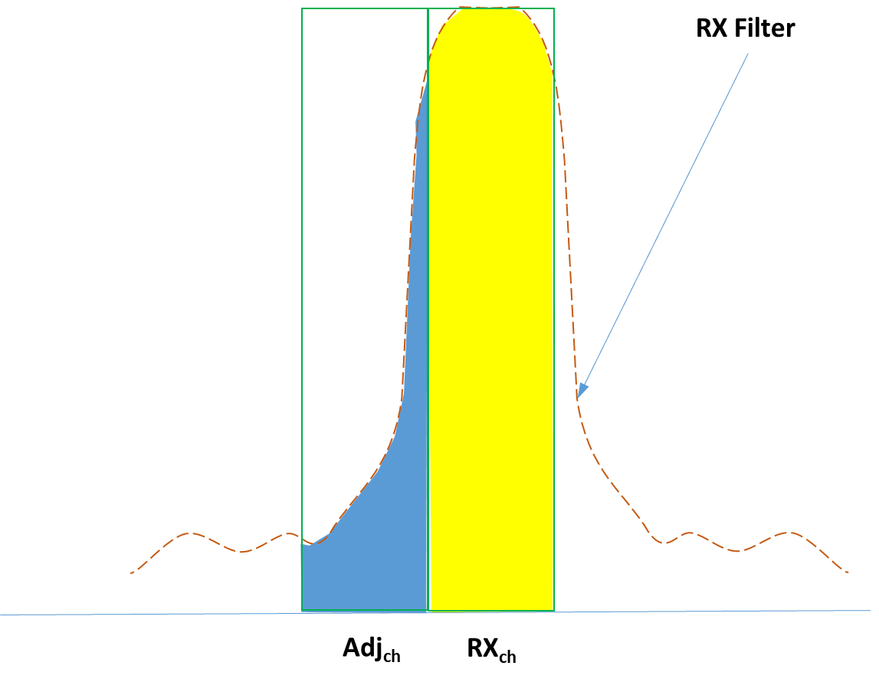

Figure 59: ACS concept visualisation

As shown in section 4.2.6.1 of this ECC Report, ACS is evaluated starting from a Iadj-ch/C test, but with additional post elaboration according the formula presented in that section.

With reference to the various parameters that can be identified in the usual Iadj-ch/C test shown in Figure 60, the above concept is far differently exploited in the considered ETSI standards.

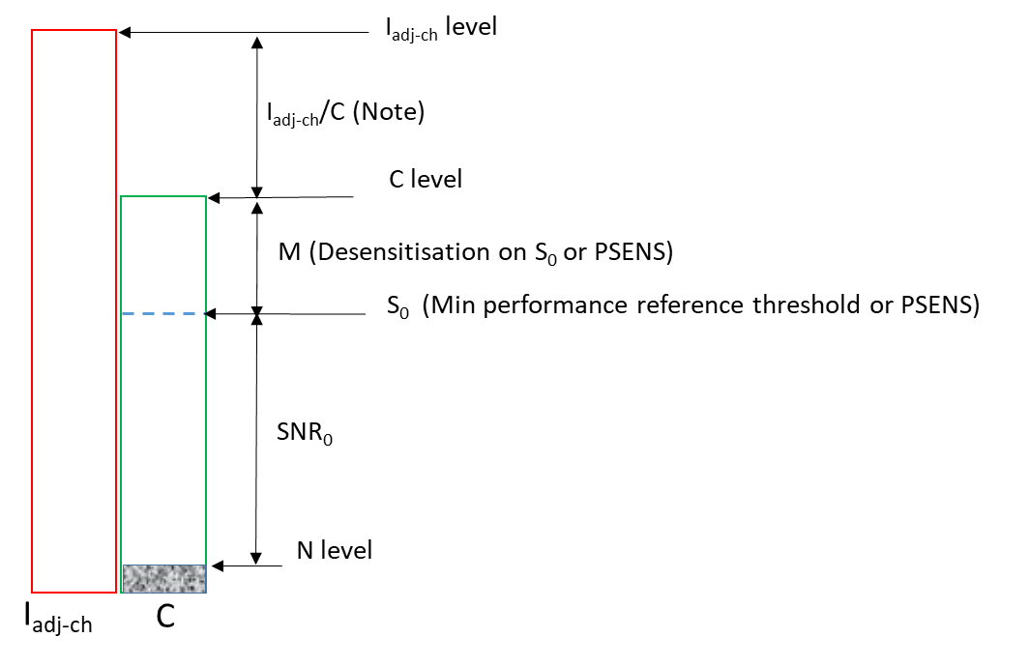

Figure 60: Parameters used in ACS tests (levels intended as total power in the relevant Bandwidth)

NOTE: Iadj-ch/C actually represents the “ACR” definition and value.

* + - 1. ETSI EN 301 908 (ERM/MSG) series e.g. Part 3 (UTRA-FDD BS) [44], Part 13 (E-UTRA UE) [45]

Test: Through single C/Iadj-ch test at RX level with predefined degradation (i.e. desensitisation M=5.3 dB for BS and M=14 dB for UE) with respect to the RX level threshold (S0) (i.e. for BS it is the S0 for BER = 0.001, or for UE 95% of the maximum throughput) in absence of interference.

Post-elaboration: Actually, ETSI EN 301 908-3 (BS), under the ACS section, does not explicitly fix the ACS value, but gives only separate levels of C and Iadj-ch to apply for assessment. Therefore, the related Iadj-ch /C value might easily be misunderstood as the real ACS for sharing/compatibility studies. Differently, ETSIEN 301 908-13 (UE) also specifies the C and Iadj-ch to apply for the ACS test, but add also an “ACS Table” where the reported values are ACS = Iadj-ch/C + 1.5 (the 1.5 dB factor is not explained, but might be related to the “measurement uncertainty” given in the EN, actually 1.5 dB).

* + - 1. ETSI EN 302 574-2 (SES MES/UE 2 GHz) [47] and ETSI EN 302 574-1 (SES-MES/IMT-2000 Complementary Ground Component (CGC) 2 GHz) [46]

Test: Through single Iadj-ch/C test at RX level with 14 dB predefined desensitisation (M) with respect to the RX level threshold called “REFSENS” (i.e. ${RX}_{SENS}$ level for 95% of the maximum throughput) in absence of interference.

Please note that the ETSI EN labels as “M” the Iadj-ch/C ratio, but without any relationship with parameter M in this ECC Report.

Post-elaboration in ETSI EN 302 574-2, the ACS is then calculated as:



The factor 0.17 dB is related to the predefined degradation (i.e. M = 14 dB) and, even if not specifically made evident, it should be the result of the following elaboration (see section A5.4)



Corresponding to 0.17 dB for M=14 dB. With simple equivalence, noting that:



and



Where RXSENS and SNR0 are the sensitivity threshold (called RXsens elsewhere in this Report) and the related SNR, respectively.

The formula proposed in the ETSI EN can be expressed as:



i.e. exactly the same as ${ACS}_{Relative}$ mentioned in Equation in 4.2.6.1.

Post-elaboration in ETSI EN 302 574-1 [46]: unfortunately, it does not present any “post-elaboration” of the Iadj-ch/C test as in Part 2. Possible explanation is because it tends to align with the ETSI EN 301 908 series for IMT applications.

Therefore, it seems that the two parts of the same standard provide different ACS concepts and the CGC part might permit the same potential misunderstanding on ACS value as the ETSI EN 301 908 UTRA series.

* + - 1. ETSI EN 302 544 (BRAN BWA 2.6 GHz e.g. WiMAX) [48]

Test: Through single Iadj-ch/C test at Rx level with predefined degradation (i.e. M = 3 dB) with respect to the Rx level threshold (i.e. Rx level for BER = 10E-6) in absence of interference.

Post-elaboration: The ACS is then calculated as: ACS (dB) = Iadj-ch (dBm) – Nth (dBm)

where the term Nth, in that EN, is equivalent to the receiver noise floor (N) used in this Report.  
Noting that, with M = 3 dB, the factor $10\log\left({10}^{{M(dB)}/{10}}-1\right)$ become = 0 dB, also in this case the ACS value is exactly the same ${ACS}_{Relative}$ mentioned in equation in 4.2.6.1 and that in ETSI EN 302 574-2 [47] in A5.3.2.2 above.

Also, with further elaboration:



* 1. ACS derivation through ACIR concepts visually explained

ACS, ACIR and ACLR are introduced in section 4.2.6.1 of this ECC Report. In this section the mathematical relationship between ACIR (and NFD) is explained:



(all in linear terms)



It can be easily seen that if ACLR >> ACS (as required in all ACS tests in ETSI ENs) the formula will be simplified into:



It is also known from section 4.2.6.1 that ACIR (as well as NFD and, in the above case, ACS too) can be well represented through two C/I tests producing the same characteristics degradation (Pdeg) as follows:



This case is visually shown in Figure 61 where the green lines represent the Rx filter shape.

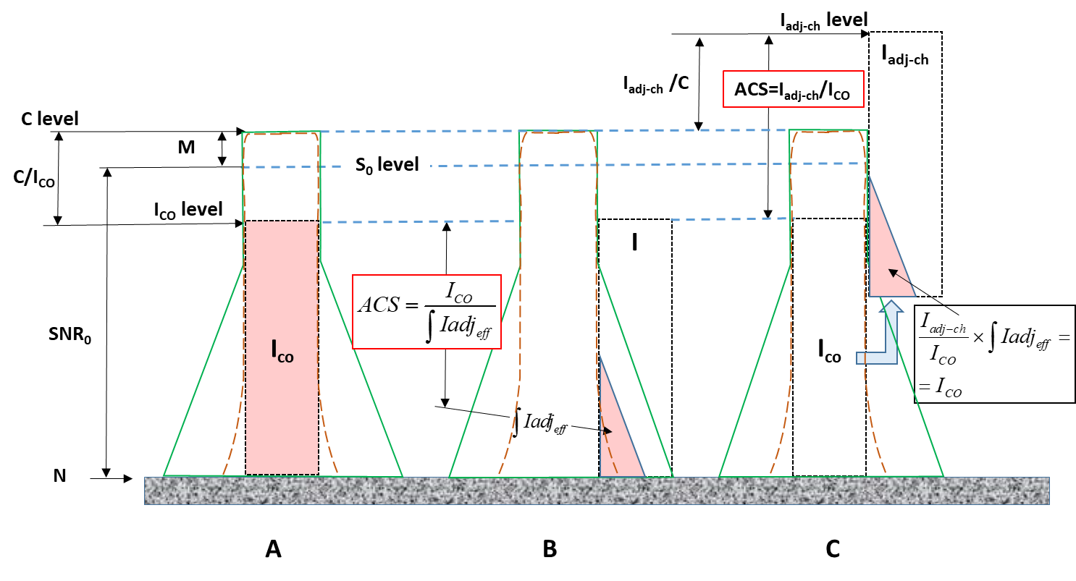

Figure 61: C/I tests process to test ACIR (and NFD) – Extension to evaluate ACS

Figure 61-A represents a $C/{I_{co-ch}}$ test at fixed M desensitisation. Figure 61-B, here shown only for intermediate explanatory purpose, is the situation with the interfering signal (I) moved in frequency to the adjacent channel (obviously resulting in far less interference). It is evident that, using “nearly rectangular” interference signals (as it is the case for a number of modern digital systems (e.g. OFDM or QAM with low roll-off) the ACS is the ratio of the “efficient” power (i.e. integral of the pink areas), in linear terms, represented in Figures 59- A and B and given by the formula:



Figure 61-C is the actual adjacent channel $C/{I_{adj-ch}}$ test at the same receiver desensitisation (M) obtained increasing $I_{adj-ch}$ level; generating the same degradation, the effective interference powers, in linear terms, in test A and test C are also equal: $I_{co-ch}= \int{{Ia}_{eff}}×{I_{AC}I_{adj-ch}}/{I_{COco-ch}}$.

Comparing the two formulas above the simpler relationship could be derived:



or



* 1. ACS evaluation in absence of co-channel C/I reference test

None of the three ENs considered, require co-channel $I_{co-ch}/C$ reference test; therefore, ACS, as defined by all three, cannot directly refer to the $I_{adj-ch}$/C ratio used for adjacent channel test.

However, some define a “post-elaboration” of that data.

Considering Figure 61, in linear terms, the parameters of Equation can be elaborated using the following equivalences:





Merging Equation into Equation :



and, in dB units is reached the same Equation for ${ACS}_{Relative}$ in section 4.2.6.1:



The correction factor  as a function of M(dB) is shown in Figure 62.



Figure 62: Correction factor function of selected desensitisation M(dB)

* 1. Noise Figure (NF) evaluation

When not directly, and appropriately, provided by ETSI standards, the calculation of ACS from usual $I_{adj-ch}$/C test, through Equation in Section 4.2.6.1, would require the knowledge of the noise factor ($F_{n}$) for evaluating the noise figure (NF). NF is not commonly given in ETSI standards; however, typical values (well suitable for normal sharing/compatibility studies) can be found in literature or in other informative ETSI or ECC deliverables. For example, ETSI TR 103 053 [53] provides reference NF for typical point-point fixed links; these NF are presented here in Table 32.

Table 33: Reference NF for typical point-point fixed links

|  |  |
| --- | --- |
| Frequency Band (GHz) | "Reference" Total Noise Figure  Duplexer Loss + Noise figure (dB) |
| 1.5 (1.350 to 1.517) | 4 |
| 2 (2.025 to 2.290) | 4 |
| L4 (3.4 to 4.2) | 5 |
| U4 (4.4 to 5) | 5 |
| L6 (5.925 to 6.425) | 5 |
| U6 (6.425 to 7.125) | 5 |
| 7 (7.110 to 7.725) | 5 |
| 8 (7.725 to 8.500) | 5 |
| 10.5 (10 to 10.68) | 5 |
| 11 (10.7 to 11.7) | 5 |
| 13 (12.7 to 13.25) | 5 |
| 15 (14.4 to 15.35) | 5 |
| 18 (17.7 to 19.7) | 6 |
| 23 (21.2 to 23.6) | 6 |
| 26 (24.5 to 26.5) | 7 |
| 28 (27.5 to 29.5) | 7 |
| 32 (31.8 to 33.4) | 7 |
| 38 (37 to 39.5) | 8 |
| 42 (40.5 to 43.5) | 8 |
| 50 (48.5 to 50.2) | 9 |
| 52 (51.4 to 52.6) | 10 |
| 55 (55.78 to 57.0) | 10 |
| 70 (71 to 76) | 13 |
| 80 (81 to 86) | 13 |

* 1. Net filter discrimination concept

While NFD is widely used concept (mostly in Fixed Service practice, but also well-known elsewhere), surprisingly, very few “definitions” are found in literature. Recommendation ITU-R F.746 [54] gives it as in following abstract:

“The choice of radio-frequency channel arrangement depends on the values of cross-polar discrimination (XPD) and on the net filter discrimination (NFD) where these parameters are defined as:

$XPD=\frac{Power received on polarization H\left(V\right)transmitted on polarization H(V)}{Power received on polarisation V\left(H\right)transmitted on polarization H(V)}$ (see Note 2)

$NFD=\frac{Adjacent channel received power }{Adjacent channel received powerby the main receiver after RF, IF and BB filters }$ (see Note 3)

.................

NOTE 2 : The definition and application of XPD is different from that of cross-polarization isolation (XPI) as defined in Recommendation ITU-R P.310.

NOTE 3 : In the definition of NFD the following assumptions are made:

– adjacent channels XPD, if any, has not been taken into account;

– a single side interfering channel only is considered; for double side like-modulated interferences a NFD value 3 dB lower should be taken into account.”

It should be noted that in Rec. ITU-R F.746 [54] XPD stands for Cross Polar Discrimination and the receiver selectivity is appropriately considered as the sum of all the filters (using either analogue or digital techniques) consecutively placed along the whole receiver chain made by RF, IF and Base Band (BB) circuits.

In addition, NFD concept is commonly intended but not limited to one or few adjacent channel offsets. It may be calculated/defined at any frequency offset between wanted and interfering signals.

NFD is a parameter that can be “calculated”; tests are also possible only based on two C/I tests (at co-channel and at a specified frequency offset between wanted and interfering signals).

A visual presentation of the NFD concept is given in Figure 63 that shows the components for calculation of NFD for the first and second adjacent channel cases. It can be seen that while the first adjacent case is dominated by the “overlapping” of the signals, in second adjacent case the interference is clearly split into two components, which along the whole Rx chain could produce non-linear effects when the I/C ratio becomes large; therefore, the evaluation of NFD when W and I signals are widely spaced would be more appropriate using the real I/C test at a common predefined desensitisation (M).

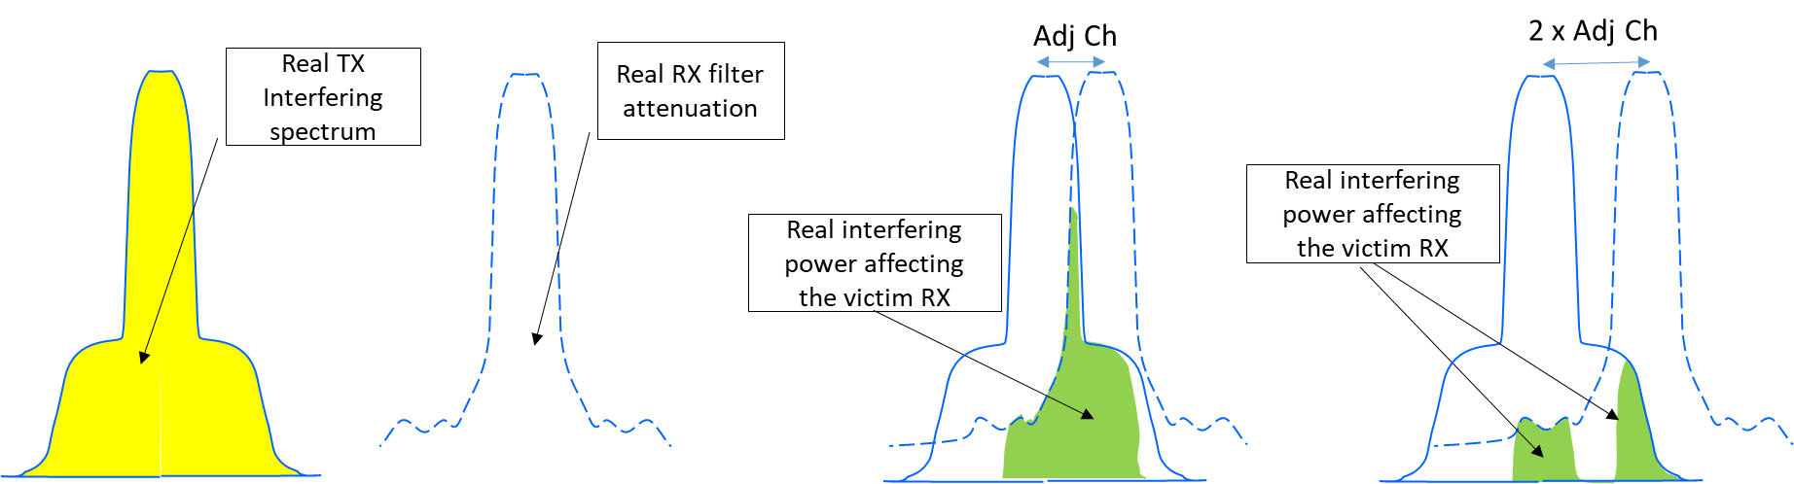

Figure 63: NFD visual definition

Then the NFD is expressed as:



1. TECHNICAL BACKGROUND FOR DERIVING RECEIVER SELECTIVITY FROM KNOWN ACS AND BLOCKING CHARACTERISTICS OF THE RECEIVER
   1. Introduction

In general, the term selectivity indicates the transfer function of a given two-port network in terms of gain (or attenuation) versus frequency.

When the two-port network comprises several complex and active functions the transfer function is a combination of many elementary parts; the presence of active functions also implies that the total transfer function depends also on the levels of the signals passing through (e.g. due to non-linear effects).

In digital microwave receivers the input and output signals are inhomogeneous (RF modulated signal input and digital data stream output); therefore, a plain gain/frequency transfer function cannot be practically defined or tested. In addition, the signal environment is generally "broadband"; therefore, single frequency selectivity values are not practically enough for deriving the receiver's response to a wide band interference (i.e. wide band integration is necessary).

Furthermore, the digital implementation of filters, typically employed for the final baseband channel shaping, implies that the predicted performance of the receiver is experienced only in the presence of like-modulated interfering signals. For interfering signals of different nature, the response of the receiver, while its performance is still close, cannot be assumed the same; therefore, the use of CW line interference becomes appropriate and convenient for interfering signals far from the wanted signal centre frequency where the analogue parts of the filter chain (typically at RF and IF level) become more predominant. Here the CW line interference becomes quite representative for any kind of interfering signal, including broadband ones, e.g. for sharing/compatibility with service/systems allocated in adjacent bands.

For the above reasons, receiver selectivity, at a predefined frequency separation between wanted and interfering signals, is generally described, and easily tested, through receiver sensitivity (in terms of BER or other performance indicator) degradation (i.e. desensitisation of M dB) in the presence of interference at certain C/I (Protection Ratio) .

In ETSI ENs, the C/I tests are usually prescribed for adjacent channel (for ACS or ACR evaluation using like wanted and interfering signals) and in a more distant frequency offset range (for blocking evaluation using a CW interfering signal). In some ETSI ENs, other similar C/I tests are prescribed, such as co-channel PR and second adjacent channel PR. Those tests are typically prescribed assuming the same desensitisation (M) for all of them.

Care should be taken, when ACS limits seem to be directly given in ETSI ETSI ENs, to ensure that the value represents the “true” ACS according its definition and not just the C/I for test (see ANNEX 5: where some examples of ENs are not in line with the definition).

Tx parameter ACLR is also generally provided in ETSI ENs (either directly, or in terms of detailed spectrum power density mask, easily converted into ACLR by simple area integration).

Therefore, according to the equations in section 4.2.6.1 of this ECC Report, it is possible to derive the “true” value of ACS for the system under consideration.

Considering the NFD concept (see ANNEX 5:), it is also generally assumed that NFDAD (at adjacent channel separation) is equivalent to ACIR. Therefore Equation in section 4.2.6.1 can be extended to NFD:



, for ACLR >> ACIR $,$

Whenever also second adjacent protection ratio is also provided, the above equation can be used for defining a ${NFD}_{2adj-ch}$ value.

However, NFD concept (see ANNEX 5:) may be extended to any frequency separation; therefore, the above equation can be generalised:



and then:



In addition, far from the Rx pass band, the selectivity is no longer sharply varying, therefore, the impact of a CW interference to the wanted receiver becomes equivalent to like modulated interference of similar bandwidth to the wanted signal bandwidth.

In conclusion, for the frequency range covered by the blocking requirement the Equation and can be written as:



and then:



Where suffix “Δf-BR” means any frequency in the required blocking range where a blocking C/I performance is prescribed. Unique condition is the same prescribed desensitisation (M) for all C/I tests in the standard.

The above ${NFD}_{AD}$ and ${NFD}_{∆f-BR}$ (and ${NFD}_{2adj}$, if available) represent the corner points for a “channel bandwidth” integrated selectivity (CBSEL) response, comprehensive of all effects (linear and not linear) that define the overall response of the receiver to interference; therefore, it is intended as the real selectivity of the digital receiver towards interference of comparable bandwidth (CB). Being derived from ETSI standards requirements, the CBSEL can be conservatively used for sharing/compatibility studies.

* 1. Graphical representation of CBSEL

From the above background it is possible to derive the CBSEL in graphical form as shown in Figure 64.

The graphic in Figure 64 is usually used as response to a relatively "broadband" interference, i.e. with bandwidth comparable to that of the concerned wanted signal; therefore, the point derived from blocking CW line interference is considered applicable, in such broadband context, from the Nth channel spacing (CS) where the blocking requirement starts. In the example shown in Figure 64 it is assumed that the blocking range starts from the 250% of the channel separation, which is a common starting point for blocking requirement.

The graph so derived already represents the “integral” selectivity to be applied to any interfering signal power placed at that frequency separation and possibly of similar bandwidth (CB) of the wanted signal (i.e. no further integration is necessary for calculating the overall interfering power). This is valid as far as the interfering signal is comparable or narrower than the wanted signal bandwidth.

It should be noted that, for interfering signals significantly wider than the wanted signal, the CBSEL can be assumed to benefit (i.e. a higher selectivity) of the interfering bandwidth ratio to the wanted bandwidth in the range from 0 (co-channel) to adjacent channel (see background in section 7.1.1). CBSEL derived from CW blocking figure would remain constant.

Interference frequency

offset [n X

Channel bandwidth]

0.5

1

2

3

4

C

BSEL

[

dB/ChBw]

0

See note 1

1

st

adjacent

(see note 2)

>

3

rd

adjacent (see note 4)



2

nd

adjacent

(see note 3)

NFD

adj

(

dB)

NFD

2adj

(

dB)

NFD



f

-

BR

(

dB)

Note 1: It is commonly assumed that, at 0,5 × CS, 3 dB of CBSEL is obtained.

Note 2: CBSEL first adjacent channel separation.

Note 3: CBSEL second adjacent channel separation (if second adjacent channel figures are provided by the relevant EN)

Note 4: CBSEL in the frequency range where blocking is defined (± 250% channel separation in this example). It should also be understood that CBSEL in this range is applicable on real interference environment only if the interfering signal emission exhibits a corresponding reduction of its OOB and spurious emissions within the victim RX bandwidth.

Figure 64: Channel bandwidth integrated selectivity (CBSEL) graphical representation

1. Example of derivation of a SEAMCAT blocking mask
   1. Technique for determining a device’s SEAMCAT blocking mask

The following technique can be used to determine a device’s intrinsic vulnerability to CW interference and the result used to determine the necessary co-channel signal to noise ratio (S/N) and SEAMCAT blocking mask.

The measurement of a device’s vulnerability to interference – in this case protection ratio - has been determined for a typical SRD as defined in ETSI EN 300 220-1 V3.1.0 Section 5.18, but with measurement points from the narrow band network (NBN) standard ETSI EN 303 204 +/- 2 MHz offset from the edge of the operating channel in steps of 100 kHz, and more often where the function is changing greatly with frequency. The points are determined as protection ratios (i.e. relative to a weak wanted signal, 3 dB higher than the receiver sensitivity).

An example of measured protection ratio curve is shown in Figure 65.



Figure 65: Protection ratio measurements for SRD Narrow Band Network (NBN) victim

The protection ratio curve shows that the performance of this victim receiver reaches -30 dB at an offset of 175 kHz from the centre of the 200 kHz operating channel, while ETSI EN 303 204 defines a limit of -32 dB at a frequency offset of 2 MHz. The curve also shows that the wanted signal level required must be on average 12.9 dB above the in-channel interference level, however, the detail in the operating channel – which depends on the modulation scheme, interfering signal BW and demodulating circuitry – cannot be processed in the SEAMCAT model. This explains why in some cases a victim’s vulnerability that dependent on the detailed protection ratio curve cannot be assessed by this model. This data presented in Figure 65 can be used to construct a SEAMCAT blocking mask (as described in Section 4.2 of the SEAMCAT Manual) [37]), as set out below.

The blocking mask in SEAMCAT represents the effective attenuation of OOB interfering signals that is combined with the wanted signal at the receiver's input. The blocking mask (PRs, as set out in Section 4.2.3 of the SEAMCAT Manual [37]) in the OOB area can be calculated by:

* Attenuation (∆f) = Required C/(N+I) – Measured PR (∆f), which is simply the receiver interference ratio (RIR) for ∆f > 0.1 MHz.

The calculated attenuations are presented in Table 33:

Table 34: Protection ratio measurements for SRD Narrow Band Network (NBN) victim

|  |  |  |  |
| --- | --- | --- | --- |
| Offset  (MHz) | Protection Ratio  (dB) | Required  C/(I+N) (dB) | Attenuation  (dB) |
| 0.1 | 5 | 12.9 | 7.9 |
| 0.125 | -9 | 12.9 | 21.9 |
| 0.14 | -20 | 12.9 | 32.9 |
| 0.15 | -25 | 12.9 | 37.9 |
| 0.175 | -31 | 12.9 | 43.9 |
| 0.2 | -32 | 12.9 | 44.9 |
| 0.25 | -35 | 12.9 | 47.9 |
| 0.3 | -38 | 12.9 | 50.9 |
| 0.4 | -41 | 12.9 | 53.9 |
| 0.5 | -44 | 12.9 | 56.9 |

Entered into SEAMCAT, this data is as shown below: required C/(I+N) ratio (12.9 dB), channel bandwidth (200 kHz) and blocking mask detail.

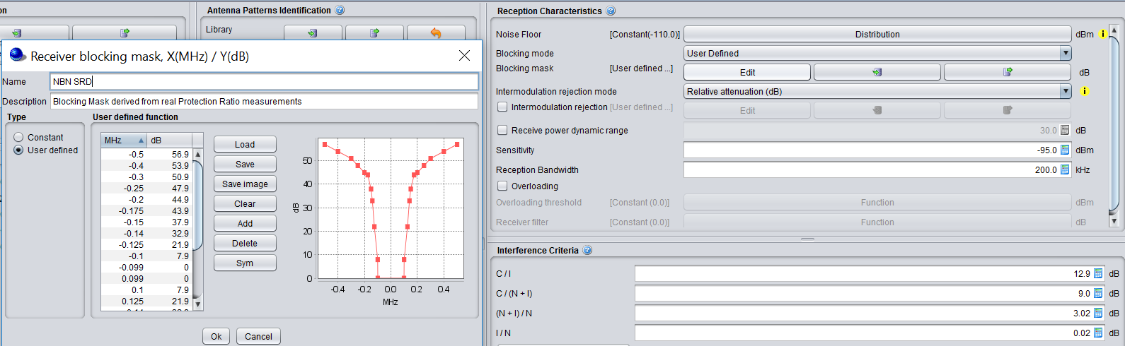

Figure 66: SEAMCAT Receiver data for SRD Narrow Band Network (NBN) victim (SEAMCAT version 5.1)

In conclusion, great care needs to be exercised in order for accurate coexistence assessments to be carried out for heterogeneous systems, because of the challenges of assessing the impact of devices with varying bandwidths as they are brought close to one another in the frequency domain. Careful measurements of a victim system’s protection ratio and the interferer’s transmission mask are required in order for the SEAMCAT studies to be accurate. It would also be sensible for direct measurements of systems’ coexistence in a laboratory to be carried out to confirm the appropriateness of the SEAMCAT model.

1. Receiver threshold for adaptive spectrum sharing techniques
   1. Introduction

Spectrum sharing and compatibility studies involving some form of adaptive spectrum sharing require taking into account time aspects as well as the static receiver parameters discussed above. In the following sections various sharing mechanisms are introduced, followed by a discussion of the relevance of receiver parameters for the operation and efficiency of adaptive sharing mechanisms.

* 1. Sharing mechanisms
     + 1. Non-adaptive sharing mechanisms

Non-adaptive sharing mechanisms are effectively blind mechanisms. The simplest sharing mechanism is a duty cycle restriction: it assures intervals between transmissions that can be used by other spectrum users. The transmission protocol used is simple: transmit and hope for the best. Feedback from the intended receiver is non-real-time and does not affect transmission decisions. The Aloha[20] protocol is a good example. Unless a time slot mechanism is used by all contenders, the protocol is called pure Aloha and its aggregate capacity is 18% or less of the theoretical spectrum capacity[21]. If slotting is applied the theoretical aggregate efficiency goes up to 36%. However, in licence exempt spectrum bandwidth as well as transmission timings differ and therefore, the actual efficiency obtainable is well below the theoretical value. Spectrum sharing and compatibility studies should assume a conservative aggregate efficiency factor of 10% or less.

* + - 1. Adaptive sharing mechanisms

Adaptive spectrum sharing makes use of information about the state of the spectrum in order to make transmission decisions. Adaptive spectrum sharing may make use of the spatial domain, the frequency domain or the time domain, or combinations thereof. The first is addressed by the parameters RF power, antenna directivity and receiver sensitivity, the second is addressed by transmitter filtering and receiver selectivity in the broadest sense. Sharing schemes and compatibility studies involving the time domain require time aspects to be taken into account in addition to the other parameters. Three basic types of spectrum sharing mechanisms are discussed below, including references the receiver parameters that affect their operation.

Adaptive sharing schemes all have the same basic functions: detection, response and recovery. Detection requires a threshold which, if exceeded, triggers a response action and the action, once taken may be reversed under certain conditions.

Relevant for sharing and compatibility studies involving adaptive sharing capabilities in one or more of the systems being studied, are the detection threshold, the timing and effectiveness of the response and the recovery conditions.

Detection may use a variety of mechanisms, e.g. on RF signals, error rate feedback or transmission failure.

* + - 1. Listen-Before-Talk (LBT)

Listen-Before-Talk is widely used in SRDs and other equipment operating in shared spectrum on a best effort basis. Detection of energy above a set threshold in the operating channel triggers a delay type response followed by a quick recovery which is again dependent on the detection threshold. In theory, LBT schemes allow multiple and different systems to share the same spectrum or channel but the efficiency varies with the mix of transmission modes and transmitter power levels as well as propagation conditions. Wi-Fi uses an LBT variant known as CSMA/CA: Carrier Sense Multiple Access with Collision Avoidance.

Important receiver parameters for LBT schemes are receiver sensitivity and receiver desensitisation/blocking. The required levels vary with the intended use and the (population of the) frequency band of operation. Receiver selectivity does affect LBT operation only in the sense that inadequate selectivity causes false positive detection events and therefore is diminishes the rate of spectrum access of such a device.

LBT can be simulated by using the Cognitive Radio system functionality of SEAMCAT, as set out in section 6 of the SEAMCAT Handbook, with computational details in Annexes 6 and 16. SEAMCAT then calculates the resulting interference to the victim systems as well as the success that the LBT devices have in trying to transmit.

* + - 1. Detect and Avoid (DAA)

Detect and avoid, also known as adaptive frequency agility, has a threshold which may be for example an energy level or error rate detection. The response action is to change operating frequency so that interference is avoided. Recovery involves changing frequency again, e.g. to avoid another interferer. The detection may operate in real time or it may be based on long-term monitoring of a frequency range. Which mechanism is preferable depends on the intended use of the interferer as well as that of the victim(s). In either case, the response may not be instantaneous and the time between response and recovery can be very long – again depending on use case and operational parameters.

A well-known example of a DAA scheme is dynamic frequency selection (DFS), the scheme that prevents RLANs from interfering with radar systems. It has an RF signal threshold[22] fixed by regulation and is derived from the radar protection requirements and the RLAN transmitter power. DFS has a defined response requirement - vacating the channel within a given time and it has a recovery condition: no detection of radar activity for a given period. Whereas DFS operates on a macro scale, LBT and its derivatives operate on a micro-scale: detection causes a – typically short - delay followed by another attempt, etc, until the transmission is completed

The relevant receiver parameters usually utilised DAA schemes are similar to those for LBT schemes.

* + - 1. Automatic Transmit Power Control (ATPC)

Adaptive Transmitter Power Control aims to reduce the potential interference generated by minimising the RF power, relative to the required signal level at the intended receiver. The latter level may be based on the required SNR or, in the case of interference limited conditions, on the required SINR. Detection is typically based on the signal received from the intended receiver and the action is immediate. Recovery may be fast, based on continuous receiver monitoring, or slow, depending on variation in the propagation conditions.

The relevant receiver parameters for usually utilised ATPC schemes are similar to those for LBT schemes

* 1. Example for Short Range Devices

SRDs routinely operate with a mixture of technologies both in the same and neighbouring bands, and so are a good example of systems that might need to be studied that have unlike bandwidths and different technologies.

The operating characteristics of SRDs vary radically, with high and low power; wide (and ultra-wide) and narrow (and ultra-narrow) band; indoor and outdoor; and mobile and fixed applications sharing the same bands. The philosophy of these bands is that any and all technologies are encouraged to operate together and so regulations are typically limited to higher level limits such as transmit power (or power spectral density), duty cycle and bandwidths or requirements for adaptive medium access. Stipulation of exact channel rasters or even bandwidths are rare.

The arrangements for determining which types of technology can coexist with others (both SRDs and formal services) is determined by careful study (e.g. using SEAMCAT) within ECC. Parameters on deployment and intended use are given in relevant ETSI SRDocs.

Although technologies are encouraged to use ‘polite sharing’ (e.g. adaptive medium access) ‘techniques’ in order to be ‘good neighbours’, generally sharing opportunities are controlled by limiting the time that nodes are on the air – or ‘duty cycle (DC) limits. Although individual systems/technologies usually provide for coordinated transmissions to better use spectrum, they operate in bands in which random access or ‘Aloha’[23] or some form of listen-before-talk (LBT) operation dominates. Theory shows that with Aloha type medium access the maximum throughput that can be achieved is 18% of channel capacity or 35% for synchronised slotted Aloha. LBT type medium access can increase channel throughput.

Meaning of blocking and adjacent channel rejection

In a regime in which many technologies can coexist and even overlap (in the frequency domain) the meaning of adjacent channel can be a moot concept outside of any one technology, although these terms are often used interchangeably with the concept of blocking.

Susceptibility of services and systems to interference

In order to provide a realistic assessment of the feasibility of coexistence, systems’ vulnerability to interference - typically in the form of protection ratio curves - need to be accurately determined. Typically, data is entered into SEAMCAT from available specifications, often extrapolating between blocking performance points several MHz apart, which are therefore, too inexact. Experience shows that the results of such simulations computed by SEAMCAT are very sensitively determined by these curves and so it is suggested that the methodology set out in ANNEX 7: be used to determine the appropriate SEAMCAT Blocking Mask.

Timing considerations

When sharing an Aloha channel, theory shows that transmissions of a similar duration have the best chance of maximising throughput. Longer transmissions tend to be vulnerable to interference from shorter transmissions. For example, in EN 303 204 [32] (Networked SRDs) the typical maximum transmission durations are encouraged to be no longer than 400 ms, whereas for EN 300 220 [26] (Non-specific SRDs) the limit is 1s.

Use of LBT

The Aloha channel limit can be drastically extended if effective LBT techniques are used. Therefore, very often, systems that implement an effective LBT technique do not require a duty cycle limit. LBT works best, however, if the ‘sensing’ and ‘sensed’ technologies transmit at similar powers, else ‘hidden node’ issues can cause lower-powered devices to be overheard (not heard).use of LBT across heterogeneous systems is a unique challenge to SRD operation not only because of mismatched power, but also mismatched bandwidths and channel overlap. Such mechanisms – and appropriate regulation - need to be designed cognizant of the other types of systems with which they share.

For example, a relatively narrowband system might need to sense over a wider bandwidth – typical of possible victim systems – or accept a lower detect threshold value. A relatively wideband system may need to listen for longer than might be considered necessary for homogeneous system operation in order to be able to detect the relatively long transmissions of a narrow band system.

* 1. Receiver thresholds for Adaptive Spectrum Sharing

Spectrum sharing and compatibility studies involving adaptive spectrum sharing require taking into account the threshold level (either signal level or another mechanism), the response time and effect and the recovery restrictions or absence thereof. An additional consideration in the case of licence exempt spectrum is the risk of spectrum overload and any method to prevent this or to mitigate the effects.

The detection threshold should be considered from the viewpoint of protection of the victim as well as the potential denial of transmit opportunity to the interferer. In general, the signal detection threshold should be such that, the difference between the e.i.r.p. of the victim and the detection threshold level is equal to less than the difference between e.i.r.p. of the interferer and the MUS of the victim plus a protection margin. The general formula is given below; using PSD for the signal levels avoids the need for involving the bandwidths of victim and interferer.



The underlying assumptions are that the pathloss between victim and interferer is the same is each direction and that the interference from other sources is negligible. Eliminating the equal factors at both sides gives:

 dBm/MHz

The values of these two margins depend on local considerations (technologies, frequency band). An example of a threshold level that is well above the MUS of the victim receivers is the CCA threshold of IEEE 802.11: it is 24 dB above the assumed receiver noise floor.

Factors that affect sensing based adaptivity mechanisms are: blocking energy, adjacent channel leakage and intermodulation effects caused by in-band and out-of-band sources. All cause a decrease in sensitivity of the detection mechanisms and this will lead to false negatives and therefore increased medium access attempts and/or medium access collisions. Notably in the case of licence exempt spectrum, the interference will be variable over a wide range of time scales.

1. List of References
2. Directive 2014/53/EU of the European Parliament and of the Council of 16 April 2014 on the harmonisation of the laws of the Member States relating to the making available on the market of radio equipment and repealing Directive 1999/5/EC
3. Directive 1999/5/EC of the European Parliament and of the Council of 9 March 1999 on radio equipment and telecommunications terminal equipment and the mutual recognition of their conformity
4. ITU Radio Regulations, Edition of 2016
5. CEPT Report 30: Report from CEPT to the European Commission in response to the Mandate on “The identification of common and minimal (least restrictive) technical conditions for 790 - 862 MHz for the digital dividend in the European Union", October 2009
6. ECC Report 138: “Measurements on the performance of DVB-T receivers in the presence of interference from the mobile service (especially from UMTS)”, June 2010
7. ECC Report 148: “Measurements on the performance of DVB-T receivers in the presence of interference from the mobile service (especially from LTE)”, June 2010
8. ECC Report 191: “Adjacent band compatibility between MFCN and PMSE audio applications in the 1785-1805 MHz frequency range”, September 2013
9. ECC Report 165: “Compatibility study between MSS complementary ground component operating in the bands 1610.0-1626.5 MHz and 2483.5-2500.0 MHz and other systems in the same bands or in adjacent bands”, May 2011
10. ECC Report 174: “Compatibility between the mobile service in the band 2500-2690 MHz and the radiodetermination service in the band 2700-2900 MHz”, April 2012
11. ECC Report 263: “Adjacent band compatibility studies between IMT operating in the frequency band 1492-1518 MHz and the MSS operating in the frequency band 1518-1525 MHz”, March 2017
12. ECC Report 299: “Measures to address potential blocking of MES operating in bands adjacent to 1518 MHz (including 1525-1559 MHz) at sea ports and airports”, March 2019
13. ECC Report 127: “The impact of receiver standards on spectrum management”, November 2008
14. ECC Report 229: “Guidance for improving coexistence between GSM-R and MFCN in the 900 MHz band”, May 2015
15. ECC Recommendation (02)01: “Specification of Reference Receiver Performance Parameters”, February 2002
16. Radio Spectrum Policy Group Report on “Furthering Interference Management through exchange of regulatory best practices concerning regulation and/or standardisation”, June 2013
17. ETSI EG 203 336 V1.1.1 (2015-08): “Guide for the selection of technical parameters for the production of Harmonised Standards covering article 3.1(b) and article 3.2 of Directive 2014/53/EU”
18. ECC Recommendation (02)05: “Unwanted emissions”, amended March 2012
19. ERC Recommendation 74-01: “Unwanted emissions in the spurious domain”, 29 May 2019
20. Recommendation ITU-R SM.1541-6: “Unwanted emissions in the out-of-band domain”
21. Recommendation ITU-R SM.329-12: “Unwanted emissions in the spurious domain”
22. Official Journal of the EU
23. ETSI EN 303 340 V1.1.2 (2016-09): “Digital Terrestrial TV Broadcast Receivers; Harmonised Standard covering the essential requirements of article 3.2 of Directive 2014/53/EU”
24. ETSI EN 300 328 V2.1.1 (2016-11): “Wideband transmission systems; Data transmission equipment operating in the 2,4 GHz ISM band and using wide band modulation techniques; Harmonised Standard covering the essential requirements of article 3.2 of Directive 2014/53/EU”
25. ETSI EN 301 893 V2.1.1 (2017-05): “5 GHz RLAN; Harmonised Standard covering the essential requirements of article 3.2 of Directive 2014/53/EU”
26. ETSI EN 301 444 V2.1.2 (2016-11): “Satellite Earth Stations and Systems (SES); Harmonised Standard for Land Mobile Earth Stations (LMES) providing voice and/or data communications, operating in the 1,5 GHz and 1,6 GHz frequency bands covering the essential requirements of article 3.2 of the Directive 2014/53/EU”
27. ETSI EN 300 220-1 V3.1.1 (2017-02): "Short Range Devices (SRD) operating in the frequency range 25 MHz to 1 000 MHz; Part 1: Technical characteristics and methods of measurement "
28. ETSI EN 300 220-2 v3.2.1 (2018-06): “Short Range Devices (SRD) operating in the frequency range 25 MHz to 1 000 MHz; Part 2: Harmonised Standard for access to radio spectrum for non specific radio equipment”
29. ETSI EN 300 220-4 V1.1.1: “Short Range Devices (SRD) operating in the frequency range 25 MHz to 1 000 MHz; Part 4: Harmonised Standard covering the essential requirements of article 3.2 of Directive 2014/53/EU; Metering devices operating in designated band 169,400 MHz to 169,475 MHz”
30. ETSI EN 300 220-3-2 v1.1.1: “Short Range Devices (SRD) operating in the frequency range 25 MHz to 1 000 MHz; Part 3-2: Harmonised Standard covering the essential requirements of article 3.2 of Directive 2014/53/EU; Wireless alarms operating in designated LDC/HR frequency bands 868,60 MHz to 868,70 MHz, 869,25 MHz to 869,40 MHz, 869,65 MHz to 869,70 MHz”
31. ETSI EN 300 220-3-1 v2.1.1: “Short Range Devices (SRD) operating in the frequency range 25 MHz to 1 000 MHz; Part 3-1: Harmonised Standard covering the essential requirements of article 3.2 of Directive 2014/53/EU; Low duty cycle high reliability equipment, social alarms equipment operating on designated frequencies (869,200 MHz to 869,250 MHz)”
32. ETSI EN 301 908-14 V13.1.1: “IMT cellular networks; Harmonised Standard for access to radio spectrum; Part 14: Evolved Universal Terrestrial Radio Access (E-UTRA) Base Stations (BS)”
33. ETSI EN 303 204 V2.1.2 (2016-09): “Network Based Short Range Devices (SRD); Radio equipment to be used in the 870 MHz to 876 MHz frequency range with power levels ranging up to 500 mW; Harmonised Standard covering the essential requirements of article 3.2 of the Directive 2014/53/EU”
34. ETSI EN 302 217-2 V3.1.1 (2017-05): “Fixed Radio Systems; Characteristics and requirements for point-to-point equipment and antennas; Part 2: Digital systems operating in frequency bands from 1 GHz to 86 GHz; Harmonised Standard covering the essential requirements of article 3.2 of Directive 2014/53/EU”
35. ETSI ES 202 131 V1.2.1 (2003-07): “Electromagnetic compatibility and Radio spectrum Matters (ERM); Wideband Transmission systems; Data transmission equipment operating in the 2,4 GHz ISM band using spread spectrum modulation techniques and 5 GHz high performance RLAN equipment; Specification of Reference Receiver Performance Parameters for Spectrum Planning”
36. William G. Duff Electromagnetic Compatibility in Telecommunications Volume 7, (published 1988)
37. ETSI TR 103 265 V1.1.1 (2013-12): “Electromagnetic compatibility and Radio spectrum Matters (ERM); Definition of radio parameters”
38. ECC Report 252: “SEAMCAT Handbook Edition 2”, April 2016
39. ETSI TR 102 914 V1.1.1 (2009-01): “Electromagnetic compatibility and Radio spectrum Matters (ERM); Aspects and implications of the inclusion of receiver parameters within ETSI standards”
40. ETSI TR 102 137 V1.3.1 (2019-11: “Use of radio frequency spectrum by equipment meeting ETSI standards”
41. ETSI EG 202 150 V1.1.1 (2003-02): “ETSI Guide on "Common Text" for Application Forms/Short Equipment Description Forms”
42. ETSI TS 103 567 V.1.1.1 (2019-09): “Requirements on signal interferer handling”
43. CEPT Report 41: “Compatibility between LTE and WiMAX operating within the bands 880-915 MHz / 925-960 MHz and 1710-1785 MHz / 1805-1880 MHz (900/1800 MHz bands) and systems operating in adjacent bands”, November 2010
44. ECC Report 162: “Practical mechanism to improve the compatibility between GSM-R and Public mobile networks and guidance on practical coordination”
45. ETSI EN 301 908-3 V11.1.3: “IMT cellular networks; Harmonised Standard covering the essential requirements of article 3.2 of Directive 2014/53/EU; Part 3: CDMA Direct Spread (UTRA FDD) Base Stations (BS)”
46. ETSI EN 301 908-13 V11.1.2: “IMT cellular networks; Harmonised Standard covering the essential requirements of article 3.2 of Directive 2014/53/EU; Part 13: Evolved Universal Terrestrial Radio Access (E-UTRA) User Equipment (UE)”
47. ETSI EN 302 574-1 V2.1.2: “Satellite Earth Stations and Systems (SES); Harmonised Standard for Mobile Earth Stations (MES) operating in the 1 980 MHz to 2 010 MHz (earth-to-space) and 2 170 MHz to 2 200 MHz (space-to-earth) frequency bands covering the essential requirements of article 3.2 of the Directive 2014/53/EU; Part 1: Complementary Ground Component (CGC) for wideband systems”
48. ETSI EN 302 574-2(V2.1.2: “Satellite Earth Stations and Systems (SES); Harmonised Standard for Mobile Earth Stations (MES) operating in the 1 980 MHz to 2 010 MHz (earth-to-space) and 2 170 MHz to 2 200 MHz (space-to-earth) frequency bands covering the essential requirements of article 3.2 of the Directive 2014/53/EU; Part 2: User Equipment (UE) for wideband systems”
49. ETSI EN 302 544-1 V1.1.2: “Broadband Data Transmission Systems operating in the 2 500 MHz to 2 690 MHz frequency band; Part 1: TDD Base Stations; Harmonized EN covering the essential requirements of article 3.2 of the R&TTE Directive”
50. ETSI EN 302 544-2 V1.1.2: “Broadband Data Transmission Systems operating in the 2 500 MHz to 2 690 MHz frequency band; Part 2: TDD User Equipment Stations; Harmonized EN covering the essential requirements of article 3.2 of the R&TTE Directive”
51. ETSI EN 302 774 V1.2.1: “Broadband Wireless Access Systems (BWA) in the 3 400 MHz to 3 800 MHz frequency band; Base Stations; Harmonized EN covering the essential requirements of article 3.2 of the R&TTE Directive”
52. ETSI EN 301 841-3 V2.1.1: “VHF air - ground Digital Link (VDL) Mode 2; Technical characteristics and methods of measurement for ground-based equipment; Part 3: Harmonised Standard covering the essential requirements of article 3.2 of the Directive 2014/53/EU”
53. ETSI EN 302 217-2 V3.1.1: “Fixed Radio Systems; Characteristics and requirements for point-to-point equipment and antennas; Part 2: Digital systems operating in frequency bands from 1 GHz to 86 GHz; Harmonised Standard covering the essential requirements of article 3.2 of Directive 2014/53/EU”
54. ETSI TR 103 053 V1.1.1 (2014-09): Fixed Radio Systems; Parameters affecting the Signal-to-Noise Ratio (SNR) and the Receiver Signal Level (RSL) threshold in point-to-point receivers; Theory and practice
55. ITU-R Recommendation F.746-10: “Radio-frequency arrangements for fixed service systems”
56. ETSI Directives Version 40, April 2019
57. Report ITU-R M.2039: “Characteristics of terrestrial IMT-2000 systems for frequency sharing/interference analyses”, 2004
58. ERC Report 063: “Introduction of radio microphone applications in the frequency range 1785 - 1800 MHz”, May 1998
59. ERC Recommendation 70-03: “Relating to the use of Short Range Devices (SRD)”, amended June 2019
60. ERC Report 064: “Frequency sharing between UMTS and existing fixed services”, May 1999
61. ERC Report 065: “Adjacent band compatibility between UMTS and other services in the 2 GHz band” November 1999
62. ECC Recommendation (19)02: “Guidance and methodologies when considering typical unwanted emissions in sharing/compatibility studies”, May 2019
63. ETSI EN 301 511 12.5.1 (2017-03): “ Global System for Mobile communications (GSM); Mobile Stations (MS) equipment; Harmonised Standard covering the essential requirements of article 3.2 of Directive 2014/53/EU”
64. ETSI TS 145 005 V10.8.0 (2014-01): “Digital cellular telecommunications system (Phase 2+) (GSM); GSM/EDGE Radio transmission and reception (3GPP TS 45.005 version 13.3.0 Release 13)”
65. Recommendation ITU-R P.372-14 (08/2019): “Radio noise”
66. ETSI EN 301 406 V1.5.1 (2003-07): Digital Enhanced Cordless Telecommunications (DECT); Harmonised Standard covering the essential requirements of article 3.2 of the Directive 2014/53/EU
67. ETSI EN 300 175-2 V2.8.1 (2019-12): “Digital Enhanced Cordless Telecommunications (DECT); Common Interface (CI); Part 2: Physical Layer (PHL)”
68. ETSI TS 151 010-1 V13.10.0 (2019-10): “Digital cellular telecommunications system (Phase 2+) (GSM); Mobile Station (MS) conformance specification; Part 1: Conformance specification”
69. 3GPP TS 05.05 V3.16.0 (1995-01): “European digital cellular telecommunications system (Phase 1); Radio Transmission and Reception (GSM 05.05)”
70. ETSI TS 102 933-2 v2.1.1 (2015-06): “Railway Telecommunications (RT); GSM-R improved receiver parameters; Part 2: Radio conformance testing”
71. ECC Decision(16)02: “Harmonised technical conditions and frequency bands for the implementation of Broadband Public Protection and Disaster Relief (BB-PPDR) systems”, amended March 2019
72. ECC Decision(15)01: “Harmonised technical conditions for mobile/fixed communications networks (MFCN) in the band 694-790 MHz including a paired frequency arrangement (Frequency Division Duplex 2x30 MHz) and an optional unpaired frequency arrangement (Supplemental Downlink)”, March 2015
73. ETSI EN 303 413 V1.1.1 (2017-06): “Satellite Earth Stations and Systems (SES); Global Navigation Satellite System (GNSS) receivers; Radio equipment operating in the 1 164 MHz to 1 300 MHz and 1 559 MHz to 1 610 MHz frequency bands; Harmonised Standard covering the essential requirements of article 3.2 of Directive 2014/53/EU”
74. ECC Report 096: “Compatibility between UMTS 900/1800 and systems operating in adjacent bands”, April 2007
75. ECC Report 082: “Compatibility study for UMTS operating within the GSM 900 and GSM 1800 frequency bands”, June 2006
76. CEPT Report 42: “Compatibility between UMTS and existing and planned aeronautical systems above 960 MHz”, November 2010

1. Published in the Official Journal of the European Union on 22 May 2014, repealed the Radio and Telecommunications Terminal Equipment Directive (R&TTE) 1999/5/EC
2. Where a manufacturer bases a presumption of conformity in their declaration of conformity by applying a relevant Harmonised Standard cited in the Official Journal of the European Union.
3. Published in the Official Journal of the European Union on 22 May 2014, repealed the Radio and Telecommunications Terminal Equipment Directive (R&TTE) 1999/5/EC.
4. Some receiver parameters were included in certain Harmonised Standards under the R&TTE Directive
5. Where a manufacturer bases a presumption of conformity in their declaration of conformity by applying a relevant Harmonised Standard cited in the Official Journal of the European Union.
6. This section describes the “interference driven” overloading effects; however, overloading is a generic phenomenon of all receivers.
7. Noting that many other factors including transmitter performance are included in a full sharing/compatibility study
8. Manufacturers placing equipment on the European Market need to conform with the Radio Equipment Directive. There are three modules for conformity, two involve the use of a third party notified body, one is using a Harmonised Standard
9. https://ec.europa.eu/growth/single-market/european-standards/Harmonised-standards/red_en
10. See footnote 8
11. <https://cept.org/files/6682/MoU%20ECC%20and%20ETSI%20-%20update%202016.pdf> Noting, 4.1 (a) and Mandate M/536.
12. ETSI currently has an open work item to review this guide.
13. Overloading is not listed in ETSI EG 203 336 [16]. However, it has been including on this list as the overload parameter is analysed in several other places in this document.
14. [www.seamcat.org](http://www.seamcat.org)
15. <https://ecocfl.cept.org/display/SH/SEAMCAT+Handbook>
16. However, this could be determined by separately setting the transmitter attenuation or receiver filtering arbitrarily high and re-running the calculation.
17. In this case, BEM is taken to be specific to audio PMSE applications under study.
18. Measurements of some mobile service equipment indicate that the level of unwanted emissions falling into the band above 2700 MHz may be much lower than the above mentioned limit and hence the impact may be less severe than the results based on the regulatory levels.
19. when the MES operates above 1520 MHz
20. The ALOHA solution allows each client to send its data without controlling when it is sent, with an acknowledgment/retransmission scheme used to deal with collisions. This was first descibeddescribed in the paper: N. Abramson, “The ALOHA System-Another alternative for computer communications,” AFIPS Conf. Proc.. vol. 37. Montvale. N. J.: .AFIPS Press. computer communications,” in 1970 Fall Joint Comput. Conf.,1970, pp. 281 - 285
21. Leonard Kleinrock and Fouad Tobagi. Packet switching in radio channels: Part I -carrier sense multiple access modes and their throughput delay characteristics. IEEE Transactions on Communications, vol. 23, no. 12, pp. 1400-1416, Dec. 1975
22. A second major requirement is that the RLAN is able to detect a specified set of radar pulse patterns. However, this is not relevant from a receiver performance point of view
23. The ALOHA solution allows each client to send its data without controlling when it is sent, with an acknowledgment/retransmission scheme used to deal with collisions. This was first descibed in the paper: N. Abramson, “The ALOHA System-Another alternative for

    AFIPS Conf. Proc.. vol. 37. Montvale. N. J.: AFIPS Press. computer communications,” in 1970 Fall Joint Comput. Conf.,1970, pp. 281 - 285..