A country-by-country analysis on defining PSAP-side statistics to quantify the effectiveness of emergency caller location information received for mobile calls
approved 22 May 2019
ECC Report 300

Executive summary
When a member of the public makes a call to the emergency services, it is essential that emergency services organisations are able to determine the location of the caller with a high degree of confidence in the shortest possible time. Accurate and reliable caller location information is vital for enabling the emergency services organisations to provide a timely response to an emergency incident.
This Report considers both how and why collecting and reviewing statistical data regarding the accuracy and reliability of location information received by the emergency services can be an important part of continually improving the quality of the caller location information received.
To inform this Report, a questionnaire was circulated to relevant stakeholders in European Conference of Postal and Telecommunications Administrations (CEPT countries. The questionnaire was addressed to those entities that collect or could collect or process relevant information, e.g. PSAPs, emergency services (e.g. police, fire brigade, ambulance) or public authorities.
The overall objective of the questionnaire was to better understand how, and to what extent, data regarding location information is collected and evaluated to generate statistics.
Analysis of the responses to the questionnaire, and the follow-up information provided, leads us to conclude that there is considerable variation in techniques and outputs from those that do collect location information for statistical reasons ranging from simple corroboration between handset and network-derived location to calculation of variances between them. At this time, therefore, it is difficult to make a recommendation for a harmonised approach across Europe while technology and approaches continue to evolve rapidly.
Further work could be to look in more detail at the technical approaches developed by some respondents particularly in relation to the costs involved of implementation along with the perceived benefits to emergency services, the telecoms industry and associated regulatory bodies.
In practice, only the emergency responders can definitively confirm whether the location provided to the Public Safety Answering Point (PSAP) is accurate. However, their primary objective on attending the incident is to provide urgent assistance rather than verifying caller location information. While handset-derived or network-derived location information can have associated ‘confidence’ levels, the actual location can only be confirmed by emergency responders at the scene. As a result, the systematic collection and analysis of location accuracy statistics can be difficult, unless an automatic data collection method is used such as in Slovenia: A reporting application about accidents and incidents (SPIN) application - a reporting application about accidents and incidents.

TABLE OF CONTENTS

0 Executive summary 2
1 Introduction 5
1.1 Current implementation of caller location solutions at European Level 5
1.1.1 Network based solutions 5
1.1.2 Handset based location solutions 5
1.1.2.1 Advanced Mobile Location (AML) 5
1.1.2.2 Implementation of an emergency application 5
1.2 Why statistics are needed 6
2 Objectives of the report 7
2.1 Definitions and terms used in the questionnaire 7
3 Results of the questionnaire 8
3.1 Questions addressed to all respondents (Questions 1-2) 8
3.1.1 Summary of responses 8
3.2 Questions addressed to those that are currently collecting and evaluating statistical data about the quality of location information for emergency calls originating on mobile networks (Questions 3-9) 8
3.2.1 Summary of responses 8
3.3 Questions addressed to those that aren’t collecting and evaluating statistical data about the quality of location information for emergency calls originating on mobile networks (QUESTIONS 10-15) 9
3.3.1 Summary of responses 10
3.4 Recommendations from the respondents 11
4 Case studies 12
4.1 Lithuania 12
4.2 Malta 13
4.3 Portugal 14
4.4 Romania 15
4.5 Slovenia 15
4.6 Sweden 16
4.7 UK 17
5 Main Findings 18
ANNEX 1: Summary of responses to questionnaire 19
ANNEX 2: list of References 32

LIST OF ABBREVIATIONS

Abbreviation | Explanation
AML | Advanced Mobile Location
Cell-ID | Cell-Identification
CEPT | European Conference of Postal and Telecommunications Administrations
COCOM | European Commission Communications Committee
ECC | Electronic Communications Committee
EU | European Union
GC4 | General Conditions
GDPR | General Data Protection Regulation
GIS | Geographic Information System
GNSS | Global Navigation Satellite System
KPI | Key Performance Indicators
MNO | Mobile Network Operator
NRA | National Regulation Authority
PSAP | Public Safety Answering Point
PT ES | Project Team Emergency Services
SNECS | Single National Emergency Calls System
SPIN | A reporting application about accidents and incidents
WG NaN | Working Group Numbering and Networks
Wi-Fi | Technology for wireless local area networking with devices based on the IEEE 802.11 standards

Introduction
When a member of the public makes a call to the emergency services, it is essential that emergency services organisations are able to determine the location of the caller with a high degree of confidence in the shortest possible time. Accurate and reliable caller location information is vital for enabling the emergency services organisations to provide a timely response to an emergency incident. This Report considers both how and why collecting and reviewing statistical data regarding the accuracy and reliability of location information received by the emergency services can be an important part of the ongoing improvement process of emergency call handling.
In practice, only the emergency responders can definitively confirm whether the location provided to the PSAP was accurate. However, their primary objective on attending the incident is to provide urgent assistance rather than verifying caller location information.

Current implementation of caller location solutions at European Level
The results of the European Commission Communications Committee's (COCOM) eleventh data-gathering report on the implementation of the European emergency number 112 [1], provides an overview of the implementation status of the various network-based and handset-based location solutions in European Union (EU) Member States. Information, where available, on the implementation status in non-EU European Conference of Postal and Telecommunications Administrations (CEPT) countries is also provided in this section.

Network based solutions
Cell-ID is implemented in all EU Member States and in most CEPT countries. With this solution, highly reliable data is transmitted to the PSAP operator with reported accuracy ranging from 70 to 5000 meters. Enhanced cell/sector ID solutions are also implemented in some CEPT countries as follows:
- Timing advance / Round trip time - Lithuania;
- Cell Sector ID - Czech Republic, Romania, Spain and the United Kingdom.

Handset based location solutions

Advanced Mobile Location (AML)
AML is implemented in the following CEPT countries - Austria, Belgium, Estonia, Finland, Iceland, Ireland, Italy, Lithuania, Malta, Norway and the UK. Deployment of AML is well advanced in the Czech Republic, Latvia and Sweden. AML is now supported on Android-based handsets (dating back to Android Gingerbread) and Apple iOS-based handsets (dating back to iOS 11.3 on iPhone 5s).

Implementation of an emergency application
Emergency applications for smartphones are available in some CEPT countries. Here are some examples of those applications which are currently available - Belgium ("112.be"), Cyprus ("SafeTrX"), Denmark ("112app"), Finland ("112 Suomi"), Hungary ("112 SOS Hallássérülteknek"), Italy ("Where Are U" and "FlagMii"), Latvia ("My safety" app), Malta ("112mt"), Norway (“Help 113”), Romania ("Apel112"), Spain (My112, Fress112, 112 SOS-Deiak and Alpify), Switzerland ("Rega", "HELP", "RetteMi", "echo112", "SOS Mobile" and "my144") and the United Kingdom ("RealRider.com").

Why statistics are needed
In 2014, ECC Report 225 [2] was published. To inform this Report, a questionnaire was circulated in 2013 to gather information from stakeholders involved in the process of localisation of emergency calls. The objective of the questionnaire was to inform the report by better understanding the needs of the key stakeholders in terms of accuracy and reliability of caller location information.
Some questions were addressed to emergency services organisations. The questionnaire asked emergency services organisations if they measure in any way the impact of accuracy and/or reliability of the 112 caller location information related problems or quantify the impact they have on the performance of emergency service responders. The vast majority responded that they did not.
In sub-section 3.7 of ECC Report 225 (Conclusions on the Functional Requirements of the Emergency Services Organisations), the ECC concluded that: ”A regulatory solution to mandate more efficient accuracy and reliability requirements on electronic communications service providers is preferable but there is also a need for close collaboration, on an ongoing basis, between PSAPs and emergency organisations, service providers and the competent national authorities to improve accuracy and reliability”. In order to assess the quality (i.e. precision, accuracy and reliability) of the location and to find solutions to improve it, statistics are really needed to describe the quality of the location information received.
Furthermore, in the final conclusions of ECC Report 225 (Chapter 9), the Electronic Communications Committee (ECC) noted the importance of having statistics to “measure” the adequacy of the location information mechanisms implemented with real life emergency incidents, once methods to increase accuracy of location information have been implemented: “It is expected that even after the implementation of A-GNSS and network-based measures there may still be a percentage of emergency calls where adequate caller location information is not provided. Evidence and statistics will need to be gathered in order to understand this gap".

Objectives of the report
Since the publication of ECC Report 225, the situation in Europe has changed dramatically, particularly with the ongoing deployment of AML. As PSAPs receive more and more calls with both network-based and handset-based location information it is now timely to examine how effective this information is. There are a number of ways that the quality of the location information can be established that could require new technologies or processes being adopted by emergency services and public authorities. Understanding the benefits and challenges associated with these approaches could help identify those that offer the best overall quality.
To inform this Report, a questionnaire was circulated to relevant stakeholders in CEPT countries. The questionnaire was addressed to those entities that collect or could collect or process relevant information, e.g. PSAPs, emergency services (e.g. police, fire brigade, ambulance) or public authorities.
The overall objective of the questionnaire was to better understand how, and to what extent, data regarding location information is collected and evaluated to generate statistics. The questionnaire aimed to gather information on three specific aspects:
- To understand whether and how the quality of location information is currently collected for emergency calls originating on mobile networks;
- To identify whether and how the collected information is evaluated regarding the quality of the location information received;
- To understand if and how the assessment may change in the future in light of technological developments.
The aim of the Report is to present and analyse the results of the questionnaire and provide conclusions where possible.

Definitions and terms used in the questionnaire
Technical location information: location derived by the network using only technical means (e.g. Cell-ID) and/or handset (e.g. Global Navigation Satellite System (GNSS) coordinates) point defined by (latitude, longitude), radius circle centred at that point or other geometric shapes, e.g. ellipse.
Location information obtained by interviewing the caller: location obtained during the dialogue between the caller and the PSAP operator.
Actual location information of the incident: point defined (by latitude, longitude) established by the intervention team for example with a Global Navigation Satellite System (GNSS) positioning device.
Technical methods of location:
- Network-based methods (e.g. Cell-ID, Timing Advance);
- Handset-based (e.g. AML, network initiated handset-based GNSS location, Apps);
- Hybrid (1+2);
- Others.

Results of the questionnaire
In order to evaluate the effectiveness of the various technical methods used for establishing the location of the emergency caller, the ECC circulated the questionnaire on 15 June 2017, with responses requested by 30 September 2017. The questionnaire asked if and how data is collected on the quality of location information is currently received for emergency calls originating on mobile networks and how the collected information is evaluated. 16 responses from 15 countries were received. In this section, a summary of the questions and answers are provided. Full details of all responses received to the questionnaire are contained in Annex 2 of this Report.

Questions addressed to all respondents (Questions 1-2)
Two questions were asked to all respondents, entities that collect or could collect or process relevant information, e.g. PSAPs, emergency services (e.g. police, fire brigade, ambulance) or public authorities.

Summary of responses
Q1. What are the technical methods used for establishing the location of emergency mobile calls in your country?
The technical methods used for establishing the location of emergency mobile calls: 13 countries are using network-based methods; four countries are using handset-based methods while three countries are using hybrid methods.
Q2. Are you currently collecting and evaluating statistical data about the quality of location information for emergency calls originating on mobile networks?
Of the 15 countries that responded to the questionnaire, six countries collect and evaluate statistical data about the quality of location information for emergency calls originating on mobile networks.

Questions addressed to those that are currently collecting and evaluating statistical data about the quality of location information for emergency calls originating on mobile networks (Questions 3-9)
Seven questions were addressed to those that are currently collecting and evaluating statistical data about the quality of location information for emergency calls originating on mobile networks. (i.e. six respondents)

Summary of responses
Q3. Which tools do you use to assess the location information obtained using the technical location method versus the actual location of the incident?
The tools that are used to assess the location information obtained using the technical location method versus the actual location of the incident are:
- interview with caller;
- verbal or written report submitted by the intervention team;
- comparison between different localisation methods;
- a program which can compare the location set by the individual PSAP call-taker, after interviewing the caller, with the cell-ID provided by the Mobile Network Operator (MNO);
- to measure distances between coordinates of network location and emergency location and also between network location and AML location.
Q4. Do you collect any supplementary data which you consider relevant for the evaluation of the caller location statistics? If yes, please specify in the “Remarks” field below.
Out of the six respondents who are using tools to assess the location information, two respondents mentioned that they collect supplementary data for the evaluation of the caller location statistics: “information of location from callers on 112 in application SPIN” and “statistics on Cell-ID radius”.
Q5. Who processes the data necessary for these statistics? How is the information centralised and by whom? Please describe.
In all five cases where data is being processed, the data is processed by the entity who receives 112 calls. The statistical data is processed by the technical department and then is centralised by an internal department, or an analytical tool is used to generate daily and on-demand reports which are then sent to management.
Q6. What is the frequency with which the data is collected (e.g. on permanent basis, for all incidents or for a determined set of incidents, based on geography, type of incidents or other criteria or on a case by case basis)?
Q7. What is the frequency with which statistics based on the data collected are made?
In relation to Q6 and Q7, the majority responded that data is collected on a permanent basis and the statistics are generated on a daily or monthly basis.
Q8. Who analyses the statistics and who decides the implementation of the necessary measures as a result of the analysis (i.e. for improvement purposes)?
In almost all cases, the statistics are analysed by the PSAP’s operator, sometimes in conjunction with the NRA.
Q9. Considering the current processes and tools you are using, do you have any suggestions on how to improve these?
In their responses, some respondents suggested that an automatic mechanism for error detection on the location system should be implemented: “if in the GIS application the actual location of the incident is not in the area provided by the technical location method, an alert should be triggered to inform the administrators about the error in order to analyse the situation and take further measures.”
One respondent said that there should be a common standard on how the location data is transmitted in emergency calls for all of Europe, and mandatory KPIs on it.
Another respondent proposed that in the future such data should be publicly available (Open Data).

Questions addressed to those that aren’t collecting and evaluating statistical data about the quality of location information for emergency calls originating on mobile networks (QUESTIONS 10-15)
Six questions were addressed to those that are not collecting and evaluating statistical data about the quality of location information for emergency calls originating on mobile networks.

Summary of responses
Q10. Are you planning to collect and evaluate statistical data about the quality of location information for emergency calls originating on mobile networks?
Of the 11 countries that responded to this question, four countries are planning to collect statistical data about the quality of location information for emergency calls originating on mobile networks: Finland, Slovak Republic, Croatia and Latvia.
Q11. If "Yes" to Question 10, please answer questions 12-15. If No, do you consider useful this kind of assessment?
This question was addressed to those that are not collecting or planning to collect statistical data. The vast majority responded that this kind of assessment is very useful, but it’s better to collect and evaluate the quality of the location information after the improvement of the actual localisation method (in the most cases, Cell-ID method).
Q12. Who should process the data necessary for these statistics? How should the information be centralised and by whom? Please describe
In almost all cases, the respondents said that the data necessary for statistics should be processed by the entity who receives the location information, i.e. by the PSAP. Also, one respondent mentioned that “based on the lessons learned” (i.e. incorrectly locating, impossibility of locating etc.) corrective actions in cooperation with telecom operators should be undertaken. Another respondent said that the information should be processed by one institution and it should be the one who is administrating the system.
Q13. What is the frequency with which the data should be collected (e.g. on a permanent basis, for all incidents or for a determined set of incidents, based on geography, type of incidents or other criteria or on a case by case basis)?
To this question the opinions are different. The respondents said that the frequency with which the data should be collected: “for a set of incidents within one or more specific PSAP areas within a certain timeframe”, “for all incidents”, “on a case by case basis” or “once in a month”.
One respondent mentioned that it is important to make a distinction between urban, rural and mountainous areas, and extreme cases should be selected and analysed case-by-case in order to identify and minimise the occurrence of the extreme cases where possible. Also, the frequency could be set based on the overall number of calls received per month and the number of incidents.
As example, the UK mentioned that: “At this time in the UK, statistical data gathering and analysis of mobile location caller accuracy does not take place, but there is a process whereby if the network-provided information is not received by the emergency control room, a ‘discrepancy’ is reported back to the mobile network operator for further investigation. Ofcom, the national regulatory authority (NRA) receives summaries of these discrepancy reports as part of an ongoing programme of oversight of relevant General Conditions (GC4) for both fixed and mobile networks, and follows up with the relevant MNO when considered necessary. If an approach similar to the current discrepancy reporting for fixed networks is adopted, the frequency of data collection and reporting may be decided by each emergency authority.”
Q14. What is the frequency with which statistics based on the data collected should be made?
As in case of data collection, the respondents’ opinions differ regarding the frequency with which statistics based on the data collected should be made: twice a year, quarterly, online, yearly, on request, for the purpose of reporting and monthly.
Q.15. Who should analyse the statistics and who should propose the implementation of the necessary measures resulting from analysing statistics (i.e. for improvement purposes)?
The respondents indicated that the analysis should be made in collaboration with PSAP. The regulation must be sufficiently clear in order to promote a transparent compliance assessment. An analytical department should propose measures to improve the quality of the location information: increased location accuracy, shorter information delivery time, etc.

Recommendations from the respondents
Of the 15 countries that responded to the questionnaire, six countries collect and evaluate statistical data about the quality of location information for emergency calls originating on mobile networks and the vast majority are using “interview with caller” and/or “in house” solutions to assess the location information.
Countries that already collect statistical data have given provided some recommendations which are summarised in this section:
- An automatic mechanism for error detection should be implemented on the location system: if in the Geographic Information System (GIS) application the actual location of the incident is not in the area provided by the technical location method, an alert should be triggered to inform the administrators about the error in order to analyse the situation and take further measures;
- There should be a common standard on how the location data is transmitted in emergency calls for all Europe and mandatory Key Performance Indicators (KPIs) on it.
Those countries that aren’t collecting and evaluating statistical data have also provided some observations and recommendations:
- It may be preferable to collect and review statistical data after improvements to the actual location method have been implemented;
- It is easier to collect and evaluate data if there are GNSS coordinates for emergency calls from mobile devices, rather than simply Cell-ID etc.;
- To have a comprehensive statistical data gathering and analysis activity, reporting would need to capture and compare information from a variety of sources: the mobile network, the handset, the caller and the emergency response team that is dispatched bearing in mind that the recorded location of the caller may not always reflect the actual location of the emergency (e.g. a call from one building concerning a fire in another building or where the caller is moving);
- While statistical data should be collected for all incidents, it is important to make a distinction between urban, rural and mountainous areas. In particular, extreme cases should be selected and analysed case-by-case in order to identify and minimise the occurrence of the extreme cases where possible.

Case studies
The following case studies are based on information received during the questionnaire and additional information was requested by follow-up correspondence with respondents who are already collecting data for generating statistics. The information presented in this Chapter reflects the situation at the point in time when the data was collected.

Lithuania
- Localisation method: Cell-ID TA/RTT, AML - GNSS/Wi-Fi accuracy: radius of less than 100 meters in 63% of cases;
- Collecting data for statistics?: YES;
- Tools used: SAP Business object tool; ERC measures distances between coordinates of network location and emergency location and also between network location and AML location. However it is sometimes quite hard to find out whether reported position and actual position match together. Especially in cases when the caller calls from one city to report emergency in another city. On the other hand a significant mismatch between Cell and AML coordinates may mean inaccuracy in one of them;
- Frequency of collection: Everything is recorded and analysed;
- Frequency with which statistics are generated: Not specified;
- Statistical Analysis:
Responsible Entity: ERC's ICT Unit;
The mechanism: The location information (Mobile Network Operator (MNO), Advanced Mobile Location (AML) and incident) is gathered using SAP Business object tool from location and CAD databases under predefine templates;
The information is taken from databases and reports are generated and distributed by email automatically. The reports are occasionally reviewed in order to understand the situation;
In case inaccuracies are found between MNO location data and real incident data, MNOs are informed in order to update their location databases;
- Suggestions on how to improve: To make Open Data to the public available (share some of statistics to the public on the website automatically);
- Table 1, Table 2 and Table 3 below provide examples of the type of information provided in Lithuania:
Table 1: Daily report on whether incident location falls within AML
location information's radius (source: Lithuania)
Table 2: Daily report on whether incident location falls within
network location information's radius (source: Lithuania)
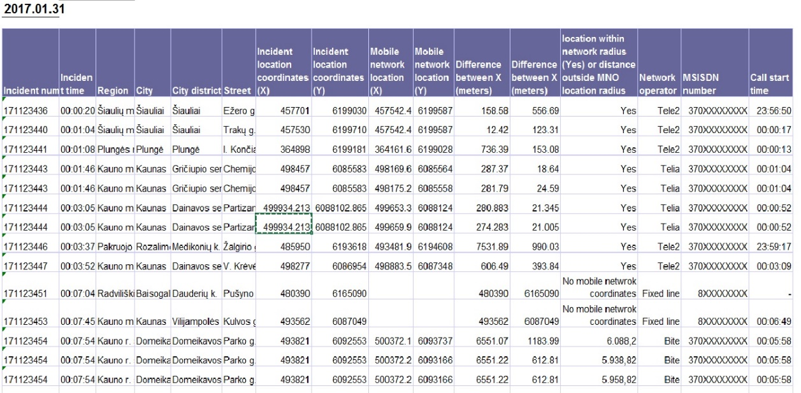

Table 3: Monthly AML performance report (source: Lithuania)
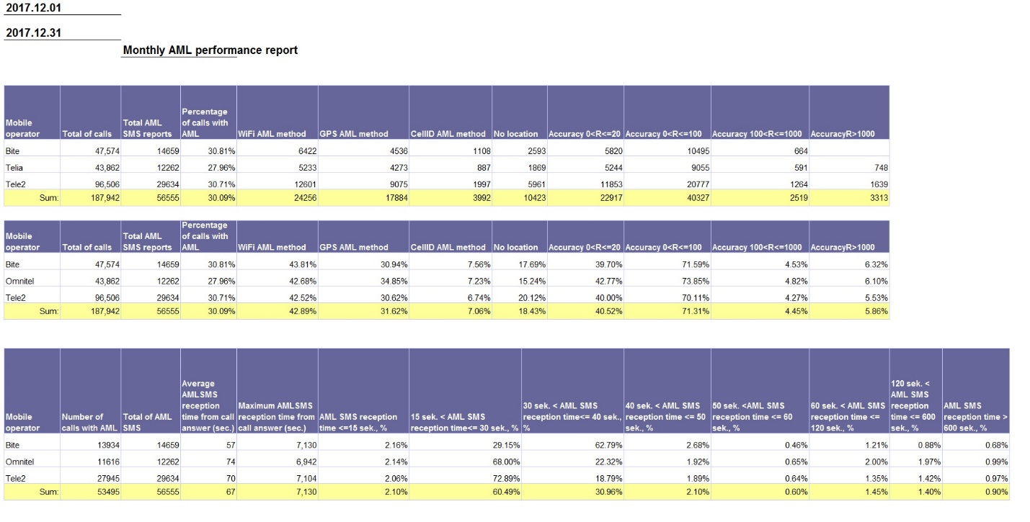

Malta
- Localisation method: Cell-ID / ESL (Google) launched in February 2018;
- Collecting data for statistics?: YES;
- Tools used: Interview with caller, Verbal or written report submitted by the intervention team;
- Frequency of collection: All calls made to the 112 PSAP are permanently collected;
- Frequency with which statistics are generated: Monthly;
- Statistical Analysis:
Responsible Entity: Head of Ministry responsible for PSAP and the Heads at the PSAPs;
The mechanism: location information is either given verbally to the PSAP by the 112 caller or, provided by the local service provider as per Universal Service Directive requirements. In the case of the latter, the call taker reconfirms the data prior to submitting the report to the concerned authorities, namely, Fire, Emergency, Army and Police. Things will change shortly when the new 112 system is in place. In this case, location information will be automatically available to the PSAP. The new solution will be using GIS and AML services in order to attain location information;
Statistics are mainly processed by the Police. Statistical information can be categorised in accordance with various requirements, namely:
number of calls per day;
% of hoax calls;
calls defined and closed by entity;
types of services provided - firefighting, ambulance requirements etc.;
automatically or manually triggered eCall requirement.
- The statistics may be used for national statistical purposes, magisterial warrants etc.
- Suggestions on how to improve: The Ministry is in the process of adopting a state of the art technological solution based on Caller location as per Universal Service directive requirements. The solution will also cater for eCall (adhering to eCall regulation). This will provide PSAPs with precise locations of emergency services whilst having records of activity sheets related to each call. GIS mapping and AML services will enhance and minimise the timeframes at which every emergency team reaches the location from where the call has been generated. Such a system may eventually be integrated with other existing systems (Transport Malta camera feeds). The latter would provide traffic visibility and possible routes to adopt through TomTom devices installed within defined vehicles (Fire Engines, Ambulances and Police Cars etc.). The system is modular and scalable and therefore the Ministry is exploring other enhancements which would enrich operations to maximum levels - reaching to Gold Command when a national crisis occurs.

Portugal
- Localisation method: Cell-ID;
- Collecting data for statistics?: YES;
- Tools used: Interview with caller;
- Frequency of collection: Permanent basis;
- Frequency with which statistics are generated: No determined period;
- Statistical Analysis:
Responsible Entity: 112 along with the Communications Regulator (ANACOM);
The mechanism: Although the location information obtained by interviewing the caller about the location of the incident is not the subject of this Report, Portugal provided a very useful breakdown of the accuracy/reliability of Cell-ID technology in the Report COCOM17-01 [3]. An extract is provided in Table 4 below for illustrative purposes:
Table 4: Breakdown of the accuracy/reliability of Cell-ID technology
Radius (m) | %
100 | 1,00%
250 | 0,50%
500 | 1,00%
750 | 4,50%
1000 | 10,00%
2000 | 22,50%
4000 | 34,00%
10000 | 21,50%
20000 | 5,50%
40000 | 0,50%

- Suggestions on how to improve: There should be a common standard on how the location data is transmitted in emergency calls for all Europe, and mandatory KPIs on it.

Romania
- Localisation method: Cell-ID/Sector ID;
- Collecting data for statistics?: YES;
- Tools used: Interview with caller; Verbal or written report submitted by the intervention team;
- Responsible entity: The statistical data is processed by the technical department within Single National Emergency Calls System (SNECS) using a ticketing application. The data is centralised by the internal Network Operations Centre;
- Frequency of collection: The analysis is made continuously by the call takers and dispatchers, case-by-case. If errors for the location provided are found, a new ticket is issued by the technical department for the internal Network Operations Centre;
- Frequency with which statistics are generated: Statistics are generated on a daily basis regarding the errors reported to the internal Network Operations Centre;
- Statistical Analysis:
The mechanism: The structure specialised in analysis, optimisation and development of the system evaluates and collects all errors and forwards to the management. Management then make proposals for sending requests for corrections to the Mobile Network Operators;
Statistics are made based on the identified error: calls without location or incorrect code calls. Table 5 below provides an example;
* Between 1 and 23 March 2018.
Table 5: Statistics on location information received with emergency calls (source: Romania)
Month | Calls without location codes |  | Calls with incorrect location codes |  | Calls with unknown location codes  (not provided in the RF maps by the operators) |  | Total number of emergency calls from mobile phones
 | Number of calls | Percentage | Number of calls | Percentage | Number of calls | Percentage
January | 74 | 0.01% | 2283 | 0.21% | Not analysed | Not analysed | 1078328
February | 99 | 0.01% | 628 | 0.06% | 15243 | 1.55% | 983871
March* | 245 | 0.03% | 152 | 0.02% | 3633 | 0.50% | 733616
Based on statistics there are less 1% calls without location or incorrect code.
- Suggestions on how to improve: An automatic mechanism for error detection should be implemented on the location system. If in the Geographic Information System (GIS) application the actual location of the incident is not in the area provided by the technical location method, an alert should be triggered to inform the administrators about the error in order to analyse the situation and take further measures.

Slovenia
- Localisation method: Cell-ID/Sector ID, RF Pattern coverage with three levels of probability, Advanced Mobile Location (AML), Smart locator;
- Collecting data for statistics?: YES;
- Tools used: SPIN - A reporting tool about accidents and incidents;
- Frequency of collection: Data is collected for all incidents or accidents;
- Frequency with which statistics are generated: Not specified;
- Statistical Analysis:
The mechanism: Information about RF pattern is reported by telephone operators. The PSAP receives the information through an information channel i.e. VPNs between 112 centres and telecom operators. The information from AML is received directly through SMS messages;
All the information is collected in application SPIN. When a call to 112 is made, all the information is collected in SPIN and is immediately published. The caller location is fixed by using SPIN and GIS;
Collected data are used by rescue units and also announced publicly on the SPIN website. This is illustrated in Figure 1:
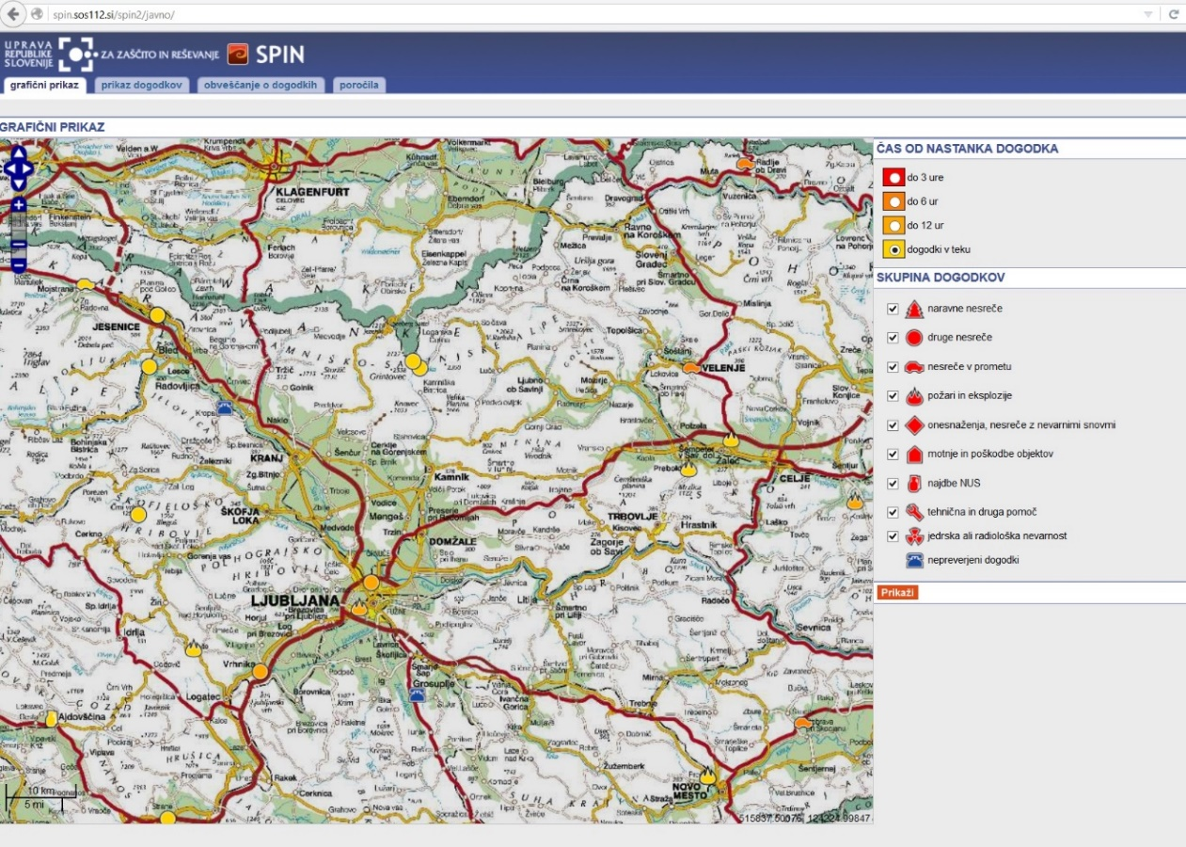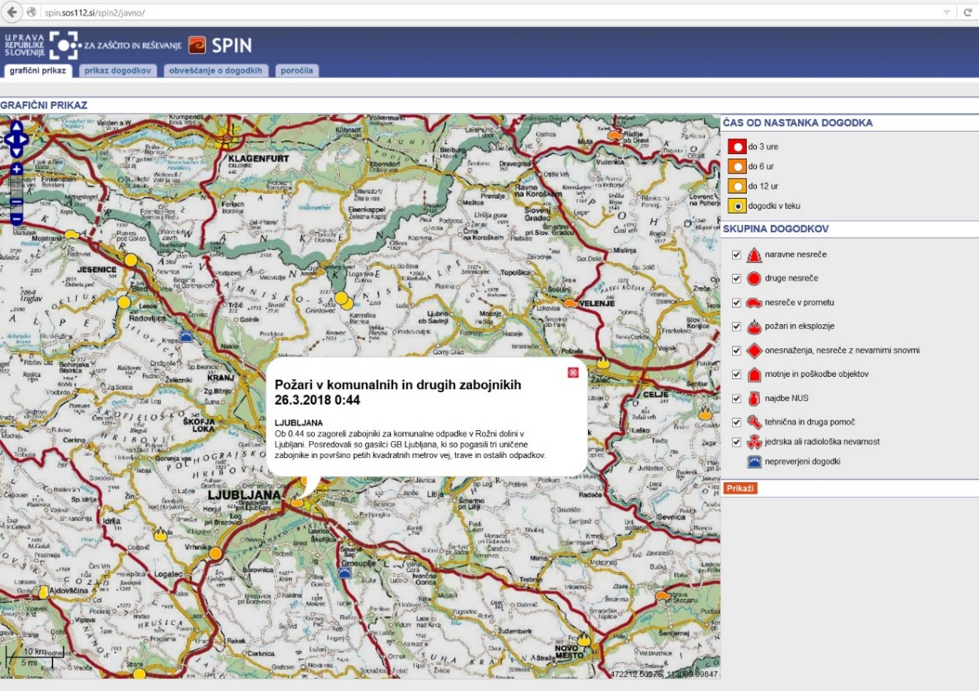
Figure 1: SPIN (source: Slovenia)
Statistics based on the data collected are not processed.

Sweden
- Localisation method: Cell-ID; AML-ready. AML is not operational because techniques that involves gaining access to information stored in the terminal equipment of a subscriber or user is only allowed if it fulfils the requirements in Article 5.3 of Directive 2002/58/EC. According to this Article the subscriber or user concerned must be provided with clear and comprehensive information in accordance with General Data Protection Regulation (GDPR), inter alia about the purposes of the processing, and must be offered the right to refuse such processing by the data controller. However, this shall not prevent any technical storage or access for the sole purpose of carrying out or facilitating the transmission of a communication over an electronic communications network, or as strictly necessary in order to provide an information society service explicitly requested by the subscriber or user;
- Collecting data for statistics?: YES;
- Tools used: a program which can compare the location set by the 112 call-taker with the cell-ID provided by the MNO;
- Frequency of collection: Data is collected on a "need-to-know-basis";
- Frequency with which statistics are generated: Not regularly since this is done manually (already have concerns about the inadequate location area which is obtained from MNO´s; in average about a 3 km2 area, where the caller quite often are outside the cell-ID area);
- Statistical Analysis:
Responsible Entity: Data is analysed on different levels in SOS Alarm;
The mechanism: the location set by the 112 call-taker is compared with the cell-ID provided by the MNO, using an IT program.

UK
- Localisation method: combination of Cell Sector-ID provided by Mobile Network Operators and, if the handset supports this capability, AML;
- Collecting data for statistics?: sample calls are monitored to verify/confirm the veracity of handset-derived (AML) information;
- Statistical Analysis: At this time, there are no plans to collect and evaluate statistical data on location information for emergency calls from mobile phones. While sample calls are monitored to verify/confirm the veracity of handset-derived (AML) information, this is not conducted on a wide-scale or statistical level. In addition, samples of AML-received information are compared with received mobile cell coverage to determine the accuracy of mobile network cell coverage estimates. Any material differences are discussed with the relevant MNOs to help improve the accuracy of network-provided Cell Sector information. Having a better understanding of the accuracy of location information can be useful to help drive improvements;
- In the UK over 40,000 emergency calls are received from mobile phones each day, so to have a comprehensive statistical data gathering and analysis activity would require additional resource at most, if not all, emergency control rooms (of which there are over 100 in the UK). Such reporting would need to capture and compare information from a variety of sources: the mobile network, the handset, the caller and the emergency response team that is dispatched. There are likely to be a variety of circumstances in which the recorded location of the caller may not reflect the location of the emergency (e.g. a call from one building concerning a fire in another building or where the caller is moving). While call operators need to have confidence in the location information provided, it also needs to be recognised that this information may not be reliable 100% of the time for a variety of reasons, some of which are beyond the control of network operators or handset providers. We could envisage that in time (once capabilities such as AML are available on all handsets), emergency control room operators could have the same level of confidence in the location information provided by mobile networks as currently achieved by fixed networks. In such circumstances, we could expect the emergency authorities to report material discrepancies to the mobile network operators in a similar manner as occurs for discrepancies identified in fixed networks today. The criteria that would be used to warrant discrepancy reporting could be for the emergency authorities to determine based on their own needs and expectations;
- The mechanism: At this time in the UK, statistical data gathering and analysis of mobile location caller accuracy does not take place, but there is a process whereby if the network-provided information is not received by the emergency control room, a ‘discrepancy’ is reported back to the mobile network operator for further investigation. Ofcom, the national regulatory authority (NRA) receives summaries of these discrepancy reports as part of an ongoing program of oversight of relevant General Conditions (GC4) for both fixed and mobile networks, and follows up with the relevant MNO when considered necessary;
- Suggestions on how to improve: The accuracy and reliability of received location data needs to be considered in the context of the anticipated future expectations of this data by the emergency call centres. We can envisage that for emergency calls from mobile devices (across all networks and from all handsets) accurate GNSS data would be available (normally derived from the mobile handset) coupled with network-based corroboration.

Main Findings
The information received during the questionnaire and the follow-up work should be interesting to those involved in collecting data to generate statistics on the effectiveness of caller location information for emergency calls and also to those who are planning to collect such data in the future.
The information may also be interesting to those who are not yet planning to collect data to generate statistics.
There is considerable variation in techniques and outputs from those that do collect location information on a statistical basis, from simple corroboration between handset and network-derived location to calculation of variances between them. At this time, therefore, it is hard to make a recommendation for a harmonised approach across Europe while technology and approaches continue to evolve rapidly.
Further work could be to look in more detail at the technical approaches developed by some respondents particularly in relation to the costs involved of implementation along with the perceived benefits to emergency services, the telecoms industry and associated regulatory bodies.
In practice, only the emergency responders can definitively confirm whether the location provided to the PSAP was accurate. However, their primary objective on attending the incident is to provide urgent assistance rather than verifying call details. While handset-derived or network-derived location information can have associated ‘confidence’ levels, the actual location can only be confirmed by emergency responders at the scene. As a result, the systematic collection and analysis of location accuracy statistics can be difficult, unless an automatic data collection method is used (e.g. SPIN application in Slovenia).

- Summary of responses to questionnaire
Submission dates: 15-06-2017 - 30-09-2017
Question 1: What are the technical methods used for establishing the location of emergency mobile calls in your country?
Romania | a. Network-based methods (Cell-ID, Cell Sector ID, RTT, Timing Advance, RF Pattern Matching (e.g. Polygons), other network-based solutions please specify all used in the “Remarks” field below): Cell-ID, Cell Sector ID
Norway | a. Network-based methods (Cell-ID, Cell Sector ID, RTT, Timing Advance, RF Pattern Matching (e.g. Polygons), and other network-based solutions please specify all used in the “Remarks” field below): Cell-ID, Cell Sector ID, RTT, Timing Advance, Polygons. AML is has been prepared for implementation but awaits legal privacy clarifications
Switzerland | a. Network-based methods (Cell-ID, Cell Sector ID, RTT, Timing Advance, RF Pattern Matching (e.g. Polygons), other network-based solutions please specify all used in the “Remarks” field below)  b. Handset-based methods (e.g. AML, network initiated handset-based GNSS location, Apps, other handset-based solutions please specify all used in the “Remarks” field below)  Cell-ID, Cell Sector ID, RTT, Timing Advance, RF Pattern Matching, Apps, WLAN localisation
Finland | a. Network-based methods (Cell-ID, Cell Sector ID, RTT, Timing Advance, RF Pattern Matching (e.g. Polygons), other network-based solutions please specify all used in the “Remarks” field below)  b. Handset-based methods (e.g. AML, network initiated handset-based GNSS location, Apps, other handset-based solutions please specify all used in the “Remarks” field below)
Slovenia | a. Network-based methods (Cell-ID, Cell Sector ID, RTT, Timing Advance, RF Pattern Matching (e.g. Polygons), other network-based solutions please specify all used in the “Remarks” field below)  • RF Pattern coverage with three levels of probability, • eCall, • Advanced Mobile Location (AML), • Smart locator.
Spain | a. Network-based methods (Cell-ID, Cell Sector ID, RTT, Timing Advance, RF Pattern Matching (e.g. Polygons), other network-based solutions please specify all used in the “Remarks” field below)
Lithuania | a. Network-based methods (Cell-ID, Cell Sector ID, RTT, Timing Advance, RF Pattern Matching (e.g. Polygons), other network-based solutions please specify all used in the “Remarks” field below)  b. Handset-based methods (e.g. AML, network initiated handset-based GNSS location, Apps, other handset-based solutions please specify all used in the “Remarks” field below)
Lithuania | c. Hybrid methods (please specify all used in the “Remarks” field below)  Lithuania is currently using Cell- ID Timing Advance method and AML method for establishing the location of emergency mobile calls.
Czech Republic | a. Network-based methods (Cell-ID, Cell Sector ID, RTT, Timing Advance, RF Pattern Matching (e.g. Polygons), other network-based solutions please specify all used in the “Remarks” field below)  b. Handset-based methods (e.g. AML, network initiated handset-based GNSS location, Apps, other handset-based solutions please specify all used in the “Remarks” field below)
Portugal | a. Network-based methods (Cell-ID, Cell Sector ID, RTT, Timing Advance, RF Pattern Matching (e.g. Polygons), other network-based solutions please specify all used in the “Remarks” field below)
Malta | a. Network-based methods (Cell-ID, Cell Sector ID, RTT, Timing Advance, RF Pattern Matching (e.g. Polygons), other network-based solutions please specify all used in the “Remarks” field below)  ESL (Google) will be implemented soon.
Slovak Republic | a. Network-based methods (Cell-ID, Cell Sector ID, RTT, Timing Advance, RF Pattern Matching (e.g. Polygons), other network-based solutions please specify all used in the “Remarks” field below)  Network based Cell-ID/Sector ID Implementation of the AML in preparatory phase
Croatia | a. Network-based methods (Cell-ID, Cell Sector ID, RTT, Timing Advance, RF Pattern Matching (e.g. Polygons), other network-based solutions please specify all used in the “Remarks” field below)  These were the answers from our PSAP and the operators: PSAP: OFF-LINE positioning. Information consists of Cell-ID location (name and location), date, time and direction where signal came from. Such locating is mostly used in search and rescue actions. ON-LINE positioning. Based on information obtained from the caller (latitude and longitude). The operator manually enters the data into the GIS application and locate the caller on the map. Currently, there is no possibility to automatically display the location of the caller OPERATORS: -We are using Gateway Mobile Location Centre (GMLC) functionality to support establishing location data of emergency mobile calls. Technical methods are NI-LR (Network Initiated Location Request) and MTLR (Mobile Terminating Location Request). -At the setup of Emergency call, the Initial location can be pushed up to the PSAP. The 3GPP Network Induced location functionality in the network nodes (MSCs) is used to invoke the push of initial location at the setup of Emergency call. Pull-method is primarily used for used for “follow-on” locations, during the call.
Sweden | a. Network-based methods (Cell-ID, Cell Sector ID, RTT, Timing Advance, RF Pattern Matching (e.g. Polygons), other network-based solutions please specify all used in the “Remarks” field below)  Cell-ID. We are "AML-ready" but legal aspects prohibit us to start with AML. A change of law is required according to Swedish authorities (The Swedish post and Telecom Agency and the Swedish Data Protection Authority). We now set the hope to upcoming regulations on EU level (E-Privacy Regulation).
Latvia | c. Hybrid methods (please specify all used in the “Remarks” field below)  Cell-ID + AML
United Kingdom | c. Hybrid methods (please specify all used in the “Remarks” field below)  UK uses a combination of Cell Sector-id provided by Mobile Network Operators and, if the handset supports this capability, AML.

Question 2: Are you currently collecting and evaluating statistical data about the quality of location information for emergency calls originating on mobile networks? If Yes, please answer questions 3-9. If no, please go to question 10.
Romania | Yes
Norway
Switzerland | No
Finland | No
Slovenia | Yes
Spain | No
Lithuania | Yes
Lithuania | No
Czech Republic | No
Portugal | Yes
Malta | Yes
Slovak Republic | No
Croatia | No
Sweden | Yes
Latvia | No
United Kingdom | No

Current Situation (Questions 3-9) For those respondents who answered "Yes" to Question 2.

Question 3: Which tools do you use to assess the location information obtained using the technical location method versus the actual location of the incident?
Romania | Interview with caller.  Verbal or written report submitted by the intervention team
Norway
Switzerland
Finland
Slovenia | Comparison between RF pattern coverage and AML or Smart locator location is possible
Spain
Lithuania | At ERC we measure distances between coordinates of network location and emergency location and also between network location and AML location. However it is sometimes quite hard to find out whether reported position and actual position match together. Especially in cases when the caller calls from one city to report emergency in another city. On the other hand significant mismatch between Cell and AML coordinates may mean inaccuracy in one of them.
Lithuania
Czech Republic
Portugal | Interview with caller
Malta | Interview with caller.  Verbal or written report submitted by the intervention team
Slovak Republic
Croatia
Sweden | Interview with caller  Our chief architect in IT has developed a program which can compare the location set by the 112 call-taker with the cell-ID provided by the MNO
Latvia
United Kingdom

Question 4: Do you collect any supplementary data which you consider relevant for the evaluation of the caller location statistics? If yes, please specify in the “Remarks” field below.
Romania | No
Norway
Switzerland
Finland
Slovenia | Yes, we collect information’s of location from callers on 112 in application SPIN. We can compare it from RF pattern data
Spain
Lithuania | No
Lithuania
Czech Republic
Portugal | Yes, statistics on Cell-Id radius
Malta | No
Slovak Republic
Croatia
Sweden | No
Latvia
United Kingdom

Question 5: Who processes the data necessary for these statistics? How is the information centralised and by whom? Please describe.
Romania | The statistical data is processed by the technical department within SNECS (Single National Emergency Calls System) using a ticketing application. The data is centralized by the internal Network Operations Centre.
Norway
Switzerland
Finland
Slovenia | We do not process it yet.
Spain
Lithuania | We use SAP Business Objects analytical tool that is managed by ERC's ICT Unit. Daily and on-demand reports are generated and send to interested employees.
Lithuania
Czech Republic
Portugal | 112
Malta | 112 Data is retained for a period of time as defined by Data Protection Principals. It is processed mainly by the Police Department. However, when the lines of the latter are all busy, 112 calls are routed to the CPD control room. When eventually a call is dispatched to the secondary PSAPs, all activity sheets in relation to the case are updated by the respective party (CPD, Health, AFM or Police themselves). Therefore, all statistical data is based on incoming 112 calls only.
Slovak Republic
Croatia
Sweden | SOS Alarms Chief Architect can provide the data for all of SOS Alarms PSAPs.
Latvia
United Kingdom

Question 6: What is the frequency with which the data is collected (e.g. on permanent basis, for all incidents or for a determined set of incidents, based on geography, type of incidents or other criteria or on a case by case basis)?
Romania | Due to the fact that the location information is provided with each call, the analysis is made continuously by the call takers and dispatchers, case by case. If errors for the location provided are found, a new ticket is issued by the technical department for the internal Network Operations Centre.
Norway
Switzerland
Finland
Slovenia | We collect data for all incidents or accidents
Spain
Lithuania | Everything is recorded and analysed.
Lithuania
Czech Republic
Portugal | permanent basis
Malta | Calls made to the 112 PSAP are permanently collected.
Slovak Republic
Croatia
Sweden | Data is collected on a "need-to-know-basis", for example before meetings with The Swedish post and Telecom Agency The Swedish post and Telecom Agency and from time to time to evaluate the correctness of cell-ID compared to for example GPS-position provided by AML or eCall.
Latvia
United Kingdom

Question 7: What is the frequency with which statistics based on the data collected are made?
Romania | Other (please specify in the "Remarks" field below)  Daily statistics regarding the errors reported to the internal Network Operations Centre are made
Norway
Switzerland
Finland
Slovenia | Other (please specify in the "Remarks" field below)  We do not make a statistic yet
Spain
Lithuania | Other (please specify in the "Remarks" field below)  Daily, Monthly
Lithuania
Czech Republic
Portugal | Other (please specify in the "Remarks" field below)  There is not a determined period
Malta | Monthly
Slovak Republic
Croatia
Sweden | Other (please specify in the "Remarks" field below)  Not regularly since this is done manually today. We don´t see that we should need to do it on a more regular basis since we already have concerns about the inadequate location area that we get from MNO´s; in average about a 3 km2 area, where the caller quite often are outside the cell-ID area.
Latvia
United Kingdom

Question 8: Who analyses the statistics and who decides the implementation of the necessary measures resulting from analysing statistics (i.e. for improvement purposes)?
Romania | The structure specialized in analysis, optimization and development of the system evaluates and collects all errors and forwards to the management proposals for sending the requests for corrections to the Mobile Network Operators.
Norway
Switzerland
Finland
Slovenia | /
Spain
Lithuania | ERC's ICT Unit.
Lithuania
Czech Republic
Portugal | 112 along with the Communications Regulator (ANACOM)
Malta | Head of Ministry responsible for PSAP and the Heads at the PSAPs
Slovak Republic
Croatia
Sweden | Data is analysed on different levels in SOS Alarm. Measures is hard to take since the regulations today are to loosely structure as we see it. It allows a "best effort" from MNOs which they take literally. Technically, we are probably likely to get a GPS-position from the MNO´s already today, but since this is not explicit mandatory and would mean a cost for them this would require a more strict EU regulation. Therefore our chief measure at this time is to impact on the Swedish Government (Ministry of Enterprise and Innovation so that EU regulation can allow us to use AMML and similar handset based location solutions.
Latvia
United Kingdom

Question 9: Considering the current processes and tools you are using, do you have any suggestions on how to improve these?
Romania | An automatic mechanism for error detection on the location system should be implemented. If in the GIS application the actual location of the incident is not in the area provided by the technical location method, an alert should be triggered to inform the administrators about the error in order to analyse the situation and take further measures.
Norway
Switzerland
Finland
Slovenia
Spain
Lithuania | To make Open Data to the public available is thought in the future.
Lithuania
Czech Republic
Portugal | Think there should be a common standard on how the location data is transmitted in emergency calls for all Europe, and mandatory KPI's on it.
Malta | The Ministry is in the process of adopting a state of the art technological solution based on Caller location as per Universal Service directive requirements. The solution will also cater for eCall (adhering to eCall regulation). This will provide PSAPs with precise locations of emergency services whilst having records of activity sheets related to each call. GIS mapping and AML services will enhance and minimize the timeframes at which every emergency team reaches the location from where the call has been generated. Such a system may eventually be integrated with other existing systems (Transport Malta camera feeds). The latter would provide traffic visibility and possible routes to adopt through TomTom devices installed within defined vehicles (Fire Engines, Ambulances, and Police Cars etc.). The system is modular and scalable and therefore the Ministry is exploring other enhancements which would enrich operations to maximum levels - reaching to Gold Command when a national crisis occurs.
Slovak Republic
Croatia
Sweden | No.
Latvia
United Kingdom

Plans for the future (Questions 10 -15) - For those respondents who answered "No" to Question 2.

Question 10: Are you planning to collect and evaluate statistical data about the quality of location information for emergency calls originating on mobile networks?
Romania
Norway | No
Switzerland | No
Finland | Yes
Slovenia | No
Spain | No
Lithuania
Lithuania | No
Czech Republic | No
Portugal
Malta
Slovak Republic | Yes
Croatia | Yes
Sweden
Latvia | Yes
United Kingdom | No

Question 11: If "Yes" to Question 10, please answer questions 12-15.
If No, do you consider useful this kind of assessment?
Norway | Yes  The information is very useful, but it is too early to say that the NRA is planning to collect and evaluate. Probably we will do this in the future if the location measures improve. Today we have enough material to conclude that existing caller location information is inaccurate. Generally, it is easier to collect and evaluate if we get GNSS coordinates, rather than Cell-ID etc.
Switzerland | Yes
Finland
Slovenia
Spain | ES DEBIDO A QUE EL ACTUAL SISTEMA DE LOCALIZACIÓN BASADO EN INFORMACION OBTENIDA POR LA RED (Cell-ID), Y EN EXTREMADURA POR LA EXTENSIÓN Y DISPERSION GEOGRAFICA LA DENSIDAD DE REPETIDORES ES BAJA, Y TANTO LA PRECISIÓN, EXACTITUD DE ESTE DATO DE LOCALIZACIÓN ES MUY BAJO Y REALMENTE NO APORTA NADA, ESTO NO TENDRÁ SOLUCIÓN HASTA QUE NO SE IMPLEMENTE UN SISTEMA DE LOCALIZACIÓN BASADO EN TELEFONO TIPO AML.
Lithuania
Lithuania | Yes  Our PSAP collects all relevant information
Czech Republic | Yes
Malta
Slovak Republic
Croatia | OPERATORS: - Operator’s view is that the evaluation of the quality of location information should be primary driven by the end users of the location information, which are in this case national PSAPs. This is because national PSAPs are the ones who have direct communication with the customer and potential insight in multiple/additional location information which can be compared.
Sweden
Latvia | Yes
United Kingdom | Yes,  The accuracy and reliability of received location data needs to be considered in the context of the anticipated future expectations of this data by the emergency call centres. We can envisage that for emergency calls from mobile devices (across all networks and from all handsets) accurate GPS data would be available (normally derived from the mobile handset) coupled with network-based corroboration. Similarly, for emergency calls from landline phones, consistent location information could be expected, based upon the handset’s physical location (as opposed to, say, a billing address). At this time, there are no plans to collect and evaluate statistical data on location information for emergency calls from mobile phones. While sample calls are monitored to verify/confirm the veracity of handset-derived (AML) information, this is not conducted on a wide-scale or statistical level. In addition, samples of AML-received information are compared with received mobile cell coverage to determine the accuracy of mobile network cell coverage estimates. Any material differences are discussed with the relevant MNOs to help improve the accuracy of network-provided Cell Sector information. Having a better understanding of the accuracy of location information can be useful to help drive improvements. However, it should be recognised that in the UK over 40,000 emergency calls are received from mobile phones each day, so to have a comprehensive statistical data gathering and analysis activity would require additional resource at most, if not all, emergency control rooms (of which there are over 100 in the UK). Such reporting would need to capture and compare information from a variety of sources: the mobile network, the handset, the caller and the emergency response team that is dispatched. There are likely to be a variety of circumstances in which the recorded location of the caller may not reflect the location of the emergency (e.g. a call from one building concerning a fire in another building or where the caller is moving). While call operators need to have confidence in the location information provided, it also needs to be recognised that this information may not be reliable 100% of the time for a variety of reasons, some of which are beyond the control of network operators or handset providers. We could envisage that in time (once capabilities such as AML are available on all handsets), emergency control room operators could have the same level of confidence in the location information provided by mobile networks as currently achieved by fixed networks. In such circumstances, we could expect the emergency authorities to report material discrepancies to the mobile network operators in a similar manner as occurs for discrepancies identified in fixed networks today (see Q13). The criteria that would be used to warrant discrepancy reporting could be for the emergency authorities to determine based on their own needs and expectations.

Question 12: Who should process the data necessary for these statistics? How should the information be centralised and by whom? Please describe.
Norway | PSAPs in cooperation with central entities (in Norway probably the CRDB) and NRAs
Switzerland
Finland | CAD system producer should gather the data.
Slovenia | The Administration for Civil Protection and Disaster Relief of the Republic of Slovenia will make a data processing and statistics
Spain
Lithuania
Lithuania
Czech Republic
Malta
Slovak Republic | In case of Slovak Republic, the location data should be processed by the Ministry of Interior, governing body for Police, Fire and Rescue and Civil Protection PSAPs. The data does not need to be centralised as these are the only PSAPs that receive caller location from the MNOs and use the same infrastructure for processing the location data.
Croatia | PSAP: Location data will be collected and statistically analysed by the Analytical department within National Protection and Rescue Centre (PSAP).  Based on the “lessons learned” (incorrect locating, impossibility of locating etc.) corrective actions in cooperation with telecom operators will be undertaken
Sweden
Latvia | The institution administrating the data (IT administration) should process it. The information should be processed by one institution and it should be the one who is administrating the system.
United Kingdom

Question 13: What is the frequency with which the data should be collected (e.g. on permanent basis, for all incidents or for a determined set of incidents, based on geography, type of incidents or other criteria or on a case by case basis)?
Norway | Probably for a set of incidents within one or more specific PSAP areas within a certain timeframe.
Switzerland
Finland | on permanent basis, for all incidents
Slovenia | We will collect data for all incidents or accidents
Spain
Lithuania
Lithuania
Czech Republic
Malta
Slovak Republic | The data should be collected for all incidents, however it is important to make distinction between urban, rural and mountainous areas, extreme cases should be selected and analysed case by case in order to identify and minimize the occurrence of the extreme cases where possible.
Croatia | the data should be collected on a case by case basis
Sweden
Latvia | The frequency could be once in a month. Of course it depends on overall number of calls received per month and number of incidents. Depending on that the frequency could be set.
United Kingdom | At this time in the UK, statistical data gathering and analysis of mobile location caller accuracy does not take place, but there is a process whereby if the network-provided information is not received by the emergency control room, a ‘discrepancy’ is reported back to the mobile network operator for further investigation. Ofcom, the national regulatory authority (NRA) receives summaries of these discrepancy reports as part of an ongoing programme of oversight of relevant General Conditions (GC4) for both fixed and mobile networks, and follows up with the relevant MNO when considered necessary.  If an approach similar to the current discrepancy reporting for fixed networks is adopted, the frequency of data collection and reporting may be decided by each emergency authority.

Question 14: What is the frequency with which statistics based on the data collected should be made?
Norway | Other (please specify in the "Remarks" field below)  Twice a year?
Switzerland
Finland | Quarterly
Slovenia | Other (please specify in the "Remarks" field below)  Online
Spain
Lithuania
Lithuania
Czech Republic
Malta
Slovak Republic | Yearly
Croatia | Other (please specify in the "Remarks" field below)  PSAP: On request, for the purpose of reporting
Sweden
Latvia | Monthly
United Kingdom

Question 15: Who should analyse the statistics and who should propose the implementation of the necessary measures resulting from analysing statistics (i.e. for improvement purposes)?
Norway | NRAs should monitor compliance with the EU regulation, decide on sanctions etc. The regulation must be sufficiently Clear in order to promote a transparent compliant assessment. The case-evidence must be based on the locations received by PSAPS compared to the PSAPs determination of the actual location of the incidents.
Switzerland
Finland | Here in Finland analysing should be done in collaboration with Finnish communications regulatory authority and ERCA.  Implementation of the necessary measures are responsibility of Finnish communications regulatory authority.
Slovenia | The Administration for Civil Protection and Disaster Relief of the Republic of Slovenia and Agency for Communications, Networks and Services of the Republic of Slovenia
Spain
Lithuania
Lithuania
Czech Republic
Malta
Slovak Republic | Ministry of Interior in cooperation with relevant research or analytical institutions, subject to consideration.
Croatia | PSAP:  A statistical analysis of the locations will be carried out by an Analytical department that will propose measures to improve (increased location accuracy, shorter information delivery time, technical and legal framework, etc.)
Sweden
Latvia | Responsible institution.
United Kingdom

- list of References

- COCOM18-03: “Implementation of the European emergency number 112 – Results of the eleventh data-gathering round”, 09 February 2018
- ECC Report 225: “Establishing Criteria for the Accuracy and Reliability of the Caller Location Information in support of Emergency Services”
- COCOM17-01: “Implementation of the European emergency number 112 – Results of the tenth data-gathering round”, 10 February 2017

Available in Lombardia and Rome
Available in Piemonte
Croatia, Czech Republic, Finland, Latvia, Lithuania, Malta, Norway, Portugal, Romania, Slovak Republic, Slovenia, Spain, Sweden, Switzerland and the United Kingdom.
http://spin.sos112.si/spin2/javno/

