Body effect of hand-held and body-worn audio PMSE equipment

28 September 2018

ECC Report 286

# Executive summary

This Report gathers historical data from previous ECC Reports and results from recent work on the effect of the human body on the transmission characteristics of audio PMSE equipment (body effect). The scenarios include both hand-held and body-worn PMSE equipment.

The body effect values provided in this Report are to be used as gain of the corresponding wireless microphone antenna in dBd.

A total of 78 scenarios of measurements and simulations have been combined and evaluated and presented using the same methodology, allowing comparison of results. Measurements focus on existing audio PMSE bands from 470 to 1800 MHz. Mathematical modelling (simulation) was carried out by Ofcom (Switzerland) at frequencies up to 6 GHz.

The measurement results for hand-held PMSE transmitters showed consistency with the simulation results.

For the body-worn transmitters there was a deviation between the measured and simulation results. This deviation was traced to the variation of the distance of the antenna from the body: in the simulations, the distance was assumed to be 10 mm, whereas in the measured results, the distance was less than 5 mm. The lower distance reflects the actual usage of body-worn transmitters. Limited additional simulations assuming a smaller distance of 4 mm showed an improved correlation with the measured results, indicating that the simulation results do not always reflect the actual usage of the equipment.

Therefore, only the measurement results are used as the basis for the modelling developed in this Report.

A hand-held PMSE transmitter placed in a table-stand demonstrates a smaller variation in power because it is at a greater distance from a human body. Nevertheless, because hand-held PMSE transmitters are optimised for use in the human hand, when used in a table stand it has been observed that the radiation pattern is affected and the radiated power is reduced.

Analysis of the historical data provided in ECC Reports and the measurement data and simulation results referenced in the Report has resulted in frequency dependant formulas for use in sharing and compatibility studies. The appropriate values are calculated according to the scenario and frequency range under study. The standard deviation (σ) obtained from the set of measurements is also provided.

The value for the body effect using a dipole antenna as a reference includes the antenna gain of the wireless microphone antenna as well as the attenuation of the body. This means that in compatibility studies the antenna gain of the wireless microphone does not need to be considered as an additional factor.

The minimum body effect is the effect of the body on possible interference from PMSE transmitter, referred to as "maximum radiation" in the measurements. This may be used for interference calculations using MCL.

The maximum body effect is the effect of the body into the transmission path (or link budget) of PMSE applications, referred to as "PMSE Path" in the measurements. This may be used for path loss calculation.

The mean body effect is the average effect of the body. This may be used for interference calculations in SEAMCAT.

Min. Body Effect (for interference calculation in MCL)

* 1) Hand-held Audio PMSE: Min. Body Effect [dB] = 0.0015 dB/MHz * F [MHz] - 8.5239 dB (σ = 1.84 dB)
* 2) Body-worn Audio PMSE: Min. Body Effect [dB] = -0.0045 dB/MHz * F [MHz] - 4.7997 dB (σ = 2.98 dB)

Max. Body Effect (for path loss calculation of audio PMSE)

* 1) Hand-held Audio PMSE: Max. Body Effect [dB] = 0.0028 dB/MHz * F [MHz] - 37.63 dB (σ = 6.63 dB)
* 2) Body-worn Audio PMSE: Max. Body Effect [dB] = -0.009 dB/MHz * F [MHz] - 29.693 dB (σ = 5.91 dB)

Mean Body Effect (for interference calculation in SEAMCAT)

* 1) Hand-held Audio PMSE: Mean Body Effect [dB] = 0.0025 dB/MHz * F [MHz] - 13.622 dB (σ = 2.1 dB)
* 2) Body-worn Audio PMSE: Mean Body Effect [dB] = -0.0058 dB/MHz * F [MHz] - 8.5917 dB (σ = 3.3 dB)

TABLE OF CONTENTS

0 Executive summary 2

1 Introduction 6

2 Definitions 7

3 Relevant background material 8

4 Report from recent measurements and simulation study on body effect of audio PMSE 9

4.1 Body effect measurements provided by APWPT/DKE 9

4.1.1 Test method for measurements of body effect parameters of audio PMSE 9

4.1.2 Measurements results 10

4.1.3 Additional considerations 13

4.1.3.1 Effect of human body on antenna matching of body-worn PMSE 13

4.1.3.2 Human Hand: Effect on hand-held Microphones 14

4.1.3.3 Effect of table stands 15

4.2 Simulation results from OFCOM (CH) study 16

4.3 Simulation results from APWPT 18

4.3.1 Introduction 18

4.3.2 Dipole without body 18

4.3.3 Body effect 19

4.3.4 Conclusions 21

5 Comparison of measured and simulated values of the Body Effect of audio PMSE 22

5.1 Overview of the comparison 22

5.2 Analysis 23

6 Conclusions 25

ANNEX 1: Relevant background material 26

ANNEX 2: Simulated Human Body Loss 32

ANNEX 3: Virtual Population (ViP) 35

ANNEX 4: Subset of measurements results provided by APWPT/DKE 36

ANNEX 5: Subset of simulation results 40

ANNEX 6: Results from Ofcom UK Measurements 42

ANNEX 7: List of Reference 43

LIST OF ABBREVIATIONS

|  |  |
| --- | --- |
| Abbreviation | Explanation |
| 3D | 3 Dimensional |
| APWPT | Association of Professional Wireless Production Technologies |
| CEPT | European Conference of Postal and Telecommunications Administrations |
| DKE | German Commission for Electrical, Electronic & Information Technologies of DIN and VDE |
| ECC | Electronic Communications Committee |
| ERP | Effective Radiated Power |
| ETHZ | Swiss Federal Institute of Technology in Zürich |
| MCL | Minimum Coupling Loss |
| OFCOM | Federal Office of Communications, Switzerland |
| PMSE | Programme Making and Special Events |
| RF | Radio Frequency |
| RMS | Root Mean Square |
| SEAMCAT | Spectrum Engineering Advanced Monte Carlo Analysis Tool |
| ViP | Virtual Population |

# Introduction

Since 1992, many compatibility studies have been performed within the ECC in relation to audio PMSE and various incumbent and adjacent services. During these activities, it became apparent that the body effect for hand-held and body-worn PMSE equipment was an important factor, which was difficult to quantify in compatibility studies, despite the availability of relevant information and measurement results.

Thus, the scope of this Report is to collect and summarise data related to body effect for hand-held and body-worn PMSE equipment, with the aim to identify an appropriate model that can be used in sharing studies. The body effect values provided in this Report are to be used as gain of the corresponding wireless microphone antenna in dBd.

Measurements and simulations used within this Report have been produced under ideal conditions, i.e. in dry conditions with the test subjects dry and holding the microphone correctly, and in the case of body-worn units on a dry and un-costumed body. Figure 1 shows the use of body-worn radio microphones in operational conditions.

  

Figure 1: Use of body-worn radio microphones in operational conditions

# Definitions

|  |  |
| --- | --- |
| Term | Definition |
| Body effect | The ratio of the power radiated by the wireless microphone antenna in the proximity of the user's body and the power radiated by a reference dipole antenna when the body is not present. (This definition is used in horizontal plane measurements) |
| Body loss | The ratio of the power radiated by the wireless microphone antenna in the proximity of the user's body and the power radiated by the same antenna when the body is not present [2]. (This definition is used in 3D simulations) |
| Body-worn | SK-027  A transmitter, which is battery-operated and attached to a part of the human body with its antenna in close proximity or taped to the skin. |
| Hand-held | A transmitter, which is battery-operated and held in the hand, the antenna is integral. |
| Salty Man | There are several forms of artificial human beings currently used in radiated testing. The three most commonly used types are the Saltwater column, the Salty man and Salty-lite. The Saltwater column has historically been used not only for testing body-worn devices e.g. paging receivers, but also for tests on maritime and other mobile equipment. It was the first in existence and is mainly used in measurements on body-worn equipment operating below 50 MHz. At higher frequencies, many tests are currently performed using two types of Salty man which are basically saltwater filled plastic cylinders of the height of an average adult |

# Relevant background material

Considerations on body loss and body effect for audio PMSE have been included in a range of ECC deliverables, including measurement results and assumptions used in compatibility studies. An overview is provided in ANNEX 1.

Furthermore, simulation studies from OFCOM Switzerland [5][6] and measurements from OFCOM UK [3] are provided in ANNEX 2 and ANNEX 6 respectively.

# Report from recent measurements and simulation study on body effect of audio PMSE

## Body effect measurements provided by APWPT/DKE

### Test method for measurements of body effect parameters of audio PMSE

* Measure the conducted output power provided to the PMSE transmitter antenna port;

RMS RF power meter

Audio PMSE

* A signal generator is set to the output level measured in first point and connected to   
  a reference dipole in a non‐anechoic test chamber;

RF generator

Reference dipole antenna

* Measure the power level of the 360 degree antenna characteristic and using the maximum radiated power levels to create a 360 degree plot that shows the 0 dB reference point;

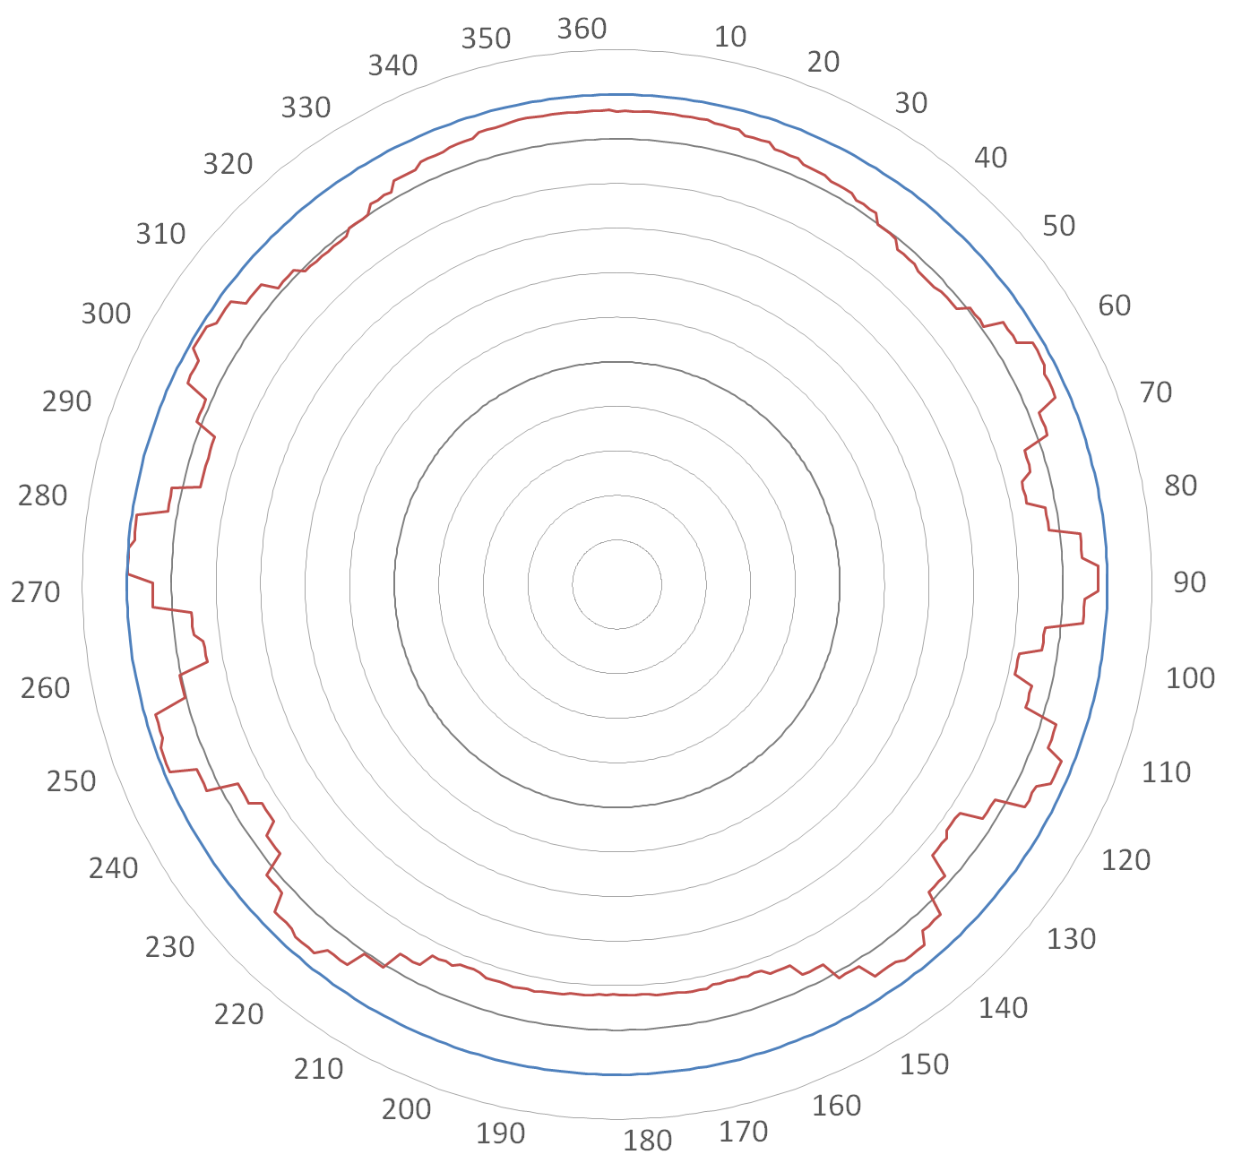   
Figure 2: Typical result plot

* Fix the audio PMSE transmitter on a human’s body at representative positions and measure for each position the 360 degree antenna characteristic. Extract from the measurement results the MINIMUM and MEDIAN parameter;

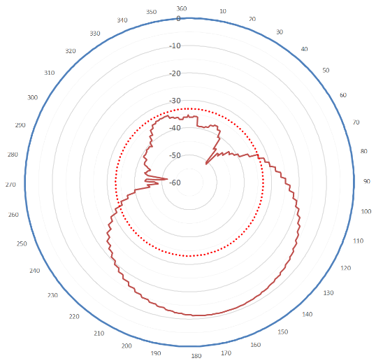

Figure 3: Location of the PMSE device and typical output result

For reference purposes, some measurements were carried out without the presence of a human body; this was to evaluate the characteristics of the device.

Measurements have primarily been made in a calibrated chamber using two male and one female subject; they are in two planes, horizontal and vertical. All measurement scenarios were evaluated and presented using the same methodology, making it easier to compare the results.

Figure 4 below summarises important results in a polar graphic. This figure is completed with explanatory information.

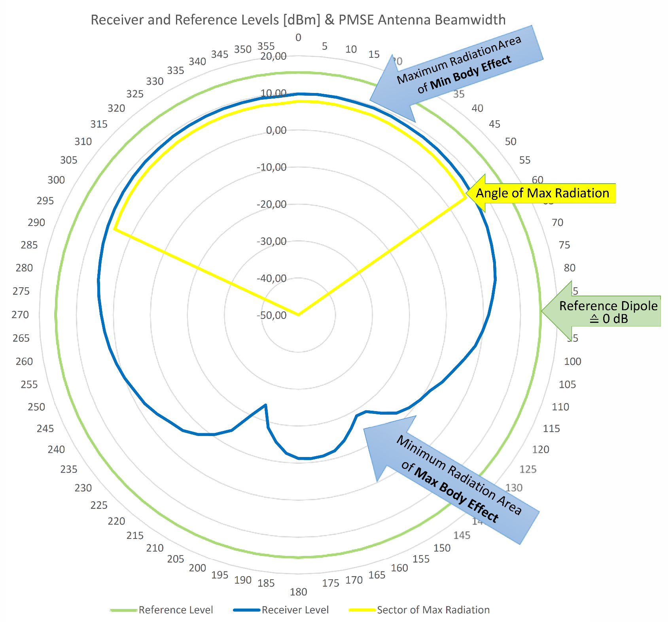

Figure 4: Polar graphic with explanatory information

Additional information on measurements, such as the ones carried out for the 1492-1525 MHz band can be found in Annex 1 of ECC Report 253 [8].

### Measurements results

The detailed results of these measurements are comprehensively covered in the excel sheet available in [4]. An overview is provided in this section. A relevant subset of the measurements results for both body-worn and hand-held audio PMSE devices is included in ANNEX 4:

Two main scenarios have been considered:

* Body effect on possible interference from PMSE transmitter, referred to as "maximum radiation" of PMSE (i.e. Min. Body Effect) (see Figure 5 and Figure 6);
* Body effect into the transmission path (or link budget) of PMSE applications referred to as "PMSE Path" (i.e. Max. Body Effect) (see Figure 7 and Figure 8).

Figure 5 below summarises the measurement results of the maximum radiation of hand-held PMSE transmitters. The red line in the middle is the trend of all measurements. The formula of this line is shown. This allows the body effect to be calculated at other frequencies. In addition, the maximum deviation and variance of the measured data is included. The deviations occurred during the measurements due to different basic conditions, for example the position of the transmitter in relation to the body slightly changed during the test period.



Figure 5: Summary of measured Body Effect Values of hand-held PMSE - Maximum Radiation

Figure 6 summarises the measurement results of the maximum radiation of body-worn PMSE transmitters. The red line in the middle is the trend of all measurements. The formula of this line is shown. This allows the body effect to be calculated at other frequencies. In addition, the maximum deviation and variance of the measured data is included. The deviations occurred during the measurements due to different basic conditions, for example the position of the transmitter in relation to the body slightly changed during the test period.

Figure 6: Summary of measured Body Effect Values of body-worn PMSE - Maximum Radiation

Figure 7 below summarises the measurement results of the maximum loss in the propagation path of hand-held PMSE transmitters. The red line in the middle is the trend of all measurements. The formula of this line is shown. This allows the body effect to be calculated at other frequencies. In addition, the maximum deviation and variance of the measured data is included. The deviations occurred during the measurements due to different basic conditions, for example the position of the transmitter in relation to the body slightly changed during the test period.



Figure 7: Summary of measured Body Effect Values of hand-held PMSE - PMSE Path

Figure 8 below summarises the measurement results of the maximum loss in the propagation path of body-worn PMSE transmitters. The red line in the middle is the trend of all measurements. The formula of this line is shown. This allows the body effect to be calculated at other frequencies. In addition, the maximum deviation and variance of the measured data is included. The deviations occurred during the measurements due to different basic conditions, for example the position of the transmitter in relation to the body slightly changed during the test period.



Figure 8: Summary of measured Body Effect Values of body-worn PMSE - PMSE Path - Link budget

### Additional considerations

As part of these measurements, three additional factors have been assessed:

* Effect of human body on antenna matching of body-worn microphone transmitters;
* Effect of human hand on hand-held microphones;
* Effect of table stands.

#### Effect of human body on antenna matching of body-worn PMSE

The topic of body effect is very complex and the existing results of measurements and simulations should be verified by alternative methods in random samples. APWPT carried out additional measurements in three different scenarios for body-worn PMSE equipment.

Figure 9 below shows the three measured scenarios:

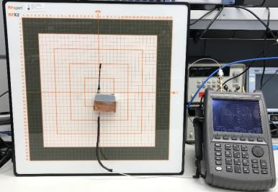 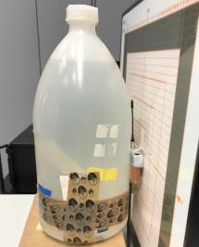 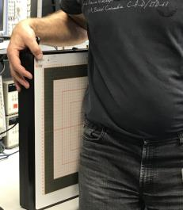  
Scenario a Scenario b Scenario c

Figure 9: Scenarios for antenna-matching measurements

These three different antennas were measured in the frequency range 400 MHz to 1000 MHz and below the results of the reflection coefficient (s11) for a 500 MHz antenna and a 700 MHz antenna are shown. The matching (simplified interpretation of reference point s11) of the antenna changes the closer the antenna moves to the human body. This has an effect on the radiated power of the body-worn PMSE TX, which is usually smaller than expected.

* Scenario a: Antenna matching of a body-worn PMSE without human body

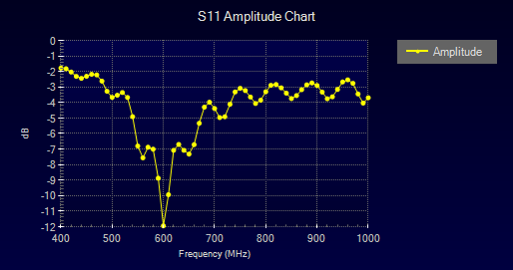 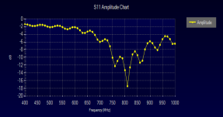  
 S11 of 500 MHz antenna S11 of 700 MHz antenna

Figure 10: Reflection coefficient (s11) for a 500 MHz and a 700 MHz antenna (scenario a)

* Scenario b: Antenna matching with the influence of a bottle filled with salt water / "Salty Man[1]"

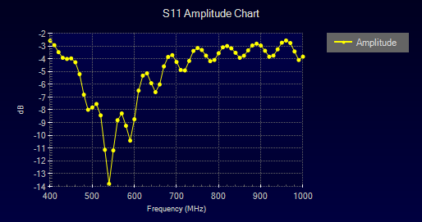 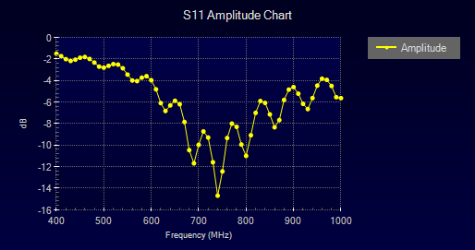e  
 S11 of 500 MHz antenna S11 of 700 MHz antenna

Figure 11: Reflection coefficient (s11) for a 500 MHz and a 700 MHz antenna (scenario b)

* Scenario c: Antenna matching with the influence of the human body

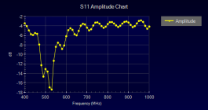 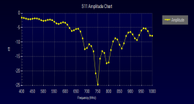   
 S11 of 500 MHz antenna S11 of 700 MHz antenna

Figure 12: Reflection coefficient (s11) for a 500 MHz and a 700 MHz antenna (scenario c)

These images clearly show that the human body strongly influences the antenna matching (simplified interpretation of reference point s11) in value and frequency, which naturally has an effect on the maximum transmission power emitted by the PMSE transmitter to the PMSE antenna. Manufacturers of PMSE equipment must find a compromise to ensure the best possible operation of PMSE on the human body.

The value for the body effect using a dipole antenna as a reference includes the antenna gain of the wireless microphone antenna as well as the energy absorption of the body. This means that in compatibility studies the antenna gain of the wireless microphone does not need to be considered as an additional factor.

If the power radiated by the wireless microphone antenna in the proximity of the user's body would be related to the radiated power of the wireless microphone antenna without the user's body as a reference, the antenna gain of the wireless microphone antenna may need to be taken into account as an additional factor in compatibility studies. It should, however, be noted that the polar diagram is modified by the human body and so this approach may overestimate the body effect, because the design of wireless microphone antennas is optimised to operate in the proximity of the human body (e.g. with respect to matching and resonance).

#### Human Hand: Effect on hand-held Microphones

For hand-held microphones, the position of the hand is critical. A 550 MHz test scenario shows that the body effect is increased by 10 dB by the hand. For higher frequencies, the effect also shows a significant increase.

Table 1: Human Hand Scenarios

|  |  |  |  |  |
| --- | --- | --- | --- | --- |
| Special scenario of hand-held audio PMSE: antenna unaffected or enclosed by user's hand | | | | |
| # | Number of data set | Category | Frequency [MHz] | Comment |
| 1 | 31 | Hand-held | 550 | Manufacturer 5, Test Person 1, PMSE antenna unaffected |
| 2 | 32 | Hand-held | 550 | Manufacturer 5, Test Person 1, PMSE antenna enclosed by user's hand |

 

Figure 13: Free-Space radiation PMSE antenna on the left and antenna enclosed by hand on right

#### Effect of table stands

A table stand is not a body in the context of the mandate of this Report. The output of measurements is presented to take this scenario into account.

Measurements on a table stand scenario have been performed with an uncluttered table stand (see Figure 14 below). In real use, the effect of surrounding people, furniture and equipment such as laptops would reduce these figures by up to 10 dB.

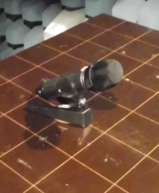  

Figure 14: Photo of the test setup and plots measured at 520 MHz, 800 MHz and 1795 MHz

Figure 15 below shows the results of all measured scenarios.



Figure 15: Summary of measured Effect of table stands - PMSE Path

## Simulation results from OFCOM (CH) study

A simulation study, which examines the effect of the human body on the wireless microphone transmission, has been carried out by [IT'IS](https://www.itis.ethz.ch/who-we-are/) Foundation (Foundation for Research on Information Technologies in Society)[2] of the Swiss Federal Institute of Technology in Zürich (ETHZ)[3] and commissioned by [OFCOM (Switzerland).](https://www.bakom.admin.ch/) The complete results of this study can be found in [5].

This is the first major 3D simulation study which has been available and whilst the full report shows three body types only two have been shown in this Report so that comparison with previous ECC and APWPT results can be made. The body types belong to Virtual Population (ViP) consisting of detailed high-resolution anatomical models created from magnetic resonance image data of volunteers (see ANNEX 3:). The two ViP models shown in this Report are:

* Duke (athletic adult male, 1.74 m / 70 kg)
* Fats (obese adult male, 1.78 m / 120 kg)

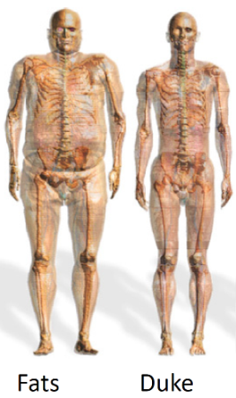

Figure 16: A subset of the human models used in the original study

Note that the simulated body loss (3D) and measured body effect (horizontal plane) cannot be compared directly as they use different definitions.

In the simulations, the body loss is defined as the ratio of the power radiated by the wireless microphone antenna in the proximity of the user's body and the power radiated by the same antenna when the body is not present (free space) [2].

The APWPT measurements, on the other hand, are done in the horizontal plane only, and the body effect is defined as the ratio of the power radiated by the wireless microphone antenna in the proximity of the user's body and the power radiated by a reference dipole antenna when the body is not present. The body effect, as defined in the measurements, is practically the gain of the system (wireless microphone + body) with respect to a dipole.

In order to compare the simulated and measured results, the definition of body effect (as used in the measurements) has been applied to the simulated antenna gain. The gain was extracted from 3D simulations in the horizontal plane in the presence of the two body types (Duke and Fats). The resulting simulated body effect is compared to the measured body effect in Section 4.1 of this Report for the frequency range up to 2 GHz.

Simulated body loss in the frequency range from VHF (235 MHz) to SHF (6 GHz) is given in ANNEX 2:of this Report. Examples of simulated patterns are provided below for hand-held for body-worn microphone.

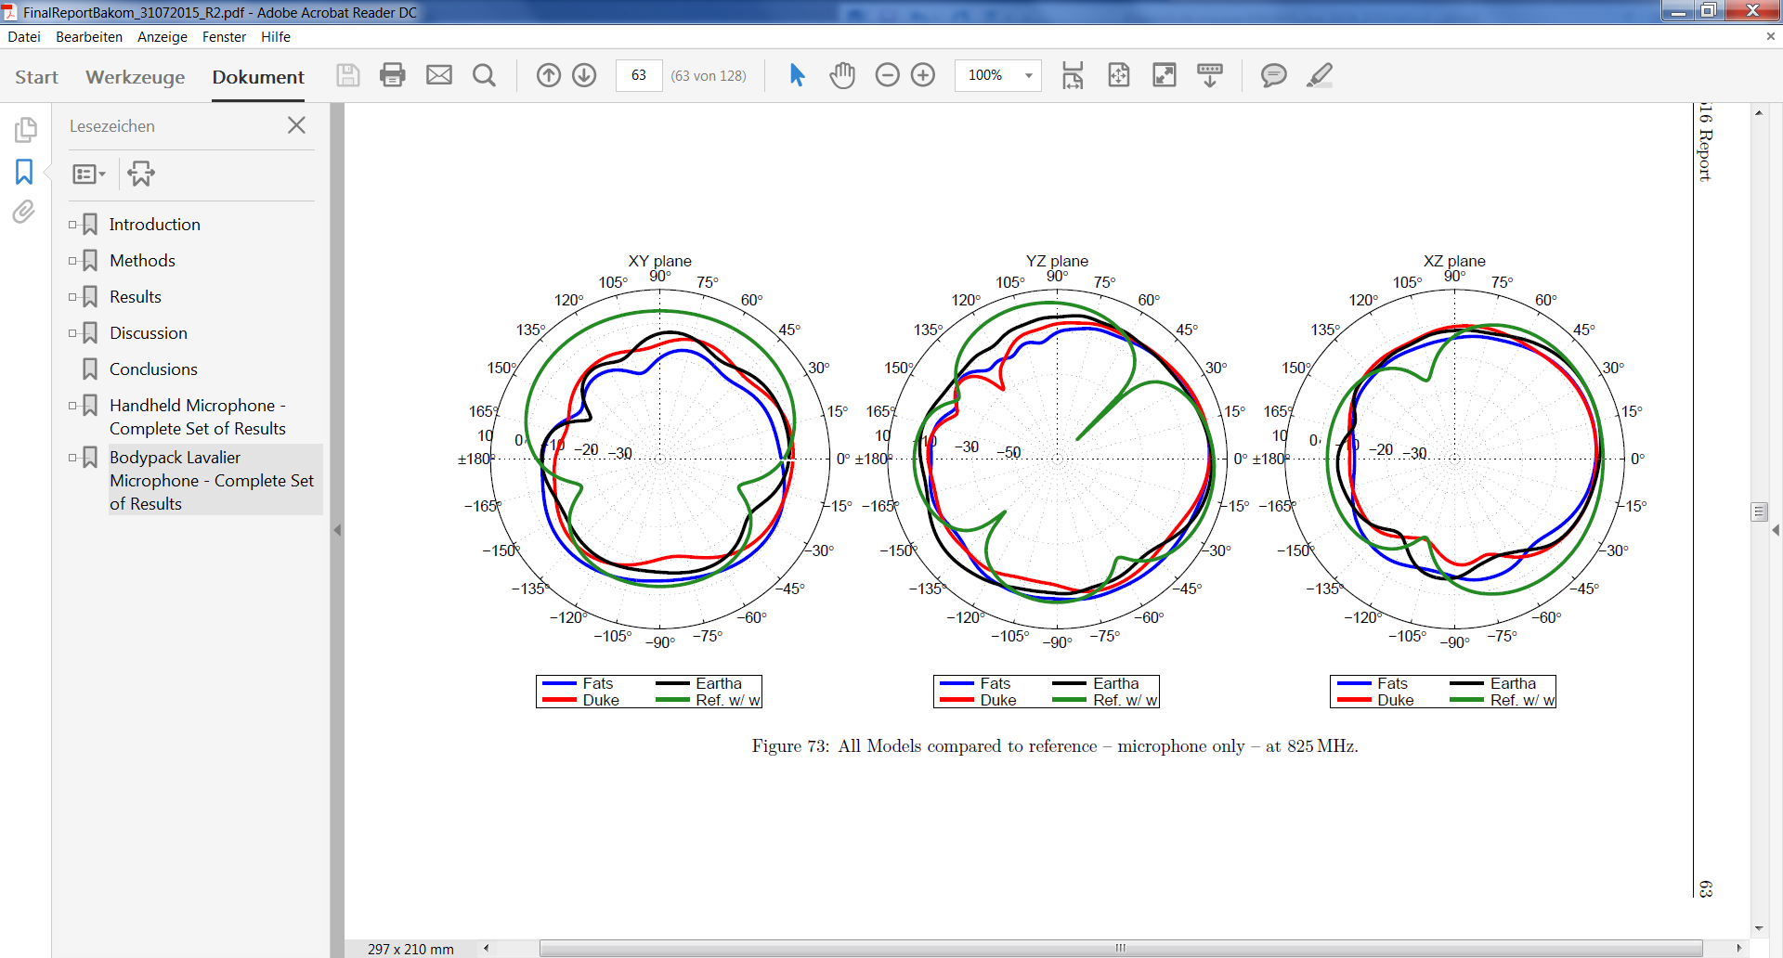

Figure 17: Example of simulated radiation patterns - hand-held microphone at 825 MHz

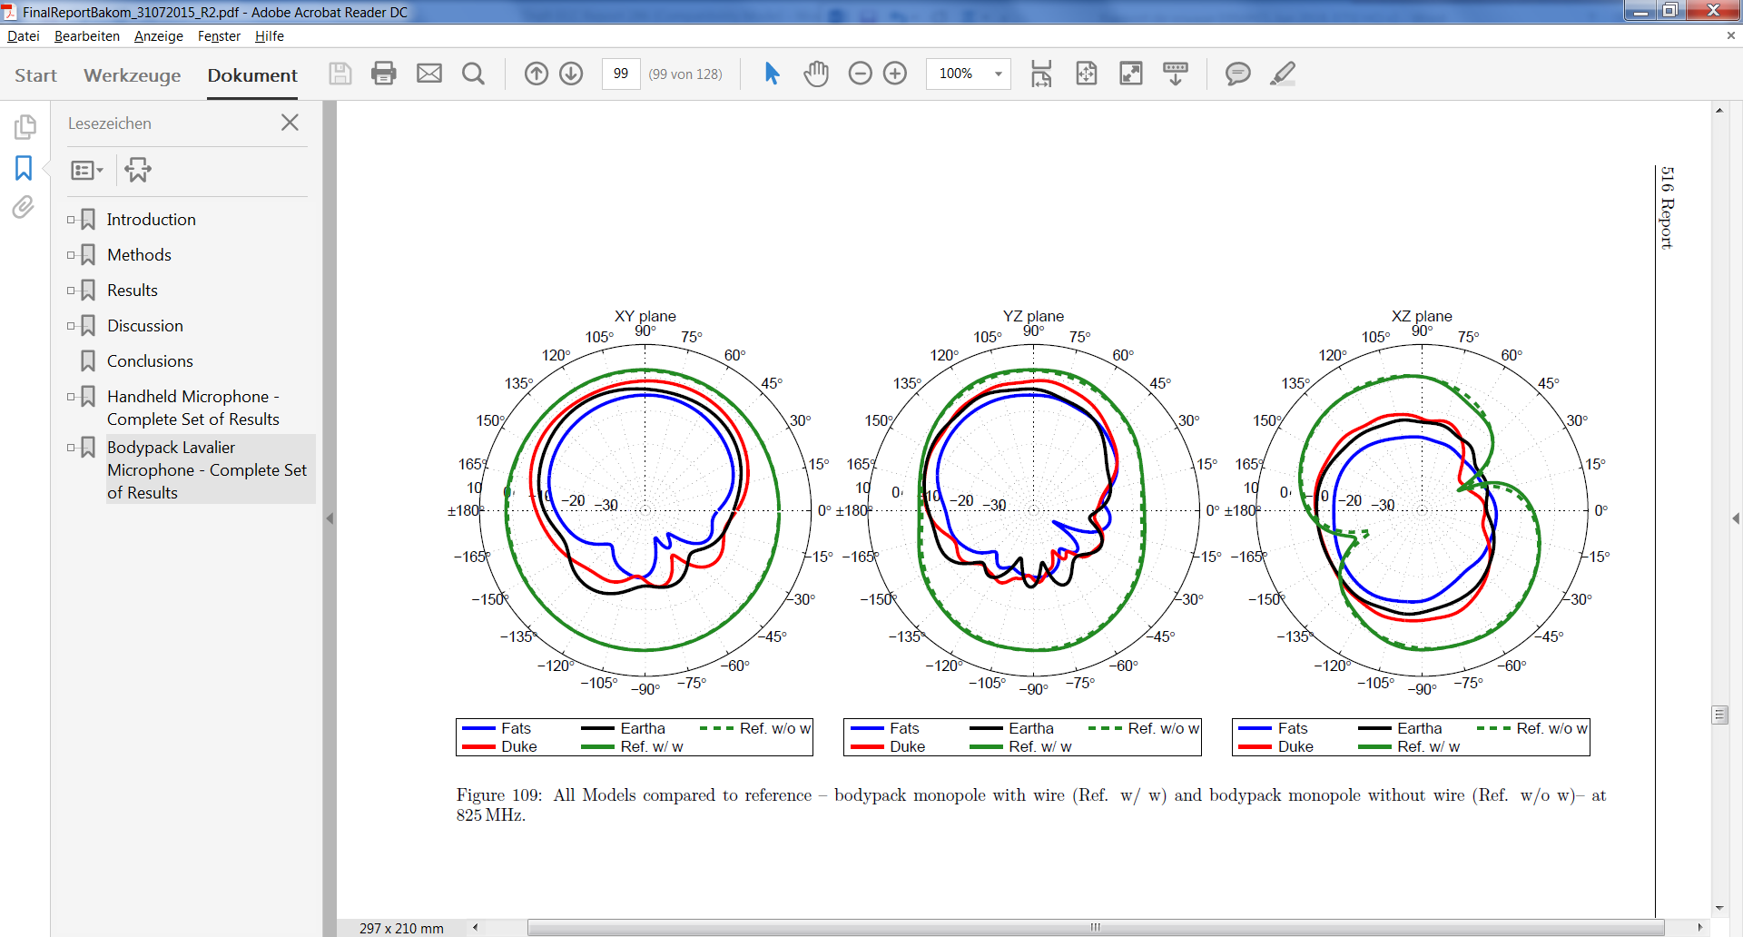

Figure 18: Example of simulated radiation patterns - body-worn microphone at 825 MHz

For comparison purposes, the results from the simulation from OFCOM CH were processed and included in the data sheet available in [4]. A summary of the main results is available in ANNEX 5:.

## Simulation results from APWPT

### Introduction

Additional simulations have been performed to support the measurements and simulations presented in the previous sections in order to have a deeper understanding of the body effect.

An 800 MHz dipole scenario is used to simulate free-space radiation. The body simulation is simplified and only shows the effect of absorption of RF energy in the direction of body and the concentration of the electric field into the body. The result shows a strong degradation of the field energy in the supposed uninfluenced “free” direction away from the body.

The simulations have been performed by the CST microwave studio using their full 3D simulation software.

### Dipole without body

A simple dipole for the frequency of 844 MHz is used. The following   
Figure 19-Figure 21 show the s11 (the reflection coefficient, which for simplification can be considered as matching), the far-field view “realised gain” in 3D and polar graphics.

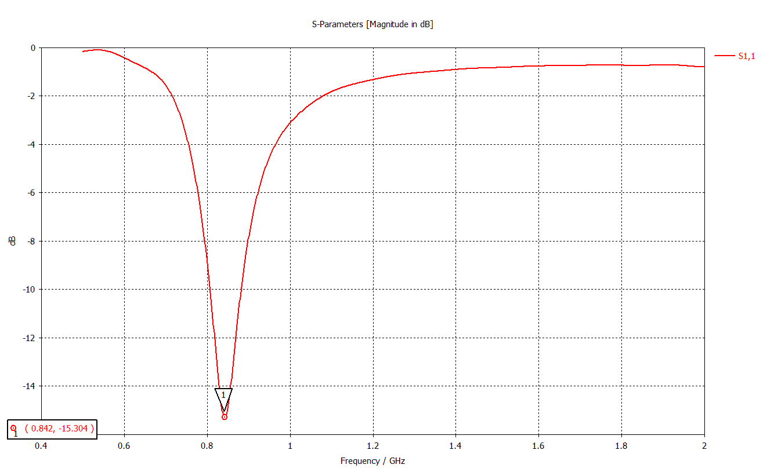  
Figure 19: Matching point of free dipole

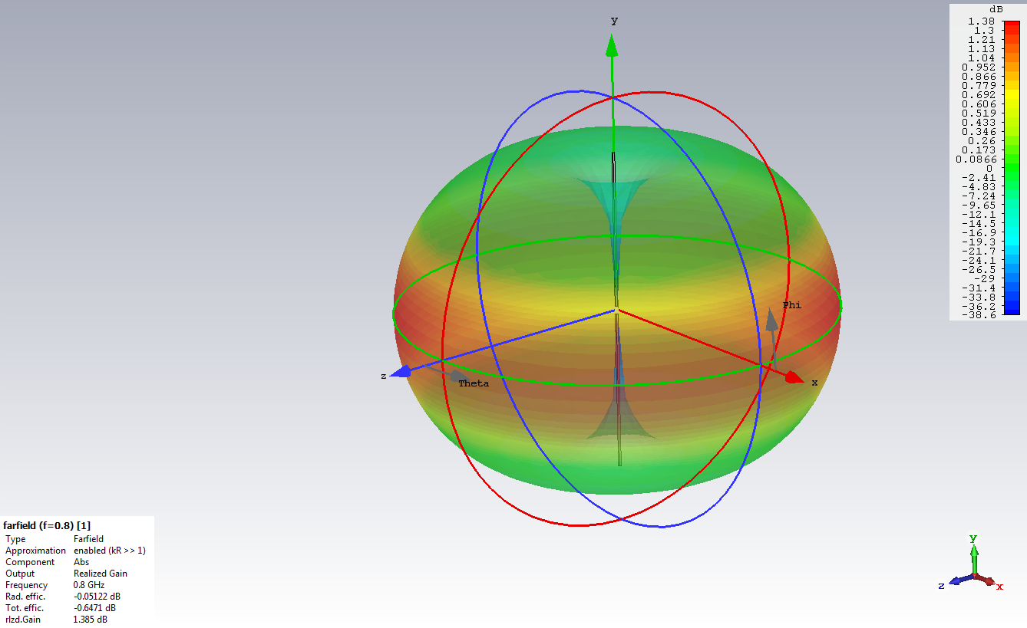

Figure 20: Far-field view of free dipole showing realised gain

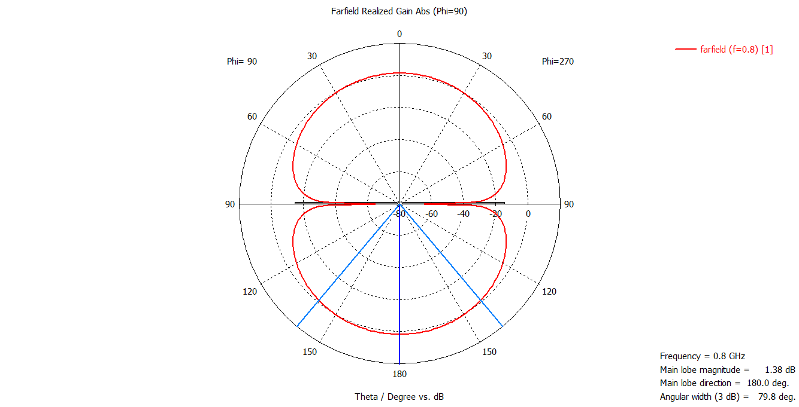

Figure 21: Far-field polar diagram of free dipole at 800 MHz

### Body effect

An artificial body of saltwater (in simulation used permittivity is 74 and the conductivity is 3.5 S/m) with dimensions of 40 x 30 x 20 cm in a distance of app. 5 mm to the dipole should show the body effect of antenna.

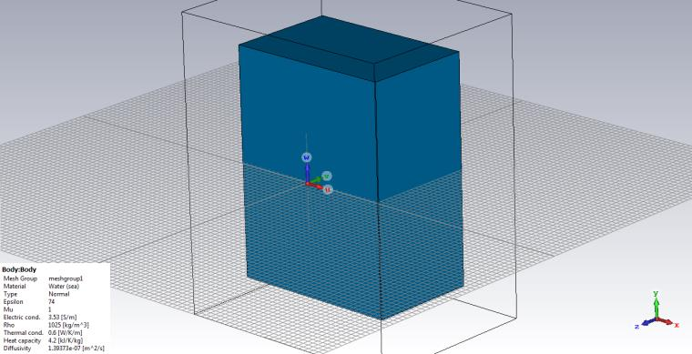

Figure 22: Artificial body of saltwater "Salty Man"

Note: In practical body-worn PMSE operation, the antenna spacing to the body is less than 5 mm.

Figure 23 and Figure 24 below show that the common known resonance frequency detuning is about 32 MHz.

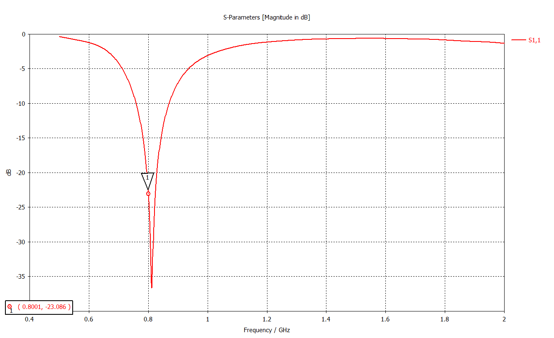

Figure 23: S11 of body-worn dipole

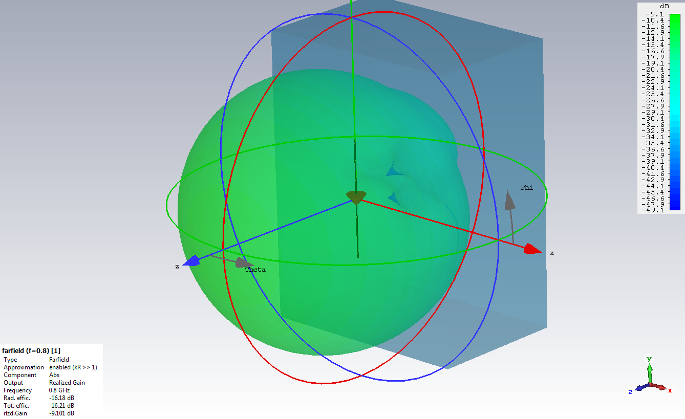

Figure 24: 3D far-field of body-worn dipole

Note: the mark in the picture on the left side shows the s11 point before the addition of the artificial body.  
The far-field is strongly degraded in the direction of salty man/body (absorption) and the air medium in the opposite direction.

Interestingly not only the direction of body is influenced, in addition the field strength in free direction away from the body is decreased more than 10 dB.   
The explanation could be the concentration of the electric field into the body.

Figure 25 below clearly shows the effect in the polar plot of the far-field of the effect of a body-worn antenna:

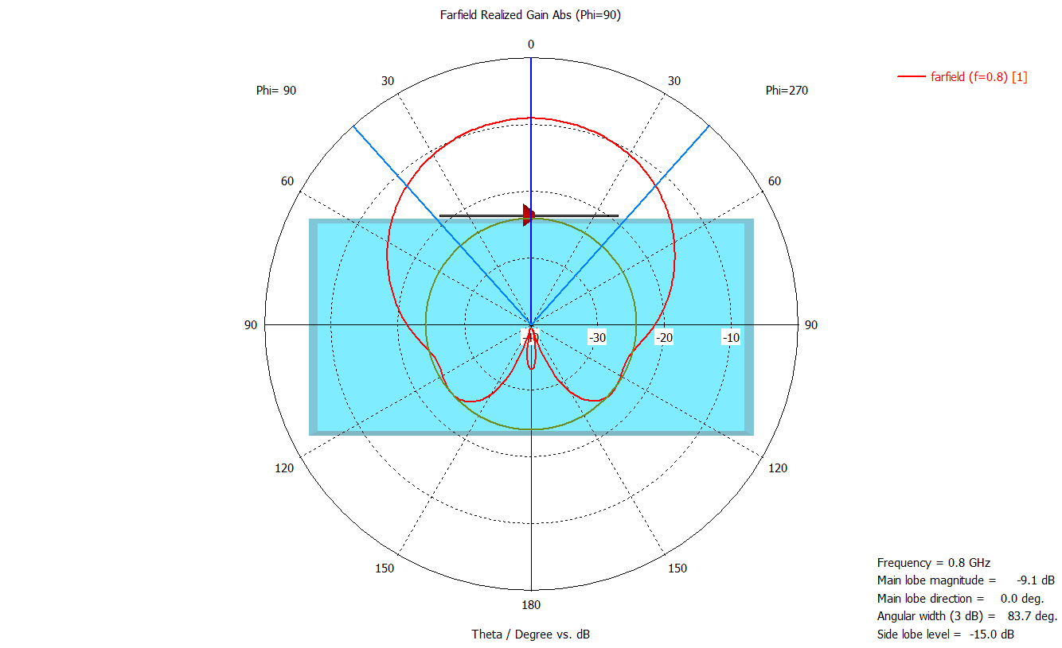

Figure 25: Far-field view free dipole 800 MHz polar that is operated close to an artificial body /salty man

### Conclusions

The body-worn dipole in the 800 MHz spectrum (and below) shows a marked performance degradation in relation to the free-space dipole.

The reasons for this are:

* Detuning / mismatching;
* Absorption (body direction);
* Field concentration to the body (away from body and antenna).

# Comparison of measured and simulated values of the Body Effect of audio PMSE

The results of measurements performed by APWPT (see section 4.1) and of the simulations commissioned by OFCOM CH (see section 4.2) have been put together in the excel sheet available in [4]. Relevant subsets of the measurements and of the simulation are available in ANNEX 4:and in ANNEX 5:respectively.

## Overview of the comparison

The following Figure 26-Figure 29 provide an overview of the comparison between the measurements and simulations for both body-worn and hand-held audio PMSE devices:

* Body effect on possible interference from PMSE transmitter, referred to as "maximum radiation" of PMSE



Figure 26: Measurements and Simulations of Maximum Radiation of body-worn PMSE



Figure 27: Measurements and Simulations of Maximum Radiation hand-held PMSE

* Body effect into the transmission path (or link budget) of PMSE applications referred to as "PMSE Path"



Figure 28: Measurements and Simulations of PMSE Path body-worn PMSE



Figure 29: Measurements and Simulations of PMSE Path - hand-held PMSE

## Analysis

The measurement results for hand-held PMSE transmitters showed consistency with the simulation results.

For the body-worn transmitters there was a deviation between the measured and simulation results. This deviation was traced to the variation of the distance of the antenna from the body: in the simulations, the distance was assumed to be 10 mm, whereas in the measured results, the distance was less than 5 mm. The lower distance reflects the actual usage of body-worn transmitters. Limited additional simulations assuming a smaller distance of 4 mm showed an improved correlation with the measured results, indicating that the simulation results do not always reflect the actual usage of the equipment.

Therefore, only the measurement results are used as the basis for the modelling developed in this Report. A hand-held PMSE transmitter placed in a table-stand demonstrates a smaller variation in power because it is at a greater distance from a human body. Nevertheless, because hand-held PMSE transmitters are optimised for use in the human hand, when used in a table stand it has been observed that the radiation pattern is affected and the radiated power is reduced.

The following formulas are provided for use in sharing and compatibility studies. The appropriate values are calculated according to the scenario and frequency range under study. The standard deviation (σ) obtained from the set of measurements is also provided.

The minimum body effect is the effect of the body on possible interference from PMSE transmitter, referred to as "maximum radiation" in the measurements. This may be used for interference calculations using MCL.

The maximum body effect is the effect of the body into the transmission path (or link budget) of PMSE applications, referred to as "PMSE Path" in the measurements. This may be used for path loss calculation.

The mean body effect is the average effect of the body. This may be used for interference calculations in SEAMCAT.

Min. Body Effect

* 1) Hand-held Audio PMSE: Min. Body Effect [dB] = 0.0015 dB/MHz * F [MHz] - 8.5239 dB (σ = 1.84 dB)
* 2) Body-worn Audio PMSE: Min. Body Effect [dB] = -0.0045 dB/MHz * F [MHz] - 4.7997 dB (σ = 2.98 dB)

Max. Body Effect

* 1) Hand-held Audio PMSE: Max. Body Effect [dB] = 0.0028 dB/MHz * F [MHz] - 37.63 dB (σ = 6.63 dB)
* 2) Body-worn Audio PMSE: Max. Body Effect [dB] = -0.009 dB/MHz * F [MHz] - 29.693 dB (σ = 5.91 dB)

Mean Body Effect

* 1) Hand-held Audio PMSE: Mean Body Effect [dB] = 0.0025 dB/MHz * F [MHz] - 13.622 dB (σ = 2.1 dB)
* 2) Body-worn Audio PMSE: Mean Body Effect [dB] = -0.0058 dB/MHz * F [MHz] - 8.5917 dB (σ = 3.3 dB)

# Conclusions

The human body comes in a wide range of sizes and shapes; measurements and modelling can only address a small range of these. With the introduction of the virtual population shown in ANNEX 3:, the range of the modelling is considerably increased, and comparisons of a range of shapes are provided within the OFCOM (Switzerland) reports [5] and [6]. These reports provide the first information of what can be achieved by software modelling as well as giving an indication of the body effect up to 6 GHz.

A hand-held PMSE transmitter placed in a table-stand demonstrates a smaller variation in power because it is at a greater distance from a human body. Nevertheless, because hand-held PMSE transmitters are optimised for use in the human hand, when used in a table stand it has been observed that the radiation pattern is affected and the radiated power is reduced.

Analysis of the historical data provided in ECC Reports and the measurement data and simulation results referenced in the Report has resulted in frequency dependant formulas for use in sharing and compatibility studies. The appropriate values are calculated according to the scenario and frequency range under study. The standard deviation (σ) obtained from the set of measurements is also provided.

The value for the body effect using a dipole antenna as a reference includes the antenna gain of the wireless microphone antenna as well as the attenuation of the body. This means that in compatibility studies the antenna gain of the wireless microphone does not need to be considered as an additional factor.

The minimum body effect is the effect of the body on possible interference from PMSE transmitter, referred to as "maximum radiation" in the measurements. This may be used for interference calculations using MCL.

The maximum body effect is the effect of the body into the transmission path (or link budget) of PMSE applications, referred to as "PMSE Path" in the measurements. This may be used for path loss calculation.

The mean body effect is the average effect of the body. This may be used for interference calculations in SEAMCAT.

Min. Body Effect (for interference calculation in MCL)

* 1) Hand-held Audio PMSE: Min. Body Effect [dB] = 0.0015 dB/MHz * F [MHz] - 8.5239 dB (σ = 1.84 dB)
* 2) Body-worn Audio PMSE: Min. Body Effect [dB] = -0.0045 dB/MHz * F [MHz] - 4.7997 dB (σ = 2.98 dB))

Max. Body Effect (for path loss calculation of audio PMSE)

* 1) Hand-held Audio PMSE: Max. Body Effect [dB] = 0.0028 dB/MHz * F [MHz] - 37.63 dB (σ = 6.63 dB)
* 2) Body-worn Audio PMSE: Max. Body Effect [dB] = -0.009 dB/MHz * F [MHz] - 29.693 dB (σ = 5.91 dB)

Mean Body Effect (for interference calculation in SEAMCAT)

* 1) Hand-held Audio PMSE: Mean Body Effect [dB] = 0.0025 dB/MHz * F [MHz] - 13.622 dB (σ = 2.1 dB)
* 2) Body-worn Audio PMSE: Mean Body Effect [dB] = -0.0058 dB/MHz * F [MHz] - 8.5917 dB (σ = 3.3 dB)

1. Relevant background material
   1. Reference material from ECC

ERC Report 42 [1], published in 1996, is a handbook on radio equipment and systems radio microphones and simple wide band audio links. It includes in its section 5 examples of radiated power polar patterns for body-worn and hand-held transmitters derived from measurements carried out at 650 MHz.

|  |  |
| --- | --- |
|  |  |

Figure 30: Radiated power polar patterns for body-worn and hand-held transmitters at 650 MHz (ERC Report 42)

* 1. Compatibility studies performed within ECC with consideration of body loss and body effect for audio PMSE

Table 2 below summarises the considerations related to body loss and effect included in compatibility studies contained in published ECC Deliverables

Table 2: Assumptions on body effect in existing ECC deliverables

|  |  |  |
| --- | --- | --- |
| Deliverable (date) | Relevant compatibility scenarios | Consideration on body effect |
| ERC Report 62 (1998) | Compatibility between UIC systems and radio microphones around 900 MHz | Body loss of:   * 14 dB for body-worn radio microphones * 6 dB for hand-held equipment |
| ERC Report 63 (1998) | Compatibility studies related to radio microphones in 1785-1800 MHz | Body loss of:   * 14 dB for body-worn radio microphones * 6 dB for hand-held equipment |
| ERC Report 88 (2000) | Compatibility between DVB-T and radio microphones in bands IV and V | Body loss of:   * 14 dB for body-worn radio microphones * 6 dB for hand-held equipment |
| ECC Report 121 (2008) and ECC Report 147 (2010) | Compatibility related to professional wireless microphones in the 1452-1559 MHz range | Body-worn antenna pattern (omnidirectional linear polarised dipole gain 2.14 dBi max. |
| CEPT Report 30 (2009) | Technical conditions for digital dividend in 790-862 MHz (includes compatibility between MFCN and PMSE in Annex 5) | * 18 dB for body-worn radio microphones * 8 dB for hand-held equipment |
| CEPT Report 41 (2010) | Compatibility related to LTE and WiMAX in the 900 and 1800 MHz bands (includes compatibility with radio microphones around 1800 MHz) | Body loss of:   * 14 dB for body-worn radio microphones * 6 dB for hand-held equipment |
| ECC Report 185 (2013) | Definition of technical and operational requirements for WSD in 470-790 MHz (includes compatibility between WSD and PMSE) | Refers to patterns provided in ERC Report 42 |
| ECC Report 191 (2013) | Compatibility between MFCN and audio PMSE applications in 1785-1805 MHz | Body loss of:   * 15 dB for body-worn radio microphones * for hand-held equipment, 1 dB around 0°, 7 dB elsewhere |
| CEPT Report 50 (2013) | Technical conditions for wireless microphones in the bands 821-832 MHz and 1785-1805 MHz | Body loss derived from:   * CEPT Report 30 at 800 MHz; * ECC Report 191 at 1800 MHz. |
| ECC Report 221 (2014) | Compatibility between MFCN and audio PMSE applications in the 700 MHz frequency band | 2 different sets of body loss:   * 1 dB for hand-held equipment, 15 dB for body-worn radio microphones (as in ECC Report 191); * 8 dB for hand-held equipment, 18 dB for body-worn radio microphones (as in CEPT Report 30). |
| CEPT Report 53 (2014) | Technical conditions for wireless broadband in the 700 MHz band (includes studies between MFCN and wireless microphones) | 2 different sets of body loss:   * 1 dB for hand-held equipment, 15 dB for body-worn radio microphones (as in ECC Report 191); * 8 dB for hand-held equipment, 18 dB for body-worn radio microphones (as in CEPT Report 30). |
| CEPT Report 60 (2016) | Technical conditions for wireless broadband in the 700 MHz band (confirms results from CEPT Report 53 between MFCN and wireless microphones) | * 1 dB for hand-held equipment, 15 dB for body-worn radio microphones (as in ECC Report 191); |
| ECC Report 245 (2016) | Compatibility between audio PMSE and other systems/services in the band 1350-1400 MHz | * Body loss for hand-held wireless microphones: minimum value 6 dB, median value 11 dB; * Body loss for body-worn wireless microphones: minimum value 11 dB, median value 21 dB; * Details and results of measurements available in Annex 1 of ECC Report 245. |
| ECC Report 253 (2016) | Compatibility studies for audio PMSE at 1492-1518 MHz and 1518-1525 MHz | * Body loss for hand-held wireless microphones: minimum value 6 dB, median value 11 dB; * Body loss for body-worn wireless microphones: minimum value 11 dB, median value 21 dB; * Details and results of measurements available in Annex 1 of ECC Report 253. |

The information available in the ECC Deliverables is summarised in Table 3 and Table 4 below for the body loss applicable to hand-held equipment and to body-worn equipment respectively:

Table 3: Body loss (dB) assumed for hand-held PMSE

|  |  |  |  |  |  |  |  |  |  |  |  |  |  |
| --- | --- | --- | --- | --- | --- | --- | --- | --- | --- | --- | --- | --- | --- |
| Frequency (MHz) | ERC Report 42 (1996) | ERC Report 62 (1998) | ERC Report 63 (1998) | ERC Report 88 (2000) | CEPT Report 30 (2009) | CEPT Report 41 (2010) | CEPT Report 50 (2013) | ECC Report 191 (2013) | CEPT Report 53 (2014) | ECC Report 221 (2014) | CEPT Report 60 (2016) | ECC Report 245 (2016) | ECC Report 253 (2016) |
| 470-694 |  |  |  | 6 |  |  |  |  |  |  |  |  |  |
| 694-790 |  |  |  | 6 |  |  |  |  | 8 | 8 | 7 |  |  |
| 790-821 |  |  |  | 14 | 8 |  |  |  |  |  |  |  |  |
| 821-832 |  |  |  | 14 | 8 |  | 8 |  |  |  |  |  |  |
| 832-862 |  |  |  | 14 | 8 |  |  |  |  |  |  |  |  |
| 876-880 |  | 6 |  |  |  |  |  |  |  |  |  |  |  |
| 880-915 |  | 6 |  |  |  | 6 |  |  |  |  |  |  |  |
| 921-925 |  |  |  |  |  | 6 |  |  |  |  |  |  |  |
| 925-960 |  |  |  |  |  |  |  |  |  |  | 6-11 |  |  |
| 1350-1400 |  |  |  |  |  |  |  |  |  |  |  | 6-11 |  |
| 1492-1518 |  |  |  |  |  |  |  |  |  |  |  |  | 6-11 |
| 1518-1525 |  |  |  |  |  |  |  |  |  |  |  |  | 6-11 |
| 1710-1785 |  |  |  |  |  | 6 |  |  |  |  |  |  |  |
| 1785-1805 |  |  | 6 |  |  |  | 7 | 7 |  |  |  |  |  |
| 1805-1880 |  |  |  |  |  | 6 |  |  |  |  |  |  |  |

Table 4: Body loss (dB) assumed for body-worn PMSE

|  |  |  |  |  |  |  |  |  |  |  |  |  |  |
| --- | --- | --- | --- | --- | --- | --- | --- | --- | --- | --- | --- | --- | --- |
| Frequency  (MHz) | ERC Report 42 (1996) | ERC Report 62 (1998) | ERC Report 63 (1998) | ERC Report 88 (2000) | CEPT Report 30 (2009) | CEPT Report 41 (2010) | CEPT Report 50 (2013) | ECC Report 191 (2013) | CEPT Report 53 (2014) | ECC Report 221 (2014) | CEPT Report 60 (2016) | ECC Report 245 (2016) | ECC Report 253 (2016) |
| 470-694 |  |  |  | 14 |  |  |  |  |  |  |  |  |  |
| 694-790 |  |  |  | 14 |  |  |  |  | 16.5 | 16.5 | 15 |  |  |
| 790-821 |  |  |  | 14 | 18 |  |  |  |  |  |  |  |  |
| 821-832 |  |  |  | 14 | 18 |  | 18 |  |  |  |  |  |  |
| 832-862 |  |  |  | 14 | 18 |  |  |  |  |  |  |  |  |
| 876-880 |  | 14 |  |  |  |  |  |  |  |  |  |  |  |
| 880-915 |  |  |  |  |  | 14 |  |  |  |  |  |  |  |
| 921-925 |  | 14 |  |  |  |  |  |  |  |  |  |  |  |
| 925-960 |  |  |  |  |  | 14 |  |  |  |  |  |  |  |
| 1350-1400 |  |  |  |  |  |  |  |  |  |  |  | 11-21 |  |
| 1492-1518 |  |  |  |  |  |  |  |  |  |  |  |  | 11-21 |
| 1518-1525 |  |  |  |  |  |  |  |  |  |  |  |  | 11-21 |
| 1710-1785 |  |  |  |  |  | 14 |  |  |  |  |  |  |  |
| 1785-1805 |  |  | 14 |  |  | 14 | 15 | 18.5 |  |  |  |  |  |
| 1805-1880 |  |  |  |  |  | 14 |  |  |  |  |  |  |  |

* 1. Relevant material from ITU-R

RECOMMENDATION ITU-R P.1406: "PROPAGATION EFFECTS RELATING TO TERRESTRIAL LAND MOBILE SERVICE IN THE VHF AND UHF BANDS" [7]



Figure 31: Typical body loss - Portable transceiver

1. Simulated Human Body Loss

In this Annex, the results of the simulation study from OFCOM (Switzerland) are summarised.

3D gain patterns of both hand-held and body-worn wireless microphones were simulated using 3D full wave numerical simulations in the electromagnetic solver SEMCAD-X (see Figure 32). The microphones were carried or held by three ViP human body models of different sizes and body-mass indices: Eartha (child), Duke (adult male), and Fats (obese adult male), see ANNEX 3:. The complete results of this study are available in the following full report[4]. Using these 3D gain patterns, the body loss was computed for the simulated frequency range from VHF (235 MHz) to SHF (6 GHz) and the complete results are available in the following full report[5].

Currently multi-channel audio PMSE use is below 2 GHz with some units available at the 2.4 GHz band, this information was felt to be an important indicator for the future but has not been compared to actual measurements to date.

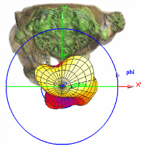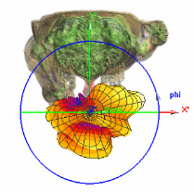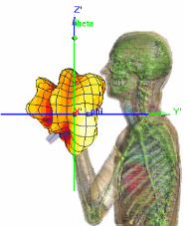

Hand-held microphone at f = 825 MHz

Hand-held microphone at f = 1890 MHz

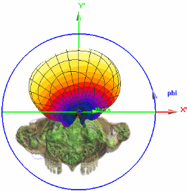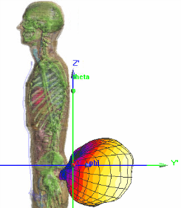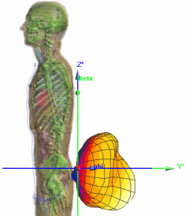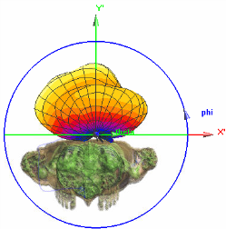

Body-worn microphone at f = 1890 MHz

Body-worn microphone at f = 825 MHz

Figure 32: 3D gain patterns of hand-held and body-worn microphones in the presence of the ViP model Duke at two different frequencies

* 1. Body Loss Definition

Gain of the wireless microphone antenna generally decreases in proximity of the user’s body. The reasons for this phenomenon are twofold [2]:

* one part of the radiated power is absorbed in the human tissue, leading to reduced radiation efficiency;
* the presence of the human tissue near the wireless microphone antenna changes the input impedance of the antenna, which may either improve or degrade the antenna matching, thus changing the amount of radiated power.

The ratio of the power radiated by the antenna in the presence of the user's body $p_{rad}$ and the power radiated by the same antenna in free-space $p_{rad,fs }$ is denoted as body loss (BL) and can be expressed in dB as follows:

$$BL= -10\log_{10}{\frac{p_{rad}}{p_{rad,fs}}}$$

Note that in the study summarised in this annex, the effect of antenna mismatch was not taken into account.

* 1. Body Loss Simulation Results

Using this formulation, the total body loss was computed taking into account the power radiated in the complete 3D space ($φ∈[0, 2π], θ∈[0,π]$) for hand-held and body-worn wireless microphones. The parts of the body loss as pertaining to the semi-spaces in front of and behind the user were also computed for all the simulated frequencies and for three different body types (Eartha, Duke and Fats). Figure 33 and Figure 34 show body loss as a function of frequency for body-worn and hand-held wireless microphone, respectively, in the presence of the user Duke. The complete results of the study can be found in the OFCOM CH reports [5][6].

Figure 33: Total body loss and body loss in the semi-spaces in front of (shadow) and behind Duke with body-worn wireless microphone as a function of frequency

Figure 34: Total body loss and body loss in the semi-spaces in front of and behind (shadow) Duke with hand-held wireless microphone as a function of frequency

* 1. Summary

Two zones around the microphone are distinguished: the shadow zone in which the wireless microphone link is obstructed by the body (in front of the presenter with a body-worn microphone and behind the presenter with a hand-held microphone) and the non-shadow zone in which the body does not obstruct the wireless microphone transmission link.

The simulations have shown that the gain of a body-worn or hand-held microphone in the shadow zone is smaller than the gain of the corresponding standalone microphone and this difference that is due to the obstruction of the link by the presence of the body is significant at all the observed frequencies. The only exception is in the case of body-worn microphone at lower frequencies, where the wire connecting the microphone to the wireless transmitter acts as a counterpoise (or an extension) to the antenna and allows the signal at those frequencies to be radiated also in the shadow zone.

On the other hand, the gain in the non-shadow zone is less affected by the presence of the body than it is the case in the shadow zone. In this zone, the body loss is more important at lower frequencies because of a stronger absorption of the radiated power by the body at those frequencies. Contrary to that, at higher frequencies, the body loss is less prominent since the body seems to behave more as a lossy conductor that reflects the radiated energy rather than absorbing it.

It can be observed that the total body loss for the body-worn microphone has a general trend of decreasing with frequency from about 12 dB at the lowest simulated frequency to about 2 dB at the highest one. The same can be observed for the body loss of the hand-held microphone, with somewhat lower values that range from about 5 dB to about 0.4 dB. Much closer proximity to the body of the body-worn microphone as compared to the hand-held one is the reason for this.

1. Virtual Population (ViP)

The Virtual Population (ViP) models are a set of detailed high-resolution anatomical human models (Figure 35). The human models are based on high resolution magnetic resonance images of healthy volunteers with different heights and body mass indices. More than 80 different tissues were distinguished during the segmentation of the models. For the simulations, the tissues are assigned with the corresponding frequency dependent dielectric properties, as defined in the database available online[6].

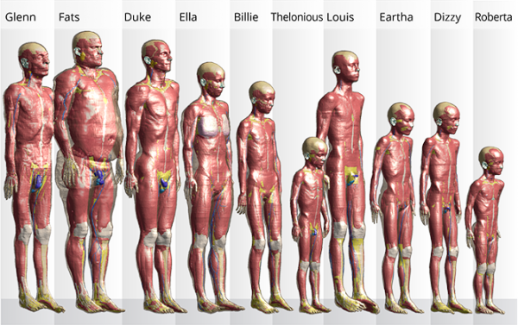

Figure 35: Virtual Population (ViP)[7]

1. Subset of measurements results provided by APWPT/DKE

The source of the data is the file “BodyEffectScenariosUpdSimReferencesUpdFeb2018.xlsx” which can be downloaded via this link: <https://www.apwpt.org/downloads/summary_of_be_scenarios_rev1.zip>. It is also available at <https://cept.org/Documents/fm-51/43083/body-effect-5_summary-of-measurements-and-simulations> .

This Annex summarises the main results of these measurements. Additional information can be found in section 4.1.

* 1. Body Effect for the radiated Power of body-worn Audio PMSE Devices operated below 3 GHz

Table 5: Summary of measurement results of body effect for the radiated power of body-worn Audio PMSE Devices

|  |  |  |  |  |  |  |  |
| --- | --- | --- | --- | --- | --- | --- | --- |
| No  [#] | Data Set  [#] | Scenario | Frequency  [MHz] | Configuration | Mean Body Effect  [dB] | Min Body Effect  [dB] | Max Body Effect |
| 1 | 4 | M04/08/2015 | 500 | P1 with BP1M1 | -13.6 | -9,62 | -36,27 |
| 2 | 19 | M19/08/2015 | 700 | P1 with BP1M1 | -14.9 | -10,82 | -36,48 |
| 3 | 5 | M05/08/2015 | 500 | P2 with BP1M1 | -11.6 | -7,68 | -32,81 |
| 4 | 20 | M20/08/2015 | 700 | P2 with BP1M1 | -12.2 | -7,04 | -32,91 |
| 5 | 6 | M06/08/2015 | 500 | P1 with BP1M2 | -8.9 | -3,88 | -37,24 |
| 6 | 14 | M14/08/2015 | 700 | P1 with BP2M2 | -13.7 | -9,16 | -35,78 |
| 7 | 7 | M07/08/2015 | 500 | P2 with BP1M2 | -8.8 | -4,55 | -35,64 |
| 8 | 15 | M15/08/2015 | 700 | P2 with BP2M2 | -17.7 | -13,02 | -35,91 |
| 9 | 21 | M21/08/2015 | 1795 | P1 with BP3M2 | -17.6 | -12,6 | -40,42 |
| 10 | 22 | M22/08/2015 | 1795 | P2 with BP3M2 | -20.8 | -16,94 | -44,51 |
| 11 | 53 | M53/04/2015 | 1455 | TX Matthias at back | -16.8 | -10,01 | -49,54 |
| 12 | 54 | M54/04/2015 | 1455 | TX Matthias at body | -17.4 | -10,15 | -54,01 |
| 13 | 55 | M55/04/2015 | 1455 | TX Sonja at body | -16.9 | -10,03 | -42,88 |
| 14 | 56 | M56/04/2015 | 1455 | TX Sonja at back | -16.5 | -10 | -45,43 |
| 15 | 58 | M58/04/2015 | 1455 | TX Sonja close at back | -16.2 | -10,06 | -40,24 |
| 16 | 59 | M59/04/2015 | 1455 | TX on bottle | -15.4 | -10 | -37,62 |
| 17 | 10 | M10/08/2015 | 550 | P1 with BP1M3 | -10.9 | -6,35 | -29,65 |
| 18 | 11 | M11/08/2015 | 550 | P2 with BP1M3 | -10.0 | -5,52 | -36,55 |
| 19 | 12 | M12/08/2015 | 660 | P1 with BP1M4 | -13.4 | -9,03 | -32,47 |
| 20 | 13 | M13/08/2015 | 660 | P2 with BP1M4 | -15.1 | -9,92 | -29,56 |
| 21 | 8 | M08/08/2015 | 520 | P1 with BP1M5 | -10.3 | -5,74 | -39,58 |
| 22 | 16 | M16/08/2015 | 800 | P1 with BP1M5 | -14.1 | -9,74 | -37,94 |
| 23 | 9 | M09/08/2015 | 520 | P2 with BP1M5 | -8.9 | -4,85 | -37,3 |
| 24 | 17 | M17/08/2015 | 800 | P2 with BP1M5 | -12.7 | -7,65 | -32,37 |
|  | | | | Standard deviation [dB] | 3.3 | 4.51 | 15.54 |

Figure 36 summarises the measurements for body-worn PMSE (Mean Body Effect). For the similar results for the Min. Body Effect and Max. Body Effect, see section 4.1.2.



Figure 36: Summary of measurements for body-worn PMSE (Mean body effect)

* 1. Body Effect for the radiated Power of hand-held Audio PMSE Devices operated below 3 GHz

Table 6: Summary of measurements results of body effect for the radiated power of hand-held Audio PMSE Devices

|  |  |  |  |  |  |  |  |
| --- | --- | --- | --- | --- | --- | --- | --- |
| No  [#] | Data Set  [#] | Scenario | Frequency  [MHz] | Configuration | Mean Body Effect  [dB] | Min Body Effect [dB] | Max Body Effect [dB] |
| 1 | 25 | M25/08/2015 | 500 | P3 with H1M1 | -13.4 | -7,79 | -30,15 |
| 2 | 26 | M26/08/2015 | 500 | P1 with H1M1 | -12.3 | -8,18 | -35,83 |
| 3 | 27 | M27/08/2015 | 700 | P3 with H1M1 | -9.1 | -6 | -26,77 |
| 4 | 28 | M28/08/2015 | 700 | P1 with H1M1 | -10.0 | -6,12 | -36,24 |
| 5 | 29 | M29/08/2015 | 700 | P2 with H1M1 | -11.8 | -7,55 | -50,73 |
| 6 | 30 | M30/08/2015 | 500 | P2 with H1M1 | -16.2 | -10,55 | -28,09 |
| 7 | 36 | M36/08/2015 | 520 | P1 with H3M2 | -13.2 | -7,68 | -39,26 |
| 8 | 37 | M37/08/2015 | 520 | P2 with H3M2 | -11.5 | -6,31 | -36,57 |
| 9 | 38 | M38/08/2015 | 800 | P1 with H2M2 | -8.9 | -4,04 | -36,36 |
| 10 | 39 | M39/08/2015 | 800 | P2 with H2M2 | -10.1 | -5,46 | -38,65 |
| 11 | 40 | M40/08/2015 | 1795 | P1 with H1M2 | -9.0 | -5,23 | -38,78 |
| 12 | 41 | M41/08/2015 | 1795 | P2 with H1M2 | -8.2 | -5,49 | -24,86 |
| 21 | 23 | M23/08/2015 | 1795 | P1 with H1M5 | -11.0 | -7,14 | -31,54 |
| 22 | 24 | M24/08/2015 | 800 | P2 with H1M5 | -12.4 | -9,47 | -30,85 |
| 23 | 34 | M34/08/2015 | 800 | P1 with H2M5 | -12.2 | -9,92 | -34,11 |
| 24 | 35 | M35/08/2015 | 800 | P2 with H2M5 | -13.0 | -8,73 | -44,4 |
|  | | | | Standard deviation [dB] | 2.1 | 1.84 | 6.63 |

Figure 37 summarises the measurements for hand-held PMSE (Mean Body Effect). For the similar results for the Min. Body Effect and Max. Body Effect, see section 4.1.2.



Figure 37: Summary of measurements for hand-held PMSE (Mean body effect)

1. Subset of simulation results

The source of the data is the file “BodyEffectScenariosUpdSimReferencesUpdFeb2018.xlsx” which can be downloaded via this link: <https://www.apwpt.org/downloads/summary_of_be_scenarios_rev1.zip>. It is also available at <https://cept.org/Documents/fm-51/43083/body-effect-5_summary-of-measurements-and-simulations>.

The main results of these simulations are summarised in this Annex. Additional information can be found in section 4.2.

Table 7: Summary of simulations of body effect for the radiated power of hand-held Audio PMSE Devices

|  |  |  |  |  |  |  |  |
| --- | --- | --- | --- | --- | --- | --- | --- |
| No  [#] | Data Set  [#] | Scenario | Frequency  [MHz] | Configuration | Mean Body Effect  [dB] | Min Body Effect [dB] | Max Body Effect [dB] |
| 13 | 60 | Duke 1 - HH | 470 | Simu_1.74m_70kg | -6.6 | -3,48 | -12,11 |
| 14 | 61 | Duke 2 - HH | 825 | Simu_1.74m_70kg | -7.0 | -2,88 | -13,16 |
| 15 | 62 | Duke 3 - HH | 1400 | Simu_1.74m_70kg | -5.7 | -1,41 | -16,20 |
| 16 | 63 | Duke 4 - HH | 1890 | Simu_1.74m_70kg | -3.9 | 0,60 | -26,42 |
| 17 | 64 | Fats 1 - HH | 470 | Simu_1.78m_120kg | -7.7 | -5,75 | -14,61 |
| 18 | 65 | Fats 2 - HH | 825 | Simu_1.78m_120kg | -6.6 | -2,94 | -16,01 |
| 19 | 66 | Fats 3 - HH | 1400 | Simu_1.78m_120kg | -5.2 | 0,16 | -23,43 |
| 20 | 67 | Fats 4 - HH | 1890 | Simu_1.78m_120kg | -4.1 | 1,42 | -30,21 |
|  | | | |  |  |  |  |

Table 8: Summary of simulations of body effect for the radiated power of body-worn Audio PMSE Devices

|  |  |  |  |  |  |  |
| --- | --- | --- | --- | --- | --- | --- |
| Data Set  [#] | Scenario | Frequency  [MHz] | Antenna distance to body | Mean Body Effect  [dB] | Min Body Effect [dB] | Max Body Effect [dB] |
| 68 | Duke 1 - BW | 945 | 4 mm | -13,6 | -8,83 | -31,70 |
| 69 | Duke 2 - BW | 1400 | 4 mm | -13,2 | -8,21 | -33,58 |
| 70 | Duke 3 - BW | 1890 | 4 mm | -12,8 | -7,30 | -36,67 |
| 71 | Duke 5 - BW | 470 | 10 mm | -11,4 | -6,94 | -25,27 |
| 72 | Duke 6 - BW | 825 | 10 mm | -7,5 | -3,09 | -26,20 |
| 73 | Duke 7 - BW | 1400 | 10 mm | -6,3 | -0,49 | -27,76 |
| 74 | Duke 8 - BW | 1890 | 10 mm | -5,4 | -0,92 | -34,77 |
| 75 | Fats 5 - BW | 470 | 10 mm | -13,4 | -9,65 | -25,71 |
| 76 | Fats 6 - BW | 825 | 10 mm | -12,4 | -7,40 | -33,41 |
| 77 | Fats 7 - BW | 1400 | 10 mm | -8,0 | -1,69 | -30,32 |
| 78 | Fats 8 - BW | 1890 | 10 mm | -6,9 | -0,90 | -29,54 |

1. Results from Ofcom UK Measurements

In 2009, Ofcom (UK) commissioned a short measurement programme to evaluate the loss of a transmitted signal from a PMSE belt-pack (body-worn transmitter). The measured losses were a combination of body absorption as well as multipath effects caused by scattering and reflections from objects within the auditorium. The report of the measurements programme is available in [3]

The study focussed on overall propagation loss from the PMSE transmitter to receivers within the auditorium, but a small set of measurements were carried out in an anechoic chamber to assess body loss without the multipath effects in the theatre environment. The measurements were undertaken with a PMSE transmitter transmitting at 860.15 MHz, attached to the small of the back on a single subject.

The results of this minimal test indicated body loss values of 22 to 25 dB along the main vertical axis. These results were similar to those contained in ERC Report 42 [1] for a transmitter at 650 MHz.

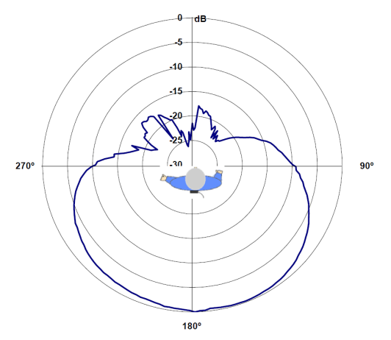

Figure 39: Polar plot of body loss as a function of angle measured inside an anechoic chamber (from Figure 13 of [3])

1. List of Reference
2. ERC Report 42: "Handbook on radio equipment and systems radio microphones and simple wide band audio links", October 1996
3. J. Krogerus, J. Toivanen, C. Icheln and P. Vainikainen, “Effect of the human body on total radiated power and the 3-D radiation pattern of mobile handsets,” IEEE Transactions on Instrumentation and Measurement, vol. 56, no. 6, pp. 2375–2385, 2007
4. Ofcom UK: Analysis of PMSE Wireless Microphone Body Loss effects, 2009. Available at: <https://www.ofcom.org.uk/__data/assets/pdf_file/0022/104485/cobham-pmse-wireless-microphone.pdf>.
5. Measurements from APWPT/DKE and simulations from Ofcom Switzerland in an Excel sheet: <https://www.apwpt.org/downloads/summary_of_be_scenarios_rev1.zip>
6. OFCOM Switzerland: Final Report Project 516 - The Effect of the Human Body on Wireless Microphone Transmission, Eugenia Cabot, Myles Capstick. Available at:   
   <https://cept.org/Documents/fm-51/37139/body-effect-1_study-commissioned-by-ofcom-switzerland-july-2015>
7. OFCOM Switzerland: Additional Report - The Impact of Body Loss and Transmission Path Loss on Wireless Microphone Radio Links. Available at:   
    <https://www.cept.org/Documents/fm-51/37141/body-effect-3_additional-report-from-ofcom-switzerland-december-2017>
8. Recommendation ITU-R P.1406: " Propagation effects relating to terrestrial land mobile and broadcasting services in the VHF and UHF bands"
9. ECC Report 253: “Compatibility studies for audio PMSE at 1492-1518 MHz and 1518-1525 MHz”, September 2016,

1. See ETSI TR 100 027 Clause 4.4 for further information
2. <https://www.itis.ethz.ch/>
3. <https://www.ethz.ch/en.htm>
4. <https://cept.org/Documents/fm-51/37139/body-effect-1_study-commissioned-by-ofcom-switzerland-july-2015>
5. <https://www.cept.org/Documents/fm-51/37141/body-effect-3_additional-report-from-ofcom-switzerland-december-2017>
6. Hasgall PA, Di Gennaro F, Baumgartner C, Neufeld E, Gosselin MC, Payne D, Klingenböck A, Kuster N, “IT’IS Database for thermal and electromagnetic parameters of biological tissues,” DOI: 10.13099/VIP21000-03-0. [www.itis.ethz.ch/database](https://www.itis.ethz.ch/virtual-population/tissue-properties/)
7. <https://www.itis.ethz.ch/virtual-population/virtual-population/overview/>