Sharing studies between Telecoil Replacement Systems (TRS) and Mobile Satellite Service (MSS) in the frequency range 1656.5-1660.5 MHz

approved 26 January 2018

ECC Report 270

# Executive summary

The compatibility between Telecoil Replacement Systems (TRS) and Mobile Satellite Service (MSS) in the frequency band 1656.5-1660.5 MHz is analysed in this Report. The analysis has considered both the aggregate interference from TRS into the MSS satellite receivers and the interference from Mobile Earth Station (MES), both aeronautical and land stations, into the TRS/Assistive Listening Device (ALD) receivers.

TRS considered in this analysis transmit speech or audio over a digital radio link to ALD receivers. Assistive Listening Systems (ALS) systems will be used by the hearing impaired in public spaces such as airports, railway stations, churches and theatres: the TRS transmitter is connected to the audio programme or public address systems, and the ALD receiver is worn by the users or integrated into users’ hearing aids.

Protection of MSS space station

Concerning the aggregate interference from TRS into the MSS satellite receivers, the following table provides the maximum number of TRS with a single spot beam satellite (see Table 3) depending on the e.i.r.p., activity factor (which has been derived from monitoring at railway stations and airports), Satellite Gain (Gs), protection criteria of the MSS and wall loss.

In scenario 1, the aggregate interference affecting the MSS GSO satellite receivers where several TRS transmitting at the same frequency are located within the beam footprint was calculated.

Table 1: Calculated number of 600 kHz bandwidth TRS on one 600 kHz channel – Scenario 1

|  |  |  |  |  |  |
| --- | --- | --- | --- | --- | --- |
| Activity factor | Assumptions | Protection Criteria 1% & Wall loss  6 dB | Protection Criteria 6% & Wall loss  6 dB | Protection Criteria 1% & Wall loss  20 dB | Protection Criteria 6% & Wall loss  20 dB |
| 100% | Tx: 3 dBm, Gs: 46 dBi | 59 | 352 | 1472 | 8831 |
| Tx: 5 dBm, Gs: 41 dBi | 117 | 701 | 2937 | 17621 |
| Tx: 5 dBm, Gs: 46 dBi | 37 | 222 | 929 | 5572 |
| Tx: 12.5 dBm, Gs: 41 dBi | 21 | 125 | 522 | 3133 |
| 12% | Tx: 3 dBm, Gs: 46 dBi | 488 | 2930 | 12266 | 73593 |

It should be noted that some assumptions made for TRS were taken from Recommendation ITU-R M.1076 [2], since no ETSI Harmonised Standard was available for TRS at the time of the development of this Report. Not all the characteristics of the TRS system are defined; therefore, the outputs of the compatibility studies will be used in order to define some of the characteristics.

It was assumed that a TRS system will only be deployed indoors and at train stations using down tilt aerials with a hopping sequence on a licensed basis and maximum 3 dBm e.i.r.p. Typically in the airports and the train stations, it will be fixed on the lower point of the screens providing information about the time schedule or any emergency information.

Based on Table 1 above, for example, by using TRS with 600 kHz channels with a maximum transmit power of 3 dBm and -6 dBi antenna gain, 59 TRS devices can be deployed with a wall loss of 6 dB and protection criteria of 1% and activity factor of 100%; the maximum number of TRS devices:

* is reduced to 21 for a maximum Tx of 12.5 dBm;
* but is increased to 1472 for a wall attenuation of 20 dB.

The model to calculate aggregate interference into the MSS satellite front-end within a single spot beam satellite footprint has been considered for this study.

The aggregate interference to the MSS satellite coming from multiple interferers in the area of the UK, which is approximately equal to the area covered by single MSS spot beam was studied.

The results in this Report are valid for the MSS system parameters considered as shown in Tables 2 and 3; consideration of other MSS systems in particular with regional or global beams may lead to different results. It should be noted that TRS would not be deployed over large areas including over the seas and rural areas.

Administrations may consider managing the deployment of the TRS base stations, for example, through licensing of individual base stations.

Taking into account the sharing study between TRS systems and MSS systems, it is also proposed that TRS deployment would be with a transmitter power not greater than 3 dBm e.i.r.p. and the proposed conditions contained in ANNEX 4:.

Interference from aeronautical Mobile Earth Stations (MES) to TRS

The study of interference from aeronautical MESs has considered aircraft at three different altitudes above ground level, and two different types of victims (TRS User Equipment and TRS Low Power Base Station). The coexistence between the two systems can never be 100% ensured. In fact, the TRS/ALD receivers may be interfered when located within the vicinity of the aircraft (if the aircraft MES is transmitting).

In the studies, no path loss generated by human bodies and surrounding structures has been considered plus any fuselage loss from the aircraft. In addition, the probability of having both the TRS and the MES equipment operating on the same channel at the same time was not considered.

In view of the results from aeronautical interference calculations, a monitoring campaign was started in order to assess whether the use of spectrum by the aeronautical system could in practice prevent its use by the TRS systems. An excess of 600 hours of monitoring in the 1656.5-1660.5 MHz band at a number of sites in six countries both indoor and outdoor has not detected potentially harmful interference from aeronautical systems. Details are to be found in ANNEX 3:. It should be noted that measurements could not be considered as representative of the overall occupation of the spectrum, but focused on the interference potential to the TRS system at the time and location of the measurements.

Interference from land Mobile Earth Stations to TRS

Relating to the impact of land MES on TRS, considering the Extended Hata Model (urban environment, victim and interferer heights = 1.5 m), the separation distances are small (maximum about 250 m). In addition the monitoring campaign showed no interference.

Considering the deployment scenarios of TRS, the communication protocol between the TRS base station and the ALD devices, and the results of the study, it is estimated that the probability of interference from a MES into ALD receivers is low.

TABLE OF CONTENTS

0 Executive summary 2

1 Introduction 6

2 Definitions 8

3 TECHNICAL CHARACTERISTICS 9

3.1 TRS parameters 9

3.2 Mobile Satellite Service System parameters 12

3.2.1 MSS space stations 12

3.2.2 Mobile Earth Station 13

4 SCENARIOS Considered 16

4.1 Scenarios 16

4.2 Propagation models 16

4.3 Methodology 16

4.3.1 Scenario 1 (based on MCL calculations) 16

4.3.2 Scenario 2 (based on MCL calculations) 17

4.3.3 TRS Deployment 18

5 Compatibility Analysis 19

5.1 Scenario 1 with 100% activity factor 19

5.2 Scenario 1 with 12% activity factor 22

5.3 Scenario 2 22

5.4 Summary of the results 28

6 Conclusions 31

ANNEX 1: deployment of TRS 33

ANNEX 2: Marleybourne Railway Station, London 35

ANNEX 3: Monitoring of the band 1656.5-1660.5 MHz 36

ANNEX 4: Conditions to be considered for TRS Base stations 39

ANNEX 5: List of References 40

LIST OF ABBREVIATIONS

|  |  |
| --- | --- |
| Abbreviation | Explanation |
| AFILS | Audio Frequency Induction Loop Systems |
| AMS(R)S | Aeronautical Mobile Satellite (Route) Service |
| ALD | Assistive Listening Device |
| ALS | Assistive Listening Systems |
| BS | Base Stations |
| CEPT | European Conference of Postal and Telecommunications Administrations |
| Δf | Frequency offset |
| ΔT/T | ΔT/T |
| EC | European Commission |
| ECC | Electronic Communications Committee |
| e.i.r.p. | Effective Isotropic Radiated Power |
| e.r.p. | Effective Radiated Power |
| ETSI | European Telecommunications Standards Institute |
| GMDSS | Global Maritime Distress And Safety System |
| Gs | Satellite Gain |
| GSO | Geostationary Satellite Orbit |
| I/N | Interference to Noise ratio |
| ICAO | International Civil Aviation Organisation |
| IMO | International Maritime Organisation |
| MESs | Mobile Earth Stations |
| MSS | Mobile Satellite Service |
| PC | Protection criteria |
| RCTA | Radio Technical Commission for Aeronautics |
| SARs | Search and Rescue |
| SBB | Swift Broadband |
| SRD | Short Range Devices |
| TRS | Telecoil Replacement Systems |
| UE | User Equipment |
| WG FM | Working Group Frequency Management |
| WG SE | Working Group Spectrum Engineering |

# Introduction

This Report assesses the compatibility between Telecoil Replacement Systems (TRS) and Mobile Satellite Service (MSS) in the frequency range 1656.5-1660.5 MHz. The frequency band 1626.5 – 1660.5 MHz (Earth-to-space) is allocated to the MSS in the three ITU-R Regions on a primary basis. This frequency band is currently in use by a number of GSO MSS operators, and it is used globally and extensively for MSS operations.

The band 1626.5-1660.5 MHz is used by Inmarsat and other MSS operators for land, maritime and aviation applications, reference can be made to relevant ICAO and IMO documentations.

It should be noted that some assumptions made for TRS were taken from Recommendation ITU-R M.1076 [2] since no ETSI Harmonised Standard for TRS was available at the time of the development of this Report. Not all the characteristics of the TRS system are defined; therefore, the outputs of the compatibility studies may be used in order to define some of the characteristics.

Hearing aids improve the hearing of hearing-impaired persons by amplifying and filtering sounds, helping them to hear sounds with clarity that they would otherwise have had difficulty for hearing.

Historically, hearing aids consisted of little more than basic "miniature audio amplifiers" placed in or behind their ear(s) solely boosting the incoming sounds. As semiconductor technology evolved and became miniaturised, hearing impaired people can benefit from extremely sophisticated digital systems incorporating a range of communication capabilities. However, real life offers a variety of listening environments, in some of which, even the most sophisticated hearing instruments show only a limited benefit. Examples of such acoustic environments where the performance of conventional hearing instruments can substantially be improved by applying additional communication devices are the following:

* reverberant environments such as public address systems in public areas, big churches or lecture halls;
* communication over larger distances e.g. in a lecture or in a classroom;
* communication on the telephone, especially cell phones.

A major role of allowing the hearing impaired to communicate and also enjoy similar experiences to those with normal hearing has been played by the Telecoil systems. Telecoil systems are based on induction loop, which use a large coil antenna integrated in the floor or wall of a large room for radiating the magnetic field carrying the sound. Once installed, and given that the listener's hearing aids include "T" coils to hear the audio, a person has simply to enter in the looped area and switch his/her personal hearing aids to the Telecoil position. Unfortunately, Telecoil systems can be impractical to install due to technical restrictions in large public places such as airports and train stations. They are also expensive to install and maintain. Finally, they only supply a single low quality voice channel, compared to contemporary wireless systems over digital radio link where multi-audio channel transmission is possible and for e.g. within 200-600 kHz occupied bandwidth, it is possible to have three or more audio channels depending on the voice coding rate used and latency.

Telecoil has been installed in some theatres, shop counters, cinemas, churches and lifts. In today's mobile population, a single channel does not allow for multiple languages or stereo in cinemas. To implement a supplementary[1] Telecoil replacement service effectively, wireless technology would be needed in order to transmit speech or audio from a microphone or sound source, over a digital radio link, to a receiver. An Assistive Listening System (ALS) for use by the hearing impaired in public spaces such as airports, railway stations, churches and theatres, where the transmitter is connected to the audio programme or public address system and the receiver is worn by hearing-impaired users or integrated into users’ hearing aids (ref: ETSI TR 102 791 [1] and Recommendation ITU-R M.1076 [2]). TRSs, despite their name, are not expected to replace the current Telecoil system, but would supplement it in locations where installation of Telecoil is not practical.

This Report examines the potential co-channel interference from TRS transmitters into MSS operating in the band 1656.5-1660.5 MHz. TRS deployment will be multi-national and hence the aggregate interference from multiple TRS transmitters within the footprint of the MSS satellite needs to be taken into account.

It was agreed to consider the United Kingdom (UK) case only, as the UK is covered by one narrow beam MSS footprint. It is important to take into account certain aspects of the potentially global nature of any future TRS deployment. Thus, it should be noted that consideration of MSS systems with regional or global footprints may lead to the other sharing results than presented in this Report.

Additionally, this Report considers the interference from Mobile Earth Stations (MESs) into TRS receivers.

# Definitions

|  |  |
| --- | --- |
| Term | Definition |
| ALD | Assistive Listing Device: a hearing aid with a radio link to external microphone or audio system. |
| ALS | Assistive Listening System (ALS): systems utilizing electromagnetic, radio or light waves or a combination of these, to transmit the acoustic signal from the sound source (a loudspeaker or a person talking) directly to the hearing impaired person. |
| Hearing Aid | Medical devices in the context of Directive 93/42/EEC (MDD) comprising electro acoustic amplifiers including a microphone and a loudspeaker and having a frequency response and dynamic characteristics specific to each person's individual hearing loss. |
| Telecoil | Audio Induction Loop systems, also called audio-frequency induction loops (AFILs) or hearing loops are an aid for the hard of hearing  NOTE: They are a loop of cable around a designated area, usually a room or a building, which generates a magnetic field picked up by a [hearing aid](http://en.wikipedia.org/wiki/Hearing_aid#Telecoil). The benefit is that it allows the sound source of interest - whether a musical performance or a ticket taker's side of the conversation - to be transmitted to the hearing-impaired listener clearly and free of other distracting noise in the environment. Typical installation sites would include concert halls, ticket kiosks, high-traffic public buildings (for personal announcements), auditoriums, places of worship, and homes. In the United Kingdom, as an aid for disability, their provision where reasonably possible is required by the [Disability Discrimination Act 1995](http://en.wikipedia.org/wiki/Disability_Discrimination_Act_1995), and they are available in "the back seats of all London taxis, which have a little microphone embedded in the dashboard in front of the driver; at 18,000 post offices in the United Kingdom; at most churches and cathedrals. |
| TRS | TRS considered in this analysis transmit speech or audio over a digital radio link, to ALD receivers. ALS systems will be used by the hearing impaired in public spaces such as airports, railway stations, churches and theatres: the TRS transmitter is connected to the audio programme or public address systems and the ALD receiver is worn by the users, or integrated into users’ hearing aids. |

# TECHNICAL CHARACTERISTICS

## TRS parameters

TRS considered in this Report transmit speech or audio over a digital radio link to ALD receivers. ALS systems will be used by the hearing impaired in public spaces such as airports, railway stations, churches and theatres: the TRS transmitter is connected to the audio programme or public address systems and the ALD receiver is worn by the users, or integrated into users’ hearing aids.

For TRS, the traffic density will be dependent on the location of the installation. For example, TRS in a theatre or a cinema would have constant transmission for the duration of a performance, say two to three hours, whereas a train station would be intermittent use for eighteen hours a day and home use would be dependent on the TV programs preferred by the viewer.

It should be noted that some assumptions made for ALD were taken from Recommendation ITU-R M.1076, since there is no ETSI Harmonised Standard at the time of the development of this Report.

According to Recommendation ITU-R M.1076 [2] these systems could operate in approximately 200 kHz, 400 kHz and 600 kHz occupied bandwidth. It can be assumed that a 200 kHz channel could accommodate an overall bitrate of 100 kbps. If the system would be used to provide 32 kbps audio channels, the 200 kHz band could be shared among three transmitters with 33% duty cycle.

Recommendation ITU-R M.1076 states:

Depending on available spectrum and coexistence requirements, systems to operate in approximately 200 kHz, 400 kHz and 600 kHz occupied bandwidth are outlined. The transmitter and receiver duty cycle is inversely proportional to the bandwidth, which means that the amount of spectrum resource used is roughly independent of the bandwidth, but the receiver power consumption is proportional to the duty cycle.

This means that a 600 kHz system would allow receivers to consume approximately 1/3 the power of a 200 kHz system, which is highly beneficial in power-limited applications such as hearing aids[2]. Wider bandwidth also decreases end-to-end delay, which is of benefit to many audio applications where the audio must maintain lip-sync with the talker in order to maximise intelligibility.

However, it is not always possible to maintain lip-sync in airports and railway stations where the sound is coming from a public announcement system, but 600 kHz systems may be necessary where more than one language needs to be transmitted.

Below are given technical parameters for wireless communication systems for access of hearing impaired people to public services assumed in this Report.

Table 2: TRS/ALD technical characteristics

|  |  |  |
| --- | --- | --- |
| Parameter | Unit | Value |
| Maximum e.i.r.p. for Base Station | dBm | 3 |
| Reference Bandwidth | kHz | 600 |
| Antenna Pattern | - | See Figure 1 |
| Duty cycle | % | 100 |
| Activity factor | % | 12.5 |
| Antenna Gain | dBi | -15 for a User Equipment (UE), representative for a small hearing aid |
| +6.4 boresight TRS Base Station (BS) or personal hub.  From Figure 1 the assumed antenna gain towards the satellite is -6 dBi without shielding. |
| TRS antenna height | m | 2.5 – 3 |
| Receiver Thermal Noise | dBm | -121 |
| Receiver Noise Figure | dB | 10 |
| Receiver Noise Floor | dBm | -111 |
| Receiver height | m | 1.6 |
| I/N protection criterion | dB | -10 |
| Interference protection level | dBm | -121 |

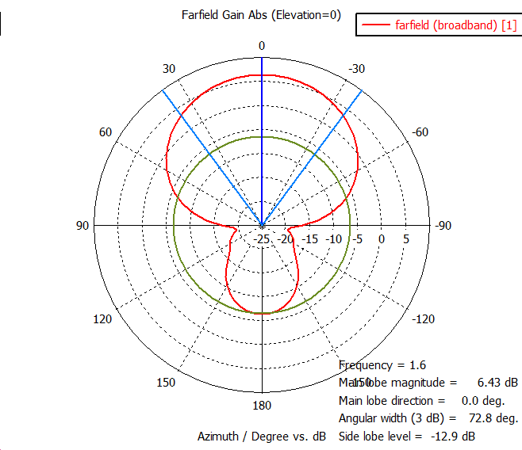

Figure 1: TRS antenna radiation pattern

The system will only be deployed indoor and at train stations using down tilt aerials with a hopping sequence on a licensed basis and maximum 3 dBm e.i.r.p. Typically in the airports and the train stations, it will be fixed on the lower point of the screens providing information about the time schedule or any emergency information, and in specific areas identified by a similar logo to one shown in Figure 2.

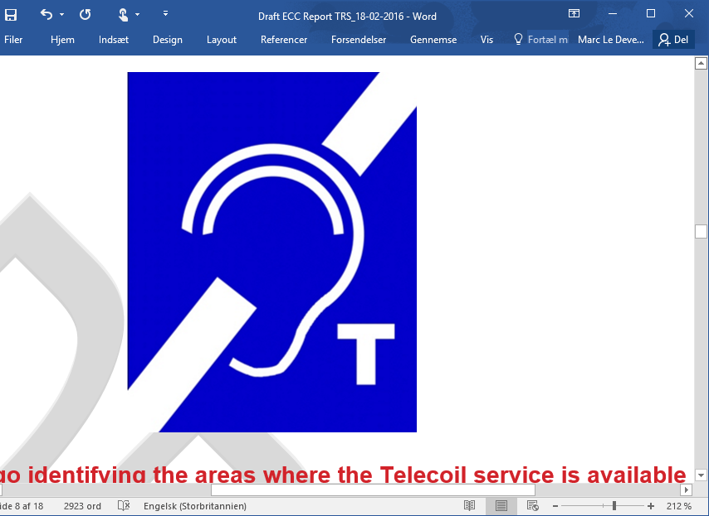

Figure 2: Logo identifying the areas where the current Telecoil service is available

## Mobile Satellite Service System parameters

### MSS space stations

Characteristics of some MSS space stations are given in Recommendation ITU-R M.1184-2 [3] and Recommendation ITU-R M.1799 [4]. The main parameters of spot beam MSS used in the study are contained in Table 3.

Figure 3 illustrates the aggregate interference mechanism affecting MSS GSO satellites, where several TRS transmitting at the same frequency are located within the beam footprint. This study is based on ΔT/T approach described in Appendix 8 of the ITU Radio Regulations, which provides a method to estimate the impact of interference within the beam of a satellite antenna from other GSO satellite networks. The maximum allowable aggregate interference originating from other GSO satellite networks is set to ΔT/T of 6%. The maximum allowable aggregate interference apportioned to all other interference sources to GSO satellite network, therefore, should not exceed a threshold of 1% of ΔT/T. ECC Report 64 [5] used ΔT/T of 1% for the protection of GSO systems from the aggregate interference of low power UWB systems. Given this Report is considering aggregate interference into GSO systems from low power TRS systems, it is proposed to use ΔT/T threshold for the maximum allowable aggregate interference originated by all TRS deployed globally is 1% of ΔT/T. It should be noted that the initial baseline aggregate interference analysis is only considering TRS deployed in the UK, noting that the main beam MSS footprint approximates to the size of the UK. Consideration on other MSS systems, in particular with regional or global beams, may lead to different results.

Table 3: MSS space station characteristics

|  |  |  |
| --- | --- | --- |
| Parameter | Unit | Value |
| Satellite | - | Geostationary |
| Satellite coverage area (one spot beam) | km | Approximately 500 km radius at nadir – narrow beam |
| Peak Satellite Antenna Gain | dBi | 41 / 46 |
| Polarisation | - | Circular |
| Satellite Receiver Temperature | K | 501 |
| Reference Bandwidth | kHz | 200 |
| Frequency | MHz | 1660 |
| ΔT/T threshold for the maximum allowable aggregate interference | % | 1 non-satellite and  6 intra-satellite |

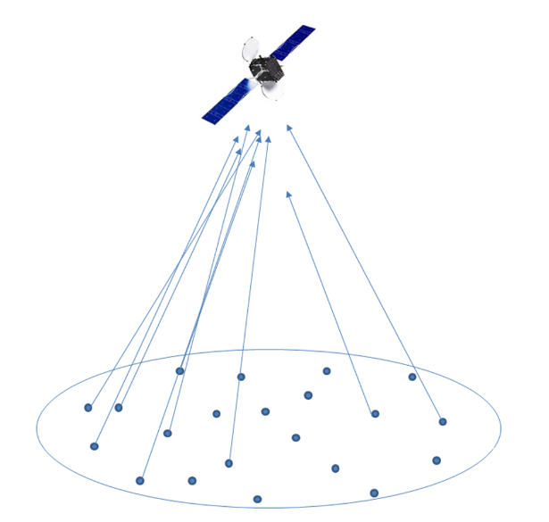

Figure 3: Aggregation of the interference from TRS transmitters within the satellite beam

### Mobile Earth Station

Mobile Earth Stations (MESs) in these bands may be operated on land, on aircraft and on ships. Recommendation ITU-R M.1184-2 [3] contains a range of characteristics of MSS systems operating in these bands. Only some sets of MSS characteristics are used here. The characteristics of maritime terminals are similar to those of land terminals, although naturally the terminals are installed on sea and river vessels. The main parameters used in the study are contained in the following Table 4.

Table : MES characteristics

| Scenario | Type | Value | Antenna gain | Inmarsat service |
| --- | --- | --- | --- | --- |
| Land | Low gain | dBi | 3 | GSPS |
| High gain | dBi | 17.5 | BGAN class 1 |
| Sea (maritime) | Low gain | dBi | 3 | Inmarsat-C |
| High gain | dBi | 21 | Fleet-77 |
| Air (aeronautical) | Low gain | dBi | 3 | Aero-L |
| High gain | dBi | 12 | Aero-H |

The following figures provide the corresponding antenna patterns[3].



Figure 4: Inmarsat-Maritime high gain (peak gain = 21 dBi) radiation pattern



Figure 5: Inmarsat-Land high gain (peak gain = 17.5 dBi) radiation pattern



Figure 6: Inmarsat-Aero/Land low gain (peak gain = 3 dBi) radiation pattern

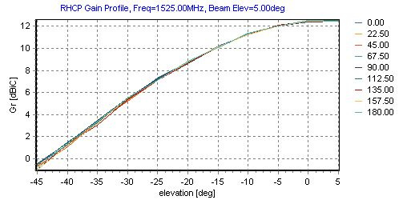

Figure 7: Inmarsat-Aero high gain (peak gain = 12 dBi) radiation pattern

It has to be noted that the gain pattern of the Aero-high gain antenna is based on measured in a calibrated antenna test facility, in an anechoic environment, with a ground plane added to simulate the fuselage effect. As can be seen from the plot in Figure 7, at 30 degrees below the horizon (35° off-axis) there is 7 dB of antenna discrimination with antenna gain of 5 dBi.

# SCENARIOS Considered

## Scenarios

The following scenarios have been investigated:

1. Aggregate interference affecting the MSS GSO satellite receivers, where several TRS transmitting at the same frequency are located within the beam footprint.
2. Interference from MES into the ALD/TRS receivers, considering two different types of MES use (aeronautical and land) and different ALD/TRS receivers (UE and BS).

## Propagation models

For scenario 1: the free-space propagation model is used, computed according to the Recommendation ITU-R P.525 [6].

For scenario 2: in case of the transmission between aeronautical MES and TRS/ALD receiver, the free-space propagation model is used.

In case of the transmission from land MES into TRS/ALD receivers, the propagation model used is based on the Recommendation ITU-R P.452 [7] , with attenuation not exceeded for 20% of time, land path 100%, also considering the Extended Hata Model.

## Methodology

### Scenario 1 (based on MCL calculations)

For scenario 1, the interference from a single source of TRS low power base station into the MSS satellite receiver is evaluated considering the following formula:

$$I=P_{T}+G_{T}+G_{R}-L_{prop}$$

where

* $I$ is the ALD interferer power at the MSS satellite receiver (dBm);
* $P_{T}$ is the transmitted power by the interferer (dBm);
* $G_{T}$ is the gain of the transmitter antenna (the interferer) in the direction of the satellite (dBi);
* $G_{R}$ is the gain of the receiver antenna (the victim) in the direction of the interferer (dBi);
* $L_{prop}$ is the loss due to propagation (dB).

The increment of the thermal noise into the wanted satellite receiver (ΔT) from a single source is then calculated using the following formula:

$$ΔT=\frac{{10}^{I/{10}}}{K∙B_{ref}∙1000}$$

where

* $K$ is the Boltzmann constant;
* $B_{ref}$ is the reference bandwidth of the affected system (kHz).

The percentage of amount of additional noise temperature caused by a single interferer is:

$${ΔT}_{\%}=\frac{ΔT}{T}∙100$$

where

* ${ΔT}_{\%}$ is the percentage of amount of additional noise temperature caused by a single interferer;
* $T$ is the satellite receiver temperature.

The aggregate interference is then calculated by multiplying the percentage of amount of additional noise caused by a single interferer by the total number of assumed interferers:

$${ΔT}_{\%, agg}=M∙{ΔT}_{\%}$$

where

* ${ΔT}_{\%, agg}$ is the percentage of aggregate amount of additional noise caused by the interferers within the satellite beam;
* $M$ is the assumed number of interferers transmitting at the same frequency within the same satellite beam.

It is worth noting that this study has assumed a single value for the free-space loss without considering the exact elevation between the interferers and the victim. Figure 8 shows the free space loss as a function of the elevation to the satellite: it is shown that the free space loss is between 189.2 dB for 0° elevation angle and 187.9 dB for 90° elevation angle. Hence, the elevation angle between the interferer and the satellite has a small impact in the overall calculation. This study has assumed a free space loss of 188.5 dB corresponding to an elevation angle of 35°.

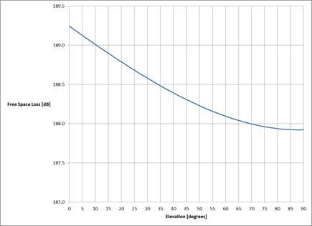

Figure 8: Free Space Loss in function of the elevation to satellite

### Scenario 2 (based on MCL calculations)

For Scenario 2, the interference from a MES transmitter into the ALD/TRS receiver is evaluated considering the following formula:

$$I=P_{T}+G_{T}+G_{R}-L_{prop}$$

where

* $I$ is the MES interferer power at the ALD/TRS receiver (dBm);
* $P_{T}$ is the transmitted power by the interferer (dBm);
* $G_{T}$ is the gain of the transmitter antenna (the interferer) in the direction of the victim (dBi);
* $G_{R}$ is the gain of the receiver antenna (the victim) in the direction of the interferer (dBi);
* $L_{prop}$ is the loss due to propagation (dB).

### TRS Deployment

As it was stated earlier in this Report, TRS deployment will not be outdoors. Hence, there is a need to consider wall attenuation in the interference analysis for cases where the TRS installation is completely indoors such as in cinemas and theatres, while for TRS deployment for e.g. in railways, it cannot be guaranteed that there will always be a wall between the TRS and low elevation satellite, and between TRS and land MES.

This study assumes TRS operating only indoors.

When considering interference from TRS deployed in train stations into a low elevation satellite, there might not be wall attenuation, while for high elevation satellite, the attenuation will come from the "ceiling" structure of the railway station or airport.

There are different studies on measured wall attenuation that show the wall loss values ranging in values depending on the type of wall and the material used. One such study is the UK Ofcom's "Building Materials and Propagation Final Report, 2604/BMEM/R/3/2.0” [8]. According to this Report, at 1.6 GHz frequency, wall loss values range from 6 dB to 20 dB. Ceiling attenuation might have different values.

# Compatibility Analysis

## Scenario 1 with 100% activity factor

The results for this study are based on the assumptions listed in section 3 and the methodology described in section 4.3.1.

Table 5: Compatibility analysis for Scenario 1 with 100% activity factor with Satellite Gain (Gs) of 46 dBi

|  |  |  |  |  |
| --- | --- | --- | --- | --- |
| Protection Criterion (PC) | PC 1% (wall attenuation of 6 dB) | PC 6% (wall attenuation of 6 dB) | PC 1% (wall attenuation of 20 dB) | PC 6% (wall attenuation of 20 dB) |
| Tx (dBm) | 3 | 3 | 3 | 3 |
| Bandwidth (kHz) | 600 | 600 | 600 | 600 |
| Gain towards the sky (dBi) TRS BS | -6 | -6 | -6 | -6 |
| Att wall (dB) | 6 | 6 | 20 | 20 |
| Att (dB) | 188.5 | 188.5 | 188.5 | 188.5 |
| Gs (dBi) | 46 | 46 | 46 | 46 |
| Received Power (dBm) | -151.5 | -151.5 | -165.5 | -165.5 |
| Received Power (dBW) | -181.5 | -181.5 | -195.5 | -195.5 |
| K | 1.38E-23 | 1.38E-23 | 1.38E-23 | 1.38E-23 |
| Delta T (K) | 0.086 | 0.086 | 0.0034 | 0.0034 |
| T (K) | 501 | 501 | 501 | 501 |
| Delta T/T (%) | 0.0171 | 0.0171 | 0.00068 | 0.000681 |
| Acceptable interference (%) | 1 | 6 | 1 | 6 |
| Number of TRS on one 600 kHz channel | 59 | 352 | 1472 | 8831 |

Table 6: Compatibility analysis for Scenario 1 with 100% activity factor with Satellite Gain (Gs) of 41 dBi and Tx TRS power of 5dBm

|  |  |  |  |  |
| --- | --- | --- | --- | --- |
| Protection Criterion (PC) | PC 1% (wall attenuation of 6 dB) | PC 6% (wall attenuation of 6 dB) | PC 1% (wall attenuation of 20 dB) | PC 6% (wall attenuation of 20 dB) |
| Tx (dBm) | 5 | 5 | 5 | 5 |
| Bandwidth (kHz) | 600 | 600 | 600 | 600 |
| Gain towards the sky (dBi) TRS BS | -6 | -6 | -6 | -6 |
| Att wall (dB) | 6 | 6 | 20 | 20 |
| Att (dB) | 188.5 | 188.5 | 188.5 | 188.5 |
| Gs (dB) | 41 | 41 | 41 | 41 |
| Received Power (dBm) | -154.5 | -154.5 | -168.5 | -168.5 |
| Received Power (dBW) | -184.5 | -184.5 | -198.5 | -198.5 |
| K | 1.38E-23 | 1.38E-23 | 1.38E-23 | 1.38E-23 |
| Delta T (K) | 0.043 | 0.043 | 0.0017 | 0.0017 |
| T (K) | 501 | 501 | 501 | 501 |
| Delta T/T (%) | 0.0086 | 0.0086 | 0.00034 | 0.00034 |
| Acceptable interference (%) | 1 | 6 | 1 | 6 |
| Number of TRS on one 600 kHz channel | 117 | 701 | 2937 | 17621 |

Note: Gs = 41 dBi is given in Rec. ITU-R M.1184-2 [3] as a reference in the section dealing with MSS characteristics (see table 2 in the Rec. ITU-R M.1184-2 [3]

Table 7: Compatibility analysis for Scenario 1 with 100% activity factor with Satellite Gain (Gs) of 41 dBi and Tx TRS power of 12.5 dBm

|  |  |  |  |  |
| --- | --- | --- | --- | --- |
| Protection Criterion (PC) | PC 1% (wall attenuation of 6 dB) | PC 6% (wall attenuation of 6 dB) | PC 1% (wall attenuation of 20 dB) | PC 6% (wall attenuation of 20 dB) |
| Tx (dBm) | 12.5 | 12.5 | 12.5 | 12.5 |
| Bandwidth (kHz) | 600 | 600 | 600 | 600 |
| Gain towards the sky (dBi) BS | -6 | -6 | -6 | -6 |
| Att wall (dB) | 6 | 6 | 20 | 20 |
| Att (dB) | 188.5 | 188.5 | 188.5 | 188.5 |
| Gs (dB) | 41 | 41 | 41 | 41 |
| Received Power (dBm) | -147.0 | -147.0 | -161.0 | -161.0 |
| Received Power (dBW) | -177.0 | -177.0 | -191.0 | -191.0 |
| K | 1.38E-23 | 1.38E-23 | 1.38E-23 | 1.38E-23 |
| Delta T (K) | 0.24 | 0.24 | 0.0096 | 0.0096 |
| T (K) | 501 | 501 | 501 | 501 |
| Delta T/T (%) | 0.048 | 0.0485 | 0.0019 | 0.0019 |
| Acceptable interference (%) | 1 | 6 | 1 | 6 |
| Number of TRS on one 600 kHz channel | 21 | 125 | 522 | 3133 |

Note: Gs = 41 dBi is given in Rec. ITU-R M.1184-2 [3] as a reference in the section dealing with MSS characteristics (see table 2 in the Rec. ITU-R M.1184-2 [3]

Table 8: Compatibility analysis for Scenario 1 with 100% activity factor with Satellite Gain (Gs) of 46 dBi and Tx power TRS: 5 dBm

|  |  |  |  |  |
| --- | --- | --- | --- | --- |
| Protection Criterion (PC) | PC 1% (wall attenuation of 6 dB) | PC 6% (wall attenuation of 6 dB) | PC 1% (wall attenuation of 20 dB) | PC 6% (wall attenuation of 20 dB) |
| Tx (dBm) | 5 | 5 | 5 | 5 |
| Bandwidth (kHz) | 600 | 600 | 600 | 600 |
| Gain towards the sky (dBi) BS | -6 | -6 | -6 | -6 |
| Att wall (dB) | 6 | 6 | 20 | 20 |
| Att (dB) | 188.5 | 188.5 | 188.5 | 188.5 |
| Gs (dB) | 46 | 46 | 46 | 46 |
| Received Power (dBm) | -149.5 | -149.5 | -163.5 | -163.5 |
| Received Power (dBW) | -179.5 | -179.5 | -193.5 | -193.5 |
| K | 1.38E-23 | 1.38E-23 | 1.38E-23 | 1.38E-23 |
| Delta T (K) | 0.14 | 0.14 | 0.0054 | 0.0054 |
| T (K) | 501 | 501 | 501 | 501 |
| Delta T/T (%) | 0.027 | 0.027 | 0.0011 | 0.0011 |
| Acceptable interference (%) | 1 | 6 | 1 | 6 |
| Number of TRS on one 600 kHz channel | 37 | 222 | 929 | 5572 |

## Scenario 1 with 12% activity factor

Table 9: Compatibility analysis for Scenario 1 with 100% activity factor with Satellite Gain (Gs) of 46 dBi and Tx TRS power of 3 dBm

|  |  |  |  |  |
| --- | --- | --- | --- | --- |
| Protection Criterion (PC) | PC 1% (wall attenuation of 6 dB) | PC 6% (wall attenuation of 6 dB) | PC 1% (wall attenuation of 20 dB) | PC 6% (wall attenuation of 20 dB) |
| Tx (dBm) | 3 | 3 | 3 | 3 |
| Bandwidth (kHz) | 600 | 600 | 600 | 600 |
| Activity factor (dB) (12%) | -9.2 | -9.2 | -9.2 | -9.2 |
| Gain in the sky (dBi) TRS | -6 | -6 | -6 | -6 |
| Att wall (dB) | 6 | 6 | 20 | 20 |
| Att (dB) | 188.5 | 188.5 | 188.5 | 188.5 |
| Gs (dBi) | 46 | 46 | 46 | 46 |
| Received Power (dBm) | -160.7 | -160.7 | -174.7 | -174.7 |
| Received Power (dBW) | -190.7 | -190.7 | -204. | -204.7 |
| K | 1.38E-23 | 1.38E-23 | 1.38E-23 | 1.38E-23 |
| Delta T (K) | 0.01026 | 0.01026 | 0.000408 | 0.000408 |
| T (K) | 501 | 501 | 501 | 501 |
| Delta T/T (%) | 0.002048 | 0.002048 | 8.15E-05 | 8.15E-05 |
| Acceptable interference (%) | 1 | 6 | 1 | 6 |
| Number of TRS on one 600 kHz channel | 488 | 2930 | 12266 | 73593 |

## Scenario 2

The results for this study are based on the assumptions listed in section 3 and the methodology described in section 4.3.2.

Figure 11 and Figure 12 present the results of the impact of aeronautical MESs into TRS/ALD receivers. The study has considered aeronautical MES at three different altitudes above ground level, and two different types of victims (TRS User Equipment in Figure 11 and TRS Low Power Base Station in Figure 12). The analysis has also assumed an off-axis angle between the interferer and the victim of 30°. In this case, it is shown that the coexistence between the two services can never be ensured. In fact, the ALD/TRS receivers will be interfered as soon as the aircraft and the ALD/TRS are within radio visibility of each other. However, these studies are based on a worst case MCL analysis which doesn’t take account of link budget or a number of mitigation factors such as human body loss, aircraft fuselage loss and building attenuations.

The probability of interference actually occurring will be impacted by the probability of transmission of both systems (i.e. MSS and TRS) in the same geographical area on the same channel at the same time, and from the monitoring campaign the probability of interference appears to be low.

Fuselage loss on aircraft is relative to the type of aircraft, whether the antenna is tail mount or fuselage mount and the relative position of the aircraft, Figure 9 gives information on the relative positions of the antennas in relation to the aircraft body during various aircraft movements.



Figure 9: Relative positions of the antennas in relation to the aircraft body during various aircraft movements

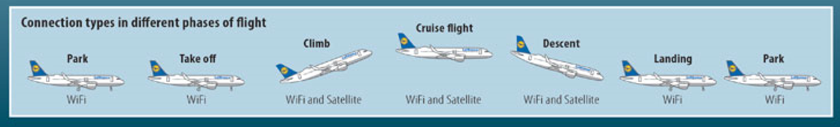

Figure 10: Connections types in different phases of flight

When considering aircraft body attenuation ITU-R M.2283-0 [10] states:

Aircraft fuselage attenuation values differ due to variations in the aircraft type and configuration, the measurement frequency range and the type of measurement e.g. near field or far field (referred to the aircraft’s size).

In general, fuselage attenuation of any given aircraft is not a constant but rather is a directional property of the aircraft. To reflect this fact, ECC Report 175 introduces different attenuation values for different viewing angles of the aircraft. This concept is also used in this Report and summarized in Table 5.

ITU-R M.2283-0 then provides in Table 5 a range of attenuation figures for transmitters installed in the cabin and lower lobe of the aircraft; these vary from 10 to 45 dB. No figures are available in that Report for fuselage loss from the top of aircraft to ground, which is the relevant scenario in this case.

Additional losses are not considered in Figure 11 and Figure 12 for the impact of aeronautical MESs into TRS/ALD receivers.

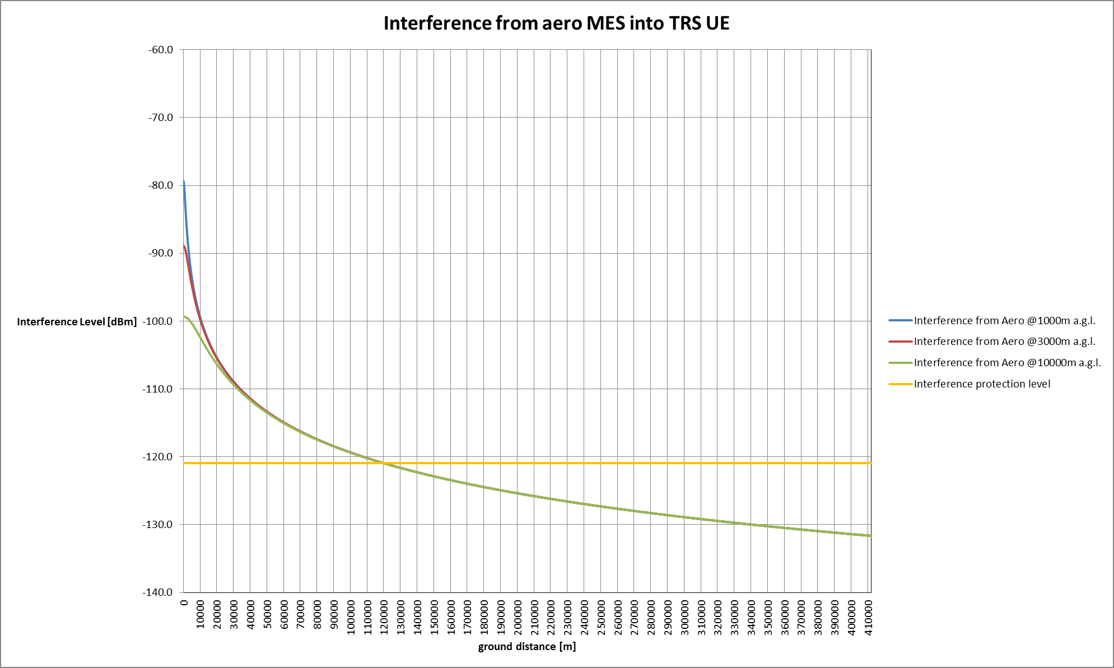

Figure 11: Interference from aeronautical MES into TRS UE

Table 10: Calculations for the TRS UE (Wall losses: 6 and 20 dB)

|  |  |  |  |  |
| --- | --- | --- | --- | --- |
|  | MES Low gain | | MES High gain | |
| e.i.r.p. (dBm) | 42 | 42 | 56 | 56 |
| Antenna gain (dB) | 3 | 3 | 12 | 12 |
| Tx power (dBm) | 39 | 39 | 39 | 39 |
| Gain in the side lobe (dB) | 0 | 0 | -10 | -10 |
| e.i.r.p. in the TRS direction (dB) | 39 | 39 | 29 | 29 |
| Wall loss (dB) | 6 | 20 | 6 | 20 |
| TRS gain in MES direction (dB) | -15 | -15 | -15 | -15 |
| Protection criterion (dBm) | -121 | -121 | -121 | -121 |
| Required attenuation (dB) | 139 | 125 | 129 | 115 |
| Attenuation at 13000 m (dB) | 119 | 119 | 119 | 119 |
| Margin (dB) altitude 13000 m | 20 | 6 | 10 | -4 |
| Distance on the ground (km) | 127 | 22 | 38 | NA |

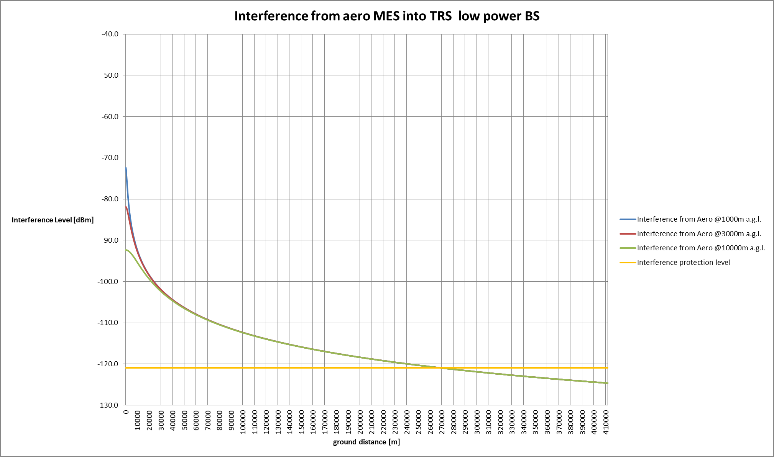

Figure 12: Interference from aeronautical MES into TRS low power BS

Table 11: Calculations for the TRS BS (Wall losses: 6 and 20 dB)

|  |  |  |  |  |
| --- | --- | --- | --- | --- |
|  | MES Low gain | | MES High gain | |
| e.i.r.p. (dBm) | 42 | 42 | 56 | 56 |
| Antenna gain (dB) | 3 | 3 | 12 | 12 |
| Tx power (dBm) | 39 | 39 | 39 | 39 |
| Gain in the side lobe (dB) | 0 | 0 | -10 | -10 |
| e.i.r.p. in the TRS direction (dB) | 39 | 39 | 29 | 29 |
| Wall loss (dB) | 6 | 20 | 6 | 20 |
| TRS gain in MES direction (dB) | -6 | -6 | -6 | -6 |
| Protection criterion (dBm) | -121 | -121 | -121 | -121 |
| Required attenuation (dB) | 148 | 134 | 138 | 124 |
| Attenuation at 13000 m (dB) | 119 | 119 | 119 | 119 |
| Margin (dB) altitude 13000 m | 29 | 15 | 19 | 5 |
| Distance on the ground (km) | 361 | 113 | 70 | 19 |

Figure 13 and Figure 14 represent the results of the impact of land MESs with high and low gains into the ALD/TRS receivers. The study has considered two different types of victims ALD User Equipment in Figure 13 and TRS Low Power Base Station in Figure 14.

The following is found assuming the Extended Hata model.

Table 12: Minimum distances between land MES and TRS UE

|  |  |  |  |  |
| --- | --- | --- | --- | --- |
|  | MES Low gain | | MES High gain | |
| e.i.r.p. (dBm) | 39 | 39 | 51 | 51 |
| Antenna gain (dB) | 7.5 | 7.5 | 16.5 | 16.5 |
| Tx power (dBm) | 31.5 | 31.5 | 34.5 | 34.5 |
| Gain in the side lobe (dB) | -5 | -5 | -5 | -5 |
| e.i.r.p. in the TRS direction (dB) | 26.5 | 26.5 | 29.5 | 29.5 |
| Wall loss (dB) | 6 | 20 | 6 | 20 |
| TRS gain in MES direction (dB) | -15 | -15 | -15 | -15 |
| Protection criterion (dBm) | -121 | -121 | -121 | -121 |
| Required attenuation (dB) | 126.5 | 112.5 | 129.5 | 115.5 |
| Distance (m) | 115 | 82 | 140 | 86 |

Table 13: Minimum distances between land MES and TRS BS

|  |  |  |  |  |
| --- | --- | --- | --- | --- |
|  | MES Low gain | | MES High gain | |
| e.i.r.p. (dBm) | 39 | 39 | 51 | 51 |
| Antenna gain (dB) | 7.5 | 7.5 | 16.5 | 16.5 |
| Tx power (dBm) | 31.5 | 31.5 | 34.5 | 34.5 |
| Gain in the side lobe (dB) | -5 | -5 | -5 | -5 |
| e.i.r.p. in the TRS direction (dB) | 26.5 | 26.5 | 29.5 | 29.5 |
| Wall loss (dB) | 6 | 20 | 6 | 20 |
| TRS gain in MES direction (dB) | -6 | -6 | -6 | -6 |
| Protection criterion (dBm) | -121 | -121 | -121 | -121 |
| Required attenuation (dB) | 135.5 | 121.5 | 138.5 | 124.5 |
| Distance (m) | 207 | 95 | 253 | 101 |

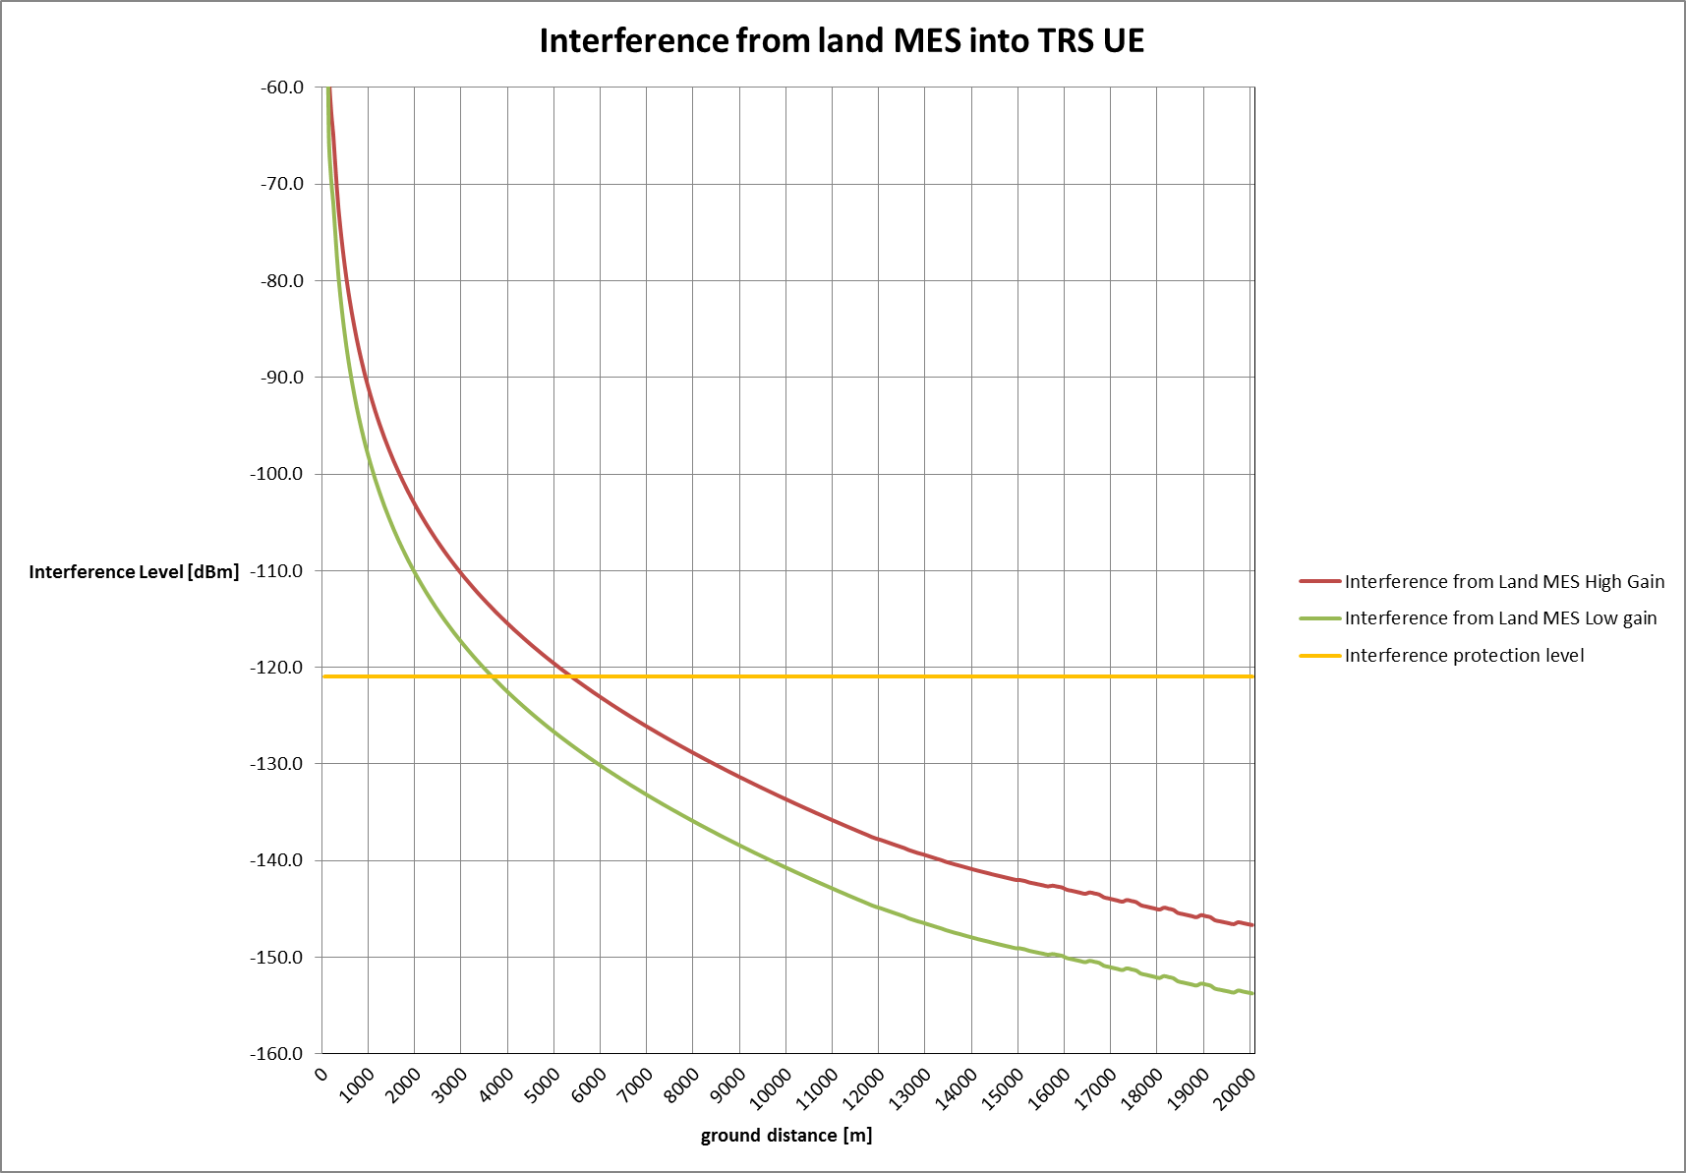

Figure 13: Interference from land MES into TRS UE

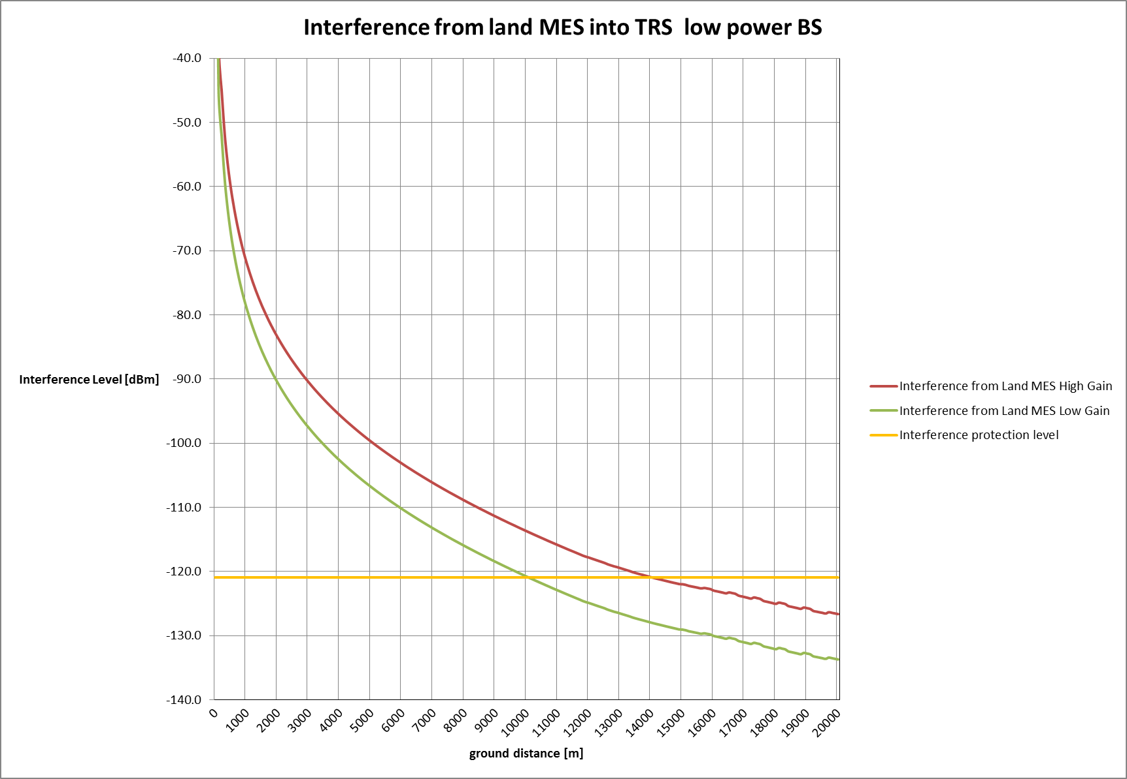

Figure 14: Interference from land MES into TRS low power BS

Figure 13 and Figure 14 show the interference received for a give separation distance. In this case, it is shown that the coexistence between the two services cannot be ensured for distances lower than those represented in Table 14.

Table 14: Minimum distances between land MES and ALD receivers

|  |  |  |
| --- | --- | --- |
|  | **Land MES**  **High gain** | **Land MES**  **Low gain** |
| ALD User Equipment (-15 dBi) | 5.6 km | 3.6 km |
| TRS BS (5 dBi) | 14.00 km | 10.00 km |

## Summary of the results

Scenario 1 has considered the aggregate interference affecting the MSS GSO satellite receivers, where several low power TRS transmitting at the same frequency are located within the satellite beam footprint. A range of e.i.r.p. values were used, to determine the maximum e.i.r.p. value for which a viable number of TRS with a single spot beam satellite (see Table 3) can be deployed. Based on this analysis a maximum e.i.r.p. of 3 dBm is considered to be acceptable to ensure coexistence.

Table 15: Calculated number of 600 kHz TRS on one channel – Scenario 1

|  |  |  |  |  |  |
| --- | --- | --- | --- | --- | --- |
| Activity factor | Assumptions | PC1% & Wall loss 6 dB | PC 6% & Wall loss 6 dB | PC1% & Wall loss 20 dB | PC 6% & Wall loss 20 dB |
| 100% | Tx: 3 dBm, Gs: 46 dBi | 59 | 352 | 1472 | 8831 |
| Tx: 5 dBm, Gs: 41 dBi | 117 | 701 | 2937 | 17621 |
| Tx: 5 dBm, Gs: 46 dBi | 37 | 222 | 929 | 5572 |
| Tx: 12.5 dBm, Gs: 41 dBi | 21 | 125 | 522 | 3133 |
| 12% | Tx: 3 dBm, Gs: 46 dBi | 488 | 2930 | 12266 | 73593 |

Scenario 2 has considered the interference from MES (both aeronautical and land stations) into the TRS/ALD receivers.

The study of interference from aeronautical MESs has considered aircraft at three different altitudes above ground level, and two different types of victims (TRS User Equipment and TRS Low Power Base Station). The coexistence between the two services can never be 100% ensured. In fact, the TRS/ALD receivers may be interfered when located within the vicinity of the aircraft.

In the studies, no path loss generated by human bodies and surrounding structures has been considered plus any fuselage loss from the aircraft. In addition, the probability of having both the TRS and the MES equipment operating on the same channel was not considered, there is a very low probability of this happening.

Following the results of these calculations a monitoring campaign was instigated, in excess of 600 hours of monitoring in the 1656.5-1660.5 MHz band at a number of sites in six countries both indoor and outdoor has shown no signals being received from aircraft systems. The plots below combining two days of monitoring in Germany are typical of all the results. Whilst these scans used a wideband circular dipole, a variety of antenna have been used ranging from telescopic to directional with up to 8 dBd gain which are of much greater efficiency than those integrated antenna proposed for TRS. The measurements do not preclude the possibility of interference to spectrum use may be different in other locations or a change in spectrum use.

Relating to the impact of land MES on TRS, considering the Extended Hata Model (urban environment, victim and interferer heights = 1.5 m) the separation distances are small (maximum about 250 m).

The following figures are extracted from ANNEX 3: that provides various monitoring measurements in the frequency band.

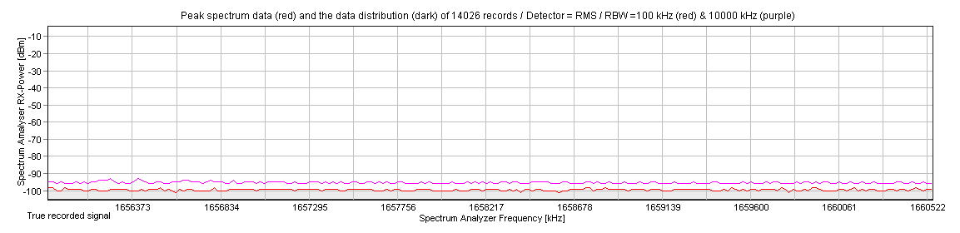

Figure 15: Two days of monitoring in Germany

Expanding the scan shows no significant signals in the range 1600-1700 MHz.

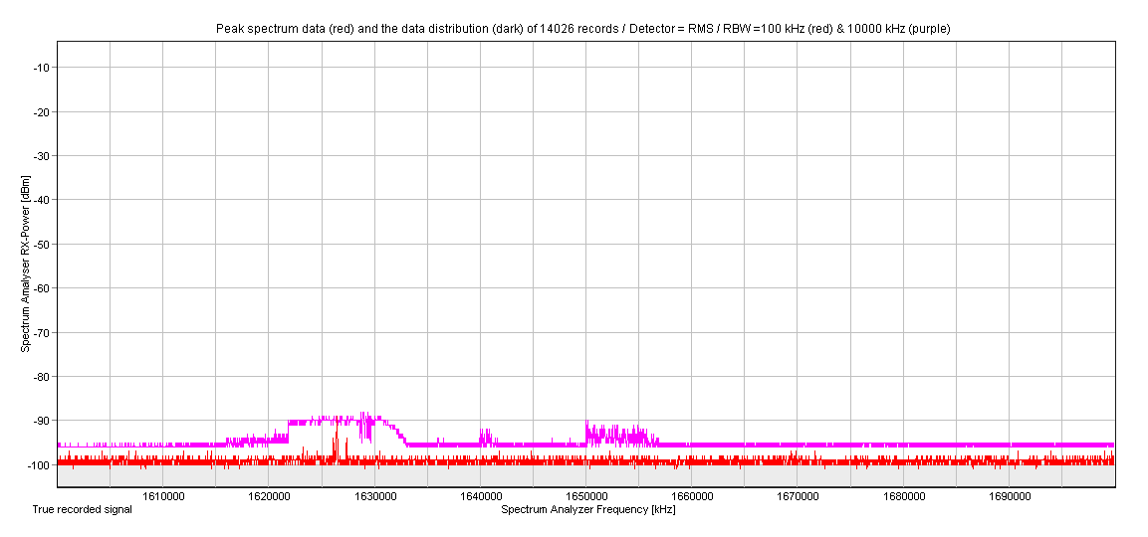

Figure 16: Two days of monitoring in Germany expanded scan showing adjacent spectrum

# Conclusions

The compatibility between Telecoil Replacement Systems (TRS) and Mobile Satellite Service (MSS) in the frequency band 1656.5-1660.5 MHz is analysed in this Report. The analysis has considered both the aggregate interference from TRS into the MSS satellite receivers and the interference from Mobile Earth Station (MES), both aeronautical and land stations, into the TRS/Assistive Listening Device (ALD) receivers.

TRS considered in this analysis transmit speech or audio over a digital radio link, to ALD receivers. Assistive Listening Systems (ALS) systems will be used by the hearing impaired in public spaces such as airports, railway stations, churches and theatres: the TRS transmitter is connected to the audio programme or public address systems, and the ALD receiver is worn by the users or integrated into users’ hearing aids.

Protection of MSS space station

Concerning the aggregate interference from TRS into the MSS satellite receivers, the following table provides the maximum number of TRS with a single spot beam satellite (see Table 3) depending on the e.i.r.p., activity factor (which has been derived from monitoring at railway stations and airports), Satellite Gain Gs, protection criteria of the MSS and wall loss.

In scenario 1, the aggregate interference affecting the MSS GSO satellite receivers where several TRS transmitting at the same frequency are located within the beam footprint was calculated.

Table 16: Calculated number of 600 kHz bandwidth TRS on one 600 kHz channel – Scenario 1

|  |  |  |  |  |  |
| --- | --- | --- | --- | --- | --- |
| Activity factor | Assumptions | Protection Criteria 1% & Wall loss  6 dB | Protection Criteria 6% & Wall loss  6 dB | Protection Criteria 1% & Wall loss  20 dB | Protection Criteria 6% & Wall loss  20 dB |
| 100% | Tx: 3 dBm, Gs: 46 dBi | 59 | 352 | 1472 | 8831 |
| Tx: 5 dBm, Gs: 41 dBi | 117 | 701 | 2937 | 17621 |
| Tx: 5 dBm, Gs: 46 dBi | 37 | 222 | 929 | 5572 |
| Tx: 12.5 dBm, Gs: 41 dBi | 21 | 125 | 522 | 3133 |
| 12% | Tx: 3 dBm, Gs: 46 dBi | 488 | 2930 | 12266 | 73593 |

It should be noted that some assumptions made for TRS were taken from Recommendation ITU-R M.1076 [2], since no ETSI Harmonised Standard was available for TRS at the time of the development of this Report. Not all the characteristics of the TRS system are defined; therefore, the outputs of the compatibility studies will be used in order to define some of the characteristics.

It was assumed that a TRS system will only be deployed indoors and at train stations using down tilt aerials with a hopping sequence on a licensed basis and maximum 3 dBm e.i.r.p. Typically in the airports and the train stations, it will be fixed on the lower point of the screens providing information about the time schedule or any emergency information.

Based on Table 16 above, for example, by using TRS with 600 kHz channels with a maximum transmit power of 3 dBm and -6 dBi antenna gain, 59 TRS devices can be deployed with a wall loss of 6 dB and protection criteria of 1% and activity factor of 100%; the maximum number of TRS devices:

* is reduced to 21 for a maximum Tx of 12.5 dBm;
* but is increased to 1472 for a wall attenuation of 20 dB.

The model to calculate aggregate interference into the MSS satellite front-end within a single spot beam satellite footprint has been considered for this study.

The aggregate interference to the MSS satellite coming from multiple interferers in the area of the UK, which is approximately equal to the area covered by single MSS spot beam was studied.

The results in this report are valid for the MSS system parameters considered, as shown in Tables 2 and 3; consideration of other MSS systems in particular with regional or global beams may lead to different results. It should be noted that TRS would not be deployed over large areas including over the seas and rural areas.

Administrations may consider managing the deployment of the TRS base stations, for example, through licensing of individual base stations.

Taking into account the sharing study between TRS systems and MSS systems, it is also proposed that TRS deployment would be with a transmitter power not greater than 3 dBm e.i.r.p. and the proposed conditions contained in ANNEX 4:.

Interference from aeronautical Mobile Earth Stations (MESs) to TRS

The study of interference from aeronautical MESs has considered aircraft at three different altitudes above ground level, and two different types of victims (TRS User Equipment and TRS Low Power Base Station). The coexistence between the two systems can never be 100% ensured. In fact, the TRS/ALD receivers may be interfered when located within the vicinity of the aircraft (if the aircraft MES transmits).

In the studies, no path loss generated by human bodies and surrounding structures has been considered plus any fuselage loss from the aircraft. In addition, the probability of having both the TRS and the MES equipment operating on the same channel at the same time was not considered.

In view of the results from aeronautical interference calculations, a monitoring campaign was started in order to assess whether the use of spectrum by the aeronautical system could in practice prevent its use by the TRS systems. An excess of 600 hours of monitoring in the 1656.5-1660.5 MHz band at a number of sites in six countries both indoor and outdoor has not detected potentially harmful interference from aeronautical systems. Details are to be found in ANNEX 3:. It should be noted that measurements could not be considered as representative of the overall occupation of the spectrum, but focused on the interference potential to the TRS system at the time and location of the measurements.

Interference from land Mobile Earth Stations to TRS

Relating to the impact of land MES on TRS, considering the Extended Hata Model (urban environment, victim and interferer heights = 1.5 m), the separation distances are small (maximum about 250 m). In addition the monitoring campaign showed no interference.

Considering the deployment scenarios of TRS, the communication protocol between the TRS base station and the ALD devices, and the results of the study, it is estimated that the probability of interference from a MES into ALD receivers is low.

1. deployment of TRS

Deployment of TRS in Railway Stations

In order to ascertain the likely activity factor of TRS monitoring of public announcements at a number of London railway stations was undertaken the results are shown in ANNEX 2:.

Table 17: Deployment of TRS in railways

|  |  |  |  |
| --- | --- | --- | --- |
| Country | Number | Source | Country |
| Great-Britain | 2550 | <http://en.wikipedia.org/wiki/Rail_transport_in_Great_Britain> | Great-Britain |
| Scotland | 350 | <http://www.transportscotland.gov.uk/consultations/j203179-09.htm> | Scotland |
| Wales | 220 | <http://gov.wales/statistics-and-research/rail-station-usage/?lang=en> | Wales |

Considering the current deployment of Telecoil and the cost of the equipment, it is expected that the system will be deployed only in the larger stations. Therefore, the number of 1000 stations over the United Kingdom is considered.

In addition, about 80 have been identified as the busiest stations (<http://en.wikipedia.org/wiki/Rail_transport_in_Great_Britain>). In those stations, it is assumed that several channels will be used in order to transmit information in different languages (4 channels are considered per base station) and 8 base stations will be deployed. In this environment, a TRS base station is assumed to be transmitting 12% of the time[4] during operational hours.

In the “normal” stations, one TRS is deployed using two channels. This may not be fully representative of the UK case, since the native language is English, therefore, it is likely that only one channel is going to be used while in other countries two channels could be used (one for the national language and one for English). In this environment, a TRS base station is assumed to be transmitting 5% of the time.

Deployment of TRS in airports

There are 52 airports in the United Kingdom. Among them, 22 have a limited activity (<http://www.caa.co.uk/default.aspx?catid=80&pagetype=88&sglid=3&fld=201502>) and therefore, do not need to implement TRS. For the remaining 30 airports, 8 TRS base stations are deployed using 4 channels of 200 kHz. In this environment, a TRS base station is assumed to be transmitting 12% of the time[5]. As for the railways case, this may not be fully representative of the UK, since the native language is English, therefore, it is likely that only one channel is going to be used.

Deployment of TRS in theatres

There are 101 theatres in London and 240 outside of London, this gives 341 in the United Kingdom. Assuming that 60% of the theatres used TRS in the future, about 205 sites should be considered. 2 TRS base stations using 2 channels of 600 kHz are considered. A duty cycle is applied to consider that the will not be operated all the time (6 hours over 24 hours is considered as a worst case corresponding cinema/theatre to days where in addition to the normal performance a “matinee” is also provided).

Deployment of TRS in cinemas

Of the 3867 total (Source: Dodona Research; BFI RSU analysis [9]) probably 50% would install TRS systems. 5 TRS Base Stations using 2 channels of 600 kHz are considered. A duty cycle is applied to consider that the cinema will not be operated all the time (8 hours over 24 hours is considered).

1. Marleybourne Railway Station, London

Public Address Use January - March 2015

Marleybourne Railway station is located slightly to the west of central London and serves commuter and main line routes to a variety of destinations including Birmingham and Oxford. It is probably the third or fourth busiest station in the capitol. Services start from 06:17 and cease 00:17.

Radio Monitoring was carried out using:

* AoR 8000 (500 kHz to 1900 MHz) handheld receiver with integral antenna or:
* Signal Hound SA44B (1Hz to 4.4 GHz) and its supplied telescopic antenna connected to a Dell laptop Public address Monitoring was carried out during Busy periods coinciding with the working day using a stop watch.

Table 18: Measurements at the Radio Monitoring at Marleybourne Railway station, London

|  |  |  |  |  |  |  |
| --- | --- | --- | --- | --- | --- | --- |
| Date | Time Start | Time Stop | Number of  Monitored Hours | | Use per hour | Radio Signal Received |
|  |  |  | Hours | Minutes | in Min |  |
| 06-Jan | 07:00:00 | 09:30:00 | 2 | 30 | 3.9 | Noise floor only |
| 06-Jan | 16:30:00 | 18:00:00 | 1 | 30 | 4 | Noise floor only |
| 08-Jan | 07:30:00 | 09:00:00 | 1 | 30 | 3.4 | Noise floor only |
| 08-Jan | 16:30:00 | 18:30:00 | 2 |  | 5 | Noise floor only |
| 09-Jan | 06:17:00 | 08:45:00 | 2 | 28 | 3.8 | Noise floor only |
| 09-Jan | 15:30:00 | 18:30:00 | 3 |  | 5.6 | Noise floor only |
| 14-Jan | 06:00:00 | 08:30:00 | 2 | 30 | 3.8 | Noise floor only |
| 14-Jan | 14:45:00 | 18:00:00 | 3 | 15 | 3.9 | Noise floor only |
| 04-Feb | 06:00:00 | 08:30:00 | 2 | 30 | 2.5 | Noise floor only |
| 04-Feb | 16:30:00 | 18:30:00 | 2 |  | 5 | Noise floor only |
| 12-Feb | 06:17:00 | 08:45:00 | 2 | 28 | 3 | Noise floor only |
| 12-Feb | 16:30:00 | 18:30:00 | 2 |  | 5 | Noise floor only |
| 01-Mar | 10:30:00 | 11:30:00 | 1 |  | 1.5 | Noise floor only |
| 01-Mar | 21:00:00 | 22:00:00 | 1 |  | 3 | Noise floor only |
| 03-Mar | 07:00:00 | 09:30:00 | 2 | 30 | 5 | Noise floor only |
| 03-Mar | 14:00:00 | 17:00:00 | 3 |  | 4 | Noise floor only |
| 04-Mar | 08:00:00 | 09:00:00 | 1 |  | 6 | Noise floor only |
| Sub Totals |  |  | 32 | 251 |  |  |
| Total |  |  | 35Hrs  18 min |  |  |  |

17 Monitoring sessions with 68.4 minutes of public address giving an average of 6.7% activity factor. Monitoring at London Bridge and Euston for shorter periods showed higher activity factor and an average figure of 12% activity factor was deemed reasonable.

1. Monitoring of the band 1656.5-1660.5 MHz

Concern was expressed that TRS systems using this band would suffer high levels of interference from the incumbent satellite systems which would make the band unusable. A monitoring campaign, detailed below, was undertaken to clarify the risk of interference.

Over 600 hours of monitoring in various sites in six countries have shown only noise floor reception with no high level adjacent band signals. It can therefore be expected that TRS will not suffer high levels of interference from satellite system. Monitoring was carried out by proponents of the TRS system.

Monitoring

Telescopic antenna supplied with the SA 44B where considered "worse case" as they are omnidirectional and will have higher all round reception then either the low power base station or the body worn units, both of which will be directional.

Table 19: Measurement results

|  |  |  |  |  |
| --- | --- | --- | --- | --- |
| Measurement Location and dates | Equipment used | Hours measuring indoors | Hours measuring outdoors | Outcome of the measurements |
| Bergen, Norway  April 2016 | Signal Hound spectrum analyser SA44B 1Hzto 4.4GHz USB connected to a Dell laptop E6540, using the supplied telescopic antenna | 12 | 4 | noise floor only -95--102 approximately |
| Oxford, UK | Both Signal Hound and Marconi model 2390, 9 kHz-22 GHz spectrum analyser. Antenna telescopic and  8 dB directional | Some 650 hours of monitoring from January until March 2017 both indoor and outdoor using both antenna types | | no satellite signals only noise floor reception |
| Luxembourg on 30 January - 3 February 2017 | Signal Hound spectrum analyser SA44B 1 Hz to 4.4 GHz USB connected to a Dell laptop E6540, using the supplied telescopic antenna | 16 | 6 | noise floor only -95 -102 approximately |
| ETSI Sophia Antipolis on 20-24 February 2017 and on 4-7 April 2017 | Signal Hound spectrum analyser SA44B 1Hzto 4.4GHz USB connected to a Dell laptop E6540, using the supplied telescopic antenna | 28 | 4 | noise floor only -95--102 |
| ECO, Copenhagen on 22-24 March 2017 for indoor measurements;  Mercure Hotel, Copenhagen for outdoor measurements | Signal Hound spectrum analyser SA44B 1 Hz to 4.4 GHz USB connected to a Dell laptop E6540, using the supplied telescopic antenna | 20 | | No satellite signals received only noise floor reception. |
| Lake District, UK, on 25-30 March 2017 both indoors and a variety of outdoor sites up to 1600 feet | Signal Hound spectrum analyser SA44B 1Hzto 4.4GHz USB connected to a Dell laptop E6540, using the supplied telescopic antenna | 28 hours | | See Table 20 |

Table 20: Monitoring Results for Lake District, UK

|  |  |  |  |  |  |
| --- | --- | --- | --- | --- | --- |
| Frequency MHz | Radio Signal Received, (dBm) | Frequency MHz | Radio Signal Received, (dBm) | Frequency MHz | Radio Signal Received, (dBm) |
| 1656.501 | -102.083 | 1656.557 | -109.324 | 1660.490 | -109.703 |
| 1656.503 | -103.779 | 1656.558 | -105.854 | 1660.492 | -117.849 |
| 1656.505 | -105.967 | 1656.560 | -104.301 | 1660.494 | -116.050 |
| 1656.507 | -109.578 | 1656.562 | -110.802 | 1660.496 | -109.550 |
| 1656.509 | -112.295 | 1656.564 | -106.014 | 1660.497 | -107.785 |
| 1656.511 | -114.923 | 1656.566 | -105.429 | 1660.499 | -107.515 |
| 1656.513 | -114.737 | 1656.568 | -109.632 | 1660.501 | -106.337 |
| 1656.515 | -111.482 | 1656.570 | -102.173 | 1660.503 | -105.416 |
| 1656.517 | -111.337 | 1656.572 | -98.419 | 1660.505 | -107.060 |
| 1656.518 | -110.790 | 1656.574 | -96.378 | 1660.507 | -113.238 |
| 1656.52 | -111.621 | 1656.576 | -95.766 | 1660.509 | -121.410 |
| 1656.522 | -113.283 | 1656.577 | -95.134 | 1660.511 | -115.189 |
| 1656.524 | -106.026 | 1656.579 | -95.170 | 1660.513 | -109.794 |
| 1656.526 | -103.720 | 1656.581 | -96.056 | 1660.515 | -107.277 |
| 1656.528 | -105.109 | 1656.583 | -97.438 | 1660.517 | -108.042 |
| 1656.53 | -107.588 | 1656.585 | -99.517 | 1660.518 | -115.986 |
| 1656.532 | -105.244 | 1656.587 | -101.980 | 1660.520 | -111.518 |
| 1656.534 | -102.682 | 1656.589 | -108.919 | 1660.522 | -106.185 |
| 1656.536 | -102.104 | 1656.591 | -109.222 | 1660.524 | -105.705 |
| 1656.537 | -102.657 | 1656.593 | -112.987 | 1660.526 | -108.739 |
| 1656.539 | -102.276 | 1656.595 | -112.965 | 1660.528 | -115.765 |
| 1656.541 | -103.122 | 1656.597 | -104.577 | 1660.530 | -116.833 |
| 1656.543 | -119.377 | 1656.598 | -101.603 | 1660.532 | -113.111 |
| 1656.545 | -108.706 | 1656.600 | -109.913 | 1660.534 | -110.939 |
| 1656.547 | -103.804 | 1656.602 | -112.388 | 1660.536 | -112.490 |
| 1656.549 | -99.841 | 1656.604 | -107.106 | 1660.537 | -124.485 |
| 1656.551 | -99.075 | 1656.606 | -100.173 | 1660.539 | -105.789 |
| 1656.553 | -98.963 | 1656.608 | -97.825 | 1660.541 | -104.185 |

Marylebone Railway Station-Euston railway station

Only noise floor reception, please see ANNEX 2: for dates and times.

North of Bavaria, Germany

The plot below combining two days of monitoring in Germany is typical of all the results.

This scan used a wideband discone with an R&S FSP3 spectrum analyser and shows no significant signals were detected in the 1656.5-1660.5 MHz band during the measurement.

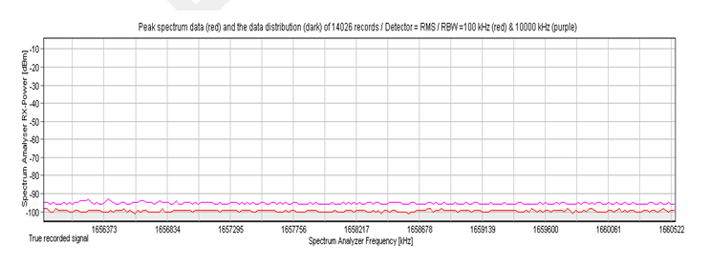

Figure 17: Two days of scanning in Germany

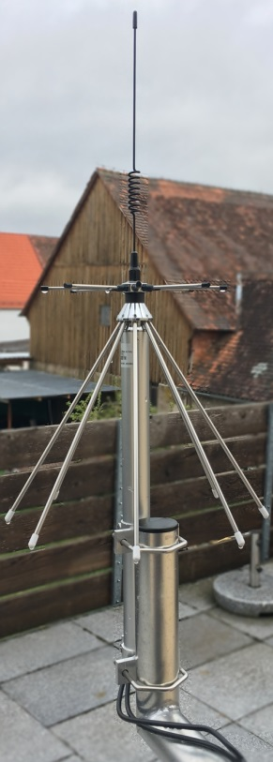

Figure : Wideband discone Antenna

1. Conditions to be considered for TRS Base stations

The following parameters are derived from this Report:

* Maximise downward Antenna tilt;
* Front-to-back ratio and sidelobe performance;
* Transmitter power of 3 dBm e.i.r.p.;
* Receiver should only open automatically or be opened by the user when in the vicinity of a TRS transmitter;
* Use of 600 kHz channels;
* Use in indoor environments (including train stations with canopy/wall attenuation);
* Case to minimise radiation from back, sides and bottom of case.

1. List of References
2. ETSI TR 102 791 'Electromagnetic compatibility and Radio spectrum Matters (ERM); System Reference Document; Short Range Devices (SRD); Technical characteristics of wireless aids for hearing impaired people operating in the VHF and UHF frequency range, V1.1.1´ (2012-05)
3. Recommendation ITU-R M.1076 'Wireless communication systems for persons with impaired hearing' (02/2015)
4. Recommendation ITU-R M.1184-2 'Technical characteristics of mobile satellite systems in the frequency bands below 3 GHz for use in developing criteria for sharing between the mobile-satellite service (MSS) and other services' (06/2003)
5. Recommendation ITU-R M.1799 'Sharing between the mobile service and the mobile-satellite service in the band 1 668.4-1 675 MHz' (03/2007)
6. ECC Report 64 'The protection requirements of radiocommunications systems below 10.6 GHz from generic UWB applications', February 2005
7. Recommendation ITU-R P.525 'Calculation of free-space attenuation' (08/94)
8. Recommendation ITU-R P.452 'Prediction procedure for the evaluation of interference between stations on the surface of the Earth at frequencies above about 0.1 GHz' (09/2013)
9. UK Ofcom's "Building Materials and Propagation Final Report, 2604/BMEM/R/3/2.0”, 14th September 2014 <https://www.ofcom.org.uk/__data/assets/pdf_file/0016/84022/building_materials_and_propagation.pdf>
10. Dodona Research; BFI RSU analysis <http://www.bfi.org.uk/sites/bfi.org.uk/files/downloads/bfi-exhibition-2016-06-30.pdf>
11. Recommendation ITU-R M.2283-0 'Technical characteristics and spectrum requirements of Wireless Avionics Intra-Communications systems to support their safe operation' (12/2013)

1. The system will be in addition to the current Telecoil system.
2. A single 1.5 V cell is typically used
3. Note that all patterns are average side lobe levels.
4. The figure is derived from timings at Marleybourne and other stations in London over a number of visits; please see ANNEX 2:
5. Obtained from a number of visits to Heathrow airport, UK