Description of the software tool for processing of measurements data of IRIDIUM satellites at the Leeheim station

approved 29 January 2016

ECC Report 247

amended 2 October 2020

ECC Report 247

# Executive summary

ECC has undertaken a number of monitoring campaigns on the IRIDIUM satellite constellation to identify the unwanted emissions falling into the radio astronomy band 1610.6-1613.8 MHz. Measurements were taken on individual satellites to ensure high precision. However, it was necessary to process these measurements and simulate the aggregate impact of the complete constellation of 66 satellites on radio astronomy observations. Software packages were therefore developed to:

* 1. process raw spectrogram data measured from individual satellites by the Leeheim Satellite monitoring station according to the principles described in ECC Report 171 [1] (see example in Annex 1) to produce a statistical profile of the unwanted emissions;
  2. determine the position of each satellite at each point of the simulation using a dynamic model (STK package) of the satellite constellation;
  3. quantitatively assess data loss in radio astronomy observations together with error estimates using the emission profiles from step (a) and the satellite positions from step (b) and create detailed and comprehensive documentation of the measured satellite emissions and their interference impact on the radio astronomy service in the band 1610.6-1613.8 MHz.

Calibration information for the monitoring set-up is derived from on/off observations of celestial sources and used to create data sets of calibrated spectral power flux density (spfd) data from which the noise background of the receiver and sky have been subtracted (step (a) above). More information about calibration procedures can be found in ECC Report 171 [1] with some additional practical information in Annex 2 of this document.

Initial measurements taken on a few IRIDIUM replacement satellites ("IRIDIUM NEXT") in 2017 revealed some problems with the noise characterisation and the measurement sensitivity of the Leeheim equipment, due to the lower emissions observed at that time. Thus, the measurement methods and software modules were revised in 2019 and 2020 to improve accuracy and sensitivity in the case of lower observed emissions.

An automatic report of the entire calibration and calculation steps is generated to enable checks and repeats of the analysis as well as the incorporation of results into summary reports.

The calibrated data is then used together with a dynamic mode of the satellite constellation (using the commercial STK™ (System tool kit) software, step (b) above) to calculate the equivalent power flux density (epfd) at a radio astronomy observatory according to Recommendation ITU-R M.1583 [3] and the resulting data loss (step (c) above).

Because of the limitations of the measurement set-up sensitivity due to noise, users may want to characterise the minimum measurable data loss, evaluated by processing measurements made by tracking "void" orbits offset from real IRIDIUM satellites orbits.

TABLE OF CONTENTS

0 Executive summary 1

1 Introduction 4

2 System requirements and software installation 6

2.1 Copyright 6

2.2 System requirements 6

2.3 Software Installation 6

3 processing a new collection of measurements 7

3.1 Setup 7

3.2 Processing and Calibration of raw data 7

3.2.1 Structure of calibrated data save sets 10

3.2.2 Reducing the same dataset with different choices of parameters 10

3.3 EPFD Calculations 11

3.3.1 Setup for epfd calculations: 11

3.3.2 Running epfd calculations 11

3.3.3 Optional epfd calculation for all 164 frequency channels 13

4 Conclusions 14

ANNEX 1: Structure of raw data MATLAB savesets 15

ANNEX 2: Calibration of Antenna and Spectrometer using Strong Cosmic Radio Sources 16

ANNEX 3: Sample Report generated for calibration 24

ANNEX 4: Sample report created by eval_data 27

ANNEX 5: Sample Report of an EPFD calculation 30

ANNEX 6: Example of an EPFD frequency survey 33

ANNEX 7: Creating Visibility data with STK 34

ANNEX 8: Data format for pointing range FILE. 35

ANNEX 9: License Agreement 36

ANNEX 10: List of References 37

LIST OF ABBREVIATIONS

|  |  |
| --- | --- |
| Abbreviation | Explanation |
| ANFR | National Frequency Agency (France) |
| CAS-A | Cassiopeia A |
| CEPT | European Conference of Postal and Telecommunications Administrations |
| CYG-A | Cygnus A |
| ECC | Electronic Communications Committee |
| epfd | Equivalent power-flux density |
| pfd | power flux density |
| RAS | Radio Astronomy Service |
| Spfd | spectral power flux density |
| STK | System tool kit |

# Introduction

ECC has undertaken a number of monitoring campaigns on the IRIDIUM non-geostationary satellite constellation, to identify the unwanted emissions falling into the radio astronomy band 1610.6-1613.8 MHz. Measurements were taken on individual satellites to ensure high precision. However, it was necessary to process these measurements and simulate the aggregate impact of the complete constellation of 66 satellites on radio astronomy observations. Separate software packages were therefore used:

* 1. MATLAB® tools were used to process raw spectrogram data measured from individual satellites by the Leeheim Satellite monitoring station according to the principles described in ECC Report 171 [1] (see example in Annex 1) and to produce a statistical profile of the unwanted emissions for each 20 kHz channel in the measurement range;
  2. determine the position of each satellite at each point of the simulation using a dynamic model (STK package) of the satellite constellation and to calculate the position relative to the RAS antenna;
  3. quantitatively assess data loss in radio astronomy observations together with error estimates using the emission profiles from step (a) and the satellite positions from step (b) and create detailed and comprehensive documentation of the measured satellite emissions and their interference impact on the radio astronomy service in the band 1610.6-1613.8 MHz.

ECC Report 171 [1] outlines the procedure for obtaining accurately calibrated measurements from individual satellites, based on prior calibrations of a tracking antenna and a suitable spectrometer using catalogued celestial sources (referred to as "standard candles" by radio astronomers). The principles of this calibration procedure were also described in Recommendation ITU-R S.733-2 [6] and have been adapted to the specific requirements of the Leeheim station. Updates to the calibration process were developed in 2018 and 2019, to model the antenna noise which varies with elevation pointing angle (known as "ground noise temperature").

In order to use the calibrated measurements to determine the impact of the satellite emissions on radio astronomy, they must be converted to a format that can be compared to the recommended protection thresholds for radio astronomy. Recommendation ITU-R M.1583 [3] describes a method of calculating effective power flux density (epfd) levels at a radio astronomy receiver, and was used to estimate the data loss (see ECC Report 171 [1] or ECC Report 226 [2]). The software package uses the calibrated interference profiles obtained in step (a) as input for the epfd simulation (step (c)). Error estimates, very important in statistical simulations, had been lacking in the previous software version and are now also provided, as is additional statistical information about the frequency distribution of the received signal strengths. An additional and optional step allows for the automatic calculation of data loss for all spectral channels in the band.

Following analysis of new measurements in 2017, a fundamental assumption in the process - that satellite emissions produced a constant pfd on Earth regardless of elevation - was found to be incorrect. As a result, the software was amended to take the elevation angle into account: the pfd of simulated satellite is extracted from satellites measured at a comparable elevation in the datasets.

The software package takes into account the RAS site location for computing the positions of each satellite for each simulation time steps (step (b)).

The software contains an additional feature, which allows taking into account the pointing constraints for individual RAS antennas. The overall data loss is computed over the possible antenna pointing range. To compare the results of future analysis with those reported in ECC Reports 171 [1] and 226 [2], the method to be used does not include limitations in pointing directions of the RAS antennas. These conditions are hereafter referred as 'generic calculation'.

The software provides a simple interface guiding the user through the necessary steps. It also saves intermediate results and documentation of processing and results in separate directories for later archiving or a re-run of the computations.

The current version of the software tool does not consider diffraction by terrain effects and partial visibility of the radio telescope dish; it considers standard antenna pattern as described in Recommendation ITU-R RA. 1631 [7]. In addition, near field effects are also not considered.

Because of the noise of the Leeheim measurement chain, it may not be possible to assess data loss performance down to the 2% objective. In order to assess the sensitivity of the measurement chain, users may use data taken from several "void satellite passes", i.e. without pointing towards IRIDIUM satellites, and assess data loss relative to that figure. This would give an indication of the minimum data loss measurement achievable by the measurement chain under the circumstances.

# System requirements and software installation

## Copyright

ANFR reserves the copyright for the following MATLAB® routines contained in the core of the epfd calculation package ("epfdcalculations.zip"): "analyse.m", "cdf.m", "gen_distribution.m", "M_1583_IRIDIUM_par.m", "lect_csv_access.m". Potential users of the epfd package should sign the License Agreement provided in Annex 9: and send it to the ANFR at the specified address before the installation and/or use of the package.

Analytical Graphics, Inc. (AGI), 220 Valley Creek Blvd. Exton, PA 19341 USA holds the copyright for the Systems Tool Kit (STK) used to generate the satellite visibilities.

## System requirements

Leeheim raw data is expected to be supplied in the form of binary MATLAB savesets (*.mat). A short description of the data format is given in Annex 1 of this document.

The data processing requires MATLAB™ 64 bit and should therefore be largely platform and operating system independent, as long as the requirements for running MATLAB are met and a licensed version of MATLAB is installed.

Processing the high resolution Leeheim spectrometer data requires sufficient disk space (>1.5 GB per typical day of measurements) and 2.5-3 GB RAM allocated for MATLAB alone. It is therefore recommended that at least 6 GB of RAM are installed.

Calculations of epfd do not require that amount of RAM, but are CPU intensive. It is advisable to use a multi-core host system (>2 cores) and the parallel processing option of MATLAB (separate license needed). The modified epfd routine will detect the parallel processing capability if available, allocate the resources and automatically distribute the computation tasks. There is a communication overhead between CPUs, which results in a speed-up by about N/2 where N is the number of CPUs available. A single epfd trial iteration takes about 20-30 seconds on an eight-core system.

It is advisable to use parallel processing for the full band data loss survey. At least 164 x 5 = 820 iterations will be needed, which will take about six to eight hours on a parallel CPU host.

## Software Installation

The software is distributed in two zip containers:

* "Datareduction.zip" for the processing and calibration of Leeheim raw data including the automatic generation of reports for each satellite and the daily calibration as well as the creation of MATLAB save sets for the calibration and the calibrated satellite data;
* "epfdcalculations.zip" for calculating epfd and data loss and the creation of results and documentation.

Copy all files from both containers into one directory ('source directory'). Packages are compatible and work from one directory, which is simpler for the user, but separate source directories are also supported.

Obtain suitable visibility files for the envisaged epfd calculations for the constellation using STK. A sample file "RAS_IRIDIUM_REAL.CSV" is included in "epfdcalculations.zip". This "RAS_IRIDIUM_REAL.CSV" is specific to a given location.

# processing a new collection of measurements

## Setup

Create three new directories for the following:

1. raw data of new measurement session and move your new data to it;
2. processing results, such as calibrated data, pfd distributions etc;
3. documentation that is generated by data processing;

Steps 2+3 can also be taken on the first call to eval_data:

* Delete the following files, should they still exist from a previous session:
* "dir_config.mat";
* "calibration_data.mat";
* "epfd_parms.txt".

Make sure that processing and documentation directories are empty, if you are re-using them.

Start your MATLAB® session or clear your workspace using 'clear' and select the source directory as primary.

## Processing and Calibration of raw data

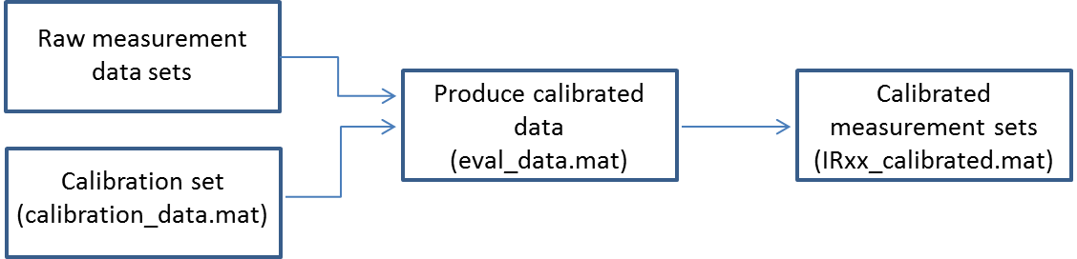

Figure 1: Diagram illustrates overall process

Each measurement of a satellite transit must be individually processed to determine the background noise level and the range of valid data. To process the data from one measurement, simply enter

>>eval_data

and repeat the procedure outlined below for all measurements of a satellite transit of the session.

The system will now prompt the user for the names of the three directories described in the previous section at the first call of eval_data:

1. datadir for the raw data;
2. resultsdir for calibrated data and distributions;

and

1. reportdir for the generated documentation.

The last two calls may also be used to create the directories, if that is supported by your operating system.

The names of these directories will be saved in dir_config.mat in your source directory and automatically loaded when detected on every new call.

One may also use command

>> assign_directories

separately if a re-assignment of the directories is wanted.

Now the system will check for the existence of previously generated calibration information in the results directory. If that is not present (e.g. the first call was to eval_data), then the user is prompted for the name of a data set containing a calibration measurement in the data directory and taken through the calibration procedure (see Annex 2 for details).

A report containing calibration results is then placed in the reports directory under "cal_report.doc" and the calibration file "calibration_data.mat" is stored in the results directory. An example of "cal_report.doc" is provided in Annex 3.

Should there be a need to repeat the calibration with different input data or parameters, then the simplest way is deleting "calibration_data.mat" in the results directory and calling eval_data again.

The eval_data command will carry out the following steps:

1. it prompts for the name of a data file to be processed and then for the name of the object. Important: please use Irxx for IRIDIUM satellites with xx being the satellite number (e.g. Ir10) for IRIDIUM 10. It is also advisable to use Cas-A or Cyg-A for the calibration sources.
2. the routine display_data will ask if you want to select a subset of the data. Enter '1' if that is the case and afterwards the approximate index number of the first and last spectrum in the spectrogram (Hint: dividing the time given on the vertical axis of the spectrogram by 1.05 will yield the approximate index). Otherwise, enter 0 and all the data will be used for later processing. It is advisable to enter 0 and keep the entirety of the data at this stage, as the software allows in the further steps to visualise and choose the portion of the data to be retained. For each satellite pass, the routine asks first for the associated "noise pass" file (measurement taken ideally the same day, without IRIDIUM satellite present in order to estimate ground noise). Then the routines asks for the satellite pass file. Once data is displayed, the user is asked for start and stop time of the observation.
3. The routine calibrate will prompt you regarding the background part of the observation. Please enter the start and end time of the background observation within the current data set. The areas can be identified in the raw data plots from display "data.m" and should be at least 100 seconds in duration. They are typically at the beginning or at the end of the measurement, corresponding to about 50° elevation. Please make sure that you do not have any interference in that part, as it will result in incorrect values for the measured fluxes later on. Inspect again the system temperature plot to ensure that no interference occurred during background observation. If the system temperature is too high or shows deviation from a smooth curve, then there has been either interference or a receiver problem. This may happen with some measurements, which will have to be discarded. But in most cases one can find a good background measurement needed for the background subtraction.

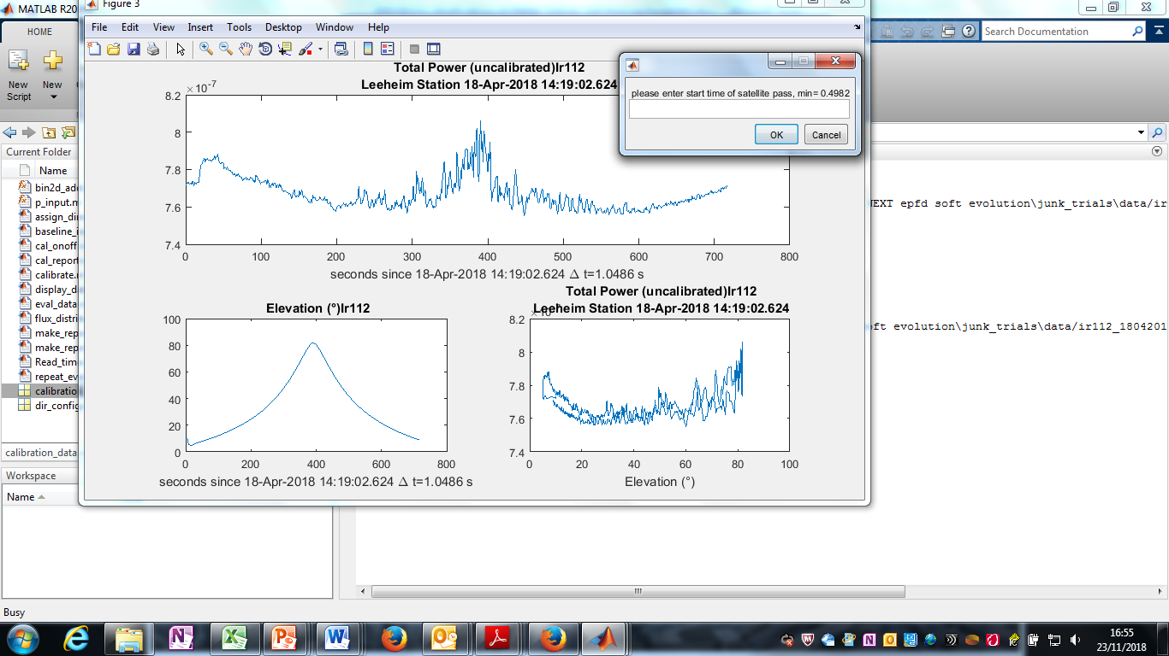

Figure 2: Prompt window for selecting the satellite and background measurements

1. The routine will display calibrated spectra and spectrograms in various units, on linear and log (dB) scales. The calibrated spectrograms are stored internally in array 'S' in Jy, channel frequencies (Hz) are in array 'fchan1' and the times of the spectra, counted in seconds from the beginning of the measurements are in the array 't2'.

The final routine "flux_distributions.m" needs no user input and generates four additional graphs:

1. the distribution of received fluxes as a function of frequency with the spectral power flux density (spfd) on the vertical axis and the channel frequency (f) on the horizontal axis. The number of instances of a particular flux as measured in a frequency channel is shown colour encoded on a logarithmic scale at each (f, spfd) position (Annex 4, Figure 23).
2. the likelihood of flux measurements exceeding the threshold as a function of frequency. The 2% level is indicated. This graph may be useful for discriminating strongly interfered frequency ranges from those that are less affected (Annex 4, Figure 24).
3. a histogram of the number of channels in which the threshold has been exceeded by a certain fraction of the time. This may help to describe the distribution of strongly affected channels (Annex 4, Figure 24).
4. the calibrated data vs time, together with the background noise average curve ("raw bkgd" curve) and the background noise curve corrected ("corr bkgd" curve) by the background spot measurement taken after each satellite pass. The measured data with background suppressed is also shown on the same panel. These sets of data are shown for respectively the lowest, mid and upper RAS channel. The purpose of this display is to check that the background noise correction has been done properly. An example is provided below:

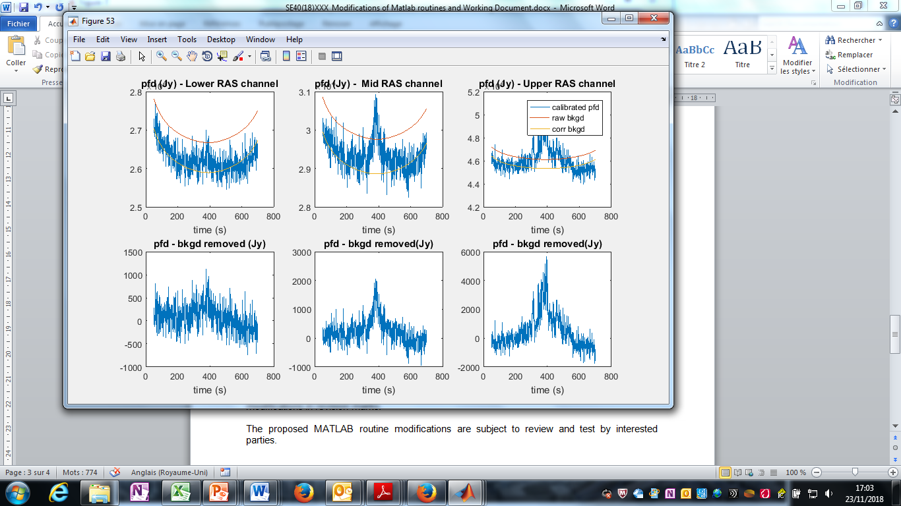

Figure 3: Calibrated data window

The documentation will be stored in the results directory as "objectname.doc", where objectname is the name given by the user to the object (e.g. IrXX, Cas-A, Cyg-A) after the call to eval_data. An example is provided in Annex 4.

### Structure of calibrated data save sets

The routine flux_distributions creates statistical information from the calibrated spectrogram and saves 'objectname','S0','fchan1','mean_SJy','t3','time_of_arrivel', 'elev' in a data set with the file name constructed as [objectname '_calibrated.mat'] in the results directory.

* 1. The objectname must be of the form' Irxx' (see explanation above).
  2. S0 contains the calibrated data in Jy (= 10-26 Wm-2Hz-1) with the selected background data finally removed for all frequency channels.
  3. the variable elev contains the elevation of the satellite at each measured point.
  4. The array mean_SJy contains the average fluxes per channel at the end of the measurements.
  5. The centre frequency per channel (Hz) is given by fchan1 and t3 together with time_of_arrivel give the time (UT) when a particular spectrum of the set S0 was obtained.

### Reducing the same dataset with different choices of parameters

If one wants to repeat the processing of the chosen data set, but use other parameters for the selection of valid data and background, then call

>>repeat_eval_data

and go through the same steps, however avoiding the selection of the dataset and the prompt for a new name. Calibrated data and report files will be overwritten.

## EPFD Calculations

### Setup for epfd calculations:

* Data reduction must be completed for all measurements and the calibrated data been saved via the last step of 'flux_distributions' and conforming to the naming convention 'Irxx_calibrated.mat' in a results directory. Data of other origin can also be used as long as it conforms to structure and naming conventions outlined above.
* The software from epfdcalculations.zip may either reside in its own directory or in a separate one.
* If using a separate directory, then the directory names for results and reports again have to be assigned at the first call of eval_epfd and a local "dir_config.mat" file will be created. Make sure to delete any remaining dir_config.mat files which may point to previous epfd calculations for other data than the ones you intend to investigate.
* If all routines for data reduction and epfd calculations have been loaded into one directory, then the same directory setup will be used for the results and the reports.
* Create a text file epfd_parms.txt in your source directory with list of satellite numbers of the satellite measurements of those wanted to be included in the epfd calculation. Enter only one number per line of text. The numbers xx must correspond to existing 'Irxx_calibrated.mat' files in the results directory.
* If available, the pointing range information for specific RAS site could be specified in the file "RAS_site_mechanical.mat". If such information is not provided, the 'generic calculation' is performed.

### Running epfd calculations

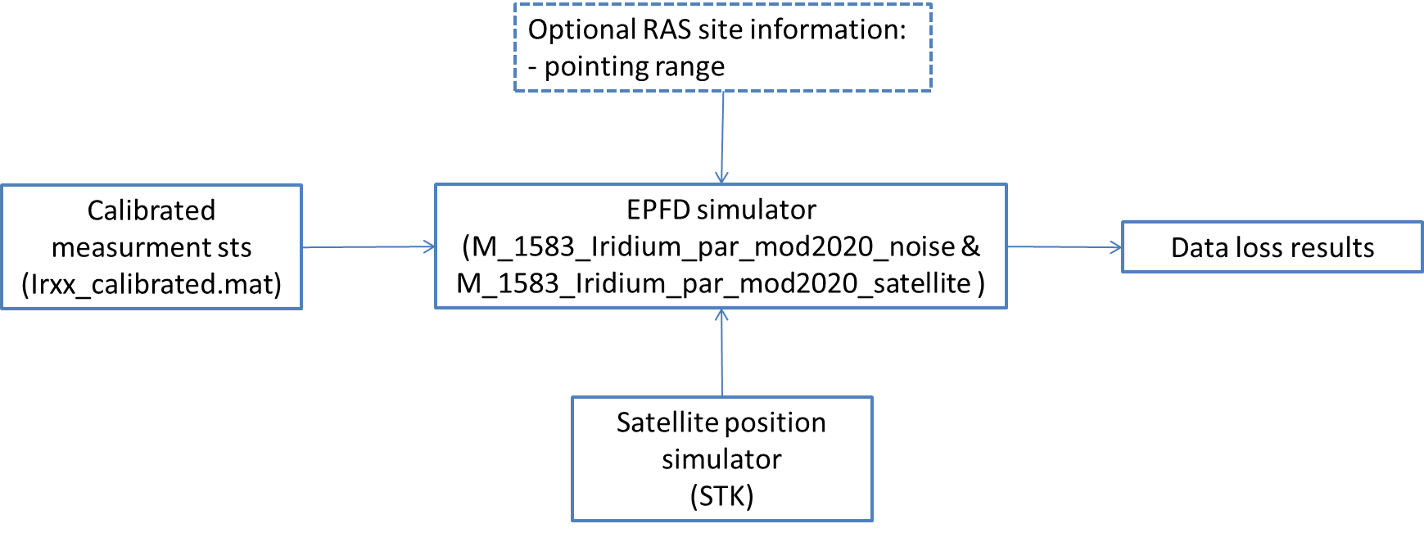

Figure 4: epfd calculations process

Simply enter:

>>epfd_report

at the MATLAB® prompt and the calculation will be performed, and documentation will be created in the results directory.

If no documentation is needed, enter:

>>eval_epfd

1. Enter a frequency in MHz units within the range 1610.6-1613.8 MHz. The software will determine the centre frequency of the nearest frequency channel and calculate the epfd for it. Then enter the minimum elevation of the data to be considered in the statistics. A value of 10° is advised to keep large amount of data, but higher minimal elevation may be used after examination of the data during the calibration.
2. The routine gen_distribution_mod2020.m generates a MATLAB® file with pfd measurements classified by elevation (3° step) based on all satellites listed in the text file epfd_parms.txt for the chosen frequency channel from the corresponding calibrated data. They are saved in a sub-directory of the results directorynamed '..\DistributionElevation'.
3. Next enter the number of trials (= full sky epfd calculations with random choices of measured satellites and emission levels that conform to satellite visibilities from the position of Leeheim station and the measured distribution of received radiation for that frequency). Note that the default number of trials has been set to 5, which ensures a fast calculation and keeps statistical errors of the epfd below 1-2%. The statistical error of the epfd simulation (more below) is mainly determined by the steep distribution of received pfd's and the antenna characteristics and decreases only very slowly with the number of trials. (Note: The canonical number of trials for ECC Report 171 [1] has been chosen to 100, which returns the same mean epfd result, but reduced statistical error perhaps by a factor of 2-3 at the expense of twenty times the execution time).
4. Next define the measurements used for the simulation (IRIDIUM OOB measurements or noise measurements).
5. The routines "M_1583_IRIDIUM_par_mod2020_Satellite.m" and "M_1583_IRIDIUM_par_mod2020_Noise.m" which are entered to calculate the epfd is a version of the original "M_1583_IRIDIUM.m" adapted to a modest degree of parallel processing and calculating the epfd only for one frequency with the advantage of being incorporated into an external loop over frequencies (see later at epfd_survey). The epfd calculation algorithm is otherwise unchanged. The antenna diameter D is set to 100 m and integration time dur_init is set to 2000 seconds in "eval_epfd.m".
6. On the first call "M_1583_IRIDIUM_par_mod2020_Satellite.m"or "M_1583_IRIDIUM_par_mod2020_Noise.m" will ask for the name of a satellite visibility file as generated by e.g. the STK package and generate an internal representation of the satellite sky coverage. An example of such a file is provided in the software distribution; however, it is possible to use the STK package to generate a different file that may, for instance take into account the constellation at the time of the measurements. A short description of the basic steps needed to generate a visibility file for a given date and location is given in Annex 7. Special attention should be paid to this process given that differences in the visibility windows of one or several IRIDIUM satellites may lead to differences on the calculation results. If RAS site specific information is provided in the file "RAS_site_mechanical.mat", the routine "M_1583_IRIDIUM_par.m" will load the data. In the absence of such information, a generic computation (flat terrain, full sky visibility) is done. The data format for such information in provided in Annex 8.
7. The main part of the calculation will now start and the user will be informed and updated about the time needed per trial, the number of trials completed and an estimate of the time needed for finishing the calculations. The results of the calculations are stored in another subdirectory of the results folder named '2000 s/ YYYY.ZZZZ' with the same convention as has been used for the pfd distributions.
8. A modified version of the routine "analyse.m" is used to calculate the average percentage of epfd sky cells that exceed a certain threshold. The routine has been modified in order to:

be called with an additional argument for the number of the figure window for the epfd sky plot, with zero indicating no plot and suppression of text output for a call in an external loop,

use the directory information from assign directories via "dir_config.mat",

and to calculate and return the statistical error of the result in addition to the average percentage of cells exceeding the threshold. For this purpose, the percentages of each trial are not only averaged, but their standard deviation is also computed.

1. In accordance to the procedure of ECC Report 171 [1], the routine "analyse.m" is first called with a threshold of -238 dBWm2Hz-1 (Recommendation ITU-R RA.769, table 2 [4]) reduced[1] by the computed maximum gain of the antenna 'Gmax' computed before in "M_1583_IRIDIUM_par.m".
2. In "eval_dec.m" the routine "analyse.m" is called for a sequence of additional attenuations of the signals with the variable 'dec' ranging from 0 to -50 (dB) and the attenuation required to meet the 2% criterion will be computed by finding the closest match of the returned average epfd to 2%. A sky plot showing the epfd data loss (Annex 5, Figure 26) and its statistical errors as a function of the additional attenuation is produced (Annex 5, Figure 27).
3. Finally, the epfd data loss for an increased threshold corresponding to only 30 seconds integration time is also computed via a call to "analyse.m". For this, a threshold argument of -238-Gmax-5*log10(30/2000) is used (Annex 5, Figure 28).
4. All outputs will be saved in the report directory under 'EPFD_YYYY.ZZZZ.doc', using again the same convention for frequency designations.

### Optional epfd calculation for all 164 frequency channels

A sample of 19.5 kHz channel was assessed in the ECC Report 171 [1], however if sufficient processing power (or time) is available, then it could be worthwhile to calculate the epfd values for all 164 channels 19.5 kHz bandwidth in a total of 164 x 5 = 820 trials (using five trials per frequency).

Call:

>>epfd_survey

Finally a graph of the epfd data loss as function of frequency for the default parameters (2000 seconds and 5 trials per frequency) will be created (Annex 6, Figure 28 and Figure 30).

If a printable document in the report directory is required, then use

>>publish('survey_report.m','format',fmt,'outputDir',reportdir,'figureSnapMethod','print','showCode',false );

Annex 6 provides an example output of an epfd frequency survey.

# Conclusions

The software described in this report allows the processing of measurements by a satellite tracking station such as Leeheim in accordance with the methods described in ECC Report 171 [1], with some amendments to improve resolution and accuracy at low emission levels.

The tracking antenna and its spectrometer can be calibrated using catalogued celestial radio sources as standard candles. A sweep of the sky, avoiding IRIDIUM satellites, is used to provide a noise calibration of the antenna to eliminate the elevation-dependent noise variation.

Raw data from measurements of emissions from satellites that are tracked during their transits are converted into fully calibrated spectrograms. The software provides statistical information about the frequency distribution of the interference for each satellite.

The resulting calibrated spectrograms are converted into cumulated probability distributions of received signal levels for each satellite, and for each 20 kHz frequency channel in the range 1610.6-1613.8 MHz.

These are used as input data for an epfd calculation. epfd calculations are time consuming and CPU intensive. The software allows for distributed computation if supported by the host system and the available software license.

Results of the epfd calculations can be provided for 2000s or 30 s integration time. Their dependence on additional attenuation is also provided (see example in bullet 10 of Section 3.3.2).

To ensure reasonable run-times, epfd calculations can be undertaken for individual RAS channels (for example, the top and bottom channels). An option to calculate the percentage of data loss for all frequency channels is also available, although this requires a much longer run-time.

Input parameters and processing results (text and graphics) are automatically documented in specific MS-Word files for the inclusion into other documents or for a later reproduction and verification of the processing steps.

Because of the noise of the measurement chain, it may not be possible to assess data loss performance down to the 2% objective. In order to assess the sensitivity of the measurement chain, users may use data taken from several "void satellite passes", i.e. without pointing towards IRIDIUM satellites, and assess data loss on that basis. This would give an indication of the minimum data loss measurement achievable by the measurement chain under the circumstances.

The epfd calculations provide the additional DEC parameter, which is the estimated attenuation of the interference level needed to reach the 2% target. A differential approach may be used to estimate the DEC for the IRIDIUM constellation:

* The DEC factor from measurements on IRIDIUM satellites includes the contribution from IRIDIUM and from the noise due to the Leeheim setup. This value is called DEC (IRIDIUM+Noise);
* The DEC factor from measurements without IRIDIUM satellites includes only the contribution from the noise due to the Leeheim setup. This value is called DEC (Noise).

The DEC factor resulting from IRIDIUM alone is therefore estimated by:

* DEC (IRIDIUM) = DEC (IRIDIUM + Noise) - DEC (Noise).

1. Structure of raw data MATLAB® savesets

As explained in section 3, the raw data files are made accessible to MATLAB® in a user-defined folder prior to running the analysis. In the MATLAB environment the substructures of a data are listed together with the corresponding values and size of array structures.

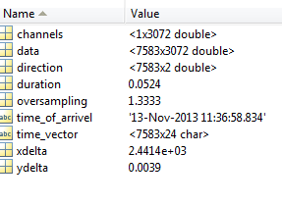

Figure 5: The structure of a raw data file, as seen on the MATLAB® platform

"channels": Frequency of data channel.

"data": Raw spectrogram

"duration": Integration time per raw spectrum

"time_of_arrivel": Start of measurement

"time_vector": Timestamp

= time_of_arrivel + sequence no of spectrum (first index of array data)* "duration"

"xdelta": Frequency difference between spectral channels

"direction": Vector containing AZ, EL corresponding to spectrum sequence in "data" (if available);

1. Calibration of Antenna and Spectrometer using Strong Cosmic Radio Sources

First make calibration measurements on Cygnus A and Cassiopeia A.

The measurement should be a continuous recording of data, first at least 200 seconds on the source   
 Cas-A: RA 23h 23m 26s DEC 58° 48' 0" (J2000 coordinates)

or

Cyg-A: RA 19h 55m 00s DEC 40° 44' 0"

Then at least 200 seconds on the reference position of

RA 23h 10m 30s DEC 56° 30' 0" for Cas-A calibrations

and

RA 19h 24m 00s DEC 41° 0' 0" for Cyg-A calibrations

Make sure that both positions are recorded in the same data set. The longer one integrates on source and off-source, the more accurate the calibration data will be.

It is preferable to use Cyg-A as a primary source for calibrations as its radio flux density is constant on the timescales of thousands of years, whereas the flux density Cas-A is slowly decaying with time at a rate of about 10 Jy/year at 1612 MHz.

A MATLAB® routine "radioflux4.m" may be used for the calculation of the spectral flux density of the calibration sources that is needed as an input later on:

>> radioflux4(frequency (MHz), year+month/12, object nr).

For Cas-A enter:

>> radioflux4(1612, 2013+11/12,1)

to obtain the spectral power flux density of the source Cas-A (third argument 1) at 1612 MHz (first argument) for November 2013 (second argument) as

1.5359e+003 Jy

For Cyg-A the call is similar, only with ‘2’ as the third argument:

>> radioflux4(1612, 2013+11/12,2),

which yields

1.3693e+003 Jy

Now load the data and run "display_data.m", e.g.

>> load cygnus_and_cold_space_241013.mat

>> display_data

This should provide a clear recording of on and off source positions:

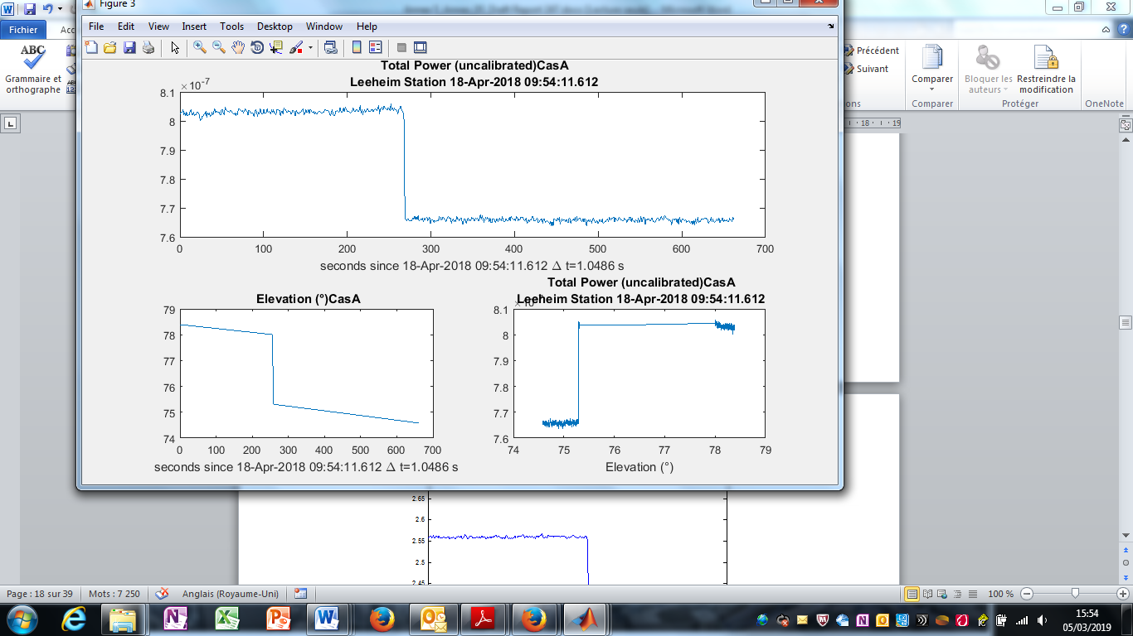

Figure 6: Total uncalibrated power from a calibration measurement, illustrating   
the on- and off-source positions

and a clean interference-free band pass:



Figure 7: An interference-free band pass in a calibration measurement

Note that the ripple in this spectrum is caused by reflections from mismatching cable or amplifier terminations. The wavelength c/0.5 MHz indicates a reflection of on a cable of about 300m length, shorter for higher insulation dielectrics. This amount of ripple is just tolerable for calibration, but when higher levels occur the fault should be traced and removed as it will affect the precision of the calibration. The same is true for observations showing strong interference lines in the spectrum. The measurements should be repeated in such cases.

**select good clean intervals for on and off source observations from the spectrogram and total power plots given by** "display_data.m" **(see above)**

start time ON source 1

stop time ON source 250

start time OFF source 290

stop time OFF source 650

enter the strength of the reference sources obtained from previous calls to "radioflux4.m" at 1610 MHz use e.g. 1535 Jy for Cas-A in 2013 and 1369 Jy for Cyg-A

The cal_onoff code will locate intervals in array:

i_on_0=find(t2>t_on_0,1,'first');  
i_on_1=find(t2>t_on_1,1,'first')-1;   
i_off_0=find(t2>t_off_0,1,'first');  
i_off_1=find(t2>t_off_1,1,'first')-1;  
%

**make separate arrays for on and off**

P_on=D(i_on_0:i_on_1,:);  
P_off=D(i_off_0:i_off_1,:);  
%

**calculate time averages per channel**

S_on=sum(P_on)/size(P_on,1);  
S_off=sum(P_off)/size(P_off,1);  
%

get source strength per channel in spectrometer units **and divide it by catalogue value S_ref**

S_src=S_on-S_off;  
s_conv=S_src/S_ref;

Fit a third order polynomial **and calculate interpolated smoothed gain coefficients.**

This will create warnings because of the noise: ignore them!

s_coeff=polyfit(fchan1,s_conv,3);  
s_conv_smooth=polyval(s_coeff,fchan1);  
%

Warning: Polynomial is badly conditioned. Add points with distinct Xvalues, reduce the degree of the polynomial, or try centring and scaling as described in HELP POLYFIT.

Note: this warning is caused by the noise in the data and may be ignored.

Display Results

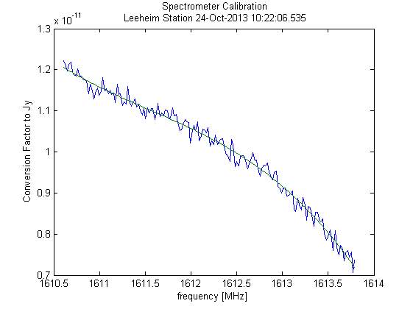

Figure 8: Plot of interpolated gain coefficients

Display System noise level (Jy)

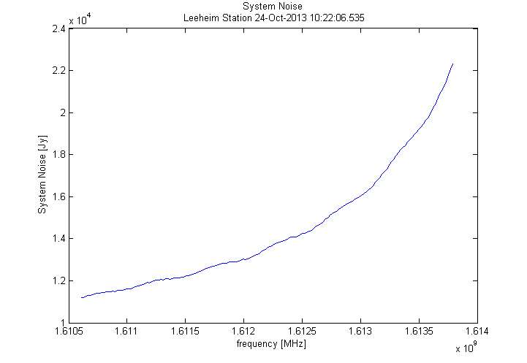

Figure 9: System noise level of Leeheim station in flux units

**Display System Temperature assuming 0.026 K/Jy conversion:**

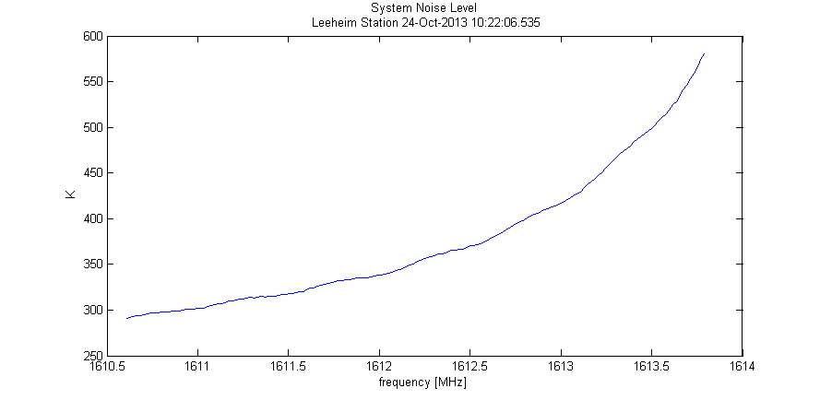

Figure 10: Measured system noise temperature as a function of frequency

This figure should correspond closely to ECC Report 171, figure 5 [1], shown for the reader’s convenience below (see also [here](http://www.cept.org/files/5360/SE40(10)013%20-%20Radio%20astronomical%20support%20for%20future%20Leeheim%20measurements%20CRAF_rev1.doc)):



Figure 11: The green trace shows the expected system temperature at ɸ=90° (zenith),   
the black trace at ɸ=5° and the red trace at ɸ=0° (horizontal). The filter loss is responsible   
for the majority of the system noise, only for elevations near the horizon (< 3°),   
one can expect a significant contribution of the ground radiation

Save calibration data for processing of subsequent observations

save 'calibration_data.mat' s_conv_smooth;

Make a Cross Check using the other source

Observe the other strong source in the same manner and load and display the data:

>> clear

>> load cassiopeia_and_cold_space_241013.mat

>> display_data

* measurement made on 24-Oct-2013 12:29:56.086
* time resolution 0.052429 seconds
* rebinning time by 20 new time resolution 1.0486 s
* rebinning frequency by 8 new channel bandwidth 19.5313 kHz
* last 0.68157 seconds discarded
* top 2.4414 kHz discarded
* please enter 1 if you want to select a smaller data set 0

This will result in a similar total power plot:



Figure 12: Total uncalibrated in-band power for Cas-A measurement in spectrometer units

and the data can be used to verify stability and consistency of the procedures but using the "calibrate.m" procedure on the cosmic source measurement.

>> calibrate

please enter start time of background observation, min = 0.4978 250

please enter end time of background observation, max = 375.888 350

The result will be a graph of calibrated data for the source:



Figure 13: Calibrated total spectral flux density for a Cas-A on-off measurement

Zooming into the graph shows that the measured flux is about 1470 Jy, which is about 4% less than the predicted value, but within the measurement errors of roughly 5%.



Figure 14: High resolution graph of Cas-A spectral flux density measurement

A further verification of the system can be seen in the plot of system temperature (Figure 15):



Figure 15: System noise temperature (K) as calibrated on Cyg-A

which should be very close to the one for the other source on the previous page and correspond to the appropriate trace for the measurement elevation in Figure 11.

1. Sample Report generated for calibration

Calibration Report

for Cas-A created 22-Jul-2014

Data directory = data

data file = A33_cass_cold_13112013_1301.mat

measurement made on 13-Nov-2013 13:01:50.379

time resolution 0.052429 seconds

rebinning in time by 20 to new time resolution 1.0486 s

rebinning in frequency by 8 to new channel bandwidth 19.5313 kHz

Data selection from 1.0486 s to 476.0535 s

(index 1 to 454)

start time ON source 1 s

stop time ON source 190 s

start time OFF source 210 s

stop time OFF source 380 s

strength of reference source = 1851Jy

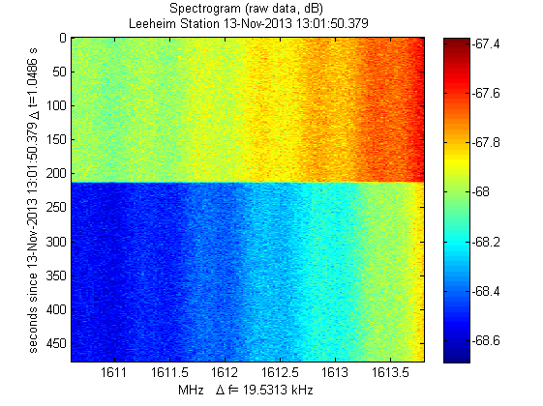

Figure 16: Spectrogram display of raw data from Cas-A measurement

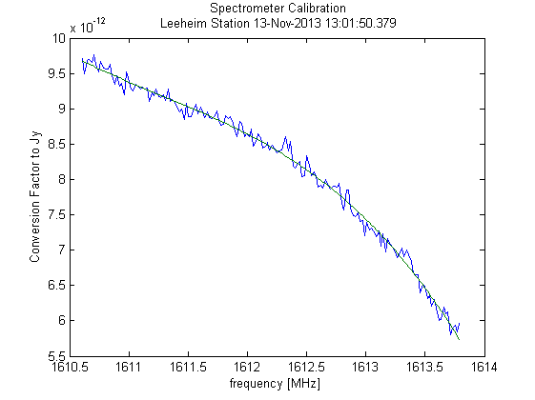

Figure 17: Calibration curve as function of frequency obtained with Cas-A

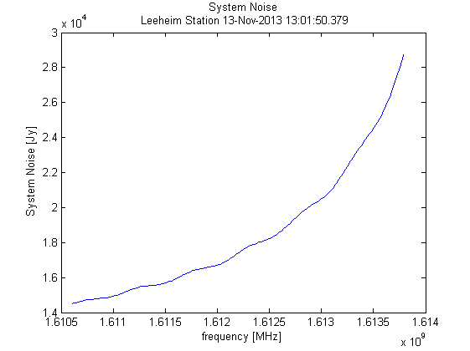

Figure 18: System temperature assuming a 0.026 K/Jy conversion factor

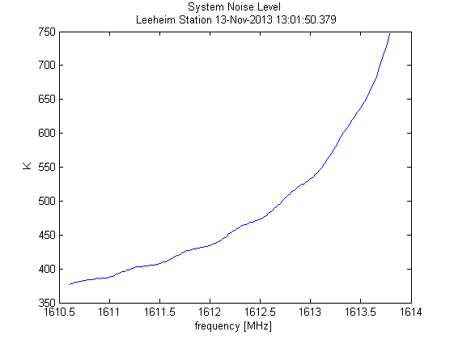

Figure 19: Same as Figure 15, but for Cas-A

1. Sample report created by eval_data

Measurement Report

for IR12 created 12-Aug-2014

Data directory = C:\E\MATLAB®\work\IRIDIUM\Leeheim\data

data file = A27_IR12_15112013_0802_RX1_20131115_075851.00001.mat

measurement made on 15-Nov-2013 07:58:51.758

time resolution 0.052429 seconds

rebinning in time by 20 to new time resolution 1.0486 s

rebinning in frequency by 8 to new channel bandwidth 19.5313 kHz

Data selection from 1.0486 s to 891.2896 s(index 1 to 850)

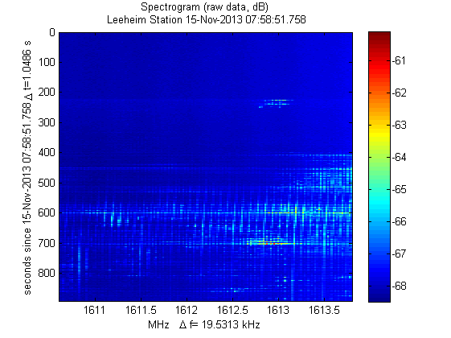

Figure 20: Spectrogram display of raw data from measurements of IRIDIUM satellite No. 12

Calibrated Data

Background measurement from 3.1457 s to 200.278 s (index 3 to 191) Recommendation ITU-R RA.769 [4] threshold single measurement = 7004.3045 Jy. Threshold exceeded in 5.6% of measurements.

Recommendation ITU-R RA.769 threshold for average spectrum = 272.4359 Jy exceeded in 128 of 164 channels.

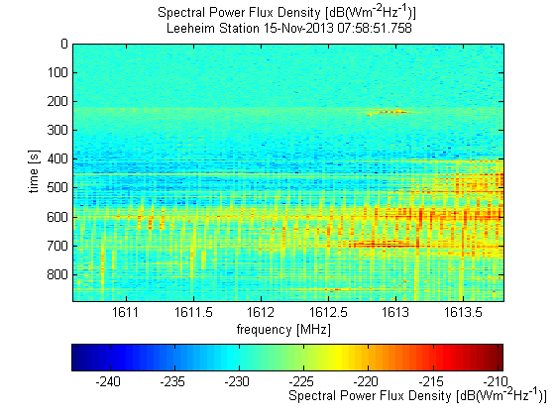

Figure 21: Calibrated spdf (logarithmic scale)

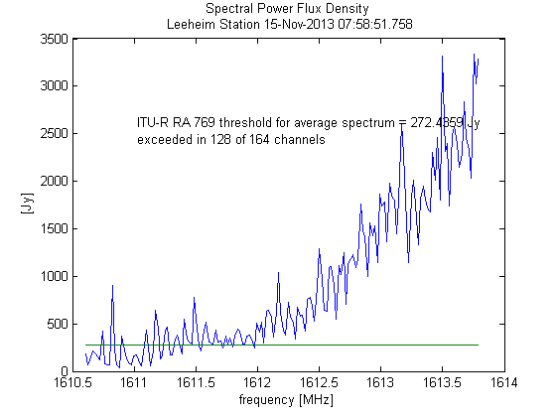

Figure 22: Time averaged spectrum. The green line is the appropriately scaled interference limit   
(see also examples in [5])

Statistics

Maximum interference likelihood of 18.6 % for frequency 1613.752 MHz in channel 162 threshold exceeded by more than 2% of the time in 79 of 164 frequency channels.

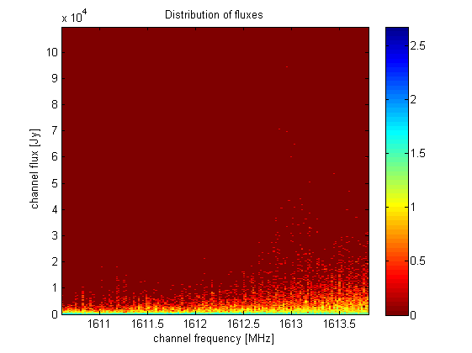

Figure 23: Two dimensional histogram (frequency / spdf) of the measured radio fluxes.   
The colour coding corresponds to log10 of the number of occurrences of a   
articular frequency and spdf combination

Figure 23 shows how often a radio flux S was measured at a given frequency f during the measurement. The colour is encoded on a logarithmic scale given by log10( NS,f  + 1) and indicates the number NS,f of 1 second measurements at a frequency f yielding a radio flux level S.

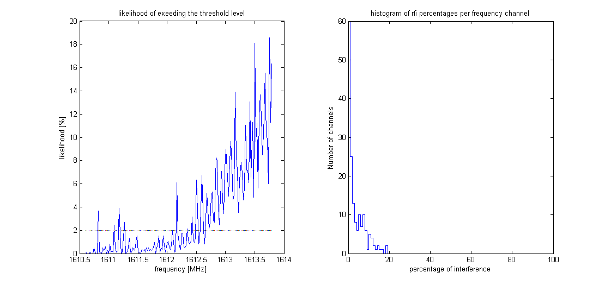

Figure 24: Graphic summary of the interference distribution. Left panel: per channel ratio of the number of 1 second samples exceeding the threshold to the total number of samples.   
Right panel: Histogram of the number of channels having a certain percentage of   
samples exceeding the threshold

1. Sample Report of an EPFD calculation

Please enter frequency to be analysed in MHz [1610.6-1613.8] 1610.6267. Distribution generation for 1610.6267 MHz, number of intervals 128 satellites:

Columns 1 through 6

12 13 29 32 59 65

Columns 7 through 11

70 75 76 77 86

selected frequency 1610.627 MHz, closest channel no. 2 centre frequency 1610.627 MHz mkdir C:\E\MATLAB®\work\IRIDIUM\Leeheim\results/distributions: Directory already exists. number of epfd trials (default = 5 0 to keep default ) ? 5

nb_tirage = 5

epfd calculation for 1610.6267 MHz using 5 trials measurement time 1 s, simulated integration time 2000 s, Antenna diameter 100 m visibility file = C:\E\MATLAB®\work\IRIDIUM\Leeheim\RAS_IRIDIUM_REAL.csv distribution data directory C:\E\MATLAB\work\IRIDIUM\Leeheim\results/distributions/1610.6267 satellites in constellation 66 satellites measured 12*[2]* finished on 11-Aug-2014 15:11:41 after 2.2597 minutes epfd Data loss for 1610.6267 MHz and 2000s integration time 97.3179% of time lost, statistical error 0.18076% required reduction of emissions 25.5102 dB

epfd data loss for 1610.6267 MHz and 30s integration time 24.3016% of time lost, statistical error 0.67839%

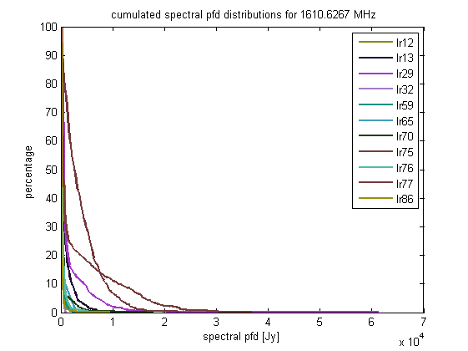

Figure 25: Cumulated spectral power flux density distributions for   
different IRIDIUM satellites at 1610.6 MHz

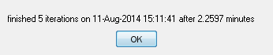

This window appears at the end of a successful epfd simulation.

The figure below is a representation of the sky and provides the percentage of data loss calculated at every cell in which the sky is divided.

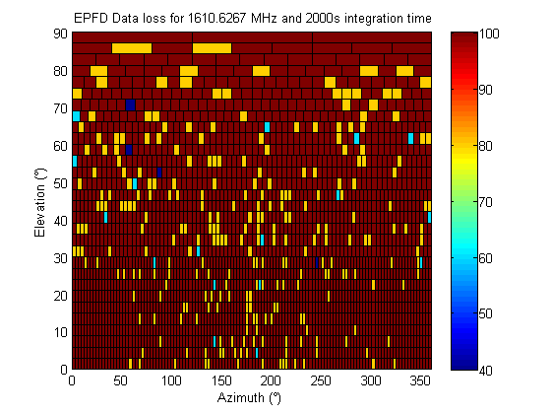

Figure 26: Result of epfd calculation at 1610.6 MHz for 2000 s integration time.   
Percentages are colour coded

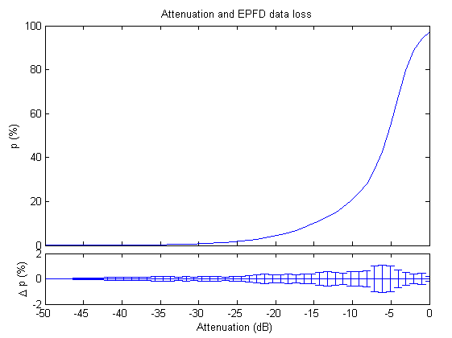

Figure 27: epfd data loss as a function of additional signal attenuation

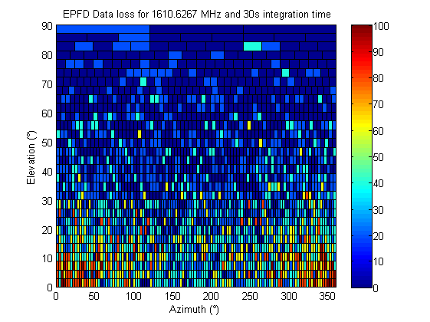

Figure 28: Result of epfd calculation for 30 s integration time. Percentages are colour coded

Figure 29: Result of epfd with pointing constraint below 8° elevation. Percentages are colour coded

1. Example of an EPFD frequency survey

epfd Data loss in the band 1610.60-1613.80 MHz

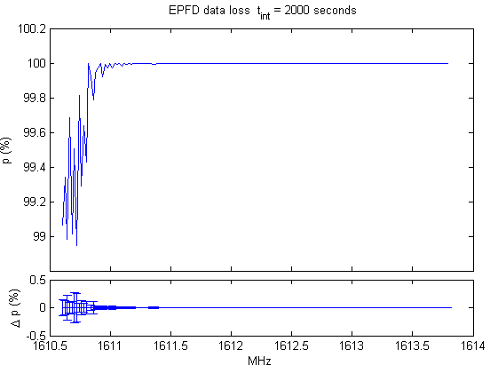

Figure 30: percentage of data loss in the band 1610.60-1613.80 MHz   
for 2000 s of integration time

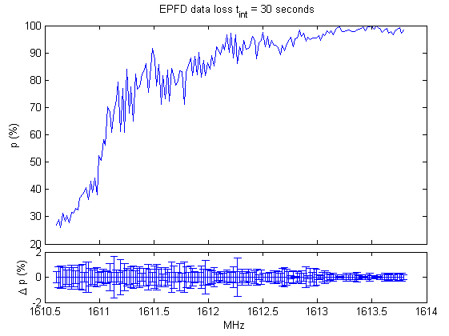

Figure 31: same as above, but for integration time of 30 s

1. Creating Visibility data with STK

The epfd simulation will select the orbital tracks across the sky (visibilities) and use the measured spectrum of the satellites for the computation of the received signal levels.

1. Create a scenario and load the RAS station as the first object and choose a date for which the simulation should be carried out as well as the duration for the orbit calculations. The duration should be at least one day.
2. Then add all active IRIDIUM satellites. Ensure that not only the satellite names are loaded, but their orbits too or create a constellation with IRIDIUM parameters.
3. Then open 'Analyse' -> 'Access'. All the objects that have been loaded will be shown. It is important to use the RAS Station as the object for which visibilities are computed. The visibilities are calculated for a specific location.
4. Again (!) select all satellites and click 'compute'. This will be quick and afterwards the AER report button is highlighted.
5. After the AER report button has been clicked and all visibilities have been computed the report will be displayed.
6. Right-click on the report itself and select ‘complete export’ that appears in the drop down menu! IMPORTANT: Do not use the Excel export button, this creates incompatible files which are also of type .csv but are differently formatted and organised. These files cannot be used by the epfd routines.
7. Data format for pointing range FILE

The data for antenna mechanical constraints should be defined in the MATLAB® file:

* RAS_site_mechanical.mat

Per default, the file will be a flat earth and no mechanical constraint.

The data format for telescope pointing range (elevation vs azimuth) shall be given as 2 vectors:

* x (azimuth in degree)
* y (elevation in degree)

The vectors x and y shall have the same size.

For generic computations (i.e. no information on telescope pointing ranges), the values of vector y above shall be set to 0.

1. **License Agreement**



LICENCE AGREEMENT

ANFR has developed programme codes to process data resulting from the measurements of the IRIDIUM constellation satellites. This set of programme codes are given in the folder “Iridium – radio-astronomy” which is made available to the organisation/institution designed below.

ANFR makes available these programmes codes under the following conditions that are accepted by the organisation/institution designed below:

ANFR reserves all rights on these programmes including but not limited to source codes as well as all accompanying documentation, which remain its exclusive property. ANFR is considered as the author of such programmes and documentation in accordance with French intellectual property laws.

These programmes shall not be transferred or provided to third parties under any form or by any means without prior authorisation from ANFR.

Any commercial use of these programmes is prohibited.

ANFR shall not be held liable for any damages or losses that could result directly or indirectly from the use of these programmes and in particular, ANFR shall not be held liable for errors in the data obtained from these programmes.

Please, fill, sign and return (by e-mail or fax) this license agreement to Jérôme André ([jerome.andre@anfr.fr](mailto:jerome.andre@anfr.fr), fax: +33 2 98 34 12 20).

Date: _______________________

For the User: Institution/Organisation: ________________________________________________

Address: __________________________________________________________________

Telephone: _________________________ E-mail address: __________________________

Name: _____________________________ Signature: ______________________________

1. List of References
2. ECC Report 171: “Impact of unwanted emissions of IRIDIUM satellites on radioastronomy operations in the band 1610.6-1613.8 MHz”, Tallinn, approved October 2011
3. ECC Report 226: “Unwanted emissions of IRIDIUM satellites in the band 1610.6-1613.8 MHz, monitoring campaign 2013”, approved January 2015
4. Recommendation ITU-R M.1583, “Interference calculations between non-geostationary mobile-satellite service or radionavigation-satellite service systems and radio astronomy telescope sites”
5. Recommendation ITU-R RA.769-2: ”Protection criteria used for radio astronomical measurements”
6. Axel Jessner: “Dealing with Radio Interference”, (<http://www.mpifr-bonn.mpg.de/948165/Jessner_Dealing_with_RFI.pdf>)
7. Recommendation ITU-R S.733-2: Determination of the G/T Ratio for Earth stations operating in the Fixed Satellite Service
8. Recommendation ITU-R RA. 1631: “Reference radio astronomy antenna pattern to be used for compatibility analyses between non-GSO systems and radio astronomy service stations based on the epfd concept”

1. Note that the M_1583_IRIDIUM_par.m calculates epfd values referred to the boresight gain of the antenna (Equation 1 of Recommendation ITU-R M.1583), whereas the threshold levels in Recommendation ITU-R RA.769 are referred to 0 dBi antenna gain (Recommendation ITU-R M.1583, equation 2).
2. This gives the number of available measurements in the directory, there may be more measurements than the selection in epfd_parm.dat.