Compatibility and sharing studies for M2M applications in the 733-736 MHz / 788-791 MHz band

Approved 04 March 2016

ECC Report 242

# Executive summary

This report provides the coexistence analysis between machine-to-machine communication (M2M) applications in 733-736 / 788-791 MHz and services in adjacent bands.

The ECC/DEC/(15)01 [1] specifies the MFCN harmonised frequency arrangement in the band 694-790 MHz as a paired frequency arrangement (FDD 2x30 MHz) and an optional unpaired frequency arrangement of zero or up to four block(s) of 5 MHz for SDL. In order to address national needs, alternative options for PMSE, PPDR and M2M are also considered around the given channelling arrangement for MFCN in the 700 MHz band. Figure 1 illustrates possible scenarios in this band.

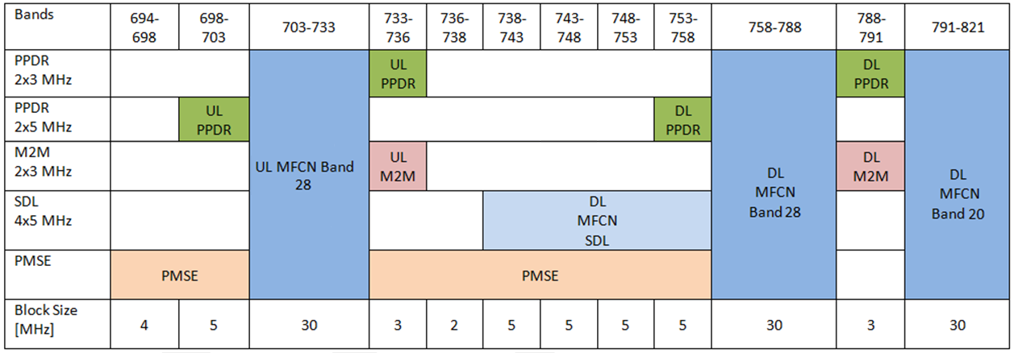

Figure 1: Coexistence scenarios

In this report, M2M applications only cover LTE-based M2M and narrowband M2M technologies (GSM-based M2M and NB-IoT[1]), where narrow band M2M can be implemented with 200 kHz system bandwidth.

The studied co-existence scenarios and the corresponding results are as follows:

* M2M vs. MFCN 700/800

It is concluded that coexistence between MFCN and M2M is possible since there is no adjacency between base station and terminal transmissions.

* M2M vs. MFCN SDL

The implementation of BS equipment is studied for M2M UL and SDL considering the SDL e.i.r.p. limits from ECC/DEC/(15)01 in order to protect the band 733-736 MHz (-52 dBm/3 MHz, -55 dBm/1.4 MHz,   
-64 dBm/200 kHz).

Considering a separate SDL BS transmitting unit specifically designed to fulfil the LRTC requirements of the ECC/DEC/(15)01 in the band 738-758 MHz, it is possible to design an internal 10 pole filter providing sufficient rejection, i.e. -52 dBm/3 MHz, -64 dBm/200 kHz below 736 MHz, with 2 MHz frequency separation.

Based on current 3GPP standardisation assumptions[2], coexistence is possible between SDL and M2M with 2 MHz offset and higher insertion loss for M2M BS Rx filter. M2M terminals based on LTE can be standard Band 28 terminals. More than 2 MHz separation between M2M and SDL is usually needed to allow for colocation. Additional alternative to manage colocation may be to rely on different site solutions, e.g. by using appropriate antenna isolation.

* M2M vs. PMSE

Coexistence between M2M and PMSE is possible with PMSE OOB restrictions according to ECC Report 221 [2] and a frequency offset of 1-10 MHz from the M2M UL upper edge.

* M2M vs. PPDR

Countries can decide to implement within the band considered in this report either M2M or PPDR. It is assumed that the M2M option is mutually exclusive to the PPDR 2x3 MHz option[3], since spectrum is overlapping. Therefore, coexistence studies of M2M and PPDR 2x3 MHz operating in the same bands in a given country has not been considered in this report, neither is covered the coexistence case of one country operating M2M 2x3 MHz and a neighbouring country operating PPDR 2x3 MHz. In addition, the study of coexistence between M2M and the operation of PPDR in the 753-758 MHz block is covered by the study of coexistence between M2M and SDL.

TABLE OF CONTENTS

0 Executive summary 2

1 Introduction 6

2 M2M Parameters 7

3 Coexistence scenarios 9

3.1 M2M vs. SDL 9

3.1.1 Impact of transmitting M2M UE (UL) into receiving MFCN UE (SDL) 9

3.1.1.1 Methodology 10

3.1.1.2 Calculation 12

3.1.1.3 Technical parameters 14

3.1.1.4 Results 16

3.1.2 Impact of transmitting MFCN BS (SDL) into receiving M2M BS (UL) 17

3.2 M2M vs. MFCN 700/800 19

3.3 M2M vs. PMSE 19

3.4 M2M vs. PPDR 20

4 Conclusions 21

ANNEX 1: List of References 22

LIST OF ABBREVIATIONS

| **Abbreviation** | **Explanation** |
| --- | --- |
| **3GPP** | 3rd Generation Partnership Project |
| **ACLR** | Adjacent Channel Leakage power Ratio |
| **ACIR** | Adjacent Channel Interference Ratio |
| **ACS** | Adjacent Channel Selectivity |
| **B2B** | Business to Business |
| **B2B2C** | Business to Business to Consumer |
| **B2C** | Business to Consumer |
| **BS** | Base station |
| **CEPT** | European Conference of Postal and Telecommunications Administrations |
| **ECC** | Electronic Communications Committee |
| **e.i.r.p.** | effective isotropic radiated power |
| **GSM** | Global System for Mobile Communications |
| **IoT** | Internet of Things |
| **IP** | Interference Probability |
| **ITU** | International Telecommunication Union |
| **LTE** | Long-Term Evolution |
| **M2M** | Machine-to-Machine |
| **MCBTS** | Multi Carrier Base Transceiver Stations |
| **MFCN** | Mobile/Fixed Communications Networks |
| **MSR** | Multi-standard Radio |
| **NB-IoT** | Narrow Band Internet of Things |
| **NF** | Noise figure |
| **OOBE** | Out-of-band emission |
| **PMSE** | Programme Making and Special Events |
| **PPDR** | Public Protection and Disaster Relief |
| **SDL** | Supplemental Downlink |
| **TPC** | Transmit Power Control |
| **TR** | Technical Report |
| **TS** | Technical Specification |
| **UE** | User Equipment |
| **UL** | Uplink |

# Introduction

M2M (Machine to Machine communication) is a general term and corresponds to a very complex ecosystem including IoT (Internet of Things). M2M embraces applications and services on a B2B (Business to Business), B2B2C (Business to Business to Consumer) or B2C (Business to Consumer) basis. From an applicative standpoint, the M2M domain covers a wide gamut of vertical markets, including utility provisioning, transportation, healthcare, energy, retail, public safety, building and many others. Part of them can be grouped under important classes such as City Automation, also called Smart City, and some others are connected objects, automotive, telematics or mobile healthcare, etc.

Presently the access technologies developed in 3GPP for M2M usage are based on LTE, GSM and NB-IoT which fall within the definition of MFCN.

The RF requirements of NB-IoT in stand-alone M2M operation scenario should meet the unwanted emission requirement for GSM MCBTS and MSR configurations.

In this report, we categorise both M2M GSM and NB-IoT as narrow band M2M technology and relevant studies are considered accordingly.

This report only contains studies of the co-existence between M2M applications based on LTE-based M2M and narrowband M2M in the 733-736 / 788-791 MHz band and services in neighbouring frequency bands.

# M2M Parameters

In this report M2M characteristics are only based on LTE (LTE-based M2M) and narrowband M2M technology (GSM-based M2M/ NB-IoT).

The parameters for compatibility studies for LTE based M2M are based on 3GPP TS 36.101 [8] and TS 36.104 [9] for the M2M terminal and base station characteristics respectively, using 1.4 MHz and 3 MHz bandwidth. Narrowband M2M, parameters are based on 3GPP TS 45.005 [10] with 200 kHz bandwidth. See Table 1 and Table 2 for parameters.

This section applies to both M2M and MFCN systems.

Table 1: Parameters for an M2M UE

| **Parameter** | **Unit** | **Value** | | **Comment** |
| --- | --- | --- | --- | --- |
| **LTE-Based** | **Narrow band M2M** |
| Channel Bandwidth | MHz | 1.4/3 | 0.2 |  |
| Noise Figure (NF) | dB | 9 | 10 | 3GPP TS 36.101 [11]  3GPP TS 45.005 [10] |
| Antenna Height | m | 1.5 | |  |
| Antenna Gain | dBi | -3 | | Average value  Omni directional |
| Maximum Transmit Power | dBm | 23 | 23/33 | 3GPP TS 36.101 [8], Table 6.2.2-1  3GPP TS 45.005 |

Table 2: Parameters for an M2M macro BS (wide area)

| **Parameter** | **Unit** | **Value** | | **Comment** |
| --- | --- | --- | --- | --- |
| **LTE-Based** | **Narrow band M2M** |
| Channel Bandwidth | MHz | 1.4/3 | 0.2 |  |
| Noise Figure (NF) | dB | 5 | 8 | 3GPP TS 36.104 [8]  3GPP TS 45.005 [10] |
| Antenna Height | M | 30 | |  |
| Antenna Gain  (with cable loss) | dBi | 15 | | Report ITU-R M.2292 |
| Maximum Transmit Power | dBm | 43 | | Report ITU-R M.2292 |
| Vertical antenna pattern (Monte-Carlo Simulations) | dB | A down-tilt of 3° is assumed | | Recommendation  ITU-R F.1336 [16] with parameters from ITU-R M.2292 [13] |
| Horizontal antenna pattern | dB |  | | Recommendation  ITU-R F.1336 [16] with parameters from ITU-R M.2292 [13] |

# Coexistence scenarios

ECC/DEC/(15)01 [1] specifies the MFCN harmonised frequency arrangement in the band 694-790 MHz as a paired frequency arrangement (FDD 2x30 MHz) and an optional unpaired frequency arrangement of zero or up to four block(s) of 5 MHz for SDL. In order to address national needs, alternative options for PMSE, PPDR and M2M are also considered around the given channelling arrangement for MFCN in the 700 MHz band. These alternatives are still under consideration. Figure 2 illustrates possible scenarios in this band.

The following co-existence scenarios need to be addressed:

* M2M vs. MFCN SDL;
* M2M[4] vs. MFCN 700/800;
* M2M vs. PMSE;
* M2M vs. PPDR.



Figure 2: Coexistence scenarios

## M2M vs. SDL

### Impact of transmitting M2M UE (UL) into receiving MFCN UE (SDL)

This study is to assess compatibility issues between M2M in the band 733-736 MHz and SDL operating in the band 738-743 MHz, assuming different systems located in the same geographical area. In particular the study is aimed at identifying proper technical conditions that allow the protection of the MFCN SDL UE service from interference from M2M UL.

The scenario under consideration is shown in Figure 3. It is representative of the scenarios involving adjacent-channel interference from M2M UL to other MFCN SDL UE in its vicinity.



BS SDL

BS M2M

UE –UE interference

UE SDL

UE M2M

Wanted signal

Figure 3: Terminal-to-terminal interference scenario

This study aims to derive the statistics of  experienced by SDL UEs receiving in the 738-743 MHz block and subject to interference from M2M UEs emitting in the 733-736 MHz block. In the SINR expression, CSDL is the received power of the wanted SDL signal, N is the noise power and IM2M,tot is the total interfering power of the M2M UEs in the vicinity of the SDL UE.

For the purposes of this analysis a Monte Carlo approach is used, which is the same methodology as in draft ECC Report 239 [3].

#### Methodology

For the assessment of M2M UE interference into SDL UEs it is assumed to consider a single SDL BS and its associated coverage area. Interference is assessed following a statistical approach, according to the so-called Monte Carlo method.

The simulation process can be structured in general terms as follows (see Figure 5):

For the Monte Carlo event “i” an SDL UE is randomly placed (with an uniform distribution) within the SDL coverage area of radius rSDL (see Figure 4);

For the selected UE SDL the median value of wanted received power is calculated considering the evaluation of the path-loss of the Extended Hata propagation model available in ITU-R Report SM.2028-1 [15]. The power variation due to the random Gaussian behaviour of the propagation is taken into account in determining the wanted power;

A number of “n” (with n = 1, 2, 3, 4 or 5) M2M UEs are randomly placed (with a uniform distribution) within a radius rint around the selected SDL UE as shown in Figure 4.

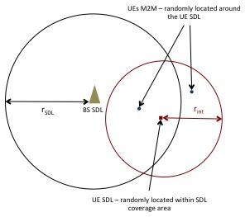

Figure 4: Overview of the interference scenario considered in Monte Carlo simulations

The transmit e.i.r.p. for each M2M UE can be selected as the maximum e.i.r.p. value they can transmit according to a power control mechanism (TPC);

For each M2M UE the interfering power is calculated relative to the SDL UE considering the evaluation of the path-loss of the Extended Hata propagation model available in ITU-R Report SM.2028-1 [15]. The power variation due to the random Gaussian behaviour of the propagation is taken into account in determining the interfering power;

The power sum of the interference contribution from all M2M UEs during the Monte Carlo event “i” is calculated;

For the event “i” the  is computed and a counter is increased by 1 if ;



These operations are repeated for each Monte Carlo event;

The quotient of all interference events by the number of events yields the Interference Probability (IP).

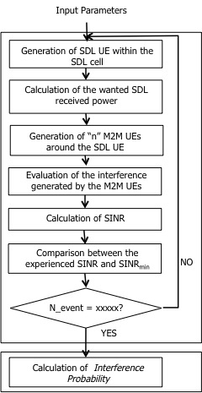

Figure 5: Simulation process

#### Calculation

For each Monte Carlo snapshot, the calculation proceeds as follows.

The mean wanted signal power of the SDL link (BS SDL to UE SDL) is given by:



where

* e.i.r.p.BS, SDL is the product of the transmit power and the antenna gain of the SDL BS;
* GUE, SDL is the antenna gain of the SDL UE;
* PLSM2028 is the path loss between the BS and the UE SDL according to the Extended-Hata propagation model defined in the ITU-R SM2028-1 [15] and applied under the urban environment assumption;
* Lbody is the body loss;
* Lwall is the wall loss. In the simulations this value is considered randomly for each receiving point. It is assumed that SDL UEs can be located outdoor/indoor.

To CSDL,i a random component to account for location variability derived from standard deviation of log-normal distribution of the wanted path () is added.



Interference power impairing SDL UE reception can be broken into two parts: the first part consists in the out of band emission (ACLR) of the M2M UE falling into the SDL block. The second is due to the imperfect rejection (ACS) of adjacent channel of the SDL UE.

For the event “i” the total interfering power of all (“nUE”) M2M UEs located in the vicinity of the SDL UE is given by the following equation:





where

* PI-CC,i is the mean in-band interference power from the M2M UE into the SDL UE adjacent channel;
* PI-AC,i is the mean adjacent channel interference power from the M2M UE into the SDL UE channel;
* PUE,M2M is the in-band transmit power of the M2M UE;
* GUE,M2M is the antenna gain of the M2M UE;
* GUE,SDL is the antenna gain of the SDL UE;
* PLSM2028 is the path loss between the M2M UE and the SDL UE according to the Extended-Hata propagation model defined in the ITU-R SM2028-1 [15] and applied under the urban environment assumption;
* Lwall is the wall loss. In the simulations this value is considered randomly for each receiving point. It is assumed that M2M UEs can be located outdoor/indoor;
* ACS is the Adjacent Channel Selectivity of the SDL UE in the M2M UE band;
* ACLR is the Adjacent Channel Leakage Ratio of the M2M UE in the SDL channel.

Also to each IM2M,j a random component to account for the location variability derived from standard deviation () of the log-normal distribution of the unwanted path is added.



The SINR for each Monte Carlo snapshot is given by:



In dB it is:



#### Technical parameters

The system parameters for the SDL and LTE-based M2M systems are listed in Table 3, Table 4, Table 5 and Table 6.

Table 3: SDL BS parameters

| **Parameter** | **Value** | **Comment** |
| --- | --- | --- |
| Operating frequency | 740.5 MHz |  |
| Channel bandwidth | 5 MHz |  |
| Transmission bandwidth | 4.5 MHz |  |
| Maximum output power | 43 dBm | TS 36.104 v10.2.0 |
| Down-tilt | 3° |  |
| Antenna gain (cable loss included) | 15 dBi |  |
| Antenna height | 30 m |  |

Table 4: SDL UE parameters

| **Parameter** | **Value** | **Comment** |
| --- | --- | --- |
| Operating frequency | 740.5 MHz |  |
| Channel bandwidth | 5 MHz |  |
| Transmission bandwidth | 4.5 MHz |  |
| Reference sensitivity | -98.5 dBm | 3GPP TS 36.101 v12.4.0 [8] |
| ACS | 33 dB | 3GPP TS 36.101 v12.4.0 [9] |
| Antenna gain (cable loss included) | -3 dBi |  |
| Antenna height | 1.5 m |  |
| Noise Figure (NF) | 9 dB | 3GPP TR 36.942 [11], Table 4.8 |
| Boltzmann constant, K | 1.38* 10-23 J/K |  |
| Noise temperature, T | 290 Kelvin |  |
| Noise power, N | -98.45 dBm |  |
| Body loss | 4 dB | Report ITU-R M.2292 |

Table 5: LTE-based M2M UE parameters, BW = 3 MHz

| **Parameter** | **Value** | **Comment** |
| --- | --- | --- |
| Operating frequency | 734.5 MHz |  |
| Channel bandwidth | 3 MHz |  |
| Transmission bandwidth | 2.7 MHz |  |
| Maximum output power | 23 dBm | 3GPP TS 36.101 v12.4.0 [8], Table 6.2.2.1 |
| Minimum output power | -40 dBm | Report ITU-R M.2039 [14] |
| ACLR | 30 dB | 3GPP TS 36.101 v12.4.0 |
| Antenna gain (cable loss included) | -3 dBi |  |
| Antenna height | 1.5 m |  |

Table 6: Other parameters used in simulations

| **Parameter** | **Value** | **Comment** |
| --- | --- | --- |
| Cell range of SDL, rSDL | 500 m | Report ITU-R M.2292 [13] and 3GPP 36.942 [11] |
| Interference area range, rint | 564.2 m (1 km2) |  |
| Standard deviation of wanted path, | 5.5 dB | CEPT Report 30 [5] |
| Standard deviation of unwanted path, | 8 dB |  |
| Median Wall loss, Lwall | 11 dB | Recommendation ITU-R P.1812-4 [17] |
| Monte Carlo events | 500000 |  |
| SINRmin (dB) | -3/0/5 | ECC report 239 [4] |
| Number of M2M UEs | 1/2/3/4/5 per km2 | ECC report 239 |
| Propagation model | Extended-Hata, | ITU-R Report SM.2028-1 [15]  Applied under urban environment assumptions |

#### Results

A sensitivity study is carried out for different numbers of active LTE-based M2M UEs located in the vicinity of the SDL UE and for different SINR requirements for the SDL UE. The resulting interference probabilities are summarised in Table 7.

Table 7: SDL Interference Probability - (Power Control)

| **Active M2M UEs per km²** | **SINRmin requirement for SDL UE (dB)** | | |
| --- | --- | --- | --- |
|  | -3 | 0 | 5 |
| 1 | <0.01 % | 0.01 % | 0.02 % |
| 2 | 0.02 % | 0.02 % | 0.05 % |
| 3 | 0.03 % | 0.03 % | 0.07 % |
| 4 | 0.03 % | 0.05 % | 0.10 % |
| 5 | 0.04 % | 0.06 % | 0.12 % |

Results in Table 7 show that the impact of LTE-based M2M UE on SDL UE is very limited. From the results it is evident how the interference probability increases with the number of active LTE-based M2M UEs around the SDL victim. Similarly, interference probability increases as the SDL UE requirements, in terms of SINRmin, become more stringent.

For GSM-based M2M, Figure 6 shows the mobile station emission mask. Assuming that the SDL system is separated by a 2 MHz offset; the ACLR into a 5 MHz BW can be calculated by mask integration. Figure 6 is also applicable to NB-IoT as mobile station emission mask. See Table 8 for results.

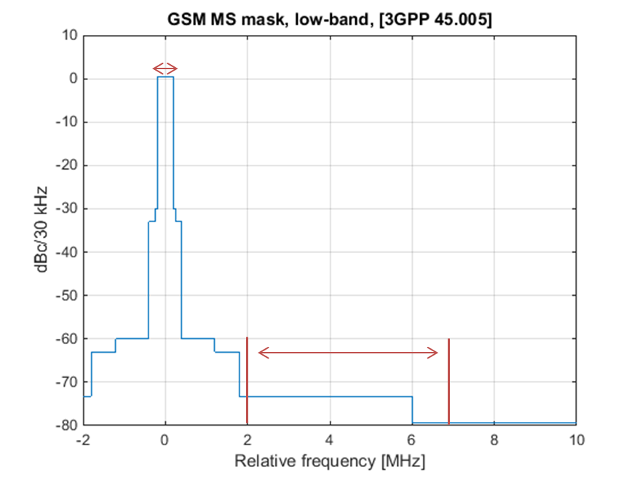

Figure 6: GSM mobile station emission mask for bands below 1 GHz and output powers <33 dBm

Table 8: Adjacent channel compatibility parameters

| **Parameter** | **LTE-based M2M** | **Source** | **Narrow band M2M** | **Source** |
| --- | --- | --- | --- | --- |
| M2M UE ACLR | 30 dB | 3GPP TS 36.101 | 53 dB | Derived from Figure 6 by mask integration. |
| SDL UE ACS | 33 dB | 3GPP TS 36.101 | 38 dB | CEPT Report 30 [5], section A5.2.2, narrowband interferer at 2 MHz offset |
| ACIR | 28 dB | 3GPP TS 36.101 | 38 dB |  |

The ACIR for GSM-based M2M UE into SDL UE is noted to be 10 dB higher than what was used to simulate the results in Table 8. Given that emission from GSM-based M2M terminals is up to 10dB higher than LTE based M2M terminals, the coexistence situation is equivalent. This means that the simulation results in Table 7 are valid for narrowband M2M technologies.

### Impact of transmitting MFCN BS (SDL) into receiving M2M BS (UL)

The implementation of BS equipment is studied for M2M UL and SDL considering the SDL e.i.r.p. limits from ECC/DEC/(15)01 to protect 733-736 MHz (-52 dBm/3 MHz, -55 dBm/1.4 MHz, -64 dBm/200 kHz) and 3GPP standard requirements for coexistence and colocation (-49 dBm/MHz and -96 dBm/100 kHz), respectively. In addition, the M2M UL Rx filter is studied when analysing the 3GPP coexistence and colocation scenario.

Considering a separate SDL BS transmitting unit specifically designed for 738-758 MHz, it is possible to design an internal 10 pole filter providing sufficient rejection to fulfil the LRTC, i.e. -52dBm/3MHz and-64 dBm/200 kHz, below 736 MHz, with 2 MHz frequency separation.

Figure 7 shows a simulation of a BS Tx filter for 4x5 MHz SDL (2 MHz guard band) to achieve the co-location protection of the M2M UL. In the SDL frequency range, the upper black curve represents the forward gain / insertion loss and the lower black curve represents the input reflection / return loss. It can be seen insertion loss at the lower SDL edge is unacceptably high.

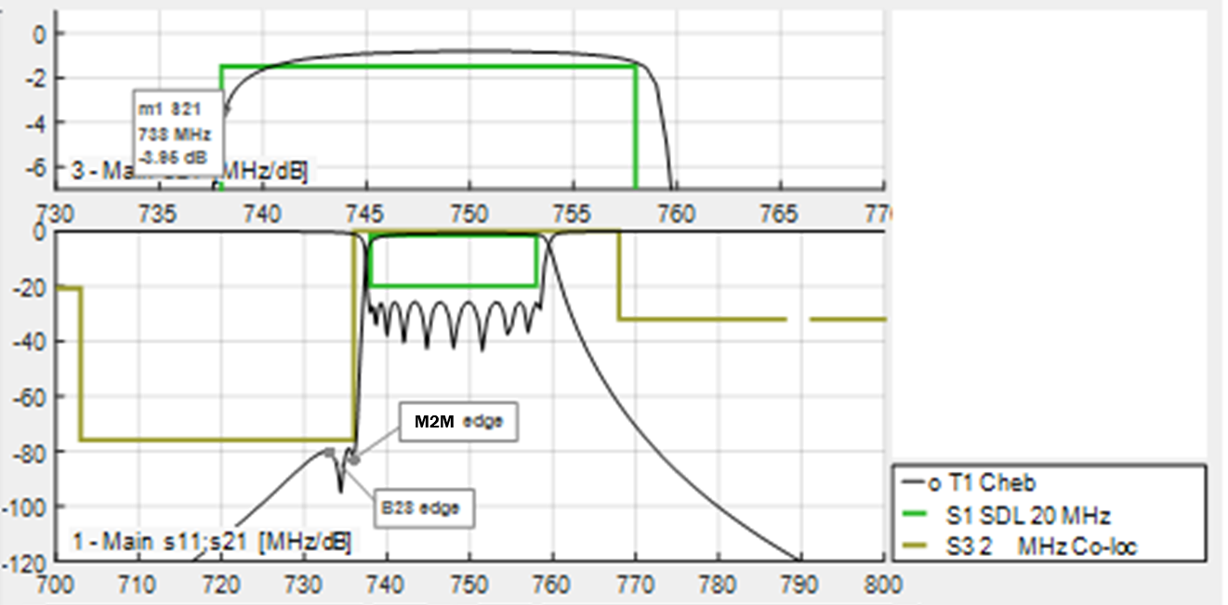

Figure 7: SDL TX filter simulations for co-location with M2M UL X axis:   
Frequency (MHz), Y axis: Filter gain (dB)

Figure 8 shows a simulation of a M2M BS Rx filter to protect itself from a co-located SDL transmitter, assuming 1 dB desensitisation and 2 MHz guard band. It can be seen that the expected insertion loss across the pass band is higher than standard value and thus will affect M2M UL performance.

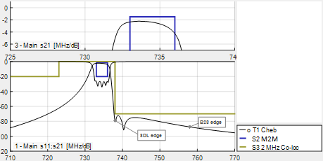

Figure 8: M2M BS RX filter simulations for co-location with SDL X axis:   
Frequency (MHz), Y axis: Filter gain (dB)

Figure 9 shows the corresponding co-existence scenario. The insertion loss is lower but is still affecting UL performance.

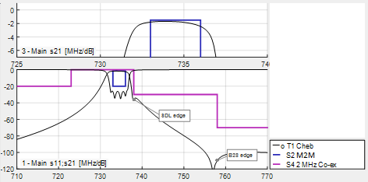

Figure 9: M2M BS RX filter simulations for co-existence with SDL X axis:   
Frequency (MHz), Y axis: filter gain (dB)

Based on the simulations above, it can be concluded that when taking the ECC/DEC/(15)01 [1] requirements and its implementation within standardisation into consideration, coexistence is possible between SDL and M2M with 2 MHz offset and higher insertion loss for M2M BS Rx filter.

More than 2 MHz separation between M2M and SDL is usually needed to allow for colocation. Additional alternative to manage colocation may be to rely on different site solutions, e.g. by using appropriate antenna isolation.

For emissions into GSM bands, 3GPP requirements are slightly different. However, it does not represent a significant difference in filter design so above conclusions apply also for narrowband M2M technologies.

## M2M vs. MFCN 700/800

The preferred channelling arrangement in the 694-790 MHz band identified by CEPT uses a conventional duplex arrangement (uplink in the lower part of the band and downlink in the upper part of the band). The proposed M2M option is aligned with this arrangement. The 790-862 MHz band uses a reversed duplex arrangement (downlink in the lower part of the band and uplink in the upper part of the band), starting at 791 MHz.

As a consequence, the 700 MHz base station transmit band is adjacent to the 800 MHz base station transmit band. This avoids adjacency between base stations and terminal stations and therefore provides compatibility between the existing 790-862 MHz channelling arrangement and the MFCN channelling arrangement for the 694-790 MHz band including the proposed M2M band.

A channelling arrangement where transmit bands and receive bands are grouped together separately enables reusability of sites and sharing of radio and site equipment. This is true in particular when technology radio characteristics are similar, such as when the access technologies involved are LTE based. Even in the case where access technologies are different, coexistence is readily achieved. In particular, coexistence between GSM and LTE/UMTS was demonstrated to be easily achievable in the context of the 900MHz band in ECC Report 82 [4] and CEPT Report 40 [5]. Therefore, the coexistence between narrowband M2M technologies and GSM/LTE/UMTS also can be achievable in 700/800/900 MHz bands.

## M2M vs. PMSE

The CEPT Report 53 [7] has studied PMSE usage of spectrum in MFCN duplex gap. These studies are also applicable for M2M UL since technical parameters are well aligned. The LTE M2M DL is not adjacent to the PMSE frequency range and is thus not included.

Table 9: OOB restrictions for hand held and body worn microphones

| **Frequency Range** | **e.i.r.p.** | **Measurement bandwidth** | **Reasoning** |
| --- | --- | --- | --- |
| M2M uplink frequencies | -45 dBm | 200 kHz | ETSI EN 300 422 [12] |

The ECC Report 221 [2] considers interference from commercial mobile network to PMSE equipment. These studies are also applicable for M2M since technical parameters are well aligned. The results of the studies are illustrated in Table 10, adjusted for the 736 MHz band edge. The results indicate that for PMSE operation a frequency separation of 1 to 10 MHz from M2M uplink (depending on spatial distance between M2M UE and PMSE receiver) is needed.

Table 10: SEAMCAT simulation results: M2M interfering PMSE receiver

| **Scenario** | **Separation distance** | **Interferer** | **PMSE Frequency [MHz] Unwanted / Blocking probability [%]** | | | | |
| --- | --- | --- | --- | --- | --- | --- | --- |
|  | | | 736.1 | 737.1 | 745.9 | 746.9 | ≥757.9 |
| Outdoor | 15 – 100m | LTE UE | 6.87 / 0 | 3.06 / 0 | 0 / 0 | 0 / 0 | 0 / 0 |
| Indoor | 5 – 50m | LTE UE | 64.25 / 0 | 47.11 / 0 | 3.16 / 0 | 0.35 / 0 | 0.13 / 0 |

## M2M vs. PPDR

The work item description remarks that studies will cover PPDR above 736 MHz where applicable.

Countries can decide to implement within the band considered in this report either M2M or PPDR. It is assumed that the M2M option is mutually exclusive to the PPDR 2x3 MHz options[5], since spectrum is overlapping. Therefore, coexistence studies of M2M and PPDR 2x3 MHz operating in the same bands in a given country has not been considered in this report, neither is covered the coexistence case of one country operating M2M 2x3 MHz and a neighbouring country operating PPDR 2x3 MHz.

In addition, the study of coexistence between M2M and the operation of PPDR in the 753-758 MHz block is covered by the study of coexistence between M2M and SDL.

# Conclusions

In this report coexistence between M2M (LTE based and narrowband M2M) applications in 733–736 / 788–791 MHz and services in adjacent bands have been investigated.

Below the co-existence scenarios and corresponding conclusions are presented:

* M2M vs. MFCN 700/800

It is concluded that coexistence between MFCN and M2M is possible since there is no adjacency between base station and terminal transmissions.

* M2M vs. MFCN SDL

The implementation of BS equipment is studied for M2M UL and SDL considering the SDL e.i.r.p. limits from ECC/DEC/(15)01 in order to protect 733-736 MHz (-52 dBm/3 MHz, -55 dBm/1.4 MHz, -64 dBm/200 kHz).

Considering a separate SDL BS transmitting unit specifically designed for 738-758 MHz to fulfil the requirements of the ECC/DEC/(15)01, it is possible to design an internal 10 pole filter providing sufficient rejection to fulfil the LRTC, i.e. -52 dBm/3 MHz and -64dBm/200 kHz below 736 MHz, with 2 MHz frequency separation.

Based on current standardisation assumptions, coexistence is possible between SDL and M2M with 2 MHz offset and higher insertion loss for M2M BS Rx filter. M2M terminals based on LTE can be standard Band 28 terminals. More than 2 MHz separation between M2M and SDL is usually needed to allow for colocation. Additional alternative to manage colocation may be to rely on different site solutions, e.g. by using appropriate antenna isolation.

* M2M vs. PMSE

Coexistence between M2M and PMSE is possible with PMSE OOB restrictions according to ECC Report 221 [2] and a frequency offset of 1-10 MHz to M2M UL.

* M2M vs. PPDR

Countries can decide to implement within the band considered in this report either M2M or PPDR. It is assumed that the M2M option is mutually exclusive to the PPDR 2x3 MHz option[6], since spectrum is overlapping. Therefore, coexistence studies of M2M and PPDR 2x3 MHz operating in the same bands in a given country has not been considered in this report, neither is covered the coexistence case of one country operating M2M 2x3 MHz and a neighbouring country operating PPDR 2x3 MHz.

In addition, the study of coexistence between M2M and the operation of PPDR in the 753-758 MHz block is covered by the study of coexistence between M2M and SDL.

1. List of References
2. ECC Decision (15)01 of 6 March 2015 on Harmonised technical conditions for mobile/fixed communications networks (MFCN) in the band 694-790 MHz including a paired frequency arrangement (Frequency Division Duplex 2x30 MHz) and an optional unpaired frequency arrangement (Supplemental Downlink)
3. ECC Report 221: Adjacent band compatibility between MFCN and PMSE audio applications in the 700 MHz frequency band.
4. ECC Report 239: Compatibility and sharing studies for BB PPDR systems operating in the 700 MHz range
5. ECC Report 82: Compatibility study for UMTS operating within the GSM 900 and GSM 1800 frequency bands
6. CEPT Report 30: Report from CEPT to the European Commission in response to the Mandate on The identification of common and minimal (least restrictive) technical conditions for 790 - 862 MHz for the digital dividend in the European Union
7. CEPT Report 40: Report from CEPT to European Commission in response to Task 2 of the Mandate to CEPT on the 900/1800 MHz bands “Compatibility study for LTE and WiMAX operating within the bands 880-915 MHz / 925-960 MHz and 1710-1785 MHz / 1805-1880 MHz (900/1800 MHz bands)”
8. CEPT Report 53: Report A from CEPT to the European Commission in response to the Mandate “To develop harmonised technical conditions for the 694 -790 MHz ('700 MHz') frequency band in the EU for the provision of wireless broadband and other uses in support of EU spectrum policy objectives”
9. 3GPP TS 36.101: Evolved Universal Terrestrial Radio Access (E-UTRA); User Equipment (UE) radio transmission and reception
10. 3GPP TS 36.104: Evolved Universal Terrestrial Radio Access (E-UTRA); Base Station (BS) radio transmission and reception
11. 3GPP TS 45.005: Radio transmission and reception
12. 3GPP TR 36.942: Evolved Universal Terrestrial Radio Access (E-UTRA); Radio Frequency (RF) system scenarios
13. ETSI EN 300 422: Electromagnetic compatibility and Radio spectrum Matters (ERM); Wireless microphones in the 25 MHz to 3 GHz frequency range; Part 1: Technical characteristics and methods of measurement
14. Report ITU-R M.2292: Characteristics of terrestrial IMT-Advanced systems for frequency sharing/interference analyses
15. ITU-R Report M.2039: Characteristics of terrestrial IMT-2000 systems for frequency sharing/ interference analyses
16. ITU-R Report SM.2028-1: Monte Carlo simulation methodology for the use in sharing and compatibility studies between different radio services or systems
17. Recommendation ITU-R F.1336: Reference radiation patterns of omnidirectional, sectoral and other antennas in point-to-multipoint for use in sharing studies in the frequency range from 1 GHz to about 70 GHz
18. Recommendation ITU-R P.1812 A path-specific propagation prediction method for point-to-area terrestrial services in the VHF and UHF bands
19. ECC Report 218: Harmonised conditions and spectrum bands for the implementation of future European broadband PPDR systems

1. NB-IoT is one narrowband M2M technology, which aims to provide low complexity and low throughput radio access technology to address the requirements of cellular internet of things.
2. The parameters for compatibility studies for LTE-based M2M are based on 3GPP TS 36.101 and 3GPP TS 36.104 for the M2M terminal and base station characteristics respectively, using 1.4 MHz and 3 MHz bandwidth. For GSM-based M2M, parameters are based on 3GPP TS 45.005 with 200 kHz bandwidth.
3. See ECC report 218 [18]
4. M2M as LTE-based M2M or narrowband M2M.
5. See ECC report 218 [18]
6. See ECC report 218 [18]