ecc_logocept logo

Adjacent band compatibility studies for aeronautical CGC systems operating in the bands 1980-2010 MHz and 2170-2200 MHz

Approved May 2015

ECC Report 233

# EXECUTIVE SUMMARY

ECC Decision ECC/DEC/(06)09 [1] designates the bands 1980-2010 MHz and 2170-2200 MHz for use by systems in the Mobile Satellite Service (MSS), including those supplemented by a Complementary Ground Component (CGC). This Decision follows a number of studies conducted by the ECC, namely CEPT Report 013 [2] that was developed in response to the mandate from the European Commission, and ECC Report 197 [3] that deals with compatibility studies between transmitting MSS user terminals in the band 1980-2010 MHz and ECN services operating in the adjacent bands.

The studies conducted by the ECC considered that CGC systems have characteristics similar to ECN base stations, but did not consider potential use of aeronautical CGC systems, which introduce new interference scenarios. This ECC Report considers compatibility issues related to a possible implementation of aeronautical CGC systems operating in the 2 GHz MSS band (1980-2010 MHz uplink, 2170-2200 MHz downlink).

This Report identifies certain technical and operational requirements for an aeronautical CGC system within the 2 GHz MSS band. Such technical requirements are necessary to ensure protection of the services operating in the adjacent bands (i.e. 1920-1980 MHz, 2010-2025 MHz, 2110-2170 MHz, above 2200 MHz) and of the conventional CGCs of MSS systems in the 2 GHz MSS band. The planned use of the band 2010-2025 MHz is currently under discussion within the CEPT. The studies in this Report have considered potential use of this band by Direct Air to Ground Communications (DA2GC) systems and Video Link and Cordless Camera (VLCC) systems.

The results show that the aeronautical CGC ground stations will not create any harmful interference to the Electronic Communication Network (ECN), VLCC and Mobile Communications on Aircraft (MCA) systems.

With regard to the aeronautical terminals operating in the aeronautical CGC system, this Report shows that in some cases (for example when the aeronautical terminal is transmitting with high power at low altitudes) interference issues could potentially occur in to DA2GC ground stations, ECN base stations in adjacent bands, or in conventional CGCs of MSS systems in the 2 GHz MSS band. Therefore mitigation techniques and /or specific planning are needed in order to provide compatibility between the services and the systems studied. The studies have demonstrated that the maximum values of out-of-band radiation from aeronautical terminals, in order to protect ground networks, depend on the elevation angle at which the ground victim receiver sees the interfering aircraft. To address these issues, out-of-band power flux density (PFD) thresholds on the ground are derived. This Report identifies two PFD masks for aeronautical terminals: one in the band 1920-1980 MHz to protect ECN base stations (that can also be applied to protect conventional CGCs of other MSS systems in the 2 GHz MSS band), and another one in the band 2010-2025 MHz to protect DA2GC base stations. Regarding potential interference to MCA systems from aeronautical terminals within an Aeronautical CGC system, the Report has shown that this may only occur for a short duration (when the two aircraft are in close proximity), and therefore does not require additional constraints on aeronautical CGC systems. The Report also concludes that no measures are required for aeronautical terminals to protect VLCC systems.

The proposed PFD limitations to protect ECN BS in the band 1920-1980 MHz can also be applied within the band 1980-2010 MHz to protect other MSS systems using conventional CGCs, on the condition that the characteristics of those CGC GSs are similar to those of the ECN BSs considered in this Report.

In summary, this Report has identified the conditions under which the aeronautical CGC systems can be operated without causing harmful interference to DA2GC and MCA systems and terrestrial networks in the adjacent bands, and to conventional CGCs of other MSS systems in the 2 GHz MSS band.

Table 1 shows an overview of all scenarios including cases in which mitigation might be required. Table 2 show the proposed mitigation measures.

Table 1: Summary of study result

| Summary of Aero CGC in the band 1980 - 2010 MHz | | |
| --- | --- | --- |
| Scenario ID | Interfering Aeronautical MSS/CGC component | Potentially interfered-with system component |
| 1 | Aeronautical terminal transmitting to the satellite (1980-2010 MHz) | ECN Receiving BS (1920-1980 MHz) and Conventional CGCs of other MSS systems in the 2GHz MSS band (1980-2010 MHz) |
| M1, M2, M4 |
| 2 | Aeronautical terminal transmitting to the aeronautical CGC ground station (1980-2010 MHz) | ECN Receiving BS (1920-1980 MHz) and Conventional CGCs of other MSS systems in the 2GHz MSS band (1980-2010 MHz) |
| M1, M2 |
| 3 | Aeronautical terminal transmitting to the aeronautical CGC ground station  (1980-2010 MHz) | DA2GC FDD ground station (2010-2025 MHz) |
| M1, M2, M5 |
| 4 | Aeronautical terminal transmitting to the satellite (1980-2010 MHz) | DA2GC FDD ground station (2010-2025 MHz) |
| M1, M2, M4 |
| 5 | Aeronautical terminal transmitting to the aeronautical CGC ground station (1980-2010 MHz) | VLCC receiver (2010-2025 MHz) |
| M3 |
| 6 | Aeronautical terminal transmitting to the satellite (1980-2010 MHz) | VLCC receiver (2010-2025 MHz) |
| M3 |
| 7 | Aeronautical terminal transmitting to the aeronautical CGC ground station  (1980-2010 MHz) | MCA receiving BS (1920-1980 MHz) |
|  |
| 8 | Aeronautical terminal transmitting to the satellite (1980-2010 MHz) | MCA receiving BS (1920-1980 MHz) |
|  |
| 9 | Aeronautical CGC ground station transmitting to the aeronautical terminal  (2170-2200 MHz) | MCA receiving MS (2110-2170 MHz) |
|  |
| 10 | Aeronautical CGC ground station transmitting to the aeronautical terminal  (2170-2200 MHz) | Receiving MS in ECN FDD systems (2110-2170 MHz) |
|  |
| 11 | Aeronautical CGC ground station transmitting  to the aeronautical terminal  (2170-2200 MHz) | PMSE receiver (2200-2290 MHz) |
|  |

Table 2: Applicable mitigation techniques

|  |  |
| --- | --- |
| **Mitigation measure** | |
| M1 | Improved Tx filtering |
| M2 | e.i.r.p. reduction depending on aircraft altitude |
| M3 | Shielding/receiver depointing (including natural terrain shielding) |
| M4 | fuselage attenuation |
| M5 | co-siting of different ground stations |

|  |  |
| --- | --- |
|  | Compatibility is achieved with the basic system parameters |
|  | Compatibility may be achieved with mitigation techniques or restrictions |

TABLE OF CONTENTS

[0 EXECUTIVE SUMMARY 2](#_Toc419377151)

[1 INTRODUCTION 8](#_Toc419377152)

[2 DEFINITIONS 9](#_Toc419377153)

[3 FREQUENCY USAGE 10](#_Toc419377154)

[4 SHARING SCENARIOS 13](#_Toc419377155)

[5 ASSUMPTIONS AND SYSTEM PARAMETERS 14](#_Toc419377156)

[5.1 AERONAUTICAL CGC SYSTEM COMPONENTS 14](#_Toc419377157)

[5.1.1 Aeronautical Complementary Ground Component characteristics 14](#_Toc419377158)

[5.1.2 Aeronautical Terminal parameters 15](#_Toc419377159)

[5.2 DA2GC Ground station characteristics 17](#_Toc419377160)

[5.3 ECN characteristics 19](#_Toc419377161)

[5.3.1 ECN Base Station Characteristics 19](#_Toc419377162)

[5.3.2 ECN User Terminal characteristics 21](#_Toc419377163)

[5.4 PMSE and PPDR characteristics 22](#_Toc419377164)

[5.5 MCA CHARACTERISTICS 23](#_Toc419377165)

[6 ANALYSIS AND RESULTS 25](#_Toc419377166)

[6.1 Scenario 1 25](#_Toc419377167)

[6.2 Scenario 2 30](#_Toc419377168)

[6.3 Scenario 3 33](#_Toc419377169)

[6.4 Scenario 4 36](#_Toc419377170)

[6.5 Scenario 5 39](#_Toc419377171)

[6.6 Scenario 6 44](#_Toc419377172)

[6.7 Scenario 7 53](#_Toc419377173)

[6.8 Scenario 8 56](#_Toc419377174)

[6.9 scenario 9 58](#_Toc419377175)

[6.10 scenario 10 60](#_Toc419377176)

[6.11 scenario 11 63](#_Toc419377177)

[7 SUMMARY AND DISCUSSION OF RESULTS 64](#_Toc419377178)

[8 CONCLUSION 66](#_Toc419377179)

[ANNEX 1: COMPARISON OF FLAT EARTH MODEL ASSUMPTION WITH SPHERICAL EARTH MODEL 67](#_Toc419377180)

[ANNEX 2: INTERFERENCE AGGREGATION 69](#_Toc419377181)

[ANNEX 3: LIST OF REFERENCES 72](#_Toc419377182)

LIST OF ABBREVIATIONS

|  |  |
| --- | --- |
| **Abbreviation** | **Explanation** |
| **ACIR** | Adjacent Channel Interference Ratio |
| **ACLR** | Adjacent Channel Leakage power Ratio |
| **ACS** | Adjacent Channel Selectivity |
| **a.g.l.** | Above ground level |
| **AT** | Aeronautical Terminal (whether transmitting to a ground station or a satellite) |
| **BS** | Base Station |
| **BW** | Bandwidth |
| **CCL** | Cordless Camera Link |
| **CEPT** | European Conference of Postal and Telecommunications Administrations |
| **CGC** | Complementary Ground Component |
| **C/I** | Carrier to Interference ratio |
| **DA2GC** | Direct Air to Ground Communications |
| **DEC** | Decision |
| **DECT** | Digital Enhanced Cordless Telecommunications |
| **ECC** | European Communications Committee |
| **ECN** | Electronic Communication Network |
| **EESS** | Earth Exploration Satellite Service |
| **e.i.r.p.** | effective isotropic radiated power |
| **ETSI** | European Telecommunications Standards Institute |
| **FDD** | Frequency Division Duplex |
| **FDMA** | Frequency Division Multiple Access |
| **FSL** | Free Space Loss |
| **GS** | Ground Station |
| **I/N** | Interference to Noise |
| **IMT** | International Mobile Telecommunications |
| **ITU-R** | International Telecommunication Union – Radiocommunication |
| **LTE** | Long Term Evolution |
| **MCA** | Mobile Communications on Aircraft |
| **MS** | Mobile Station |
| **MSS** | Mobile Satellite Service |
| **MVL** | Mobile Video Link |
| **NCU** | Network Control Unit |
| **OOB** | Out Of Band |
| **PFD** | Power Flux Density |
| **PMSE** | Programme Making and Special Events |
| **PPDR** | Public Protection and Disaster Relief |
| **PVL** | Portable Video Link |
| **Rx** | Receiver |
| **SAB** | Services Ancillary to Broadcasting |
| **SAP** | Services Ancillary to Programme making |
| **TDD** | Time Division Duplex |
| **TDMA** | Time Division Multiple Access |
| **Tx** | Transmitter |
| **UE** | User Equipment |
| **UMTS** | Universal Mobile Telecommunications System |
| **VLCC** | Video Link and Cordless Camera |
| **3GPP** | The 3rd Generation Partnership Project |

# INTRODUCTION

Air passengers are able to access a wide range Internet based services such as web browsing, real-time social media updates, emails, live streaming TV, safety instructions in their own language, international news or connecting flight information. As of Q3 2014, within Europe, the only solution to link the on-board communication services to the ground is to go through satellite links operating in L band, Ku band and in Ka band. Connectivity applications may also serve a wide range of airline’s administrative and operational communications, including digital cabin logbook, aircraft documentation viewer, telemedicine and on-board rescheduling of traveller flight connections.

Forecasts (e.g. from Eurocontrol [4] and others [5] [6]) show an expected annual air traffic growth rate in Europe of around 4% for the next 20 years. In order to meet the growing need of in-flight connectivity services, terrestrial only systems, known as Direct Air to Ground Communications (DA2GC), are being considered in CEPT.

A Mobile Satellite Service (MSS) solution for European aircraft with a Complementary Ground Component (CGC) supplementing the satellite service has also been suggested.

Combining and operating MSS satellites and aeronautical CGC networks in a hybrid network in the 2 GHz MSS band will offer additional capacity. The aeronautical CGC network will be located within the coverage of the MSS satellite. It is expected that the geostationary satellite service is the core service that will be available in Europe, complemented by the aeronautical CGC ground stations in high-density flight paths.

ECC Decision ECC/DEC/(06)09 [1] designates the bands 1980-2010 MHz and 2170-2200 MHz to the mobile satellite service, including systems supplemented by CGC. This Decision followed a number of studies conducted by the ECC, namely CEPT Report 13 [2] that was developed in response to the mandate from the European Commission, and ECC Report 197 [3] that deals with compatibility studies between transmitting MSS user terminals in the band 1980-2010 MHz and ECN services operating in adjacent bands. However, the studies conducted by the ECC considered that CGC systems have characteristics similar to ECN base stations and did not consider potential use of aeronautical CGC systems, which introduce new interference scenarios.

This Report considers adjacent band compatibility issues related to a possible implementation of aeronautical CGC systems operating in the 2 GHz MSS band (1980-2010 MHz uplink, 2170-2200 MHz downlink).

The term "aeronautical CGC system" in this Report defines the whole system, composed of the satellite, the aeronautical terminals communicating with the satellite, the aeronautical terminals communicating with the CGC, the CGC ground stations, the gateway earth station, the terrestrial core network and the spectrum and network management system. This Report addresses potential interference from the following system elements:

1. the CGC ground stations;
2. the aeronautical terminal transmitting to the CGC ground stations;
3. the aeronautical terminal transmitting to the satellite.

# DEFINITIONS

The following definitions are used in this report:

|  |  |
| --- | --- |
| Term | Definition |
| Aeronautical CGC ground station | Station on the ground in the Aeronautical CGC system communicating with the aircraft. |
| Aeronautical CGC system | The system composed of the satellite, the aeronautical terminals communicating with the satellite, the aeronautical terminals communicating with the Aeronautical CGC, the Aeronautical CGC ground stations, the gateway earth station, the terrestrial core network and the spectrum and network management system. |
| Aeronautical Terminal transmitting to the Aeronautical CGC ground station | Terminal on-board aircraft providing the radio, control and telecommunication link towards the Aeronautical CGC ground station. |
| Aeronautical Terminal transmitting to the satellite | Terminal on-board aircraft providing the radio, control and telecommunication link towards the satellite. |

# FREQUENCY USAGE

The different services in the 2 GHz MSS bands and adjacent bands are illustrated in Figure 1:

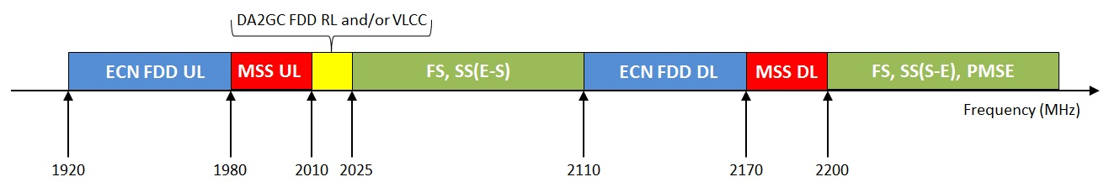

Figure 1: Services/systems around the 2 GHz bands

The 1980-2010 MHz frequency band (MSS “uplink” band) will be used for aeronautical terminal-to-satellite and aeronautical terminal-to-CGC ground station, while the 2170-2200 MHz (MSS “downlink” band) will be used for satellite-to-aeronautical terminal and CGC ground station-to-aeronautical terminal, as shown in Figure 2.

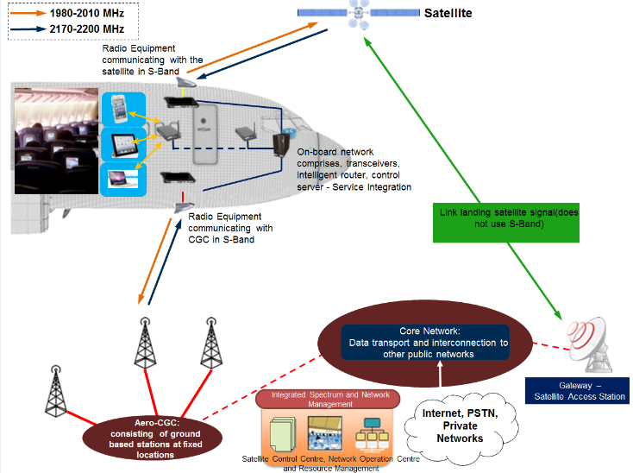

Figure 2: Aeronautical CGC system

Table 3 summarises the direction of the communication links for adjacent terrestrial and Aeronautical CGC systems.

Table 3: Designation and use of spectrum in the 1920-2290 MHz range

| **Frequency** | **Aero MSS/CGC system** | **Adjacent band system** |
| --- | --- | --- |
| 1920-1980 MHz | - | ECN FDD MS-to-BS (including MCA) |
| 1980-2010 MHz  (MSS “uplink” band) | Aeronautical terminal-to-satellite and aeronautical terminal-to-CGC ground station | - |
| 2010-2025 MHz |  | Planned uses currently being reviewed by CEPT |
| … | ... | ... |
| 2110-2170 MHz | - | ECN FDD BS-to-MS (including MCA) |
| 2170-2200 MHz (MSS “downlink” band) | Satellite-to-aeronautical terminal and CGC ground station-to-aeronautical terminal |  |
| 2200-2290 MHz |  | PMSE  Space Research  (space-to-Earth and space-to-space)  Earth Exploration Satellite Service  (space-to-Earth and space-to-space) |

The provisions of the ITU Radio Regulations and national regulations applicable to these bands govern the operation in the 2 x 30 MHz.

In the European Union (EU), the 2 GHz MSS bands are divided between two MSS operators through Commission Decision 2009/449/EC [21] one MSS system in 1980-1995 MHz and 2170-2185 MHz, and the other one in 1995-2010 MHz and 2185-2200 MHz. The proposed power flux density limitations for Aeronautical CGC systems to protect ECN BS can be applied within the band 1980-2010 MHz to protect other MSS systems using conventional CGCs, on the condition that the characteristics of the CGC GSs are similar to those of the ECN BS considered in this Report.

CEPT has agreed two scenarios for possible use of the “unpaired” 2 GHz bands 1900-1920 and 2010-2025 MHz. Figure 3 and Figure 4 report the two scenarios agreed for the 2010-2025 MHz band. Therefore the studies in this Report have considered potential use of this band by Direct Air to Ground Communications (DA2GC) systems and Video Link and Cordless Camera (VLCC) systems. If only scenario #2 will be further developed in CEPT and the ECC Decision on the 2 GHz unpaired bands will consider only VLCC systems in the band 2010-2025 MHz, the out-of-band PFD mask proposed in this Report to protect DA2GC will not be required.

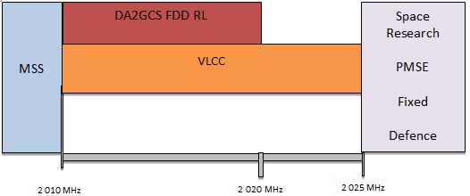

Figure 3: Scenario #1 for the 2010-2025 MHz band

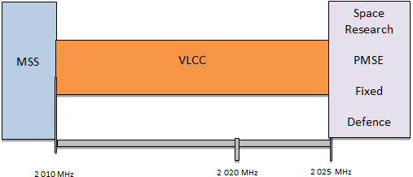

Figure 4: Scenario #2 for the 2010-2025 MHz band

With regard to potential interference from aeronautical CGC ground stations to the various systems in the band 2200-2290 MHz, potential interference from CGC ground stations to EESS, space research and space operations earth stations is already addressed in Recommendation ECC/REC/(10)01 [7]. This report considers the potential interference from aeronautical CGC ground station to PMSE (Programme Making and Special Events) receivers operating in the bands 2200-2290 MHz, which may be operated on an occasional basis.

Any interference caused by the MSS space station to ECN systems needs not to be considered as the power flux density of Out Of Band emissions can be expected to be similar to any MSS system operating in these bands, and in any case would be too low to cause any impact on terrestrial services in the adjacent bands.

# SHARING SCENARIOS

Taking account of the frequency usage described in section 2, the adjacent band compatibility scenarios considered are shown in Table 4.

Table 4: Interfering Scenarios

| **Scenario ID** | **Interfering Aeronautical MSS/CGC component** | **Potentially interfered-with system component** |
| --- | --- | --- |
| 1 | Aeronautical terminal transmitting to the satellite (1980-2010 MHz) | ECN Receiving BS (1920-1980 MHz).  Conventional CGCs of other MSS systems in the 2GHz MSS band  (1980-2010 MHz) |
| 2 | Aeronautical terminal transmitting to the aeronautical CGC ground station (1980-2010 MHz) | ECN Receiving BS (1920-1980 MHz).  Conventional CGCs of other MSS systems in the 2GHz MSS band  (1980-2010 MHz) |
| 3 | Aeronautical terminal transmitting to the aeronautical CGC ground station  (1980-2010 MHz) | DA2GC FDD ground station (2010-2025 MHz) |
| 4 | Aeronautical terminal transmitting to the satellite (1980-2010 MHz) | DA2GC FDD ground station (2010-2025 MHz) |
| 5 | Aeronautical terminal transmitting to the aeronautical CGC ground station (1980-2010 MHz) | VLCC receiver (2010-2025 MHz) |
| 6 | Aeronautical terminal transmitting to the satellite (1980-2010 MHz) | VLCC receiver (2010-2025 MHz) |
| 7 | Aeronautical terminal transmitting to the aeronautical CGC ground station  (1980-2010 MHz) | MCA receiving BS (1920-1980 MHz) |
| 8 | Aeronautical terminal transmitting to the satellite (1980-2010 MHz) | MCA receiving BS  (1920-1980 MHz) |
| 9 | Aeronautical CGC ground station transmitting to the aeronautical terminal  (2170-2200 MHz) | MCA receiving MS  (2110-2170 MHz) |
| 10 | Aeronautical CGC ground station transmitting to the aeronautical terminal  (2170-2200 MHz) | Receiving MS in ECN FDD systems  (2110-2170 MHz) |
| 11 | Aeronautical CGC ground station transmitting  to the aeronautical terminal  (2170-2200 MHz) | PMSE receiver  (2200-2290 MHz) |

Each of the above scenarios is examined in this Report.

# ASSUMPTIONS AND SYSTEM PARAMETERS

## AERONAUTICAL CGC SYSTEM COMPONENTS

In the following sections, we describe the parameters used for the compatibility studies performed in this Report. Since the interference caused by the MSS space station to ECN systems has not to be considered, the satellite characteristics are not part of this Report.

### Aeronautical Complementary Ground Component characteristics

The parameters listed in Table 5 are applicable to the aeronautical CGC ground stations. The vertical antenna pattern is shown in Figure 5.

Table 5: Main Parameters used for Aeronautical CGC Ground Station

| **Aeronautical CGC Ground Station parameters** | |
| --- | --- |
| Output power at antenna connector | 47 dBm per polarization |
| Ground station type | Macro |
| Cell Radius | 70 km to 150 km (typical value 90 km) |
| Maximum Antenna Gain | 15 dBi |
| Channel Bandwidth | 2 x 10 MHz (FDD)(1) – according to ETSI TS 136 104 V11.6.0  (2013-10) Clause 5.6 [8] |
| Frequency reuse factor | 1 |
| Antenna Height | 25 to 50 m (Note: technical analysis was performed taking into account 30 m antenna height) |
| Antenna up-tilt | 10° |
| Antenna type | Directional sector antenna for three 120° sectors |
| Vertical Antenna Pattern | Reported in figure 5 |
| Adjacent Channel Leakage Ratio | 44.2 dB or absolute -15 dBm/MHz – according ETSI EN 301 908-14 V6.2.1 (2013-10), Clause 4.2.3, Tables 4.2.3.2-1 and 4.2.3.2-2 [9] |

(1) Uplink: 50 x 180 KHz = 9 MHz, Downlink: 15 KHz + 50 x 180 KHz = 9.015 MHz

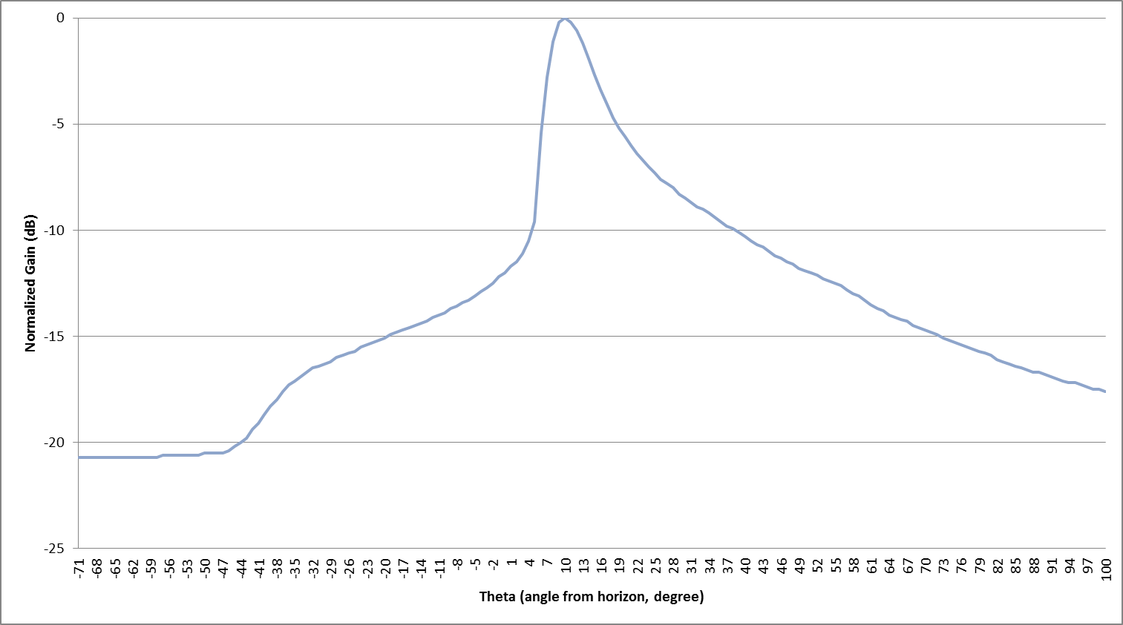

Figure 5: Vertical Antenna Pattern for Aeronautical CGC Ground Station

### Aeronautical Terminal parameters

The parameters listed in Table 6 are applicable to the aeronautical terminals transmitting to Aeronautical CGC ground stations. The vertical antenna pattern is shown in Figure 6.

Table 6: Aeronautical Terminal parameters, transmitting to Aeronautical CGC Ground Station

| **Aeronautical Terminal parameters (transmitting to Aeronautical CGC Ground Station)** | |
| --- | --- |
| Tx power (max/min) | 37 dBm/-26 dBm (63 dynamic range, power control) |
| Antenna type | Azimuth: omni-directional  Elevation: see Figure 6 |
| Antenna Gain | 3 dBi |
| Antenna height above ground level | 1000-13000 m |
| Channel Bandwidth | 2 x 10 MHz (FDD) |
| Adjacent Channel Leakage Ratio | 37 dB |

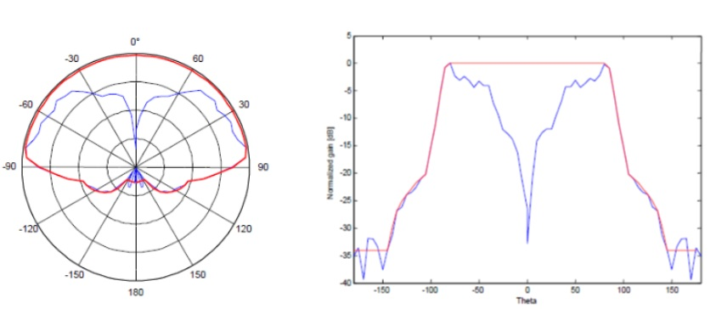

Figure 6: Vertical Antenna Pattern for aeronautical terminal antenna when transmitting   
to ground station (polar representation)

Note: The red curve (”filled null”) is used for compatibility studies while the blue curve shows a typical monopole pattern.

The parameters for the aeronautical terminals transmitting to the satellite are summarised in Table 7 and the antenna pattern is shown in Figure 7.

Table 7: Aeronautical terminal parameters, transmitting to the Satellite

| **Aeronautical Terminal parameters (transmitting to satellite)** | |
| --- | --- |
| Tx power max | 25 dBm |
| Antenna type | Directional |
| Antenna Gain | Max 15 dBi |
| Antenna height a.g.l. | 1000-13000 m |
| Emission Bandwidth | 200 kHz |
| Adjacent Channel Leakage Ratio | 30 dB |
| Antenna Pattern | As per rec. 4.1 of Rec. ITU-R F.1336-4 [10] (see Figure 7) |

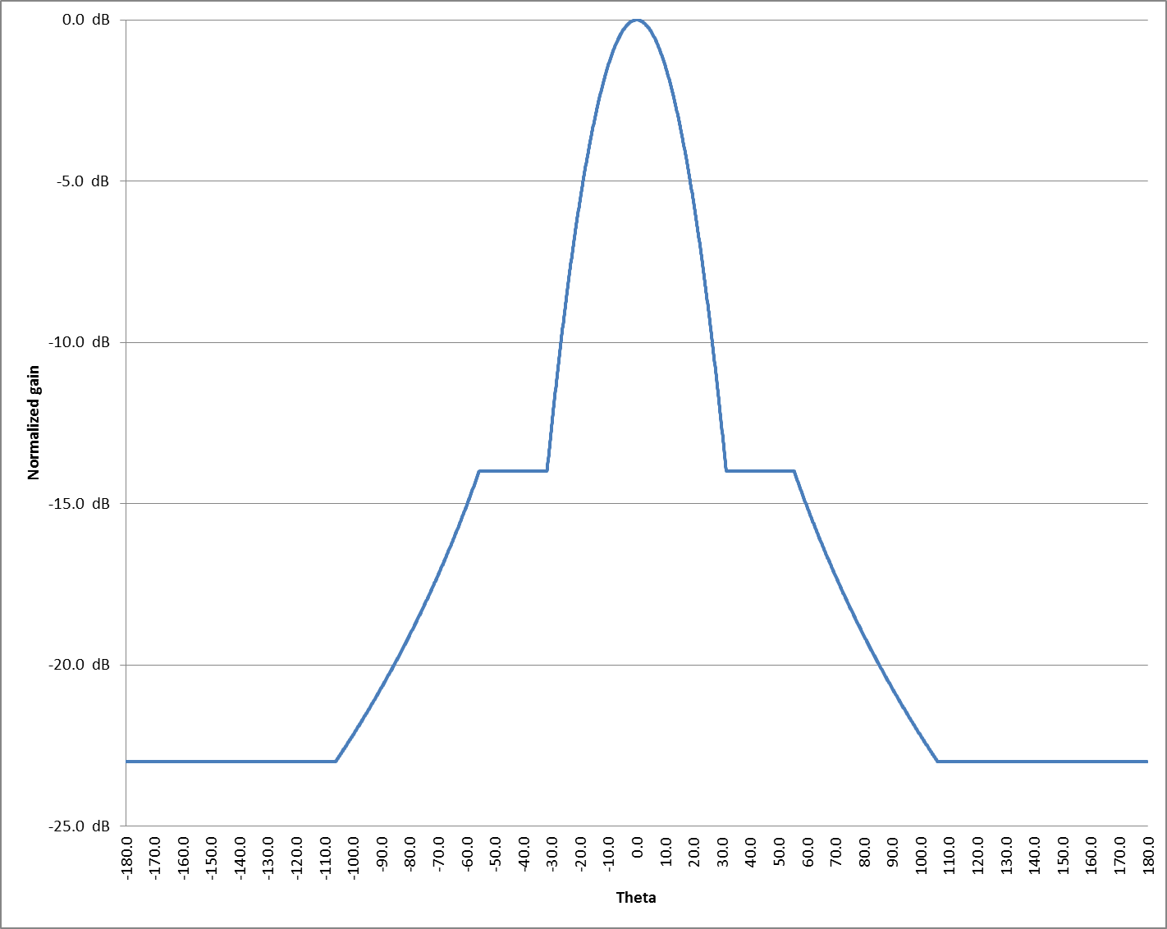

Figure 7: Antenna Pattern for aeronautical terminal antenna transmitting to satellite

## DA2GC Ground station characteristics

A broadband DA2GC system aims to provide access to broadband communication services during continental flights on a Europe-wide basis. A detailed description of DA2GC system and parameters can be found in ECC Report 209 [11]. The Table 8 summarises the main characteristics used for the ground station according to the ETSI system reference document TR 103 054 [12]. Figure 8 and Figure 9 provide the horizontal antenna and the vertical antenna pattern respectively.

Table 8: Main Parameters used for DA2GC ground station – FDD

| **DA2GC ground station parameters** | |
| --- | --- |
| Base station type | Macro |
| Environment | Rural |
| Cell radius (max.) | Up to 100 km |
| Antenna type | 3 x 120° sector antennas (90° half power beam width) |
| Maximum antenna gain | 20 dBi |
| Antenna height | 50 m |
| Antenna tilt | 10°(up-tilt) (Note 1) |
| Channel bandwidth | 2 x 10 MHz |
| Frequency re-use factor | 1 |
| Signal bandwidth (related to number of occupied resource blocks with bandwidth of 180 kHz) | 9 MHz |
| Rx thermal noise | -104.5 dBm |
| Rx noise figure | 5 dB |
| Rx noise floor | -99.5 dBm |
| Rx reference sensitivity level | -101.5 dBm |
| Interference protection ratio I/N | -6 dB |
| Interference protection level | -105.5 dBm |
| Rx in-band / out-of-band blocking | According to 3GPP TS 36.104 [8]: Base station (BS) radio transmission and reception |
| Rx adjacent channel selectivity (ACS) | 43.5 dB (according to 3GPP TS 36.104 [8]: Base station (BS) radio transmission and reception) |

Note 1: The antenna up-tilt is dependent on the final characteristic of the antenna and the cell radius to be covered. The value used here is suitable for large cells; for cells with smaller radius the main lobe should have higher up-tilt.



Figure 8: Horizontal sector antenna pattern characteristic of the DA2GC ground station



Figure 9: Vertical sector antenna pattern characteristic of the DA2GC ground station

Note: up-tilt not considered in the diagram

## ECN characteristics

### ECN Base Station Characteristics

The parameters listed in Table 9 are applicable to the ECN BS (source ECC Report 197 [3], table 3 and ITU-R M.2039-3). Figure 10 and Figure 11 provide the antenna pattern in the vertical plane for the Macro BS and for the Micro BS respectively.

Table 9: ECN base station parameters

|  | **Macro BS** | **Micro BS** | **Pico BS** |
| --- | --- | --- | --- |
| Output power at antenna connector | 43 dBm | - | - |
| Antenna Gain (3 x 120° sector antennas) | 18 dBi | 5 dBi | 0 dBi |
| Feeder loss | 3 dB | 1 dB | 0 dB |
| Channel Bandwidth | 3.84 MHz | 3.84 MHz | 3.84 MHz |
| 1st channel ACS (± 5 MHz) | 46 dB | 46 dB | 46 dB |
| Rx thermal noise ((Note 1) | -108.1 dBm | -108.1 dBm | -108.1 dBm |
| Rx noise Figure | 5.4 dB | 15.4 dB | 19.4 dB |
| Rx noise floor (Note 2) | -102.7 dBm/3.84 MHz | -92.7 dBm/3.84 MHz | -88.7 dBm/3.84 MHz |
| Interference protection ratio I/N | -6 dB | -6 dB | -6 dB |
|  |  |  |  |
| Antenna height | 30 m | 5 m | 2 m |
| Sectorisation | 3 sectors | - | - |
| Antenna down tilt | 3° | 0° | 0° |
| Antenna Pattern | ITU-R F.1336-4 [10] (Recommends 3.1)  ka = 0.7  kp = 0.7  kh = 0.7  kv = 0.3  (see Figure 10) | ITU-R F.1336-4 [10] (Recommends 2.1)  k = 0.7  (see Figure 11) | Omni antenna |

Note 1: This value has been calculated. Rx thermal noise = KTB, where K is the Boltzmann constant, T is 290 K and B is 3.84 MHz.

Note 2: This value has been calculated. Rx noise floor = Rx thermal noise + Rx noise figure

Note 3: This Report uses an I/N protection criterion of -6 dB, which is the same criterion used in the ECC Report 209 to protect ECN – UMTS FDD systems in the band 1920-1980 MHz from DA2GC operations, which is a similar interference scenario to that for aero CGC systems. Report ITU-R M.2039-3 proposes different protection criteria corresponding to different interference situations: I/N = −6 dB (corresponding to 1 dB reduction of the receiver sensitivity) is applicable to cases where interference affects one or a few cells or when the IMT-2000 system is interference limited. In other cases I/N = −10 dB (corresponding to 0.4 dB reduction of the receiver sensitivity) is applicable.

The characteristics of the ECN Macro base stations can also be applied to “conventional” CGC ground stations operating in the band 2170-2200 MHz.

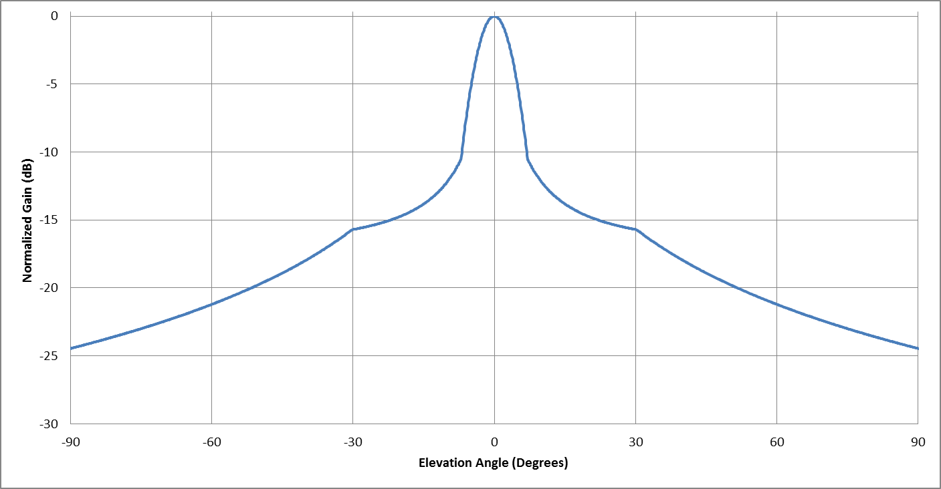

Figure 10: Vertical plane antenna pattern characteristic of the ECN Base Station (Macro BS)

Note: down-tilt not considered in the diagram

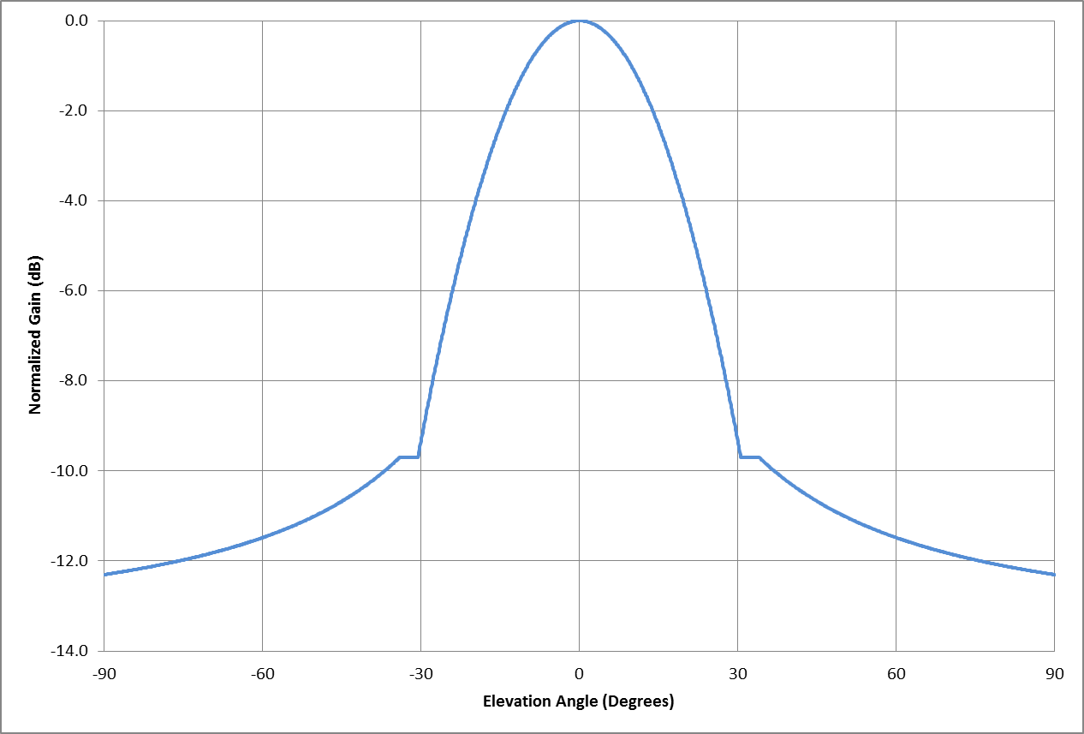

Figure 11: Vertical plane antenna pattern characteristic of the ECN Base Station (Micro BS)

### ECN User Terminal characteristics

The parameters listed in Table 10 are applicable to the ECN User Terminals (source ECC Report 197 [3], Table 4):

Table 10: ECN User Terminal parameters

| **ECN User Terminal parameters** | |
| --- | --- |
| Antenna Gain | 0 dBi (Omni) |
| Feeder Loss | 0 dB |
| Reference sensitivity | -117 dBm |
| Channel Bandwidth | 3.84 MHz |
| 1st channel ACS (± 5 MHz) | 33 dB |
| Noise Figure | 9 dB |
| Antenna height above ground level | 1.5 m |
| Rx thermal noise (Note 2) | -108 dBm/3.84 MHz |
| Rx noise floor (Note 3) | -99 dBm/3.84 MHz |

Note 1: The receiver parameters for ECN user terminals are applicable when operating in MCA systems, with the exception of the height a.g.l. parameter. It should be highlighted that for the study related to the on-board user-terminals used in an MCA system, the aircraft fuselage attenuation is considered in the range of 1-9 dB, but the final calculation is based on a single value (5 dB).

Note 2: This value has been calculated. Rx thermal noise = KTB, where K is the Boltzmann constant, T is 290 K and B is 3.84 MHz.

Note 3: This value has been calculated. Rx noise floor = Rx thermal noise + Rx noise figure

## PMSE and PPDR characteristics

The same technical framework and equipment, i.e. temporary video links and cordless cameras, may be foreseen for both PMSE and some ad-hoc PPDR applications and therefore a common set of technical parameters are used for both applications (CEPT Report 52, section 3.6 [13]). Consequently, the studies provided in this Report related to Video Link and Cordless Camera (VLCC) applications are based on PMSE systems supporting broadcasting, news gathering, theatrical productions and special events, such as cultural and sport events. Within broadcasting, these applications are commonly known as Services Ancillary to Programme making (SAP) and Services Ancillary to Broadcasting (SAB). The equipments are used in a variety of scenarios which are quite different from each other. For example, a cordless camera link might consist of a small hand-held camera transmitter and a small portable receiver. On the other hand, large TV trucks or even helicopters can be used to carry video link equipment which gives significant difference in antenna height and gain.

For the present study, three significant usage scenarios of PMSE use have been selected, as described in ECC Report 172 [21] and ECC Report 220 [15], which includes a collection of examples. ECC Report 220 and ECC Report 172 provide a summary of the scenarios, which are reported in Table 11. ECC Report 219 [14] also contains characteristics of PMSE systems, some of which differ slightly from these assumptions. For PMSE systems with different characteristics, the results may change, but are not expected to be significantly different.

Table 11: PMSE scenarios from ECC Report 220 [15] and ECC Report 172 [21]

|  | **Name** | **Transmitter** | **Tx Ant. Type, Gain, Height** | **Receiver** | **Rx Ant. Type, Gain, Height** |
| --- | --- | --- | --- | --- | --- |
| 1 | Cordless Camera Link | Portable Hand-Held camera | Semi-sphere omnidirectional, 5dBi, 1.5m | Portable hand-held receiver | Directional (e.g. Disk Yagi),  16 dBi, 1.5m |
| 2 | Mobile Video Link | Portable Camera on Motocycle | Semi-sphere omnidirectional, 5dBi, 1.5m | Receiver on helicopter | Semi-sphere omnidirectional,  5dBi, 150 m |
| 3 | Portable Video Link | Two-man radio camera | Directional (e.g. Disk Yagi), 16 dBi, 3m | TV Van | 1.2m Parabolic Dish,  27 dBi, 5m |

Since this study considers the transmitter and the receivers aligned on the same vertical plane (worst case), only the vertical antenna patterns are relevant and they are given in Figure 12 (normalised – Disk Yagi antenna) and Figure 13 (normalized – 1.2 m parabolic dish).



Figure 12: Vertical antenna pattern for Disk Yagi antenna



Figure 13: Vertical antenna pattern for parabolic dish

Additional parameters used for PMSE wireless video links scenarios are summarised in Table 12.

Table 12: Additional PMSE parameters

| **Additional parameters for PMSE** | |
| --- | --- |
| Occupied Bandwidth | 10 MHz |
| Channel Bandwidth | 8 MHz |
| Rx Antenna Direction | Pointed at interferer as worst case or depointed (25 dB attenuation due to depointing) |
| ACS | 30 dB |
| Rx thermal noise (Note 1) | -104.9 dBm/8 MHz |
| Rx noise figure | 4 dB |
| Rx noise floor (Note 2) | -100.9 dBm/8 MHz |
| I/N threshold | -6 dB |

Note 1: This value has been calculated. Rx thermal noise = KTB, where K is the Boltzmann constant, T is 290 K and B is 8 MHz.

Note 2: This value has been calculated. Rx noise floor = Rx thermal noise + Rx noise figure.

## MCA CHARACTERISTICS

Mobile communication on aircraft (MCA) systems cover the in-flight use of mobile phones and other devices to make calls, send and receive messages, and other communications such as e-mail.

In an aircraft fitted with MCA equipment, a controlled communications environment is established in the cabin, so all mobile phones connected to the MCA base station have their power level set to a specific value (see ECC/Decision (06)07 [16] for more details). MCA equipment consists of a pico-BS, and of a Network Control Unit (NCU) that ensures that the on-board mobile phones are only able to receive the signal transmitted by the on-board pico-BS and therefore can only register on it (if compatible). The NCU is effectively a noise generator which injects sufficient RF noise into the cabin to prevent the mobile phones on-board from being able to synchronise with terrestrial cellular networks. To ensure minimal risk to terrestrial networks, the use of MCA is restricted to aircraft cruising at an altitude of 3000 metres above the ground or above.

A detailed description of MCA systems can be found in ECC Report 093 [17] and ECC Report 187 [18].

MCA base station parameters can be found in ECC Report 93 [17] and 3GPP TR.136.931 [19].

Given that the length of the aircraft is considerably smaller than the separation distances considered in this study, the MCA base station antenna (a leaky feeder antenna) can be considered as omnidirectional.

ITU-R Report M.2039 [20] provides the channel bandwidth, ACS, noise figure and I/N threshold for compatibility analysis for UMTS pico-cell, and those characteristics provide a basis for MCA systems. The MCA base station parameters used in this study are summarised in Table 13.

Table 13: MCA Base Station parameters

| **MCA Base Station parameters** | |
| --- | --- |
| Channel Bandwidth | 3.84 MHz |
| Antenna Gain (leaky feeder) | -25 dBi (Omni) |
| 1st channel ACS (± 5 MHz) | 45 dB |
| RX Noise figure | 5 dB |
| I/N threshold | -6 dB |
| Reference noise level | -103 dBm/3.84MHz |

With regards to MCA mobile terminals, the parameters are the same as the ECN user terminals described in section 5.3.2

# ANALYSIS AND RESULTS

## Scenario 1

Scenario 1 considers the interference caused by an aeronautical terminal transmitting to the satellite into an ECN receiving base station operating in the 1920-1980 MHz band.

Figure 14 illustrates the interfering path.

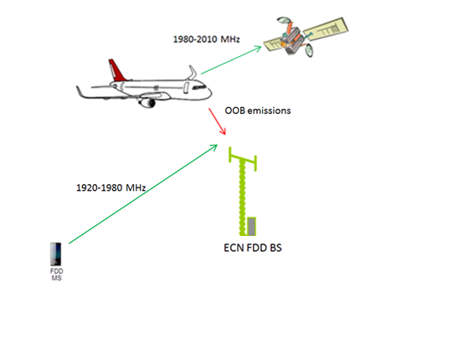

Figure 14: Scenario 1

The methodology used is based on the I/N calculation at the ECN base station. For the I/N computation, the resulting adjacent channel interference ratio (ACIR) is required. The ACIR is a parameter quantifying the interference caused in the adjacent channel. It’s a function both of the victim receiver’s ability to reject signals in the adjacent channels (ACS) and is also a function of the out-of–band spurious power emitted by the undesired transmitter (ACLR). The relationship between ACIR, ACLR and ACS is as follows:

$$ACIR=\frac{1}{\left(\frac{1}{ACLR}+\frac{1}{ACS}\right)}$$

In this scenario, the ACIR is 29.9 dB, as a result of the combination of the ACLR of the transmitter on the aircraft (30 dB) and the ACS of the ECN BS receiver (46 dB).

The I/N at the receiver can be calculated with the following formula:

$$\frac{I}{N}= P_{T}+G_{T}+G_{R}-FL-FSL-ACIR-KTB-NF$$

where:

* $P_{T}$ is the maximum power transmitted by the aeronautical terminal (dBW);
* $G_{T}$ is the antenna gain of the aeronautical terminal (dBi) in the direction of the ECN Base Station;
* $G_{R}$ is the antenna gain of the ECN BS (dBi) in the direction of the aircraft, taking into account both the downtilt of the antenna and the elevation angle to the aircraft;
* $FL$ is the feeder loss of the receiver;
* $FSL$ is the Free Space Loss at distance (dB);
* $ACIR$ is the Adjacent Channel Interference Ratio (dB) – explained above;
* $KTB$ is the Thermal Noise Power assuming T = 290 K (dBW);
* $NF$ is the noise figure of the receiver (dB).

The previous formula shows that the interference to noise ratio is directly proportional to the antenna gain of the ECN BS and inversely proportional to the feeder loss and to the noise power. As a possible method to compare the I/N for the three different types of ECN base stations, and to understand which BS is the most sensitive to the interference, the formula below was developed:

$$ß= G_{R}- FL- KTB-NF$$

The base station with the highest ß is the most sensitive to the interference.

Figure 15 represents $ß$ for the different types of ECN BS: since $G_{R}$ is the antenna gain of the ECN BS in the direction of the aircraft, $ß$ depends on the angle of arrival at the Earth’s surface. The figure shows that the most sensitive BS to interference is the macro BS for any angle of arrival at Earth’s surface. Therefore this Report considers the impact on the worst case situation only, i.e. the considered victim is the ECN macro BS.

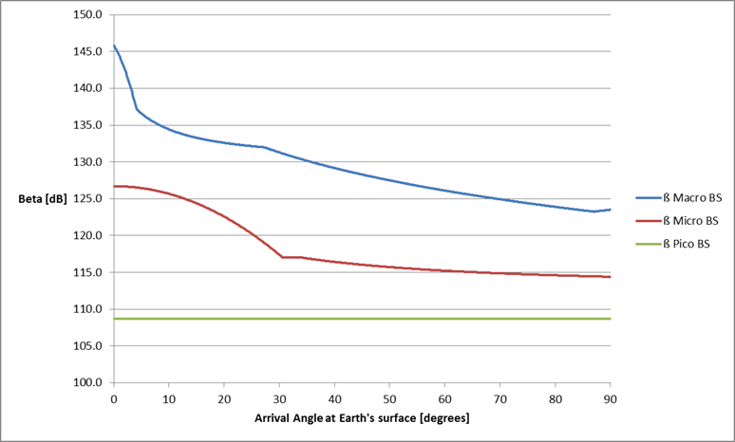

Figure 15: ECN BS sensitivity to interference (ß)

With respect to interference, the worst case assumption is to have line-of-sight propagation between interferer and victim. Therefore, only free space loss was applied. Furthermore, the victim and the interferer have been positioned on the same vertical plane. The geometry of the scenario is shown in Figure 16. In real scenarios there may be a reduction of the interfering signal due to horizontal antenna gain discriminations or to shadowing, resulting in improved system performance compared to the results given in the present analysis. Additionally, it should be noted that this Report uses a flat Earth model: the justification for this simplification is provided in ANNEX 1:

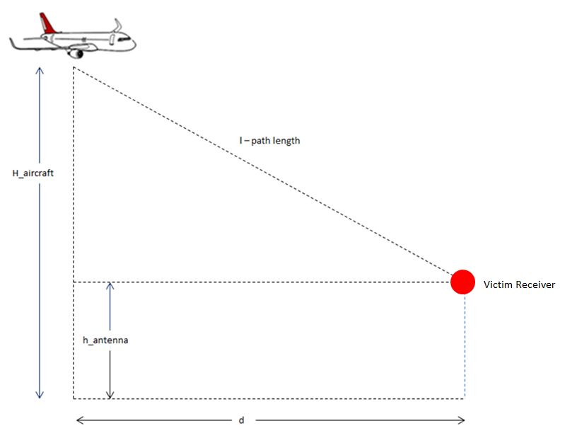

Figure 16: Illustration of the path length and the distance d

The graphs in Figure 17, Figure 18, Figure 19 and Figure 20 show the I/N at the ECN Macro BS receiver for different aircraft altitudes a.g.l., as a function of the distance d represented in Figure 16.

The I/N level will depend on the elevation angle of the aircraft satellite antenna. For lower elevation angles, the interference toward the ground increases. Even for lower elevation and lower altitudes a.g.l. (i.e. 10° elevation and 3000 m altitude a.g.l.), the I/N does not exceed the threshold. However, at an altitude of 1000m a.g.l. the I/N level exceeds the threshold for distance up to 25 km if elevation angles are lower than 15 degrees. Some additional signal blockage from the fuselage could be expected, since the aircraft satellite antenna will be installed on the top of the plane but this is not taken into account in the analysis.

The additional mitigation of the out-of-band emissions from the aeronautical terminal into the 1920-1980 MHz band required when aircraft is at 1000 m altitude a.g.l. to meet the protection criteria I/N = -6 dB is shown in Table 14. This additional mitigation can be achieved by decreasing the power transmitted by the aeronautical terminal in the band 1980-2010 MHz (i.e. by decreasing the maximum power transmitted) or improving the emission mask.

In non-interference limited areas and where several cells are impacted by interference simultaneously, from the aeronautical terminal, the evaluation criteria I/N = -10dB is applicable according to ITU-R Report M.2039-3.

Table 14: Additional mitigation according to elevation angle (when aircraft is at 1000 m altitude a.g.l.)

| Elevation angle (degrees) | Attenuation (dB) (I/N=-6dB) |
| --- | --- |
| 10 | 1,5 |
| 15 | 0 |
| 20 | 0 |

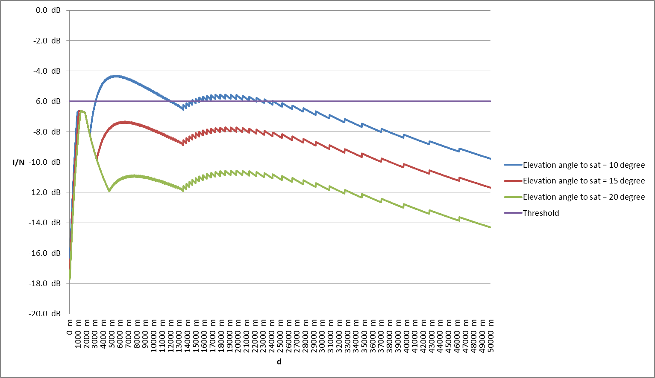

Figure 17: I/N at ECN Macro BS from aircraft at 1000 m altitude a.g.l. transmitting to satellite

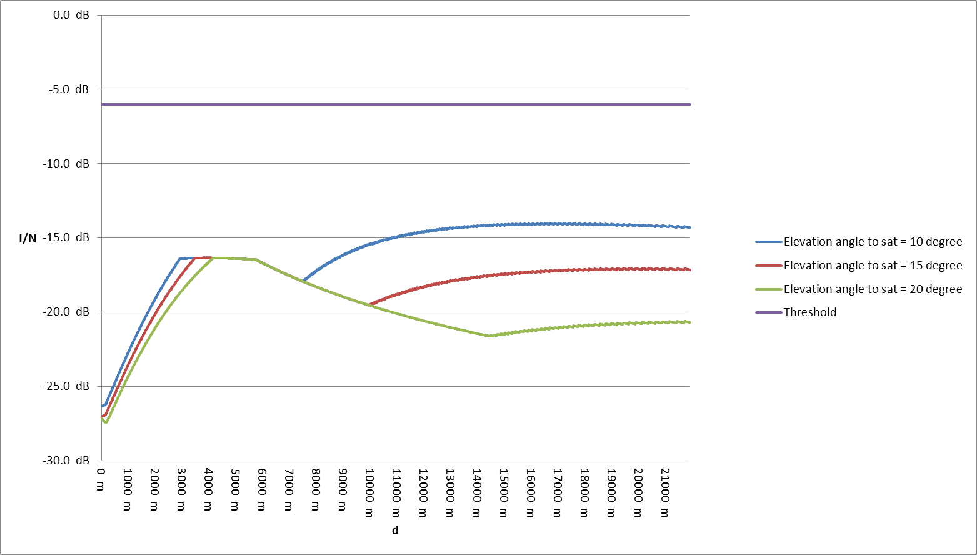

Figure 18: I/N at ECN Macro BS from aircraft at 3000 m altitude a.g.l. transmitting to satellite

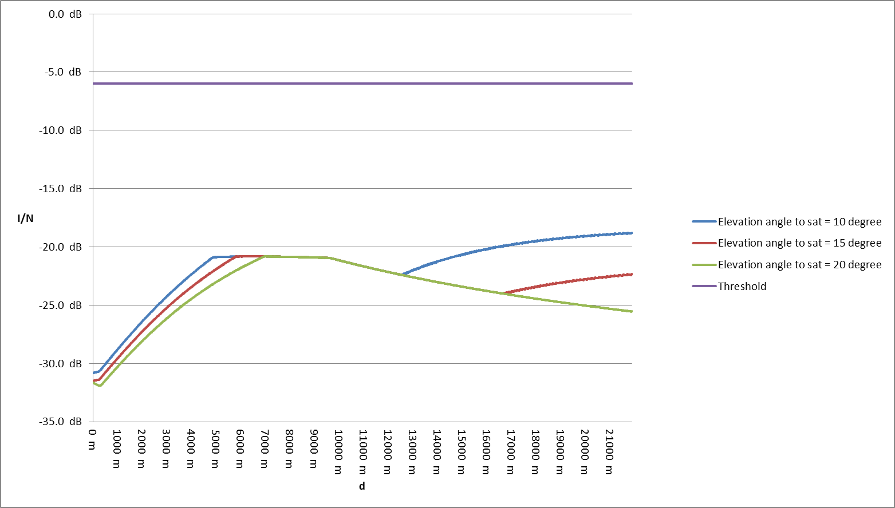

Figure 19: I/N at ECN Macro BS from aircraft at 5000 m altitude a.g.l. transmitting to satellite

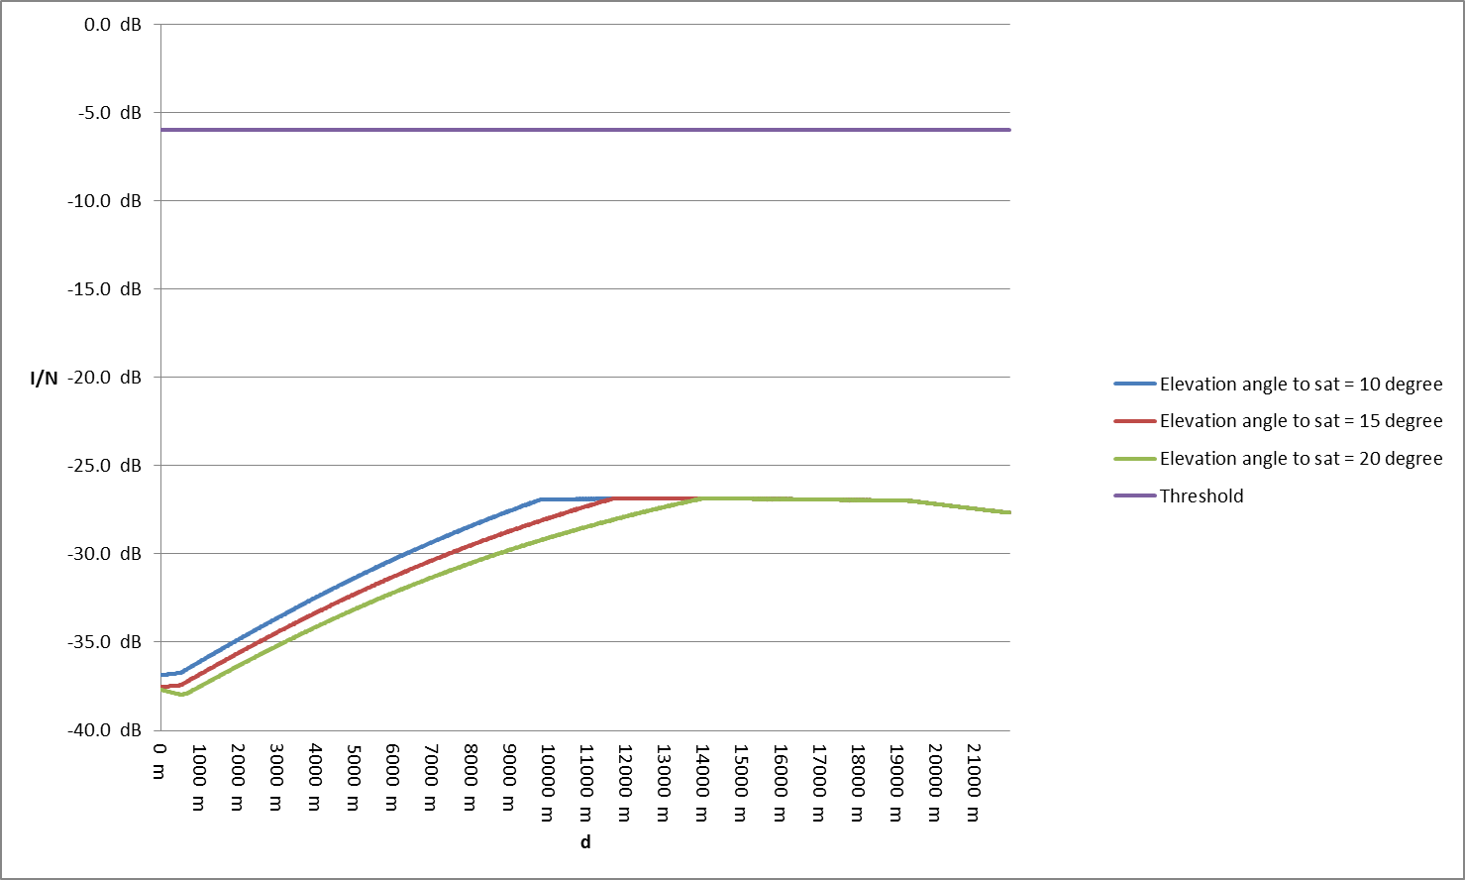

Figure 20: I/N at ECN Macro BS from aircraft at 10000 m altitude a.g.l. transmitting to satellite

## Scenario 2

Scenario 2 considers the interference caused by an aeronautical terminal transmitting to an aeronautical CGC ground station into an ECN receiving macro base station operating in the 1920-1980 MHz band.

Figure 21 illustrates the interfering path.

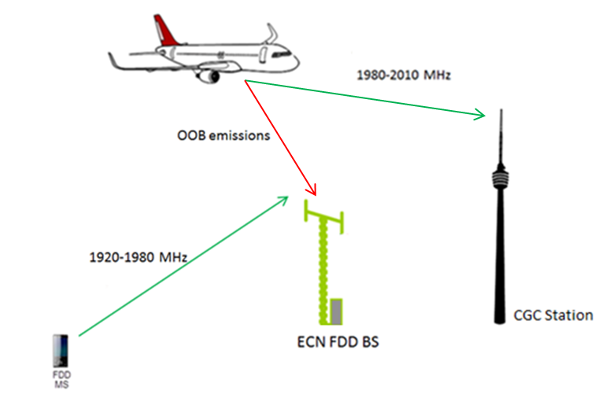

Figure 21: Scenario 2

Figure 22 shows the I/N at the ECN BS receiver for different aircraft altitudes a.g.l., as a function of the distance d represented in Figure 16. In this scenario, the ACIR is 36.5 dB, as a result of the combination of the ACLR of the transmitter on the aircraft (37 dB) and the ACS of the ECN BS receiver (46 dB).

The I/N never exceeds the threshold for 3000 m altitudes a.g.l.; at 1000 m altitudes above ground level, power control could be applied in order to reduce the maximum e.i.r.p. transmitted by the aeronautical terminal according to the flight altitude a.g.l.. (A similar mitigation technique has been proposed also in ECC Report 209 [11], Section 4.3.9, Table 17, for DA2GC systems). Alternatively, the out-of-band emissions could be reduced by improving the transmission filters.

The additional attenuation of the out-of-band emissions from the aeronautical terminal into the 1920-1980 MHz band required to meet the protection criteria I/N = -6 dB is shown in Table 15. This additional attenuation can be achieved by decreasing the power transmitted by the aeronautical terminal in the band 1980-2010 MHz (i.e. by decreasing the maximum power transmitted) or improving the emission mask.

In non-interference limited areas and where several cells are impacted by interference simultaneously, from the aeronautical terminal, the evaluation criteria I/N = -10dB is applicable according to ITU-R Report M.2039-3 [20].

Table 15: Additional attenuation according to the aircraft altitude a.g.l.

| Altitude a.g.l.  (metres) | Attenuation (dB) (I/N=-6dB) |
| --- | --- |
| 1000 | 4 |
| 3000 to 10000 | 0 |

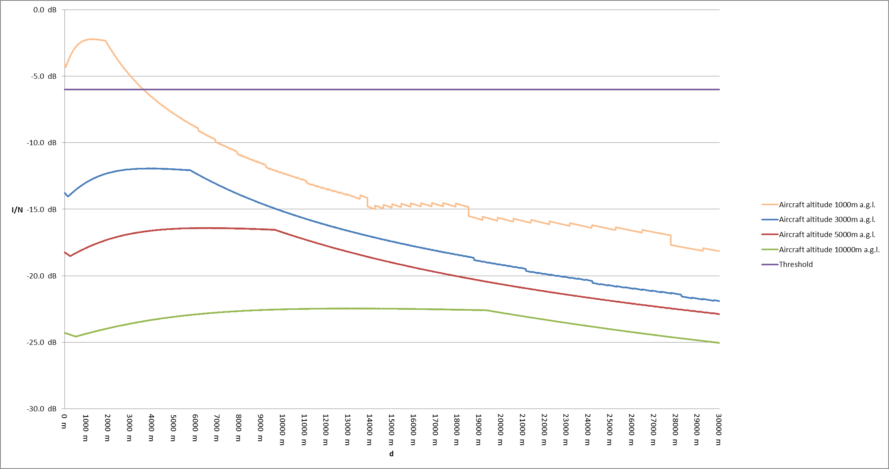

Figure 22: I/N at ECN BS from aeronautical terminal transmitting to Aeronautical CGC GS

The maximum power flux density at the ground which meets the protection requirement for the ECN base station can be calculated from the following formula:

$$P_{T}+G_{T}+G_{R}-FL-FSL-ACIR-KTB-NF= I/N$$

Isolating the Tx e.i.r.p.:

$$P_{T}+G_{T}=-G_{R}+FL+FSL+ACIR+KTB+NF+I/N$$

The maximum power flux density ${PFD}_{MAX, IN}$ can be obtained from the above formula, substracting on both terms 10 times the logarithm of the sphere surface with radius $l$ and considering the ${I/N}_{threshold}$ protection criteria:

$${{PFD}_{MAX, IN}=P}_{T}+G_{T}-10\log\left(4πl^{2}\right)$$

$$=-G_{R}+FL+10\log\left[{\left(4π\right)}^{2}l^{2}\frac{f^{2}}{c^{2}}\right]+ACIR+KTB+NF+{I/N}_{threshold}-10log⁡(4πl^{2})$$

Assuming that the ACIR is dominated by the ACLR, the out-of-band PFD on the ground, for which the protection criterion of the ECN BS is just met, is the following:

$${{PFD}_{MAX, OOB}=-G_{R}+FL+10log\left(4π\frac{f^{2}}{c^{2}}\right)+KTB+NF+I/N}_{threshold}$$

Since $G_{R}$ is the antenna gain of the ECN BS in the direction of the aircraft, the maximum PFD depends on the angle of arrival at the Earth’s surface and it’s represented in

Figure 23

Figure 23 also shows the mask that provides adequate protection to ECN BS receiving in the 1920 - 1980 MHz, deployed or planned to be deployed in CEPT countries. The mask is the following:

$$PFD\left(δ\right)= 2*δ-125.5 dB\left(W/{m^{2}}\right) for 0°≤δ≤5°$$

$$PFD\left(δ\right)= \frac{13}{85}*δ -116.3 dB\left(W/{m^{2}}\right) for 5°<δ≤90°$$

where $δ$ is the angle of arrival at the Earth’s surface (degrees above the horizontal) and the PFD is calculated in a reference of 5 MHz.

The PFD mask proposed is applicable to any aeronautical terminal and is a threshold not to be exceeded in order to protect ECN BSs operating in adjacent band.,

The analysis considers interference from a single aircraft terminal at any moment in time, although in practice several aircraft may be visible to the ECN BS. This simplified analysis may be considered valid based on the following factors which mitigate the impact of multiple aircraft:

* antenna discrimination in the azimuth plane is not taken into account at the ECN BS and at the aeronautical terminal;
* for the ECN BS peak-side lobe pattern is assumed;
* in practice aircraft will not exactly meet the PFD mask for every elevation angle, for most elevation angles additional margin will exist.
* It is expected that the aeronautical CGC system will use TDMA/FDMA, for which in most cases one aeronautical terminal within a sector or within a satellite beam will transmit on a given frequency.

In those cases where the effects of aggregated interference from several aeronautical terminals towards ECN BSs should be considered, specific planning of CGC ground stations for communication with aeronautical terminals at altitudes below 3000m a.g.l. may be required (see example in ANNEX 2:).

Furthermore, in the European Union (EU), the 2 GHz MSS bands are divided between two MSS operators through Commission Decision 2009/449/EC: one MSS system in 1980-1995 MHz and 2170-2185 MHz, and the other one in 1995-2010 MHz and 2185-2200 MHz. This represents within the EU another scenario of adjacent band operations between aeronautical CGCs of an MSS system and conventional CGCs of another MSS system, similar to Scenario 2 for ECN BS in 1920-1980 MHz. For this scenario, *the proposed power flux density limitations for Aeronautical CGC systems to protect ECN BS can also be applied* within the band 1980-2010 MHz to protect other MSS systems using conventional CGCs, on the condition that the characteristics of the CGC GSs are similar to those of the ECN BS considered in this Report.

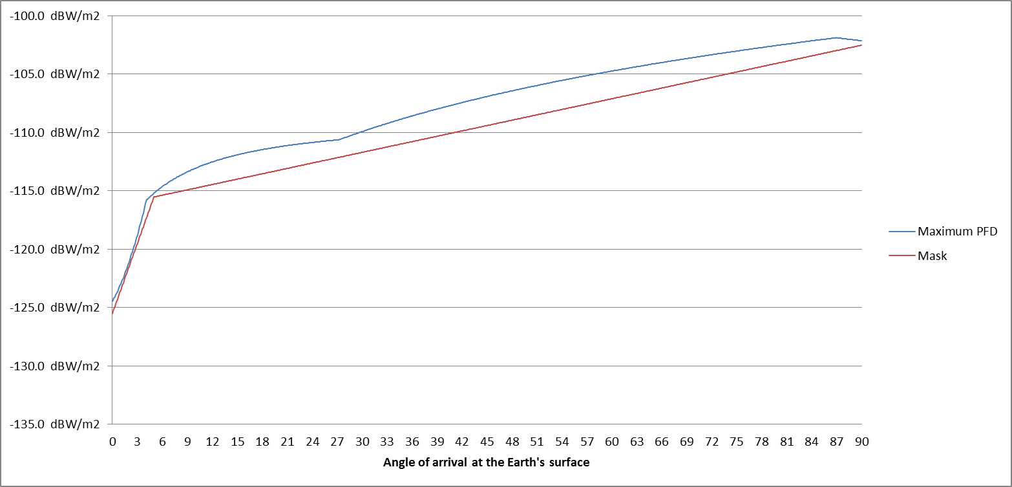

Figure 23: Maximum PFD at ECN BS (5 MHz reference)

## Scenario 3

Scenario 3 considers the interference caused by an aeronautical terminal transmitting to an Aeronautical CGC ground station in the band 1980-2010 MHz into a DA2GC ground station operating in the 2010-2025 MHz band.

Figure 24 illustrates the interfering path.

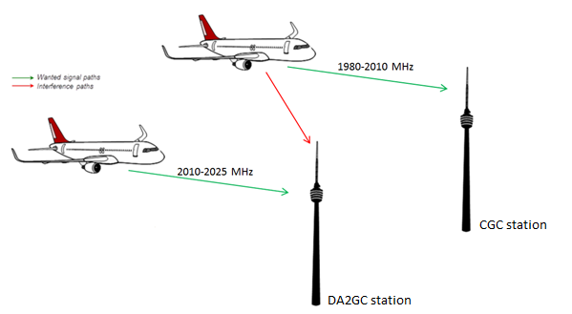

Figure 24: Scenario 3

The methodology used is based on the I/N calculation at the DA2GC base station.

In this scenario, the ACIR is 36.1 dB, as a result of the combination of the ACLR of the transmitter on the aircraft (37 dB) and the ACS of the DA2GC receiver (43.5 dB).

Figure 25 shows the I/N at the DA2GC ground station receiver for different aircraft altitudes a.g.l., as a function of the distance d as represented in Figure 16. The I/N at the DA2GC ground station receiver could exceed the criterion of -6 dB up to a distance of 30 km from the DA2GC ground station, depending on the altitude a.g.l. of the interferer. Nevertheless, it has to be noted that the power control feature of the aeronautical terminal is not applied, i.e. the signal is assumed to be transmitted with full power of 37 dBm. As per scenario 2, power control could be applied to reduce the e.i.r.p. transmitted by the aeronautical terminal according to the flight altitude a.g.l. or the out-of-band emissions could be reduced. When the aircraft will be close to the aeronautical CGC ground station, it will reduce the transmitted power by up to 63 dB. In this case the I/N will not exceed the criterion even for lower altitudes and the power flux density will meet the protection requirement for the DA2GC ground station. An additional possible mitigation would be to install the aeronautical CGC ground stations and DA2GC ground stations at the same or nearby locations, so that the aeronautical CGC aeronautical terminal would transmit at high power only when located a large distance from both the CGC ground station and the DA2GC ground station, keeping interference below the criterion.

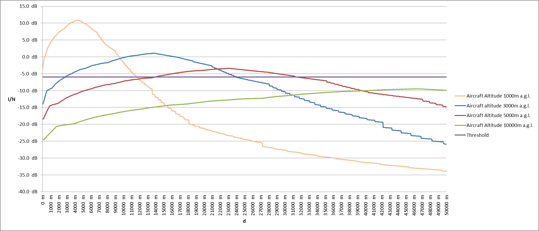

Figure 25: I/N at DA2GC ground station from aeronautical terminal transmitting to Aeronautical CGC ground station

The additional attenuation of the out-of-band emissions from the aeronautical terminal into the 2010-2025 MHz band required to meet the protection criteria I/N = -6 dB is shown in Table 13. This additional attenuation can be achieved by decreasing the power transmitted by the aeronautical terminal in the band 1980-2010 MHz (i.e. by decreasing the maximum power transmitted) or improving the emission mask.

Table 16: Additional attenuation according to the aircraft altitude a.g.l.

| Altitude a.g.l. (metres) | Attenuation (dB) |
| --- | --- |
| 1000 | 17 |
| 3000 | 7 |
| 5000 | 3 |
| 10000 | 0 |

As shown in Scenario 2, assuming that ACIR is dominated by the ACLR, the out-of-band PFD on the ground, for which the protection criterion of the DA2GC ground station is just met, is the following:

$${{PFD}_{MAX, OOB}=-G_{R}+10log\left(4π\frac{f^{2}}{c^{2}}\right)+KTB+NF+I/N}_{threshold}$$

Since $G_{R}$ is the antenna gain of the DA2GC ground station in the direction of the aircraft, the maximum PFD depends on the angle of arrival at the Earth’s surface and is represented in Figure 26. Figure 26 also shows the PFD mask that provides adequate protection to the DA2GC ground station receiving in the 2 010 - 2 025 MHz proposed to be deployed in CEPT countries. The mask is the following:

$$PFD\left(δ\right)= -{23}/7*δ-105 dB\left(W/{m^{2}}\right) for 0°≤δ≤7°$$

$$PFD\left(δ\right)= -128 dB\left(W/{m^{2}}\right) for 7°<δ≤12°$$

$$PFD\left(δ\right)= {29}/{78}*δ -132.5 dB\left(W/{m^{2}}\right) for 12°<δ≤90°$$

where $δ$ is the angle of arrival at the Earth’s surface (degrees above the horizontal) and the PFD is calculated in a reference bandwidth of 10 MHz.

The PFD mask proposed, is applicable to any aeronautical terminal, and is a threshold not to be exceeded in order to protect adjacent DA2GC GSs.

Where for example co-siting of aeronautical CGC ground stations and DA2GC ground stations is employed, it may be possible to relax the pfd requirements.

The analysis considers interference from a single aircraft terminal at any moment in time, although in practice several aircraft may be visible to the DA2GC ground station. This simplified analysis may be considered valid based on the following factors which mitigate the impact of multiple aircraft:

* antenna discrimination in the azimuth plane is not taken into account at the DA2GC ground station and at the aeronautical terminal;
* for the DA2GC ground station peak-side lobe pattern is assumed;
* in practice aircraft will not exactly meet the PFD mask for every elevation angle, for most elevation angles additional margin will exist.
* It is expected that the aeronautical CGC system will use TDMA/FDMA, for which, in most cases one aeronautical terminal within a sector or within a satellite beam will transmit on a given frequency. In those cases where the effects of aggregated interference, from several aeronautical terminals, towards ECN BSs should be considered, specific planning of CGC Ground Stations for communication with aeronautical terminals at altitudes below 3000m a.g.l. may be required (see example in ANNEX 2:).

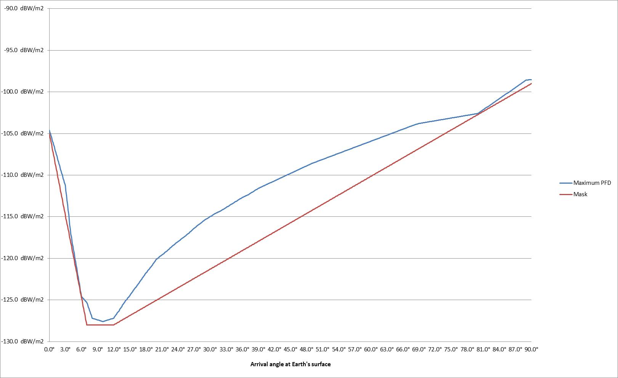

Figure 26: Maximum PFD at DA2GC GS (10 MHz reference)

## Scenario 4

Scenario 4 considers the interference caused by an aeronautical terminal transmitting to a satellite into a DA2CG ground station operating in the 2010-2025 MHz band. Figure 27 illustrates the interfering path.

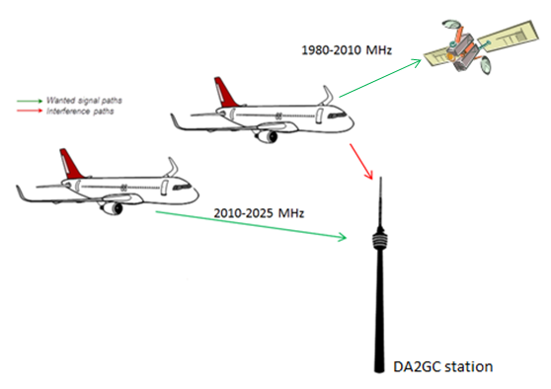

Figure 27: Scenario 4

The methodology used is based on the I/N calculation at the DA2GC ground station.

In this scenario, the ACIR is 29.8 dB, as a result of the combination of the ACLR of the transmitter on the aircraft (30 dB) and the ACS of the DA2GC receiver (43.5 dB).

The graphs in Figure 28, Figure 29, Figure 30 and Figure 31 show the I/N at the DA2GC ground station receiver for different aircraft altitudes a.g.l., as a function of the distance d represented in Figure 16. It is assumed in the analysis that the DA2GC GS and the aircraft are in the same vertical plane, meaning that no azimuthal discrimination has been considered, whereby the maximum possible aeronautical terminal antenna gain is taken in the calculations. In reality, additional azimuthal antenna discrimination would be available, in most cases leading to lower interference levels than those calculated in this Report.

When the aircraft is at 1000m altitude a.g.l., the I/N at the DA2GC BS receiver could exceed the threshold. At 3000 m altitude a.g.l., the protection criteria could be exceeded for elevation angles lower than 20°. At 5000 m, the protection criteria could be exceeded for elevation angles lower than 15°. At 10000 m altitude a.g.l., the protection criterion is never exceeded. Some additional signal blockage from the fuselage could be expected, since the aircraft satellite antenna will be installed on the top of the plane but that is not considered in the analysis.

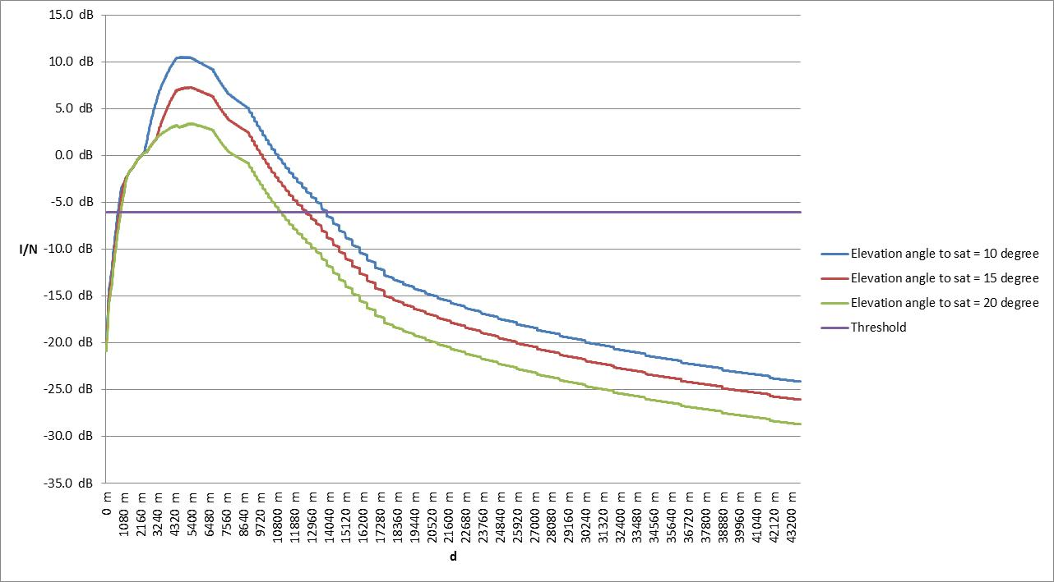

Figure 28: I/N at DA2GC GS from aircraft at 1000 m altitude a.g.l. transmitting to satellite

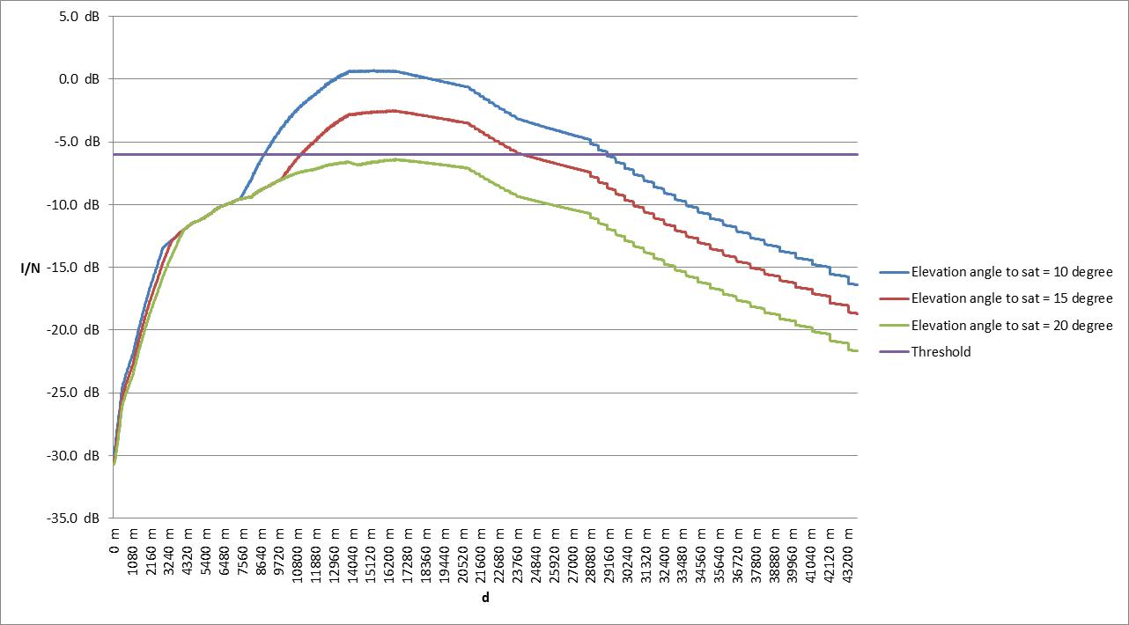

Figure 29: I/N at DA2GC GS from aircraft at 3000 m altitude a.g.l. transmitting to satellite

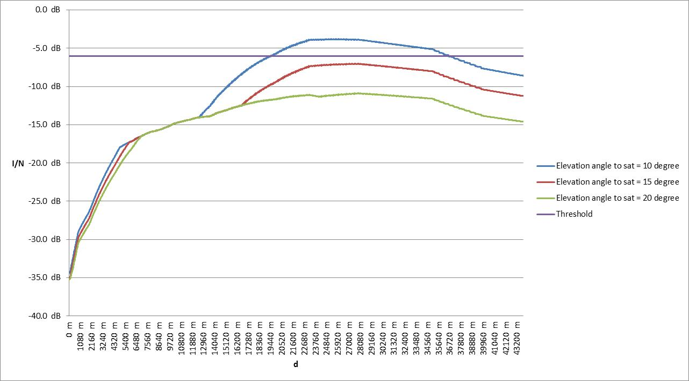

Figure 30: I/N at DA2GC GS from aircraft at 5000 m altitude a.g.l. transmitting to satellite

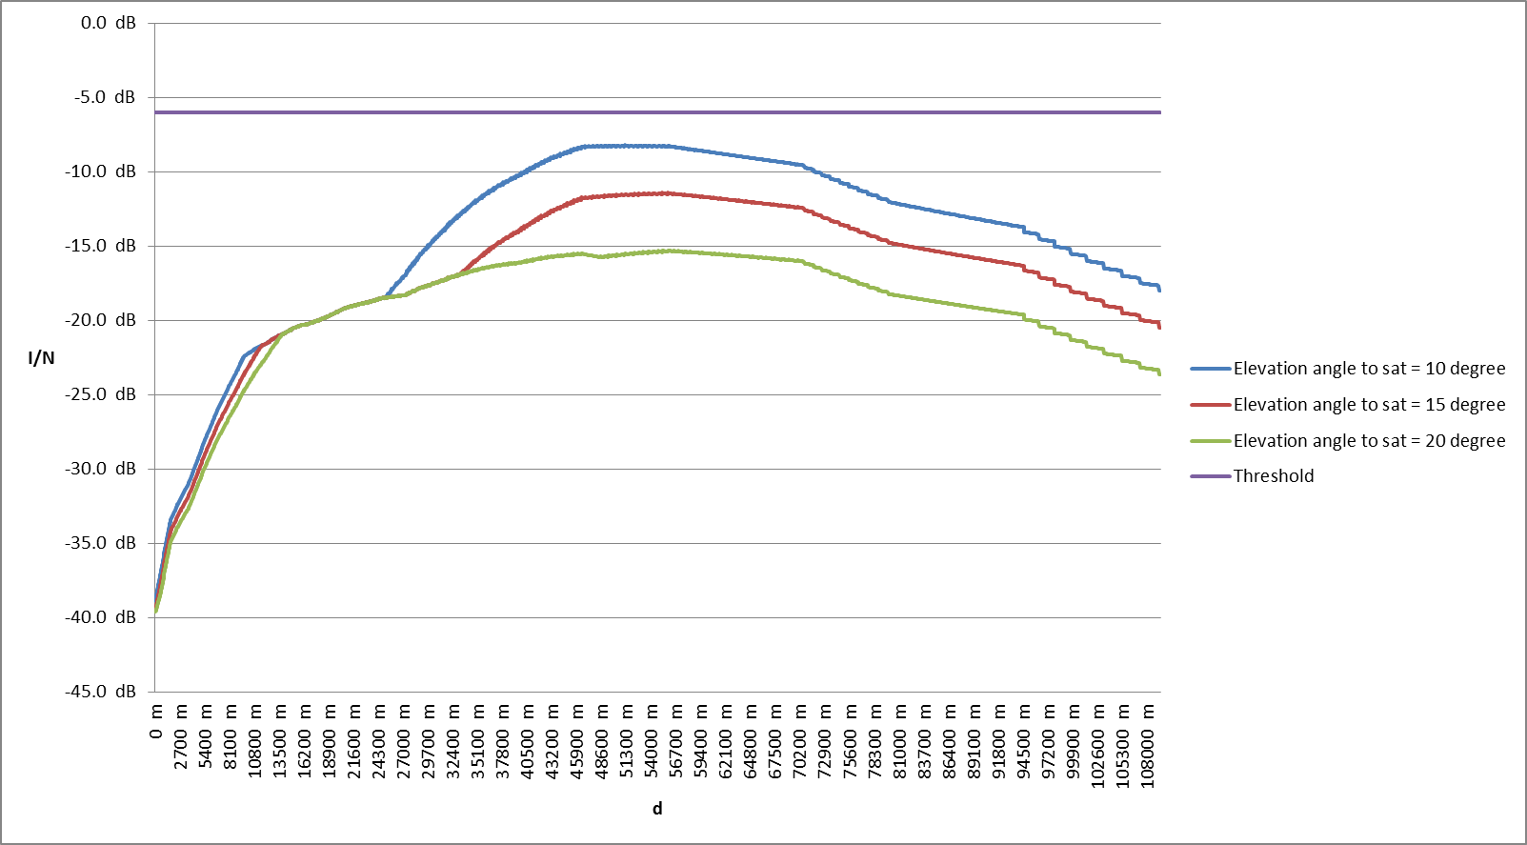

Figure 31: I/N at DA2GC GS from aircraft at 10000 m altitude a.g.l. transmitting to satellite

The PFD on the ground, for which the protection criterion of the DA2GC ground station is met, is the same as that determined in Scenario 3. Consequently, the pfd threshold determined in section 6.3 may be applied to the aeronautical terminal, irrespective of whether it is transmitting to the ground station or to the satellite.

## Scenario 5

Scenario 5 considers the interference created by an aeronautical terminal, transmitting to the aeronautical CGC ground station, into a VLCC receiver operating in the 2010-2025 MHz band. As already explained in section 4.6, this study is limited to three different types of PMSE receivers, which represent the variety of PMSE currently in the market. The same technologies and equipment may be used for ad-hoc PPDR, therefore the results of this Report may be applied to every kind of VLCC application. The interference scenarios are shown in Figure 32, Figure 33 and Figure 34.

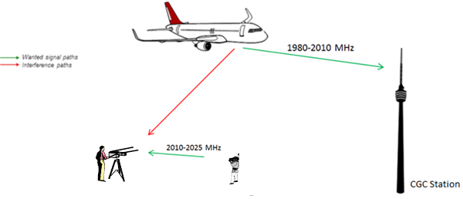

Figure 32: Scenario 5, interference to Cordless Camera Link (CCL)

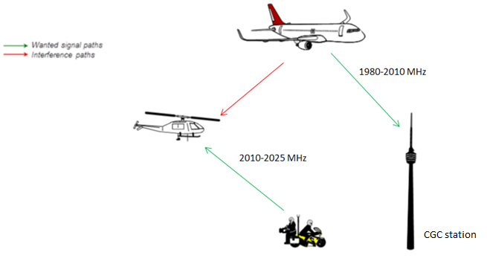

Figure 33: Scenario 5, interference to Mobile Video Link (MVL)

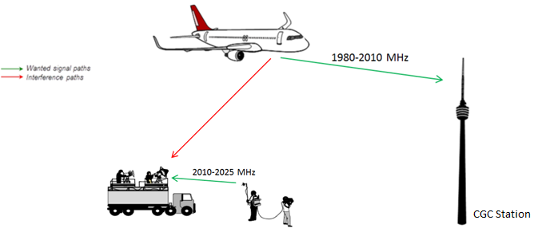

Figure 34: Scenario 5, interference to Portable Video Link (PVL)

The initial analysis is based on the worst case, meaning that the aeronautical terminal is transmitting with maximum power and the receiver antenna beam is pointed toward the interferer, in line-of-sight.

The methodology used is based on the I/N calculation at the PMSE receiver. It should be noted that the considered ACS of PMSE systems is quite low (30 dB), and consequently the overall ACIR is limited by the inability of the PMSE receiver to reject signals in the adjacent channel.

The graphs in Figure 35, Figure 36, Figure 37 and Figure 38 show the I/N at the victim receiver for this worst case scenario, as a function of the distance d represented in Figure 16. In the case of adjacent channel operation, the resulting ACIR is not sufficient to reduce the interference impact below the I/N threshold in all cases.

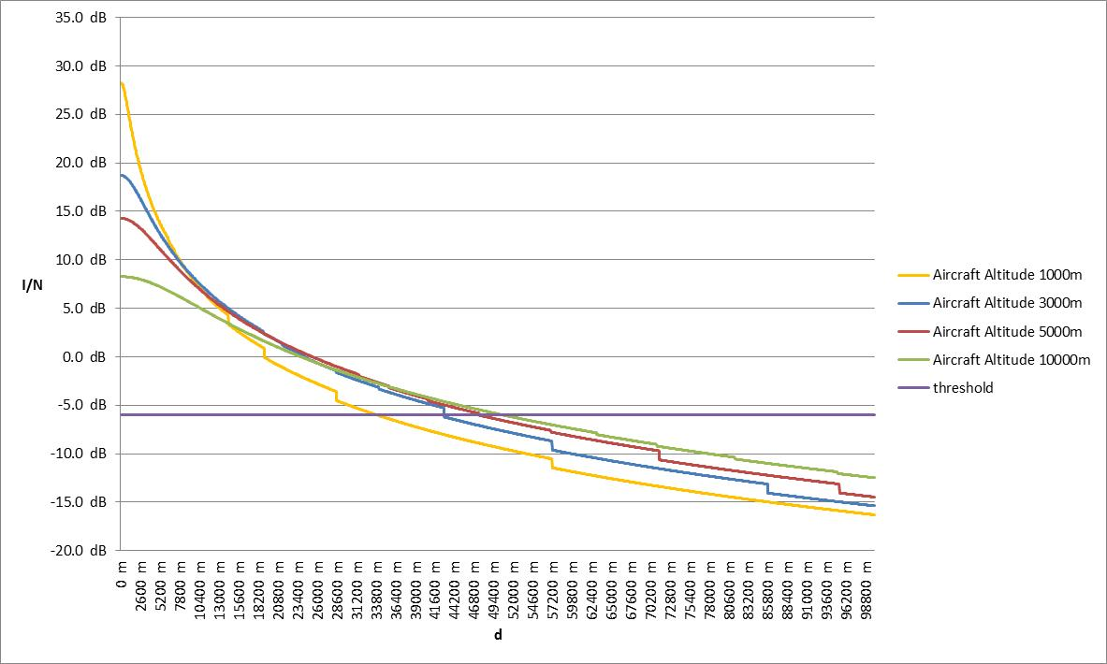

Figure 35: I/N at CCL receiver from aeronautical terminal transmitting to Aeronautical CGC GS   
(worst case)

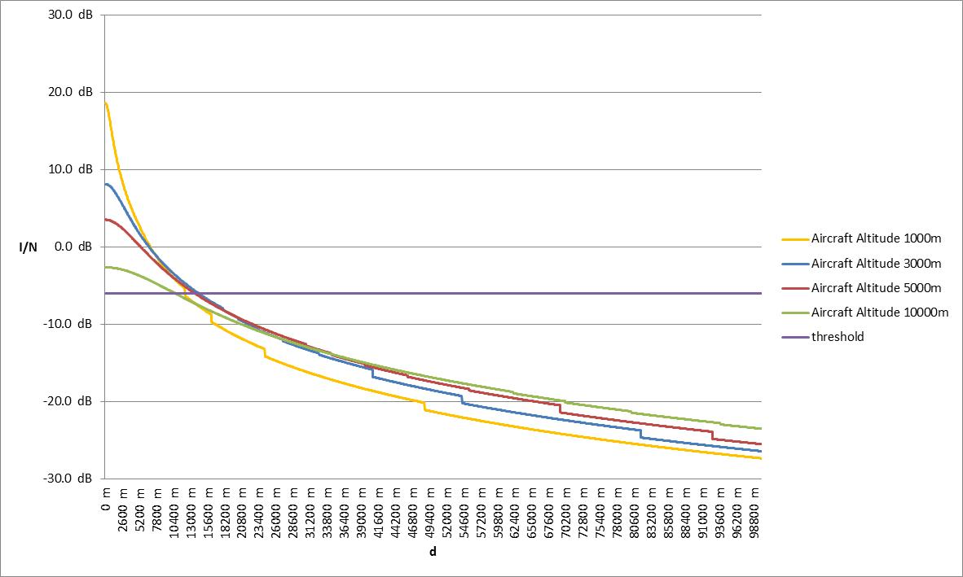

Figure 36: I/N at MVL receiver from aeronautical terminal transmitting to Aeronautical CGC GS   
(worst case)

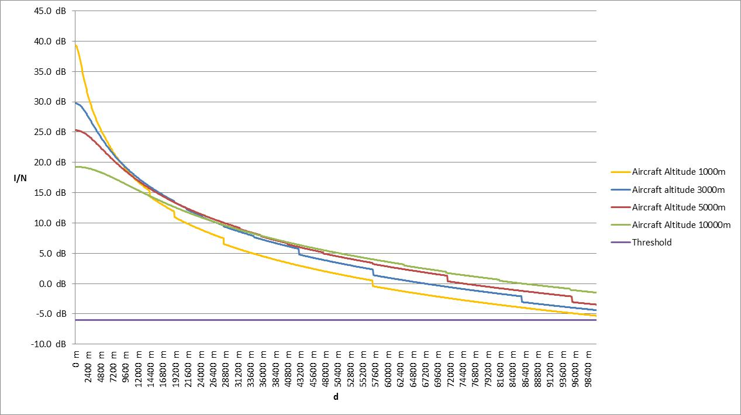

Figure 37: I/N at PVL receiver from aeronautical terminal transmitting to Aeronautical CGC GS   
(worst case)

The interference power will be reduced if the adjustment of the receiving dish antenna is only slightly changed or if the line-of-sight condition between the receiver antenna and the aircraft is affected. In a real environment the receiving antenna diagram will have an attenuation (up to 20-25 dB) in the direction to the aircraft and the interfering signal power could be further decreased by ground clutter (building, vegetation etc.). In addition the interference probability will be further reduced by the transmit power control feature of the aircraft system. Figure 38, Figure 39 and Figure 40 provide the I/N with a reduced gain of the receiving PMSE antenna (reduction applied 25 dB).

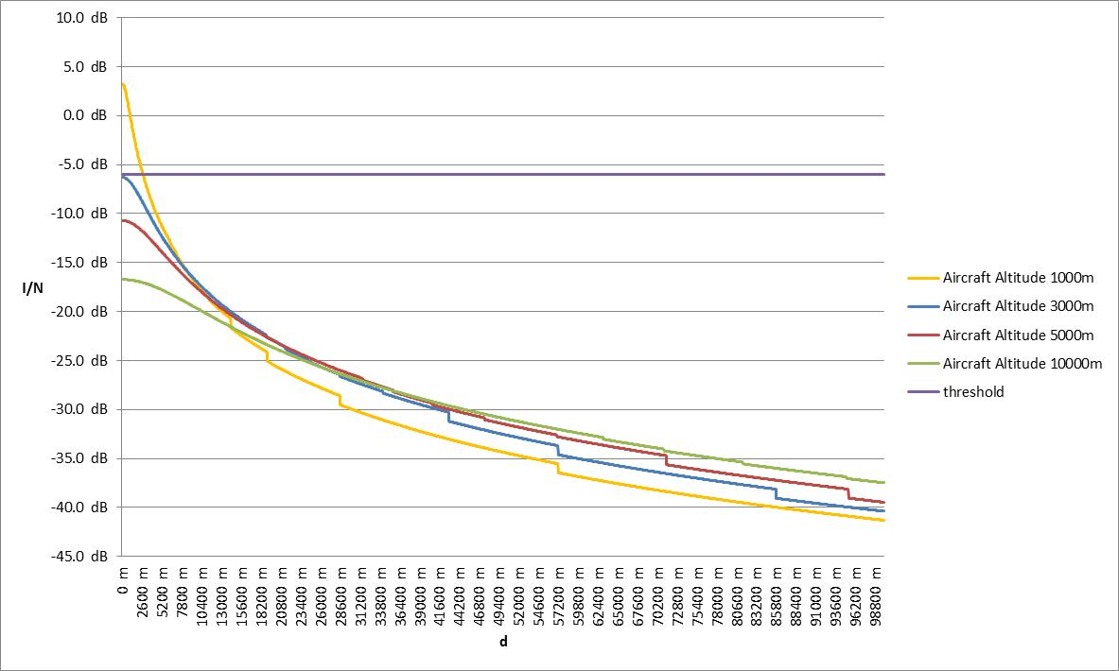

Figure 38: I/N at CCL receiver from aeronautical terminal transmitting to Aeronautical CGC GS (depointed Rx)

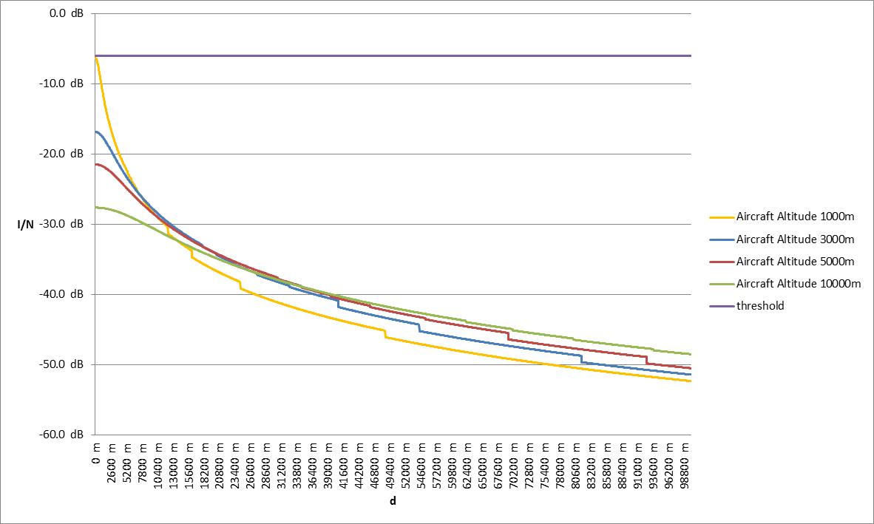

Figure 39: I/N at MVL receiver from aeronautical terminal transmitting to Aeronautical CGC GS (depointed Rx)

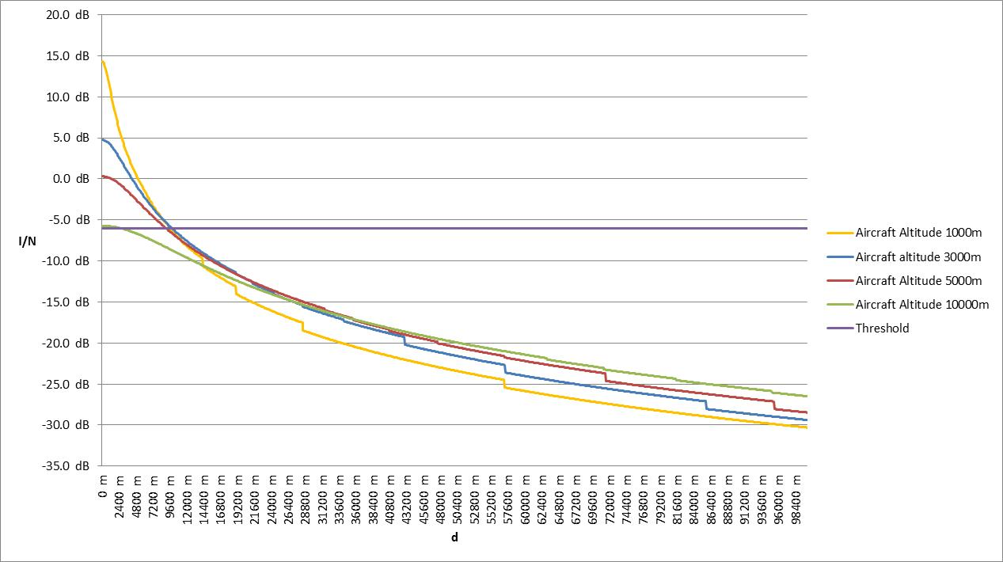

Figure 40: I/N at PVL receiver from aeronautical terminal transmitting to Aeronautical CGC GS (depointed Rx)

## Scenario 6

Scenario 6 considers the interference created by an aeronautical terminal transmitting to Aeronautical CGC GS, transmitting to the satellite station, into a PMSE receiver operating in the 2010-2025 MHz band. The interference scenarios are shown in Figure 41, Figure 42 and Figure 43.

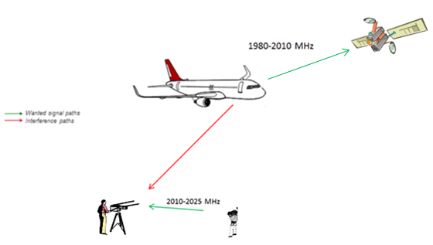

Figure 41: Scenario 6, interference to Cordless Camera Link (CCL)

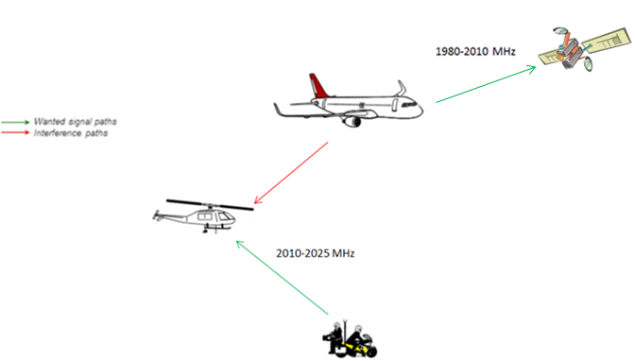

Figure 42: Scenario 6, interference to Mobile Video Link (MVL)

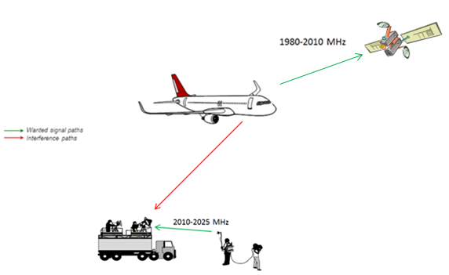

Figure 43: Scenario 6, interference to Portable Video Link (PVL)

The methodology used is based on the I/N calculation at the PMSE receiver. Figure 44 to Figure 55 provide the I/N trends for different types of PMSE receivers (CCL, MVL and PVL), interferer altitudes a.g.l. (1000 m, 3000 m, 5000 m and 10000 m) and different elevation angles of the aircraft antenna pointing to satellite (10°, 15° and 20°), as a function of the distance d represented in Figure 16. In each case, it is assumed that the PMSE receiver and the azimuth of the aeronautical terminal are in the same plane, which is a worst case assumption.

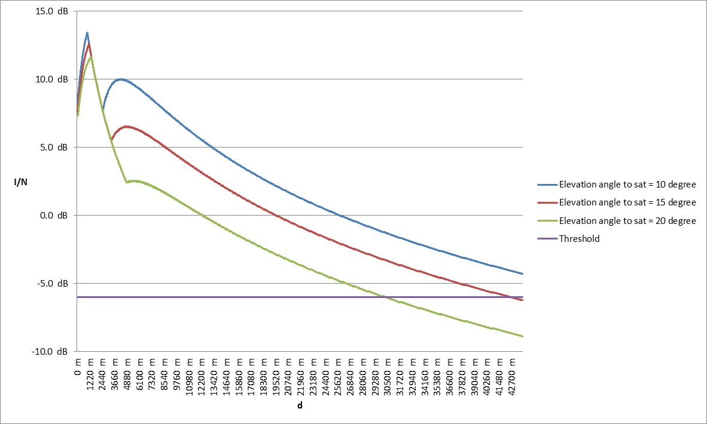

Figure 44: I/N at CCL Rx from aircraft at 1000m altitude a.g.l. transmitting to satellite   
(worst case)

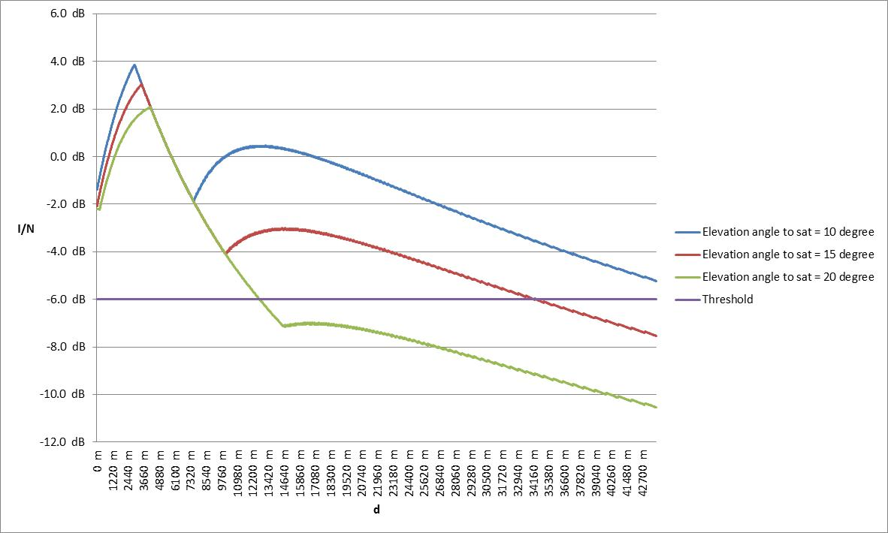

Figure 45: I/N at CCL Rx from aircraft at 3000m altitude a.g.l. transmitting to satellite   
(worst case)

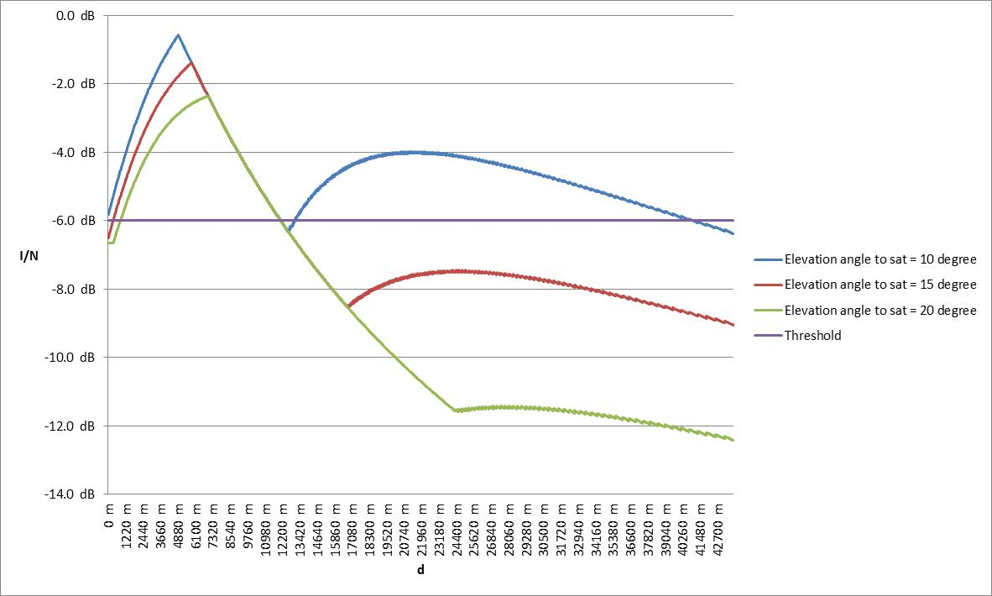

Figure 46: I/N at CCL Rx from aircraft at 5000m altitude a.g.l. transmitting to satellite   
(worst case)

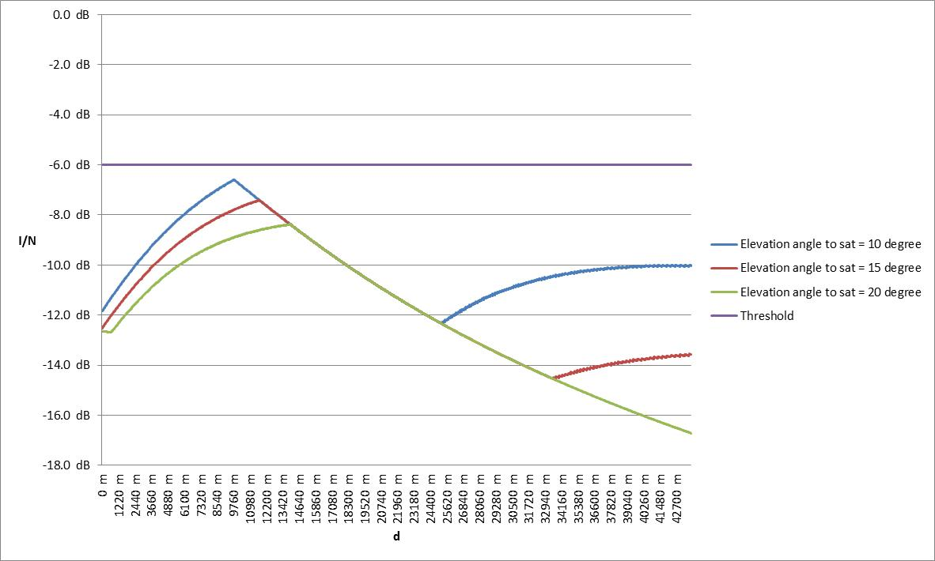

Figure 47: I/N at CCL Rx from aircraft at 10000m altitude a.g.l. transmitting to satellite   
(worst case)

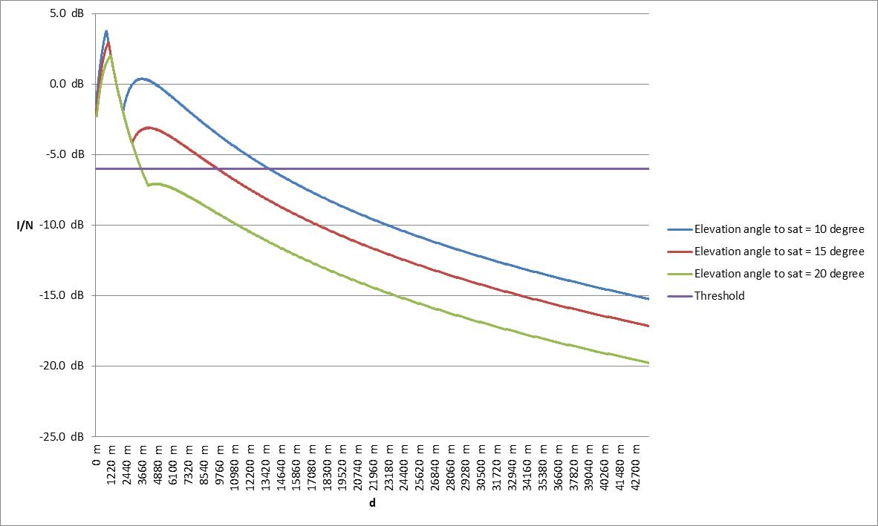

Figure 48: I/N at MVL Rx from aircraft at 1000m altitude a.g.l. transmitting to satellite   
(worst case)

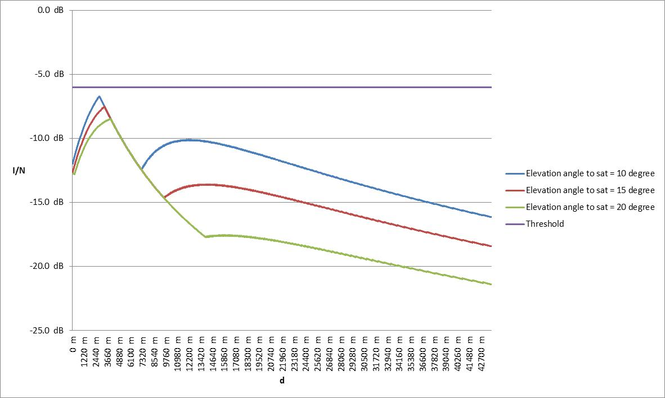

Figure 49: I/N at MVL Rx from aircraft at 3000m altitude a.g.l. transmitting to satellite   
(worst case)

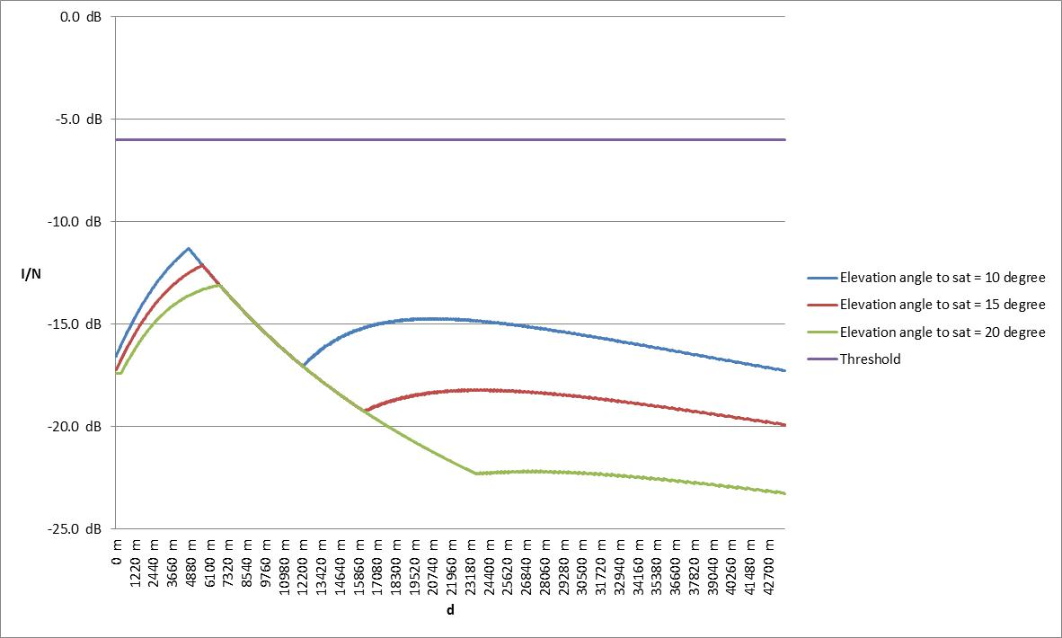

Figure 50: I/N at MVL Rx from aircraft at 5000m altitude a.g.l. transmitting to satellite   
(worst case)

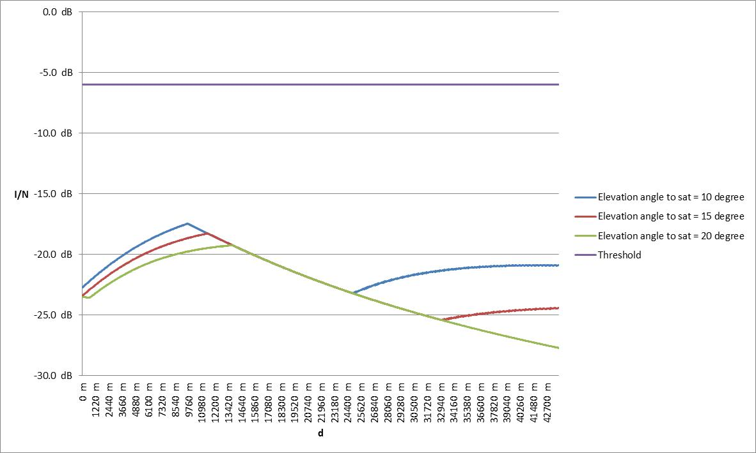

Figure 51: I/N at MVL Rx from aircraft at 10000m altitude a.g.l. transmitting to satellite   
(worst case)

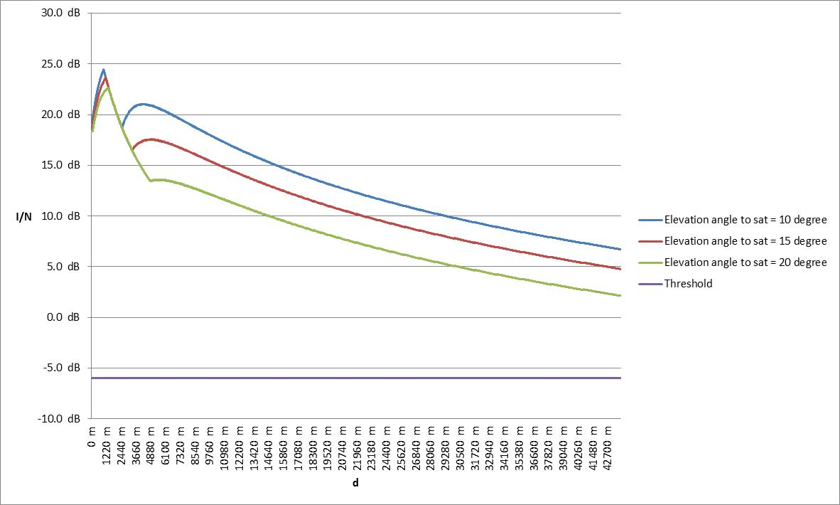

Figure 52: I/N at PVL Rx from aircraft at 1000m altitude a.g.l. transmitting to satellite   
(worst case)

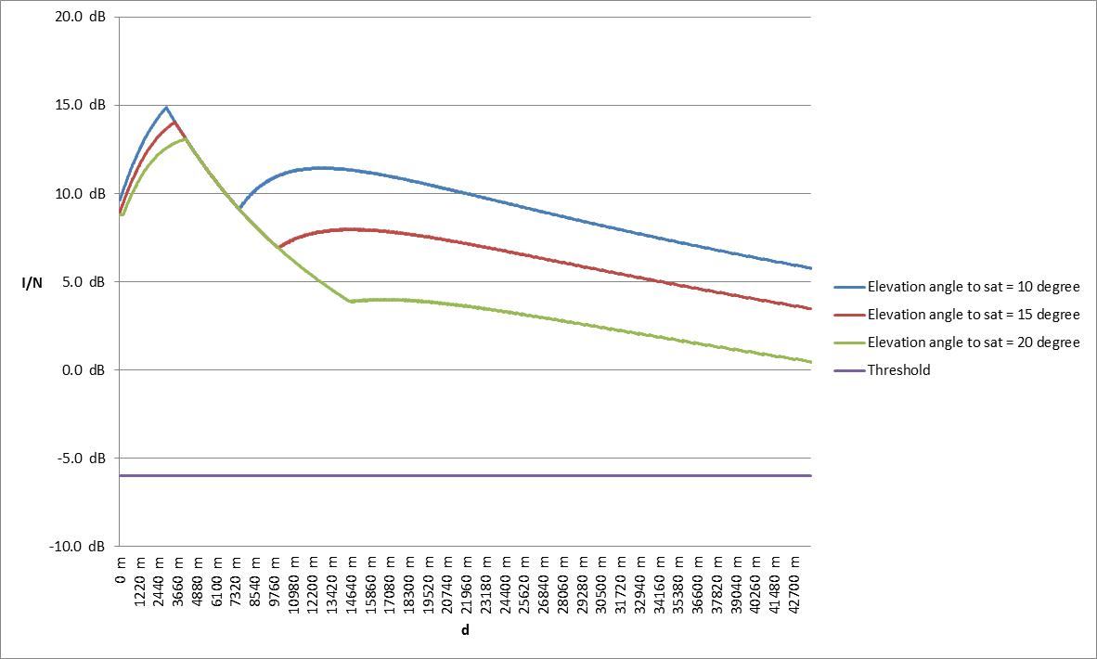

Figure 53: I/N at PVL Rx from aircraft at 3000m altitude a.g.l. transmitting to satellite   
(worst case)

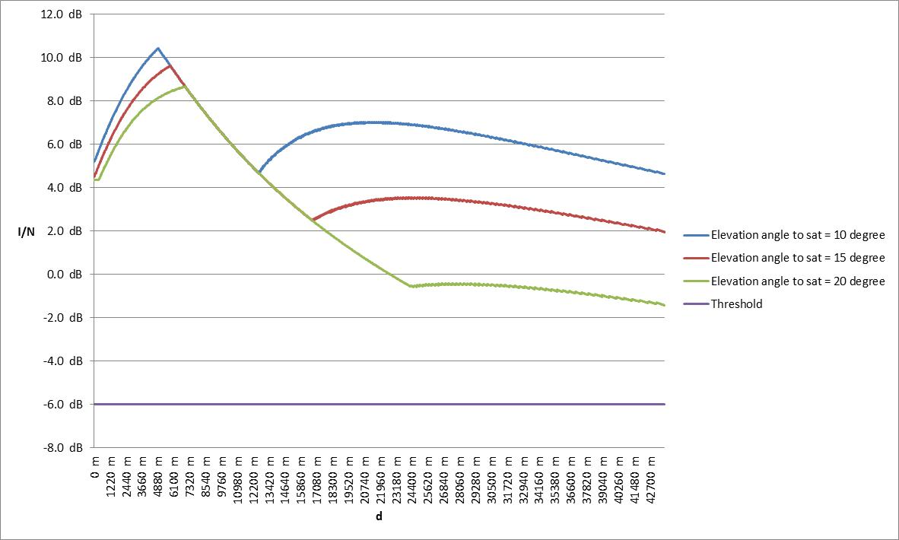

Figure 54: I/N at PVL Rx from aircraft at 5000m altitude a.g.l. transmitting to satellite   
(worst case)

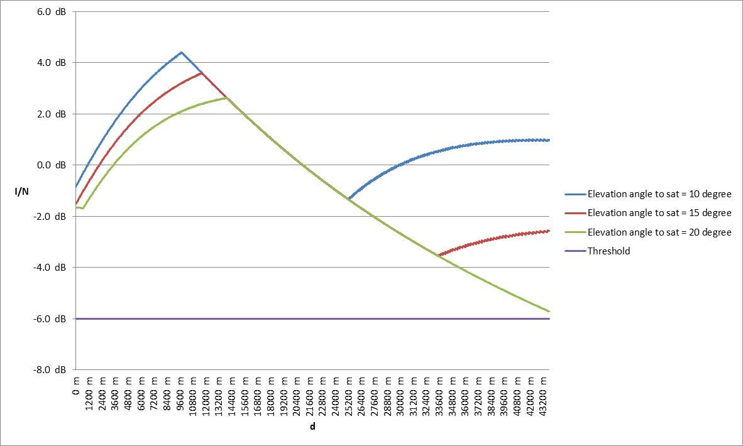

Figure 55: I/N at PVL Rx from aircraft at 10000m altitude a.g.l. transmitting to satellite   
(worst case)

The interference power will be reduced if the adjustment of the PMSE receiving dish antenna is only slightly changed or if the line-of-sight condition between the receiver antenna and the aircraft is affected. In a real environment the receiving antenna diagram will have attenuation (up to 20-25 dB) in the direction to the aircraft. The interfering signal power could be further decreased by ground clutter (building, vegetation etc.). Some additional signal blockage from the fuselage could be expected, since the aircraft satellite antenna will be installed on the top of the plane, but this additional attenuation is not included in the analysis.

Figure 56, Figure 57 and Figure 58 provide the I/N with a reduced gain of the receiving PMSE antenna (reduction applied 25 dB) for aircraft altitudes of 1000m. Under this hypothesis, the I/N threshold is never exceeded for CCL and MVL. The protection criterion, without considering any further attenuation due to ground clutter or to the aircraft fuselage, is exceeded in case of PVL for distances lower than 9 km considering the aircraft antenna pointing to satellite at 10 degrees elevation. For higher elevation angles (15° and 20°) of the aircraft antenna pointing to satellite, the protection criterion is exceeded for distance lower than 3 km.

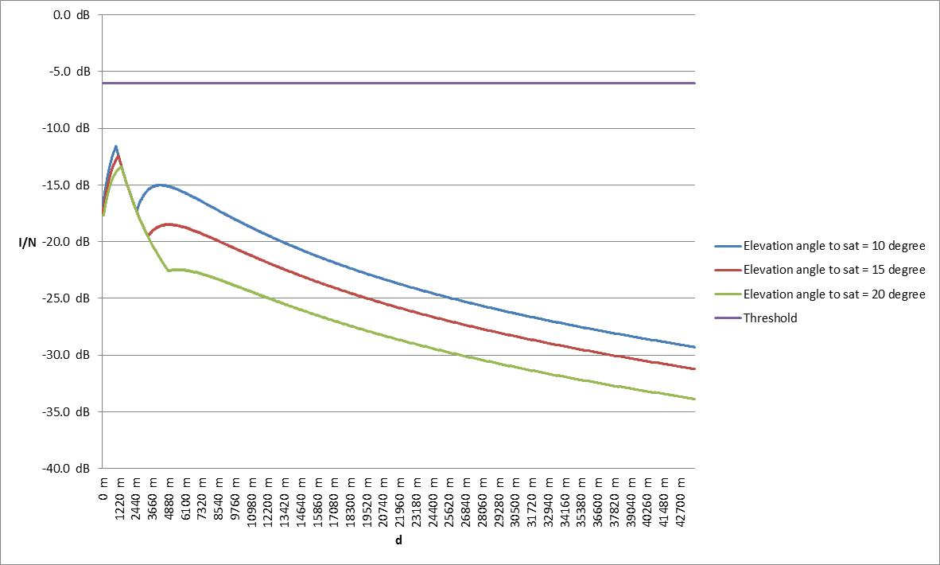

Figure 56: I/N at CCL Rx from aircraft at 1000m altitude a.g.l. transmitting to satellite   
(depointed Rx)

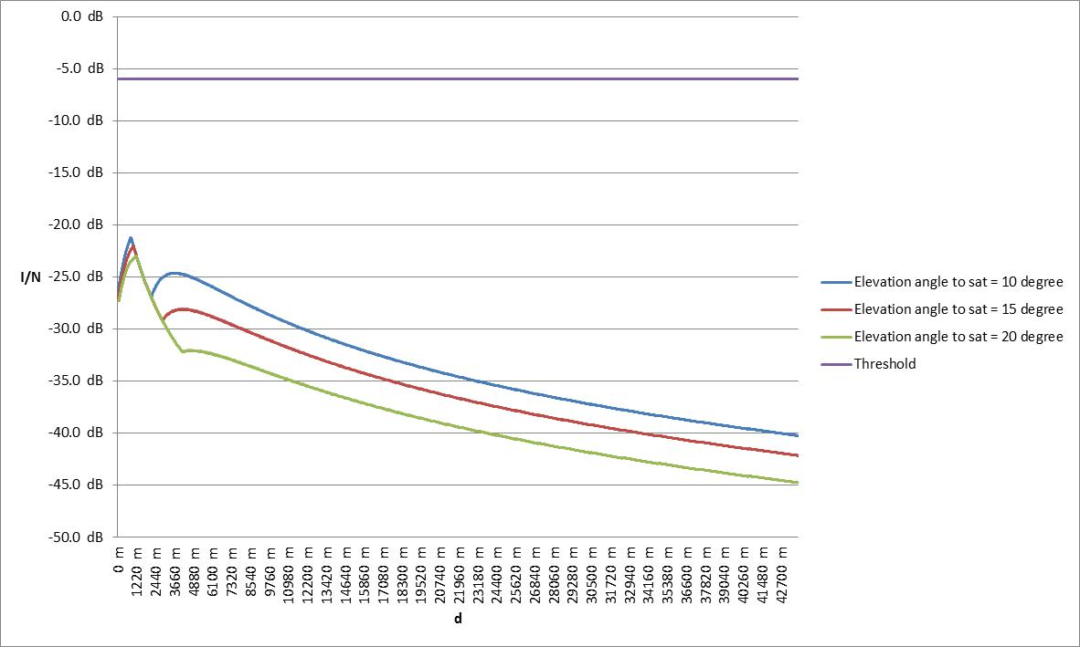

Figure 57: I/N at MVL Rx from aircraft at 1000m altitude a.g.l. transmitting to satellite   
(depointed Rx)

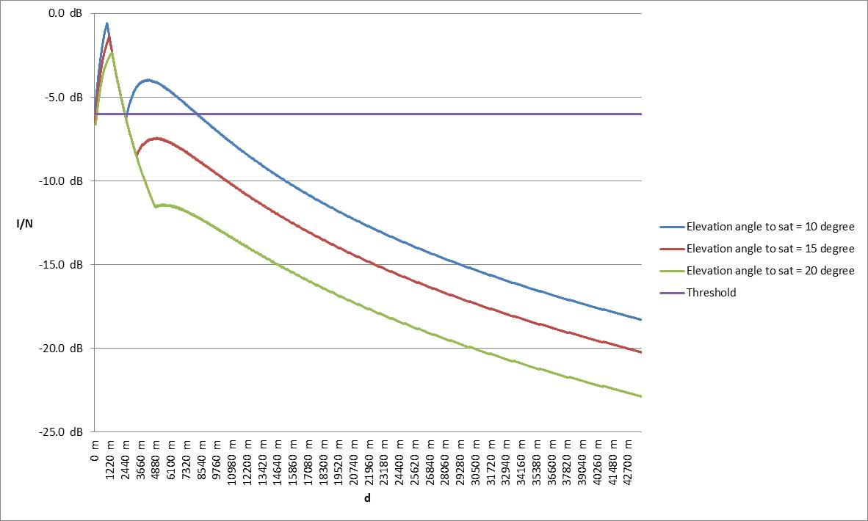

Figure 58: I/N at PVL Rx from aircraft at 1000m altitude a.g.l. transmitting to satellite   
(depointed Rx)

## Scenario 7

Scenario 7 considers the adjacent band interference created by the transmission from an aeronautical terminal transmitting to a CGC ground station (1980-2010 MHz) into a MCA base station (receiving at 1920-1980 MHz).

Figure 59 illustrates the interfering scenario.

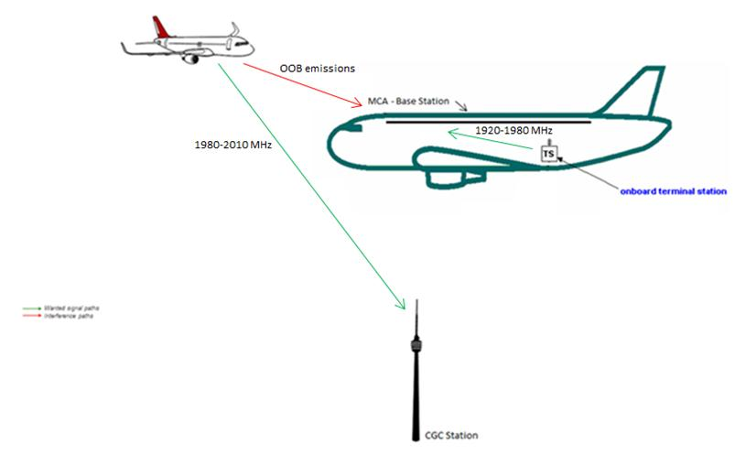

Figure 59: Scenario 7

In order to calculate the I/N, the attenuation effects of the aircraft fuselage to radio-frequency signals entering into the cabin should be considered. The ECC Report 93, Annexes C and F, contains a summary of different measurement campaigns. Measurements and technical analysis show that the attenuation varies with both horizontal and vertical angle between the aircraft fuselage and the line of sight to the observation point. Nevertheless, the results provided in this report, as in ECC Report 93, are not based on angle-dependency attenuation, but instead a range of non-angle dependent values.

In this scenario the signal attenuation due to fuselage attenuation of the MCA aircraft is assumed to be 5 dB.

The I/N at the MCA base station is given by the following formula:

$$\frac{I}{N}= P_{T}+G_{T}+G_{R}-FSL-ACIR-KTB-NF-L_{aircraft}$$

where:

* $P_{T}$ is the power transmitted by the aeronautical terminal (dBW);
* $G_{T}$ is the antenna gain of the interferer aeronautical terminal (dBi) toward the MCA Base Station;
* $G_{R}$ is the MCA Base Station gain toward the interferer (dBi) – in this case -25 dBi
* $FSL$ is the Free Space Loss (dB);
* $ACIR$ is the Adjacent Channel Interference Ratio (dB) – in this case it’s 36.4dB, as a result of the combination between the aeronautical terminal ACLR (37 dB) and the ACS of the MCA BS (45 dB);
* $KTB$ is the Thermal Noise Power of the receiver assuming 290 K (dBW);
* $NF$ is the noise figure of the receiver (dB);
* $L_{aircraft}$ is the attenuation due to the aircraft fuselage.

Figure 60: below shows the I/N at the MCA BS for a fuselage attenuation factor of 5 dB. The minimum separation distance in these plots is assumed to be 300 metres, which is equivalent to 1000 feet. This distance is the minimum vertical separation between two aircraft required by air traffic control in order to reduce the risk of collisions, as well as to prevent accidents due to wake turbulence. If any two aircraft are separated by less than the minimum vertical separation, then some form of horizontal separation must exists. Therefore the worst case for this scenario is to have the two aircraft on the same vertical axis, with the victim (the MCA system) on a lower flight altitude a.g.l. than the interferer (the aeronautical terminal transmitting to the aeronautical CGC).

The I/N never exceeds the threshold, even when the aeronautical terminal is transmitting with the maximum power.

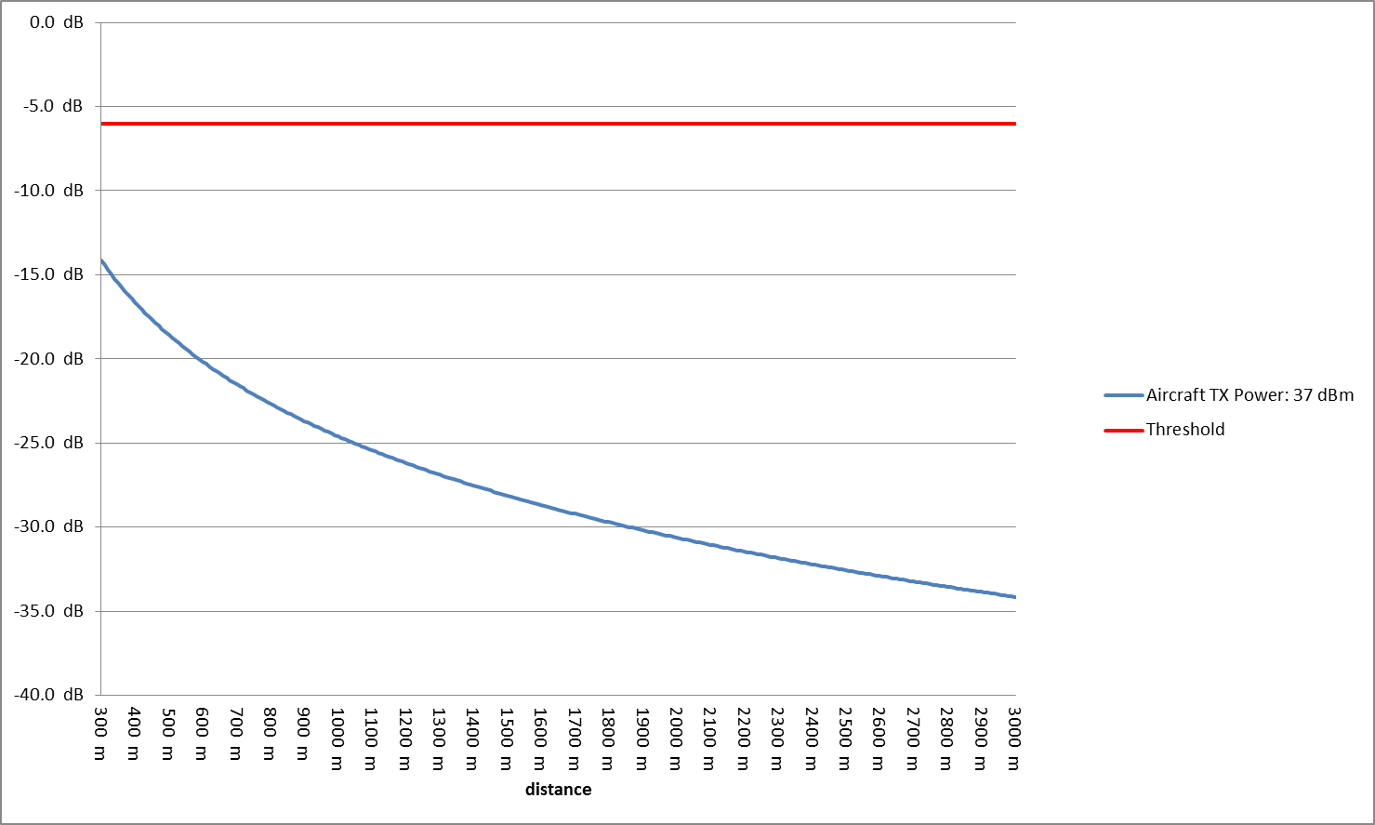

Figure 60: I/N at MCA BS for fuselage attenuation of 5 dB

## Scenario 8

Scenario 8 considers the adjacent band interference created by the transmission from an aeronautical terminal transmitting to the satellite (1980-2010 MHz) into a MCA base station (receiving at 1920-1980 MHz). Figure 61 illustrates the interfering scenario.

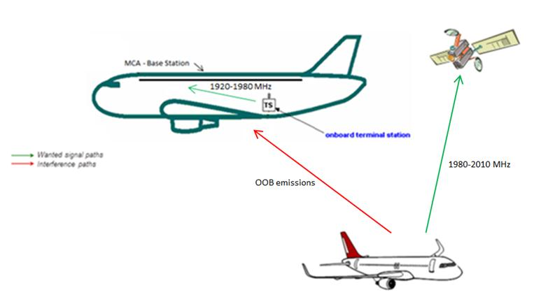

Figure 61: Scenario 8

The I/N at the MCA base station can be calculated with a similar formula as the one provided in scenario 7, with modified parameters of the transmitter. The ACIR in this case is 29.9 dB, as a result of the combination between the aeronautical terminal ACLR (30 dB) and the ACS of the MCA BS (45 dB). The results are shown in Figure 62 and Figure 63.

The worst case for this scenario is to have the victim (the MCA system) on the same axis between the interferer (the aeronautical terminal) and the satellite, with the victim on a higher flight level than the interferer. In this case, the victim is assumed to be within the main beam of the aeronautical terminal antenna.

The I/N exceeds the protection criteria for distances lower than 400 metres in case of fuselage attenuation equal to 5 dB. This distance could be reduced if higher fuselage attenuation values were assumed. Additionally, the probability to have the victim at 400 metres distance from the interferer and within the main beam of the interferer antenna is low, and the duration of any interference event would be short.

Figure 63 shows the interference zone for scenario 8 with the worst case assumptions for the transmitter power and fuselage attenuation. The interferer is located at the axis origin of the elevation plane and it is assumed to be transmitting with maximum power 25 dBm. The victim, on-board of an aircraft with fuselage attenuation 5 dB, experiences the I/N shown in the figure depending on its position relative to the interferer. If the victim will be on a flight level lower than the interferer, it would not experience any interference. If the victim will be on a flight level higher than the interferer, it could be potentially interfered if the distance is lower than 400m and if no horizontal separation exists.

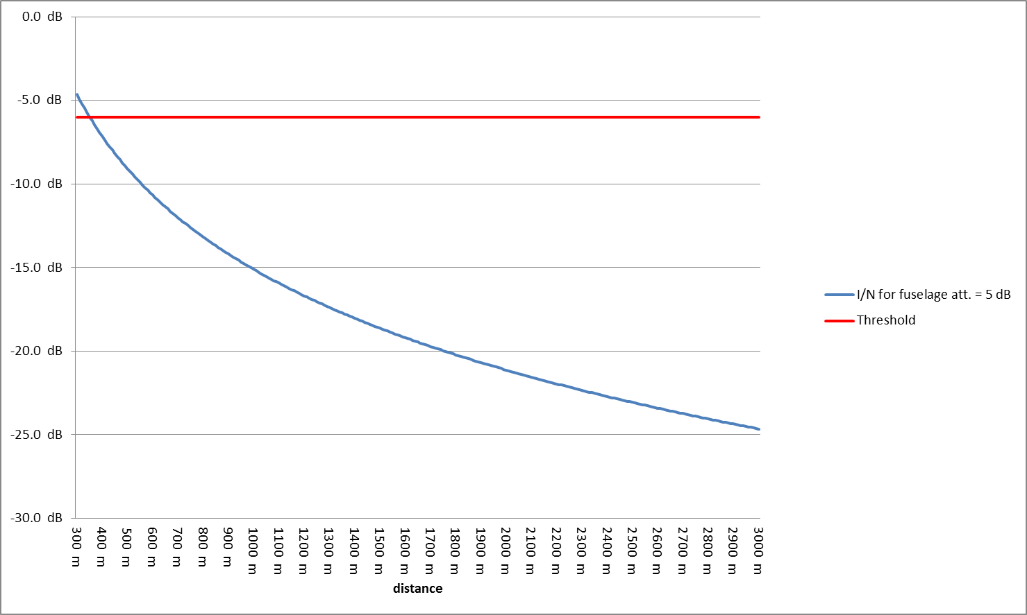

Figure 62: I/N at MCA BS

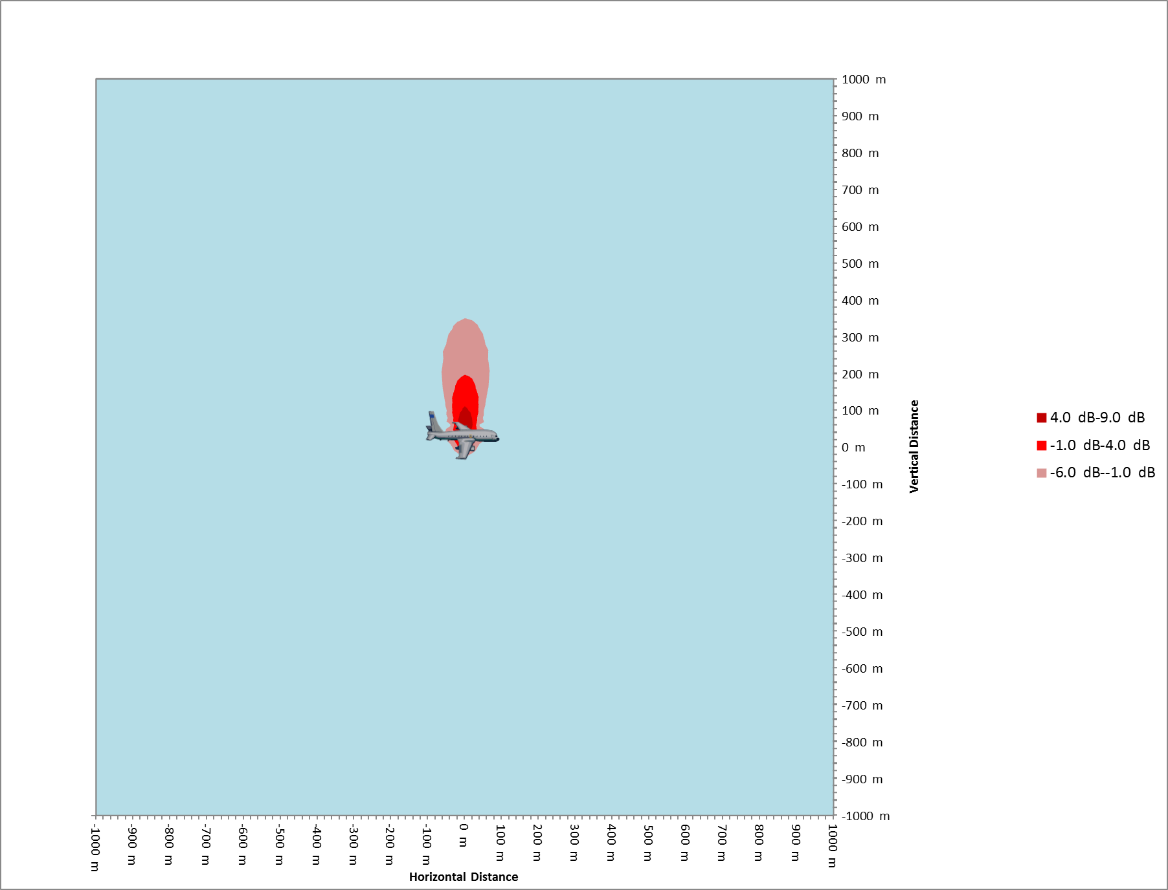

Figure 63: I/N at MCA BS – interference zones around aeronautical terminal transmitting to satellite

Note: The interfering aircraft is assumed being transmitting with maximum power (25 dBm) and the victim fuselage attenuation is 5 dB.

## scenario 9

Scenario 9 considers the interference created by an aeronautical CGC ground station into an MCA receiving MS (i.e. ECN user terminal on-board an aircraft) receiving in the 2110-2170 MHz band. Figure 64 illustrates the interfering path.

The NCU, described in ECC Report 93 [17] section 4.3.7 and Annex D, is a part of the MCA system designed to ensure (by raising the noise floor inside the aircraft cabin) that mobile terminals within the cabin cannot access the ground based public networks and that those compatible with the on board technology could only connect to the on-board base station. The power level of the NCU at the aircraft window in the above mentioned band should be at least equal to the expected power level received on-board by the ground based ECN base station.

A comparison of the interference, caused by co-frequency operations of ground based ECN systems with that of aeronautical CGC ground stations, is therefore provided.

This Report, following the guideline of ECC Report 093, provides calculations based on fuselage attenuation of 5 dB.

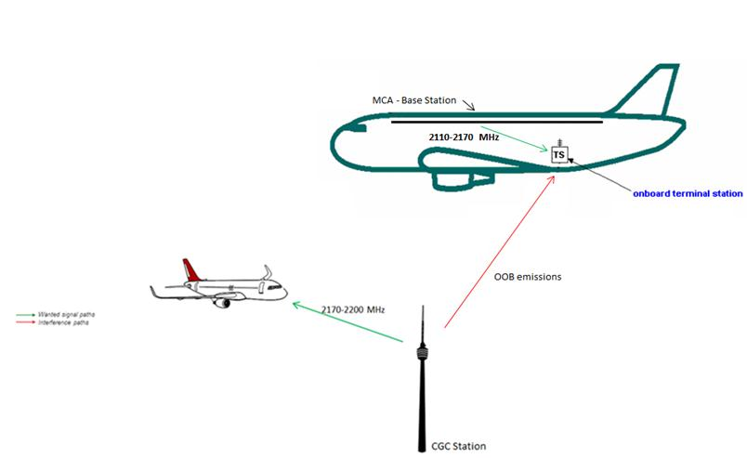

Figure 64: Scenario 9

The I/N at the on-board terminal user is given by the following formula:

$$\frac{I}{N}= P_{T}+G_{T}+G_{R}-FSL-ACIR-KTB-NF-L_{aircraft}$$

where:

* $P_{T}$ is the power transmitted by the aeronautical CGC ground station (dBW);
* $G_{T}$ is the antenna gain of the aeronautical CGC ground station (dBi) toward the ECN User Terminal;
* $G_{R}$ is the on-board user terminal gain toward the interferer (dBi) – in this case it is 0 dBi, as the user terminal antennae are omni-directional;
* $FSL$ is the Free Space Loss (dB);
* $ACIR$ is the Adjacent Channel Interference Ratio (dB) – in this case 32.7 dB, as a result of the combination between the aeronautical CGC ground station ACLR (45 dB) and the ACS of the ECN UT (33 dB);
* $KTB$ is the Thermal Noise Power of the receiver assuming T = 290 K (dBW);
* $NF$ is the noise figure of the receiver (dB);
* $L_{aircraft}$ is the attenuation due to the aircraft fuselage.

The analysis has been done for a MCA system at three different heights above ground level: 3000 metres, 5000 metres and 10000 metres. The result is reported below in Figure 65, and shows that the threshold is never exceeded when the aircraft is at 5000m and 10000 m altitude above ground level.

When the aircraft is at 3000 m altitude a.g.l. and the separation distances are lower than 20 km, the I/N protection criteria might be exceeded.

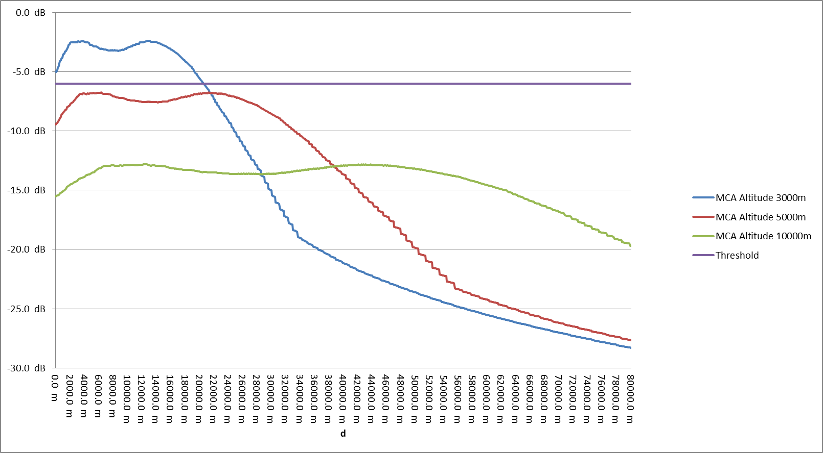

Figure 65: I/N at MCA MS for Fuselage Attenuation of 5 dB

Note: the CGC Ground Station Antenna height in this calculation is assumed being 50 m

Furthermore, the MCA system is equipped with a Network Control Unit, and if the cabin fuselage does not provide sufficient attenuation, the NCU is activated in order to mask the signals from co-frequency terrestrial mobile networks that enter the cabin, which prevents on-board mobile terminals to access the ground mobile networks. To do so, the noise floor within the cabin is increased artificially, and its level (which is more or less equal to the signal received on-board the aircraft from the ground ECN network) is higher than the out-of-band emission from the aeronautical CGC ground stations (see Figure 66). It should be noted that the OOB emissions from aeronautical CGC networks are at least 30 dB lower than the in-band emission of the terrestrial ECN networks. Therefore the I/N of -6 dB will never be exceeded.

Figure 66 compares the power flux density values of the aeronautical CGC ground station with those of the terrestrial ECN base station in the 2110-2170 MHz frequency band at 3000 m altitudes a.g.l.. This comparison is based on the parameters in Table 5 for the aeronautical CGC ground station, and the parameters in Table 9 for the ECN base station.

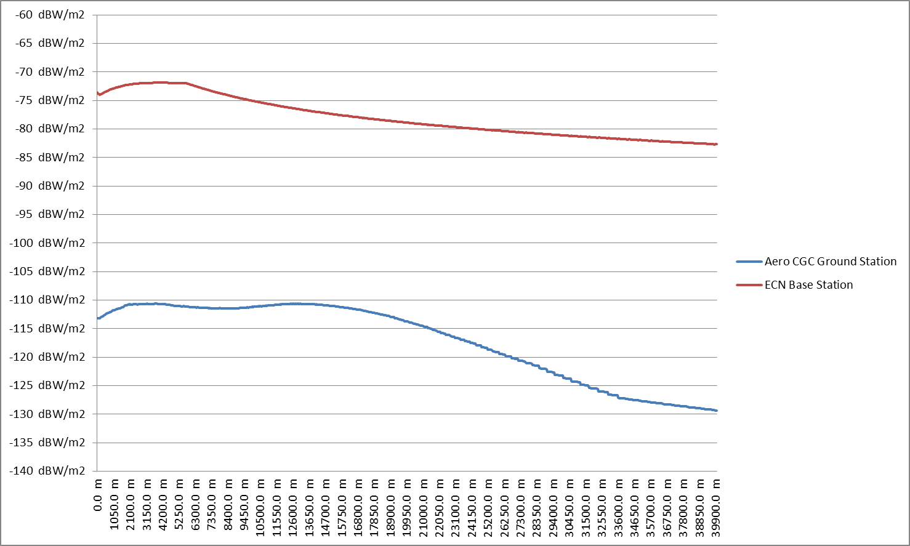

Figure 66: Power Flux Density at Aircraft Altitude 3000m a.g.l.

## scenario 10

Scenario 10 considers the interference caused by an aeronautical CGC ground station operating in the band 2170-2200 MHz into an ECN user terminal operating in the band 2110-2170 MHz.

Figure 67 illustrates the interfering path.

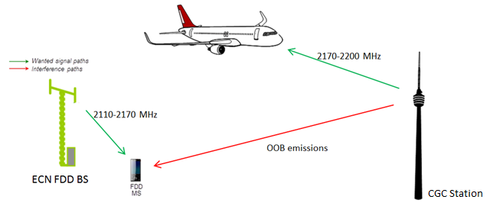

Figure 67: Scenario 10

The analysis is a comparison between the aeronautical CGC transmitter parameters and those of the existing similar systems, e.g. ECN, UMTS base stations and conventional CGC ground stations.

The used parameters are shown in Table 17. The transmitted power of the aeronautical CGC ground station in the adjacent channel does not exceed the power of ECN, UMTS and conventional CGC systems.

The aeronautical CGC ground station antenna is tilted upward by 10° in order to direct the beam over the sky and optimise the coverage for aircraft communications, while the antenna of UMTS and ECN base stations and CGC ground stations are pointed downward, since the purpose is to provide coverage for terrestrial applications. Therefore taking into account the different antenna patterns, the PFD at the ground on the adjacent channel may be calculated using the following formula:

$PFD\left(d\right)=P_{T}+G\left(ϑ\right)-10\log_{10}\left(4πd^{2}\right)-ACLR$

where:

* $PFD\left(d\right)$ is the Power Flux Density calculated at a distance $d$, (dBW/m2);
* $P_{T}$ is the power transmitted by the Base Station (dBW) in the reference bandwidth;
* $ϑ$ is the angle between the transmitter and the observation point (degree);
* $G\left(ϑ\right)$ is the gain of the transmitting Base Station antenna at angle $ϑ$ (dBi);
* $ACLR$ is the Adjacent Channel Leakage Ratio of the considered system (dB).

Figure 68 shows that the PFD of the aeronautical CGC ground stations is similar or lower than PFD of UMTS ECN and conventional CGC systems. Therefore the transmitted power levels at ground of the aeronautical CGC systems are expected to be similar to the power levels of the existing systems. It is worth noting that the PFDs have to be compared in the same amount of spectrum. Since the assumed aeronautical CGC signal is a 10 MHz carrier, while the UMTS and ECN BS signals are 5 MHz carrier, the power flux density of the aeronautical CGC has been scaled by 3 dB in order to have a common reference bandwidth (i.e. the PFD formula for aeronautical CGC includes: -10log10(10/5), where 10/5 = 10 MHz carrier/ 5 MHz, which results in a scale factor of 3 dB).

Table 17: Comparison between aeronautical CGC ground stations and existing applications

|  |  |  |  |
| --- | --- | --- | --- |
|  | **ECN BS / Conventional CGC** | **UMTS Rep. ITU-R M.2039-2 – table 10a** | **Aero CGC GS** |
| Output power at antenna connector (dBm) | 43 (from table 3 ECC Report 197) | 43 | 47 dBm |
| Maximum Antenna Gain (dBi) | 18 (from table 3 ECC Report 197) | 17 | 15 |
| Channel bandwidth (MHz) | 5 (from table 3 ECC Report 197) | 5 | 10 MHz channel bandwidth |
| ACLR | ITU-R Report M.2039 [10] provides typical base stations e.i.r.p. of 61 dBm/5MHz in-band limit for sharing studies.  CEPT Report 39, [22] Table 7 defines out-of-band BEM requirements for ECN base stations within the spectrum allocated to ECN applications -5 to 0 MHz from lower block edge -> max mean out-of-band e.i.r.p. = 16.3 dBm for 5 MHz 🡪 ACLR = 44.7 dB | 45 dB | ACLR = 44.2 dB,  In-band emission e.i.r.p. = 59 dBm/5 MHz,  Out-of-band 59 dBm/5 MHz – 44.2 = 14.8 dBm/5MHz |
| Maximum e.i.r.p.in the adjacent block  (5 MHz) | 16.3 dBm | 15 dBm | 14.8dBm |
| Antenna height (m) | 45 (rural) 30 (urban) | 30 | 25 to 50 (Note: technical analysis was performed taking into account 30m antenna height) |
| Antenna tilt | 3° - down | 2.5° - down | 10° - up |

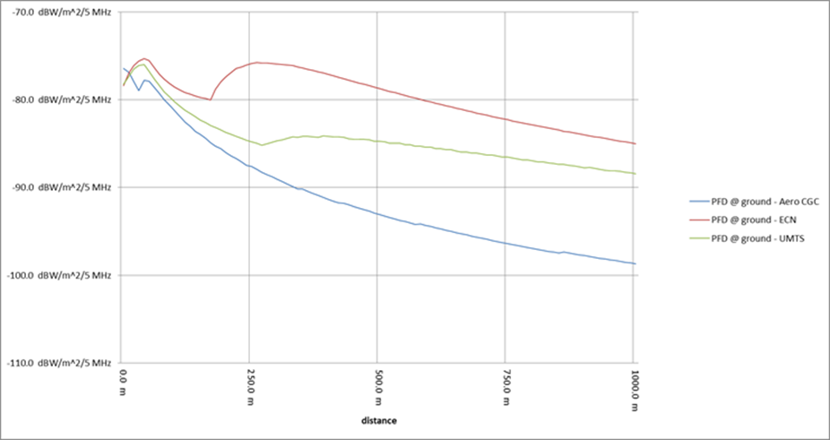

Figure 68: Power Flux Density at ground - 5 MHz adjacent channel

Note: In this Figure, the height of the antennas is assumed to be 30m for the three systems (Aeronautical CGC, ECN and UMTS).

## scenario 11

Scenario 11 considers the interference caused by an aeronautical CGC ground station transmitting in the band 2170-2200 MHz into a PMSE receiver operating in the band 2200-2290 MHz.

As shown in scenario 10, the transmitted power levels at the ground of the aeronautical CGC systems in the band 2200-2290 MHz are expected to be lower than an ECN and a conventional CGC system, due to the up-tilt of the aeronautical CGC ground station antenna. Therefore it’s not expected that the use of CGC systems to support aeronautical applications will cause any increase in potential interference into PMSE systems operating at 2200-2290 MHz.

# SUMMARY AND DISCUSSION OF RESULTS

This section summarises the eleven scenarios considered in sections 6 and 6, in order to highlight the most important aspects.

Scenario 1, 4, 6, and 8 consider the aeronautical terminal transmitting to satellite in the band 1980-2010 MHz and interfering into services operating in adjacent bands.

* Section 6.1 (Scenario 1) has shown that the I/N at the ECN base station receiver exceeds the interference threshold only for altitude a.g.l. lower than 3000 metres. A PFD threshold mask, derived in section 6.2, applicable to the OOB emissions of the aeronautical terminal in the band 1920-1980 MHz is proposed to ensure the protection for the ECN base stations in adjacent bands, and for conventional CGCs of other MSS systems in the 2 GHz MSS band. In cases where the effects of aggregated interference, from several aeronautical terminals, towards ECN BSs should be considered, specific planning of CGC ground stations for communication with aeronautical terminals at altitudes below 3000m a.g.l. may be required (see example in ANNEX 2:). The above is based on I/N protection criterion of -6 dB, although in non-interference limited areas and where several cells are impacted by interference simultaneously, from the aeronautical terminal, the evaluation criteria I/N = -10dB could be applicable according to ITU-R Report M.2039-3;
* Section 6.4 (Scenario 4) has shown that the I/N at the DA2GC ground station could exceed the threshold when the aircraft is at 1000 m altitude a.g.l., irrespective of the elevation angle of the antenna pointing to the satellite. At 3000 m altitude a.g.l. the protection criterion may be exceeded for elevation angles of the antenna pointing to the satellite lower than 20°. At 5000 m altitudes a.g.l., the protection criterion may be exceeded for elevation angles of the antenna pointing to the satellite lower than 15°- The protection criteria is never exceeded at 10000 m altitude a.g.l.. A power flux density threshold mask, derived in section 6.3, is proposed for the OOB emissions of the aeronautical terminal to protect DA2GC systems in the band 2010-2025 MHz.
* Section 6.6 (Scenario 6) has shown that the I/N threshold at VLCC receiver could be exceeded when the VLCC receiver antenna is pointed toward the aircraft. However, in a real environment the receiving antenna diagram will have an attenuation (up to 20-25 dB) in the direction to the aircraft. The interfering signal power could be further decreased by ground clutter (building, vegetation etc.). Some additional signal blockage from the fuselage could be expected, since the aircraft satellite antenna will be installed on the top of the plane. Due to the low ACS of the VLCC receiver, a reduction of the OOB emissions of the aeronautical terminal would not significantly improve the results.
* Section 6.8 (Scenario 8) has shown that the I/N on MCA base station receiver exceeds the protection criteria for distances between the victim and the interferer lower than 400 metres in case of fuselage attenuation equal to 5 dB. However, as interference would occur only when the aircraft operating the MCA system would be in the main beam of the aeronautical terminal operating in the Aeronautical CGC system, the probability of interference would be low, and the duration of interference would be short.

Scenario 2, 3, 5 and 7 consider the aeronautical terminal transmitting to the aeronautical CGC ground station in the band 1980-2010 MHz and interfering into services operating in adjacent bands.

* Section 6.2 (Scenario 2) has shown that the I/N at the ECN base station never exceeds the threshold for aircraft altitudes higher than 3000 m. To avoid the protection criteria exceedance at lower altitudes, power reduction could be used in order to reduce the maximum e.i.r.p. transmitted by the aeronautical terminal according to the flight altitude a.g.l. A second solution could be to reduce the out-of-band emissions of the aeronautical terminal. A limit on the power flux density of the OOB emissions of the aeronautical terminal in the band 1920-1980 MHz is proposed to ensure the protection for the ECN base stations in adjacent bands, and for conventional CGCs of other MSS systems in the 2 GHz MSS band. The above is based on I/N protection criterion of -6 dB, although in non-interference limited areas and where several cells are impacted by interference simultaneously, from the aeronautical terminal, the evaluation criteria I/N = -10dB could be applicable according to ITU-R Report M.2039-3.
* Section 6.3 (Scenario 3) has shown that the I/N at the DA2GC ground station receiver could exceed the protection criterion depending on the altitude a.g.l. of the interferer. For altitudes a.g.l. lower than 10000 m power control could be applied to reduce the e.i.r.p. of the aeronautical terminal according to the flight altitude a.g.l. or reducing the out-of-band emissions. Additionally CGC ground stations and DA2GC ground stations could be installed at the same or nearby locations, so that the aeronautical terminal would transmit at high power only when located a large distance from both the Aeronautical CGC ground station and the DA2GC ground station, keeping interference below the criterion. A pfd threshold applicable to the OOB emissions in the band 2010-2025 MHz is developed, that would ensure that the DA2GC ground station is protected from harmful interference. This is proposed to be a coordination threshold, as the operators of aeronautical CGC systems and DA2GC systems may be able to agree on pfd levels higher than the threshold levels on the basis of coordination.
* Section 6.5 (Scenario 5) has shown that the I/N at the VLCC receiver could be exceeded when the VLCC receiver antenna is pointed toward the interferer. In a more typical scenario, the interference power will be reduced if the adjustment of the receiving dish antenna is only slightly changed or if the line-of-sight condition between the receiver antenna and the aircraft is affected. In addition the interference probability will be further reduced by the transmit power control feature of the aircraft system. Due to the low ACS of the VLCC receiver, a reduction of the OOB emissions of the aeronautical terminal would not significantly improve the results.
* Section 6.7 (Scenario 7) has shown that the I/N at the MCA base station never exceeds the threshold, even when the aeronautical terminal is transmitting with the maximum power toward the aeronautical CGC base station.

Scenario 9, 10 and 11 consider the aeronautical CGC ground station transmitting to the aeronautical terminal in the band 2170-2200 MHz and interfering on services operating in adjacent bands.

* Section 6.9 (Scenario 9) has shown that the I/N criterion at the ECN user terminal receiver is exceeded when the aircraft is at 3000 m altitude a.g.l. and for separation distances lower than 20 km. It should be mentioned that aircraft at such altitude are either on ascent or descent phase, therefore close to an airport. However, the MCA system is equipped with a Network Control Unit which is activated to screen the ground ECN network when the aircraft fuselage does not provide sufficient attenuation. The level of the noise floor will be increased through the NCU to a level equal to the signal received on-board the aircraft from the ground ECN network. This level will be higher than the out-of-band emission from the aeronautical CGC ground stations. It should be noted that the OOB emissions from aeronautical CGC networks are at least 30 dB lower than the in-band emission of the terrestrial ECN networks. Therefore the I/N of – 6 dB will never be exceeded.
* Sections 6.10 (Scenario 10) and 6.11 (Scenario 11) have shown that the transmitted power flux density levels at the ground by the aeronautical CGC ground stations are expected to be similar to the power levels of the existing terrestrial systems transmitting to ground based terminals. Therefore aeronautical CGC ground stations will not create any harmful interference to ECN user terminals operating in the 2210-2170 MHz or PMSE systems operating in the band 2200-2290 MHz.

# CONCLUSION

This report described compatibility studies related to Aeronautical CGC systems operating in the bands 1980-2010 MHz and 2170-2200 MHz.

* The studies have identified the conditions under which the aeronautical CGC systems can be operated without causing harmful interference to the existing ECN networks, PMSE and MCA systems in the adjacent bands, or conventional CGCs of other MSS systems in the 2 GHz MSS band;
* To address potential interference to ECN systems operating below 1980 MHz, the out-of-band PFD on the ground, from aeronautical terminals should be compliant with the following mask:

$$PFD\left(δ\right)= 2*δ-125.5 dB\left(W/{m^{2}}\right) for 0°≤δ≤5°$$

$$PFD\left(δ\right)= \frac{13}{85}*δ -116.3 dB\left(W/{m^{2}}\right) for 5°<δ≤90°$$

where $δ$ is the angle of arrival at the Earth’s surface (degrees above the horizontal) and the PFD is calculated in a reference bandwidth of 5 MHz in any part of the 1920-1980 MHz. This mask applies to any aeronautical terminal and should be considered as a threshold, such that higher values might be agreed by the concerned administrations and/or operators of ECN networks

In cases where the effects of aggregated interference, from several aeronautical terminals, towards ECN BSs should be considered, specific planning of CGC ground stations for communication with aeronautical terminals at altitudes below 3000 m a.g.l. may be required (see example in ANNEX 2:)

In the European Union (EU) where the 2 GHz MSS bands are divided between two MSS operators through Commission Decision 2009/449/EC [21] the power flux density limitations for Aeronautical CGC systems to protect ECN BS can be applied within the band 1980-2010 MHz to protect other MSS systems using conventional CGCs, on the condition that the characteristics of the CGC GSs are similar to those of the ECN BS considered in this Report.

* To address potential interference to DA2GC systems in the band 2010-2025 MHz, the out-of-band PFD on the ground from aeronautical terminals should be compliant with the following mask:

$$PFD\left(δ\right)= -{23}/7*δ-105 dB\left(W/{m^{2}}\right) for 0°≤δ≤7°$$

$$PFD\left(δ\right)= -128 dB\left(W/{m^{2}}\right) for 7°<δ≤12°$$

$$PFD\left(δ\right)= {29}/{78}*δ -132.5 dB\left(W/{m^{2}}\right) for 12°<δ≤90°$$

where $δ$ is the angle of arrival at the Earth’s surface (degrees above the horizontal) and the PFD is calculated in a reference of 10 MHz in any part of the band 2010-2025 MHz.

This mask applies to any aeronautical terminal and should be considered a threshold, such that higher values might be agreed by the concerned administrations and/or operators of DA2GC networks.

* The studies in this Report have considered potential use of the band 2010-2025 MHz by both Direct Air to Ground Communications (DA2GC) systems and Video Link and Cordless Camera (VLCC) systems. If CEPT will consider only VLCC development in this band, the out-of-band PFD mask proposed in this Report to protect DA2GC on the 2010-2025 MHz will not be required.
* Any potential interference to MCA systems from aeronautical terminals within an aeronautical CGC system will occur for a short duration (when the two aircraft are in close proximity), and therefore does not require additional constraints on aeronautical CGC systems.

1. COMPARISON OF FLAT EARTH MODEL ASSUMPTION WITH SPHERICAL EARTH MODEL

As explained in Section 6.1, this Report uses a flat Earth model: this Annex provides the justification for this simplification.

In Figure 69, the path length $l$ and the elevation angle $ψ_{e}$ calculated with a flat Earth model are compared with the path length $l^{'}$ and the elevation angle ${ψ_{e}}^{'}$ calculated with a spherical Earth model.

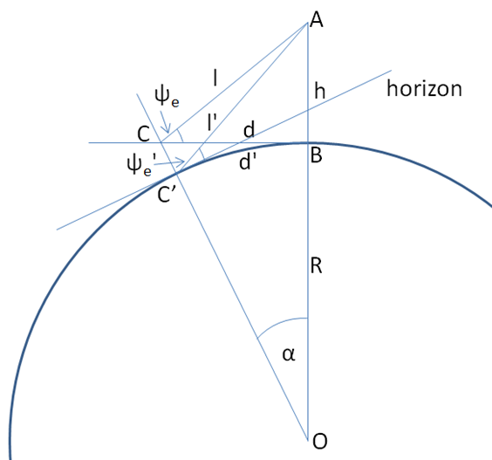

Figure 69: Flat Earth and spherical Earth models

Point A is the location of the aircraft at height $h$ above the ground, B its projection on the earth surface and $d$ the distance between B and a generic point on the flat Earth surface C, the path length $l$ between A and C is given by the Pythagoras theorem.

$$l= \sqrt{h^{2}+d^{2}}$$

The elevation angle from C to A is given by the following formula:

$$ψ_{e}=⁡\cos^{-1}\left(\frac{d}{l}\right)$$

The angle $α$ is calculated considering the right triangle BOC, where $R$ is the earth radius.

$$α=\tan^{-1}{\frac{d}{R}}$$

Therefore $l'$ can be calculated using the Carnot theorem and ${ψ_{e}}^{'}$ using the law of sines applied to the triangle AOC’:

$$l^{'}= \sqrt{{\left(R+h\right)}^{2}+ R^{2}-2R\left(R+h\right)\cos{α}}$$

$$\frac{l'}{\sin{α}}=\frac{R+h}{\sin\left(ψ_{e}+\frac{π}{2}\right)} →\cos{ψ_{e}}=\frac{\left(R+h\right)\sin{α}}{l'}→ψ_{e}=\cos^{-1}\left(\frac{\left(R+h\right)\sin{α}}{l'}\right)$$

Table 18 shows the difference between $l'$ and $l$ and between $ψ_{e}$ and $ψ_{e}'$ for different set of altitudes and distances used in this Report. The differences are negligible therefore the use of a flat earth model is appropriate for such an analysis.

Table 18: Comparison between flat and spherical Earth models

|  |  |  |  |
| --- | --- | --- | --- |
| d | 50 km | 50 km | 100 km |
| h | 10 km | 1 km | 10 km |
| l | 50.990 km | 50.010 km | 100.499 km |
| l’ | 51.028 km | 50.013 km | 100.568 km |
| l-l’ | 0.037 km | 0.003 km | 0.069 km |
| $$ψ_{e}$$ | 11.3° | 1.1° | 5.7° |
| $$ψ_{e}'$$ | 11.1° | 0.9° | 5.3° |
| $ψ_{e}$- $ψ_{e}'$ | 0.2° | 0.2° | 0.4° |

It should be noted that for the calculations in the Table 18 the actual Earth radius 6371 km has been used. If the effective Earth radius of 4R/3 were to be used in place of the actual Earth radius to correct for refractions by the atmosphere, the differences would be even smaller.

1. INTERFERENCE AGGREGATION

The typical cell radius for the aeronautical CGC system, specified in the Table 5, is 90 km. This implies that several aeronautical terminals can transmit towards the same aeronautical CGC GS, and it may be possible that some of these aeronautical terminals transmit simultaneously with power up to 37 dBm. Hence, within the cell radius of the aeronautical CGC system, hundreds or thousands of ECN BS might be be affected. The locations of the ECN BS are unknown to the aeronautical CGC system. Therefore this Annex considers the impact of aggregate interference into an ECN BS receiver.

It is expected that the aeronautical CGC system will use TDMA/FDMA, for which, in most cases only one aeronautical terminal within a sector or within a satellite beam will transmit on a given frequency. In other cases where the effects of aggregated interference, from several aeronautical terminals, transmitting towards ECN BSs should be considered, specific power limitations for the aeronautical terminals may be required.

It’s worth noting that this study has been based on the following assumptions, which may overestimate aggregate interference:

* the ECN BS antenna pattern is based on peak-side lobe pattern, while for aggregate interference estimation the analysis should use the mean-side lobe pattern;
* no discrimination due to polarization loss has been considered;
* no discrimination due to the azimuthal plane antenna pattern has been considered;
* no 'extended range' effects for coverage improvements, which will increase PSD (Power Spectral Density), have been considered;

The dynamic power control of the aeronautical terminal can optimise the performance of the return links, but the aeronautical CGC system has no knowledge of the interference level at the victim ECN receivers. Hence this analysis considers no power control applied by the aeronautical terminal.

As an example, this Annex considers a worst case scenario where several aeronautical terminals at 1000 m altitude a.g.l. arrive with 1 minute separation in the direction of the main lobe of the ECN BS, with speed of 250-300km/h, which is equivalent to a separation distance of 4166-5000 metres between the aeronautical terminals.

The scenario with two interferers involved is represented in Figure 70. In the following analysis, up to 12 aircraft in a line, each at 1000m altitude are considered.

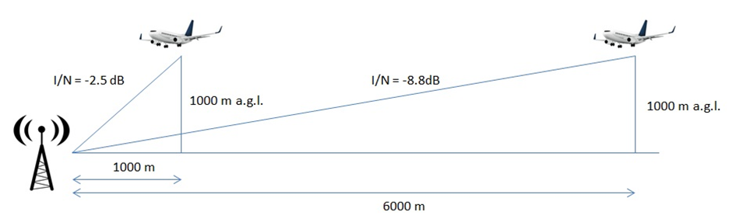

Figure 70: Example of scenario involving two potential interferers

Figure 22 shows that the highest interference is caused by an aeronautical terminal at 1000 m height a.g.l. to an ECN BS at roughly 1000 m separation distance. Consequently this study considers several aeronautical terminals arriving with distance of 1000 + n\*5000 metres, towards an ECN BS. The distances of the terminals and the estimated I/N at the ECN BS receiver caused by these interferers are taken from Figure 22 (for the case when aeronautical terminal is at 1000m height a.g.l. and at various horisontal distances from an ECN BS). Results of calculations for both cases with and without the additional attenuation introduced in Table 15 were considered and presented in Table 19.

Table 19: I/N calculations at ECN BS receiver for various single interferer distances

|  |  |  |  |
| --- | --- | --- | --- |
| **Interferer at 1000 m a.g.l.** | **Distance [m]** | **I/N without attenuation [dB]** | **I/N with 4 dB attenuation [dB]** |
| 1 | 1000 | -2.5 | -6.5 |
| 2 | 6000 | -8.8 | -12.8 |
| 3 | 11000 | -12.8 | -16.8 |
| 4 | 16000 | -14.6 | -18.6 |
| 5 | 21000 | -15.9 | -19.9 |
| 6 | 26000 | -16.6 | -20.6 |
| 7 | 31000 | -18.2 | -22.2 |
| 8 | 36000 | -19.1 | -23.1 |
| 9 | 41000 | -19.9 | -23.9 |
| 10 | 46000 | -20.7 | -24.7 |
| 11 | 51000 | -21.3 | -25.3 |
| 12 | 56000 | -22.8 | -26.8 |

From the table above, without considering any additional attenuation, for aircraft at altitude 1000 m a.g.l. and at distance 1000 m, the I/N at the ECN BS is -2.5 dB, while for an aircraft at altitude 1000 m a.g.l. and at distance 6000 m, the I/N at the ECN BS is -8.8 dB. The aggregation of these two interferences is

$$10\log_{10}\left({10}^{{-2.5}/{10}}+{10}^{{-8.8}/{10}}\right)=-1.6 dB$$

Using this methodology, Table 20 shows the results considering various numbers of interferers. The maximum I/N is -0.5 dB in case the 4 dB attenuation is not applied, and -4.5 dB in case the 4 dB attenuation is applied.

Table 20: Aggregate interference generated by aircrafts at 1000 m altitude a.g.l.

|  |  |  |
| --- | --- | --- |
|  | **I/N without att. [dB]** | **I/N with 4 dB att. [dB]** |
| 2 interferers | -1.6 | -5.6 |
| 3 interferers | -1.3 | -5.3 |
| 4 interferers | -1.1 | -5.1 |
| 5 interferers | -0.9 | -4.9 |
| 10 interferers | -0.6 | -4.6 |
| 12 interferers | -0.5 | -4.5 |

Table 20 shows that for this scenario, the I/N may be exceeded by 5.5 dB in case the 4 dB additional attenuation described in Table 15 is not applied, and by 1.5 dB in case this attenuation is applied.

Considering the pessimistic assumptions for this assessment described in the bullet points above, the actual I/N estimation will be lower than the values shown in Table 20 by some dBs. Nevertheless, this shows that in order to minimise the impact of the aggregate interference, the aeronautical terminals transmitting below 3000 m a.g.l. should implement the additional attenuation of the out-of-band emissions shown in Table 15 this attenuation can be achieved by decreasing the power transmitted by the aeronautical terminals in the band 1980-2010 MHz or improving the emission mask.

1. LIST OF REFERENCES
2. ECC Decision (06)09: ECC Decision of 1 December 2006 on the designation of the bands 1980-2010 MHz and 2170-2200 MHz for use by systems in the Mobile-Satellite Service including those supplemented by a Complementary Ground Component (CGC)
3. CEPT Report 13: Harmonised technical conditions for the use of the 2 GHz bands for Mobile Satellite Services in the European Union
4. ECC Report 197: Compatibility studies – MSS terminals transmitting to a satellite in the band 1980 - 2010 MHz and adjacent channel UMTS services
5. Eurocontrol, European Air Traffic in 2035:

<http://www.eurocontrol.int/sites/default/files/article/content/documents/official-documents/reports/201306-challenges-of-growth-2013-task-4.pdf>

1. Boeing, Long-Term market: http://www.boeing.com/boeing/commercial/cmo/
2. Airbus, Global Market Forecast 2014-2033: http://www.airbus.com/company/market/forecast/
3. ECC Recommendation (10)01: On guidelines for compatibility between complementary ground components (CGC) operating in the band 2170-2200 MHz and EESS/SOS/SRS Earth stations operating in the band 2 200 - 2 290 MHz
4. ETSI TS 136 104 V11.6.0 (2013-10): LTE; Evolved Universal Terrestrial Radio Access (E-UTRA); Base Station (BS) radio transmission and reception (3GPP TS 36.104 version 11.6.0 Release 11)
5. ETSI EN 301 908-14 V6.2.1 (2013-10): IMT cellular networks; Harmonized EN covering the essential requirements of article 3.2 of the R&TTE Directive; Part 14: Evolved Universal Terrestrial Radio Access (E-UTRA) Base Stations (BS)
6. Recommendation ITU-R F.1336-4: Reference radiation patterns of omnidirectional, sectoral and other antennas for the fixed and mobile services for use in sharing studies in the frequency range from 400 MHz to about 70 GHz
7. ECC Report 209: Compatibility/sharing studies related to Broadband Direct-Air-to-Ground Communications (DA2GC) in the frequency bands 1900-1920 MHz / 2010-2025 MHz and services/applications in the adjacent bands
8. ETSI TR 103 054: Electromagnetic compatibility and Radio spectrum Matters (ERM); System Reference Document; Broadband Direct-Air-to-Ground Communications operating in part of the frequency range from 790 MHz to 5 150 MHz
9. CEPT Report 52: Report from CEPT to the European Commission in response to the Mandate “To undertake studies on the harmonised technical conditions for the 1900-1920 MHz and 2010-2025 MHz frequency bands (“Unpaired terrestrial 2 GHz bands”) in the EU”
10. ERC Report 38: Handbook on radio equipment and systems video links for ENG/OB use
11. ECC Report 220: Compatibility/sharing studies related to PMSE, DECT and SRD with DA2GC in the 2 GHz unpaired bands and MFCN in the adjacent 2 GHz paired band
12. ECC Decision (06)07: The harmonised use of airborne GSM and LTE systems in the frequency bands 1710-1785 MHz and 1805-1880 MHz, and airborne UMTS systems in the frequency bands 1920-1980 MHz and 2110-2170 MHz
13. ECC Report 93: Compatibility between GSM equipment on board aircraft and terrestrial networks
14. ECC Report 187: Compatibility study between mobile communication services on board aircraft (MCA) and ground based systems
15. 3GPP TR.136.931: 3GPP Specification detail
16. ITU-R Report M.2039: Characteristics of terrestrial IMT-2000 systems for frequency sharing/interference analyses
17. Commission Decision 2009/449/EC on the selection of operators of pan-European systems providing mobile satellite services (MSS)
18. CEPT Report 39: Report from CEPT to the European Commission in response to the Mandate to develop least restrictive technical conditions for 2 GHz bands