ECC Report 227

Compatibility Studies for Mobile/Fixed Communication Networks (MFCN) Supplemental Downlink (SDL) operating in the 1452-1492 MHz band

**Approved January 2015**

# Executive summary

Late 2010, CEPT decided to undertake a review of the use of the 1452-1492 MHz band with the aim to enable the use of those 40 MHz of prime spectrum for new services and applications that could bring substantial social and economic benefits for Europe. In September 2013, the ECC adopted the ECC Report 202 [5] deriving Out-Of-Band emission (OOB) limits applicable to MFCN SDL operating in 1452-1492 MHz. In November 2013, the ECC adopted the ECC Decision ECC/DEC/(13)03 [2] on the harmonised use of the frequency band 1452-1492 MHz for MFCN SDL.

ECC Report 202 [5] did not study all compatibility scenarios as it focused on the development of harmonised SDL OOB emission limits. The present report complements the ECC Report 202 by:

* Identifying all compatibility scenarios applicable to the band.
* Studying the following compatibility scenarios:
* Scenario D: Impact of MFCN SDL on systems of the Broadcasting service operating in adjacent channel;
* Scenario L: Impact of MFCN SDL on systems of the Broadcasting service operating co-channel;
* Scenario O: Impact of MFCN SDL on Aeronautical Telemetry systems operating co-channel;
* Scenario P: Impact of systems of the Broadcasting service on MFCN SDL operating co-channel;
* Scenario S: Impact of Aeronautical Telemetry systems on MFCN SDL operating co-channel.

The results of the compatibility studies are summarized below.

## Scenario D: Impact of MFCN SDL on systems of the Broadcasting service operating in adjacent channel.

The scenario is studied through both MCL and Monte-Carlo (SEAMCAT) analysis.

A SDL critical BEM, guaranteeing that interference due to blocking is the dominant interference factor for any guard band is defined as follows:

Table 1: Critical SDL Tx BEM

|  |  |  |
| --- | --- | --- |
| **Frequency range of**  **out-of-block emissions** | **Maximum mean**  **out-of-block e.i.r.p.**  **[dBm]** | **Measurement**  **Bandwidth**  **[MHz]** |
| 0 – 1.3 MHz from block edge | 9.3 | 1 |
| 1.3-1.5 MHz from block edge | 2.8 | 1 |
| 1.5-1.8 MHz from block edge | -6.7 | 1 |
| 1.8-2 MHz from block edge | -12.4 | 1 |
| 2-2.3 MHz from block edge | -13.7 | 1 |
| 2.3-5 MHz from block edge | -14.9 | 1 |
| Remaining T-DAB frequencies | -14.9 | 1 |

The interference from SDL to T-DAB in adjacent channel is moderate under assumptions corresponding to rural deployment. In such a case, deployment with limited (0.5 MHz) guard band seems to be appropriate.

In urban environment, the probability of interference from SDL implementing the out-of-block emission from ECC/DEC/(13)03 (See Table 11) to T-DAB is substantial (more than 10 %) for guard band lower than 1 MHz.

The adoption of the SDL critical BEM guarantees low level of interference from SDL to T-DAB for a guard band of 1.5 MHz, even in urban deployment scenario, as detailed in the Table below. It should be noted that no assessment was conducted on whether the proposed SDL critical BEM can be implemented on a cost efficient manner.

Studies could be required on a national basis in order to select a different (than 1.5 MHz) guard band between T-DAB and SDL, and accordingly the SDL BEM corresponding to that guard band.

Table 2: Probability of SDL urban interfering L-RN2 T-DAB vs guard band

|  |  |  |  |  |  |
| --- | --- | --- | --- | --- | --- |
| **Guardband (MHz)** | **0** | **0.5** | **1** | **1.5** | **2** |
| SDL ECC/DEC(13)03 BEM  Probability of interference (%) | 40.4 | 14.4 | 13.9 | 13.9 | 13.9 |
| SDL Critical Mask  Probability of interference (%) | 40.1 | 10.2 | 6 | 1.1 | 0.75 |

## Scenario L: Impact of MFCN SDL on systems of the Broadcasting service operating co-channel and Scenario P: Impact of systems of the Broadcasting service on MFCN SDL operating co-channel

Two countries parties to the Maastricht Special Arrangement can coordinate their respective T-DAB and MFCN use of the band according to the provisions of the MA02revCO07 Arrangement.

The recommended coordination thresholds are:

* cross-border coordination for MFCN SDL interfering T-DAB: 41 dBµV/m measured over the bandwidth of a single T-DAB block for an antenna height of 10m (in conformity with Maastricht arrangement);
* cross-border coordination for T-DAB interfering MFCN SDL: 56.4 dBμV/m over the bandwidth of a single SDL block (5 MHz) for an antenna height of 10m measured (relaxing the threshold level from Maastricht arrangement).

Maastricht Special Arrangement refers to the propagation model in the Recommendation ITU-R P.1546 [15]. The administrations concerned may agree to use a different propagation prediction method in their bilateral coordination.

## Scenario O: Impact of MFCN SDL on Aeronautical Telemetry systems operating co-channel and Scenario S: Impact of Aeronautical Telemetry systems on MFCN SDL operating co-channel

In order to provide protection of aeronautical mobile telemetry ground receivers in Region 1 from co-frequency interference caused by MFCN stations, required separation distances would generally exceed 100 kilometers. However, when applying mitigation techniques (e.g., sector antenna disabling at MFCN base stations) separation distances may be reduced to few tens of kilometers. This will be addressed during coordination between the concerned administrations. According to realistic scenario which takes into account measured distribution of antenna gain of airborne transmitter (provided in Recommendation  
ITU-R M.1459), the separation distance of 15 km is sufficient to protect MFCN UE receiver with less than 0.5% interference probability. In the ITU discussions related to cross-border coordination, the required separation distance for UE from cross-border would be not less than 25 km and regarding the results of study included in this document, this value is appropriate for the protection of UE Rx from brief interfering airborne transmitter in co-channel sharing.

**TABLE OF CONTENTS**

0 Executive summary 2

0.1 Scenario D: Impact of MFCN SDL on systems of the Broadcasting service operating in adjacent channel. 2

0.2 Scenario L: Impact of MFCN SDL on systems of the Broadcasting service operating co-channel and Scenario P: Impact of systems of the Broadcasting service on MFCN SDL operating co-channel 3

0.3 Scenario O: Impact of MFCN SDL on Aeronautical Telemetry systems operating co-channel and Scenario S: Impact of Aeronautical Telemetry systems on MFCN SDL operating co-channel 3

1 Introduction 7

2 Compatibility scenarios 8

2.1 Adjacent band compatibility 8

2.1.1 Systems in bands adjacent to 1452-1492MHz 8

2.1.2 Compatibility scenarios 8

2.2 Compatibility studies between Systems operating in 1452-1492 MHz 9

2.2.1 Systems operating in 1452-1492MHz 9

2.2.2 Adjacent channel compatibility scenarios (national applications) 9

2.2.3 Co-channel compatibility scenarios (cross border coordination) 9

2.2.4 List of scenarios studied in this report 10

3 Description and characteristics of systems considered 11

3.1 Aeronautical telemetry characteristics 11

3.2 Broadcasting service characteristics 14

3.2.1 Broadcasting transmission 14

3.2.2 Broadcasting reception 16

3.3 MFCN SDL characteristics 17

4 Coexistence Studies 20

4.1 Scenario D: Impact of MFCN SDL on systems of the Broadcasting service operating in adjacent channel 20

4.1.1 IB-IOOB analysis 20

4.1.1.1 Reference scenario: T-DAB vs T-DAB in adjacent blocks 20

4.1.1.2 SDL Critical BEM to ensure IB = IOOB + 6 dB 20

4.1.1.3 Implementability of Critical BEM 22

4.1.2 MCL Analysis 22

4.1.2.1 Reference scenario: T-DAB vs T-DAB in adjacent blocks 22

4.1.2.2 Scenario D (MFCN vs broadcasting in adj. channel) 24

4.1.3 Monte-Carlo (Seamcat) analysis 26

4.1.3.1 Simulation of the T-DAB field strength 26

4.1.3.2 Interference Probability for L-RN1 27

4.1.3.3 Interference Probability for L-RN2 27

4.1.3.4 Conclusion from Monte-Carlo Analysis 27

4.1.4 Conclusion of Scenario D (SDL vs T-DAB in adjacent channel) 27

4.2 Scenario L: Impact of MFCN SDL on systems of the Broadcasting service operating co-channel and scenario P: Impact of systems of the Broadcasting service on MFCN SDL operating co-channel 28

4.2.1 Procedure for cross-border coordination 28

4.2.2 Maastricht applicability 28

4.2.3 Derivation of field strength limit for cross border coordination. 28

4.2.3.1 Derivation of the maximum permissible interfering field strength limit to T-DAB 28

4.2.3.2 Derivation of the maximum permissible interfering field strength limit to SDL 29

4.2.3.3 Partial overlap between SDL channel and T-DAB blocs 29

4.2.4 Conclusion 29

4.3 Scenario O: Impact of MFCN SDL on Aeronautical Telemetry systems operating co-channel 30

4.3.1 Study #1 30

4.3.1.1 Interference case 30

4.3.1.2 Calculation results 31

4.3.1.3 Interference case 33

4.3.1.4 Calculation results 34

4.3.1.5 Summary of study#1bis 35

4.3.2 Study #2 35

4.3.2.1 Interference scenario 35

4.3.2.2 Preliminary 35

4.3.2.3 Methodology 36

4.3.2.4 Results for Study A 37

4.3.2.5 Results for Study B: Practical analysis of the separation distance between ground telemetry station and LTE base station 37

4.3.2.6 Summary of study #2 44

4.4 Scenario S: Impact of Aeronautical Telemetry systems on MFCN SDL operating co-channel 45

4.4.1 Scenarios 45

4.4.2 Preliminary 45

4.4.3 MCL Pathloss Derivation 45

4.4.4 SEAMCAT Derivation 46

4.4.5 Discussion on the results 47

5 Conclusions 48

ANNEX 1: MFCN UE parameters 50

ANNEX 2: Practical SDL-T-DAB coexistence Scenarios based on Specific T-DAB implementation 52

ANNEX 3: Exhaustive list of compatibility and sharing scenarios 54

ANNEX 4: Remark on MFCN SDL parameters 55

ANNEX 5: List of reference 57

**LIST OF ABBREVIATIONS**

|  |  |
| --- | --- |
| **Abbreviation** | **Explanation** |
| **ACLR**  **ACS**  **BEM**  **BR**  **BW**  **CEPT**  **CL**  **C/I**  **DEC**  **dRSS** | Adjacent Channel Leakage Ratio  Adjacent Channel Selectivity  Block Edge Mask  Blocking Response  Bandwidth  European Conference of Postal and Telecommunications Administrations  Coupling Loss  Carrier to Interference ratio  Decision  desired Received Signal Strength |
| **ECC**  **e.i.r.p.**  **GSO**  **iRSS**  **I/N**  **L-RN1**  **L-RN2**  **MCL**  **MFCN**  **MSS**  **OOB**  **PFD**  **PR**  **RN**  **RR**  **RX**  **S-DAB**  **SDL**  **SFN**  **T-DAB**  **TRR**  **TX**  **WRC** | Electronic Communications Committee  equivalent isotropically radiated power  Geostationary Satellite Orbit  Interference Received Signal Strength  Interference to Noise ratio  Reference Network One  Reference Network Two  Minimum Coupling Loss  Mobile Fixed Communications Network  Mobile Satellite Service  Out-of-band  Power Flux Density  Protection Ratio  Reference Network  Radio Regulations  Receiver  Satellite Digital Audio Broadcasting  Supplemental Downlink  Single Frequency Network  Terrestrial Digital Audio Broadcasting  Tactical Radio Relay  Transmitter  World Radiocommunication Conference |
|  |  |

# Introduction

The 1452-1492 MHz band has remained unused in most European countries for the past decade. Since 2002, the 1452-1479.5 MHz sub-band has been harmonised for Terrestrial Digital Audio Broadcasting systems (T-DAB) through the Maastricht, 2002 Special Arrangement [1]. The arrangement was later revised in Constanţa, in 2007 [1]. Since 2003, the 1479.5-1492 MHz sub-band has been harmonised for Satellite Digital Audio Broadcasting (S-DAB) through the ECC/DEC/(03)02 [3]. The 1452-1492 MHz is referenced to, in Europe, as the L-band, 1.4 GHz or 1.5 GHz.

Late 2010, CEPT decided to undertake a review of the use of the L-band with the aim to change the current situation and enable the use of those 40 MHz of prime spectrum for new services and applications that could bring substantial social and economic benefits for Europe. The ECC took a number of steps to harmonise the use of the band 1452-1492 MHz for MFCN SDL:

* In December 2010, the ECC launched a questionnaire to CEPT administrations and industry in order to identify the current and potential candidate applications;
* In May 2011, the ECC established a Project Team to determine, based on an impact analysis, the most appropriate future use(s) of the 1452-1492 MHz band in CEPT;
* In February 2013, ECC adopted the ECC Report 188 [4] on the future harmonised use of 1452-1492 MHz;
* In June 2013, the ECC approved the decision ECC/DEC/(13)02 [3] on the withdrawal of ECC/DEC/(03)02;
* In September 2013, the ECC adopted the ECC Report 202 [5] deriving Out-Of-Band emission (OOB) limits applicable to MFCN SDL operating in 1452-1492 MHz;
* In November 2013, the ECC adopted the ECC Decision ECC/DEC/(13)03 [2] on the harmonised use of the frequency band 1452-1492 MHz for MFCN SDL.

ECC Report 202 [5] did not study all compatibility scenarios as it focused on the development of harmonised SDL OOB emission limits. The present report complements the ECC Report 202 by studying other compatibility scenarios including:

* The compatibility between MFCN SDL and systems deployed at national level in 1452-1492 MHz. This includes considerations on both co-channel operation and adjacent channel operation;
* The cross border compatibility scenarios between MFCN SDL deployed in 1452-1492 MHz in a country and other systems deployed co-channel in another country.

This ECC Report:

* Lists all potential scenarios and identifies which scenarios were studied in Section 2.2;
* Identifies the characteristics of the systems Section 3;
* Presents the compatibility studies in Section 4;
* Provides recommendations in Section 5.

# Compatibility scenarios

Exhaustive list of existing scenarios is provided in ANNEX 3:.

## Adjacent band compatibility

### Systems in bands adjacent to 1452-1492MHz

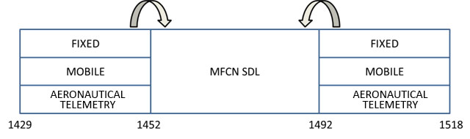

Figure 1: Services in bands adjacent to 1452-1492 MHz

In Region 1, the frequency band 1429-1518 MHz is used for Fixed and Mobile (except aeronautical mobile) services on a primary basis and the frequency band 1452-1492 MHz also for Broadcasting and Broadcasting Satellite services as a primary basis limited to digital audio broadcasting (see RR 5.345). In Region 1, there is an additional allocation to aeronautical mobile service on a primary basis limited to aeronautical telemetry, as given in RR 5.342:

**5.342** *Additional allocation:* in Armenia, Azerbaijan, Belarus, the Russian Federation, Uzbekistan, Kyrgyzstan and Ukraine, the band 1 429-1 535 MHz, and in Bulgaria the band 1 525-1 535 MHz, are also allocated to the

aeronautical mobile service on a primary basis exclusively for the purposes of aeronautical telemetry within the national territory. As of 1 April 2007, the use of the band 1 452-1 492 MHz is subject to agreement between the administrations concerned. (WRC-12).

### Compatibility scenarios

The compatibility scenarios studying the impact of MFCN SDL in 1452-1492 MHz on systems in adjacent bands have been studied in ECC Report 202 [5].

Additional compatibility scenarios (not studied in this report) include:

* Scenario A: Impact of systems of the Mobile service operating outside of 1452-1492 MHz on MFCN SDL in 1452-1492 MHz;
* Scenario B: Impact of systems of the Fixed service operating outside of 1452-1492 MHz on MFCN SDL in 1452-1492 MHz;
* Scenario C: Impact of Aeronautical Telemetry systems operating outside of 1452-1492 MHz on MFCN SDL in 1452-1492 MHz.

## Compatibility studies between Systems operating in 1452-1492 MHz

### Systems operating in 1452-1492MHz

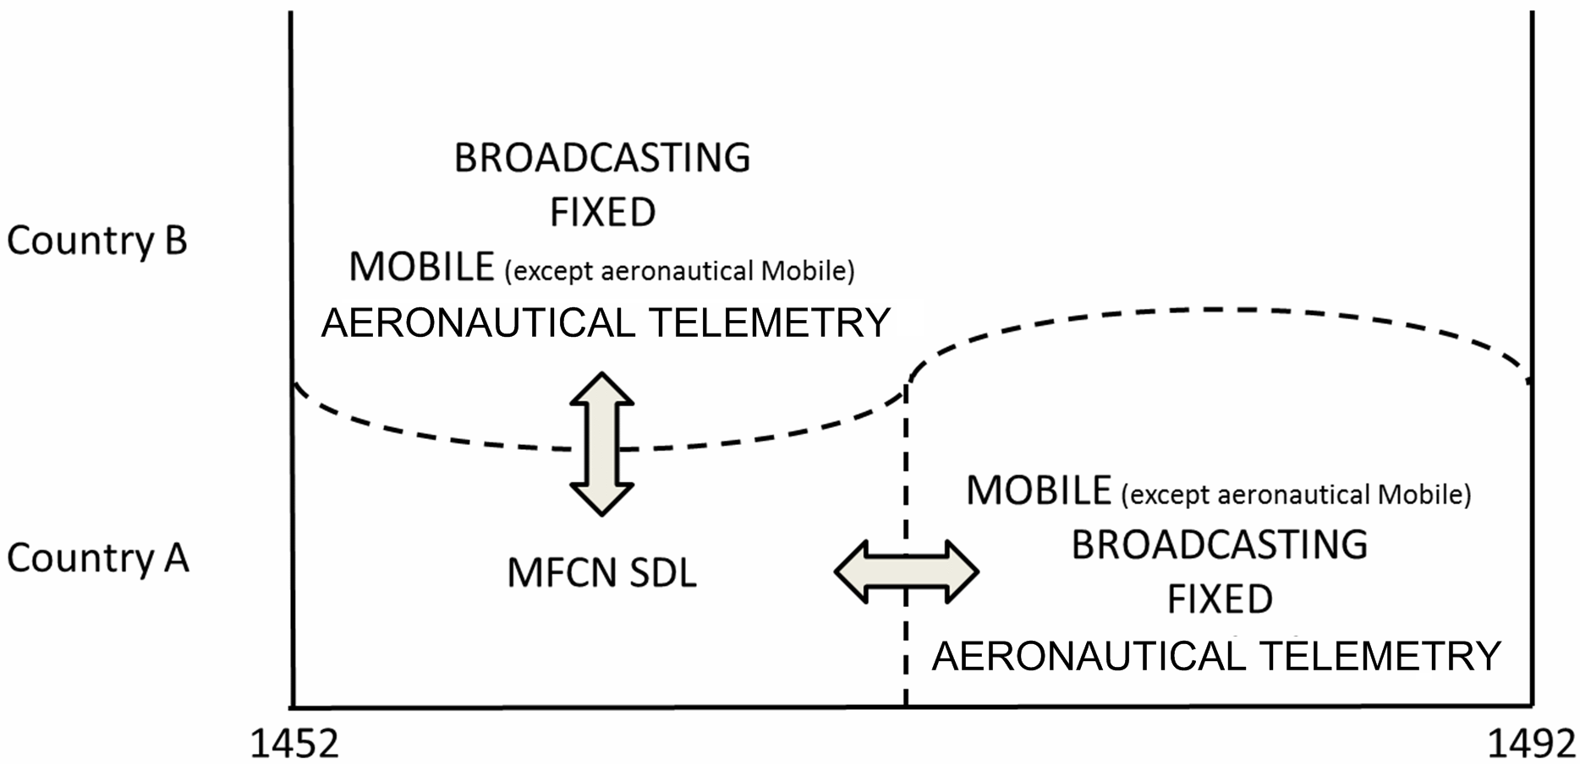

Figure 2: Services operating in the band 1452-1492 MHz

### Adjacent channel compatibility scenarios (national applications)

The following scenario is studied in this report:

* Scenario D: Impact of MFCN SDL on systems of the Broadcasting service operating in adjacent channel.

Additional compatibility scenarios (not studied in this report) include:

* Scenario E: Impact of MFCN SDL on systems of the Mobile service operating in adjacent channel   
  (ECC Report 202 studied a similar scenario for Mobile service operating in adjacent band);
* Scenario F: Impact of MFCN SDL on systems of the Fixed service operating in adjacent channel   
  (ECC Report 202 studied a similar scenario for Fixed service operating in adjacent band);
* Scenario G: Impact of MFCN SDL on Aeronautical Telemetry systems operating in adjacent channel (ECC Report 202 studied a similar scenario for Aeronautical Telemetry systems operating in adjacent band);
* Scenario H: Impact of systems of the Broadcasting service on MFCN SDL in adjacent channel;
* Scenario I: Impact of systems of the Mobile service on MFCN SDL operating in adjacent channel   
  (Similar to Scenario A);
* Scenario J: Impact of systems of the Fixed service on MFCN SDL operating in adjacent channel   
  (Similar to Scenario B);
* Scenario K: Impact of Aeronautical Telemetry systems on MFCN SDL operating in adjacent channel (Similar to Scenario C).

### Co-channel compatibility scenarios (cross border coordination)

The compatibility scenarios studied in this report include:

* Scenario L: Impact of MFCN SDL on systems of the Broadcasting service operating co-channel;
* Scenario O: Impact of MFCN SDL on Aeronautical Telemetry systems operating co-channel;
* Scenario P: Impact of systems of the Broadcasting service on MFCN SDL operating co-channel;
* Scenario S: Impact of Aeronautical Telemetry systems on MFCN SDL operating co-channel.

Additional compatibility scenarios (not studied in this report) include:

* Scenario M: Impact of MFCN SDL on systems of the Mobile service operating co-channel;
* Scenario N: Impact of MFCN SDL on systems of the Fixed service operating co-channel;
* Scenario Q: Impact of systems of the Mobile service on MFCN SDL operating co-channel;
* Scenario R: Impact of systems of the Fixed service on MFCN SDL operating co-channel.

### List of scenarios studied in this report

Table 3: List of compatibility scenarios considered in this report

| **Scenario** | **Co-channel/ Adjacent channel** | **Interferer** | **Victim** |
| --- | --- | --- | --- |
| D | Adjacent channel | MFCN SDL | Broadcasting |
| L | Co-channel | MFCN SDL | Broadcasting |
| O | Co-channel | MFCN SDL | Aeronautical Telemetry |
| P | Co-channel | Broadcasting | MFCN SDL |
| S | Co-channel | Aeronautical Telemetry | MFCN SDL |

# Description and characteristics of systems considered

## Aeronautical telemetry characteristics

The deployment of aeronautical telemetry services is limited to some CEPT countries, in accordance with ITU Radio Regulation footnote 5.342. For the purpose of this study, Aeronautical telemetry is limited to ground stations and considered appropriate parameters.[1]

The characteristics used in the compatibility assessment are based on Recommendation ITU-R М.1459 “Protection Criteria for Telemetry Systems in the Aeronautical Mobile Service and Mitigation Techniques to Facilitate Sharing with Geostationary Broadcasting-Satellite and Mobile-Satellite Services in the frequency bands 1452-1525 MHz and 2310-2360 MHz” [11].

Table 4: Typical characteristics of aeronautical mobile telemetry systems

| **Parameter** | **Value** |
| --- | --- |
| Transmitter power | 2-25 W |
| Modulation type | PCM/FM |
| Operating range | up to 320 km |
| Receiving antenna gain | 20-41 dB |
| Receiving system noise temperature | 200-500 K |
| Required C/N | 9-15 dB |
| Receive antenna first side-lobe levels for two antennas: |  |
| 10 m (diameter) | Antenna gain 20 dBi |
| From center 2.4 deg. |
| 2.44 m (diameter) | Antenna gain 7-14 dBi |
| From center 10 deg. |

This Recommendation indicates that for protection of the aeronautical telemetry ground receivers in the frequency band 1452-1525 MHz the power flux density (pfd) values of the GSO broadcasting satellite service or MSS in the referenced bandwidth of 4 kHz for any modulation types shall be limited to the following values:

–181.0 dB(W/m2) for 0 ≤ α ≤ 4°,

–193.0 + 20 log α dB(W/m2) for 4° < α ≤ 20°,

–213.3 + 35.6 log α dB(W/m2) for 20° < α ≤ 60°,

–150.0 dB(W/m2) for 60° < α ≤ 90°,

where α is angle of arrival (deg.) above the horizontal plane.

Taking into account the interference propagation from mfcn sdl stations the maximum permissible interference power flux density of minus 181 dB (W/m2) in the bandwidth of 4 kHz is used as a protection criteria for aeronautical telemetry ground receivers.

For the protection of aircraft stations of the aeronautical telemetry systems operating in the countries listed in RR No. 5.342 another criterion is used: the permissible pfd value in the reference bandwidth of 4 kHz shall not exceed (-140 dB(W/m2)).

Aeronautical telemetry characteristics can also be taken from the assignments of the Master International Frequency Register (MIFR), as a MA class of station (airborne transmitting station), from countries listed in RR 5.342 footnote.

Comparing parameters in Recommendation ITU-R M.1459 and ITU-R MIFR, these sources provide very different characteristics of telemetry systems. In order to ensure the reliability of the results, the compatibility analysis in scenario S was carried out using both sources.

Table 5: Parameters of telemetry airborne transmitter used in scenario S

| **Parameter** | **ITU-R M.1459** | **MIFR** |
| --- | --- | --- |
| Central frequency, MHz | 1474.5 | |
| Channel bandwidth, MHz | 5 | 21.3 |
| Maximum antenna gain, dBi | 10 | No information. Assumed according to Recommendation  ITU-R M.1459 |
| e.i.r.p., dBW | 23.98 | 25.15 |
| Maximum antenna height, m | 10000 | 10000 |
| Antenna type | Omnidirectional | Omnidirectional |
| Transmission path length, km | Up to 320 | Up to 600 |

The telemetry airborne transmitter ideally uses isotropic antenna to cover all possible radiation angles toward the telemetry receiving station. However, in practice, multiple reflections and specific form of the airborne fuselage (possible physical blockage, metallic surface and etc.) can cause large variations in the antenna gain pattern *GTx* (compared to *Gmax* = 10 dBi).

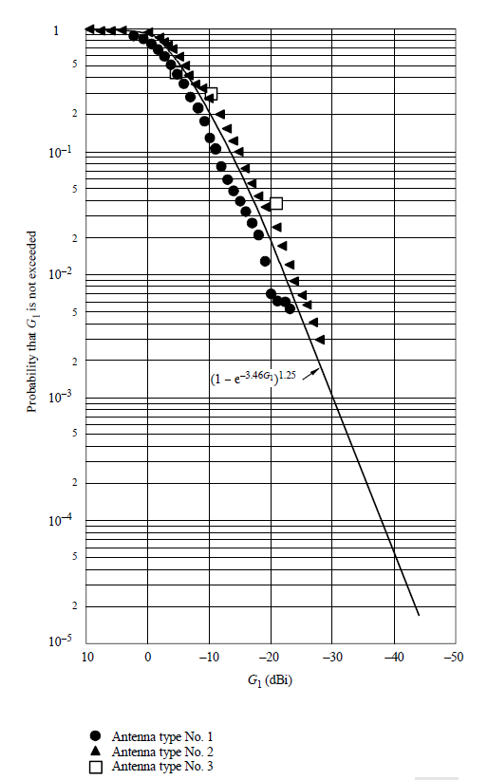

Figure 3: Airborne telemetry transmitting antenna gain variations

For example, the probability of *GTx = 0 dBi* is *P( G ≤ GTx = 0 dBi)* = 0.96. Such antenna gain variation can have significant influence to the results of this analysis. In the study for scenario S, three different telemetry transmitter antenna gain were used:

* *Gmax* = 10 dBi as maximum antenna gain according to the Recommendation ITU-R M.1459;
* *Gpossible* = 0 dBi as antenna gain in near real case scenario;
* distribution of GTX (CDF), as provided in Figure 1 of Annex 1 of Recommendation ITU-R M.1459, for Monte Carlo simulations only.

It was assumed that antenna type is omnidirectional in both cases.

## Broadcasting service characteristics

### Broadcasting transmission

The broadcasting Tx parameters are extracted from the Maastricht Special Arrangement (MA02revCO07) [1]. The Maastricht Special Arrangement introduces two references networks (L-RN1 and L-RN2), for which the critical case (Maximum e.i.r.p) is the peripheral transmitter of reference network 2. The transmitter parameters are provided in Table 6. Reference Network 1 and Reference Network 2 network structures and distances are illustrated in Figure 4: T-DAB network structures and distances, L-RN1 and L-RN2.

The broadcasting Tx mask is assumed to comply with the T-DAB mask from MA02revCO07, with additional assumption of linear (in dB) interpolation between emission at edge of T-DAB block and 0.97 MHz, as detailed in Table 7 and illustrated in Figure 5.

.

Table 6: Broadcasting Tx parameters

| **Parameter** | | **Value** |
| --- | --- | --- |
| Bandwidth (MHz) | | 1.536 |
| L-RN2 | Tx Distance (km) | 26 |
| Width coverage area (km) | 45 |
| Propagation | Hata (Urban) |
| L-RN1 | Tx Distance (km) | 15 |
| Width coverage area (km) | 60 |
| Propagation | Hata (Rural) |
| Reference Case  L-RN2,  Peripheral transmitter | Output power (dBm) | 67 |
| Antenna gain (dBi) | 4.5 |
| Max e.i.r.p. (dBm/MHz) | 69.6 |
| Antenna height (m) | 50 |
| L-RN2,  Central Transmitter | Output power (dBm) | 61 |
| Antenna gain (dBi) | 0 |
| Max e.i.r.p. (dBm/MHz) | 59.1 |
| Antenna height (m) | 150 |
| L-RN1,  Central Transmitter | Output power (dBm) | 57 |
| Antenna gain (dBi) | 0 |
| Max e.i.r.p. (dBm/MHz) | 55.1 |
| Antenna height (m) | 150 |
| L-RN1,  Peripheral Transmitter | Output power (dBm) | 60 |
| Antenna gain (dBi) | 0 |
| Max e.i.r.p. (dBm/MHz) | 58.1 |
| Antenna height (m) | 150 |
| Tx Mask | | See Table 7 and Figure 5[2] |



Figure 4: T-DAB network structures and distances, L-RN1 and L-RN2

The broadcasting Tx mask is assumed to comply with the T-DAB mask from MA02revCO07, with additional assumption of linear (in dB) interpolation between emission at edge of T-DAB block and 0.97 MHz, as detailed in Table 7 and illustrated in Figure 5.

Table 7: Broadcasting emission mask breakpoints[3]

| **Breakpoints (MHz)** | **Ratio of out-of-band power measured in 4kHz to in-block power spectrum density (dB)** |
| --- | --- |
| 0 | 0 |
| 0.768 | 0 |
| 0.97 | -30 |
| 3 | -80 |

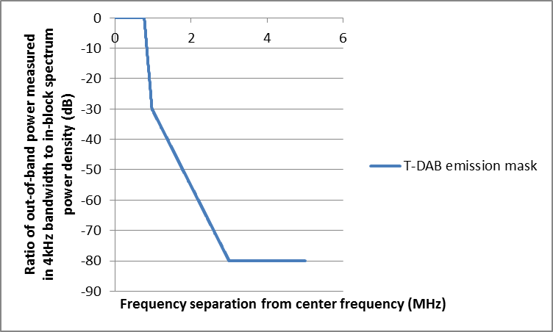

Figure 5: Broadcasting emission mask.

### Broadcasting reception

The broadcasting Rx parameters are extracted from the Maastricht Special Arrangement (MA02revCO07) [1].

Table 8: Broadcasting Rx parameters

| **Parameter** | **Value** |
| --- | --- |
| Bandwidth (MHz) | 1.536 MHz |
| Minimum equivalent field strength | 46 dB(μV/m) = -94.6 dBm |
| T-DAB co-block protection ratio | 10 dB |
| Antenna height (m) | 1.5 m |
| Rx mask | See Table 9 and Figure 5 |

The broadcast receiver blocking characteristics are obtained by combining:

* The broadcasting Rx minimum equivalent field strength;
* T-DAB co-block protection ratio;
* The broadcast Rx mask selectivity.

In the studies of section 4.1, the appropriate broadcast receiver mask selectivity is subtracted from the out-of-band interfering signal to obtain the equivalent in-band interfering signal (i.e. the in-band signal creating the same interference as the out-of-band interfering signal).

The mask of the broadcast receiver is provided in the Table 9 below and illustrated in the Figure 6 below.

Table 9: Broadcasting receiver mask breakpoints[4]

| **Frequency separation  from carrier center frequency (MHz)** | **Selectivity [dB]** |
| --- | --- |
| 0 | 0 |
| 0.6 | 0 |
| 0.7 | -1 |
| 0.8 | -5 |
| 0.9 | -17.5 |
| 1 | -30 |
| 1.5 | -30 |
| 2 | -40 |
| 2.4 | -56 |
| 2.5 | -65 |
| 2.9 | -65 |
| 3 | -75 |
| 11 | -75 |

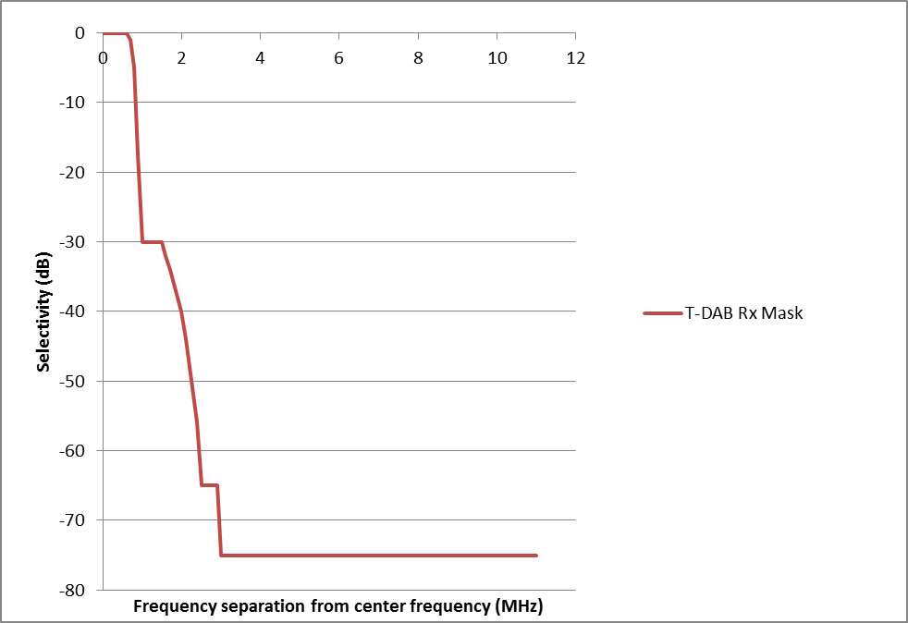

Figure 6: Broadcasting Receiver Mask

## MFCN SDL characteristics

The harmonised frequency arrangement is based on a block size of 5 MHz, resulting in the following 8 frequency blocks in 1452-1492 MHz.

Table 10: Harmonised frequency arrangement for MFCN SDL in 1452-1492 MHz

| 1452 -1457 | 1457-1462 | 1462-1467 | 1467-1472 | 1472-1477 | 1477-1482 | 1482-1487 | 1487-1492 |
| --- | --- | --- | --- | --- | --- | --- | --- |
| **Downlink (base station transmit)** | | | | | | | |
| 40 MHz (8 blocks of 5 MHz) | | | | | | | |

Table 11: Base station BEM out-of-block e.i.r.p. limits within the band 1452-1492 MHz per antenna

| **Frequency range of**  **out-of-block emissions** | **Maximum mean**  **out-of-block e.i.r.p.**  **[dBm]** | **Measurement**  **Bandwidth**  **[MHz]** |
| --- | --- | --- |
| –10 to –5 MHz from lower block edge | 11 dBm | 5 MHz |
| –5 to 0 MHz from lower block edge | 16.3 dBm | 5 MHz |
| 0 to +5 MHz from upper block edge | 16.3 dBm | 5 MHz |
| +5 to +10 MHz from upper block edge | 11 dBm | 5 MHz |
| Remaining MFCN SDL frequencies | 9 dBm | 5 MHz |

Table 12: Base station OOB e.i.r.p. limits out of the band 1452-1492 MHz

| **Frequency range of**  **out-of-band emissions** | **Maximum mean**  **out-of-band e.i.r.p.**  **[dBm]** | **Measurement**  **Bandwidth**  **[MHz]** |
| --- | --- | --- |
| Below 1449 MHz | -20 dBm | 1 MHz |
| 1449-1452 MHz | 14 dBm | 3 MHz |
| 1492-1495 MHz | 14 dBm | 3 MHz |
| Above 1495 MHz | -20 dBm | 1 MHz |

In this Report, Table 13 parameters are used in the compatibility studies; and in future compatibility studies ITU-R approved values (as in Annex 4) may be used.

Table 13: Parameters for MFCN SDL macro BS

|  |  |
| --- | --- |
| **Parameter[5]** | **Value** |
| In block e.i.r.p. | 68 dBm/5 MHz |
| Antenna height | 45 m |
| Cell size (radius)[6] | Urban: 1080 m  Rural: 8660 m |
| Horizontal antenna pattern  Vertical antenna pattern | Omni directional  A down-tilt of 3° is assumed, corresponding to an e.i.r.p. towards the horizon 1.89 dB below maximum e.i.r.p. |

In this Report, Table 14 parameters are used in the compatibility studies; and in future compatibility studies ITU-R approved values (as in Annex 4) may be used.

Table 14: Parameters for MFCN SDL UE

|  |  |  |
| --- | --- | --- |
| **Parameter** | **Value** | **Source** |
| Antenna height | 1.5 m | Report ITU-R M.2039-2 [16]  ECC Report 82 [12]  CEPT Report 40 [13]  ECC Report 191 [14] |
| Antenna gain | -4 dBi | ECC Report 191 |
| Antenna pattern | Omni | ECC Report 82  CEPT Report 40 |
| Body Loss | 3 dB | ECC Report 191 |
| Rx BW | 5 MHz | Size of frequency block |
| Receiver Temperature  (kTB) | -107 dBm |  |
| Receiver noise Figure | 9 dB | ECC Report 191  Report ITU-R M.2039-2 |
| Receiver Thermal  Noise Level | -98 dBm |  |
| I/N Target | 0 dB | Report ITU-R M.2039-2  ECC Report 191 Target Desensitization DTARGET = 3dB |
| Receiver ACS | 33 dB | Report ITU-R M.2039-2  ECC Report 82  CEPT Report 40 |
| Receiver in-band blocking | See ANNEX 1: | ECC Report 82  CEPT Report 40 |
| Receiver out-of-band blocking | See ANNEX 1: | ECC Report 82  CEPT Report 40 |
| Receiver Narrow band blocking | -67.8 dBm  then increase by 0.8 dB every 200 kHz | ECC Report 191  At 212.5 kHz from the channel edge. |

# Coexistence Studies

## Scenario D: Impact of MFCN SDL on systems of the Broadcasting service operating in adjacent channel

An analysis of the relative contribution of the interference due to blocking (IB) and the interference due to Out-of-Block emissions (IOOB) is provided in Section 4.1.1 and leads to the definition of a critical BEM (BEM which ensures that IB>IOOB).

A Minimum Coupling Loss (MCL) analysis is conducted in Section 4.1.2, including typical separation distance and estimation of the percentage of interference for both reference and study cases.

A Monte-Carlo analysis based on Seamcat is provided in Section 4.1.3.

### IB-IOOB analysis

The analysis below focuses on the relative contribution of IB vs IOOB by considering them independently of Coupling Loss (CL), i.e. by considering and comparing IB+CL and IOOB+CL.

#### Reference scenario: T-DAB vs T-DAB in adjacent blocks

The IB+CL and IOOB+CL for T-DAB vs T-DAB adjacent block coexistence scenarios are provided in Table 15.

Table 15: T-DAB vs T-DAB in adjacent blocks, IB+CL and IOOB+CL

|  |  |  |  |
| --- | --- | --- | --- |
| **Adjacent Channel** | **T-DAB Transmitter** | **IB+CL (dBm)** | **IOOB+CL (dBm)** |
| 1 | L-RN2, Peripheral Tx | 38.9 | 33.2 |
| L-RN2, Central Tx | 28.4 | 22.7 |
| L-RN1, Central Tx | 27.4 | 21.7 |
| L-RN1, Peripheral Tx | 24.4 | 18.7 |
| 2 | L-RN2, Peripheral Tx | 0.7 | -6.8 |
| L-RN2, Central Tx | -9.8 | -17.3 |
| L-RN1, Central Tx | -10.8 | -18.3 |
| L-RN1, Peripheral Tx | -13.8 | -21.3 |

The analysis of the reference scenarios indicates that T-DAB is designed to ensure that blocking is the dominant interference factor (i.e. IB ≈ IOOB + 6 dB). Depending on the reference scenario considered (adjacent channel 1 or 2), an IOOB+CL, corresponding to the out of band emission of the transmitter, of respectively 33.2 or -6.8 dBm is considered acceptable.

#### SDL Critical BEM to ensure IB = IOOB + 6 dB

The IB+CL and IOOB+CL for SDL vs T-DAB adjacent block coexistence scenarios are provided in Table 16. The Table includes the additional SDL Tx filtering required in order to ensure that IB = IOOB + 6 dB. This criterion ensures that interference would always be dominated by the blocking of the T-DAB receiver and therefore that additional filtering of SDL emission would not significantly reduce the interference.

Table 16: IB+CL and IOOB+CL analysis of scenario D

|  |  |  |  |  |  |  |  |  |  |
| --- | --- | --- | --- | --- | --- | --- | --- | --- | --- |
| **Frequency Separation**  **T-DAB block edge –**  **SDL block edge (MHz)** | **0.25** | **0.5** | **0.75** | **1** | **1.25** | **1.5** | **1.75** | **2** | **2.25** |
| IB+CL (dBm) | 29.4 | 27.4 | 23.8 | 18.2 | 10.7 | 1.1 | -4.6 | -5.9 | -7 |
| IOOB+CL (dBm) | 11.2 | 11.2 | 11.2 | 11.2 | 11.2 | 11.2 | 11.2 | 11.2 | 11.2 |
| Additional Filtering Required to achieve IB=IOOB+6dB (dB) | 0 | 0 | 0 | 0 | 6.5 | 16.0 | 21.8 | 23.0 | 24.2 |

The resulting ‘Critical BEM’ for SDL Tx is provided in Table 17 and illustrated in Figure 7. The Critical BEM could be considered for base stations that are deployed less than 5 MHz away from an operating broadcasting transmitter. Note that the critical BEM only needs to be fulfilled over operational frequencies of broadcasting stations. For example, should a T-DAB carrier be deployed 3 MHz away from the SDL carrier, the critical mask only need to be fulfilled for frequency separations larger than 3 MHz.

Table 17: Critical SDL Tx BEM

|  |  |  |
| --- | --- | --- |
| **Frequency range of**  **out-of-block emissions** | **Maximum mean**  **out-of-block e.i.r.p.**  **[dBm]** | **Measurement**  **Bandwidth**  **[MHz]** |
| 0 – 1.3 MHz from block edge | 9.3 | 1 |
| 1.3-1.5 MHz from block edge | 2.8 | 1 |
| 1.5-1.8 MHz from block edge | -6.7 | 1 |
| 1.8-2 MHz from block edge | -12.4 | 1 |
| 2-2.3 MHz from block edge | -13.7 | 1 |
| 2.3-5 MHz from block edge | -14.9 | 1 |
| Remaining T-DAB frequencies | -14.9 | 1 |

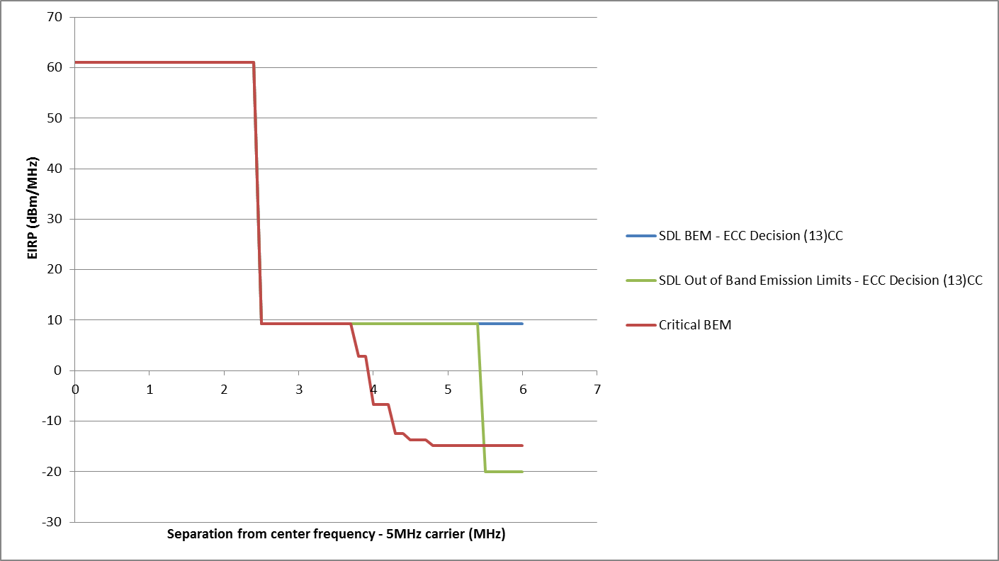

Figure 7: SDL Critical BEM. BEM and OOB emission limits from ECC/DEC/(13)03 are provided for comparative purposes

The ECC/DEC/(13)03 [2] adopts Base station OOB e.i.r.p. limits out of the band 1452-1492 MHz which are illustrated in Figure 7. These OOB e.i.r.p. limits impose filtering of SDL OOB emission beyond the SDL BEM for frequency separation larger than 3 MHz. It is noticeable that the Critical BEM corresponds approximately to the OOB e.i.r.p. limits for a frequency separation larger than 3 MHz.

#### Implementability of Critical BEM

It should be noted that the implement ability of the proposed Critical BEM has not been studied. As such, the critical BEM should be seen solely as the BEM ensuring that interference due to blocking is the dominant interference factor for any frequency separation between SDL and T-DAB.

### MCL Analysis

#### Reference scenario: T-DAB vs T-DAB in adjacent blocks

The MCL required to avoid interference for the two reference scenarios is detailed in Table 18.

Table 18: MCL analysis, Scenario D, reference scenario (T-DAB vs T-DAB in adj. channel)

|  |  |  |  |  |  |
| --- | --- | --- | --- | --- | --- |
| **Adjacent Channel** | **T-DAB Transmitter** | **Maximum in band equivalent interference field strength (dBm)** | **IB + IOOB + CL (dBm)** | **MCL (dB)** | **Interfering Distance (km)** |
| 1 | L-RN2, Peripheral Tx | -104.6 | 40.0 | 144.5 | 2.9 |
| L-RN2, Central Tx | -104.6 | 29.4 | 134.0 | 2.4 |
| L-RN1, Central Tx | -104.6 | 28.5 | 133.0 | 21.7 |
| L-RN1, Peripheral Tx | -104.6 | 25.4 | 130.0 | 18.0 |
| 2 | L-RN2, Peripheral Tx | -104.6 | 1.4 | 106.0 | 0.21 |
| L-RN2, Central Tx | -104.6 | -9.1 | 95.4 | 0.13 |
| L-RN1, Central Tx | -104.6 | -10.1 | 94.5 | 0.87 |
| L-RN1, Peripheral Tx | -104.6 | -13.1 | 91.4 | 0.6 |

The probability of interference for the reference scenario is provided in the Table 19 and illustrated in Figure 8.

Table 19: MCL analysis, Scenario D, reference scenario, interference probability

|  |  |  |
| --- | --- | --- |
| **Adjacent Channel** | **T-DAB Network** | Interference Probability (%) |
| 1 | L-RN1 | 100 |
| L-RN2 | 4 |
| 2 | L-RN1 | 0.29 |
| L-RN2 | 0.02 |

|  |  |
| --- | --- |
| L-RN1, First T-DAB Adjacent Channel | L-RN1, Second T-DAB Adjacent Channel |
| L-RN2, First T-DAB Adjacent Channel | L-RN2, Second T-DAB Adjacent Channel |

Figure 8: MCL analysis, Scenario D, reference scenario, Interference Areas

#### Scenario D (MFCN vs broadcasting in adj. channel)

The MCL, required to avoid interference between SDL Tx and broadcasting Rx, is derived in Table 20 for an SDL Tx complying with the SDL BEM.

Table 20: MCL analysis, scenario D (SDL vs broadcasting in adj. channel), SDL BEM

|  |  |  |  |  |  |  |  |  |  |
| --- | --- | --- | --- | --- | --- | --- | --- | --- | --- |
| **Frequency Separation**  **T-DAB block edge –**  **SDL block edge (MHz)** | **0.25** | **0.5** | **0.75** | **1** | **1.25** | **1.5** | **1.75** | **2** | **2.25** |
| Maximum in band equivalent interference field strength (dBm) | -104.6 | | | | | | | | |
| IB + IOOB + CL (dBm) | 29.5 | 27.5 | 24.0 | 19.0 | 14.0 | 11.6 | 11.3 | 11.3 | 11.2 |
| MCL (dB) | 134.0 | 132.1 | 128.6 | 123.6 | 118.5 | 116.1 | 115.8 | 115.8 | 115.8 |
| Interfering Distance, Hata Urban (km) | 1.35 | 1.19 | 0.94 | 0.67 | 0.47 | 0.4 | 0.39 | 0.39 | 0.39 |
| Interfering Distance, Hata Rural (km) | 10.8 | 9.5 | 7.5 | 5.3 | 3.8 | 3.2 | 3.1 | 3.1 | 3.1 |

The MCL, required to avoid interference between SDL Tx and broadcasting Rx, is derived in Table 21 for an SDL Tx complying with the SDL Critical BEM.

Table 21: MCL analysis, scenario D (SDL vs broadcasting in adj. channel), SDL Critical BEM

|  |  |  |  |  |  |  |  |  |  |
| --- | --- | --- | --- | --- | --- | --- | --- | --- | --- |
| **Frequency Separation**  **T-DAB block edge –**  **SDL block edge (MHz)** | **0.25** | **0.5** | **0.75** | **1** | **1.25** | **1.5** | **1.75** | **2** | **2.25** |
| Maximum in band equivalent interference field strength (dBm) | -104.6 | | | | | | | | |
| IB + IOOB + CL (dBm) | 29.5 | 27.5 | 24.0 | 19.0 | 11.7 | 2.1 | -3.6 | -4.9 | -6.0 |
| MCL (dB) | 134.0 | 132.1 | 128.6 | 123.6 | 116.2 | 106.7 | 101.0 | 99.7 | 98.5 |
| Interfering Distance, Hata Urban (km) | 1.35 | 1.19 | 0.94 | 0.67 | 0.41 | 0.21 | 0.14 | 0.13 | 0.12 |
| Interfering Distance, Hata Rural (km) | 10.8 | 9.5 | 7.5 | 5.3 | 3.2 | 1.7 | 1.1 | 1.1 | 1.0 |

The probabilities of interference for scenario D are provided in Table 22 and illustrated in Figure 9 for different frequency separation.

Table 22: MCL analysis, Scenario D, Interference Probability

|  |  |  |  |  |  |  |  |  |  |  |
| --- | --- | --- | --- | --- | --- | --- | --- | --- | --- | --- |
| **Environment** | **BEM** | Interference Probability (%) | | | | | | | | |
| **Frequency Separation**  **T-DAB block edge –**  **SDL block edge (MHz)** | | | | | | | | |
| **0.25** | **0.5** | **0.75** | **1** | **1.25** | **1.5** | **1.75** | **2** | **2.25** |
| Rural | SDL BEM | 100 | 100 | 100 | 60.4 | 31 | 22 | 20.7 | 20.7 | 20.7 |
| Critical BEM | 100 | 100 | 100 | 60.4 | 22 | 6.2 | 2.6 | 2.6 | 2.1 |
| Urban | SDL BEM | 100 | 100 | 100 | 62 | 30.5 | 22.1 | 21 | 21 | 21 |
| Critical BEM | 100 | 100 | 100 | 62 | 23.2 | 6.1 | 2.7 | 2.3 | 2 |

|  |  |
| --- | --- |
| Rural Deployment, SDL BEM | Rural Deployment, Critical BEM |
| Urban Deployment, SDL BEM | Urban Deployment, Critical BEM |

Figure 9: MCL analysis, Scenario D, Interference Areas

### Monte-Carlo (Seamcat) analysis

#### Simulation of the T-DAB field strength

The T-DAB signal is delivered throughout the T-DAB coverage area by a network of transmitters, either L-RN1 or L-RN2. As Seamcat does not take into account SFN gain, it is necessary in a preliminary step to obtain the T-DAB field strength.

In order to achieve this, a test receiver is simulated as being interfered co-channel by a L-RN1 or a L-RN2 network. As Seamcat does not consider hexagonal coverage areas, circular coverage areas either within the coverage hexagon or encompassing the coverage hexagon are simulated, in order to determine the worth case condition. The results are provided in the Table below.

Table 23: Simulated T-DAB Field Strength

|  |  |  |  |  |
| --- | --- | --- | --- | --- |
| **Simulation** | **1** | **2** | **3** | **4** |
| Network | L-RN1 | L-RN1 | L-RN2 | L-RN2 |
| Coverage Area Radius | 30 km | 35 km | 22.5 km | 26 km |
| Propagation Model | Hata Rural | Hata Rural | Hata Urban | Hata Urban |
| IRSS Unwanted - Mean | -54.1 dBm | -56.8 dBm | -85.2 dBm | -85.7 dBm |
| IRSS Unwanted - StdDev | 8.7 dBm | 9.2 dBm | 7.2 dBm | 8.8 dBm |

In order to take the most pessimistic assumptions, the IRSS Unwanted results of simulations 2 and 4 will be taken as basic assumption for DRSS for the further simulations.

#### Interference Probability for L-RN1

A 2 tiers 3GPP hexagonal network corresponding to rural deployment (cell radius = 8.66 km, see Rural cell radius in Table 13, Hata rural channel) is simulated as interferer, while the T-DAB field strength (dRSS) is set according to the results of Simulation 2 and the receivers are located within the center SDL cell.

The values of IRSS Unwanted, IRSS Blocking and the probability of interference according to C/I = 10 dB are summarised in the Table 25.

Table 24: Probability of SDL rural interfering L-RN1 T-DAB vs guardband

|  |  |  |  |  |  |
| --- | --- | --- | --- | --- | --- |
| **Guardband (MHz)** | **0** | **0.5** | **1** | **1.5** | **2** |
| SDL ECC/DEC(13)03 BEM  Probability of interference (%) | 1.4 | 0.3 | 0.3 | 0.3 | 0.3 |
| SDL Critical Mask  Probability of interference (%) | 1.3 | 0.2 | 0.2 | 0 | 0 |

#### Interference Probability for L-RN2

A 2 tiers 3GPP hexagonal network corresponding to urban deployment (cell radius = 1.08 km, see Urban cell radius in Table 13, Hata urban channel) is simulated as interferer, while the T-DAB field strength (dRSS) is set according to the results of Simulation 4 and the receivers are located within the center SDL cell.

The probability of interference according to C/I = 10dB are summarised in the Table 25.

Table 25: Probability of SDL urban interfering L-RN2 T-DAB vs guardband

|  |  |  |  |  |  |
| --- | --- | --- | --- | --- | --- |
| **Guardband (MHz)** | **0** | **0.5** | **1** | **1.5** | **2** |
| SDL ECC/DEC(13)03 BEM Probability of interference (%) | 40.4 | 14.4 | 13.9 | 13.9 | 13.9 |
| SDL Critical Mask  Probability of interference (%) | 40.1 | 10.2 | 6 | 1.1 | 0.75 |

#### Conclusion from Monte-Carlo Analysis

Monte-Carlo analysis indicates that a SDL network implementing the BEM from the ECC/DEC/ (13)03 [2] lead to interference to T-DAB receiver in less than 1 % in rural environment for a guard band between T-DAB and SDL equal or larger than 0.5 MHz. However, the SDL BEM of ECC/DEC/(13)03 leads to substantial interference probability (more than 13 %) in urban environment, even for a guard band of 2 MHz (the maximum band guard studied).

Adopting the critical BEM for SDL leads to low level of interference (around 1 % or less) from SDL to T-DAB for a guard band of 1.5 MHz, even in urban deployment.

### Conclusion of Scenario D (SDL vs T-DAB in adjacent channel)

The interference from SDL to T-DAB in adjacent channel is moderate under assumptions corresponding to rural deployment. In such a case, deployment with limited (0.5 MHz) guard band seems to be appropriate.

In urban deployment, the probability of interference from SDL to T-DAB is substantial (more than 10 %) for guard band lower than 1 MHz. Furthermore, the out-of-block emission from SDL, as specified in ECC/DEC/13(03) (See Table 11) becomes a significant interference factor for guard band wider than 1.3 MHz, i.e. the emission mask from ECC/DEC/(13)03 and the critical emission mask differ significantly for frequencies more than 1.3 MHz away from the SDL block.

The adoption of the SDL critical BEM defined in Table 17 guarantees:

* that interference due to blocking is the dominant interference factor,
* low level of interference (around 1 % or less) from SDL to T-DAB, even in urban deployment scenario for guard band equal or superior to 1.5 MHz.

It should be noted that no assessment was conducted on whether the proposed SDL critical BEM can be implemented on a cost efficient manner.

Studies could be required on a national basis in order to select a different (than 1.5 MHz) guard band between T-DAB and SDL, and accordingly the SDL BEM corresponding to that guard band.

To cover any case, a guard band of 1.5 MHz between SDL and T-DAB is required associated with the application of the critical SDL BEM defined in Table 17.

## Scenario L: Impact of MFCN SDL on systems of the Broadcasting service operating co-channel and scenario P: Impact of systems of the Broadcasting service on MFCN SDL operating co-channel

In CEPT, the Maastricht Special Arrangement (MA02revCO07) [1] provides the technical and regulatory framework for the introduction of T-DAB and other terrestrial multimedia systems in the frequency band 1452-1479.5 MHz and provisions for cross border coordination between T-DAB and other systems including those of the mobile service such as MFCN SDL.

Indeed, ECC/DEC/(13)03 mentions that MA02revCO07 Special Arrangement provides the necessary regulatory procedures for cross-border coordination between administrations having to coordinate incumbent terrestrial digital sound broadcasting networks in one country and MFCN SDL mobile service in another country.

### Procedure for cross-border coordination

The procedure for cross-border coordination between T-DAB and other radiocommunication services, and vice and versa, are described in the Article 5 of the Ma02revCo07 while the relevant technical procedures are specified in Annex 4.

### Maastricht applicability

Article 5 of Ma02revCo07 applies for cross-border coordination between SDL and T-DAB. Article 5.1.1 highlights that reception of stations in the mobile service, except the aeronautical mobile service, is likely to be affected by a proposed T-DAB block assignment if the appropriate limits indicated in Annex 2 are exceeded. Section 4.2.2 of Annex 2 outlines that when *'no information concerning protection ratios for other services suffering interference from T-DAB has been supplied to the Planning Meeting, the administrations concerned should develop appropriate sharing criteria by mutual agreement. When available one could use the relevant ITU-R Recommendations or ERC and ECC Decisions and Recommendations*' to determine maximum permissible interfering field strength limits. Article 5.2.1 and Section 4.2.1 of Annex 2 include similar provisions for the reverse case, namely when T-DAB allotments are likely to be affected by the mobile service.

### Derivation of field strength limit for cross border coordination.

#### Derivation of the maximum permissible interfering field strength limit to T-DAB

From Table 8 the T-DAB Minimum equivalent field strength is:

Emin(TDAB) = 46 dBμV/m

When SDL Tx interferes with T-DAB Rx within the 1452-1492 MHz band, the wanted signal, *E*, at a reception point must equal or exceed the interfering field strength *I* by the relevant protection ratio, PR:

E ≥ I + PR.

The maximum permissible interfering field strength is:

IThreshold = Emin + (99%) × σ(1 - $\sqrt{2}$) - PR

where:

* PR is the protection ratio for the wanted signal with respect to the Interferer,
* μ(X%) depicts the statistical distribution factor (for X% of the locations); μ(99%) = 2.33;
* σ = 5.5 dB represents the standard deviation corresponding to the location variation of the wanted field strength.

The formula leads to the following coordination threshold:

* Assuming Emin = 46 dBμV/m and PR = C/I = 10 dB (Maastricht Arrangement),

IThreshold = 30.7 ≈ 31 dBμV/m for h = 1.5 m,

=[7] 41 dBμV/m for h = 10 m,

This is the coordination threshold included in the Maastricht arrangement. It should be noted that this coordination threshold corresponds to the interfering field strength measured over the bandwidth of the interfered system (i.e. the T-DAB receiver bandwidth).

#### Derivation of the maximum permissible interfering field strength limit to SDL

The interference threshold is derived based on the SDL terminal characteristics and the interference criterion:

IMax (dBm) = Nth+ NF + I/N = -98 + 0 = -98 dBm

where

Nth is the thermal noise over the receiver bandwidth.

From the previous parameters, the calculation of the T-DAB field strength is performed with the following formula:

IMax (dBμV/m) = IMax (dBm) - Gr(dBi) + FeederLoss (dB) + 20log10(fTx MHz) + 77.2 = 46.4 dBμV/m

In the Maastricht arrangement, similarly as for the protection of T-DAB, the location probability factor has been used for the derivation of the coordination threshold, which is resulting in a coordination threshold of 41 dBµV/m. However, mobile systems’ cross border coordination is usually based on 50 % location probability, and it is therefore recommended that bilateral coordination for the protection of SDL from T-DAB should not take into account the location probability factor, thus:

IThreshold = 46.4 dBμV/m for h = 1.5 m

where:

IThreshold is the cross border coordination threshold.

This leads to the following coordination threshold at 10 m:

IThreshold = 56.4 dBμV/m for h = 10 m

It should be noted that this coordination threshold corresponds to the interfering T-DAB field strength measured over the bandwidth of the interfered system (i.e. the SDL receiver bandwidth).

#### Partial overlap between SDL channel and T-DAB blocs

The coordination thresholds derived above apply to the field strength measured over the bandwidth of the victim system. As such, the coordination threshold applies both to fully or partially overlapping blocks.

### Conclusion

Two countries parties to the Maastricht Special Arrangement can coordinate their respective T-DAB and MFCN use of the band according to the provisions of the MA02revCO07 Arrangement.

The recommended coordination thresholds are:

* cross-border coordination for MFCN SDL interfering T-DAB: 41 dBµV/m measured over the bandwidth of a single T-DAB block for an antenna height of 10m (in conformity with Maastricht arrangement);
* cross-border coordination for T-DAB interfering MFCN SDL: 56.4 dBμV/m over the bandwidth of a single SDL block (5 MHz) for an antenna height of 10m measured (relaxing the threshold level from Maastricht arrangement).

Maastricht Special Arrangement refers to the propagation model Recommendation ITU-R P.1546 [15]. The administrations concerned may agree to use a different propagation prediction method in their bilateral coordination.

## Scenario O: Impact of MFCN SDL on Aeronautical Telemetry systems operating co-channel

### Study #1

#### Interference case

Two sub-scenarios of interference are addressed:

* Sub-Scenario 1 (Fig.10) when the single interference impact from MFCN SDL transmitter to aeronautical telemetry ground receiver is considered. In the interference estimation the propagation model which takes into account the tropospheric scattering of radiowaves given in Recommendation ITU-R Р.1546-5 is used (50 % of locations, 10 % of time). The estimations are performed for rural propagation conditions for land and sea paths.

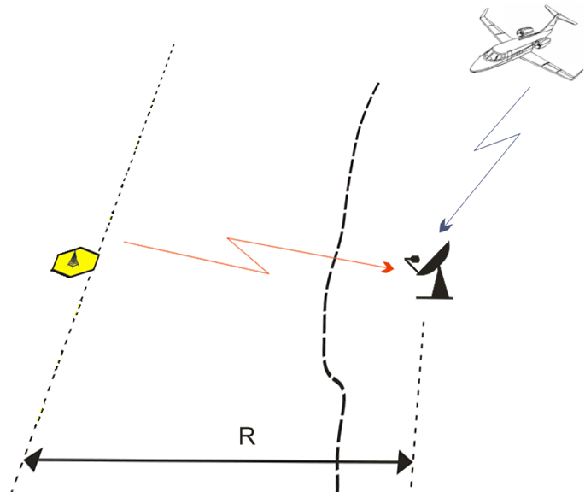

Figure 10: Single interference impact to ground receiver of aeronautical telemetry system

* Sub-Scenario 2 (Fig. 11), when interference impact from transmitter MFCN SDL network to the ground receiver of the aeronautical telemetry systems is considered. In the framework of this sub-scenario two specific cases are addressed: interference to ground receiver are caused by urban MFCN SDL (case a) and the case when interferences are caused to aeronautical telemetry ground receiver by MFCN SDL located in rural area (case b). Both cases of sub-scenario 2 are shown in Fig.12.

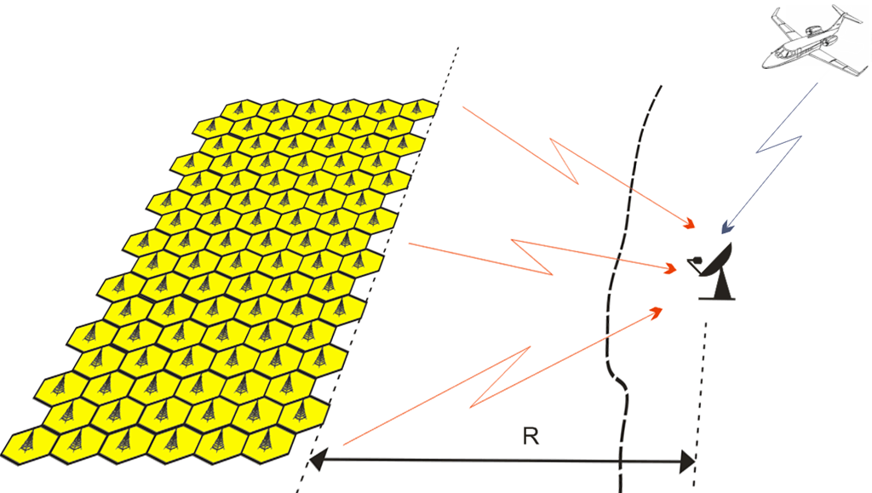

Figure 11: Aggregate interference impact to ground receiver of aeronautical telemetry



Case а Case b

Figure 12: Specific cases of aggregate interference impact

#### Calculation results

a) Calculation results for sub-scenario 1

In the framework of this sub-scenario in the interference estimation it was assumed that interference to the ground receiver is caused by single MFCN SDL transmitter with e.i.r.p. of 68 dBm/5 MHz and it corresponds to e.i.r.p. of 35 dBm/4 kHz.

For estimation of the required protection distance the protection criterion for the aeronautical telemetry ground receivers given in Section 3.1 was recalculated to the permissible interference field strength by the following formula:

 dB(μV/m),

where

*PFD* is power flux densityin dB(W/m2).

Obtained permissible interference field strength is -32.2 dB(μV/m).

Using the propagation model accounting for tropospheric scattering (see Recommendation P.1546) the calculations of the required protection distance for the aeronautical telemetry ground receivers were performed. They showed that the required protection distance for land path is 336 km. In case of sea path the required protection distance is increased up to 548 km under conditions of cold sea.

Assuming a smooth earth (as is in this report) will under estimate the attenuation between the transmitter and the receiver, and thereby lead to larger than necessary constrains.

b) Calculation results for sub-scenario 2

The calculation of the protection distances for the case of the aggregate interference caused by the emissions of MFCN SDL transmitters were performed for land and mixed paths (40% land and 60% sea). The calculation results for land path for cases 1 and 2 are shown in Table 13.

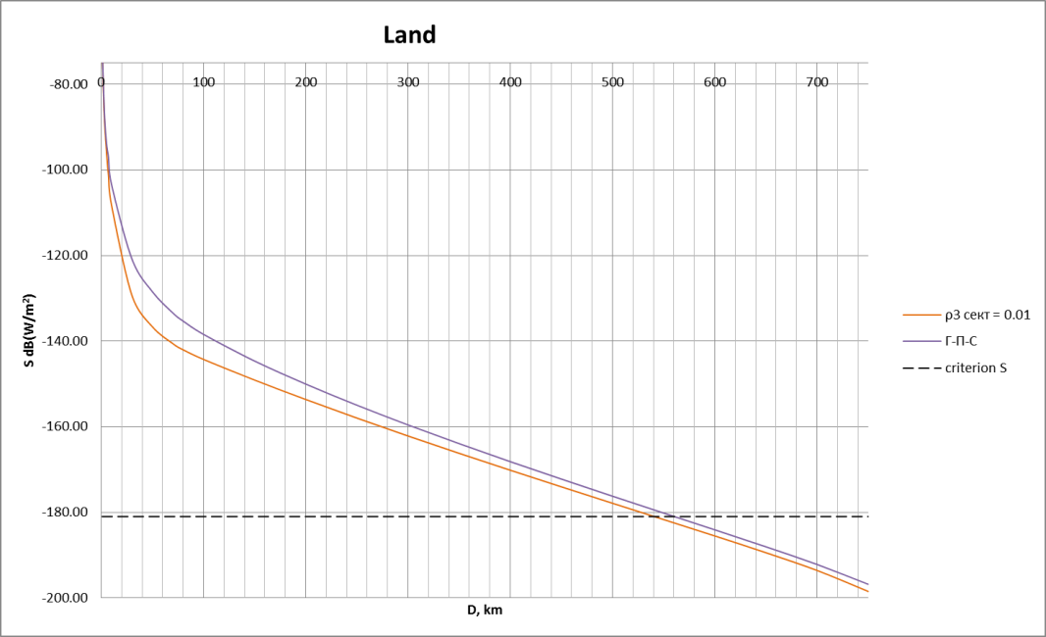

Figure 13: Determination of protection distances in case of aggregate interference for land path

In this Figure the dependence of the power flux density from the distance is shown by the brown line for rural area for Case 2, the violet line is for case with urban area (Case 1). The obtained results showed that the largest protection distance is required for Case 1, i.e. with urban area. The required protection distance for this case is 560 km.

The calculation results for mixed path are shown in Figure 14. The analysis of the obtained results showed that the required protection distance in this case is increased up to 580 km.

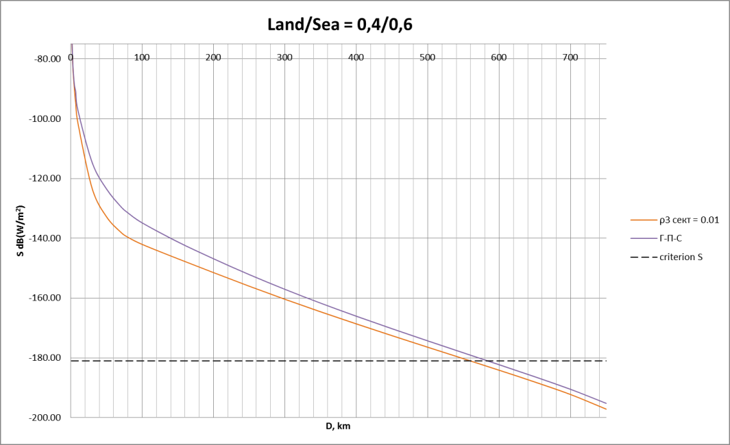

Figure 14: Determination of protection distances in case of aggregate interference for mixed path.

The pathloss required to avoid interference from MFCN SDL to Aeronautical Telemetry systems will depend on the angle between the Aeronautical Telemetry system and the horizon, as indicated in the Figure 15.

Figure 15: Pathloss required to avoid interference from MFCN SDL Tx to Aeronautical Telemetry Rx

Study #1bis.

#### Interference case

This scenario of interference is addressing an assessment of the protection distances required for protection of on-board stations in the aeronautical telemetry systems operating in the frequency band

1429-1535 MHz. The interference assessment for the on-board receivers was carried out based on the free space propagation model.

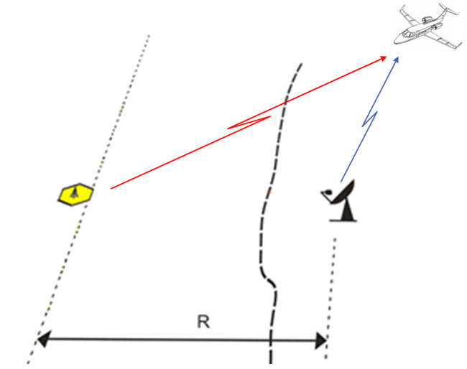

Figure 16: Single interference impact to aircraft receiver of aeronautical telemetry system

#### Calculation results

Table 26below describes the obtained estimates of protection distances for different bandwidths used by MFCN SDL base station transmitters.

Table 26: Separation distances for protecting the air-borne aeronautical telemetry stations from MFCN SDL base stations emissions

|  |  |  |  |
| --- | --- | --- | --- |
| Interference from MFCN SDL base stations | | | |
| Frequency bandwidth, MHz | 5 | 10 | 20 |
| Mean sector e.i.r.p., dBW | 25 | 28 | 28 |
| e.i.r.p. /4 kHz, dBW | –6 | –6 | –9 |
| Protection distance, km | exceeds radio line of sight (above 412 km) | | |

Analysis of obtained results shows that distance required for protecting the air-borne aeronautical telemetry receivers from single MFCN SDL base stations exceeds the air-borne receiver line-of-sight. For conventional flight altitude of 10 km the line-of-sight exceeds 412 km accounting refraction.

It would mean that MS base stations should be deployed at the above distances from the boundaries of air-borne aeronautical telemetry stations operation areas.

It should be noted that emissions from MFCN SDL user terminals could also cause interference to air-borne aeronautical telemetry receiver. In that case protection distances would be defined by deployment density for user terminals.

The presented preliminary results of analysis related to MFCN SDL station interference effect on operation of aeronautical telemetry stations provide for conclusion that dimensions of an area precluding deployment of MFCN SDL base stations would be rather large (specifically those required for protection of air-borne aeronautical telemetry receivers) even in case of assuming interference caused by a single MFCN SDL base station.

Figure 17 exemplifies border areas of the Russian Federation (shown in orange) where harmful interference would be caused to aeronautical telemetry stations. Fig. 17 analysis shows that MFCN SDL systems would not be compatible with the aeronautical telemetry systems in the frequency band 1 429-1 535 MHz practically within a whole area of about 400 km from the country border.

Figure 17 also shows:

* a green area of an air-borne aeronautical telemetry receiver potential location;
* an orange area where operation of MFCN SDL system stations would be impossible   
  (or restricted significantly).

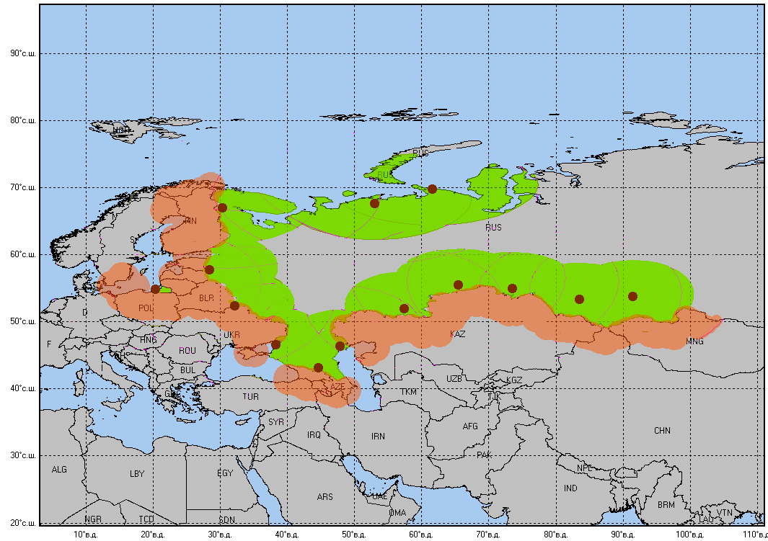

Figure 17: Areas of potential harmful interference from MFCN SDL systems to the Russian aeronautical telemetry stations in the frequency band 1429-1535 MHz

#### Summary of study#1bis

The above discussed estimates provide for conclusions that operation of MFCN SDL systems would be impractical (or restricted significantly) in areas at a distance of about 500 km from the borders of countries using aeronautical telemetry systems.

The conducted studies also show that compatibility of MFCN SDL systems and aeronautical telemetry stations would be unfeasible in the frequency band 1452-1492 MHz.

### Study #2

#### Interference scenario

This study presents results of interference impact caused by the possible stations of the mobile service to ground receivers of aeronautical telemetry in the frequency band 1 429-1 492 MHz (referred to Study A). The results also include for the results considering the ground receivers of aeronautical telemetry in the frequency band 1427-1492 MHz that are notified in the BR IFIC (referred to Study B, hereafter). In terrestrial telemetry system, telemetry signals are transmitted by airborne stations (e.g. aircraft, missile) to ground stations.

#### Preliminary

Scenario O is mostly relevant in the case of cross-border coordination of MFCN SDL in one country and aeronautical telemetry in another country. In such cross-border coordination, the exact characteristics of base stations are usually taken into account in the coordination process. As such, the maximum in block e.i.r.p. provided in Table 13 may not be the most appropriate value. An MFCN BS in-block e.i.r.p. of   
58 dBm/5MHz and an MFCN antenna height of 30m have been considered appropriate in ITU discussions related to this specific coordination case. Both Study A and Study B are based on these parameters.

Study A assumes an aeronautical telemetry receiver antenna gain of 41.2 dB and an antenna height of 10m, while Study B takes the exact gain as mentioned in BR IFIC.

#### Methodology

A minimum coupling loss approach is used, modelling only a single interferer-victim pair (as to be BS-to-Radar) and corresponding to the worst case scenario with main lobe (of the interferer transmitter antenna pattern) to main lobe (of the radar receiver antenna pattern) configuration (ML‑ML) in the horizontal plane. From this method, we derive the in-band (IB) emissions level of MFCN systems when telemetry ground stations and MFCN base stations (BS) share 1427-1492 MHz frequency band.

Equation (8) of Recommendation ITU-R M.1459 provides a methodology to calculate the maximal acceptable interference level at the receiver, from pfd limit:

$Pfd≤\frac{4π×Imax}{G_{0}λ^{2}}$

where:

*Pfd*: power flux density of the interferer (W/(m2.B);

*Imax* : maximal acceptable Interference level after the antenna the receiver (dBm);

*Go* : Telemetry receiver antenna gain in the direction of the base station.

From this expression, we deduce[8] the required isolation to ensure the sharing between the telemetry receiver and BS transmitter:

Isolation(dB) $≥$ PathLoss(dB)=Pfd(dBm/4 kHz/m2)+10log10($\frac{λ^{2}}{4π}$)- e.i.r.p. BS (dBm)

(For Study A)

The propagation model between the telemetry ground receiver and the base station is extracted from Recommendation ITU-R P.1546[9]. Recommendation ITU-R P.1546 is assumed over land paths and the flat terrain assumption[10] will cover the worst case as a minimization of the pathloss since no shadowing (e.g. clutter height: buildings, vegetation) is performed, for 10 % of time and 50 % of locations.

The radio environment choice for the Recommendation ITU-R P.1546 model is based on the geographical topology of both telemetry ground stations and base stations. Base stations are deployed in rural or urban areas while Telemetry systems are deployed in rural areas. Such assumption implies to apportion path with urban/rural components. Since BS can also be deployed in rural radio environment, we will assume that apportionment for urban is lower or equal to the rural one.

Sharing studies with propagation model Recommendation ITU-R P.1546 sea path cover cases where telemetry ground stations and BS in cross borders are separated by less than separation distance 300 kilometres and that can be kept more than 300 kilometres away. There are only very few cases where telemetry stations would need to be protected against base stations through sea path whose distance is lower than this separation distance.

(For Study B)

The propagation model between the telemetry ground receiver and the base station is extracted from Recommendation ITU-R P.452-14. The selected propagation model separating the telemetry receiver from the base station is terrestrial point-to-point propagation model which is suitable over any kind of terrestrial areas since it accounts the digital terrain model featuring the relief of the location of both transmitter and receiver. Associated parameter to the propagation model is the time for which the pathloss assessment is higher or equal is time p= 50%.

#### Results for Study A

Table 27 depicts the required isolation in propagation to protect terrestrial telemetry receiver from interfering BS transmitter, given the arrival angles range. According to the downtilt value taken by MFCN BS, the angle of arrival belongs to the 0-6° range, leading to minimum isolation value as to be 202 dB.

Table 27: Required isolation between ground telemetry station and MFCN BS

| **Arrival angle range (°)** | 0-4 | 4-20 |
| --- | --- | --- |
| **Required pathloss (dB)** | 202 | 202-188 |

From this value, we may derive the separation distance, in accordance with our previous assumptions on the propagation model.

Table 28 highlights the available pathloss for different rural/urban path apportionment, given fixed distance (100-130 kilometers) and for an arrival angle of 0°:

* green colour depicts the case where the required isolation to protect terrestrial telemetry stations from BS is met;
* yellow colour reflects urban/rural distribution of the path which does not ensure the protection of telemetry ground stations from MFCN BSs.

Table 28: Required isolation distance (dB) as a function of the urban/rural apportionment

|  |  |  |  |  |  |  |
| --- | --- | --- | --- | --- | --- | --- |
| Distance between telemetry system & mobile MFCN system  (km) | Apportionment of Urban/(Urban+Rural) in pathloss  (%) | 10 | 20 | 30 | 40 | 50 |
| 100 |  | 188 | 188 | 194 | 199 | 203 |
| 110 | 190 | 190 | 196 | 201 | 205 |
| 120 | 191 | 192 | 197 | 202 | 207 |
| 130 | 192 | 193 | 198 | 204 | 208 |

It shows that for 100-130 kilometers separation distance range, the following apportionment for urban 40-50 % path in the total path separating BS from telemetry terrestrial station could ensure sharing between both services. Such distances would then make the bilateral cross border coordination process possible on a case by case basis through good engineering practice (such as mitigation techniques: site engineering, reduction of output power).

#### Results for Study B: Practical analysis of the separation distance between ground telemetry station and LTE base station

a/ Required isolation between ground telemetry station and MFCN Base Stations

Table 28 depicts the required isolation in propagation to protect terrestrial telemetry receiver from interfering BS transmitter, given the arrival angles range. According to the downtilt value taken by MFCN BS, the angle of arrival belongs to the 0-6° range, leading to minimum isolation value as to be 200 dB.

Table 29: Required isolation between ground telemetry station and MFCN BS

| **Arrival angle range (°)** | 0-4 | 4-20 |
| --- | --- | --- |
| **Required pathloss (dB)** | 200 | 200-186 |

From this value, we may derive the separation distance, in accordance with our previous assumptions on the propagation model.

b) Declared ground telemetry stations in BRIFIC

If the ground telemetry station is receiver, it means that the transmitter is an airborne device, which is labelled as MA (for aircraft transmitting station). The BR-IFIC lists 56 assignments for such devices over   
1427-1525 MHz range with 4 different frequencies channels (1439.65 MHz, 1460.9 MHz, 1482.15 MHz and 1503.35 MHz) that are recorded for each geographical site. Thus, it leads to 14 different geographical terrestrial telemetry sites.

c) Sharing results without mitigation techniques

The following table depicts for the 14 recorder assignments whether or not the ground telemetry station is protected when MFCN base stations are located in the cross-border. They are sorted by capital letter (from A to N) for the later study. The minimum PathLoss (column 3) from the cross-border to the ground telemetry station is displayed in order to ease comparison with the required pathloss (200 dB) with reference to the concerned cross border country for each recorded assignments. This results in the last column if any “Required additional isolation dB” is mandatory.

The yellow rows depict the case where the declared ground telemetry station has been already protected at the cross-border without any mitigation techniques (separation distance, site shielding, sector disabling, down tilting…): in order to be protected, 4/14 sites do not require any mitigation techniques to apply on MFCN base stations (BS).

The blue rows correspond to the notified sites which have no data related on the digital terrain model from the NASA Shuttle Radar Topography Mission (SRTM)[11]: no path loss can be calculated for such sites: 3/14 cannot be calculated. However 2/3 are at least 980 kilometres away from the cross border which lead to the conclusion that the required isolation to protect ground telemetry station is met for 2/3 sites which have no SRTM data.

The green field indicates which ground telemetry station does not require any additional isolation to be protected from BS interference.

Table 30: Preliminary conclusion: Thus, 6/14 sites do not require any additional isolation to be protected from the interfering LTE Base Stations (green color for the last column).

|  |  |  |  |  |
| --- | --- | --- | --- | --- |
| Number | Coordinates of the ground telemetry stations | D* Distance between crossborder and ground telemetry station minimizing the pathloss | Path Loss (dB)  from the frontier to the ground telemetry station | Required  Additional  Isolation  (dB) |
| A | 91°23'00"E - 53°45'00"N | 322km-  (Kazahkstan) | 288.9 | NO |
| B | 47°52'00"E - 46°24'00"N | 54km-  (Kazakhstan) | 161 | 39 |
| C | 83°34'00"E - 53°22'00"N | 245km-  (Kazakhstan) | 214.6 | NO |
| D | 38°13'00"E - 46°41'00"N | 181km  (Ukrain) | 198 | 2 |
| E | 20°24'00"E - 54°46'00"N | 45km (Poland)  70km (Lithuania) | 132  177 | 68  23 |
| F | 32°10'00"E - 52°20'00"N | 28km  (Ukrain) | 146.5 | 53.4 |
| G | 65°25'00"E - 55°29'00"N | 92km  (Kazakhstan) | 191.6 | 8.4 |
| H | 73°34'00"E - 54°59'00"N | 105km  (Kazakhstan) | 194 | 6 |
| I | 28°24'00"E - 57°47'00"N | 37km (Estonia)  60km Latvia) | 149  163 | 51  37 |
| J | 44°36'00"E - 43°13'00"N | 50km  (Georgia) | 208 | NO |
| K | 30°22'00"E - 66°58'00"N | 58km (Finland)  239km (Norway) | No SRTM available |  |
| L | 61°34'00"E - 69°46'00"N | 1162km  (Finland-Norway) | No SRTM available | NO |
| M | 53°07'00"E - 67°38'00"N | 980km  (Finland-Norway) | No STRM available | NO |
| N | 57°19'00"E - 52°02'00"N | 102km  Kazakhstan | 223 | NO |

There is a need to investigate for the 7[12] remaining telemetry ground stations (that have been notified in the BR IFIC) the impact of the BS interference on them.

d) Sharing results with mitigation techniques

There are different mitigation techniques which may be applicable for co-channel operation between ground telemetry receivers and MFCN BS. In order to select the most suitable mitigation technique for each case, it is proposed to sort cases according to their required additional isolation ranges:

* Required additional isolation 0-9dB: downtilt antenna from 3° to 6°.

Table 31: Required additional isolation with downtilt antenna from 3° to 6° for co-channel operation between ground telemetry receivers and MFCN BS

| **Case** | **Required additional isolation (dB)** | **Required additional isolation (dB) after additional downtilt antenna** | Separation distance to the cross border (km)  **after mitigation techniques** |
| --- | --- | --- | --- |
| D | 2 | 0 | 0 |
| G | 8.4 | 2.8 | 7 |
| H | 6 | 0.4 | 1.5 |

* Required additional isolation >9 dB: disabling sector and/or site antenna depointing to very local low gain value (for the BS):
* when disabling the sector antenna, the 2 other ones (see Figure 1) are the main interfering components onto the telemetry ground station. The following figure depicts that any BS in the vicinity of the cross-border may face the radar main beam with the disabled antenna sector and thus the backlobes of the 2 active sectors facing the Telemetry ground receiver lead to 20 dB antenna gain discrimination.

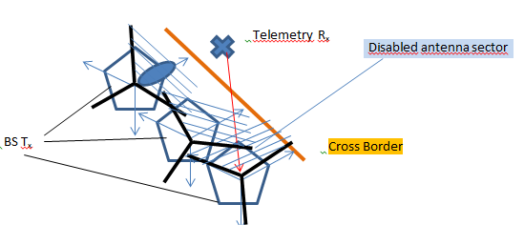

Figure 18: Overview on sector disabling

* harmful interference is avoided if the MFCN base station antennas can have nulling in the direction of the radar. Such nulling could be of the order of 20 dB antenna gain discrimination, as depicted by Figure 2.

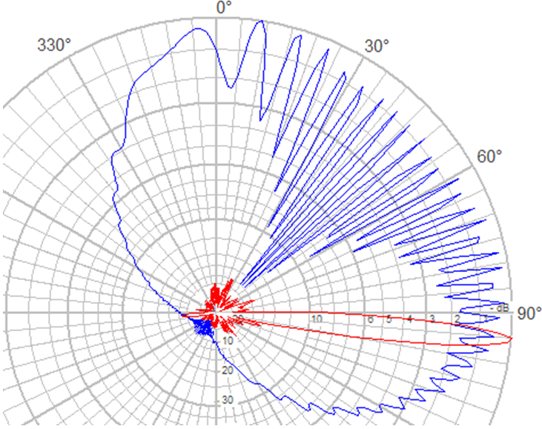

Figure 19: Nulling in horizontal main lobe of the antenna pattern

The following Figure 3, Figure 4, Figure 5 and Figure 6 display the distribution of the separation distance as a function of the required isolation (dB) for the 4 (B, E, F and I) studied cases in the vicinity of the ground telemetry stations. Colour ring-shape highlight required isolation range for –50 dB, –20 dB and 0 dB values for all figures. Cross border curve is represented in yellow as well as distances scale (50 km) to give an overall view on the required separation distance from the cross border.

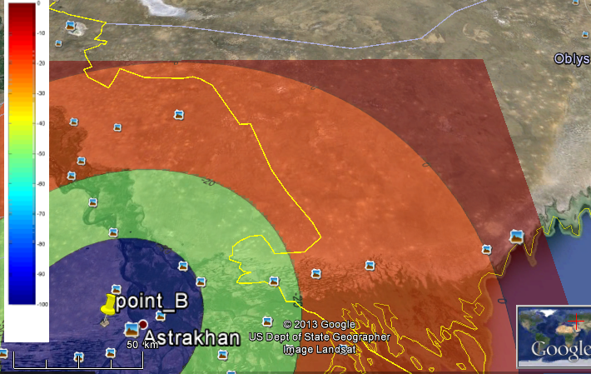

Figure 20: Iso additional required pathloss to protect case B telemetry station

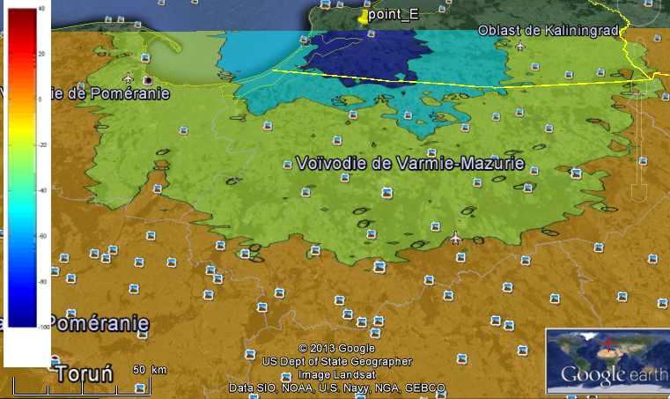

Figure 21: Iso additional required pathloss to protect case E telemetry station (Poland cross-border)

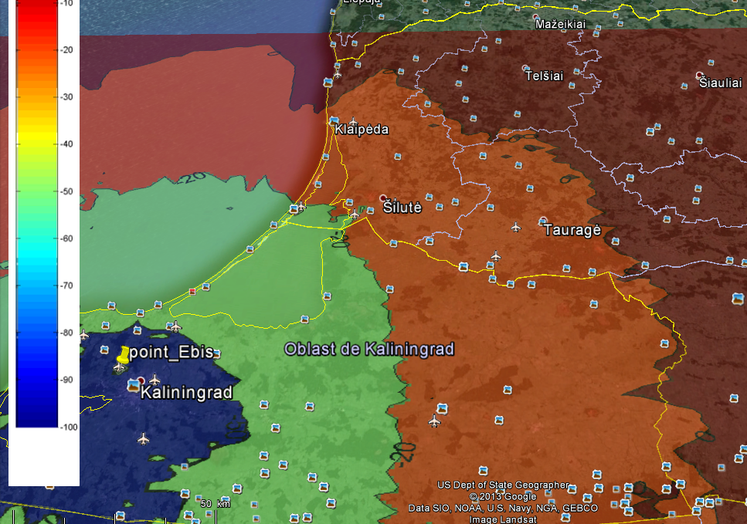

Figure 22: Iso additional required pathloss to protect case E telemetry station   
(Lithuania cross-border)

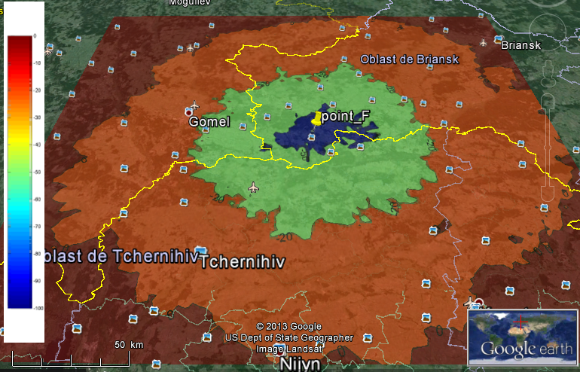

Figure 23: Iso additional required pathloss to protect case F telemetry station

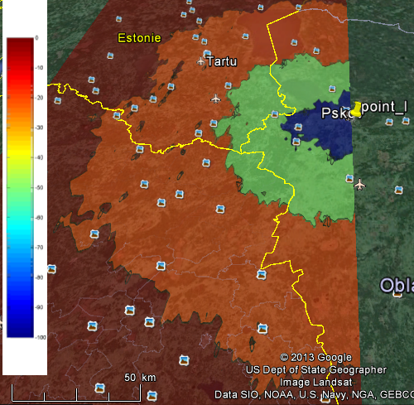

Figure 24: Iso additional required pathloss to protect case I telemetry station   
(Estonia & Latvia)

The results of the sharing studies when using mitigation techniques are summarized in the following Table 7:

Table 32: Separation distance from the cross border with disabling sector

| **Case** | **Required additional isolation (dB)** | **Required addition isolation after disabling antenna sector or antenna pattern nulling (dB)** | Separation distance from the cross border  **after mitigation techniques (km)** |
| --- | --- | --- | --- |
| B | 39 | 19 | 23 |
| E | 68(Poland)  23 (Lithuania) | 48 (Poland)  3 (Lithuania) | 30 (Poland)  7 (Lithuania) |
| F | 53.4 | 33.4 | 53 |
| I | 51 (Estonia)  37 (Latvia) | 31 (Estonia)  17 (Latvia) | 28 (Estonia)  17 (Latvia) |

Secondary conclusion: When using mitigation techniques:

* 9/14 sites would require separation distances lower than 7 kilometres from the cross‑border;
* 4/14 sites would require some tens km separation distance from the cross-border.

These separation distances from the cross-border (when using mitigation techniques) can be converted in separation distances between SDL base station transmitter and Telemetry ground station receiver as depicted in the table below:

Table 33: Separation distances between SDL base station transmitter and   
Telemetry ground station receiver from the cross border

| **Case** | **Separation distance from the cross border (km)** | **Separation distance between MFCN BS and Telemetry ground receiver (km)** |
| --- | --- | --- |
| B | 23 | 77 |
| D | 0 | 181 |
| E | 30 (Poland)  7 (Lithuania) | 75 (Poland)  77 (Lithuania) |
| F | 53 | 81 |
| G | 7 | 99 |
| H | 1.5 | 106.5 |
| I | 28 (Estonia)  17 (Latvia) | 65 (Estonia)  67 (Latvia) |

This shows that high separation distances between the interferer and the receiver (181 kilometers,   
106.5 kilometers) does not necessarily imply more stringent constraints on the MFCN BS deployment: in these cases, with mitigation techniques usage, the protection only requires few (1.5km) or no separation distances from the cross-border because of the distant location of the ground telemetry receiver from the cross-border.

(Note that the missing K case with Finland is due to the lack of STRM data and does not prevent from forecasting that the expected separation distance should not overtake the maximum reached in the other cases (53 kilometers)).

Furthermore, it has to be noted that additional mitigation techniques applied to the ground telemetry receiver such as site shielding (0-20dB) may reduce the separation distances output in the previous table, provided:

* that operation on aircraft, missiles are not expected to be launched in the vicinity of the cross-border;
* that administrations operating telemetry have to respect the principle of equitable access to spectrum as embedded in the preamble (0.6) of the RR (and which is explicitly described in Resolution 2 (Rev.WRC-03) in the case of satellite systems).

#### Summary of study #2

The presented preliminary analysis showing impact of the MFCN BS to the aeronautical telemetry stations within 1 427-1 492 MHz frequency band allows to conclude that macro BSs could be deployed in a coordinated manner with bilateral cross-border agreement which may ensure the sharing between both services by defining a suitable separation distance. Such conditions may be obtained by filtering and/or a frequency separation.

This Annex also analysed the impact of the MFCN BS to the ground aeronautical telemetry stations that are notified in the BR IFIC when they share the same band within 1427-1492 MHz. It is shown that:

* 42% of the notified ground telemetry stations do not require additional protection to operate properly without suffering harmful interference from MFCN BS;
* The 58% remaining ground telemetry stations may require mitigation techniques (sector disabling, antenna pattern nulling, down tilting…) applied to the MFCN BS to reduce the geographical distance, which would lead to tens km separation distance from the cross-border. These separation distances could be more reduced when performing mitigation techniques to the ground telemetry stations.

## Scenario S: Impact of Aeronautical Telemetry systems on MFCN SDL operating co-channel

### Scenarios

Four[13] different situations were analysed in this section:

1. Rural outdoor.
2. Rural indoor. Additionally building penetration loss of 15 dB was taken into account (reference Report ITU-R M.2292).
3. Urban outdoor. Additionally building blocking of 10 dB was taken into account (UE not in line-of-sight).
4. Urban indoor. Additionally building penetration loss 20 dB and building blocking 10 dB was taken into account.

Parameters of telemetry airborne transmitters for these calculations were taken from Table 5 according to Recommendation ITU-R M.1459 recommendation and Master International Frequency Register (MIFR). Three different antenna gains for telemetry transmitter were used in calculations:

* *G* = 10 dBi, i.e. maximum antenna gain according to the Recommendation ITU-R M.1459;
* *G* = 0 dBi, treated as near realistic in terms of interference experienced by MFCN UE;
* distribution of *GTX* (CDF), as provided in Figure 1 of Annex 1 of Recommendation ITU-R M.1459, for Monte Carlo simulations only.

### Preliminary

The following results on UE protection are based on the frequency 1439 MHz used during the JTG discussion. The accurate frequency for ECC analysis should have been 1474 MHz but the impact of such frequency gap is insignificant.

### MCL Pathloss Derivation

The impact of Aeronautical Telemetry Tx on MFCN SDL UE Rx operating co-channel was analysed in this scenario. The required separation distances were calculated.

This section shows the calculation results using Minimum Coupling Loss method based on the deterministic link budget analysis. The calculated results are isolation in dB, which were converted into a physical separation distance using Free Space Loss propagation model.

*RPC = Ptx - Srx + Grx - BodyLoss + BCF.* (1)

where:

*RPC* - Required Path Loss,

*Ptx* – e.i.r.p. of interferer,

*Srx* - victim noise level,

*Grx* - victim antenna gain,

*BodyLoss* - *considered as 3 dB,*

*BCF* - Bandwidth Correction Factor.

Calculation results are shown in the table below:

Table 34: Protection distances (km) for MFCN SDL User Equipment from MCL analysis

|  |  |  |  |
| --- | --- | --- | --- |
| Protection distances for MFCN UE receiver when interfered with by airborne transmitter, according to MCL analysis, *I/N* = 0 dB | | | |
| **Characteristics from Recommendation ITU-R M.1459, GTX = 10 dBi** | | | |
| Urban Indoor | Urban Outdoor | Rural Indoor | Rural Outdoor |
| 9.3 km | 93 km | 52 km | 294 km |
| **Characteristics from Recommendation ITU-R M.1459, GTX = 0 dBi** | | | |
| Urban Indoor | Urban Outdoor | Rural Indoor | Rural Outdoor |
| 2.9 km | 29 km | 17 km | 93 km |
| **Characteristics from MIFR** | | | |
| Urban Indoor | Urban Outdoor | Rural Indoor | Rural Outdoor |
| 5.1 km | 52 km | 29 km | 163 km |

The calculation results show significant variation of required protection distance depending on the parameters of aeronautical telemetry system and protection criteria used. MCL evaluations are based on worst case assumptions therefore lead to possibly overestimated separation distances. In practice, UE is not necessarily used in every potential occurrence of interference; additionally, the telemetry airborne transmitter is not always capable to influence UE, because telemetry airborne transmitter normally is in motion (having velocities up to 1 000 km/h) servicing the area of radii up to 320 km (according to Recommendation ITU-R M.1459) or up to 600 km (according to MIFR). Since interference is not of permanent nature, Monte-Carlo simulations using SEAMCAT software tool could show more realistic picture of interference potential.

### SEAMCAT Derivation

The interference scenario created in SEAMCAT is shown in the figure below.



Figure 25: Interference scenario

The simulations were carried out using 500,000 randomly generated snapshots. Using SEAMCAT tool worst cases (rural outdoor) from MCL calculations (See Table 34) were analysed. The proportion of 50% of MFCN UE used for indoor was taken into account (reference to Report ITU-R M.2292).

Simulation results with different separation distances (separation distances in SEAMCAT ≤ MCL separation distances) are presented in Table 35. Free Space Loss propagation model was used in the Seamcat simulation.

Table 35: Simulation results using Monte-Carlo approach

|  |  |  |  |  |
| --- | --- | --- | --- | --- |
|  | Scenario 1 (pessimistic) | Scenario 2 (near realistic) | Scenario 3 (realistic) | Scenario 4 |
| Characteristics for airborne transmitter | Recommendation ITU-R M.1459 | Recommendation ITU-R M.1459 | Recommendation ITU-R M.1459 | MIFR |
| Antenna gain for airborne transmitter | 10 dBi | 0 dBi | CDF from M.1459  (Fig. 2 of Ann. 1) | 10 dBi |
| *dsep* for *IP* = 0% | 294 km | 93 km | 71 km | 163 km |
| *dsep* for *IP* = 0.5% | 265 km | 56 km | 15 km | 95 km |
| *dsep* for *IP* = 1.0% | 250 km | 34 km | not required | 52 km |
| *dsep* for *IP* = 2.0% | 225 km | not required | not required | not required |
| *dsep* for *IP* = 3.0% | 204 km | not required | not required | not required |
| *dsep* for *IP* = 5.0% | 167 km | not required | not required | not required |
| *IP* for *dsep* = 1 km | 17.4% | 1.96% | 0.75% | 1.76% |

Results of SEAMCAT simulation show that required separation distance between aeronautical telemetry airborne transmitter and MFCN UE receiver is significantly smaller given that certain probability of interference for MFCN UE is considered to be acceptable.

### Discussion on the results

The results of analysis using MCL calculation method show significant variation of required separation distance (see Table 34) for MFCN User Equipment depending on the parameters of aeronautical telemetry system (Recommendation ITU-R M.1459 or MIFR) and receiving environment.

Probabilistic approach allowed making quantitative assessment of reduction of the protection distances which were obtained by using MCL method. Monte-Carlo simulations showed that separation distance can be significantly reduced maintaining acceptable interference probability for MFCN UE receiver (see Table 35). According to realistic scenario which takes into account measured distribution of antenna gain of airborne transmitter (provided in Recommendation ITU-R M.1459), the separation distance of 15 km is sufficient to protect MFCN UE receiver with less than 0.5% interference probability.

In the ITU discussions related to cross-border coordination, the required separation distance for UE from cross-border would be not less than 25 km and regarding the results of study included in this document, this value is appropriate for the protection of UE Rx from brief interfering airborne transmitter in co-channel sharing.

# Conclusions

ECC Report 202 [5] identified harmonised SDL OOB emission limits applicable for the harmonised use of the frequency band 1452-1492 MHz for MFCN SDL. The present report complements the ECC Report 202 by:

* Identifying all compatibility scenarios applicable to the band.
* Studying the following compatibility scenarios:
* Scenario D: Impact of MFCN SDL on systems of the Broadcasting service operating in adjacent channel.
* Scenario L: Impact of MFCN SDL on systems of the Broadcasting service operating co-channel.
* Scenario O: Impact of MFCN SDL on Aeronautical Telemetry systems operating co-channel.
* Scenario P: Impact of systems of the Broadcasting service on MFCN SDL operating co-channel
* Scenario S: Impact of Aeronautical Telemetry systems on MFCN SDL operating co-channel.

The results of the compatibility studies are summarized below.

Scenario D: Impact of MFCN SDL on systems of the Broadcasting service operating in adjacent channel.

The scenario is studied through both MCL and Monte-Carlo (SEAMCAT) analysis.

The interference from SDL to T-DAB in adjacent channel is moderate under assumptions corresponding to rural deployment. In such a case, deployment with limited (0.5 MHz) to no guard band seems to be appropriate.

In urban environment, the probability of interference from SDL implementing the out-of-block emission from ECC/DEC/(13)03 (See Table 11) to T-DAB is substantial (more than 10 %) for guard band lower than 1 MHz. The adoption of the SDL critical BEM defined in Table 17 guarantees:

* that interference due to blocking is the dominant interference factor,
* low level of interference (around 1 % or less) from SDL to T-DAB for a guard band of 1.5 MHz, even in urban deployment scenario.

Scenario L: Impact of MFCN SDL on systems of the Broadcasting service operating co-channel and Scenario P: Impact of systems of the Broadcasting service on MFCN SDL operating co-channel

Two countries parties to the Maastricht Special Arrangement can coordinate their respective T-DAB and MFCN use of the band according to the provisions of the MA02revCO07 Arrangement.

The recommended coordination thresholds are:

* cross-border coordination for MFCN SDL interfering T-DAB: 41 dBµV/m measured over the bandwidth of a single T-DAB block for an antenna height of 10m (in conformity with Maastricht arrangement).
* cross-border coordination for T-DAB interfering MFCN SDL: 56.4 dBμV/m over the bandwidth of a single SDL block (5 MHz) for an antenna height of 10m measured (relaxing the threshold level from Maastricht arrangement).

Scenario O: Impact of MFCN SDL on Aeronautical Telemetry systems operating co-channel

Scenario S: Impact of Aeronautical Telemetry systems on MFCN SDL operating co-channel

In order to provide protection of aeronautical mobile telemetry ground receivers in Region 1 from co-frequency interference caused by MFCN SDL stations, required separation distances would generally exceed 100 kilometers.

However, when applying mitigation techniques (e.g., sector antenna disabling at MFCN SDL base stations) separation distances may be reduced to few tens of kilometers. This will be addressed during coordination between the concerned administrations.

With respect to Region 1, Report ITU-R M.2286 indicated the operation of telemetry on-board receivers. However, some administrations who are not listed in No. 5.342 are considering that such airborne relay receivers cannot be considered as an assignment in conformity with RR No. 5.342 and such stations cannot be considered as a part of telemetry application and shall not be considered for protection. Providing protection for such air-borne receiver in Region 1 from co-frequency interference caused by a MFCN SDL station may require separation distances exceeding line-of-sight (460 km for typical flight altitudes). In case of airborne aeronautical receiver, necessary separation distance is equal to line of sight distance for any cases.

According to realistic scenario which takes into account measured distribution of antenna gain of airborne transmitter (provided in Recommendation ITU-R M.1459), the separation distance of 15 km is sufficient to protect MFCN UE receiver with less than 0.5% interference probability. In the ITU discussions related to cross-border coordination, the required separation distance for UE from cross-border would be not less than 25 km and regarding the results of study included in this document, this value is appropriate for the protection of UE Rx from brief interfering airborne transmitter in co-channel sharing.

1. MFCN UE parameters
   1. LTE UE Blocking parameters

Table 36: In band blocking parameters

|  |  |  |  |  |  |  |  |
| --- | --- | --- | --- | --- | --- | --- | --- |
| Rx parameter | Units | Channel bandwidth | | | | | |
| 1.4 MHz | 3 MHz | 5 MHz | 10 MHz | 15 MHz | 20 MHz |
| Wanted signal mean power | dBm | REFSENS + channel bandwidth specific value below | | | | | |
| 6 | 6 | 6 | 6 | 7 | 9 |
| BWInterferer | MHz | 1.4 | 3 | 5 | 5 | 5 | 5 |
| FIoffset, case 1 | MHz | 2.1+0.0125 | 4.5+0.0075 | 7.5+0.0125 | 7.5+0.0025 | 7.5+0.0075 | 7.5+0.0125 |
| FIoffset, case 2 | MHz | 3.5+0.0075 | 7.5+0.0075 | 12.5+0.0075 | 12.5+0.0125 | 12.5+0.0025 | 12.5+0.0075 |

NOTE 1: The transmitter shall be set to 4dB below PUMAX at the minimum uplink configuration specified in Table 7.3.1-2 of 3GPP TS 36.101 [19]

NOTE 2: The interferer consists of the Reference measurement channel specified in Annex A.3.2 with set-up according to Annex C.3.1 of 3GPP TS 36.101 [19]

Table 37: In-band blocking

|  |  |  |  |  |  |
| --- | --- | --- | --- | --- | --- |
| E-UTRA band | Parameter | Units | Case 1 | Case 2 | Case 3 |
| PInterferer | dBm | -56 | -44 | -30 |
| FInterferer (offset) | MHz | =-BW/2 – FIoffset,case 1  &  =+BW/2 + FIoffset,case 1 | ≤-BW/2 – FIoffset,case 2  &  ≥+BW/2 + FIoffset,case 2 | -BW/2 – 9 MHz  &  +BW/2 – 15 MHz |
| 3 (1800 MHz)  8 (900 mHz) | FInterferer | MHz | (Note 2) | FDL_low – 15  to  FDL_high + 15 |  |

NOTE 1: For certain bands, the unwanted modulated interfering signal may not fall inside the UE receive band, but within the first 15 MHz below or above the UE receive band

NOTE 2: For each carrier frequency the requirement is valid for two frequencies:

a. the carrier frequency -BW/2 - FIoffset, case 1 and

b. the carrier frequency +BW/2 + FIoffset, case 1

NOTE 3: FInterferer range values for unwanted modulated interfering signal are interferer centre frequencies

NOTE 4: Case 3 only applies to assigned UE channel bandwidth of 5 MHz

Table 38: Out-of-band blocking parameters

|  |  |  |  |  |  |  |  |
| --- | --- | --- | --- | --- | --- | --- | --- |
| Rx Parameter | Units | Channel bandwidth | | | | | |
| 1.4 MHz | 3 MHz | 5 MHz | 10 MHz | 15 MHz | 20 MHz |
| Wanted signal mean power | dBm | REFSENS + channel bandwidth specific value below | | | | | |
| 6 | 6 | 6 | 6 | 7 | 9 |

NOTE 1: The transmitter shall be set to 4dB below PUMAX at the minimum uplink configuration specified in Table 7.3.1-2 of 3GPP TS 36.101 [19]

NOTE 2: Reference measurement channel is specified in Annex A.3.2

Table 39: Out of band blocking

|  |  |  |  |  |  |  |
| --- | --- | --- | --- | --- | --- | --- |
| E-UTRA band | Parameter | Units | Frequency | | | |
| Range 1 | Range 2 | Range 3 | Range 4 |
| PInterferer | dBm | -44 | -30 | -15 | -15 |
| 3 (1800 MHz)  8 (900 mHz) | FInterferer (CW) | MHz | FDL_low -15 to  FDL_low -60 | FDL_low -60 to  FDL_low -85 | FDL_low -85 to  1 MHz | - |
| FDL_high +15 to  FDL_high + 60 | FDL_high +60 to  FDL_high +85 | FDL_high +85 to  +12750 MHz | - |

1. Practical SDL-T-DAB coexistence Scenarios based on Specific T-DAB implementation

The following figures provides example of the different possible configurations of T-DAB implementation in the L-band and the compatibility scenario with SDL.

In this example, T-DAB is implemented in the lower part of the frequency band.

This analysis allows to identify the frequency gap between the upper edge of the last T-DAB channel and the lower end of the closest SDL block.

Scenario N°1:

If LI T-DAB channel is used with 5 MHz SDL channel bandwidth, the frequency gap is 4.576 MHz.

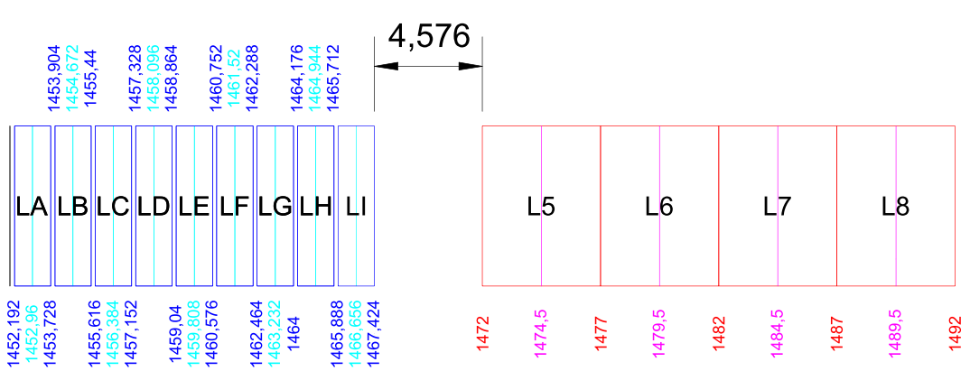

Figure 26: Scenario 1 – SDL (5 MHz) with LI T-DAB (freq. gap of 4.576 MHz)

Scenario N°2:

If LJ T-DAB channel is used with 5 MHz SDL channel bandwidth, the frequency gap is 2.864 MHz.

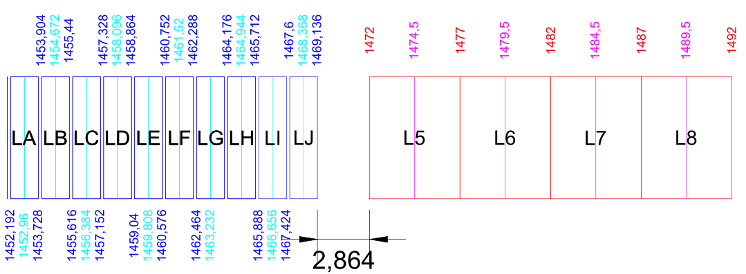

Figure 27: Scenario 2 – SDL (5 MHz) with LJ T-DAB (freq. gap of 2.864 MHz)

Scenario N°3:

If LI T-DAB channel is used with a last SDL channel bandwidth of 3 MHz, the frequency gap is 1.576 MHz.

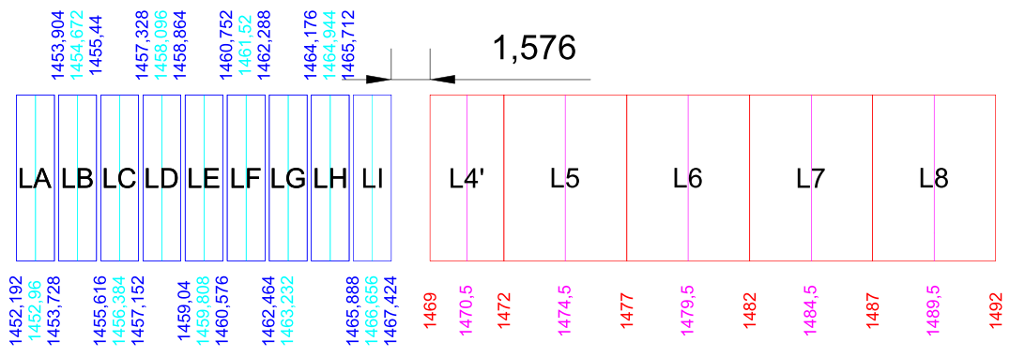

Figure 28: Scenario 3 – SDL (3 MHz) with LI T-DAB (freq. gap of 1.576 MHz)

This scenario requires applying the critical SDL BEM due to the fact that the guard band is 1.576 MHz.

At national level, each administration depending on its T-DAB vs SDL implementation scenario, could decide to fix the appropriate SDL mask in accordance with the available guard band between T-DAB and SDL channels.

1. Exhaustive list of compatibility and sharing scenarios

This list includes the exhaustive scenarios including those not studied in this report. Studied scenarios are available in paragraph 2.2.4.

Table 40: List of exhaustive compatibility scenarios

| **Scenario** | **Co-channel/ Adjacent channel** | **Interferer** | **Victim** |
| --- | --- | --- | --- |
| A | Adjacent channel | Mobile | MFCN SDL |
| B | Adjacent channel | Fixed | MFCN SDL |
| C | Adjacent channel | Aeronautical Telemetry | MFCN SDL |
| D | Adjacent channel | MFCN SDL | Broadcasting |
| E | Adjacent channel | MFCN SDL | Mobile |
| F | Adjacent channel | MFCN SDL | Fixed |
| G | Adjacent channel | MFCN SDL | Aeronautical Telemetry |
| H | Adjacent channel | Broadcasting | MFCN SDL |
| I | Adjacent channel | Mobile | MFCN SDL |
| J | Adjacent channel | Fixed | MFCN SDL |
| K | Adjacent channel | Aeronautical Telemetry | MFCN SDL |
| L | Co-channel | MFCN SDL | Broadcasting |
| M | Co-channel | MFCN SDL | Mobile |
| N | Co-channel | MFCN SDL | Fixed |
| O | Co-channel | MFCN SDL | Aeronautical Telemetry |
| P | Co-channel | Broadcasting | MFCN SDL |
| Q | Co-channel | Mobile | MFCN SDL |
| R | Co-channel | Fixed | MFCN SDL |
| S | Co-channel | Aeronautical Telemetry | MFCN SDL |

1. Remark on MFCN SDL parameters

Coordination distances between Aeronautical telemetry and MFCN SDL will be shorter at least in some cases when using parameters from Report ITU-R M.2292.

Table 41: RF energy output from each LTE base station

| **Feeder loss** | 3 dB |
| --- | --- |
| **Maximum base station output power** | 46 dBm in 10MHz |
| **Base station antenna gain** | 15 dBi |
| **Base station e.i.r.p.** | 58 dBm in 10MHz |
| **Average base station activity factor** | 50 % |
| **Average base station e.i.r.p./sector taking into account activity factor** | 55 dBm in 10MHz |

Table 42: Deployment-related parameters for bands between 1 and 3 GHz

| **Base station characteristics / Cell structure** | **Macro rural** | **Macro suburban** | **Macro urban** | **Small cell outdoor / Micro urban** | **Small cell indoor / Indoor urban** |
| --- | --- | --- | --- | --- | --- |
| Cell radius / Deployment density (for bands between 1 and 2 GHz) | > 3 km (typical figure to be used in sharing studies 5 km) | 0.5-3 km (typical figure to be used in sharing studies 1 km) | 0.25-1 km  (typical figure to be used in sharing studies 0.5 km) | 1-3 per urban macro cell  <1 per suburban macro site | depending on indoor coverage/ capacity demand |
| Cell radius / Deployment density (for bands between 2 and 3 GHz) | > 2 km (typical figure to be used in sharing studies 4 km) | 0.4-2.5 km (typical figure to be used in sharing studies 0.8 km) | 0.2-0.8 km  (typical figure to be used in sharing studies 0.4 km) | 1-3 per urban macro cell4 <1 per suburban macro site | depending on indoor coverage/ capacity demand |
| Antenna height | 30 m | 30 m (1-2 GHz)  25 m (2-3 GHz) | 25 m (1-2 GHz)  20 m 2-3 GHz) | 6 m | 3 m |
| Sectorisation | 3-sectors | 3-sectors | 3-sectors | single sector | single sector |
| Downtilt | 3 degrees | 6 degrees | 10 degrees | n.a. | n.a. |
| Frequency reuse | 1 | 1 | 1 | 1 | 1 |
| Antenna pattern | Recommendation ITU-R F.1336 (recommends 3.1)   * ka = 0.7 * kp = 0.7 * kh = 0.7 * kh = 0.7   Horizontal 3 dB beamwidth: 65 degrees  Vertical 3 dB beamwidth: determined from the horizontal beamwidth by equations in Recommendation ITU-R F.1336. Vertical beamwidths of actual antennas may also be used when available. | | | Recommendation ITU-R F.1336  (omni: recommends 2) | |
| Antenna polarization | linear / +- 45 degrees | linear / +- 45 degrees | linear / +- 45 degrees | linear | linear |
| Indoor base station deployment | n.a. | n.a. | n.a. | n.a. | 100 % |

Table 43: User terminal characteristics

| **User terminal characteristics** | |
| --- | --- |
| Antenna gain for user terminals | –3 dBi |
| Body loss | 4 dB |

1. List of reference
2. MA02revCO07: The Maastricht, 2002, Special Arrangement, as revised in Constanţa 2007.
3. ECC Decision (13)03 on the harmonised use of the frequency band 1452-1492 MHz for Mobile/Fixed Communications Networks Supplemental Downlink (MFCN SDL), November 2013
4. ECC Decision (03)02 on the designation of the frequency band 1479.5 – 1492 MHz for use by Satellite Digital Audio Broadcasting systems, October 2003
5. ECC Report 188 on Future Harmonised Use of 1452-1492 MHz in CEPT, February 2013
6. ECC Report 202 on Out-of-Band emission limits for Mobile/Fixed Communication Networks (MFCN) Supplemental Downlink (SDL) operating in the 1452-1492 MHz band, September 2013
7. Recommendation ITU-R F.758-5 System parameters and considerations in the development of criteria for sharing or compatibility between digital fixed wireless systems in the fixed service and systems in other services and other sources of interference, March 2012
8. Recommendation ITU-R F.1242 Radio-frequency channel arrangements for digital radio systems operating in the range 1 350 MHz to 1 530 MHz, 1997
9. ECC Report 121 on compatibility studies between professional wireless microphone systems (PWMS) and other services/systems in the bands 1452-1492 MHz, 1492-1530 MHz, 1533-1559 MHz also considering the services/systems in the adjacent bands (below 1452 MHz and above 1559 MHz), September 2008
10. Recommendation ITU-R F.1334 Protection criteria for systems in the fixed service sharing the same frequency bands in the 1 to 3 GHz range with the land mobile service, 1997
11. Recommendation ITU-R F.1245-1 mathematical model of average and related radiation patterns for line-of-sight point-to-point radio-relay system antennas for use in certain coordination studies and interference assessment in the frequency range from 1 GHz to about 70 GHz, 2000
12. Recommendation ITU-R M.1459 Protection criteria for telemetry systems in the aeronautical mobile service and mitigation techniques to facilitate sharing with geostationary broadcasting-satellite and mobile-satellite services in the frequency bands 1 452-1 525 MHz and 2 310-2 360 MHz, May 2000
13. ECC Report 082 on compatibility study for UMTS operating within the GSM 900 and GSM 1800 frequency bands, May 2006
14. CEPT Report 40 Report from CEPT to the European Commission in response to Task 2 of the Mandate to CEPT on the 900/1800 MHz band. “Compatibility study for LTE and WiMAX operating within the bands 880-915 MHz / 925-960 MHz and 1710-1785 MHz / 1805-1880 MHz (900/1800 MHz bands)”
15. ECC Report 191 on adjacent band compatibility between MFCN and PMSE audio applications in the 1785-1805 MHz frequency range, September 2013
16. Recommendation ITU-R P.1546 Method for point-to-area predictions for terrestrial services in the frequency range 30 MHz to 3 000 MHz
17. Report ITU-R M.2039-2 Characteristics of terrestrial IMT-2000 systems for frequency sharing/interference analyses.
18. Report ITU-R M.2292 (IMT Advanced)
19. Report ITU-R M.2286 (Operational characteristics of aeronautical mobile telemetry systems)
20. 3GPP TS 36.101, E-UTRA - User Equipment (UE) radio transmission and reception

1. For coordination issues the provisions of the ITU Radio Regulation footnote 5.342 as well as of the Maastricht Special Arrangement 2002 as revised in Constanta 2007 should be applied.
2. Spectrum Mask from MA02revCO07 for frequency separation from centre frequency > 0.97 MHz.

   Linear (in dB) interpolation between T-DAB block edge (0.768 MHz) and 0.97 MHz.
3. The mask is fully defined by linear (in dB) interpolation between breakpoints.
4. The mask is fully defined by linear (in dB) interpolation between breakpoints.
5. The parameters used for study #1 bis in the paragraph 4.3.2 are issued from Report ITU-R M.2292.
6. Corresponds to 130.7 dB CL
7. Using Antenna height gain correction = 10 dB assumption from Ma2002Rev2007 Annex 2 Section 2.2.3
8. Imax(dBm)=e.i.r.p. BS(dBm)+PathLoss(dB)+Go(dBi).
9. The adjusted Recommendation ITU-R P.1546 model is suitable for modelling propagation path loss in the broadcasting, land mobile and certain fixed services (e.g. those employing point‑to‑multipoint systems) in the frequency range 30 to 3 000 MHz and for the distance range 1 km to 1 000 km.
10. Recommendation ITU-R P.1546-4 is under revision for short paths longer than one kilometer when there is a large required correction (happening with large difference in antenna heights). dB. This is not the case here since |Cds|<10-3.
11. Available for download at: <http://dds.cr.usgs.gov/srtm/version2_1/SRTM3/Eurasia/>
12. There should be 8 but one of them (number K) does not have the SRTM data to calculate the required separation distance.
13. Urban outdoor, Additional building blocking of 5 dB may be taken into account (not all BS in line of sight). As an alternative a dual slope propagation model could be used (Hata + Free space).