CEPT Report 62

Report from CEPT to the European Commission in response to the Mandate

“Coexistence studies between seaborne UMTS and LTE with terrestrial electronic communications networks operating in the 1710-1785 / 1805-1880 MHz, 1920-1980 / 2110-2170 MHz and 2500-2570 / 2620-2690 MHz bands”

Technical conditions for the use of LTE and UMTS MCV

**Report approved on 17 June 2016 by the ECC**

# Executive summary

This Report addresses the compatibility between Mobile Communications on board Vessels (MCV) systems and land-based MFCN networks when introducing the following new combinations of technologies and bands on board vessels:

* LTE MCV in the 1710-1785 / 1805-1880 MHz and 2500-2570 / 2620-2690 MHz frequency bands (LTE MCV 1800 MHz and 2600 MHz)
* UMTS MCV in the 1920-1980 / 2110-2170 MHz frequency bands (UMTS MCV 2100 MHz).

From work carried out in CEPT and in particular based on ECC report 237, it appears that:

* The coexistence with LTE and UMTS land networks requires specific setting of some parameters of the MCV, as summarised in Table 1;
* The maximum bandwidth to be used by the MCV system (LTE or UMTS) shall be set to 5 MHz (duplex) per frequency band (1800 MHz, 2100 MHz or 2600 MHz bands);

The following MCV UMTS and LTE network system parameters are also required to be set to specific values:

* RRC user inactivity timer shall be set to 2 seconds;
* PLMN network selection timer shall be set to 10 minutes in national waters;
* MCV carrier centre frequency shall not be aligned with land network carriers;

Table 1: MCV system specific values to protect land networks systems (GSM and LTE in the 1800 MHz band / UMTS and LTE in the 2100 MHz band / LTE in the 2600 MHz band)

|  |  |  |
| --- | --- | --- |
| System | UMTS  (2100 MHz) | LTE  (1800 MHz and 2600 MHz) |
| **On/off border (from baseline)** | 2 NM | 4 NM |
| **Outdoor antennas on/off (from baseline)** | 12 NM | 12 NM |
| **MCV UE max Tx power** | 0 dBm / 5 MHz | 0 dBm (PcMax) |
| **Quality criteria Qrxlevmin** | >= -87 dBm / 5 MHz  between 2 and 12 NM | >= -105 dBm / 15 kHz  ( >= -83 dBm / 5 MHz)  between 4 and 12 NM |
| **Indoor MCV BS emission limit on deck** | - 102 dBm / 5 MHz (CPICH) | -120 dBm / 15 kHz  (-98 dBm / 5 MHz) |
| **RRC inactivity release timer** | 2 seconds | 2 seconds |
| **Cell range for the DAS1** | 600 m | 400 m |

1 The timing advance parameter has to be set according to the corresponding cell range.

**TABLE OF CONTENTS**

0 Executive summary 2

1 Introduction 5

2 Definitions, parameters and scenarios for the studies 6

2.1 Definitions 6

2.2 Scenarios 7

3 Mitigation techniques for UMTS and LTE MCV systems operation 9

3.1 Exclusion zone from baseline 9

3.2 MCV system channel bandwidth 9

3.3 Limit Maximum UE Transmit Power 9

3.4 Outdoor base station antenna OFF 9

3.5 base station Emission Limit on deck 9

3.6 Prevent connection from outdoor UE (on the vessel or near the vessel) to MCV indoor BS 9

3.7 Minimise probability for interference 10

3.8 Summary of the proposed mitigation framework and values 12

4 ConclusionS 13

ANNEX 1: cept mandate 14

ANNEX 2: LTE 1800, LTE 2600, UMTS 2100 parameters 17

ANNEX 3: Propagation models 21

ANNEX 4: Possible implementations of MCV technical conditions 23

ANNEX 5: LIst of referenceS 25

**LIST OF ABBREVIATIONS**

|  |  |
| --- | --- |
| **Abbreviation** | **Explanation** |
| **3GPP** | 3rd Generation Partnership Project |
| **BP** | Break Point |
| **BS** | Base Station |
| **CEPT** | European Conference of Postal and Telecommunications Administrations |
| **CPICH** | Common Pilot Channel |
| **DAS** | Distributed Antenna System |
| **DTX** | Discontinuous Transmission |
| **EC** | European Commission |
| **ECC** | Electronic Communications Committee |
| **EEZ** | Exclusive Economic Zone |
| **FDD** | Frequency Division Duplex |
| **GSM** | Global System for Mobile communications |
| **LTE** | Long Term Evolution |
| **IEEE** | Institute of Electrical and Electronics Engineers |
| **ITU** | International Telecommunication Union |
| **ITU-R** | ITU Radiocommunication Sector |
| **l-BS** | Land-based Base Station |
| **l-UE** | Land-based User Equipment |
| **JTG 5-6** | ITU-R Joint Task Group 5-6 |
| **MCV** | Mobile Communications on-board Vessels |
| **MFCN** | Mobile/Fixed Communications Networks |
| **NM** | Nautical Mile |
| **PCI** | Physical layer Cell Identity |
| **PCMax** | Maximum output power |
| **PLMN** | Public Land Mobile Network |
| **Qrxlevmin** | Minimum RSRP requirement for cell selection |
| **RRC** | Radio Resource Control protocol |
| **RSRP** | Reference Symbol Received Power |
| **RXLEV** | Received Signal Level |
| **SEAMCAT** | Spectrum Engineering Advanced Monte Carlo Analysis Tool |
| **SIB1** | System Information Block 1 |
| **TDD** | Time Division Duplex |
| **TS** | Technical Specification |
| **UE** | User Equipment |
| **UMTS** | Universal Mobile Telecommunications System |
| **v-BS** | Vessel-based Base Station |
| **v-UE** | Vessel-based User Equipment |

# Introduction

This CEPT Report has been developed within the European Conference of Postal and Telecommunications Administrations (CEPT) in the framework of the second EC Mandate on Mobile Communication Services on board Vessels (MCV).

CEPT was mandated to undertake studies on the coexistence of seaborne UMTS and LTE with terrestrial electronic communications networks operating in the 1710-1785 / 1805-1880 MHz, 1920-1980 / 2110-2170 MHz and 2500-2570 / 2620-2690 MHz bands. This second Mandate is a follow-up to the first EC Mandate on MCV dated 8 July 2008 with the purpose of extending the scope of compatible MCV systems and services currently available.

The European Commission noted that seaworthiness and safety aspects of MCV equipment are addressed by authorities other than spectrum management administrations and are outside the scope of the present Report.

Moreover this Report is restricted to the operation of MCV in territorial seas of the Member States.

According to the current regulatory framework within CEPT Report 28, Mobile Communications on board Vessels systems are allowed in the 900 MHz and 1800 MHz bands using GSM technology.

Since 2009, new technologies and new frequency bands have been made available for Mobile/Fixed Communications Networks (MCFN). The present Report aims to study the use of new technology/band combinations on board vessels while ensuring compatibility with land-based networks. The new technology/band combinations envisaged for the MCV systems are: LTE in the 1800 MHz and 2600 MHz bands; and UMTS in the 2100 MHz band.

The parameters used in the studies are given in Annex 2 for both the land-based networks and the MCV networks. Only the possible interference from MCV networks to land-based networks is studied since MCV networks shall not cause harmful interference to, or claim protection from, any other authorised system. A series of scenarios, as described in section 2.2, have been addressed to cover all the technology/band/network topology combinations in accordance with the propagation models described in Annex 3.

Mitigation techniques to protect land-based networks are given in section 3 and a possible implementation of the associated technical conditions for MCV systems is proposed in annex 4.

The conclusions are given in section 4.

The analysis and conclusions provided in this report rely on studies conducted within the CEPT framework and summarised in ECC Report 237 [2][1].

# Definitions, parameters and scenarios for the studies

## Definitions

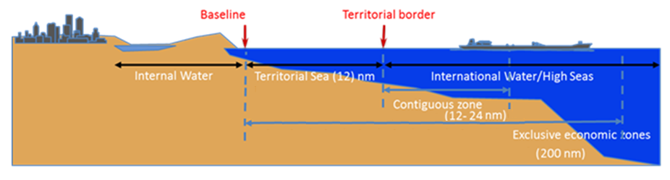

Figure 1: Maritime zones, measured from baselines (typical values)

**Internal waters** are defined as all waters shoreward of the baseline. In internal waters, vessels are subject to national/domestic jurisdiction.

**Territorial Sea** consists in the first 12 NM of ocean seaward of the baseline. In territorial sea, international law applies (for the USA and some other countries domestic law applies in the first 3 NM).

**Exclusive Economic Zone** is defined as the waters seaward of the territorial sea, extending to 200 NM from the baseline. The coastal nation has jurisdiction over foreign vessels for the purpose of management and conservation of the natural resources of the waters, seabed and subsoil of the zone.

**High Seas/international waters** are defined as all parts of the ocean seaward of any nation’s territorial sea including the Contiguous zone (which may not extend beyond 24 nautical miles from the baseline) and the Exclusive Economic Zone (EEZ). All “floating” vessels are subject to the exclusive jurisdiction of their flag nation. Systems are operated according to Article 5 of the ITU Radio Regulations [3] and international laws in the area outside the territorial border.

The following methods are used to measure a baseline under United Nations Convention on the Law of the Sea 1982 [4]

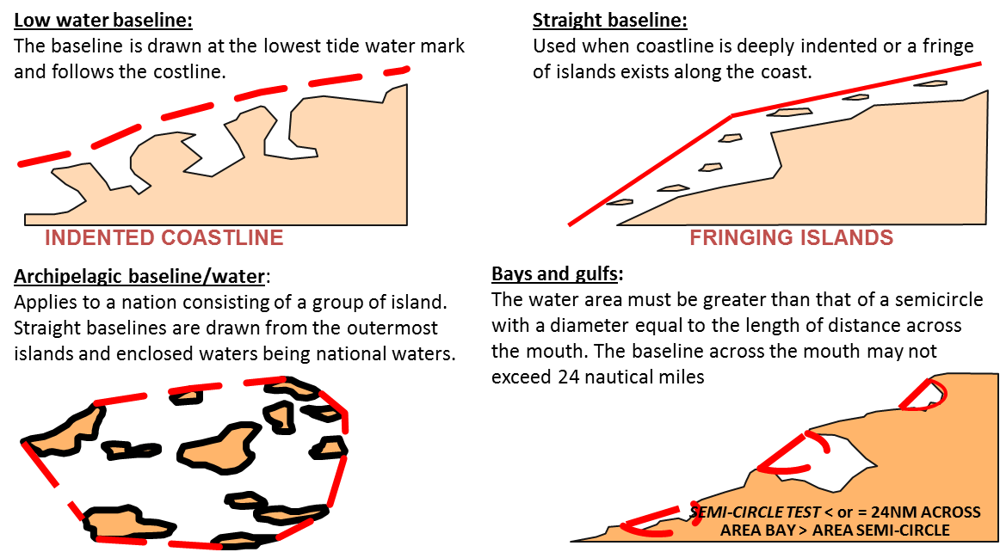

Figure 2: Definition of a baseline

The MCV system is using the baseline as reference for its operation. The baseline is defined in a map database. Modifications of the special areas may be defined to force the system to turn off in special areas (i.e. military zones, etc.).

## Scenarios

The objective of this Report is to evaluate the possibility of introducing LTE on board vessels in the 1800 MHz and 2600 MHz bands, and UMTS in the 2100 MHz band. The following scenarios are studied to assess the potential of interference to land-based mobile networks brought by the introduction of these new technologies.

For each band and for each technology considered for the interferer (the MCV system) and the victim (the land-based network), the scenario is subdivided into five sub-scenarios depending on the deployment configuration of the MCV system (indoor or outdoor).

Table 2: Scenarios studied

|  |  |  |  |  |  |
| --- | --- | --- | --- | --- | --- |
| Band | MCV Technology | Land Technology | Interferer | Victim | Scenario #  (see ECC Report 237) |
| 1800 MHz | LTE | GSM | Outdoor v-BS | l-UE | 1.1 |
| Outdoor v-UE (connected to indoor v-BS antenna) | l-BS | 1.2 |
| Outdoor v-UE (connected to outdoor v-BS antenna) | l-BS | 1.3 |
| Indoor v-BS | l-UE | 1.4 |
| Indoor v-UE | l-BS | 1.5 |
| LTE | LTE | Outdoor v-BS | l-UE | 2.1 |
| Outdoor v-UE (connected to indoor v-BS antenna) | l-BS | 2.2 |
| Outdoor v-UE (connected to outdoor v-BS antenna) | l-BS | 2.3 |
| Indoor v-BS | l-UE | 2.4 |
| Indoor v-UE | l-BS | 2.5 |
| 2 GHz | UMTS | UMTS | Outdoor v-BS | l-UE | 3.1 |
| Outdoor v-UE (connected to indoor v-BS antenna) | l-BS | 3.2 |
| Outdoor v-UE (connected to outdoor v-BS antenna) | l-BS | 3.3 |
| Indoor v-BS | l-UE | 3.4 |
| Indoor v-UE | l-BS | 3.5 |
| UMTS | LTE | Outdoor v-BS | l-UE | 4.1 |
| Outdoor v-UE (connected to indoor v-BS antenna) | l-BS | 4.2 |
| Outdoor v-UE (connected to outdoor v-BS antenna) | l-BS | 4.3 |
| Indoor v-BS | l-UE | 4.4 |
| Indoor v-UE | l-BS | 4.5 |
| 2.6 GHz FDD | LTE | LTE | Outdoor v-BS | l-UE | 5.1 |
| Outdoor v-UE (connected to indoor v-BS antenna) | l-BS | 5.2 |
| Outdoor v-UE (connected to outdoor v-BS antenna) | l-BS | 5.3 |
| Indoor v-BS | l-UE | 5.4 |
| Indoor v-UE | l-BS | 5.5 |

# Mitigation techniques for UMTS and LTE MCV systems operation

In this section several mitigation techniques are presented and analysed to assess their capability to reduce the risk of interference in the problematic scenarios to an acceptable level.

## Exclusion zone from baseline

Based on CEPT studies carried out in ECC Report 237, it is required to allow UMTS MCV systems only from 2 NM from the baseline.

Based on CEPT studies carried out in ECC Report 237, it is required to allow LTE MCV systems only from 4 NM from the baseline.

## MCV system channel bandwidth

The studies for UMTS in this Report are done for a 5 MHz channel bandwidth. As a consequence, since other bandwidths were not studied, MCV networks will only use a 5 MHz channel bandwidth for UMTS. LTE MCV networks will also be limited to 5 MHz channel bandwidth.

## Limit Maximum UE Transmit Power

According to the scenarios done for UMTS where 5 indoor users are simulated, it is proposed to reduce the maximum power of indoor MCV UEs to 0 dBm in order to reduce the risk of interference to a minimum.

For LTE, the maximum power of indoor MCV UEs (PCMax parameter) shall also be set to 0 dBm.

## Outdoor base station antenna OFF

It is proposed to switch off the outdoor antennas inside the terrestrial waters (between 0 and 12 NM) since it is an efficient way (but not sufficient - see section 3.6) to prevent outdoor UEs to connect to the MCV networks.

## base station Emission Limit on deck

It is proposed to define a maximum emitted pilot power measured on deck equal to -102 dBm / 5 MHz for UMTS.

It is proposed to define a maximum emitted pilot power measured on deck equal to -98 dBm / 5 MHz for LTE.

## Prevent connection from outdoor UE (on the vessel or near the vessel) to MCV indoor BS

Switching OFF the outdoor antennas is not enough to prevent an outdoor UE from causing harmful interference to the land network and additional mitigations are required to prevent the outdoor UE to attach to the indoor MCV antenna. This relates to the scenarios x.2 described in Table 2 (Outdoor v-UE connected to indoor v-BS with l-BS as victim).

A UE outdoor on the vessel deck or near the vessel shall not be able to connect to a MCV indoor BS and an indoor UE which is connected to an indoor antenna shall be disconnected when moving to the deck. The parameter Qrxlevmin will effectively prevent mobiles from connecting and will disconnect mobiles in idle mode.

A UE in connected mode will be disconnected when:

* For voice calls, the user ends the connection manually;
* For data calls (packet switched), the user manually ends the connection or the UE periodically switches to idle mode for testing, measurements, etc. The behaviour on circuit switched data calls is not covered;
* Radio link failure occurs (uplink or downlink signal too weak or quality too bad)

According to 3GPP TS 25.304 [5], (sections 5.4.3, 5.5.5, 5.2.3 and 5.2.6), the quality measurement Qrxlevmin can be used to disable the possibility for an outdoor v-UE to attach to and use the signal from the indoor antennas. This is achieved by requiring the v-UE to measure a signal level above what is specified as Qrxlevmin and broadcasted to all UEs in the SIB1 messages. If the measured signal (pilot signal power over the whole bandwith (RSRP)) is below the specified Qrxlevmin level, the UE will be forced to make a cell re-selection. As a consequence, the UE may select a signal from a terrestrial network and disconnect from the MCV network.

Qrxlevmin has to be 15 dB above the maximum power on the deck.

* For UMTS, the emission limit on deck of -102 dBm / 5 MHz (CPICH), leads to a Qrxlevmin equal to   
  -87 dBm / 5 MHz;
* For LTE, the emission limit on deck of -98 dBm / 5 MHz (-120 dBm/15 kHz), leads to a Qrxlevmin equal to -83 dBm / (-105 dBm / 15 kHz).

The mitigation factors (maximum UE Tx-power, limitation of MCV BS signal strength on deck and Qrxlevmin) will ensure that a mobile located near the vessel is not able to connect to the MCV system. If a mobile on deck is prevented from connecting, then all mobiles located further away from the vessel will be prevented from connecting to the MCV network. But for extra safety, it is proposed to limit the MCV cell range. In a vessel, there can be as much as 300-350 m of cabling/fibre in the antenna network.

* For UMTS systems, the resolution of the cell range parameter is 3 chips (234 m). The minimum value for the cell range should be 300-350 m (delay in cabling/fibre) + 50 m (cell range) + 234 m (resolution) that is 584-634 m. As a consequence, the recommended value, set in the NodeB, is 600 m;
* For LTE systems, the minimum value for the cell range should be 300-350 m (delay in cabling/fibres) + 50 m (cell range) that is 400 m.

It is additionally proposed to set the RRC inactivity timer to 2 seconds to ensure that UEs connected to an indoor MCV antenna will have the opportunity to quickly disconnect from the MCV network when moving outside the vessel. Indeed, using this timer, the network can disconnect a UE if there is no user activity (no user plan packets are exchanged between the UE and the BS).

## Minimise probability for interference

In order to further reduce the probability of interference, it is proposed to set the following parameters on the MCV system:

* PLMN network selection timer set to 10 minutes in national waters:
  + A shorter PLMN network timer ensures faster connection to land networks when there is one available. This will reduce the number of mobiles in the MCV network, and by that the traffic in the MCV system. This in turn will reduce the probability for interference;
* MCV carrier centre frequency not aligned with land network carriers:
  + A non-alignment of the MCV carrier centre frequency with land networks will reduce the interference level since only part of the MCV system emitted power will cause co-channel interference on a specific land cell;

## Summary of the proposed mitigation framework and values

Table 3 summarises the MCV system’s parameters and values defined in sections 3.1 to protect land networks.

The following additional parameters are also needed:

* RRC user inactivity timer shall be set to 2 seconds;
* PLMN network selection timer shall be set to 10 minutes in national waters;
* MCV carrier centre frequency shall not be aligned with land network carriers.

Table 3: MCV system specific values to protect land networks systems   
(LTE in the 1800 MHz band / UMTS and LTE in the 2100 MHz band / LTE in the 2600 MHZ band)

|  |  |  |
| --- | --- | --- |
| System | UMTS (2100 MHz) | LTE  (1800 MHz and 2600 MHz) |
| **On/off border (from baseline)** | 2 NM | 4 NM |
| **Outdoor antennas on/off (from baseline)** | 12 NM | 12 NM |
| **MCV UE max Tx power** | 0 dBm / 5 MHz | 0 dBm (PcMax) |
| **Quality criteria Qrxlevmin** | >= -87 dBm / 5 MHz  between 2 and 12 NM | >= -105 dBm / 15 kHz  ( >= -83 dBm / 5 MHz)  between 4 and 12 NM |
| **Indoor MCV BS emission limit on deck** | - 102 dBm / 5 MHz (CPICH) | -120 dBm / 15 kHz  (-98 dBm / 5 MHz) |
| **RRC inactivity release timer** | 2 seconds | 2 seconds |
| **Cell range for the DAS1** | 600 m | 400 m |

1 The timing advance parameter has to be set according to the corresponding cell range.

# ConclusionS

The compatibility between LTE on board vessels in the 1800 MHz and 2600 MHz and land network systems (GSM and LTE for the 1800 MHz band and LTE for the 2600 MHz band) can be met, according to the results of ECC Report 237, under the following conditions:

* The MCV system shall be OFF between 0 and 4 NM;
* The MCV system outdoor antennas shall be OFF between 4 and 12 NM;
* The maximum bandwidth used by the MCV system is 5 MHz (duplex) per frequency band (1800 MHz or 2600 MHz bands);
* The maximum UE transmission power is limited to 0 dBm (PcMax);
* The quality criteria Qrxlevmin is set to a value greater than or equals to -105 dBm / 15 kHz (-83 dBm /   
  5 MHz) between 4 and 12 NM;
* The indoor MCV antenna emission on deck is limited to -120 dBm /15 kHz (-98 dBm / 5 MHz);
* The RRC inactivity timer of the MCV system is set to 2 seconds;
* The timing advance value is set according to a cell range for the MCV distributed antenna system of 400m;
* The PLMN network selection timer is set to 10 minutes in the national water;
* The MCV carrier centre frequency shall not be aligned with land network carriers;

Even though ECC Report 237 considered the use of PCI of the MCV system to be different from the land networks PCIs, it is concluded that this condition would only be needed if channel centre frequencies were aligned.

The compatibility between UMTS on board vessels in the 2100 MHz and land network systems (UMTS or LTE) can be met under the following conditions:

* The MCV system shall be OFF between 0 and 2 NM;
* The MCV system outdoor antennas shall be OFF between 2 and 12 NM;
* The maximum bandwidth used by the MCV system is 5 MHz (duplex);
* The maximum UE transmission power is limited to 0 dBm / 5 MHz;
* The quality criteria Qrxlevmin is set to a value greater than or equals to -87 dBm / 5 MHz between 2 and 12 NM;
* The indoor MCV antenna emission on deck is limited to -102 dBm/ 5 MHz (CPICH);
* The RRC inactivity timer of the MCV system is set to 2 seconds;
* The timing advance value is set according to a cell range for the MCV distributed antenna system of 600m;
* The PLMN network selection timer is set to 10 minutes in the national water;
* The MCV carrier centre frequency shall not be aligned with land network carriers;

Possible implementations of these technical conditions are proposed in ANNEX 4:

1. cept mandate

|  |  |
| --- | --- |
|  | EUROPEAN COMMISSION  Directorate-General for Communications Networks, Content and Technology  The Director General |

Brussels,

DG CONNECT/B4

**Draft second Mandate to CEPT to undertake technical studies on Mobile Communication services on board Vessels (MCV)**

**1. PURPOSE**

Pursuant to Art. 4 of the Radio Spectrum Decision 676/2002/EC[2], CEPT is mandated to undertake the work required to identify the most appropriate technical criteria for the inclusion of new technologies and frequencies in the EC Decision on Mobile Communication Services on Board Vessels (MCV) (2010/166/EC) to facilitate further deployment of MCV applications in the European Union.

Art. 5 of Commission Decision of 19 March 2010 on harmonised conditions of use of radio spectrum for mobile communication services on board vessels (MCV services) in the European Union[3] establishes that *"Member States shall submit to the European Commission a report on their findings with regard to the review referred to in Article 4 of this Decision. The European Commission shall, where appropriate, proceed to a review of this Decision"*. The results of the reports and other observations from Member States in form of a questionnaire, summarised in document RSCOM 15-25rev1 which was discussed at RSC#52 of 14-15 July 2015 clearly show the need to add further communication technologies for MCV services. It should be noted that a similar update already took place for MCA (mobile communications on board aircraft) services in 2013[4].

The objective of this Mandate is to study the coexistence of seaborne UMTS and LTE with ***terrestrial electronic communications networks operating in the 1710-1785 / 1805-1880 MHz, 1920-1980 / 2110-2170 MHz and 2500-2570 / 2620-2690 MHz bands***. This Mandate is a follow-up to the first EC Mandate on MCV of 8 July 2008, and its purpose is to extend the scope of compatible MCV systems and services currently available.

Seaworthiness and safety of MCV equipment are addressed by entities at national, European and global level other than spectrum management administrations and are outside the scope of this Mandate. This Mandate addresses only the operation of MCV in territorial seas of the Member States. All other operation (on the high seas, in inland waterways, lakes, ports and harbours etc.) including operation of backhaul connections (e.g. satellite link) is outside the scope of this Mandate.

**2. JUSTIFICATION**

The first Mandate given by the Commission to CEPT on 8 July 2008 on this issue led to a final CEPT Report being delivered to the Commission on 1 July 2009 (doc. RSCOM08-49) and to a subsequent Commission Decision 2010/166/EU on harmonised conditions of use of radio spectrum for mobile communication services on board vessels (MCV services) in the European Union, which was adopted by the Commission on 19 March 2010.

Allowing people to be connected everywhere at all times is at the heart of the Digital Agenda and of the Digital Single Market. The development of increased means of communicating must be in line with the principles of service and technology neutrality as defined in the regulatory framework for electronic communications. Seaborne connectivity applications are being used also for cross-border seafaring within the European Union, as well as for cruises departing from and arriving in the European Union, and are pan-European in nature. The inclusion of new appropriate technologies and frequencies for the use of MCV services would therefore further support the objectives of the EU Single Market.

**3. ORDER AND SCHEDULE**

CEPT is hereby mandated to undertake all required activities to:

***Assess compatibility between MCV services and land based wireless networks for scenarios introducing a new combination of technology and frequency band on board vessels:***

* ***LTE on board vessels in the 1710-1785 / 1805-1880 MHz and 2500-2570 / 2620-2690 MHz bands (LTE MCV 1800 MHz and 2600 MHz).***
* ***UMTS on board vessels in the 1920-1980 / 2110-2170 MHz band (UMTS MCV 2100 MHz).***

CEPT should provide deliverables according to the following schedule:

|  |  |  |
| --- | --- | --- |
| **Delivery date** | **Deliverable** | **Subject** |
| 21 March 2016 | Draft Final Report from CEPT to the Commission | Description of work undertaken and interim results under this Mandate, subject to the outcome of the public consultation. |
| 20 June 2016 | Final Report from CEPT to the Commission, taking into account the outcome of the public consultation. | Description of work undertaken and final results under this Mandate. |

In addition, CEPT is requested to report on the progress of its work pursuant to this Mandate to all the meetings of the Radio Spectrum Committee taking place during the course of the Mandate.

The result of this Mandate can be made applicable in the European Union pursuant to Article 4 of the Radio Spectrum Decision.

In implementing this Mandate, the CEPT shall take the utmost account of EU law applicable.

****

1. LTE 1800, LTE 2600, UMTS 2100 parameters
   1. Land based MFCN parameters

Given the technologies for the land based mobile service network currently used or planned in the frequency bands under consideration, the studies are conducted for LTE in the 1800 MHz and 2.6 GHz bands and for UMTS in the 2100 MHz band. Since TDD systems are not envisaged to be used on board vessels in the duplex gap of the 2.6 GHz FDD band plan, only parameters for FDD systems are given in this section.

Table 4: Land BS MFCN parameters

|  |  |  |  |  |
| --- | --- | --- | --- | --- |
| Land MFCN base station | | LTE 1800 | LTE 2600 | UMTS 2100 |
| Channel bandwidth | MHz | 5 MHz,10 MHz | | 5 MHz |
| Transmit Power | dBm | 46 dBm / 10 MHz | | 43 dBm / 5 MHz, 10% for pilot |
| Antenna gain | dBi | 18 | | |
| Antenna pattern |  | Sector (H = 65°, V = 8°) | | |
| Antenna height above ground | m | 30 | | |
| terrain height above sea (case 1)1 | m | 300 | | |
| Terrain height above see (case 2) | m | 40 | | |
| Minimum coupling loss (UE-BS) | dB | 70 | | |
| Feeder loss2 | dB | 0 | | |
| Typical noise figure | dB | 3 | | |
| Receiver thermal noise level | dBm/channel | -104.4 dBm / 4.5 MHz | | -105.1 dBm / 3.84 MHz |
| Receiver sensitivity | dBm/channel | -103.5 dBm / 4.5 MHz | | -123 dBm /3.84 MHz |
| Protection ratio |  | I/N = -6 dB 1% throughput loss | | I/N = -6 dB 1% capacity loss |
| Cell range3 | km | 55 | 43 | 156 |
| Number of transmitting UE per cell |  | 5 | | |

1 Sites with a height up to 600m exist; this value is also used for some of the studies. Terrain height may vary considerably.

2 No feeder loss in Remote Radio Head configuration.

3 The cell ranges are calculated with link budget and free space propagation model.

The table below shows the path losses and corresponding cell ranges for the land network for free space, and for Recommendation ITU-R P.1546 [7] (sea model) and Recommendation ITU-R P.452 [8] models for BS height of 330 m. The P.1546 cell range is estimated using the sea model charts of Recommendation   
ITU-R P.1546 (SEAMCAT only has the land model). The P.452 cell range is estimated using SEAMCAT. In the studies, the free space model is used for the path between the land UE and the land BS. As a consequence, the land cell range is independent of the land network BS antenna height (studies are performed with 40 m and 300 m terrain height and an additional 30 m antenna height). The table below shows the land cell ranges used in the simulation (based on free space model) and the cell ranges using the P.1546 sea model and P.452 with a land BS antenna height of 330 m [5].

Table 5: Cell ranges

|  |  |  |  |  |
| --- | --- | --- | --- | --- |
| Scenario | Path  Loss (dB) | Free Space | ITU-R P1546 sea model (330 m l-BS antenna height) | P452  (330 m l-BS antenna height) |
| 1. MCV LTE 1800 – Land GSM 1800 | 134.5 | 70 km | 52 km | 42 km |
| 2. MCV LTE 1800 – Land LTE 1800 | 133.5 | 55 km | 49 km | 39 km |
| 3. MCV UMTS – Land UMTS | 142.0 | 156 km | 63 km | 55 km |
| 4. MCV UMTS – Land LTE 2100 | 132.5 | 48 km | 43 km | 39 km |
| 5. MCV LTE 2600 – Land LTE 2600 | 133.5 | 43 km | 42 km | 39 km |

The land MFCN parameters for the User Equipment are given in the table below.

Table 6: Land UE MFCN parameters

|  |  |  |  |  |
| --- | --- | --- | --- | --- |
| Land MFCN User Equipment (UE) | | LTE 1800 | LTE 2600 | UMTS 2100 |
| Channel bandwidth | MHz | 5 MHz, 10 MHz | | 5 MHz |
| UE Transmit Power | dBm/channel | 23 (max.) | | 24 (max.) |
| UE Antenna Gain | dB | -3 | | |
| Antenna pattern |  | Omni | | |
| Antenna height above ground | m | 1.5 | | |
| Typical terrain height above sea | m | 0 | | |
| Body loss | dB | 4 or 1 (only considering handheld loss) | | |
| Typical noise figure | dB | 8 | | |
| Receiver thermal noise level | dBm/channel | -96.4 dBm / 9 MHz | | -100.1 dBm / 3.84 MHz |
| Receiver sensitivity | dBm/channel | -95 dBm / 9 MHz | -96 dBm / 9 MHz | -118 dBm / 3.84 MHz |
| Protection ratio |  | I/N = 0 dB  1% throughput loss | | I/N = 0 dB 1% capacity loss |

The horizontal and vertical antenna patterns for the base stations of the land-based networks are as follows:

|  |  |
| --- | --- |
| Figure 3: Land Base Station antenna horizontal pattern | Figure 4: Land Base Station antenna vertical pattern |

* 1. MCV system parameters

LTE is a candidate technology for introduction in 1800 MHz and 2600 MHz bands on board vessels while for the 2100 MHz band, the candidate technology is UMTS.

Table 7: MCV base station parameters

|  |  |  |  |  |
| --- | --- | --- | --- | --- |
| MCV base station | | LTE 1800 | LTE 2600 | UMTS 2100 |
| Channel bandwidth | MHz | 5 MHz, 10 MHz | | 5 MHz |
| Indoor Antenna Transmit power (per antenna) | dBm/channel | -5 | | |
| Typical number of antennas |  | 50 | | |
| Indoor Antenna gain | dBi | 2 | 4 | 3 |
| Outdoor antennas transmit power (considering four antennas of -5 dBm/antenna facing the land modelled as a single omni antenna for MCV) | dBm/channel | 1 | | |
| Outdoor antennas (modelled as a single omni antenna for MCV) gain | dBi | 2 | 4 | 3 |
| Antenna pattern |  | Omni | | |
| Antenna height above ground | m | 3 | | |
| Typical terrain height above sea | m | 12 m, 27 m | | |
| Minimum coupling loss (UE-BS) | dB | 50 | | |
| Typical noise figure | dB | 8 | | |
| Receiver thermal noise level | dBm/channel | -99.4 dBm / 4.5 MHz | | -100.1 dBm / 3.84 MHz |
| Receiver sensitivity | dBm/channel | -98.5 dBm / 4.5 MHz | | -118 dBm / 3.84 MHz |
| Cell radius | km | 0.05 | | |
| Number of transmitting UE per cell |  | 5 indoor / 1 outdoor | | |

Table 8: MCV User Equipment (UE) parameters

|  |  |  |  |  |
| --- | --- | --- | --- | --- |
| MCV User Equipment (UE) | | LTE 1800 | LTE 2600 | UMTS 2100 |
| Channel bandwidth | MHz | 10 | | 5 |
| UE Transmit Power | dBm/channel | 23 (max.) | | 24 (max.) |
| UE Antenna Gain | dB | -3 | | |
| Antenna pattern |  | Omni | | |
| Antenna height above ground | m | 1.5 | | |
| Typical terrain height above sea | m | 10 | | |
| Body loss | dB | 4 or 1 (only considering handheld loss) | | |
| Handheld loss | dB | 1 | | |
| Typical noise figure | dB | 8 | | |
| Receiver thermal noise level | dBm/channel | -96.4 dBm / 9 MHz | | -100.1 dBm / 3.84 MHz |
| Receiver sensitivity | dBm/channel | -95 dBm / 9 MHz | -96 dBm / 9 MHz | -118 dBm / 3.84 MHz |

1. Propagation models

In order to address the scenarios mentioned in section 2.2, the following propagation paths are identified.

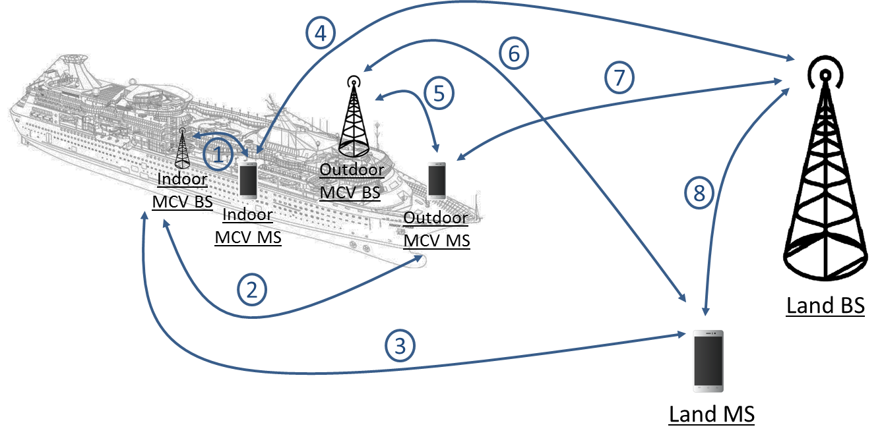

Figure 5: Propagation paths considered in the studies

Table 9 describes the propagation model used in the studies for each of the above paths.

Table 9: Propagation models

|  |  |  |
| --- | --- | --- |
| Path number | Path description | Propagation Model |
| 1 | Indoor MCV BS - Indoor MCV MS | IEEE C-Model [9] (Break Point = 15m) |
| 2 | Indoor MCV BS - Outdoor MCV MS | Baseline: IEEE C-model (BP = 15 m) + 11 dB ( = 6 dB) Sensitivity analysis: IEEE C-model (BP = 15 m) + 20 dB |
| 3 | Indoor MCV BS - Land MS | Baseline: ITU-R JTG 5-6 Sea model [10] + 11 dB ( = 6 dB) + 1 dB Sensitivity analysis: ITU-R JTG 5-6 Sea model +30 dB |
| 4 | Indoor MCV MS - Land BS | Baseline: ITU-R JTG 5-6 Sea model + 11 dB ( = 6 dB) + 1 dB Sensitivity analysis: ITU JTG 5-6 Sea model +20 dB |
| 5 | Outdoor MCV BS - Outdoor MCV MS | IEEE C-model (Break Point = 15 m) |
| 6 | Outdoor MCV BS - Land MS | ITU-R JTG 5-6 Sea model + 1 dB |
| 7 | Outdoor MCV MS - Land BS | Baseline: ITU-R JTG 5-6 Sea model + 1 dB Sensitivity analysis: ITU JTG 5-6 Sea model + 30 dB |
| 8 | Land BS - Land MS | Free space with a 3.3 dB standard deviation |

ITU-R JTG 5-6 model is equivalent to Recommendation ITU-R P1546-2 for distances greater than 1 km. The JTG 5-6 model is a SEAMCAT plugin and can thus be modified to take into account the sea path whereas Recommendation ITU-R P.1546 model is implemented in SEAMCAT with land propagation curves only and can’t be modified. The comparison between JTG 5-6 sea model, ITU-R P1546 land model, and Free Space model is plotted in Figure 6.

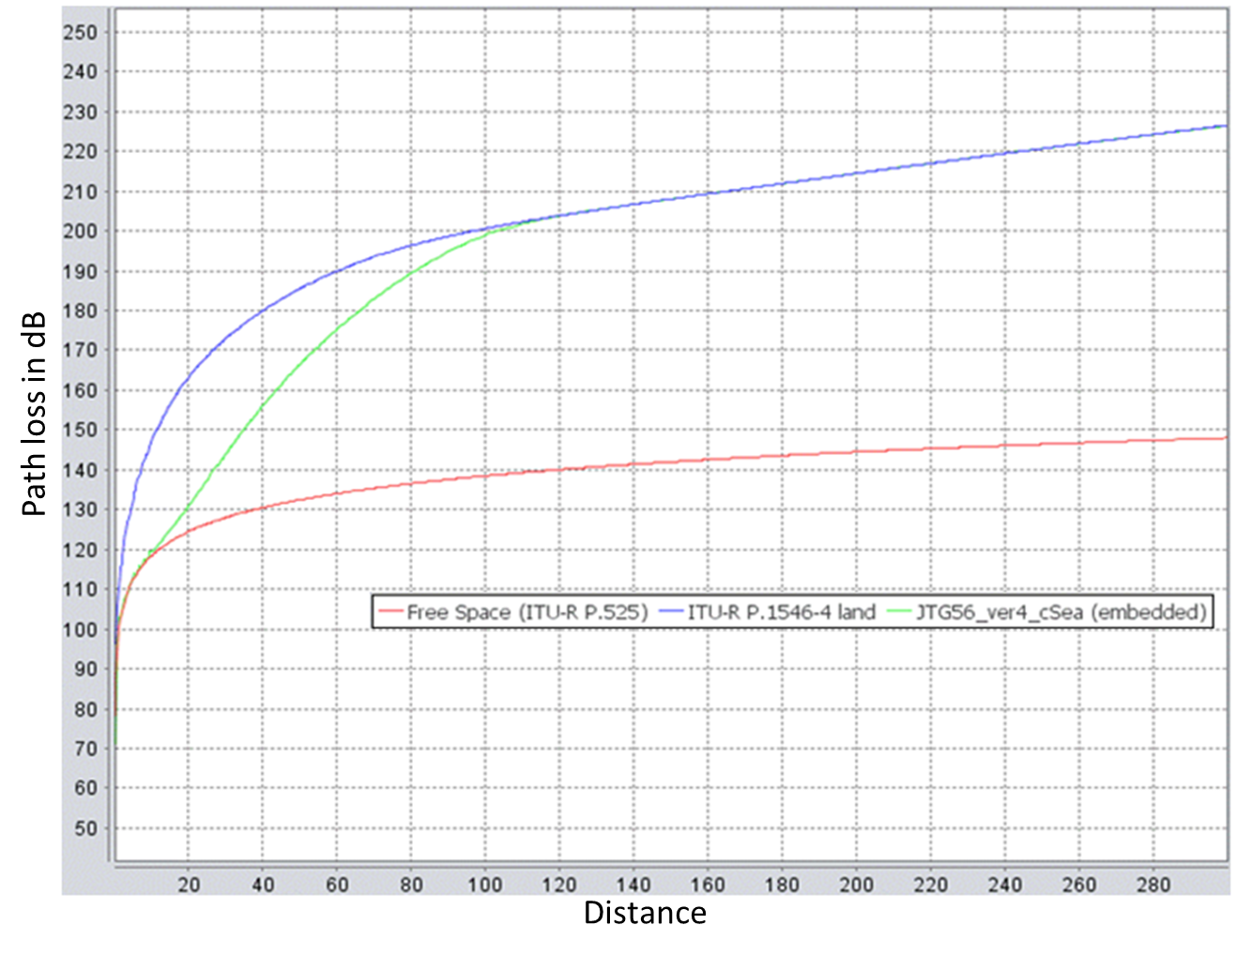

Figure 6: Propagation model comparison

For paths 2, 3, 4 and 7, several values for the additional attenuation factor are taken, accounting for all the attenuations of the body structures of the vessel (hull, walls, doors, windows, fences, etc.):

* As a baseline, the values are taken from existing Recommendation ITU-R P.1812 [6];
* For sensitivity analysis, values from actual measurements are taken.
* To take into account the specificity of the indoor environment inside vessels (presence of people across the propagation link in the corridors), the IEEE C-model is used with a breakpoint at 15 m.

1. Possible implementations of MCV technical conditions

This annex proposes possible implementations of MCV technical conditions for both UMTS in the 2100 MHz band and LTE in the 1710-1785 / 1805-1880 MHz and 2500-2570 / 2620-2690 MHz bands in the future updated EC framework.

**Technical conditions: UMTS MCV in the 1920-1980 / 2110-2170 MHz frequency bands**

Conditions to be met by a system providing UMTS MCV services in the territorial seas of the Member States of the European Union, in order to avoid harmful interference to land-based mobile networks.

The following conditions shall be met:

1. The system providing MCV services shall not be used closer than two nautical miles[5] from the baseline, as defined in the United Nations Convention on the Law of the Sea;
2. Only indoor vessel-BS antenna(s) shall be used between two and twelve nautical miles from the baseline;
3. Only bandwidth up to 5 MHz (duplex) can be used;
4. Limits to be set for mobile terminals when used on board vessel and for vessel-BS.

Table 10: Technical Conditions: UMTS MCV in the 1920-1980 / 2110-2170 MHz frequency bands

|  |  |  |
| --- | --- | --- |
| Parameter | | Description |
| **Transmit power / power density** | For mobile terminals used on board vessels and controlled by the vessel-BS in the 1920-1980 MHz band, maximum radiated output power:  0 dBm / 5 MHz | |
| **Emissions on deck** | The vessel-BS emission on deck shall be equal or below - 102 dBm / 5 MHz (CPICH) | |
| **Channel access and occupation rules** | Between two and twelve nautical miles from the baseline, the quality criteria (Qrxlevmin) shall be equal to or higher than  -87 dBm / 5 MHz | |
| PLMN network selection timer shall be set to 10 minutes | |
| The timing advance parameter shall be set according to a cell range for the MCV distributed antenna system equals to 600m | |
| RRC user inactivity release timer shall be set to 2 seconds | |
| **Non alignment with land networks** | MCV carrier centre frequency shall not be aligned with land network carriers | |

**Technical conditions: LTE MCV in the 1710-1785 / 1805-1880 MHz and 2500-2570 / 2620-2690 MHz frequency bands (LTE MCV 1800 MHz and 2600 MHz)**

Conditions to be met by a system providing LTE MCV services in the territorial seas of the Member States of the European Union, in order to avoid harmful interference to land-based mobile networks.

The following conditions shall be met:

1. The system providing MCV services shall not be used closer than four nautical miles4 from the baseline, as defined in the United Nations Convention on the Law of the Sea;
2. Only indoor vessel-BS antenna(s) shall be used between four and twelve nautical miles from the baseline;
3. Only bandwidth up to 5MHz (duplex) can be used per frequency band (1800MHz and 2600MHz);
4. Limits to be set for mobile terminals when used on board vessel and for vessel-BS in Table 11.

Table 11: Technical conditions: LTE MCV in the 1710-1785 / 1805-1880 MHz and 2500-2570 /   
2620-2690 MHz frequency bands (LTE MCV 1800 MHz and 2600 MHz)

|  |  |  |
| --- | --- | --- |
| Parameter | | Description |
| **Transmit power / power density** | For mobile terminals used on board vessels and controlled by the vessel-BS in the 1800 MHz and 2600 MHz bands, maximum radiated output power (PcMax):  0 dBm | |
| **Emissions on deck** | The vessel-BS emission on deck shall be equal or below - 98 dBm / 5 MHz (equivalent to -120 dBm / 15kHz) | |
| **Channel access and occupation rules** | Between four and twelve nautical miles from the baseline, the quality criteria (Qrxlevmin) shall be equal to or higher than -83 dBm / 5 MHz (equivalent to -105 dBm / 15kHz) | |
| PLMN network selection timer shall be set to 10 minutes | |
| The timing advance parameter shall be set according to a cell range for the MCV distributed antenna system equals to 400m | |
| RRC user inactivity release timer shall be set to 2 seconds | |
| **Non alignment with land networks** | MCV carrier centre frequency shall not be aligned with land network carriers | |

1. LIst of referenceS
2. CEPT Report 28 “Mobile Communication Services on Vessels (MCV)”
3. ECC Report 237 “Compatibility study between wideband Mobile Communication services on board Vessels (MCV) and land-based MFCN networks”
4. ITU Radio Regulations Edition of 2012
5. United Nations Convention on the Law of the Sea 1982
6. 3GPP TS 25.304 “Technical Specification Group Radio Access Network; User Equipment (UE) procedures in idle mode and procedures for cell reselection in connected mode”
7. Recommendation ITU-R P.1812 “A path-specific propagation prediction method for point-to-area terrestrial services in the VHF and UHF bands”
8. Recommendation ITU-R P.1546 “Method for point-to-area predictions for terrestrial services in the frequency range 30 MHz to 3 000 MHz”
9. Recommendation ITU-R P.452 “Prediction procedure for the evaluation of interference between stations on the surface of the Earth at frequencies above about 0.1 GHz”
10. TGn Channel Models (IEEE 802.11-03/940r2), High Throughput Task Group, IEEE P802.11, 15 March 2004.
11. ITU-R Report on the fifth and final meeting of Joint Task Group 5-6, Document JTG5-6/180, Annex 9, Section 4.3

1. ECC Report 237 also contains studies addressing the situation in international waters which are outside the scope of this CEPT Report.
2. Decision 676/2002/EC of the European Parliament and of the Council of 7 March 2002 on a regulatory framework for radio spectrum policy in the European Community, OJ L 108 of 24.4.2002, p.1.
3. OJ L72, 20.3.2010, p.38.
4. Commission Implementing Decision 2013/654/EU amending Decision 2008/294/EC to include additional access technologies and frequency bands for mobile communications services on aircraft (MCA services) of 12 November 2013. OJ L303, 14.11.2013, p.48.
5. 1 nautical mile = 1852 metres