ECC Report 204

Spectrum use and future requirements for PMSE
Approved February 2014

Executive summary
ECC Report 002 [1] was prepared in the late 1990s outlining the industry use of spectrum and considering the current and future spectrum demand by the various applications in the Services Ancillary to Programme making and Services Ancillary to Broadcasting (SAP/SAB) (now referred to as Programme Making and Special Events (PMSE). In revising the Report, due to the expansion and advances within the industry and in order to best explain the industry, the report has been split into four main parts. The main body of this Report attempts to provide information which relates to the whole PMSE sector and especially exceptional events such as the Olympic Games. In addition annexes 1 to 3 address different sectors include:
- ANNEX 1: addresses Audio PMSE,
- ANNEX 2: addresses Video PMSE and
- ANNEX 3: addresses Service Links.
Due to the interactive and flexible nature of PMSE equipment may be mentioned in more than one part.
It should be noted that exceptional and large regular events will normally involve the Administration in frequency planning the event, allowing the identification of additional spectrum from other users which can be used by PMSE during this event. In addition many PMSE allocations are listed as tuning ranges which may or may not be available or only be partially available in CEPT member countries.
When considering “events” a wide range of PMR and SRD spectrum will also be in use as control and data activities (see ANNEX 3:) and are a fundamental part of PMSE applications.
The existing structure of PMSE has been built around current spectrum allocations which have been in place for a number of decades. Changes in the CEPT Regulations have resulted in a major reduction in spectrum available for PMSE. A second problem is that spectrum which has been used as “loan spectrum” for large events (primarily currently used by the military) may also be reduced with the on-going changes of CEPT regulations.
Investigations are on-going about the suitability of use for audio PMSE of the 800 MHz (and potentially the 700 MHz) duplex gaps.
The band 1492-1518 MHz and the range 1800-1804.8 MHz were recently included in Recommendation 70-03 [6] as frequency bands suitable for audio PMSE. Additional bands should be considered.
For video PMSE to date the investigation into the unpaired bands (1900-1920 MHz and 2010-2025 MHz) have not been finalised and other bands were identified as possible new tuning ranges in the CEPT
Report 51 [14], and will be under investigation..
A review of the availability of spectrum above 3 GHz is required for video PMSE in order to achieve wider harmonised tuning ranges in particular for airborne use. Harmonised tuning ranges would help to avoid the changing of frequency and filters of equipment at national borders or close to borders during a multinational event.
In addition to audio and video PMSE applications, often a variety of different service links are required in order to facilitate and organise the production of programmes and special events. Therefore, these applications as described in ANNEX 3: of this report should have access to an appropriate amount of spectrum.
Identification of sustainable spectrum for PMSE is required as there is a time lag of some 18 months or more in developing new equipment and also considering that a long term stability of spectrum availability is required in order to enable the users to maintain and expand their activities and industries.
Additional guidance on PMSE licensing may need to be given (e.g. through the revision of ERC/REC 25-10 [3]) in order to account for the considerations given in Section 3 and ANNEX 6:.
A range of new technologies have been or are currently being developed that may increase spectrum efficiency. However, they will not have a deep penetration to user equipment for a number of years.

TABLE OF CONTENTS

0 Executive summary 2
1 Introduction 6
2 General considerations on SAP/SAB, ENG/OB and PMSE APPLICATIONS 7
2.1 Definition of PMSE including SAP/SAB, ENG/OB and SNG and further terminology 7
2.2 CEPT Regulatory framework 10
2.3 Spectrum Changes and activities since 1990 10
2.3.1 European Council Decisions Related to PMSE and PMSE Frequency Bands 11
2.3.2 CEPT Activities 11
3 LicenSing of PMSE 12
4 Events requiring the support of various pmse Equipment 13
4.1 EXCEPTIONAL EVENTS AND REGULAR LARGE EVENTS 13
4.2 Studio production 13
5 OVERVIEW of PMSE Spectrum for some uses 14
6 Conclusions 17
ANNEX 1: Audio links 18
ANNEX 2: Video links 64
ANNEX 3: SERVICE LINKS 84
ANNEX 4: Economic and Social Values 96
ANNEX 5: Changes in the regulatory framework for pmse 100
ANNEX 6: Licensing of pmse 102
ANNEX 7: London 2012 103
ANNEX 8: Tour De france 105
ANNEX 9: List of reference 110

LIST OF ABBREVIATIONS

Abbreviation | Explanation
AF | Audio Frequency baseband
ASI | Asynchronous Serial Interface
APWPT | The Association of Professional Wireless Production Technologies
BBC | British Broadcasting Corporation
BMWI | Bundesministerium fuer Wirtschaft und Technology (Germany)
BS | Base Station
CD | Compact Disc
CEPT | European Conference of Postal and Telecommunications Administrations
COFDM | Coded Orthogonal Frequency Division Multiplex
CPG | Conference Preparatory Group
C PMSE | Cognitive PMSE
C/I | Carrier over Noise ratio
DA2GCS | Direct Air to Ground Communication System
DC | Direct Current
DTV | Digital TeleVison
DVB-S | Digital Video Broadcasting via Satellite
DVB-T | Digital Video Broadcast – Terrestrial
DVD | Digital Versatile Disc
EBU | European Broadcasting Union
ECC | Electronic Communications Committee
e.i.r.p. | equivalent isotropically radiated power
ECN | Electronic Communication Network
ECO | European Communications Office
EMF | Electro Magnetic Field Limits (Human Exposure)
ENG | Electronic News Gathering
ERC | European Radio Communications committee
ETSI | European Telecommunications Standardisation Institute
EU | European Union
FDD | Frequency Division Duplex
GE06 | Geneva 2006 Broadcast agreement
GPS | Global Positioning System
GSM | Global System for Mobile Communications
HD | High Definition
IEM | In Ear Monitoring
IMT | International Mobile Telecommunications
ISDB-T | Integrated Services Digital Broadcasting – Terrestrial
ITU | International Telecommunications Union
IP | Internet Protocol
LSA | Licensed Shared Access
LTE | Long Term Evolution
MCL | Minimum Coupling Loss
MFCN | Mobile and Fixed Communication Networks
MIMO | Multi-Input-Multi-Output
MPT 1327 | An industry standard for trunked radio communications networks
NGH | Next Generation Handheld
OB | Outside broadcasting
PMR | Private Mobile Radio
PMSE | Programme Making and Special Events
PT | Project Team
QoS | Quality of Service
RF | Radio Frequency
RES | Resolution
SAB | Services Ancillary to Broadcasting
SAP | Services Ancillary to Programme making
SD | Standard Definition
SNG | Satellite News Gathering
SRD | Short Range Device
STF | Special Task Force
TDD | Time Division Duplex
TS | Terminal Station
TETRA | Terrestrial Trunked Radio
UHF | Ultra High Frequency
UHD | Ultra High Definition
UMTS | Universal Mobile Telecommunication System
WGFM | Working
WGSE | Working Group Spectrum Engineering
WRC | World Radio Conference
WSD | White Space Device
3D | 3- dimensional

Introduction
ECC Report 002 [1] was prepared in the late 1990s outlining the industry use of spectrum and considering the current and future spectrum demand by the various applications in the Services Ancillary to Programme making and Services Ancillary to Broadcasting (SAP/SAB) now referred to as Programme Making and Special Events (PMSE).
Since the publication of ECC Report 002 [1] technology used for PMSE has made significant technical progress. This has led to the use of new technologies for PMSE:
- the introduction of digital video links, for both point-to-point and mobile links;
- the introduction of digital wireless microphones;
- the introduction of narrowband technology for talkback;
- the possibility to use in programme contribution public networks, like TETRA, GSM, UMTS, etc.

In revising ECC Report 002, due to the expansion and advances within the industry and in order to best explain the industry, this report has been split into four main parts.
The main body of the Report attempts to provide information which relates to the whole PMSE sector and exceptional events such as the Olympic Games. In addition, the three Annexes 1 to 3 address different sectors of the industry:
- ANNEX 1: addresses Audio links,
- ANNEX 2: addresses Video PMSE and
- ANNEX 3: addresses Service Links.

Due to the interactive and flexible nature of PMSE equipment may be mentioned in more than one part. When considering “events” a wide range of PMR and SRD spectrum will also be in use as control and data activities (see ANNEX 3:) are a fundamental part of PMSE applications.
In recent years major reallocations of spectrum have or are taking place. Traditional parts of the spectrum used by PMSE have been reallocated to services which are not able to operate co-channel and co-located with PMSE, i.e. 790-862 MHz and in the 2 GHz band. In addition, changes in spectrum use by the primary services using those bands may further limit the access to the spectrum for PMSE devices (e.g. the introduction of new TV technologies in the UHF band). Whilst improvements in spectrum efficiency have taken place in PMSE equipment they cannot in any way make up for this loss of available spectrum. Additionally, this is reduction in available spectrum for PMSE is taking place against a background of expansion in PMSE use within every traditional and multimedia industry.
In April 2012 WG FM issued a questionnaire to CEPT administrations [2] in order to collate, summarise and analyse the regulatory procedures used by administrations in granting access to spectrum for PMSE and, when appropriate, to incorporate the results into the relevant ECC deliverables The results of this questionnaire are available on the ECC web site (http://www.cept.org/ecc/topics/programme-making-and-special-events-applications-pmse).
The material contained in this report may be considered while reviewing ERC/REC 25-10 [3] on Frequencies for SAP/SAB and ENG/OB links which are now referred as PMSE.

General considerations on SAP/SAB, ENG/OB and PMSE APPLICATIONS
This section provides general information relating to the PMSE Applications.
It should be noted that according to [4] the creative industries are among the fastest growing economic sectors in the EU; they created new jobs, assumed key positions in the global value chain and promoted innovations. In a survey among EU Member States, which was conducted at the beginning of 2010, over 97 per cent of those asked considered the culture and creative industries to be 'important' or 'very important' for innovation, economic growth and job creation.
In addition to the recognition by the EU, many other administrations have carried out similar studies. One such study is [5] and whilst it is difficult to totally isolate the PMSE contribution there are very few areas identified in both reports which do not use PMSE in its many forms.
It should be noted that in some countries the usage of wireless equipment (in particular for Audio links and Video Links).is mandatory in some locations (for example parliament, theatres, conferences, fairs…) to prevent people from falling over the large amount of cable require for wired systems.

Definition of PMSE including SAP/SAB, ENG/OB and SNG and further terminology
In order to provide an overview of the various terms used within CEPT and the various reports the following definitions are provided.
The term Programme Making and Special Events applications (PMSE) describes radio applications used for SAP/SAB, ENG/OB and applications used in meetings, conferences, cultural and education activities, trade fairs, local entertainment, sport, religious and other public or private events for perceived real-time presentation of audio/visual information.
The definitions of SAP/SAB and ENG/OB are set out as follows:

SAP: Services Ancillary to Programme making (SAP) support the activities carried out in the making of “programmes”, such as film making, advertisements, corporate videos, concerts, theatre and similar activities not initially meant for broadcasting to general public.
SAB: Services Ancillary to Broadcasting (SAB) support the activities of broadcasting industry carried out in the production of their program material.

The definitions of SAP and SAB are not necessarily mutually exclusive. Therefore they are often used together as “SAP/SAB” to refer generally to the whole variety of services to transmit sound and video material over the radio links.
ENG: Electronic News Gathering (ENG) is the collection of video and/or sound material by means of small, often hand-held wireless cameras and/or microphones with radio links to the news room and/or to the portable tape or other recorders.
OB: Outside broadcasting (OB) is the temporary provision of programme making facilities at the location of on-going news, sport or other events, lasting from a few hours to several weeks. Mobile and/or portable radio links are required for wireless cameras or microphones at the OB location. Additionally, radio links may be required for temporary point to point connections between the OB vehicle, additional locations around it, and the studio.

The definitions of ENG and OB are not mutually exclusive and certain operations could equally well reside in either or both categories. Therefore, it has been a long practice within the CEPT to consider all types of such operations under the combined term “ENG/OB”. It is also understood that ENG/OB refers to terrestrial radio communication services, as opposed to SNG/OB term, which refers to similar applications but over the satellite radio communication channels.
The SAP/SAB applications include both ENG/OB and SNG/OB applications and also the communication links that may be used in the production of programmes, such as talk-back or personal monitoring of sound-track, telecommand, telecontrol and similar applications.
Quality requirements of PMSE applications can vary depending on the task in hand. The bandwidth of the signal to be transmitted i.e. audio or video has a direct impact on the spectral bandwidth required.
The perceived quality of the signals is going to be dependent on their potential final use. The uses can vary from SNG links into a news programme through to a high quality HD TV production.
The reliability of service again can vary according to the task in hand. Typically within the events for large numbers of people and for broadcast applications there is frequently a need for a high degree of protection for the PMSE signals. This required protection inherently puts constraints on the amount of spectrum required to guarantee this quality of service.
Since the 1990’s “programme making” has found new market places to address. One major market is the many forms of audio and video streaming over the internet and accessed by both computers and smart phones.
In recent years the term “multimedia” has increasingly been used to provide a catch all phrases for any activity which may end up on the multitude of computers or other multimedia platforms, WEB and smart phones. Many of the activities use some, if not all, of the PMSE equipment described within this report.
For the purpose of this Report, other terminology is also used and defined as follows:
Radio microphone | Handheld or body worn microphone with integrated or body worn transmitter.
Asynchronous Serial Interface | Streaming data format which often carries an MPEG Transport Stream.  An ASI signal can carry one or multiple SD, HD or audio programs that are already compressed, not like an uncompressed SD-SDI (270Mbs) or HD-SDI (1.45Gbs. An ASI signal can be at varying transmission speeds and is completely dependent on the user’s setup requirements. For example, an ATSC (US Digital Standard for Broadcasting) has a maximum bandwidth of 19.392658 Mbps. Generally, the ASI signal is the final product of video compression, either MPEG2 or MPEG4, ready for transmission to a transmitter or microwave system or other device. Sometimes it is also converted to fibre, RF or SMPTE310 for other types of transmission. There are two transmission formats commonly used by the ASI interface, the 188 byte format and the 204 byte format. The 188 byte format is the more common ASI transport stream. When optional Reed-Solomon error correction data is included the packet can stretch an extra 16 bytes to 204 bytes total..
In-ear monitor | Body-worn miniature receiver with earpieces for personal monitoring of single or dual channel sound track.
Portable audio link | Body worn transmitter used with one or more microphones, with a longer operating range capabilities than that of radio microphones.
Mobile audio link | Audio transmission system employing radio transmitter mounted in/on motorcycles, pedal cycles, cars, racing cars, boats, etc. One or both link terminals may be used while moving.
Temporary point-to-point audio link | Temporary link between two points (e.g. part of a link between an OB site and a studio), used for carrying broadcast quality audio or for carrying service (voice) signals. Link terminals are mounted on tripods, temporary platforms, purpose built vehicles or hydraulic hoists. Two-way links are often required.
Cordless camera | Handheld or otherwise mounted camera with integrated transmitter, power pack and antenna for carrying broadcast-quality video together with sound signals over short-ranges.
Portable video link | Handheld camera with separate body-worn transmitter, power pack and antenna.
Mobile airborne video link | Video transmission system employing radio transmitter mounted on helicopters or other airships.
Mobile vehicular video link | Video transmission system employing radio transmitter mounted in/on motorcycles, pedal cycles, cars, racing cars or boats. One or both link terminals may be used while moving.
Temporary point-to-point video links | Temporary link between two points (e.g. part of a link between an OB site and a studio), used for carrying broadcast quality video/audio signals. Link terminals are mounted on tripods, temporary platforms, purpose built vehicles or hydraulic hoists. Two-way links are often required.
Talk-back | For communicating the instructions of the director instantly to all those concerned in making the program; these include presenters, interviewers, cameramen, sound operators, lighting operators and engineers. A number of talk-back channels may be in simultaneous use to cover those different activities. Talk-back usually employs constant transmission.
Telecomm and/remote control | Radio links for the remote control of cameras and other program making equipment and for signalling
Tally Light | In a television studio, a tally light is a small signal-lamp on a professional video camera or monitor. It is usually located just above the lens or on the so-called electronic viewfinder (EVF) and communicates, for the benefit of those in front of the camera as well as the camera operator, that the camera is 'live' - i.e. its signal is being used for the 'main program' at that moment. Tally (also known as the 'on-air' indication) lights are typically red, although some cameras and video switchers accept a preview tally signal, which is typically green.
Talk through repeater - constant carrier | All mobiles or hand portables can hear each other in the talk through mode of a repeater.
MPT 1327 | MPT 1327 is an industry standard for trunked radio communications networks. It was developed in 1988 by the British Department of Trade and Industry (DTI), Although a British standard it is widely used around the world and the most used trunked radio protocol.  • Analogue voice quality  • Fast emergency call set-up  • Comprehensive support to group and individual voice and data communications  • Digital control channel for fast call setup supports + data services  • Subscriber units support encryption levels (Option Boards)  • Data transmission via MAP27 - AVL, Message Handling Dispatcher and Email gateway.
Talk Back System | A radio or wired system or a mixture of both used for non-broadcast communication when program making Example are:  - Communications between producer and cameraman  - Communication and instructions from producer and actor or presenter

CEPT Regulatory framework
The ERC/REC 25-10 [3] provides a list of tuning ranges that CEPT administrations may consider for audio and video PMSE applications. The term “tuning range” for PMSE means a range of frequencies over which radio equipment is envisaged to be capable of operating; within this tuning range the use in any one country of radio equipment will be limited to the range of frequencies identified nationally (if any) within that country for PMSE, and will be operated in accordance with the related national regulatory conditions and requirements. The ERC/REC 25-10 [3] was last revised in 2003. It is expected to be reviewed after completion of this ECC Report.
Concerning the technical parameters applicable to the audio applications and the frequency bands under consideration in this Report, up-to-date information is available in ERC/REC 70-03 [6].
ERC/REC 70-03 [6] sets out the general position on common spectrum allocations for Short Range Devices (SRDs) for countries within the CEPT. Its annexes define the regulatory parameters as well as additional information about harmonised, standards, frequency issues and important technical parameters for various applications. In particular, the Annex 10 dealing with radio microphones and the Annex 13 dealing with wireless audio applications are relevant to the issue addressed in this ECC Report. This Recommendation has been updated recently with the inclusion of new frequency bands for radio microphones.
Spectrum identified for use by PMSE is considered on a tuning range basis, and therefore, it can appear that there is a large amount of spectrum available. However, PMSE has always shared spectrum with a wide range of services and to manage use individual licenses are generally issued for a specific use on a specific date and at a specific location. Recent reallocations of spectrum use in CEPT countries mean that the former tuning ranges have been restricted since these new services and PMSE are not able to operate co-channel and co-located. The sharing conditions in a given country depend on the licence given to the new service. The available spectrum within the tuning ranges in any particular country is determined on a national basis; each tuning range may be wholly, partially or not available on a given day, in a given location, in a given country.
Finally, it should be noted when considering the spectrum issues relating to the PMSE that from the user’s perspective their expectation is to have a high quality service from the PMSE, while in most cases, those systems are operated as a secondary service.

Spectrum Changes and activities since 1990
Since the development of the initial ECC Report 002 [1], some significant changes have occurred in the frequency bands that are available for PMSE. These changes relate to various activities.
A major threat to PMSE is that demand for spectrum enabling an operation with the required QoS will outstrip supply if the changes in spectrum allocation detailed in ANNEX 5: are implemented. The overall impact will be:
- From the changes and studies instigated by ITU and recent WRCs, many current allocation’s for Audio links and Video PMSE will be reassigned to mobile use
- Large parts of the loan spectrum currently used for equipment at exceptional and major events will not be available

Audio PMSE has a well-defined relationship with the primary broadcast use enabling it to operate with the required QoS from both analogue and digital broadcasting in the locally unused spectrum in the VHF and UHF range. The allocation of the 790-862 MHz band at the World Radio Conference 2007 (WRC 2007) and of the 694-790 MHz band (WRC-12) to the Mobile Service has resulted, and may further result, in changes of the previous situation and in losses of spectrum for audio PMSE.
Likewise Video PMSE which extensively uses the 2-3 GHz band for many applications involving non line of sight propagations may lose parts of current tuning ranges.
In addition, the impact of the out of band energy of services operating in these new allocations may require the implementation of guard bands to allow PMSE operation.

European Council Decisions Related to PMSE and PMSE Frequency Bands
- Decision 243/2012/EU of 14 March 2012 “on establishing a multiannual radio spectrum policy program” [7]
  - Article 3 a: encourage efficient management and use of spectrum to best meet the increasing demand for use of frequencies reflecting the important social, cultural and economic value of spectrum;
  - Article 6.6: Member States shall, in cooperation with the Commission, promote access to broadband services using the 800 MHz band in remote and sparsely populated areas, where appropriate. In doing so, Member States shall examine ways and, where appropriate, take technical and regulatory measures, to ensure that the freeing of the 800 MHz band does not adversely affect programme making and special events (PMSE) users.
  - Article 8.5: Member States shall, in cooperation with the Commission, seek to ensure the necessary frequency bands for PMSE, in accordance with the Union’s objectives to improve the integration of the internal market and access to culture.
- Decision 210/267/EU “on harmonised technical conditions of use in the 790-862 MHz frequency band for terrestrial systems capable of providing electronic communications services in the European Union” [8]
- Decision 128/1999/EC “on the coordinated introduction of a third-generation mobile and wireless communications system (UMTS) in the Community”

CEPT Activities
In the recent years, CEPT has undertaken various studies related to PMSE, as summarised hereafter:
- Following the milestones outlined in the EC mandate to CEPT on PMSE [12], two CEPT Reports were developed complemented with an ECC Report on compatibility studies:
- CEPT Report 50 on Technical conditions for the use of the bands 821-832 MHz and 1785-1805 MHz for wireless radio microphones in the EU [13].
- CEPT Report 51 on Technical conditions for ensuring the sustainable operation of cordless video-cameras in the EU [14].
- Adjacent band compatibility between the mobile networks and PMSE (wireless microphones) in the 1800 MHz range (see ECC Report 191 [15]).

As a follow-up of CEPT Report 51, activities are ongoing within CEPT on compatibility studies with regard to possible new frequency bands for video PMSE.
In relation to the introduction of White Space Devices into the band 470-790 MHz, ECC Report 159 [9] was initially developed and has now been complemented with two additional ECC Report 185 [10] and ECC Report 186 [11].

LicenSing of PMSE
There are a range of licensing systems and application methods in use throughout CEPT. In light of the changes in spectrum reallocation a thorough review should take place and, if possible, a harmonised application form and time scales should be put in place. This section highlights some of the current issues.
As described throughout this report, PMSE comes in many shapes and forms:
- permanent sites are well served by the current licensing system
- large scale, high profile short term events and touring performances (e.g. Formula 1 Grand Prix) which may require an Administration to deploy a dedicated team to manage spectrum authorisation.
- small scale short term events and touring performances which are not large enough to require an Administration to deploy a dedicated team to manage spectrum authorisation. ANNEX 6: provides a list of issues which have been identified.

Annex 1 of ECC Report 44 [17] provides a form which was developed in order to facilitate the harmonisation within CEPT. However, it should be noted that this form is rarely used.

CEPT may consider further reviewing this form and providing CEPT administrations with guidance on the licensing process and also considering the existing national regulations which may be binding for administration and the possibility:
- to use the most recent technologies in the process
- to reflect the on-going development in the PMSE industry (introduction of semi cognitive programmable equipment).

Events requiring the support of various pmse Equipment

EXCEPTIONAL EVENTS AND REGULAR LARGE EVENTS
As defined in section 2.1, Special Event is an occurrence of limited duration, typically between one day and a few weeks, which take place at specifically defined locations.
Exceptional events like the Olympic Games occurring each two years and regular large events like the Tour de France, Formula 1 competitions or football tournaments require the support of Audio links, Video Links and Service Links as described in ANNEX 1:, ANNEX 2: and ANNEX 3:. Links will be terrestrial, waterborne, airborne or satellites.
When these events are organised, they result in major issues requiring detailed intervention by a band manager or the administration. Carefully controlled reuse between indoor and outdoor links may be needed every kilometre or less.
Exceptional and large regular events will normally involve the Administration in frequency planning the event, allowing the identification of additional spectrum from other users which can be used by PMSE during this event. OFCOM-UK has developed a report providing the details of the spectrum planning for the Olympic Game in London 2012 [18].
Guidance to administrations on frequency management during major events is contained in ECC Report 44 [17].
The details relating to the organisation of London 2012 and Tour de France are given in the ANNEX 7: and the ANNEX 8: respectively.
Experience shows an increasing demand of spectrum for these events resulting from the increase in amount of data to be transmitted, an increase in the number of organisations involved in those events and a larger diffusion (see also section 5).

Studio production
Studios use radio for talkback, microphones, in-ear monitors for presenters, and as appropriate cordless cameras. The reason for using PMSE equipment with radio links is to give freedom of movement within the studio.
The nature of traditional studio use has changed. In some countries studios that were managed by public broadcasters have now sold off their studio complexes to private organisations. This has resulted in not only the public broadcaster using this studio but intensive use from other programme making companies. In addition, the following should be noted:
  - A range of programs having permanent new purpose built studios;
  - The development of Studio Villages or Media Cities with a concentration of facilities in a relatively small physical area as an example 358 audio wireless systems per 1 km² in Media Park, Hilversum
  - “Content” of all forms from adverts to YouTube is having an exponential grown rate since the publication of ECC Report 002 [1].

The complex frequency environment of these sites requires detailed frequency planning to ensure that no interference is generated between the devices on site. Further information is available in ANNEX 1:, ANNEX 2: and ANNEX 3:.

OVERVIEW of PMSE Spectrum for some uses
The following tables provide an overview of the number links for the Olympic Games, the Tour de France and within TV Studio. It should be noted that these numbers are indicatives and are difficult to compare one to each other considering the different sources and events. Additional information can be found in ANNEX 1:, ANNEX 2: and ANNEX 3:.
Table 1: Number of Links for the Olympic Games
Event | Radiomicrophone IEM | Service Links | Video Links
Event | Radiomicrophone IEM | Service Links | 1 GHz | 2 GHz | 3 GHz | 4.5 – 6 GHz | 10 GHz | Above 20 GHz | Total Video Links
London Olympics 2012 | 7520 (1) | 6876 | - | 434 | 82 | 160 | 2 | 0 | 678
- 7520 corresponds to the number of coordinated Radiomicrophones and IEM assignments.
Table 2: Spectrum usage for the Tour de France
Event | Radiomicrophone IEM | Service Links | Video Links
Event | Radiomicrophone IEM | Service Links | 1 GHz | 2 GHz | 3 GHz | 4.5 – 6 GHz | 10 GHz | Above 20 GHz | Total Video Links
Tour de France 2007 | 365 | No information
Tour de France 2010 | 456 | NA | 4 | 20 | 4 | 0 | 0 | 0 | 28
Tour de France 2011 | 463 | NA | 3 | 23 | 9 | 0 | 0 | 0 | 35
Tour de France 2012 | 452 | NA | 4 | 17 | 11 | 0 | 0 | 0 | 32 (1)
Tour de France 2013 (2) | 576 | No information
- For 2012, the decrease in the number of video links is due to the fact that there was one TV operator less than in 2011.
- In 2013, it was the 100th Tour de France, which may explain the increase in radiomicrophone and IEM assignments.

Table 3: Number of Audio Links for the PMSE in Studios
 |  | 2002 | 2009 | 2012
Single Studio | Average | 10 | 25 | 33-46
Single Studio | Peak | 10-14 | 20-50 | 65
"Studio Village" | Average | 35-70 | 80-112 | 225
"Studio Village" | Peak | 50-100 | 160 | 358

The numbers in Table 3 are provided by German public service broadcasters. Average use is often 50 - 70 % of installed equipment in a studio.
A further increase of some 10 % is expected by the industry in the future [20].
Manufacturers and users indicated that a yearly average increase of about 5% in PMSE units in the UHF band is to be expected in the coming 10 years as outlined in CEPT Report 32 [19].
The following provides a summary of the spectrum needs for PMSE based on the information gathered in ANNEX 1:, ANNEX 2: and ANNEX 3:.
Audio links:
  - Theatres: Productions at a given theatre will vary from a musical to a conventional play therefore it is reasonable to consider that around 40 channels may be required for a theatrical production on a geographical limited basis (see Appendix 3 to Annex 1).
  - Political and Cultural events: a requirement of some 100 channels available on a geographical basis (see for example Appendix 6 to Annex 1).
  - Studios: As an example 225 systems per 1 km² are required daily at the “media village” in Hilversum, the Netherlands.
  - Even in rural areas there is still a requirement for audio links e.g. schools, village halls, churches etc.
Video links:
The survey by EBU [20] provides an overview of the expected broadcast use which also reflects non broadcast use based on information provided by the broadcast industry.
Table 4: Forecasts on Requirements for Cordless Cameras and Wireless Video Links [20]
Cordless cameras and wireless video links  (including the mobile and airborne links)  10 MHz | Broadcasters Prognoses  October 2008
Typical studio production | 0 to 6 (4 average)
ENG for TV | 5 to 20 (12 average)
Sport events or similar OB – typical | 5 to 10 (9 average)
Sport events or similar OB – peak | 5 to 30 (16 average)

According to the EBU report [20], overall there is a need for a minimum of 10 channels of 10 MHz for the “average” event spread over sub 10 GHz spectrum within each administration plus identified spectrum which can be loaned for major events. Within the 10 channels at least 6 channels for links which can have an obstructed path need to be below 3 GHz. In addition, CEPT Report 51 [14] indicates that due to the range of activities that PMSE covers, from single camera news-gathering to multi-camera international sporting or cultural events, and the temporal and location specific nature of use it is difficult to quantify spectrum requirements. However, it is clear that the use of cordless cameras has seen an increase over the last few years as production values and coverage requirements have increased. This has correspondingly led to an increase in demand for spectrum, especially to support major events.
The following figure shows the number of daily allocations of video links in Paris in 2012. As can be seen, defining the spectrum requirement is a complex thing. Indeed the number of allocations in one day and one place can vary from 1 to around 50. Countries allocate a number of frequencies to video links for daily usage, but when this allocation is exhausted some additional spectrum needs to be borrowed from other services if all requests are to be satisfied. A balance needs to be found such that the amount of allocated spectrum is appropriate: if too many frequencies are allocated to PMSE some are likely to be unused on numerous days; if too few frequencies are allocated, it might prove difficult to borrow enough spectrum for specific events.

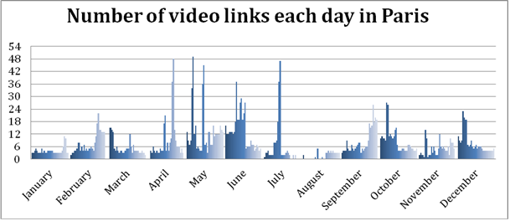
Figure 1: Daily video link allocation in Paris
It is important to note that the number of video links does not directly reflect the quantity of spectrum needed, since a given frequency may be used several times during the day at different locations or for different events.
The table below shows the numbers of links used in various major events and, where possible to determine, the total spectrum used. For these types of events, part of the spectrum is often borrowed from other services in order to meet peak demand. In order to fulfil the peak spectrum demand for these types of events, also considering that they can be unexpected, countries need to identify spectrum that can be borrowed from other services.
Table 5: Information on major event usage
Event | Number of links | Total spectrum MHz | Condition
12th World Championships in Athletics, 15-23 August 2009, Germany | 42 | 619 | Loaned/PMSE
Celebration of the 20th anniversary of the fall of the Berlin wall,  9 November 2009 | 38 | 350 | Loaned/PMSE
Berlin state elections, 18 September 2011, Prussian Landtag building | 17 | 162 | Loaned/PMSE
Tour de France 2011 | 35 | 350 | Loaned/PMSE
Natural ice skating over 200 km  (all airborne use) | 13 | 133 | Loaned/PMSE
Lower Saxony election | 13 | 144 | Loaned/PMSE
News: according to the EBU report [20], given the uncertainty of locations and timing for news events, a minimum of 4 video links and 6 audio links should be identified for national use with as much harmonisation of the tuning range as possible.

Conclusions
The existing structure of PMSE has been built around current spectrum allocations which have been in place for a number of decades. Changes in the CEPT Regulations have resulted in a major reduction in spectrum available for PMSE. A second problem is that spectrum which has been used as “loan spectrum” for large events (primarily currently used by the military) may also be reduced with the on-going changes of CEPT regulations.
Investigations are on-going about the suitability of use for audio PMSE of the 800 MHz (and potentially the 700 MHz) duplex gaps.
The bands 1492-1518 MHz and the range 1800-1804.8 MHz (in addition to 1785-1800 MHz which was already identified before) were recently included in ERC/REC 70-03 [6] as frequency bands suitable for audio PMSE. Additional bands should be considered.
For video PMSE to date the investigation into the unpaired bands (1900-1920 MHz and 2010-2025 MHz) has not been finalised and no other new spectrum in the frequency range 2-3 GHz has been identified.
A review of the availability of spectrum above 3 GHz for video PMSE is required in order to achieve wider harmonised tuning ranges in particular for airborne use. Harmonised tuning ranges would help to avoid the changing of frequency and filters of equipment at national borders or close to borders during a multinational event.
In addition to Audio and Video PMSE applications, often a variety of different service links are required in order to facilitate and organise the production of programmes and special events. Therefore, these applications as described in ANNEX 3: of this report should have access to an appropriate amount of spectrum.
Identification of sustainable spectrum for PMSE is required as there is a time lag of some 18 months or more in developing new equipment and also considering that a long term stability of spectrum availability is required in order to enable the users to maintain and expand their activities and industries.
Additional guidance on PMSE licensing may need to be given (e.g. through the revision of ERC/REC
25-10 [3]) in order to account for the considerations given in Section 3 and ANNEX 6:.
A range of new technologies have been or are currently being developed that may increase spectrum efficiency. However, they will not have a deep penetration to user equipment for a number of years.
- Audio links
  - overview
- PMSE, as defined in this ECC Report, can be divided into audio, video and service links. This Annex covers the aspects of the audio applications that fall under the PMSE definition;
- Since the development and publication of the preceding reports ERC Report 38 ([25], 1996), ERC Report 42 ([26], 1996) and ECC Report 002 [1], 2002) the situation for PMSE regarding spectrum availability has changed significantly, but the basic operating principles and constraints given in those documents are still valid;
- To update the material on the available PMSE bands, a questionnaire was developed and sent to the administrations in April 2012. The responses from 34 CEPT administrations and an associated summary are available on the dedicated section of the ECC website [2];
- Overall consideration of frequency bands for PMSE applications has proved that PMSE use is highly divergent and irregular across various CEPT countries. Because of this, only limited harmonisation may be achievable. Recognizing the impracticality of exclusive allocations the concept of tuning ranges should be pursued as the main means of harmonising PMSE spectrum use;
- Audio PMSE applications, such as wireless microphones, in ear monitoring systems are used in a broad number of applications. The operating requirements as well as the number of deployed systems vary significantly. This report provides information and guidance on the technical and spectrum requirements for audio PMSE systems;
- As the available spectrum for PMSE is becoming more and more congested, a development process towards more spectrum efficient audio PMSE systems can be observed over the last 10 years;
- Semi-cognitive analogue systems are commercially available (2011). These systems are able to sense the RF environment they are operating in, and decide on which channels to operate depending on the information they have available. These systems either work on as stand-alone platform, or are dependent on external PC. Some current licencing systems which restrict use to only specific channels in a frequency block will not gain the benefits from these systems;
- PMSE systems using digital modulation schemes are commercially available. As digital modulation involves some specific operating conditions, these systems currently cannot replace analogue systems in all fields and applications;
- Whilst digital equipment is now available in the market and will bring benefits for users, the use of digital technology alone does not eliminate the need for PMSE to have access to spectrum enabling an operation with the required QoS. Furthermore, the likely switchover from analogue to digital equipment will take a number of years;
- Initial research activities on cognitive PMSE systems have been initiated in ETSI STF 386 and in a German research project funded by BMWI (German Federal Ministry of Economics and Technology) called C-PMSE. Initial results were presented in May 2013. It is expected that it will take several years, before cognitive PMSE systems will be introduced in the market.
T OF ABBREVIATIONS
  - Introduction
This Annex focuses on audio PMSE applications, radio microphones and In Ear Monitors (IEM). It provides:
- information on current and future spectrum requirements and covers the technical and operating conditions;
- an indication of their use within the current multimedia and multiple platforms which provide content for public and private use.

Since publication of ECC Report 002 [1] in 2002, significant changes have occurred in the available spectrum:
- the implementation of the GE06 broadcast agreement on DTV and the WRC-07 decision on allocating the frequency range 790-862 MHz to IMT and IMT-advanced;

- TV channels have been compacted in the frequency range 470-790 MHz resulting in less spectrum for PMSE.

Following RES-232 (rev WRC-2012), the conditions of use of the allocation of the frequency range 694-790 MHz to IMT and IMT-advanced will be discussed at WRC-15 under agenda item 1.2. In addition, solution for accommodating PMSE requirements will be considered.
In order to provide up to date information on the available frequency bands for PMSE, CEPT WG FM 51 developed a questionnaire to the administrations to collect information on the available PMSE frequency bands and the regulatory requirements that apply to these bands. As per November 2012, 34 responses from CEPT administrations were received. The information that was received from the questionnaire was made available in the PMSE section on the ECC website [2] see also programme-making-and-special-events-applications pmse. The reduction of available spectrum triggered the development of more flexible PMSE systems.
In 2011 the first semi-cognitive analogue wireless microphone system was introduced into the market. These systems are able to sense the RF environment they are operating in, and decide on which channels to operate depending on the information they have available. These systems either work as a stand-alone platform, or are dependent on software running on external computers.
Interference mitigation in PMSE by Cognitive behaviour is studied both in ETSI STF386 and in a German research project funded by BMWI (German Federal Ministry of Economics and Technology) called C-PMSE. Both activities are aligned as some of the experts are working in both activities. On 29th of May 2013 a practical demo on cognitive behaviour was given at the Messe Berlin (Berlin Trade Fair centre). Initial frequency assignments to PMSE links are calculated, frequency handovers due to raising interference and power control to accommodate a varying link quality were shown to the public. Furthermore it was shown that link quality supervision can be done on analogue FM links in situ [28].
A review of licensing conditions may be required in some administrations in order to enable the use of cognitive and semi cognitive systems.
Digital wireless microphone systems have been commercially available for some years. However, due to the fact that digital systems exhibit a certain amount of latency, they are not currently suitable for use in all applications. It is anticipated that future advances in digital wireless technology will bring improvements in latency, intermodulation, and robustness to interference. Evaluation of these systems show, that they can be deployed in certain application scenarios where the limitations of these systems can be accepted (e.g. latency). At the current time (2013) they cannot be considered as a common solution to questions of spectrum efficiency.
  - technical aspects
    - General Requirements and Operating Principles for Audio Links including Wireless Microphones and in Ear Monitor Systems
These factors are not independent from each other and cannot be treated or adjusted independently.
      - Quality of Service Requirements
No degradation in the quality in the audio signal should be perceived during the transmission period. Use of PMSE will vary from a few hours for a news conference to many weeks for a large event such as the G8 conference and. permanently for use at studios and theatres. Details on PMSE operation and the technical requirements for PMSE use are given in APPENDIX 1:
In all cases the radio microphone equipment is the first link in a transmission chain which may end in a broadcast, recording or an amplified output. As such any perceived interference of any form will impact the whole transmission chain. Irrespective if the chain is recorded or broadcast live, interference is likely to mean that the performance will be abandoned and in many cases will be unrepeatable. Therefore interference should not affect the Quality of Service (QoS) during the transmission. General requirements regarding wireless microphone, in ear monitor and tour guide systems operation
Wireless microphone and in ear monitor systems must fulfil the highest demands for audio quality on a consistent and repeatable basis. Audio PMSE applications include wireless microphones, in ear monitors and tour guide systems which share some requirements. However, some requirements may also differ from application to application (in particular, tour guide systems do not require low latency). Additional details are given in the table provided in APPENDIX 2: . The following focuses on the requirements of high quality PMSE.
Even in religious services or other applications, the users are acutely aware of the performance of the system and do not accept reduction in performance or interference.
The key requirements for a state of the art wireless system are:
- Providing an audio quality similar to an equivalent wired system;
- Low latency; in order to achieve an acceptable latency in the complete audio chain, the latency in the radio microphone has to be as low as possible (typically below 3-4 ms, see Report ITU-R BS 2161 [35]) especially for IEM applications or lip sync is observable. For certain applications, delay is permissible for example, where the speaker is not seen by the audience;
- No interruptions: all radio microphones and IEM have a 100% audio duty cycle. In all applications users do not tolerate any corruption or interruptions in audio output. Where radio microphones are connected to large amplifiers (theatres rock concerts etc.) any interference may generate peaks of sound which can hurt or damage audience hearing. In the case of IEM (whose audio output is received in the ear canal of the user), damage to the user’s hearing can occur if interference is generated to the transmission;
- Depending on the application an operation time of 6 to 10 hours without recharging or changing the power supply is required whereas the small form factor of the transmitter limits the size of the power supply.
      - Factors that Affect the Performance of Wireless Microphones and In Ear Monitors (IEM)
The following factors may affect the performance of wireless microphones and IEM:
- Interference from other users:
- Interference from other services that fall into the receiving frequency range of wireless microphones and in ear monitors;
- Adjacent channel interference from other systems or services operating in the channel adjacent to the operating channel itself;
- Intermodulation products that are generated either by wireless microphones, in ear monitor and tour guide or by other services that fall into the wanted receiving channel;

- Other factors:
- Size of the venue, deployment density;
- Properties of the venue regarding screening and antenna positioning;
- Propagation aspects like multipath and fading.

      - Factors that Determine the Number of Channels that can be Deployed in a 8 MHz Channel
For audio PMSE, the spectrum efficiency can be described as the number of audio channels that can be supported in parallel in a given bandwidth or a TV 8 MHz channel. When carrying this analysis, a number of other parameters should be taken into account in order to conduct fair analysis, such as the quality of the audio signal transmitted and the technology requirements in terms of interference and operational range.
This matter is further considered in APPENDIX 1: .
Intermodulation
The spectrum efficiency of analogue audio PMSE is not limited so much by the spectrum efficiency of a single link, but of multiple links in a given bandwidth due to the phenomenon called intermodulation. Intermodulation is a physical phenomenon that occurs when multiple transmitters work simultaneously in close vicinity. It corresponds to the situation where one transmitter re-amplifies the signal that it picked up from another transmitter, either at the same frequency or shifted in frequency. Intermodulation can occur anywhere in the radio system:
  - in the transmitter;
  - in the receiver;
  - in ancillary RF equipment or in the environment.

The term reverse intermodulation describes the situation that occurs when RF enters the output of an RF amplifier such as the output stage of a transmitter when other unwanted signals are received via the transmitting antenna.
The number of intermodulation products present rises exponentially as the number of carriers’ increases. Consequently the number of clean frequencies available within a given bandwidth declines rapidly as the number of carriers increases.
A more detailed description of the technical requirements is given in APPENDIX 1: .
Intermodulation mitigation techniques
Intermodulation mitigation can be achieved by a number of techniques:
  - Frequency planning, in order to avoid intermodulation products which create interference on useful signal;
  - Integration of output filters and/or ferrite isolators;
  - Control of microphones transmitted power;
  - Adoption of transmission technologies that support operation in higher interference environment.

Analogue systems support the first two mitigation techniques. Cognitive systems support the first three mitigation techniques. Digital systems support all four mitigation techniques.
      - Propagation Characteristics of Frequency Bands
The propagation characteristics for Audio PMSE are shown in the table below depending on the frequency range.
Table 6: Propagation Characteristics depending on the frequency range
Frequency band | Propagation characteristics
29.7 to 47.0 MHz | Good propagation, minimum wall absorption, no reflection or diffraction.  Shielding from metal structures is low.  Only very low or lowest body absorption in this frequency range.  This band may not be practicable for all types of Audio PMSE applications due to the high ambient noise levels.  Due to the fact that it requires the implementation of very large antennas it is not suitable for body-worn equipment.  Not suitable for large multi-channel systems.
VHF band above  174 MHz | Good propagation, minimum wall absorption, low reflection or diffraction.  Shielding from metal structures is low.  Body absorption in this frequency range is low.  Low frequencies require large antennas. The noise floor and clock frequencies in electronic equipment may create interference to audio PMSE applications.
UHF band below 1 GHz | Good propagation, some wall absorption, depending on the surrounding structures reflection or diffraction can occur.  Shielding from metal structures occurs.  Significant body absorption.  Wall absorption and shielding effects of metal structures can be beneficial in reusing available frequencies in larger system setups.  Small antennas possible.  System performance can be optimised by the use of directional antennas.
UHF 1 to 1.7 GHz | Acceptable propagation, wall absorption, depending on the surrounding structures reflection or diffraction occurs.  Shielding from metal structures occurs.  Significant increased body absorption.  Wall absorption and shielding effects of metal structures can be beneficial in reusing available frequencies in larger system setups.  Small antennas possible.  System performance can be optimised by the use of directional antennas.
UHF 1.7 to 2.5 GHz | Acceptable propagation, wall absorption, depending on the surrounding structures reflection or diffraction occurs.  Shielding from metal structures occurs.  Critical body absorption.  Wall absorption and shielding effects of metal structures can be beneficial in reusing available frequencies in larger system setups.  Small antennas possible.  System performance can be optimised by the use of directional antennas.

The UHF band below 1 GHz is the best band for Audio PMSE due to the combination of antenna size, propagation, current noise floor.
    - Definitions: Analogue, Digital and Cognitive Audio PMSE
      - Analogue
Most current audio PMSE products are based on analogue modulation, e.g. FM modulation. An analogue transmission chain involves the conversion of the acoustic signal into an electric signal which directly drives the radiofrequency signal transmitted over the air (see the following figure).
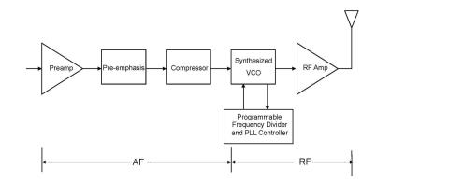
Figure 2: Typical Frequency-synthesised Analogue Transmitter
At the receiver end, the received radiofrequency signal is directly converted to an electric signal which is then assumed to be representative of the input audio signal. Such analogue transmission chain introduces minimum latency for the end-to-end transmission of the signal. However, as the signal is not encoded, any radiofrequency interference or loss of the radiofrequency signal directly degrades the transmitted audio signal. In such a case, no interference is acceptable.

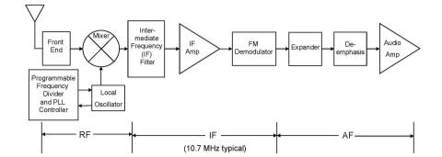
Figure 3: Typical Frequency-synthesised Analogue Receiver
      - Digital
Digital transmission chains are used in many applications, including PMSE video links. In a digital transmission chain, the acoustic signal is converted into an electric signal which is then transformed through an analogue to digital converter. Typically, the conversion into the digital domain and subsequent source encoding will be selected to obtain the desired trade-off between the transmitted signal quality and the amount of information to be transmitted. Once the signal has been digitised, it can be transmitted as any digital information through a transmission chain that potentially includes channel/forward error coding, mapping of the channel encoded information to a modulation scheme, digital to analogue conversion of the modulated signal, transmission of the radio-frequency signal, analogue to digital conversion of the received signal followed by demodulation and finally decoding of the channel/forward error correcting code.
Such a digital transmission chain may or may not involve a retransmission mechanism in case the packet is not error free at reception.
Typical transmission and reception chains are illustrated in the figures below.

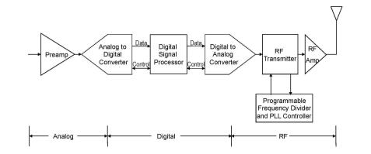
Figure 4: Typical frequency-synthesised Digital Transmitter

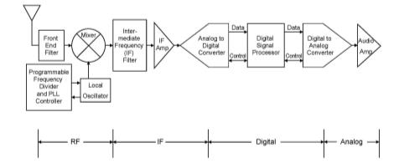
Figure 5: Typical frequency-synthesised Digital Receiver
      - Cognitive Systems
Interference mitigation in PMSE by Cognitive behaviour is being currently studied both in ETSI STF386 and in a German research project funded by BMWi (German Federal Ministry of Economics and Technology) called C-PMSE. Both activities are aligned as some of the experts are working in both activities.
On 29th of May 2013 a practical demo on cognitive behaviour was given at the Messe Berlin (Berlin Trade Fair centre). Initial frequency assignments to PMSE links are calculated, frequency handovers due to raising interference and power control to accommodate a varying link quality were shown to the public. Furthermore it was shown that link quality supervision can be done on analogue FM links in situ.
Presentations of demo Workshop are available from:
http://cpmse.research-project.de/index.php/en/project/82-cpmsenewsen/119-demonstration-workshop.

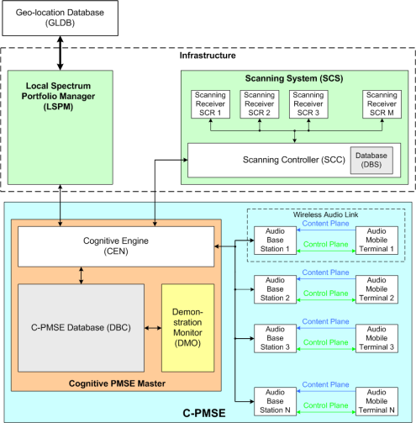
Figure 6: Overview of a PMSE cognitive system as considered by the C-PMSE project
The system demonstrated in Berlin and laid out in the output documents of ETSI STF386 is composed of three large subsystems: The Local Spectrum Portfolio Manager, the Scanning system, together reflecting the infrastructure, which may be permanently installed at an event location. Then there is the entire C-PMSE, which is composed out of the two subsystems plus the cognitive engine, which is the intelligence in the system, comprising of a database and the wireless audio links.
Signalling with the demo was mapped onto existing short range device air interface standards, which operated in unlicensed bands. This is not an option for real PMSE use as protection is not only needed on the content plane but also on the signalling plane. It also became clear that signalling requires additional spectrum in addition to the spectrum need for the content plane.
At the Messe Berlin (Berlin Trade Fair centre) five halls are equipped with, a total of 30 scanning receivers forming a large scanning grid. The scanning gird is permanently installed and is still in use thus gaining more experience with operating it. It can be accessed remotely by the project partners. For this and other purpose the German research project has been extended till end of 2013. Further findings and research results will be incorporated in phase C of ETSI STF 386 activity.
    - Current State of Play
      - Currently Available Wireless Microphones Technologies
The vast majority of wireless systems deployed and available in the market are analogue. Frequency modulation has proven to be a very suitable modulation scheme for this application as it allows transmission with minimal latency and is readily implemented. Other desirable characteristics include the fact that FM is a constant envelope modulation scheme and that analogue systems tend to die gracefully in the presence of interference. In addition the “capture ratio” allows reuse of spectrum in adjacent buildings.
In the previous report (ECC Report 002 [1]), there was uncertainty as to the impact of digital technologies on spectrum requirements. While digital microphones have been available for a number of years, they tend to introduce latency which is incompatible with some applications, specifically live performances including In Ear Monitoring. While full digital wireless microphones are not the current preferred direction for the industry, hybrid schemes such as cognitive PMSE are being investigating and can significantly increase the overall efficient use of spectrum.
      - Factors of the Present Available Wireless Microphone, in Ear Monitor and Tour Guide
The vast majority of wireless systems deployed and available in the market are analogue.
Since the introduction of wireless microphones (1912), in ear monitor and tour guide systems into the market, up to today (2013), frequency modulation has proven to be the most suitable modulation scheme for this application as it serves the following requirements the best:
- A constant envelope modulation scheme allows for long battery life time of the transmitters;
- Due to the evolved technology, the transmitters in the market have a very small form factor, high battery lifetime and a low weight;
- With the demand for more wireless systems to be deployed in a given bandwidth, the spectrum efficiency of analogue wireless microphones, in ear monitor and tour guide systems has greatly improved;
- The FM “capture ratio” facilitates spectrum reuse even between adjacent venues;
- FM systems normally decrease their performance in the presence of interference before they mute (die gracefully). Most digital systems switch off the link without warning under the same conditions.

Wireless microphones are vastly different from other mobile radio applications, as they must deliver consistently high audio quality combined with extended constant carrier operation lasting for many hours. In addition a production may have more than 100 wireless microphones operating simultaneously in close proximity. No other service is required to meet these demanding requirements.
    - PERFORMANCE COMPARISON OF DIGITAL VS. ANALOGUE
      - Digital Audio PMSE Motivation
One source of interest for digital wireless microphones is simply the desire to replace the wire connecting a high quality microphone to the audio system or the recorder. The wireless link must provide as a minimum the audio quality of the wire it is replacing which uses AES42 [33] as its standard. One of the driving forces behind digitization of wireless microphones is the move towards digitization of the whole audio chain in PMSE activities. Digital transmission guarantees no degradation of the quality of the acoustic signal from the source encoding point onwards. For example, acoustic mixing deck are increasingly digital, precisely in order to obtain the guaranteed audio quality as early as possible in the production chain.
      - Benefit of Digital Audio PMSE: Possibility to Adapt the Characteristics to Application Requirements
Digital transmission chains provide significant latitude to select the appropriate audio signal quality, but also provides full freedom to select appropriate trade-offs between the following system’s characteristics:
  - Transmitted acoustic signal quality;
  - Robustness to interference and channel fading;
  - Required received signal strength;
  - Required transmitted RF power;
  - Spectrum efficiency.

It should be stressed that by trade-offs, it is understood that digital transmission does not allow to improve all of these characteristics at the same time, but on the contrary to adapt the transmission characteristic to a specific application by sacrificing some factors in order to improve others.
A very simple example is provided thereafter: systems can be made robust to interference through sacrifices on the achievable audio quality.
      - Technology Limitations of Digital Audio PMSE
Generally speaking, a digital transmission chain introduces latency compared to a similar analogue transmission chain. Latency may restrict the applicability of digital transmission chain for the most latency sensitive audio PMSE application, most noticeably live performances involving In Ear Monitors.
    - Discussion and summary of the properties of the new technologies
The performance of audio PMSE can be characterised by the following parameters:
  - Acoustic signal quality / Audio quality;
  - Spectrum efficiency;
  - System adaptability;
  - Range/ required TX power/ required RX signal strength;
  - Robustness to interference;
  - Latency.

These parameters are in direct relation and interact with each other, they are not independent from each other and the variation of one element usually affects others. In general, the parameters cannot be varied independently from each other.
In the following diagrams, the performance of the described technologies is illustrated by using the 6 parameters as defined above. As a graphic representation, the 6 parameters were arranged in a coordinate plane. When arranged in this coordinate plane the parameters spread an envelope in this plane: “the envelope of possibilities”.
Depending on the discussed technology, some of the parameters are fixed and others can be adjusted. As a result from these dependencies the shape of the resulting envelope varies for each introduced technology. The resulting envelopes in the coordinate plane help understanding the differences of the discussed technologies and support a comparison of them with regard to the introduced parameters.
For analogue systems the shape of the envelope is fixed. For cognitive and digital systems, the corners of the envelope representing the above described parameters can be varied.
General notes for the interpretation of the diagrams:
To make the different quantities of the parameters comparable, the axes of the diagram do not show the physical quantities of the parameters themselves but an abstract utility of them which is proportional to the suitability for the user of the system, e.g. the lower the latency of the system the higher the utility of this parameter. Using this approach, for the utility of each parameter (as used in the diagrams) the simple interpretation ‘the higher the better’ holds true.
The higher the utility of a parameter, the further it is away from the origin of the coordinate plane
Light green and dark green colour is used, to compare different sets of feasible parameters for a given technology / system setup in the respective graphs.

      - Analogue Systems
The current analogue systems operate with comparatively fixed parameters and characteristics that were tailored to the requirements of the users for typical usage scenarios. Analogue audio PMSE systems deliver extremely low latency and very good acoustic signal quality. Analogue systems are susceptible to interference and have a fixed operating range, beyond that range the system performance will start to decrease. Due to performance reasons the adaptability to selecting the frequency of operation is limited.
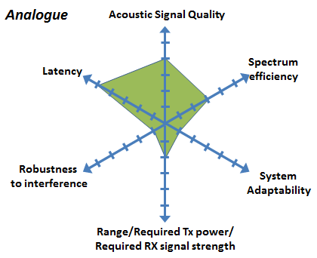
Figure 7: Analogue PMSE
      - Cognitive Systems with Analogue Audio PMSE: Envelope of Possibilities
In principal, cognitive audio PMSE systems are not limited to a specific technology and the concept can be implemented either by analogue or digital links for the transmission of the audio signal. In the following, as an extension to current analogue devices, the focus is on systems with an analogue audio link whose parameters can be adjusted and modified through a cognitive control plane taking into account the required performance criteria as pre-selected by the user. The system can therefore modify some of the characteristics of the analogue audio link within the present parameters and is hence to some extent capable of adapting to changing conditions of the environment. However, as mentioned before, there is a trade-off between the parameters. For example, a very high spectral efficiency may correspond to a lower acoustic signal quality. On the other hand, if high acoustic signal quality is favoured this may lead to compromises w.r.t. robustness to interference and/or spectral efficiency.
Therefore, a cognitive audio PMSE system is not defined by a fixed performance level, but would adapt its performance level with regard to various criteria depending on the requirement of the specific situation. Once the required performance level is set by the user, the system will work within this limitation In that sense, this kind of cognitive PMSE systems is more adaptable than a conventional analogue PMSE system.
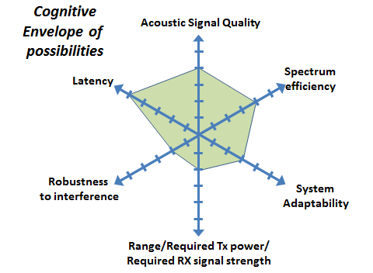
Figure 8: Cognitive PMSE envelope of possibilities
      - Cognitive Systems Example 1
In this example, the user of the cognitive system accepts to sacrifice some robustness to interference but no compromise on the other parameters ie requiring maximum audio quality. This may be the case in a very controlled RF environment where a maximum number of microphones is required, while maintaining a very good audio quality.
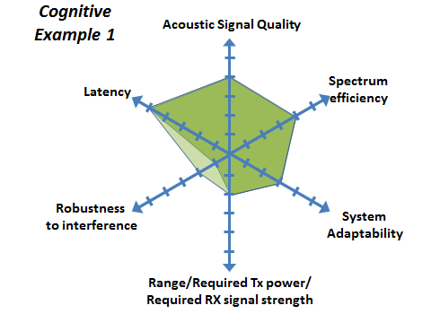
Figure 9: Cognitive PMSE – Example 1
      - Cognitive Systems: Example 2 - System Providing High Acoustic Quality
In this example, the user of the cognitive audio PMSE system would require that microphones to transmit at maximum power in order to be certain to maintain audio quality, even in case of interference.
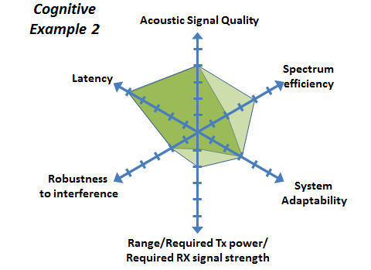
Figure 10: Cognitive PMSE – Example 2
      - Digital Systems: Envelope of Possibilities
Digital Audio PMSE systems provide a large envelope of possibilities as various elements of the technology available in the digital communication field can be reapplied to this specific use case.
If an appropriate channel coding is applied. Digital systems are capable of correcting, to some extent, errors of the audio signal caused by added noise on the channel or by interference from other systems. This cannot be achieved by analogue systems. Thus, for digital systems the resolution of the audio signal mainly depends on the quality of the microphone itself and the resolution of the analogue to digital conversion resulting in the possibility of a very high audio quality. However, this attractive feature comes at the price of an increased latency introduced by the additional signal processing steps. Moreover, a high bandwidth is required to transmit an audio signal with a high audio resolution. By using source coding techniques the necessary bandwidth can be significantly reduced and to some extent adjusted at the price of a decreased audio quality and an additional increase of latency.
Therefore, as a compromise, low latency digital PMSE systems may use tailored low latency codecs with modest coding and compression rates that accept a higher RF channel bandwidth and a higher susceptibility to interference.
If the rest of the audio chain is analogue, the received and processed digital signal must again be converted into an analogue signal resulting in additional delay. The total delay can be too high for some application scenarios in particular if in ear monitoring is used (e.g. at live performance events), as the signal from the performer must loop through the mixing console and back to the performer fast enough so that the performer does not notice the delay. In the ideal case of a completely digital audio chain these conditions are more relaxed as the additional conversion is omitted.
However the overall delay depends on all elements of the audio chain which are potentially provided by different manufacturers hence cannot be arbitrarily controlled by the single component manufacturer.
The illustrative envelope of possibilities of digital PMSE systems is provided below.
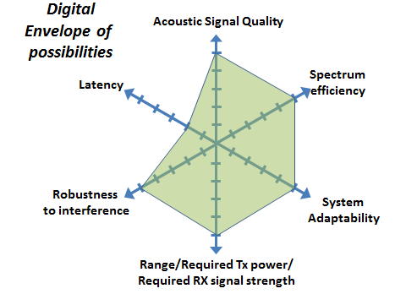
Figure 11: Digital PMSE – Envelope of possibilities
      - Digital Systems - Example 1: High Capacity System
In this example, the user of the digital audio PMSE system selects a sound encoding scheme with a high compression rate, combined with a very robust channel coding scheme. In such a case, the transmission of the system can be very robust to interference and can achieve a very large range and carry a large number of audio channels in a given bandwidth. On the other hand, such a system would suffer from latency and reduced acoustic signal quality.
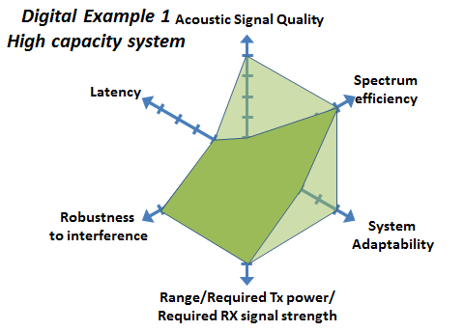
Figure 12: Digital PMSE – High Capacity system
      - Digital Systems – Example 2: System Providing High Voice Quality
In this example, the digital systems uses a very high quality sound encoding scheme (high sampling frequency, little or no compression) together with a robust channel coding scheme. This results in large data rate on the audio link, requiring a higher order modulation scheme resulting in a higher required RF bandwidth The system does therefore support a lower number of audio channels for a given bandwidth.
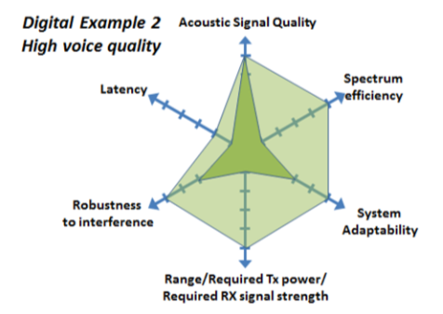
Figure 13: Digital PMSE – High Capacity system
  - spectrum requirements
The information and conclusions given in ECC Report 002 [1] were based on information from 1999. Since that date a large increase in the use of audio PMSE equipment has occurred. Since the development of the initial report, the audio PMSE use has spread to a much wider field of applications. Today (2013), the use of PMSE equipment is regarded as “THE” standard in many diverse fields both artistic and business providing flexibility for the director and designer plus safety from multiple cables. The major applications will be discussed more detailed in the following subchapters.
    - Demand for Spectrum
The demand for spectrum for PMSE applications varies depending on the scenarios of use.
In many cases where an event is known in advance, planning and coordination of spectrum use can take place. Currently some administrations “borrow spectrum” from other users for regular large events such as Formula 1, G8 and especially for extraordinary events such as the Olympics. Such “borrowing” will become more difficult considering different sharing situations in the future due to the form and type of new services now occupying the currently “borrowed” spectrum within the tuning range of PMSE equipment.
The density and deployment of PMSE audio equipment is high in urban areas and areas where production facilities are located (studios and media villages). In these hot spot areas, fixed deployments have a high probability of use. The actual use is dependent on the work/ rehearsal / performance schedule. During such phases, the probability of use is 100%. In phases of no activity the probability of use is low.
Hot spot scenarios have a high demand for spectrum. The spectrum demand will vary depending on the time of day and other factors. E.g. Theatres use a high number of PMSE applications such as wireless microphones, in-ear monitors, and wireless audio links during rehearsals and shows, other than that, there is only low or no use,
Other scenarios have a lower demand for spectrum. The demand may vary depending on the time of day and other factors. E.g. Houses of worship use only a small number of PMSE devices such as 1-2 wireless microphones, and those only during services. Other than that, there is no PMSE use at this location.
In rural scenarios where normally no PMSE applications are deployed other than Houses of Worship and clubs, spectrum requirement occurs in case of unexpected events, such as nature disasters, accidents and war situations that attract media coverage. This could be considered an ad hoc use of PMSE equipment. For this use, a certain amount of permanent spectrum must be available as spectrum coordination is not possible in the short time scales available.
To a certain extend the use and activity of the PMSE use can be planned and coordinated, In that case the duration of use and the required spectrum is well known.
Sections 4 and 5 in the main body of the Report provide information about the spectrum requirements for Audio PMSE for the London Olympic Games in London 2012, Tour de France and Studio use. The following table provides an overview for various cases and are further described in the following sections. In large events the Administration often includes IEM with radio microphone usage therefore some of the figures below will show no separate IEM use.
Table 7: Overview of the number of links for some events
Use case | Radio Microphones | IEM | Audio Link
Event
German Election | 143 | 55
Hague Election | 168
London Theatres (2 square miles) | 940 | 48
UK one day casual use snapshot | 306

Information on requirements for different types of events is given in the following sections.
      - Changes in Technical Requirements
PMSE should have access to spectrum enabling an operation with the required QoS. Due to the nature of the current technology, the spectrum planning for audio PMSE system setup is done by bespoke software tools. The system setup is normally carried out e prior to the use, and remains unchanged until the end of production. Detailed information on the technical requirements for Audio PMSE operation is given in APPENDIX 1: .
      - PMSE Sectors Addressed
Discussion of PMSE spectrum demand is divided into several sub-sections, characterising several distinctive sectors of PMSE (see also APPENDIX 2: ).
The subsections detailed below were chosen to represent a wide selection of PMSE use. The numbers given in the subchapters represent aggregate numbers considered to be mean values. Major deviations in the numbers within a sector will take place.

These sectors are:
  - Theatres and rock and pop and touring shows;
  - Studio production, these can be single buildings or cover many hectares with multiple studios;
  - News gathering for TV/radio/internet;
  - Sound broadcast;
  - Casual (sport) events and similar outside broadcasts;
  - Special events (i.e. large outside broadcasts);
  - Houses of worship;
  - Film and advert production;
  - Recording;
  - Corporate Events;
  - Social use, e.g. homes for the elderly people;
  - Conference / Political events (e.g. shareholder / board meetings) G20 summit.

In addition, the following information was provided:
  - Snapshots of Daily use;
  - Harmonised band 863-865MHz use.

The commercial development of each sector may vary from country to country, therefore the aggregate figures of expected PMSE spectrum demand may need to be adjusted accordingly for each category and each specific country.
Some sectors have an international component e.g. touring shows, Electronic News Gathering and international sports and cultural events.
It has to be noted that since the development of the initial report various surveys of the actual and future spectrum demand have been carried out. These surveys addressed and covered only certain user groups and users that are members of certain organizations. Therefore, the results from these surveys give beneficial information about basic trends and expectations for future spectrum demand, but the results cannot be considered as an exhaustive material. An example is the questionnaire developed in 2008-2009 by the EBU to its members [20].
      - Peak vs. Aggregate Demand
In assessing the spectrum requirement for PMSE, it is important to consider that the normal regular demand for spectrum should be distinguished from the “peak demand”. ”Peak demand” may be temporary or geographically limited (see CEPT Report 32 [19]).
The geographical peaks correspond to long term use within fixed sites in certain geographical areas (e.g. large urban conglomerations) where there is always a continuous heavy demand (typically multi-equipment, multi-channel users), thus most of the available UHF spectrum is needed to satisfy this demand. Every country has these in a number of locations.
The temporary peaks correspond to special events of a short term nature (big concerts, festivals etc.). When temporary events are staged at existing geographical peak locations they result in complex spectrum demand requiring detailed intervention by a band manager or the administration, as this results in a “double overload”. Spectrum planning using all available technics including building attenuation between outdoor and indoor us along with geographical shielding and borrowing spectrum must then be employed.
It should be noted that peak demand most often comes from professional users (e.g. broadcasters). Additional details are given in CEPT Report 32 Annexes 3 and 4 [19]. Demand for theatres and rock and pop and touring shows.
Theatres, concert venues and other auditoria of all sizes, both for amateur and professional use, they all use wireless microphones and to a lesser extent, in-ear monitoring systems, talkback and cordless cameras. Applications include drama, musical theatre, rock concerts, corporate events and amateur uses (for example for drama, concerts and shows, and in places of worship).
Spectrum demand is heaviest for large-scale, professional productions, and for touring musicals and rock concerts, and it is these areas on which the following discussion concentrates. Typically, this kind of usage will be most prominent in the locations with highest density of professional theatres, e.g. the West End in London, United Kingdom which covers some 2 square miles of central London (see also annex 1 appendix 3).
Analysis of typical requirements for the touring shows, e.g. rock and pop concerts, suggests that for such touring productions channel demand may be in the order of 20-60 channels,. One particular example considered in detail showed, that radiomicrophones used by performers would take around 25% of the channels, while the rest would be divided almost equally by in-ear monitors and instrument (brass, strings, guitar etc.) pick-ups.
Rock and Pop shows will use a similar infrastructure to the largest musical theatre and the maximum figures shown below can be used as representative of this genre.
Table 8: London West End (31 Theatres)
 | Radio microphone | IEM
Total | 940 | 48
Average | 31 | 1.5
Maximum | 64 | 10

      - Demand for Different kinds of Broadcasting Applications
Broadcasting involves into a broad range of applications where all forms of PMSE equipment are used.
Studio production
Studio production is covered in sections 4 and 5 of the main body of the Report.
Demand for news gathering for TV/radio/ internet
Whilst this sector is dealt with in the video section of this Report (see ANNEX 2:), it should be borne in mind that both radio microphones and equipment integral to cameras including talkback systems will be present at any site. TV news providers use radio links in order to provide rapid response coverage of developing news stories. Therefore video links as well as talkback and wireless microphones are used in the production of live and recorded news reports ‘from the scene.
Terrestrial radio links, known under the term of ENG, consist of one or more microwave links that feed video and audio signals directly from the news location to a broadcaster’s network or studio. ENG links are only one of a number of options used to transfer live or recorded material from location to the studio or network, others including:
- SNG (Satellite News Gathering) refers to the use of satellite links to achieve the same thing;
- Fibre optic links can be used where a location has a fibre termination;
- Store-and-forward over public telecommunications lines can be used for non-live inserts;
- Similarly non-live inserts can be recorded digitally and carried by motorbike or otherwise to the studio.

Each ENG operator (news provider) requires its own exclusive spectrum, for which it requires round-the-clock access over the designated area; there is no scope for event by event co-ordination as the time taken to respond to a news event is too small.
ENG operators normally operate a number of trucks, which can be quickly despatched to a location where a news event is taking place. The truck contains all the facilities required to cover the story and transmit the signal back to the studio or network for (where necessary or appropriate) further production, editing and/or transmission.
It is estimated that altogether, ENG operators providing news coverage in major conurbations with a high density of news events (typically capital and other big cities, like London, Paris etc.) may require allocation on a city wide basis of up to:
- 25-50 talkback narrowband channels;
- 15-30 channels for wireless microphones;
- The video links are further described in ANNEX 2: on Video Links.
The following table provide information on the number of links available for the four main ENG/SNG companies in the United Kingdom.
Table 9: Number of links available for the four main ENG/SNG companies in the United Kingdom
Company # | Truck | Radio Microphone and IEM
1 | 20 | 100
2 | 2 | No information
3 | 25 | 150
4 | 15 | 100
Total | 62 | 350

Indicative numbers for events are given in the following table.
Table 10: Examples of links deployment for News Gathering
Event type | Number of Crews | Radio Microphone | IEM
Local | 1 | 2 | 1
Main | 6 | 12 | 6
Large | 15 | 30 | 20

Demand for sound broadcasters
Local and national sound broadcast stations use PMSE services for newsgathering, traffic reporting (including airborne use), sports reporting, and other applications. Talkback, wireless microphones and audio links are the key services used. However not all stations make significant use of PMSE; in many cases news provision is bought in from specialist news agencies or similar providers.
Therefore PMSE demand for sound broadcast stations is quite modest, e.g. even for such major conurbation as London area, the total demand is some 10 audio links, 5 channels for wireless microphones and 5 narrow band channels for talk-back communications, some of which may be airborne.
Table 11: Examples of Sound Broadcast deployment (indicative numbers)
Event type | Number of Crews | Radio Microphone | IEM | Audio Links
Local | 1 | 2 | 1 | 1
Main | 3 | 6 | 3 | 3

Prediction of demand over the next 10 years indicate that the number of channels for audio links and for wireless microphones may double, totalling to 15-20 audio link channels and 5-10 wireless microphone channels. These are prediction from the broadcaster community [20].
Demand for regular (sport) events and similar outside broadcasts
All forms of PMSE applications are used heavily for sports and other outside broadcasts. Such events have been divided into two sectors. This section covers routine outside broadcasts; the sort of events that occur week in, week out up and down the country. Although co-ordination is needed, difficulties rarely arise and no special planning of frequencies is required. Spectrum does not have to be ‘borrowed’ from other uses to cover events in this section.
Section 4.1 in the main body of this Report deals with major events, which require detailed and specialised planning, sometimes on-the-ground co-ordination, and ‘borrowing’ of spectrum from other uses. The distinction should be emphasised that there are many more events of this type than major events. Therefore it would not be desirable to have to expend the same planning effort that goes into the large events on the events in this section, unless there were clear rewards in terms of spectral efficiency
However it should be obvious that if there is more than one broadcaster covering an event or if several events occur in the same geographical area, then the above estimates should be multiplied by the number of broadcasters. Demand may also increase if it becomes necessary to duplicate some of the links, or use repeaters, etc. for topography or other reasons.
Accepting that the Olympic Games are exceptional events and Tour de France or Formula 1 are regular large events the increase in audio PMSE use gives an indication of how the whole industry has expanded in a relatively short time period.
      - Demand for Houses of Worship
Demand may vary from a few microphones to a large number of channels for microphones and IEM plus other links as well as video links and cordless cameras, depending on the denomination.
Many houses of worship have a complete permanent PMSE installation and can be compared to a concert hall as they provide exceptional quality to those present and often for recording and broadcasting. A number of dominations have, since the 1960s set up international audio link for their services on an annual or quarterly basis, in many cases these have now evolved to include video. Some will also provide feeds to local broadcasters and hospital radio on a regular basis

Where large choirs are involved, IEM will regularly be used to keep all sections of the choir singing in tune.
Table 12: Places of Worship (indicative numbers)
Event type | Radio Microphone | IEM
Average | 1 | 0
Medium | 10 | 6
Large | 30 | 10

      - Demand for Film and Advert Production
Since the introduction of “talkies” in the 1940 is the quality of film sound has been under constant development, currently the introduction of 3D and HD films has generated complex sound requirements to complement the visual extravaganza
In many cases they are the equivalent of a 7:1 sound field system, with the actor speech coming direct via radio microphones and the surround sounds from a mixture of wired and radio microphones. Consider the case where the star is speaking and a car drives away, the stars speech is the prime information and is kept at a high level whilst the car sound dies as it drives away. All sound is recorded and edited at post production.
Along with other broadcast functions the highest quality constant audio is now required (see section A1.3.1.1 of this Annex).
Similar systems are used for sports events to give background fill in sound, events such as super bowl and football regularly use these method’s to enhance the broadcast
Adverts: can be considered the same as a film or TV show, they use the same complex PMSE infrastructure and facilities
In all cases the same common problem of “hiding” radio equipment in scanty costumes is experienced
A major film will use some 40 channels of radio microphone, 20-60 IEM (used for both coordination and actor/singer feedback) a range of audio links plus talkback and video, including video assist
Table 13: Demand for film and advert production (indicative numbers)
Event type | Radio Microphone | IEM | Audio Links
Small | 15 | 7 | 1
Major | 40 | 20-60 | 6

      - Demand for Recording Production
This will include the recording of singers, orchestra’s and other material for CD, DVD use. It may be considered as similar in PMSE use to fixed studios, but often will take place in rural or seaside locations.
      - Demand for corporate events
Corporate events are a major growth area since the early 2000s, they can be considered in the same way as a broadcast activity in that a great number of PMSE applications are used to support the infrastructure of an event. Such events in the cooperate environment vary from meetings with remote participants via telephone dial-in, to large shareholder meetings in multiple locations and product presentations which may involve multiple international locations. PMSE applications will include wireless microphones professional wireless conference systems and cordless video.
Professional conference systems are used to generate recordings that can be archived, and or the signal will be fed in a teleconference system that would allow remote participation to meetings. A video conference system represents an advanced solution; however a professional wireless conference system is still required to collect the sound from each speaker to the video conference facility.
In a cooperate environment, the usage and the relevance of wireless microphones and professional wireless conference systems can be considered equal: whether a delegate gives a presentation by using a wireless microphone or participates in a discussion using the table unit of the professional wireless conference system, the requirements with regard to the sound quality are the same.
A conference system may also include video and multiple channels which enable simultaneous translation of the prime speaker.
Another audio PMSE application that is deployed heavily in a corporate environment is wireless tour guide systems. These systems are used in multi lingual cooperate events to provide wireless reception of multiple translated languages. These systems are also used in guided factory tours, where visitors are guided through various environments such as noisy workshops or other installations. With wireless tour guide systems the visitors can follow the guide´s comments independently from the environment.
Table 14: Corporate event (indicative numbers)
Event type | Radio Microphone | IEM
Small | 10 | 4
Large (per location) | 55 | 16
Conference system (wired or wireless) | <600

      - Demand for Social Use
This covers homes for elderly people, bingo room, use in pubs, schools etc
Social use has taken advantage of the availability to purchase PMSE equipment at reasonable prices to enhance their activities, activities include, amateur music groups, schools and theatre , Children’s homes and homes for the elderly, local halls where bingo and square dancing are avid users of PMSE.
Table 15: Social use (indicative numbers)
Event type | Radio Microphone | IEM
Small | 2 | 0
Major | 15 | 2

      - Use of Harmonised Spectrum 863-865 MHz
This band is under study within CEPT in order to investigate the impact of MFCN operating below 862 MHz on Audio PMSE.
This band is currently the only license exempt audio PMSE harmonised band in EC ([27]), it came from the Detailed Spectrum Investigations of the early 1990,s and is extensively used throughout and across Europe for a wide range of applications including:
- Places of Worship;
- Touring groups;
- Schools;
- Lecture circuit;
- Complementary IEM(when main radio microphone allocation is below 862MHz);
- Fitness and sports instructors;
- Market traders;
- Assistive Listing devices.
      - Demand for Conference / Political Events
Conferences vary from events which will use a few radio microphones to extensive events such as a G8 meeting which will require the Administration to clear all available spectrums at the location, not only for the infrastructure of the conference but also for the security aspects. Such events are not covered in the usage information provided in this report.
In addition to radio microphone and IEM, complex conference systems incorporating multiple translations’ with recording facilities plus spectrum used by broadcasters will be part of the frequency plan.
An example of the complex frequency plans required for a political event is provided in APPENDIX 6: , German presidential election in the Reichstag building, 18 March 2012.This is a typical example of such events and even heavier spectrum use is required when the event is of an international nature,
In total there were 198 links and the total occupied bandwidth sums up to 37, 71 MHz (without consideration of guard bands/separation distances between the applications or intermodulation effects. Note that for these reasons the number of microphone / in ear monitoring links per 8 MHz TV channel is only about 8 to 12. Hence, for most devices currently on the market the effective bandwidth per link increases to 650 kHz –
1 MHz, which has a significant impact on the total bandwidth requirement.)
Table 16: German presidential election - Reichstag building, 18 March 2012
Radio Microphone | IEM
143 | 55

In Holland, it was reported that for the elections in the Hague 2012, about 168 microphones were used.
      - Snapshots of Daily PMSE Use
Two “snapshots” of a typical days use are available showing very different use patterns these are:
- UK, where PMSE is a licensed activity and the figures only show the licensed short term use, they do not show the UK general license use (these are used by many ENG and professional users) or the license exempt use. Please see APPENDIX 4:
Holland where the majority of spectrum is license exempt, Please see APPENDIX 5:
Table 17: Snapshots of Daily PMSE Use
 | Radio Microphone and IEM
UK short Term Licences only | 306
Holland | 231.465
    - General Considerations Related to Changes in the Available PMSE Frequency Bands
Since the writing of the ECC Report 002 [1], some significant changes have occurred in the bands that are available for PMSE audio applications. In the broadcast bands new technologies have been introduced, such as DAB and DVB-T. This has changed the sharing scenario between analogue PMSE and analogue TV. The network topology for the new technologies differs from that used with analogue television.
Other Frequency bands have been allocated to the Mobile Service on a co-primary basis. Some of those bands are adjacent to PMSE audio bands.
Most of the considerations given in section 2.3 and Annex 5 in the main body of the Report are of interest for the Audio PMSE frequency bands.
The impact of these new technologies to PMSE audio is described in the following sections.
      - Impact of DVB-T on PMSE Audio
PMSE equipment can be operated in the interleaved spectrum between broadcasting allotments on a secondary basis, e.g. on a non-interfering and non-protected basis with regard to the terrestrial broadcasting and other primary services. Whilst DVB-T has significantly different parameters than the previous analogue system; the impact on the number of usable audio PMSE channels in locally unused DVB-T channels is similar to the case where analogue TV was deployed.
      - Impact of Mobile Service on PMSE Audio
PMSE equipment can be operated in the interleaved spectrum on a secondary basis, e.g. on a non-interfering and non-protected basis with regard to the terrestrial broadcasting and other primary services. The interference potential resulting from the out of band energy of the Mobile Service on Audio PMSE is under investigation in the framework of CEPT. The results of those studies will have to be considered when reviewing ERC/REC 25-10 [3].
    - Results of PMSE Questionnaire
During the development of this Report, the ECC developed a questionnaire to CEPT administrations on the regulatory procedures used by administrations in granting access to spectrum for PMSE [2].
The questionnaire covered all frequency bands that are available for PMSE. The table below summarises the results - based on the replies of 34 CEPT administrations - relevant for PMSE audio applications regarding availability and use.
Table 18: Results of CEPT Questionnaire on the availability of spectrum for PMSR audio applications
Frequency band | Preliminary Analysis / Results
29.7-47.0 MHz | The summary shows that this band, fully or part of it, is widely available for PMSE applications across CEPT (25 from the 30 providing a response to this band). This is mostly for wireless microphones, sometimes with the extension to other low power audio applications
174-216 MHz | From the 30 administrations providing a response on this band, 28 reports about the availability of the band or parts of it for PMSE applications.  Predominant use is for radio microphones (including hearing aids), the band is also used for other PMSE applications such as wireless audio links and talkbacks with technical conditions based in most cases on ERC/REC 70-03. However, some countries apply more stringent conditions (lower e.r.p. or requirement on the bandwidth or channel spacing)
470-786 MHz | From the 31 countries providing a response on this band, 29 reports about the availability of the band or parts of it for PMSE applications.  Predominant use is for radio microphones (and also in-ear-monitors) with technical conditions based in most cases on ERC/REC 70-03
786-789 MHz | From the 31 countries providing a response on this band, 27 of them report about the availability of the band for PMSE applications.  The predominant use is for radio microphones (and also in-ear-monitors) with technical conditions based in most cases on ERC/REC 70-03 and ECC/DEC/(09)03. However, some countries apply slightly different conditions ( presumably based on previous versions of ERC/REC 70-03)
823-826 MHz | From the 31 countries providing a response on this band, 24 of them report about the current availability of the band for PMSE applications. The availability of the band is also under consideration in 3 other countries.  The predominant use is for radio microphones (and also in-ear-monitors) with technical conditions based in most cases on ERC/REC 70-03 and ECC/DEC/(09)03 However, some countries apply slightly different conditions ( presumably based on previous versions of ERC/REC 70-03)
826-832 MHz | From the 31 countries providing a response to this band, 24 of them report about the availability of the band or parts of it for PMSE applications. The availability of the band is also under consideration in 3 other countries.  The predominant use is for radio microphones (and also in-ear-monitors) with technical conditions based in most cases on ERC/REC 70-03 and ECC/DEC/(09)03  In some countries, the regulation is expected to be amended to be in line with the latest version of ERC/REC 70-03
863-865 MHz | The 30 countries providing a response on this band, report about the availability of the band for PMSE applications.  In 29 of these countries, the band is used or planned to be used by radio microphones and also in-ear-monitoring and wireless audio applications with technical conditions based in most cases on ERC/REC 70-03 (Annex 10, 13)
1785-1800 MHz | From the 30 countries providing a response on this band, 23 of them report about the availability of the band or parts of it for PMSE applications. In addition, 3 countries intend to make the band available in the near future.  The band is used or planned to be used by radio microphones and also in-ear monitoring and wireless audio applications with technical conditions based in most cases on ERC/REC 70-03 (Annex 10, 13)

From the analysis and results of the responses to the PMSE questionnaire, it can be concluded that the 8 tuning ranges are currently available for PMSE audio applications in the majority of the countries from which responses were received.
Some operating and/or usage restrictions in a given tuning range may result from other services working in the same or adjacent band as the PMSE applications. In addition the propagation conditions discussed in section A1.3.1.4 play a large part on the usability of the band and on the type of Audio PMSE applications which could be used in a given band.
    - Licensing Considerations
PMSE use requires, depending of the frequency band, applying and obtaining licenses. Throughout the administrations, the licensing regime and the relevant contact points may vary.
The PMSE questionnaire questions on the licensing regimes that is in use for PMSE. The table below, summarizes the results regarding licensing for the PMSE audio bands
Table 19: Results of CEPT Questionnaire on licensing considerations
Frequency band | Preliminary Analysis / results
29.7-47.0 MHz | From the 30 countries providing a response on this band, 25 of them report about the availability of the band or parts of it for PMSE applications  In most cases, PMSE operation is under license exempt or general licensing regime. A few countries request individual licenses, one as a general rule for radio microphones, another to allow for more relaxed technical conditions.
174-216 MHz | From the 30 countries providing a response on this band, 28 of them report about the availability of the band or parts of it for PMSE applications.  The use of this band for radio microphones is generally regulated through license exempt or general license regime, but light or individual licensing may also apply in some countries.
470-786 MHz | From the 31 countries providing a response on this band, 29 report availability of all or part of the band for PMSE applications.  The use of this band for radio microphones and IEM is generally regulated through license exempt or general license regime, but light, individual or site specific licensing may also apply in some countries
786-789 MHz | From the 31 countries providing a response on this band, 27 of them report availability of the band for PMSE applications.  The use of this band for radio microphones and IEM is generally regulated through license exempt or general license regime, but light, individual or site specific licensing may also apply in some countries.
823-826 MHz | From the 31 countries providing a response on this band, 24 of them report current availability of the band for PMSE applications. The availability of this band is also under consideration in 3 other countries.  The use of this band for radio microphones and IEM is generally regulated through license exempt or general license regime, but light, individual or site specific licensing may and also in-ear monitors also apply in some countries.  This band is also used in a few countries for other PMSE applications such as temporary SAB, generally with higher power and individual licensing.  In some countries, the regulation is expected to be amended to be in line with the latest version of ERC/REC 70-03
826-832 MHz | From the 31 countries providing a response on this band, 24 of them report current availability of the band for PMSE applications. The availability of this band is also under consideration in 3 other countries.  The use of this band for radio microphones and IEM is generally regulated through license exempt or general license regime, but light, individual or site specific licensing may also apply in some countries.  In some countries, the regulation is expected to be amended to be in line with the latest version of ERC/REC 70-03
863-865 MHz | The 30 countries providing a response on this band, report availability of the band for PMSE applications.  The use of this band is generally regulated through license exempt or general license regime, but individual licensing may also apply in a few countries. No change is expected in this band.
1785-1800 MHz | From 30 countries providing a response on this band, 23 of them report availability of the band or parts of it for PMSE applications. In addition 3 countries intend to make the band available in the near future.  The use of this band is generally regulated through license exempt or general license regime, but light or individual licensing may also apply in some countries.  It should be noted that one country reported about the availability of the band 1800-1805 MHz under the same conditions than for the 1785-1800 MHz band.

In the full responses from the administrations to the questionnaire, the administrations also provided the relevant contact points that are in charge for applying for licenses in the relevant bands. This information is available in on the ECC web site (http://www.cept.org/ecc/topics/programme-making-and-special-events-applications-pmse).
From the table it can be concluded that there are 8 core tuning ranges for PMSE audio applications. The licensing conditions for these bands may vary, but some spectrum will be available. It needs to be discussed, if there are ways to unify the licensing regimes per tuning ranges throughout the administrations. This would be beneficial for the use and circulation of PMSE equipment in the various member countries. Additional it would help reducing the administrative burden and time for the PMSE user in applying for licenses.
ANNEX 6: to this Report provides a list of items to be further considered when reviewing ERC/REC 25-10 [3].
  - Future developments related to audio pmse
    - Considerations on Future Perspectives for Audio PMSE
Developments in the film, TV and theatre world are requiring ever increasing sound quality and density from radio microphones this is coupled with increased usage of both radio microphones and IEM in all forms of multimedia platforms resulting in a conundrum of reducing spectrum availability and higher performance.
24bit, 96kHz “Pure Audio on Blue Ray” is the new Audio Format set by production companies like DECCA, Deutsche Grammophon and others. This higher contribution quality on the production side is required for each recording microphone. These “Pure Audio Blue Ray” Discs are already in the market place and the music industry has set this as future standard. This process is implemented first in the classical music – classic live is one branch in the audio industry that is growing and demands higher audio quality - and other genres will follow.
The higher audio resolution that is given by the “Pure Audio Blue Ray” gains the audio resolution especially in the mid and higher frequencies. This will give more detailed facets of the instruments used and enhances the listener’s experience.
A range of developments from 3D films to ultra high definition (UHD) will provide a challenge to the PMSE industry since number of sources and quality will increase.
    - Future Challenges
      - Highest Quality
Compression in any form, including dynamic compression, is not desirable during the contribution phase as compression always means losses for the subsequent reproduction.
Demand is to produce loss-less audio, without compression – with full dynamic range. This production material will be available in highest quality for the distribution via, TV SD/HD, CD, DVD; Blue Ray etc. and future formats can use this recording as the high quality of the original production can be transferred to any future format.
This is the real challenge for wireless vocal, instrument and atmosphere/environment microphones. This leads to higher channel PMSE bandwidth and increases spectrum demand in order to increase quality to adapt to industry needs and expand the listening experience.
      - Dynamic
Many of the current Audio PMSE is limited in their dynamic range. Because of this, adjustments have to be made individually for each audio PMSE link in a setup to secure the highest possible audio quality. Usually during rehearsal the sensitivity of the microphone connected to the transmitter will be manually adjusted. The settings are done in a way that headroom of about 10dB is given before the internal limiter of the transmitter cuts the signal. If the user of the wireless microphone exceeds this headroom of 10dB internal limiter starts working: this will be audible and reduces the perceived quality. This may happen depending on the kind of performance and the engagement of the user.
Besides this, the individual adjustment of the microphones sensitivity is an obstacle of handing this microphone over to other users. If the voice of the other user is louder, the limiter will start operating as mentioned above and downgrade the quality. If the voice of the other user is weaker, then it will sound less loud – at the mixing desk more gain needs to be added which will lead to a reduced signal-to-noise performance – a downgrade in audio quality.
The problem is the limitation in the available dynamic range that current systems are able to handle. This would need to be increased in order to give the sound engineer the full dynamic range of the of the microphone capsule to his mixing console: at the mixing console the sound engineer will adjust the dynamics in a way that it fits to the rest of the production.
For wired operations, studios have already 24 to 48 bit audio resolution. Present wireless audio equipment in 200 kHz channel bandwidth cannot support these requirements.
    - ETSI Standard EN 300 422
The ETSI EN 300 422 [29] standard has different RF bandwidths of 200, 400 and 600 kHz. Today, most of the Audio PMSE equipment uses a 200 kHz bandwidth, however, the introduction of systems using larger bandwidths will be necessary in order to accommodate an increase in the audio quality to meet the requirements of the industry this will result in an increase in term of spectrum demand.
    - Future Technologies
A number of attempts have been made to harness the new mobile technologies and other systems for radio microphone use; however all have so far failed primarily on the latency issues. Networks latencies which were achieved during those attempts far exceeds the 3-4ms (see ITU-R Report BS.2161 [35]) required to ensure lip synchronization at the front end of a production chain based on the current technology of Audio PMSE.
Reviewing the information available when developing this Report (September 2013) on future technologies and modulation schemes from CEPT, ETSI and ITU none appear to offer any practical alternatives to the current radio microphone technologies being developed by manufacturers.
Currently semi cognitive analogue and digital systems are available, dependant on the outcome of the C-PMSE project fully cognitive systems will be developed but given the complexity of both hardware and software the timescales for initial deployment and then significant market penetration are several years in the future.
    - Potential New Frequency Ranges
Currently CEPT is exploring greater access to L band and had recently identified the tuning range 1492-1518 MHz for Audio PMSE.
Investigation of the 1800-1805 MHz band has resulted in a guard band of the order of 200 kHz to prevent interference to the Mobile Service network (see ECC Report 191[15]). The range 1800-1804.8 MHz (in addition to 1785-1800 MHz which was already identified before) was recently identified as tuning ranges for Audio PMSE links in ERC/REC 70-03 [6].
In addition, it should be noted that the 800 MHz duplex gap is available in 24 CEPT countries (see the replies to the questionnaire [2]) and is currently under consideration for harmonisation by the EU.
It should be noted that the possibility for PMSE to operate in the 700 MHz duplex gap is under investigation in the framework of CEPT, EU and of WRC 2015 Agenda Item 1.2.
In addition, it would be beneficial to investigate the sharing possibilities in the 1200-1650 MHz range as proposed in JTG 4-5-6-7.
  - Conclusions
Information provided within this Report clearly shows a major reduction in spectrum available for audio PMSE due to the changes in the CEPT Regulations. Technology alone cannot fully compensate this reduction of spectrum, therefore the PMSE users require alternative spectrum in order to address this problem. From the figures and examples gathered on the various sectors, an overall demand can be identified and these figures (see section A1.4.1 of this Annex) should be used as the basis for replacement spectrum.
Frequency ranges identified within this report (see previous section) should be urgently investigated for audio PMSE use, with conditions that enable the users to maintain and expand their activities and industries. Among those conditions, a long term stability of spectrum availability is required.
Furthermore, when investigating possible frequency ranges for audio PMSE, the requirement for a very high audio quality (see section QoS) should be kept in mind, particularly, since radio microphone equipment is the first link of the transmission chain.
Based on the results of those studies, those frequency ranges may be considered for inclusion into ERC/REC 25-10 [3].
- TECHNICAL PMSE CHARACTERISTICS, RELEVANT FOR REGULATORY CONSIDERATIONS
- parameters for wireless microphones, In Ear Monitors (IEM) and audio links
Wireless microphones normally use wide band frequency modulation to achieve the necessary audio performance for professional use. For the majority of applications the transmitted signal requires a channel bandwidth of up to 200 kHz.
IEM equipment is used by stage and studio performers to receive personal fold back (monitoring) of the performance. This can be just the own voice or a complex mix of sources. The bandwidth requirement of professional IEM equipment is up to 300 kHz.
The comparison of different specifications and operational requirements of wireless microphones, IEM and audio links is given in the table below.
Table 20: Comparison of Wireless Microphones In Ear Monitors and Audio Links
Characteristics | Wireless microphones | IEM (In Ear Monitors) | Audio Links
Application | Voice (Speech, Song),Music instruments | Voice or mixed feedback to stage | ENG/ OB , voice
Transmitter
Placement of a transmitter | Body worn or handheld | Fixed Base | Body worn/vehicle mounted
Power source | Battery | AC Mains | Battery
Transmitter RF-Output power | Below 50 mW | Below 50 mW | Above 50 mW up to below 25W
Transmitter audio input | Microphone or line level | Line level | Microphone or line level
Receiver
Placement of a receiver | Fixed/Camera mounted | Body worn | Fixed / vehicle mounted
Power Source | AC mains/Battery | Battery | AC mains/Battery
Receiver audio output | Line level | Earphone | Line level/Earphone
Receiver type | Single or diversity | Single or diversity | Single or diversity
General
Link scheme | Uni-directional | Uni-directional | Bi-directional  Plus talk back channel
Battery/power pack operation time | 6 - 10 h | 6 - 10 h | 6 - 10 h
Typical Audio frequency response | ≤20 to ≥20.000 Hz | ≤80 to ≥15.000 Hz | Link to base:≤20 to≥20.000 Hz  Fold back to mobile unit: 12,5kHz
Audio mode | Mono | MPX-Stereo | 2 way Mono
RF frequency ranges | TV bands III/IV/V, 1.8 GHz (Note 1) | TV bands III/IV/V, 1.8 GHz (Note 1) | TV Bands I/ III/IV/V, 1.8 GHz
Signal to noise ratio (optimal/possible) | >100/119 dB | >60/110 dB | >100/119 dB  Talk back link: lower
Dynamic range of the RF link | 117dB | Typical 90dB | 115dB  Talk back link: lower
Modulation | FM wideband as well proprietary digital modulation | FM wideband as well proprietary digital modulation | FM wideband as well proprietary digital modulation  Talkback link: FM narrow
RF peak deviation (AF = 1 kHz) | ±50 kHz | ±50 kHz | ±50 kHz  Talkback link: voice quality
RF bandwidth | ≤200 kHz (note2) | ≤300 kHz legacy equipment  ≤200 kHz modern equipment (Note 2) | 2 times <200kHz  plus 12.5kHz
Useable equipment/channel (ΔRF = 8 MHz) | >12 | 6…8 | Not applicable
Note 1: Wireless microphones and IEM may be also used in 863-865 MHz if complying with either EN 301 357 or EN 300 422 [29] (10mW)
Note 2: Modern systems are regularly well below these figures, but legacy equipment requires a higher bandwidth identified above.

- Intermodulation, Reverse Intermodulation, WSD and PMSE
Wireless microphones and In Ear Monitors (IEM) are unusual in the radio world in that large numbers of transmitters (in excess of 80 at a large show); operate simultaneously for a number of hours and in very close proximity, in many cases within centimetres of each other.
It should be borne in mind that all wireless microphones and IEM,s will be switched on prior to the start of a performance and not switched off until the audio or recording system is shut down to prevent clicks and bangs being sent to the audio amplification or recording system.
AP 1.2.1 Intermodulation
Intermodulation occurs when two or more radio signals combine together. In radio microphone and In Ear Monitor applications this is a critical consideration.
Wireless microphones and IEMs are typically wideband FM systems, although radio microphone systems using digital technology do exist. Contrary to popular belief the digital systems are not completely immune to problems with intermodulation but the way in which they are affected is different from their analogue counterparts. For the most part we will deal with analogue systems here since they represent both the majority in current usage and the bulk of the equipment currently available on the market.
Intermodulation can occur anywhere in the radio system,
- in the transmitter;
- in the receiver;
- in ancillary RF equipment or in the environment.

Manufacturers can control the contribution that each element of their equipment makes to a large extent and significant differences in performance exist between different brands and models of PMSE equipment in respect of the levels of intermodulation produced and the levels of tolerance they have to intermodulation interference. However, since intermodulation can also occur elsewhere than within the radio microphone equipment it cannot be completely eliminated and therefore the best possible mitigation is to avoid the consequences of interference from any possible intermodulation wherever possible. Once an intermodulation product exists in the environment, regardless of how it originates, it is just another interference source and the effect that it will have on a receiver can be predicted to a large extent by reference to the C/I performance of the receiver.
The number of intermodulation products present rises exponentially as the number of carriers’ increases. Consequently the number of clean frequencies available within a given bandwidth declines rapidly as the number of carriers increases. The strength of the received signal from a radio microphone at the receiving antenna(s) varies widely as the transmitter moves around. Frequently the strength of the ‘wanted’ signal at the receiver will be less than that of one or more unwanted signals on adjacent frequencies, be they signals from other radio microphone transmitters which are in more favourable locations than the source of the ‘wanted’ signal, or intermodulation products.
In practice it is frequently the case that the wanted radio mix signal is one of the weakest at the receiving antennas since during many types of event at various times a single performer or group of performers may be on stage and therefore at a distance from the receiving antennas when the remainder of a shows cast are off stage and therefore their transmitters are closer to the receiving antennas.
Since intermodulation must exist at some point in all radio communications systems where there are multiple simultaneous transmissions many RF practitioners are often puzzled as to why it is such a major preoccupation for those involved in PMSE. To understand this one needs an appreciation of the circumstances in which intermodulation becomes the problem. In the majority of communications systems either only voice quality (300-3400 Hz) or data with check algorithms are in use. For PMSE two major contributors are the wide audio bandwidth and wide audio dynamic range (or audio signal to noise ratio) of wireless microphones and IEMs. Wireless microphones typically have audio frequency responses ranging from 20 Hz up to 20 kHz and signal to noise ratios exceeding 100 dB. Consequently a low level heterodyne that might present no problem and even go completely unnoticed in other types of radio communications will be considered harmful interference in PMSE applications (e.g. a 12.5 kHz heterodyne which demodulates as a whistle at –40dB will not be apparent in a PMR system since it will be outside the audio frequency range and also close to the audio noise floor but it will be very obvious in a radio microphone system). Since wireless microphones are at the start of the audio production chain any interference at this point affects the entire downstream audience. Since in practice the likely sources of the signals which have combined to produce a particular intermodulation product will themselves be carrying modulation the intermodulation product will also carry a combination of the contributors modulation, more often than not this makes it even more audibly obtrusive. The ultimate audio output of an event, whether broadcast, recorded or live will frequently also be a combination of the audio output from more than one radio microphone summed together and so will contain the sum of any interference experienced by those wireless microphones.
The problems can be exacerbated in IEM systems by a number of factors. When operated in Stereo mode – the default for Live Music performers – the demodulated bandwidth of the IEM receiver is necessarily considerably larger than for a mono radio microphone (or an IEM receiver operating in Mono mode). The operation of the multiplex stereo system using a 38 kHz sub carrier to carry the L-R difference information means that the receiver is susceptible to disturbance by interference that demodulates as baseband frequencies up to at least 53 kHz which are then rendered audible by the multiplex decoding process. In live music use the IEM receiver feeds high performance audio transducers inserted in to the ear canal of the artist’s ears, consequently the smallest disturbance is conducted directly to the performer’s ears which at the very least can be distracting for them and far more serious in the case of severe interference. Additionally IEM receivers are necessarily small battery powered devices and consequently are restricted in terms of antenna, space and energy resources which in turn can restrict their RF performance in comparison with what can be achieved by a top-of-the-range mains powered rack mounted radio mic receiver. Until quite recently IEM receivers did not feature diversity reception, although newer models do now benefit from this technology.
AP 1.2.2 Reverse Intermodulation
The term reverse intermodulation describes the situation that occurs when RF enters the output of an RF amplifier such as the output stage of a transmitter where other signals in the ‘ether’ are received via the transmitting antenna. Since the output is not designed to deal with signals being presented in this way mixing occurs between the ‘received’ signals and also the signal that the amplifier is amplifying. In general the more linear the amplifier the less reverse intermodulation will occur, up to a point. If the ‘received’ signals are sufficiently large then overload will occur. In a small battery powered device designed to output only a few tens of milliwatts this is quite a realistic proposition in the presence of higher powered transmitting devices particularly if they are operating in or near the same frequency band.
AP 1.2.3 Mitigation Techniques
In permanent base station installations there are a number of standard practice techniques that are commonly used which reduce intermodulation between multiple co-sited transmitters. A transmitter which is going to operate long term on a single frequency can have output filters, either internally or applied separately as part of the installation, these filters may be multi pole and have a high Q and these can contribute considerably to the reverse intermodulation performance. Ferrite isolators or circulators commonly used to combine transmitter outputs or to protect transmitters against antenna damage also produce dramatic improvements in reverse intermodulation performance at base station sites. Even antenna feeder cable loss has a beneficial effect in reducing the generation of reverse intermodulation products since it attenuates both the ‘received’ contributors travelling from the antenna to the transmitter output and also the resulting intermodulation products on their way back to the antenna.
Unfortunately most of these techniques are not suitable for small portable battery powered devices with a wide tuning range such as wireless microphones. Each contributes weight, size, reduced efficiency or a combination of all three. Highly selective filters band pass filters in radio microphone transmitter output stages were once common in high end professional devices when they operated on a single crystal controlled frequency (>20 years ago). The need for more frequency agile devices with wider tuning ranges means that modern equipment has to take a different approach with wider pass band filtering and linear output amplifiers instead. Miniature ferrite isolators do exist but have limited bandwidth thus limiting the tuning range of any equipment in to which they are incorporated and they also add size and weight which are both undesirable. A simple attenuator between the transmitter output and the antenna can deliver reverse intermodulation performance improvements without imposing significant weight or size penalties, but the effect on efficiency and therefore battery life are readily apparent and therefore not necessarily desirable.
AP 1.2.4 Frequency Planning
Since ultimately intermodulation cannot be completely prevented or controlled, the solution adopted by the PMSE industry is to plan frequency usage so as to avoid the predictable consequences of interference which would result from intermodulation as far as is reasonably possible.
If a number of carriers are evenly spaced in frequency then mutual interference due to intermodulation can be predicted. If just three carriers are each spaced evenly then two of the three carriers will be vulnerable to interference from 3rd order two tone intermodulation products.
For ten, evenly spaced, carriers the number of two tone 3rd order products which will occur directly on the carrier frequencies is forty, evenly distributed at four per carrier frequency. If we start to look at higher order intermodulation products and higher numbers of tones, although the products will individually be predictably smaller in signal strength, they will be more numerous in quantity and the cumulative effect cannot be ignored in systems with multiple transmitters. So far we have only considered the carrier frequency and assumed zero bandwidth. Once we enter the real world then we have to consider the situation where any intermodulation products which occur within the receiver channel bandwidth can also be a source of interference. How far in frequency from the carrier frequency an intermodulation product can be before it can be ignored is a major differentiator between different brands and models of PMSE equipment. For many events and locations where PMSE equipment is present there may be a mixture of makes and models of equipment in use which further complicates the frequency planning. In a multiple channel system using frequency spacing which is equal to the channel spacing plus a fraction of channel spacing will still result in intermodulation products which are within the channel bandwidth. As a simple rule of thumb the spacing between any two frequencies in a system must be different to that between any other pair of frequencies.
AP 1.2.5 Intermodulation Products vs Required Bandwidth
If the Tx frequencies of the transmitters are equally spaced within a given bandwidth, virtually the required bandwidth for the transmitter setup is low, but the RF noise generated through the intermodulation products in the vicinity of the carriers increases significantly and makes the RF channels adjacent to the Tx carriers unusable.
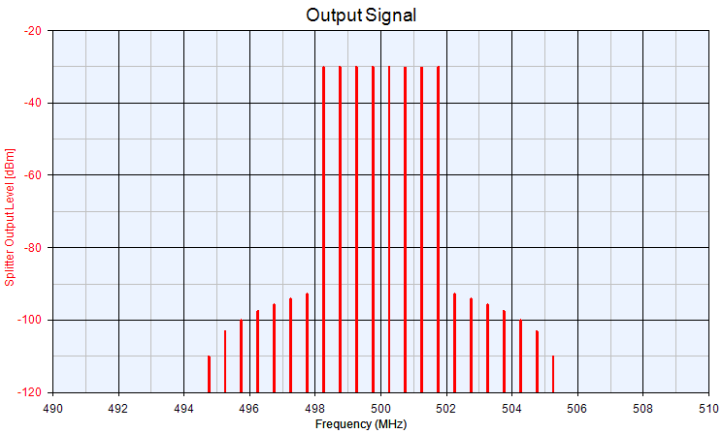
Figure 14: generated intermodulation products for 8 equally spaced transmitter carriers.
In real world situations, the maximum number of IM free channels will depend on the quality of the links as well as the equipment use. The following figure illustrates the behavious of one typical system.
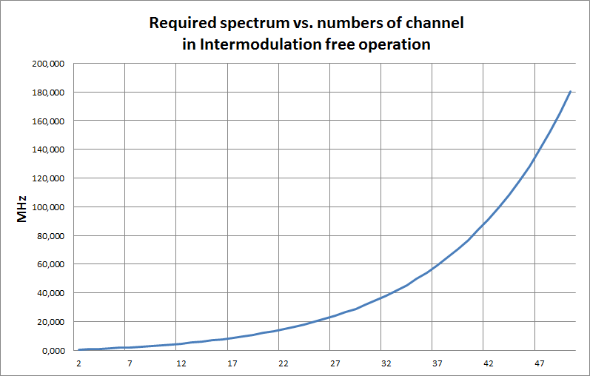
Figure 15: required spectrum vs number of channels in intermodulation free operation
For co-located and coordinated systems, it will be possible to increase the number of links as shown in the following table (see CEPT Report 32 [19]).

Table 21:
Total number of channels | Wireless Microphones | IEM | TV channels  needs to be  interference free | TV channels x 8 MHz  needs to be  interference free
12 | 12 | - | 1 | 8 MHz
12 | 10 | 2 | 2 | 16 MHz
32 | 32 | - | 5 | 40 MHz
42 | 42 | - | 7 | 56 MHz
42 | 32 | 10 | 9 | 72 MHz
53 | 53 | - | 9 | 72 MHz
62 | 62 | - | 11 | 88 MHz
62 | 52 | 10 | 13 | 104 MHz
85 | 85 | - | 15 | 120 MHz
98 | 98 | - | 18 | 144 MHz

1. Frequency spectrum is one package, e.g. 11 channels = 470 – 558 MHz

AP 1.2.6 Example of Audio PMSE in Typical Urban Environment
This section considers the number of PMSE links which can be operated in parallel in the UHF-Band in an urban environment in best case.

The following figure provides an overview of a typical urban scenario of facilities that are using audio PMSE:

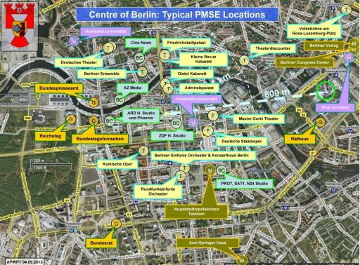
Figure 16: urban scenario of facilities using audio PMSE
Any production has to be free of interference in order to meet the QoS expected by the listeners. One source of interference is caused by intermodulation which is generated in any wireless system when it operates in close proximity of other systems. As intermodulation can be calculated the system design takes care of the effect and uses only reliable frequencies which guarantee no unwanted noise in the audio signal.
The following graph shows a typical arrangement of carriers in a multichannel system of wireless microphones operated in three UHF TV channel (24 MHz):
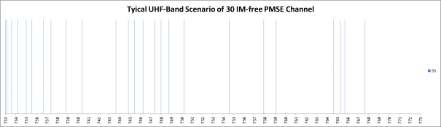
Figure 17: Typical arrangement of carriers in a multichannel system of wireless microphones
It can be seen that thirty carriers of this system are arranged in non-regular spacing.
A venue usually consists of different locations in which different events take place in parallel: in a conference centre there are different halls and rooms with different events using wireless equipment. The same situation will occur in hotels with their meeting facilities, in universities with their lecture halls, in entertainment centres with their various stages, also in exhibition halls with the booths of the exhibitors last not least at political and sport events where several ENG Teams operate in parallel in different areas.
All these events in one venue have one thing in common: they are separated by walls of by a certain distance. Separation by room, house walls or ceilings usually gives a signal attenuation of more than 15 dB in addition to the free space path loss (e.g. shielding by walls or urban installations). Taking this into account the intermodulation of the system shown above will be very low in the neighbour room or neighbour venue. This allows taking the same set of frequencies for the neighbour venue, but shifting all the frequencies by the same amount. Optimising this process will show than much more PMSE can operate in parallel:

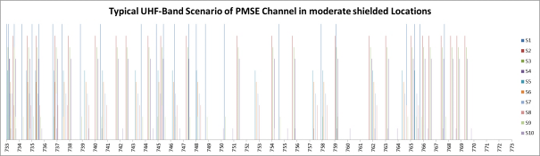
Figure 18: Scenario of PMSE channels in moderately shielded locations
As shown in the graph above these locations are named S1, S2, and S3 etc. The colours assigned to these locations can be found in the graph that shows the used frequencies from left to right. By shifting the frequencies to higher ones there will come the point where one of these frequencies exceeds the upper limit of the three UHF TV channel. These frequencies have to be left out.
This is the reason why the 10 different venues shown on the right of the graph have a different set of frequencies for the use in that location: some venues have more, some fewer frequencies.
The carriers in the graph have different levels. The one with the highest level is the venue which is the reference, from which one can look to the signals of the neighbour venues. The difference in level of the other locations indicates the attenuation the signals experience on the way to the reference location.
Each of the venues on its own have intermodulation free frequencies, but there is a risk of interference if the wanted carrier falls below the intermodulation frequency level of one of the venues. This can only happen if one of the wireless microphones leaves its venue. For high quality productions there is no alternative than intermodulation free arrangement of a set of frequencies as shown in the first graph.
It has to be mentioned that this scenario as described above will work outdoors only if the distances between the venues delivers a signal attenuation of more than 15 dB in addition to the path loss.
The system as described above is proven by practical application in everyday operation in the UHF range – for the venues as named above. This is usually done by the professional frequency coordinator who takes all the important parameters into account.
It needs to be mentioned that the use of PMSE with extended bandwidth, 400 kHz or 600 kHz, will reduce the maximum number of wireless links that can be used in one venue and a mixed scenario.
22 PMSE manufactures have software tools available that can be used to calculate the number of intermodulation free channels in a given bandwidth. In these software tools, algorithms similar to the one described above are implemented.
If operation conditions cannot be considered ideal, the maximum number of available IM free channels will be lower.
A number of distinct separated spectrum blocks will give a higher number of available IM free channels than one large continuous frequency range.
AP 1.2.7 Multi-Venue Sites
At sites where multiple venues are clustered together such as TV studio complexes , conference centres , and theatre complexes we also have to consider the effect that events in one area of the complex may have on another. Wireless microphones are portable transmitters which may travel around a venue (or beyond) outside the coverage of their receivers such as when an actor returns to the dressing room between scenes or a conference speaker leaves the room between presentations. The dressing room or the route to it may be adjacent to another studio, the conference centre bar maybe adjacent to another conference room. Taking the frequency planning for each venue on site solely in isolation exposes the receivers in each venue to the danger of intermodulation created by the proximity of a transmitter (or transmitters) from another area coming within range of the receivers. Careful planning can and does eliminate these risks allowing unhindered mobility of event participants and their wireless microphones. Similar risks exist where IEMs are used in multiple adjacent venues, but since in this case the transmitters are usually fixed in their location the situation is more controlled.
Conversely sites such as schools and universities which may have as many as forty or fifty wireless microphones distributed around a single campus need not be completely ‘intermodulation free’ allowing greater apparent spectral efficiency. Typically such institutions will have only a number of locations within them that have any concentrations of wireless microphones, such as one or two individual lecture theatres with maybe six or eight wireless microphones each. The balance of the systems will be distributed around the site in ones or twos. So long as those systems which are used together or are adjacent to each other are intermodulation free then usually all will be well since the transmitters will normally remain in or around the areas where their receivers are located.
In all of the above however the common factor is that the distribution and use of PMSE radio frequencies in and around a site is known and the ‘worst case’ scenario of everything being in use at once can be assessed, calculated and allowed for.
AP 1.2.8 Digital PMSE
Whereas the effects of intermodulation or any form of interference may become apparent and a nuisance to analogue PMSE services at even relatively low levels the onset may be gradual and the noticeable degradation in performance as levels of interference increases gives some warning of impending problems. Low levels of interference under certain circumstances (where the protection criteria are not respected) such as in location news gathering may be deemed acceptable even when noticed if the alternative is no sound at all.
By comparison low levels of radio interference may not be evident in the audio output of current digital radio microphone until the C/I ratio degrades up to or very near the point at which the audio output is suddenly lost or corrupted beyond recognition. Far from being completely immune to intermodulation issues, the choice is between managing the quantifiable audible intrusion of increasing interference or total loss of audio connection with little or no warning. Both will suffer interference as a result of intermodulation in some way. How analogue and digital systems behave in terms of interference is difficult to compare (see section A1.3.5). It is expected that digital PMSE will be less subject to intermodulation issues resulting in better frequency efficiency in some cases.
AP 1.2.9 WSD and PMSE
The PMSE industry relies on frequency planning at many levels. TV broadcast frequencies are known and do not vary short term. Event staff, venue staff, producers, manufacturers, rental houses, licencing bodies, etc. are able to work together and coordinate even extremely complex events such that interference noticed by the audience is rare enough to draw comment if and when it occurs. It will not be possible to include White Space Devices (WSD) and the frequencies on which they operate in the planning for events or fixed sites, therefore the risk of interference from these devices is significant even when they are transmitting on apparently un-used frequencies. As described earlier since the number of intermodulation products rises exponentially with the number of carriers the risk of interference rises exponentially with the number of WSD operating in or around a given location. The risk of reverse intermodulation between transmitting devices is dramatically increased by their mutual proximity. In the case of WSDs being small personal devices being carried on the person it is quite easy to see how large numbers could be brought into very close proximity to each other at any number of locations including at or near locations where PMSE equipment is being used.

- Deployment of Audio PMSE depending on the Category
Sector | Deployment / Location of use | Deployment / Area of use
Demand for theatres and rock and pop and touring shows | Everywhere | Indoor and outdoor
Studio production | Dedicated fixed site | Predominantly indoor
Demand for news gathering for TV/radio/ internet | Everywhere, airborne | Predominantly outdoor
Demand for sound broadcasters | Everywhere, airborne | Indoor and outdoor
Demand for casual (sport) events and similar outside broadcasts | Everywhere, dedicated locations, airborne | Predominantly outdoor
Demand for large outside broadcasting | Everywhere, airborne | Indoor and outdoor
Demand of coverage of major events | Everywhere, airborne | Indoor and outdoor
Demand for houses of worship | Dedicated fixed sites | Indoor and outdoor
Demand for film and advert production | Everywhere, dedicated locations, airborne | Indoor and outdoor
Demand for corporate events | Everywhere, dedicated locations | Indoor and outdoor
Demand for social use | Everywhere | Indoor and outdoor
Demand for use of harmonised spectrum in 863-865MHz | Everywhere | Indoor and outdoor
Conference / political events | Everywhere, dedicated locations | Predominantly indoor but also outdoor

- London West End Hot Spot

The following information refers to March 2013
Table 22: Number audio PMSE used in London West End
Show name | No of radio mics | No of RR/IEM
We Will Rock You | 36 | 1
Billy Elliot | 40 | 0
Les Miserables | 40 | 1
Jersey Boys | 40 | 4
Chorus Line | 41 | 4
Wicked | 36 | 0
The Lion King | 40 | 0
Matilda | 34 | 2
Rock of Ages | 26 | 5
BodyGuard | 43 | 2
Warhorse | 32 | 4
Singin' in the Rain | 32 | 1
Viva Forever | 48 | 0
Charlie and the Chocolate Factory | 64 | 10
Mamma Mia | 32 | 0
One Man Two Guvs | 16 | 4
Spamalot | 16 | 0
Once | 68 | 0
Book of Mormon | 40 | 0
Trelawny of the Wells | 8 | 2
Grandage Season | 8 | 0
Curious Incident.. | 8 | 1
Top Hat | 16 | 0
King Lear | 8 | 0
Stomp | 16 | 0
39 Steps | 16 | 0
Woman in Black | 16 | 1
Phantom Of the Opera | 40 | 3
Thriller | 40 | 1
The Mousetrap | 8 | 0
Let It Be | 32 | 2

- Snapshot of Audio PMSE Short Term Allocations for 20/8/11 within the UK

The following results for the ad-hoc short term use on 20/08/11 across the UK can be seen below:
- UHF 1 & 2 – 173 Assignments;
- TV band IV/V – 306 Assignments Radio Microphones, IEM Wide Band Talkback;
- 2-4 GHz – 37 Assignments;
- 7 GHz – 2 Assignments;
- 12 GHz – 3 Assignments.

The allocations above spread across 53 different stakeholder/licensees.
Please note that the figures above for short term access amounts to 521. This amount does not account for the significantly large number of annual allocations approximately at 13.000, which represents theatres with annual microphone, monitors & talkback allocations, local radio, area & regional assignments, hospital radio, Point to Point Audio Links and National News. We can say that the subtraction of the Short term from Annual (521 from 13.000) will exist over any weekend period. The frequency range/spread for annual allocations also runs from 48 MHz through to 12 GHz.
The Map below shows the allocations geographically
INCLUDEPICTURE "cid:image001.jpg@01CE2168.389B2490" \* MERGEFORMATINET INCLUDEPICTURE "cid:image001.jpg@01CE2168.389B2490" \* MERGEFORMATINET INCLUDEPICTURE "cid:image001.jpg@01CE2168.389B2490" \* MERGEFORMATINET INCLUDEPICTURE "cid:image001.jpg@01CE2168.389B2490" \* MERGEFORMATINET INCLUDEPICTURE "cid:image001.jpg@01CE2168.389B2490" \* MERGEFORMATINET INCLUDEPICTURE "cid:image001.jpg@01CE2168.389B2490" \* MERGEFORMATINET 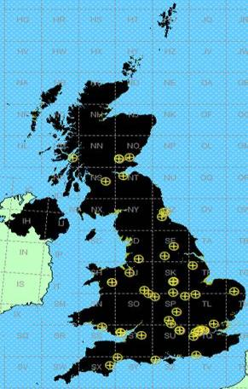
Figure 19: Snapshot of the PMSE use in the UK- Geographical repartition
Just to re-iterate the data in the interests of this study only represents short-term allocations that took place on an ad-hoc basis.
- Snapshot of PMSE Daily Use in Holland
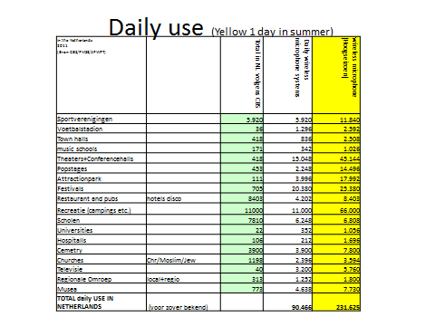
- German presidential election in the Reichstag building, 18 March 2012

In total there were 198 links and the total occupied bandwidth sums up to 37.71 MHz (without consideration of guard bands/separation distances between the applications or intermodulation effects. Note that for these reasons the number of microphone / in ear monitoring links per 8 MHz TV channel is only about 8 to 12. Hence, for most devices currently on the market the effective bandwidth per link increases to 650 kHz-
1 MHz, which has a significant impact on the total bandwidth requirement.)
Frequency  MHz | Power Watt | Band width  kHz | Broadcasting  Station/  Production  Company | Location | Device
36,640 | 0,05 | 50 | Bundestag | Reichstag | microphone
37,160 | 0,05 | 50 | Bundestag | Reichstag | microphone
37,820 | 0,05 | 50 | Bundestag | Reichstag | microphone
512,700 | 0,05 | 200 | PC 1 | Reichstag | microphone
513,250 | 0,05 | 200 | PC 1 | Reichstag | microphone
513,950 | 0,05 | 200 | PC 1 | Reichstag | microphone
514,850 | 0,05 | 200 | PC 1 | Reichstag | microphone
516,150 | 0,05 | 200 | PC 1 | Reichstag | microphone
517,550 | 0,05 | 200 | PC 1 | Reichstag | microphone
526,300 | 0,05 | 200 | BS 2 | Reichstag | microphone
527,500 | 0,05 | 200 | BS 2 | Reichstag | microphone
528,400 | 0,05 | 200 | BS 2 | Reichstag | microphone
530,350 | 0,05 | 200 | BS 2 | Reichstag | microphone
532,150 | 0,05 | 200 | BS 2 | Reichstag | microphone
534,300 | 0,05 | 200 | BS 2 | Reichstag | microphone
535,500 | 0,05 | 200 | BS 2 | Reichstag | microphone
536,400 | 0,05 | 200 | BS 2 | Reichstag | microphone
538,350 | 0,05 | 200 | BS 2 | Reichstag | microphone
540,150 | 0,05 | 200 | BS 2 | Reichstag | microphone
540,750 | 0,05 | 200 | BS 2 | Reichstag | microphone
541,000 | 0,05 | 200 | PC 1 | Reichstag | microphone
541,800 | 0,05 | 200 | PC 1 | Reichstag | microphone
542,800 | 0,05 | 200 | PC 1 | Reichstag | microphone
544,850 | 0,05 | 200 | BS 2 | Reichstag | microphone
545,200 | 0,05 | 200 | PC 1 | Reichstag | microphone
547,450 | 0,05 | 200 | PC 1 | Reichstag | microphone
549,350 | 0,05 | 200 | PC 1 | Reichstag | microphone
550,800 | 0,05 | 200 | PC 1 | Reichstag | microphone
553,350 | 0,05 | 200 | PC 1 | Reichstag | microphone
556,300 | 0,05 | 200 | PC 1 | Reichstag | microphone
558,050 | 0,05 | 200 | PC 1 | Reichstag | microphone
559,500 | 4,00 | 200 | BS 2 | Reichstag | In-ear monitor
560,850 | 1,00 | 20 | BS 2 | Reichstag | In-ear monitor
563,100 | 1,00 | 20 | BS 2 | Reichstag | In-ear monitor
564,750 | 4,00 | 200 | BS 2 | Reichstag | In-ear monitor
574,150 | 0,05 | 200 | PC 1 | Reichstag | microphone
576,200 | 0,05 | 200 | PC 1 | Reichstag | microphone
579,300 | 0,05 | 200 | PC 1 | Reichstag | microphone
582,300 | 0,05 | 200 | BS 3 | Reichstag | In-ear monitor
583,050 | 0,05 | 200 | PC 1 | Reichstag | microphone
583,500 | 0,05 | 200 | BS 3 | Reichstag | In-ear monitor
584,400 | 0,05 | 200 | BS 3 | Reichstag | In-ear monitor
584,850 | 0,05 | 200 | BS 3 | Reichstag | In-ear monitor
585,350 | 0,05 | 200 | BS 3 | Reichstag | In-ear monitor
586,000 | 0,05 | 200 | BS 3 | Reichstag | In-ear monitor
587,050 | 0,05 | 200 | PC 1 | Reichstag | microphone
589,310 | 1,00 | 20 | BS 2 | Reichstag | In-ear monitor
589,890 | 1,00 | 20 | BS 2 | Reichstag | In-ear monitor
597,310 | 1,00 | 20 | BS 2 | Reichstag | In-ear monitor
597,890 | 1,00 | 20 | BS 2 | Reichstag | In-ear monitor
598,000 | 0,05 | 200 | PC 1 | Reichstag | microphone
600,650 | 0,05 | 200 | PC 1 | Reichstag | microphone
604,600 | 0,05 | 200 | PC 1 | Reichstag | microphone
605,310 | 1,00 | 20 | BS 2 | Reichstag | In-ear monitor
605,890 | 1,00 | 20 | BS 2 | Reichstag | In-ear monitor
626,775 | 0,05 | 200 | BS 3 | Reichstag | In-ear monitor
628,000 | 0,05 | 200 | PC 1 | Reichstag | In-ear monitor
628,700 | 0,05 | 200 | BS 3 | Reichstag | In-ear monitor
630,300 | 0,05 | 200 | BS 3 | Reichstag | In-ear monitor
631,500 | 0,05 | 200 | BS 2 | Reichstag | microphone
632,850 | 0,05 | 200 | BS 2 | Reichstag | microphone
634,350 | 0,05 | 200 | BS 2 | Reichstag | microphone
635,100 | 0,05 | 200 | BS 2 | Reichstag | microphone
636,150 | 0,05 | 200 | BS 2 | Reichstag | microphone
636,750 | 0,05 | 200 | BS 2 | Reichstag | microphone
637,900 | 0,05 | 200 | BS 3 | Reichstag | In-ear monitor
638,350 | 0,05 | 200 | BS 3 | Reichstag | In-ear monitor
638,850 | 0,05 | 200 | BS 3 | Reichstag | In-ear monitor
640,400 | 0,05 | 200 | PC 1 | Reichstag | In-ear monitor
641,625 | 0,05 | 200 | BS 3 | Reichstag | In-ear monitor
643,075 | 0,05 | 200 | BS 3 | Reichstag | In-ear monitor
645,500 | 0,05 | 200 | PC 1 | Reichstag | In-ear monitor
647,500 | 0,05 | 200 | BS 2 | Reichstag | microphone
648,850 | 0,05 | 200 | BS 2 | Reichstag | microphone
651,100 | 0,05 | 200 | BS 2 | Reichstag | microphone
651,100 | 0,05 | 200 | BS 2 | Reichstag | microphone
652,750 | 0,05 | 200 | BS 2 | Reichstag | microphone
665,000 | 0,05 | 200 | PC 1 | Reichstag | In-ear monitor
668,300 | 0,05 | 200 | PC 1 | Reichstag | In-ear monitor
674,150 | 0,05 | 200 | PC 1 | Reichstag | In-ear monitor
677,300 | 0,05 | 200 | BS 4 | Reichstag | In-ear monitor
677,675 | 0,05 | 200 | BS 4 | Reichstag | In-ear monitor
677,800 | 0,05 | 200 | PC 1 | Reichstag | In-ear monitor
688,800 | 0,05 | 200 | PC 1 | Reichstag | In-ear monitor
691,800 | 0,05 | 200 | PC 1 | Reichstag | In-ear monitor
693,310 | 0,05 | 200 | BS 4 | Reichstag | In-ear monitor
693,310 | 4,00 | 200 | BS 2 | Reichstag | In-ear monitor
693,675 | 0,05 | 200 | BS 4 | Reichstag | In-ear monitor
693,875 | 0,05 | 200 | BS 4 | Reichstag | In-ear monitor
694,100 | 0,05 | 200 | BS 5 | Reichstag | microphone
695,000 | 0,05 | 200 | BS 5 | Reichstag | microphone
696,300 | 0,05 | 200 | BS 5 | Reichstag | microphone
696,750 | 0,05 | 200 | PC 1 | Reichstag | In-ear monitor
697,750 | 0,05 | 200 | BS 5 | Reichstag | microphone
702,200 | 0,05 | 200 | Bundestag | Reichstag | microphone
702,250 | 0,05 | 200 | BS 5 | Reichstag | microphone
705,800 | 0,05 | 200 | BS 5 | Reichstag | microphone
707,000 | 0,05 | 200 | BS 5 | Reichstag | microphone
708,400 | 0,05 | 200 | BS 5 | Reichstag | microphone
709,310 | 4,00 | 200 | BS 2 | Reichstag | In-ear monitor
710,500 | 0,05 | 200 | BS 5 | Reichstag | microphone
713,200 | 0,05 | 200 | BS 5 | Reichstag | microphone
716,800 | 0,05 | 200 | BS 5 | Reichstag | microphone
717,310 | 4,00 | 200 | BS 2 | Reichstag | In-ear monitor
717,450 | 0,05 | 200 | BS 5 | Reichstag | microphone
719,000 | 0,05 | 200 | BS 4 | Reichstag | microphone
719,300 | 0,05 | 200 | BS 4 | Reichstag | microphone
719,675 | 0,05 | 200 | BS 4 | Reichstag | microphone
720,200 | 0,05 | 200 | BS 4 | Reichstag | microphone
720,950 | 0,05 | 200 | BS 4 | Reichstag | microphone
722,075 | 0,05 | 200 | BS 4 | Reichstag | microphone
722,675 | 0,05 | 200 | BS 4 | Reichstag | microphone
723,125 | 0,05 | 200 | BS 4 | Reichstag | microphone
724,100 | 0,05 | 200 | BS 4 | Reichstag | microphone
724,925 | 0,05 | 200 | BS 4 | Reichstag | microphone
727,500 | 0,05 | 200 | BS 3 | Reichstag | microphone
728,500 | 0,05 | 200 | BS 3 | Reichstag | microphone
729,250 | 0,05 | 200 | BS 3 | Reichstag | microphone
732,250 | 0,05 | 200 | BS 3 | Reichstag | microphone
735,750 | 0,05 | 200 | BS 3 | Reichstag | microphone
739,125 | 0,05 | 200 | BS 4 | Reichstag | microphone
744,500 | 0,05 | 200 | BS 3 | Reichstag | microphone
744,875 | 0,05 | 200 | BS 3 | Reichstag | microphone
745,375 | 0,05 | 200 | BS 3 | Reichstag | microphone
746,250 | 0,05 | 200 | BS 3 | Reichstag | microphone
746,625 | 0,05 | 200 | BS 3 | Reichstag | microphone
747,125 | 0,05 | 200 | BS 4 | Reichstag | microphone
750,100 | 0,05 | 200 | BS 5 | Reichstag | In-ear monitor
750,500 | 0,05 | 200 | BS 5 | Reichstag | In-ear monitor
751,600 | 0,05 | 200 | BS 5 | Reichstag | In-ear monitor
753,300 | 0,05 | 200 | BS 5 | Reichstag | In-ear monitor
756,200 | 0,05 | 200 | BS 5 | Reichstag | In-ear monitor
758,250 | 0,05 | 200 | BS 3 | Reichstag | microphone
758,750 | 0,05 | 200 | BS 3 | Reichstag | microphone
759,300 | 0,05 | 200 | BS 5 | Reichstag | In-ear monitor
760,000 | 0,05 | 200 | BS 3 | Reichstag | microphone
760,125 | 0,05 | 200 | BS 5 | Reichstag | In-ear monitor
760,875 | 0,05 | 200 | BS 3 | Reichstag | microphone
761,375 | 0,05 | 200 | BS 3 | Reichstag | microphone
762,250 | 0,05 | 200 | BS 3 | Reichstag | microphone
763,125 | 0,05 | 200 | BS 3 | Reichstag | microphone
764,250 | 0,05 | 200 | BS 3 | Reichstag | microphone
764,625 | 0,05 | 200 | BS 3 | Reichstag | microphone
765,175 | 0,05 | 200 | BS 5 | Reichstag | In-ear monitor
766,000 | 0,05 | 200 | BS 3 | Reichstag | microphone
766,300 | 0,05 | 200 | BS 3 | Reichstag | microphone
766,625 | 0,05 | 200 | BS 3 | Reichstag | microphone
766,950 | 0,05 | 200 | BS 3 | Reichstag | microphone
769,275 | 0,05 | 200 | BS 3 | Reichstag | microphone
770,025 | 0,05 | 200 | BS 3 | Reichstag | microphone
771,575 | 0,05 | 200 | BS 5 | Reichstag | In-ear monitor
771,625 | 0,05 | 200 | BS 3 | Reichstag | microphone
772,800 | 0,05 | 200 | BS 3 | Reichstag | microphone
773,925 | 0,05 | 200 | BS 5 | Reichstag | In-ear monitor
782,600 | 0,05 | 200 | BS 3 | Reichstag | microphone
782,900 | 0,05 | 200 | BS 3 | Reichstag | microphone
783,585 | 0,05 | 200 | BS 3 | Reichstag | microphone
784,350 | 0,05 | 200 | BS 3 | Reichstag | microphone
786,625 | 0,05 | 200 | BS 3 | Reichstag | microphone
787,700 | 0,05 | 200 | BS 3 | Reichstag | microphone
788,700 | 0,05 | 200 | BS 3 | Reichstag | microphone
789,950 | 0,05 | 200 | BS 3 | Reichstag | microphone
790,100 | 0,05 | 200 | Bundestag | Reichstag | microphone
798,100 | 0,05 | 200 | Bundestag | Reichstag | microphone
798,300 | 0,05 | 200 | Bundestag | Reichstag | microphone
798,700 | 0,05 | 200 | Bundestag | Reichstag | microphone
799,250 | 0,05 | 200 | Bundestag | Reichstag | microphone
799,525 | 0,05 | 200 | Bundestag | Reichstag | microphone
799,950 | 0,05 | 200 | Bundestag | Reichstag | microphone
800,075 | 0,05 | 200 | Bundestag | Reichstag | microphone
800,100 | 0,05 | 200 | Bundestag | Reichstag | microphone
800,325 | 0,05 | 200 | Bundestag | Reichstag | microphone
800,375 | 0,05 | 200 | Bundestag | Reichstag | microphone
800,375 | 0,05 | 200 | Bundestag | Reichstag | microphone
801,775 | 0,05 | 200 | Bundestag | Reichstag | microphone
802,675 | 0,05 | 200 | Bundestag | Reichstag | microphone
804,250 | 0,05 | 200 | Bundestag | Reichstag | microphone
805,825 | 0,05 | 200 | Bundestag | Reichstag | microphone
806,650 | 0,05 | 200 | Bundestag | Reichstag | microphone
808,100 | 0,05 | 200 | Bundestag | Reichstag | microphone
809,575 | 0,05 | 200 | Bundestag | Reichstag | microphone
809,775 | 0,05 | 200 | Bundestag | Reichstag | microphone
811,225 | 0,05 | 200 | Bundestag | Reichstag | microphone
811,475 | 0,05 | 200 | Bundestag | Reichstag | microphone
817,125 | 0,05 | 200 | Bundestag | Reichstag | microphone
820,125 | 0,05 | 200 | Bundestag | Reichstag | microphone
824,525 | 0,05 | 200 | Bundestag | Reichstag | microphone
825,100 | 0,05 | 200 | Bundestag | Reichstag | microphone
838,100 | 0,05 | 200 | PC 1 | Reichstag | In-ear monitor
839,900 | 0,05 | 200 | PC 1 | Reichstag | In-ear monitor
845,500 | 0,05 | 200 | PC 1 | Reichstag | In-ear monitor
851,525 | 0,05 | 200 | Bundestag | Reichstag | microphone
852,325 | 0,05 | 200 | Bundestag | Reichstag | microphone
858,650 | 0,05 | 200 | Bundestag | Reichstag | microphone
860,950 | 0,05 | 200 | PC 1 | Reichstag | In-ear monitor
862,375 | 0,05 | 200 | Bundestag | Reichstag | microphone
863,475 | 0,05 | 200 | Bundestag | Reichstag | microphone
869,375 | 0,05 | 200 | Bundestag | Reichstag | microphone
The links identified as “Bundestag” are permanent equipment in the parliament building.

- Video links
  - Overview
This Annex focuses on the Video aspects of PMSE.
Since the publication of ERC Report 38 [25] and ECC Report 002 [1], many changes in the technical aspects and spectrum availability for Video PMSE have taken place. In addition, an explosion of use into every aspect of “Multi Media platforms“ is continuing, whilst ERC Report 38 [25] focused on the use of Video primarily in the Broadcast (including ENG) plus some advertising and Film use.
In 2013 we find the techniques and equipment developed for Broadcast use providing content via the internet, smartphones and a plethora of TV channels, plus conference and industrial use, with the modulation changing from exclusively analogue in the early 1990’s to almost exclusively digital in 2013. A reduction in channel bandwidth has also been achieved from some 30 MHz to 10MHz
Major changes in spectrum allocation since the publication of ECC Report 002 [1] have resulted in three issues:
- An inability to share with the new co-primary or primary services;
- A loss of many channels previously available in the 2-3 GHz band, especially those for airborne use (which is not available in other bands);
- Loss of spectrum currently available for loan use at major events due to allocation of these loan bands to new services.

Concern about the effects of loss of spectrum on the PMSE industry prompted the EC to Issue a Mandate to CEPT on technical conditions regarding spectrum harmonisation options for wireless radio microphones and cordless video-cameras (PMSE equipment) in December 2011 [2]. CEPT has responded with CEPT Report 50 [13] and CEPT Report 51[14].
A selection of events using video links is shown in section A2.3 which provides an insight into current use.
  - Introduction
This Report provides information on PMSE, its technical details, use and spectrum issues. This Annex 2 focuses on the Video aspects of PMSE. However, any and all forms of PMSE equipment are liable to be present at any event or use of Video links.
ERC Report 38 [25] provides an extensive overview of the many and complex configurations used at events for Video PMSE, the majority of these are still valid but the equipment has become more sophisticated in that:
- Auto tracking;
- Miniaturisation;
- higher definition;
- feedback and remote control.
Have allowed the use of video PMSE in almost any scenario from referees to space suits.
A major change from the early 1990’s is that the availability of fibre optic links from some venues into the telecommunication network has reduced the use of the long range high power video links.
  - CORDLESS VIDEO-CAMERAS AND VIDEO LINKS
    - Rationale for Cordless Use
The question is often asked “why not use wired Cameras and reduce the spectrum demand?”, Analysys Mason, commissioned by Ofcom UK, investigated the use of cameras for the London Olympics and Paralympics and produced two reports [30] “for spectrum planning for the 2012 Olympic and Paralympic Games” and a part 2 which went into greater depth on a London wide hybrid system.
This report states that a reduction in level of usages of wireless camera less than that used in the Beijing Olympics is not a viable option for the London Olympics.
In addition to those reports [30], a range of other factors need to be taken into account, one major consideration is the Health and Safety aspects of any wired PMSE at a site or venue, others are:
- Producers and directors have found greater artistic freedom in camera shots with increasingly smaller high definition units;
- Scenes can be shot anywhere indoor or out at short notice;
- With the miniaturization of camera units a number of cameras can be spread around a stage or studio providing the producer with multiple views to choose from:
  - Use in sport includes referees in football and bail cameras in cricket;
  - There is no other practical way to transfer images from sportsman’s helmets and cars without the use of radio spectrum;
- Instant news stories in their varied forms do not allow for the time taken to “wire up” a site.
Thus the answer to the question “why not use wired Cameras and reduce the spectrum demand?” are many and varied.
    - Changes in Use of Video Links
With the spread of fibre optic cables and switching within the Telecommunications networks providing high quality definition and low latency it became practical to expand the number of network insertion points throughout Europe for regular sporting and cultural events and in many cases for regular news venues thus allowing the output from cordless cameras to be transferred to the studio without the use of high-power video links which previously where the only practical way to achieve the high “contribution “quality connection required between the site and a suitable Network Terminating Point.
      - Contribution and Distribution Quality
A contribution link is required to be of the highest practical quality and lowest latency to allow for losses encountered in the editing process and subsequent distribution process.
Traditionally cordless cameras used analogue modulation techniques to carry the video stream from camera to the reception point and onto the production centre. These analogue techniques typically used around
30 MHz of spectrum per camera, and provided essentially real-time delivery of the video. More recently, the use of digital modulation based on widely deployed distribution standards, such as DVB-T and ISDB-T, have reduced the bandwidth requirements to typically 10 MHz per camera. Although these digital standards provide modes which allow greater data compression for distribution links, these are not used for cordless camera links due to the requirements for high picture quality, low coding delay and high robustness to transmission errors.
However, there is also a trend in video production embracing many new techniques including widescreen, high definition (HD), 3-D, and, looking forward: to ultra-high definition (UHD) and higher frame-rates, the latter especially for sports coverage to provide smoother motion. All these trends require higher capacity links, since higher resolution and higher frame-rates both demand additional data to be coded. There are some new techniques currently in development which aim to provide higher capacity within existing channel bandwidths.
      - Other Platforms for Cordless Cameras
For a range of subjects such as instant news or internet use, viewers will accept lower quality pictures but not for other content such as sport or conventional TV and Film.
Mobile Phones:
With the increase in quality of mobile phone cameras and the mobile phone networks it is common and acceptable to see content from them incorporated into instant news stories especially accidents, or into internet content of social media sites such as YouTube or Facebook. However the use of mobile phone networks introduces latency which becomes evident in a two way interaction between studio and interviewer which can be subject delay in both video and audio.
Multiple Mobile phone channels: (channel bonding)
A number of units are available on the market combining a number of mobile phone Sims to increase the bandwidth and thus the quality of a transmission. These still suffer from the network latency issues and are mainly used for “first to site” to gain a time advantage for conventional ENG crews.
In addition the capacity of Mobile phone channel bonding is very variable, usually badly congested at major events and sites of particular interest, and often only 100 kHz or 200 kHz capacity at best, or not available at all because of cell congestion.
Satellite phones
Extremely successful in providing content from war zones or other difficult to access arrears, primarily used for news stories.
WiFi:
a number of low quality cordless cameras are available using the 2.4 GHz and 5 GHz. bands, however these tend to be for non-professional domestic or security use. High quality very short range links are possible ie to an adjacent plasma screen.
IP Links using dedicated Spectrum
Although ASI over IP is not the most efficient way (bits per Hertz) of transporting the data there are a number of advantages using these point to point links in outside broadcasts:
- One system carries all the video and communication bi directional;
- Low delay (must have a dedicated network);
- High bitrates (amount of data);
- Cost (practically off the shelf customer products);
- Easy to connect to other IP based systems.

These systems will only work when it is a dedicated private network, such as a point to point fibre.
      - Next Generation Cordless Cameras
The BBC's Research and Development department, which has contributed much to the current cordless camera link technology, has been developing new techniques making use of more recent modulation and coding standards, as found for instance in DVB-T2 and DVB-NGH, to allow a ‘next generation’ cordless camera which would approximately double the spectrum efficiency compared to those based on the DVB-T standard. A key ingredient is the inclusion of ‘Multiple Input Multiple Output’ (MIMO) technologies in conjunction with COFDM in order to provide a foundation for the increased throughput sought. This is supported by an LDPC-based error-correction chain based on those used in DVB-T2 and DVB-NGH. The current state of development offers 40Mb/s in 10 MHz, but it is envisaged that a variant offering 30Mb/s in the same bandwidth is feasible, as well as ‘scaled’ systems providing up to 120Mb/s in 20 MHz, a bit-rate intended to support lightly-compressed studio quality video.
As the name implies, MIMO operation requires the use of multiple transmission and receiving antennas. The BBC technique is based on system dimension of 4x4 (i.e. four receive and four transmit antenna elements), in order to allow effective operation in environments characterised by a high degree of signal reflection and scattering (typically indoors) and those where a strong line-of-sight component is dominant (typically outdoors). Although based on a 4x4 dimension, typically two physical antennas will be used for transmission and two for reception, permitted by the use of sophisticated signal processing.
      - Other Transport Platforms
Trials have taken place with Direct Air to Ground (DA2G) using a modified LTE signal standard adapted to overcome Doppler shift to a dedicated network (see [31]). The system is designed for inflight entertainment and internet access; it is only suitable for these applications and not as a transport mechanism for contribution quality video.
  - Description of VIDEO PMSE applications
Programme Making Special Events (PMSE) covers a wide range of equipment and applications. This Annex addresses cordless cameras and associated video links. These links will often also carry the associated radio microphone audio, service links and telemetry.
Video PMSE is the process of capturing the image and taking it from the camera to the production centre.
The following table provides the definitions of video SAB/SAP links as provided in Table 1 from ERC/REC 25-10 [3].
Table 23: Definition of video SAB/SAP links (subset of the Annex 1 of ERC/REC 25-10)
Type of link | Definitions
Cordless cameras | Handheld or otherwise mounted camera with integrated transmitter, power pack and antenna for carrying broadcast-quality video together with sound signals over short-ranges.
Portable video link | Handheld camera with separate body-worn transmitter, power pack and typically a directional antenna for deployment over greater ranges, typically up to 2 km.
Mobile airborne video link (airborne and vehicular) | Video transmission system employing radio transmitter and receivers mounted on helicopters, airships or other aircraft.(includes repeaters and relays).
Mobile vehicular video link | Video transmission system employing radio transmitter mounted in/on motorcycles, pedal cycles, and cars, racing cars or boats. One or both link terminals may be used while moving.
Temporary point-to-point video links | Temporary link between two points (e.g. part of a link between an OB site and a studio or network terminating point), used for carrying broadcast quality video/audio signals. Link terminals are mounted on tripods, temporary platforms, purpose built vehicles or hydraulic hoists. Two-way links are often required.

Any and all of the PMSE elements described above plus audio PMSE and service links may be present in a production as illustrated in the following figure.

Figure 20: Actual Example of ENG/OB demand for audio and service link channels
in a European event

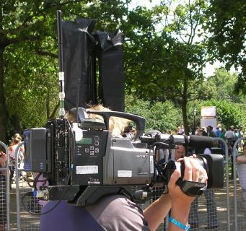
Figure 21: Cordless Camera
As shown in Figure 21, conventional cordless camera transmitter docks on the back of a traditional camera. Audio is incorporated with the pictures on the cordless camera link either from an on-board microphone or else there may be a separate wireless microphone receiver mounted on the camera. Remote control of the camera for colour balance, iris and tally light can also be by radio telemetry via a separate wireless channel received on the camera.

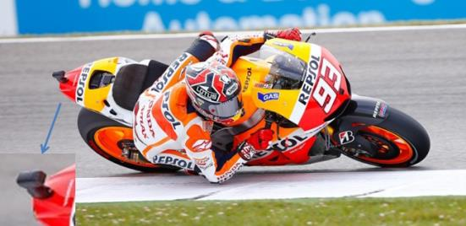
Figure 22: Cordless on board Camera
Often to bring pictures from close to the action, miniaturised cameras and transmitters are mounted on participants in cycling and motorsport (see Figure 22), utilising low profile antennas, such as patch antennas, to minimise the impact on performance. These can then be received on the ground via a network of switched receivers placed along the route, or received via an airborne platform.
To give a reliable link over a greater range a Portable Camera Transmitter is used along with a directional antenna. In the example in Figure 23 below, being moved to a new location, the transmitter, its only portable power supply, test equipment and the directional antenna are carried on a trolley. Once in place the camera is connected to it by cable. Typical applications would be motorsport or a golf course where the camera location is determined by the action. The equipment may also be mounted on a vehicle such as a golf buggy.
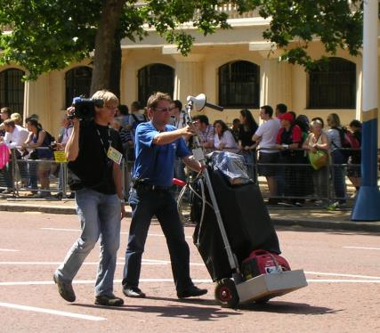
Figure 23: Portable Camera Transmitter

Mobile links can be mounted on a variety of vehicles including cars, buggies and motorcycles. In the example depicted in Figure 24 below the cameraman sits on the rear of the motorcycle connected by cable to the video link, its components in the rear panniers and above the rear wheel. A low gain, typically a patch antenna, is mounted high, for safety and a clear view of the sky. RF power is limited by the EMF human exposure limits.
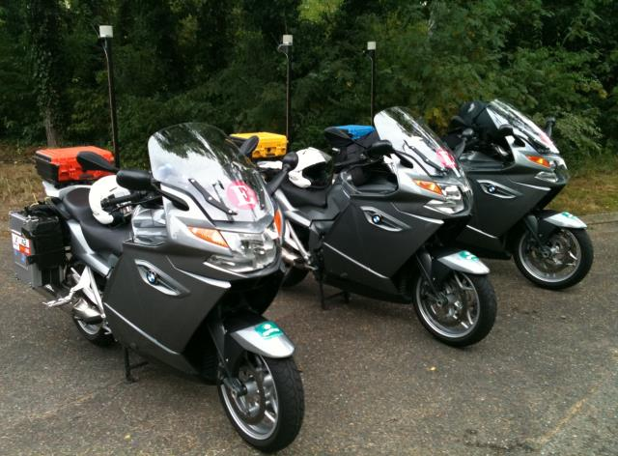
Figure 24: Mobile vehicular video link

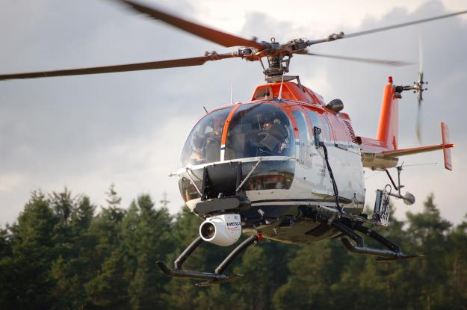
Figure 25: Airborne video link
On the above Figure 25, the gyroscopically stabilised camera can be seen on the front of the helicopter with receive and transmit antennas mounted on the landing skids. Other airborne vehicles such as airships and tethered blimps can also carry airborne video links.
As well as relaying pictures directly from the on-board camera the airborne platform can additionally receive multiple links from the ground, then transpose and transmit them down to another point on the ground. In Figure 26 below is an example of the on-board equipment required, perhaps for coverage of a marathon or cycle race.
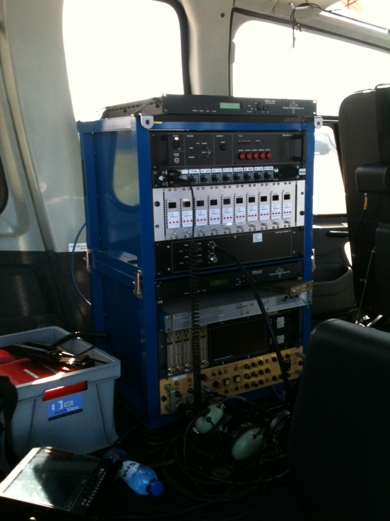
Figure 26: Airborne video link equipment

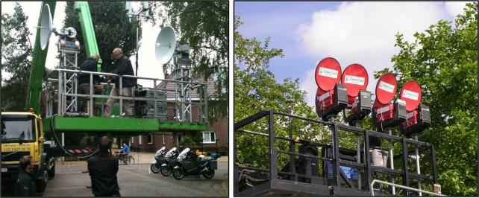
Figure 27: Temporary point-to-point video links
In the left picture there are two auto tracking units installed in a hydraulic lift. These units will track by means of GPS information from the helicopter- or aircraft downlinks.
Point-to-point video links are used to relay pictures, sound and data from remote locations to a central production location. Programme makers need their own high quality, low delay links to be able to seamlessly combine the elements of a production. These may be relatively short distances for an individual camera at a horse racing meeting or many kilometres from a remote outside broadcast part way along a cycle race, to the finish line.

    - Current Spectrum Demand for Video PMSE
The table below provide an overview of use for wireless video links, including cordless cameras, in recent events demand varies in geographical area , time and date, a hot spot can arise in a matter of minutes or hours when an unexpected event takes place. Such events range over the whole gambit of cultural, sporting and political scenes. The following material was extracted from CEPT Report 51 [14].
Table 24: Information on major event usage
Event | Number of links | Total spectrum MHz | Condition | Annex to CEPT Report 51 for further details
12th World Championships in Athletics, 15-23 August 2009, Germany | 42 | 619 | Loaned/PMSE | 5
Celebration of the 20th anniversary of the fall of the Berlin wall, 9 November 2009 | 38 | 350 | Loaned/PMSE | 6
Berlin state elections,  18 September 2011,  Prussian Landtag building | 17 | 162 | Loaned/PMSE | 7
Tour de France 2011 | 35 | 350 | Loaned/PMSE | 8
Natural ice skating over 200 km (all airborne use) | 13 | 133 | Loaned/PMSE | 9
Lower Saxony election | 13 | 144 | Loaned/PMSE | 10

In order to collect information on spectrum requirements for SAB/SAP and ENG/OB, the EBU issued a questionnaire asking its members to make in October 2008 their prognoses in number of channels required in the future for all different applications. The full results are available in [20] and are summarised in the Table 25 and the Figure 28 below for cordless cameras and portable video links.
Table 25: Cordless cameras and portable video links from EBU Survey 2008/2009 [20]
Cordless cameras and wireless video links  (including the mobile and airborne links)  10 MHz | Broadcasters Prognoses  October 2008
Typical studio production | 0 to 6 (4 average)
ENG for TV | 5 to 20 (12 average)
Sport events or similar OB typical | 5 to 10 (9 average)
Sport events or similar OB peak | 5 to 30 (16 average)

The widespread use of analogue wireless cameras is to be particularly noted.

Figure 28: Information from EBU Broadcasters questionnaire 2008/2009 [20]
    - Applications Versus Spectrum Limitations
      - Airborne Use
Whilst the majority of airborne use is from helicopter’s there are also a range of other airborne use from airships to parachuting and the recent sub space height record.
Please note: Relay plane use high altitude (20.000 ft., ca. 6100 m) giving the need for harmonisation throughout Europe for PMSE frequencies and a quick coordination scheme between Administrations
All of these applications have one thing in common: a requirement for the transmitter and receiver antenna to “see” each other whilst the subject is moving.
Whilst auto tracking systems are a vital part of the link budget the physical factors and beam width determine the success of such a system.
Currently the 2-3 GHz band proved the best and in some cases the only spectrum available for airborne use
      - Car and Motorcycle Use
This varies from rally cars to hill climbs and track racing, in each application the speed and terrain stretch the limits of the link budget with added complications of propagation in forests and pit arrears. Antenna size and coverage on both the transmitter and receiver have physical and technical limitations.
Once again the best and in many cases the only practical combinations can be achieved in the 2-3GHz band
      - Cycle Racing both Road and Track
Cordless cameras have a number of formats when covering these applications, the prime one being the helmet camera of the cyclist which is physically small and limited in its antenna size and its output power (by both power source and EMF limits).
In addition vehicle, motor bike and airborne use will be used to cover an event.
Once again the best and in many cases the only practical combinations due to the obstructed propagation path can be achieved in the 2-3 GHz band
In many cases a low power head camera will be relayed to an aircraft or helicopter via a motorcycle, once again the EMF safety issue need careful consideration for the motorcycle personal.
      - Other Applications
A range of activities such as yachting and powerboat racing will suffer from similar issues to those above plus the propagation losses from operating over water. In many cases a relay helicopter will be used to provide the link back to the Outside Broadcasting venue
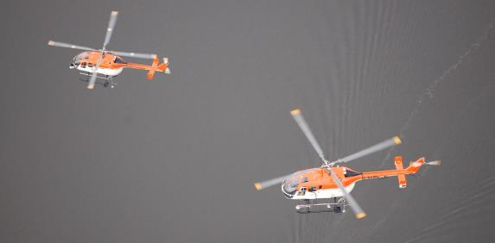
Figure 29: Relay helicopter
Golf in particular suffers from obstructed line of sight propagation even when using golf buggies as repeaters.
    - Current CEPT Regulatory Framework and Background for CORDLESS CAMERAS AND ASSOCIATED VIDEO LINKS
The ERC/REC 25-10 [3] was last revised in 2003. This document recommends CEPT Administrations to assign frequencies for audio and video SAP/SAB links on a tuning range basis. Unfortunately this gives the impression of a large amount of spectrum availability when in practice only a few (if any) channels are available in any one country.
This Recommendation would need to be updated to reflect the latest developments on some of the concerned frequency bands.
The following table is a subset of the Annex 2 of ERC/REC 25-10 [3] relevant for cordless cameras and video links
Table 26: Recommended frequency ranges for use by video SAP/SAB links
(subset of the Annex 2 of ERC/REC 25-10)
Type of link | Recommended frequencies |  | Technical parameters
Type of link | Tuning ranges | Preferred sub-bands | Technical parameters
Cordless cameras | 2025-2110 / 2200-2500 MHz  10.0-10.60 GHz  21.2-24.5 GHz  47.2-50.2 GHz | 10.3-10.45 GHz  21.2-21.4 GHz, 22.6-23.0 GHz and 24.25-24.5 GHz | ERC Report 38
Portable video links | 2025-2110 / 2200-2500 MHz  10.0-10.60 GHz | 10.3-10.45 GHz | ERC Report 38
Mobile video links  (airborne and vehicular) | 2025-2110 / 2200-2500 MHz  3400-3600 MHz (Note 4) |  | ERC Report 38
Temporary point-to-point video links | Fixed service bands (Note 5)  10.0-10.68 GHz (Note 3)  21.2-24.5 GHz | 10.3-10.45 GHz  21.2-21.4 GHz, 22.6-23.0 GHz and 24.25-24.5 GHz | ERC Report 38
Note 3: Only occasional temporary point-to-point links should be allowed in the frequency band 10.6-10.68 GHz. Studies have concluded that even limited deployment of cordless cameras and portable video links in the band 10.6-10.68 GHz will result in interference to the EESS (passive) services using this band (see ECC/REP17).
Note 4: In countries where the band 3400-3600 MHz is widely used for Fixed Wireless Access (FWA), availability of this band for mobile video SAP/SAB links may be restricted.
Note 5: Temporary point-to-point video links are often accommodated in the traditional fixed services’ bands, following the same channel arrangements as the FS links.
    - Current Usage of CORDLESS CAMERA AND VIDEO LINKS in CEPT COUNTRIES
During the development of this Report, the ECC developed a questionnaire to CEPT administrations on the regulatory procedures used by administrations in granting access to spectrum for PMSE [2]. It covers many frequency ranges and PMSE usages.
Band 2025-2110 MHz (ERC/REC 25-10 [3]): From the 32 countries providing a response on this band, 19 of them report about the availability of the band or parts of it for PMSE applications, namely temporary video links (portable, mobile with some allowance for airborne use) and cordless cameras as referred to in ERC/REC 25-10. This use is under an individual licensing regime. No change is expected for this band in relation to PMSE.
Band 2200-2500 MHz (ERC/REC 25-10): From the 32 countries providing a response on this band, 29 of them report about the availability of the band or parts of it for PMSE applications.
The main type (28 countries) is related to temporary video links (portable, mobile with some allowance for airborne use) and cordless cameras as referred to in ERC/REC 25-10. In most cases, this use is under an individual licensing regime, although low power wireless cameras can in a few countries operate under a general license. It is noted that, in addition or as an alternative, 2 countries mention specifically the use of the 2400-2483.5 MHz band for wideband data transmissions or non-specific SRD as per REC 70-03 for PMSE purpose. 5 countries mentioned that current considerations on the potential introduction of Broadband Wireless systems either as a single block or via Licensed Shared Access (LSA) in the band 2300-2400 MHz will have an impact on the availability of the band for PMSE.
Band 2500-2690 MHz (ERC/REC 25-10): From the 32 countries providing a response on this band, 5 of them report about the availability of the band or parts of it for PMSE application, namely SAB/SAP, video links. Amongst those, 3 countries expect that the use of PMSE will cease because of the introduction of terrestrial Electronic Communications Networks in the 2500-2690 MHz band. On this basis, the relevance of maintaining this band in the ERC/REC 25-10 may be considered.
Band 3400 – 3600 MHz (ERC/REC 25-10): From the 32 countries providing a response on this band, 9 of them report about the availability of the band or parts of it for PMSE applications, which tends to confirm a decrease of the availability of this band for PMSE. PMSE applications in this band cover temporary video links (portable, mobile with some allowance for airborne use) and cordless cameras as referred to in ERC/REC 25-10. This use is under an individual licensing regime. The development of IMT in this band may have an impact on the spectrum available for PMSE in this band.
Band 4400 – 5000 MHz: From the 32 countries providing a response on this band, 7 of them report about the availability of the band or parts of it for PMSE applications. PMSE applications in this band cover SAB/SAP links for temporary use deployed in a coordinated way to protect other use (mainly military applications). This PMSE use is in most cases under an individual licensing regime.
Band 10.0 – 10.68 GHz (ERC/REC 25-10): From the 32 countries providing a response on this band, 26 of them report about the availability of the band or parts of it for PMSE applications. The amount of available spectrum and the frequency bands within the overall tuning range vary significantly depending upon the country. The main PMSE applications covered in this range are wireless cameras, portable video links and point-to-point video links for temporary use as referred to in ERC/REC 25-10. This use is in most cases under an individual licensing regime. No major change is generally expected for this band in relation to PMSE.
Band 21.20 – 24.50 GHz (ERC/REC 25-10): From the 32 countries providing a response on this band, 25 of them report about the availability of the band or parts of it for PMSE applications. The amount of available spectrum and the frequency bands within the overall tuning range vary significantly depending upon the country. The main PMSE applications covered in this range are wireless cameras, portable video links and point-to-point video links for temporary use as referred to in ERC/REC 25-10. This use is in most cases under an individual licensing regime. A few changes are expected, which may slightly increase the availability of spectrum for PMSE.
Band 47.20 - 50.20 GHz (ERC/REC 25-10): From the 32 countries providing a response on this band, 16 of them report about the availability of the band or parts of it for PMSE applications. The main PMSE applications covered in this range are wireless cameras and portable video links as referred to in ERC/REC 25-10. This use is in most cases under an individual licensing regime. No change is expected with regard to PMSE in this band.
Other bands: the availability of frequency bands within the 6/8 GHz range is mentioned by 8 countries for fixed and/or mobile ENG/OB.
    - Technical Characteristics and Deployment Scenarios of CORDLESS CAMERAS AND VIDEO LINKS
      - Live News Gathering
It is commonplace to pair a cordless camera with a vehicle equipped with a satellite uplink or alternatively a terrestrial video link. There is the safety benefit and flexibility of not having to run cables between the camera and the vehicle as well as permitting optimum placement of the camera and vehicle link terminal.

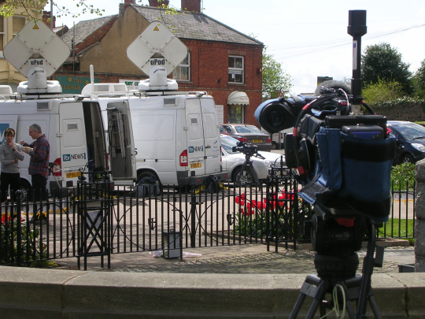
Figure 30: Cordless Camera for Newsgathering
      - Sports Coverage
The rugged nature and reliability of digital cordless camera links has led to much greater use in coverage of sporting events. Cordless cameras are routinely deployed close to the action and can be handheld or mounted on moving vehicles.

Figure 31: Cordless Camera for Sports Coverage
      - Major Events
Live coverage of major state occasions and major cultural events are greatly enhanced through the use of Cordless Camera and Video Links. Audiences have come to expect the wide range of shots from different standpoints along with close-ups that show the detail of the action. These are only possible when cameras can be located in a variety of locations, without the need to be cabled.
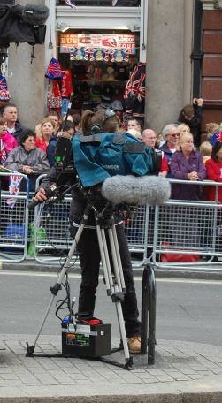
Figure 32: Cordless Camera for Major Event Coverage where cabling is not an option
Portable Video links are employed where path lengths are greater, for example to provide reliable and rugged coverage over wide areas, perhaps an entire golf course. Lower power Cordless Cameras with shorter paths to a greater number of receive points are an alternative but practical and cost implications will determine the operational decisions. Multiple hops can permit a lower power Cordless Camera to be relayed on via a higher power video link perhaps rigged in a vehicle such as a motorbike or golf buggy.
The use of video links has grown exponentially as the artistic freedom they create has resonated with producers and directors in all forms of media. Their deployment spans all forms of programme making with variations in each sector for example the film industry uses “video assist” to allow the director to see the set from the remote cameras and the attachment of cordless cameras to formula 1 and rally cars or even whales and insects. Figures below provide an indication of their popularity:
      - Considerations on PMSE Deployment Scenarios and Planning Practice:
The temporary nature of PMSE deployment can lead to less than optimum installation practices. Production vehicles and equipment are often corralled closely together creating radio frequency hotspots. Isolation between radio systems may therefore have to be compromised and it is not always possible to efficiently use spectrum in the way it would be possible with a permanent installation. The need to co-ordinate multiple PMSE users occupying the same ranges of spectrum can also limit the possibilities to promote the optimum use of spectrum in an operational environment where requirements are continually changing.
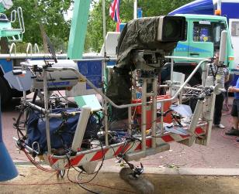
Figure 33: A temporary and less than optimum installation for Major Event coverage
      - Technical Characteristics
Multicarrier forms of digital modulation have become the preferred option with their rugged and reliable performance in the presence of multipath propagation over varying and often obstructed paths. DVB-T based links are popular and further proprietary systems have subsequently been introduced to accommodate the need for greater data capacity for High Definition and 3D. Used alongside cabled cameras and other high quality sources it is imperative for Cordless Cameras and Portable Video Links to match the same high quality and not appear inferior to the production process and the viewer.
Table 27: Typical Technical Characteristics for ENG/OB Video Links
Type of Link | Range | Max e.i.r.p. | Min Tx ant. gain | Min Rx ant. gain | Radio Link Path | Suitable Frequency Range | Description
Cordless Camera | <500m | 0dBW | 0dBi | 6dBi | Usually clear line of sight but often obstructed | Typically <8GHz though <5GHz is favoured to allow reliable operation on obstructed paths | Handheld camera with integrated transmitter, power pack and antenna
Portable Link | <2km | 16dBW | 6dBi | 17dBi | Not always clear line of sight | <5GHz | Handheld camera but with separate body worn transmitter, power pack and antenna
Mobile Link | <10km | 26dBW | 16 to 26dBi | 13dBi | Often obstructed and susceptible to multipath impairment | <5GHz | Mounted in helicopters, motorcycles, pedal cycles, cars, racing cars and boats. One or both link terminals may be used when moving
Temporary Point-to-point  Link | <80km each hop for links at <10GHz | 40dBW | 20 to 30dBi | 17dBi | Usually clear line of sight for OB, but often obstructed for ENG use | <10GHz for long hops.  Hop length at >10GHz limited by precipitation fading | Link terminals are mounted on tripods, temporary platforms, purpose built vehicles or hydraulic hoists. Two-way links are often required

      - Technological Developments
The market for PMSE equipment is small compared to other radio sectors but new technologies are being developed in parallel with the broadcast, security surveillance and military sectors.
Mesh technologies improve the reliability of links but there is a trade off in complexity of cost of the systems and their deployment as well as the additional need to ensure low delay in PMSE compared to other applications.
Airborne links have employed military technologies permitting dynamically steerable antennas at high altitude compared to the traditional less directional airborne antennas used at lower altitudes from helicopters.
  - BAND BY BAND ASSeSSMENT on the sustainable operation of cordless cameras and Video links
Deployment of video links as with other radio services is dependent upon a range of factors which contribute to the link budget, a major consideration is the propagation of the spectrum , to date the 2GHz band provides the best conditions for many application’s especially for airborne and mobile use. The relative bandwidth and size of 2GHz antenna allow automatic or manual antenna systems to track successfully for mobile use, the higher the frequency the narrower the bandwidth of the antenna and therefore harder to successfully track when mobile
    - BAND 1- 5GHz
Frequency ranges below 5GHz are favoured for low power cordless cameras operating over short obstructed paths, with the advantage of relatively low diffraction loss. Multiple carrier forms of digital modulation, particularly COFDM, which are rugged and perform well in the presence of multipath, have driven greater and increasing use of low power wireless cameras in recent years.
  - BAND 5-12 GHz
The frequency range between 5 GHz and 12 GHz.is favoured for:
- High power airborne down-links working line of sight: In these frequency bands stable pictures from moving aerial objects can only be obtained by auto tracking systems. Using DVB-S2 for downlinking no diversity or MIMO techniques are available;
- Low power wireless cameras in use should be DVB-T or ISDB-T based to benefit from reflections and diversity techniques;
- Medium power short and middle range point to point links: Equipment in use will carry encoded video signals via either DVB-T, DVB-S2 (for multiple video, audio signals) or IP links (for bi-directional multiple video, audio and data signals).
  - BAND 12 GHz and above
Frequency ranges above 12 GHz are favoured for low power short range point to point links.
Equipment in use will carry encoded video signals via either DVB-T, DVB-S2 (for multiple video, audio signals) or IP links (for bi-directional multiple video, audio and data signals).
  - ANALYSIS and Perspectives for the sustainable operation of cordless cameras and Video links
Airborne: Currently the 2-3 GHz band is the only harmonised tuning range which allows airborne use, there is an urgent need for additional airborne harmonised tuning ranges preferably within the turning range of current equipment plus a simple coordination system for licencing.
2-3 GHz: All line of sight applications should be moved from this band to higher spectrum and the remaining channels in this band reserved for obstructed links
Overall: according to the EBU report [20], there is a need for a minimum of 10 channels of 10 MHz for the “average” event spread over sub 10 GHz spectrum within each administration plus identified spectrum which can be loaned for major events. Within the 10 channels at least 6 channels for links which can have an obstructed path need to be below 3 GHz.
  - Conclusions
Since ERC Report 38 [25] was produced the use of video PMSE has expanded exponentially from primarily the Broadcast sector to almost every entertainment platform and also to many parts of industry plus medical activities. Current spectrum allocations are such that “benign” modulation schemes allow sharing with other services and a low amount of out of channel energy from adjacent spectrum allocations. New digital modulation schemes in adjacent spectrum allocations plus the reallocation of traditional 2-3 GHz spectrum to mobile use has reduced the availability of spectrum within this band, an added complication is that of airborne use (a major necessity for many sporting events) which is allowed within this band but not in many other tuning ranges.
Currently these “benign” modulation schemes and flexibility from spectrum holders (in many case military use) allow loan of spectrum for major events. With the change in spectrum allocations and in some cases the sale of such spectrum other loan spectrum requires to be urgently identified and industry notified in order that a clear upgrade and development of equipment can take place in a timely manner.
In order for video PMSE to continue to provide adequate spectrum facilities for all forms of current and future use, consideration of additional spectrum outlined in the conclusions (section 6) and the sections A2.4.4 to A2.8 and a review of licencing conditions and application systems should take place.
On one hand improvements in technology and modulation schemes will possibly reduce spectrum bandwidth but the requirement for greater definition and greater numbers of cameras to cover an event will offset these advances
- SERVICE LINKS
  - Overview
This Annex attempts to provide information on the wide definition of equipment and use covered by the term “Service Links”. In brief as the complexity of all forms of programme making have evolved, more radio infrastructure is required to coordinate actors, choirs, engineers, production staff, safety etc. and to remotely operate many items from explosives to lights on set (such bedroom lights etc.). In addition many digital PMSE systems require control and feedback links to operate successfully.
This annex addresses two main areas:
- Spectrum;
- and applications.

In order to provide as clear a picture as possible, inventive producers and engineers find new uses for radio spectrum in each production as the industry changes to the ever higher demands for higher definition and “quality”.
When considering programme making, it should be borne in mind that any and all spectrum mentioned in this annex may be present along with other public use devices such as mobile phones, and therefore event spectrum management is an essential requirement if intermodulation and reverse intermodulation is to be avoided.
  - Introduction
Since the first publication of ECC Report 002 [1] in 2002 the programme making industry has vastly expanded in both output and complexity. In revising ECC Report 002, it soon became apparent that it would be beneficial to address the various types of links into dedicated annexes, this Annex dealing with Service Links.
Service links with a few exceptions such as In Ear Monitors (IEM), wide band talkback and video assist are normally outside the PMSE spectrum allocation’s and use existing radio service spectrum such as Private Mobile Radio, Short Range Device (SRD) and even model control and similar spectrum.
Similar to PMSE activities, latency is a major consideration which is why mobile phones and their data services are not normally used for service links. Use of non PMSE spectrum often includes different forms of use; for example licenced PMR spectrum is often constant carrier out from the producer with press to talk from engineers, camera operators etc.
The programme making industry has become adapt and ingenious in using existing equipment and incorporating it into their productions. Simple examples are use of model control equipment to operate devices on a stage or set such as a bedroom light or radio receiver, another is the use of low power FM transmitters connected to a recording which plays over the FM broadcast receiver on the set.
Further information on SRD spectrum can be found in ERC/REC 70-03 [6] and the EC Decision on SRDs [27].
  - Spectrum
The following table gives an overview of spectrum which may be used for service links, frequencies may vary in different countries.
Detailed information on use and parameters will be found in ERC/REC 70-03 [6] and ERC Report 25 [32].
Table 28: Overview of spectrum which may be used for service links
Frequency range (MHz) |  | Allocation | Standard
From | To | Allocation | Standard
29.957 | 27.283 | Non-specific SRD and model control | EN 300-220
34.995 | 35.225 | Flying models | EN 300-220
40.665 | 40.695 | Four spot frequencies for model control | EN 300-220
87.5 | 108 | Low power FM transmitters | EN 301-357
148 | 174 | PMR | EN 300-086
440 | 470 | PMR | EN 300-086
863 | 870 | SRD  Wireless audio/multimedia | EN 300 220  EN 300 422  EN 301 357
2400 | 2483.5 | Wideband data links | EN 300-328
5725 | 5875 | SRD  Fixed wireless Access | EN 300 440  EN 302 502

The low Band PMR 66-88 MHz (the so-called “4m-band”) is not often used due to the noise floor and length of aerials.
  - Talkback
Talkback comes in many varieties and variations dependent on factors such as:
- Is the person using the equipment in camera shot or on stage?
- Does the user have use of both hands available (i.e. holding camera)?
- What clothes or costume is the user wearing?
- Is the user in a fixed position? Or mobile?

In many cases the producer uses a duplex constant carrier system in order to free his hands and more importantly removes clicks and bangs from those receiving his transmission.

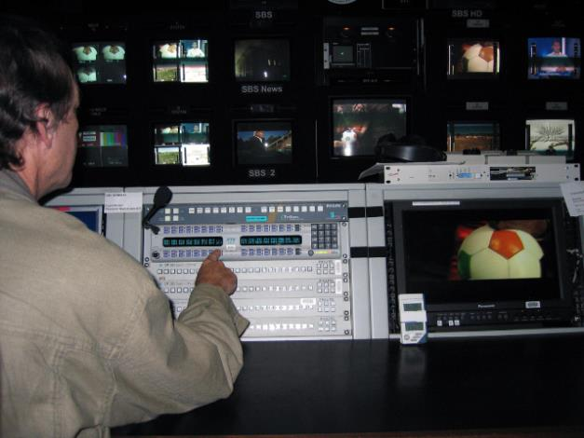
Figure 34: Talkback Management system
    - Examples of Talkbacks Use Scenarios
Three example scenarios are described below.
      - Outside Broadcast from a Race Course
Engineering circuit: In this instance the director is likely to be located in a specialist O/B vehicle which contains a mini studio with six or more video monitors and sound links, the talkback in the studio will be an open microphone feeding a duplex constant carrier system, the other transceivers will be located around the race course at fixed camera positions and a number of mobile camera units. The primary objective of the system is to allow the producer to control the camera shots and positions of the engineers. In most cases the engineer will not talk back to the producer but simply press and release the press to talk button to acknowledge that he has understood his instructions. Headphones are likely to be worn by the engineers and a loudspeaker in the vehicle for drivers of the mobile units
In this case none of the equipment will be “in shot” and therefore the size is less important and would probably be standard PMR units with a base station in the studio.
Talent circuit: Producer to presenter this will be a separate frequency from the engineering circuit and only selected by the producer when required for instructions or timing of shots.
In this case the size and shape of equipment on the talent does matter and is likely to be a specialist discreet earpiece and small receive only unit
There are likely to be up to twelve talkback circuit’s dependent on the size and complexity of the production, some may also be airborne or marine
      - Stage Production
Engineering circuit: In this instance the director is more likely to be moving around the back area of the stage in order to be able to keep a clear view of the stage and therefore using a standard PMR unit with a headset but in many cases will be constant carrier. Dependent on the complexity of the production separate circuits may be used by
- Lighting crew;
- Sound engineers;
- Scenery crew;
- Electricians;
- Medical crew ;
- Talent organisation (i.e. getting the star on at the right time and place).

In most cases there will be a common channel in addition to the specialist channels with the majority listening and not transmitting unless absolutely necessary.
Talent circuit: Producer to presenter or star this will be a separate frequency from the engineering circuits and only selected by the producer when required for instructions or timing, not as common for stage productions.
      - Choir
Latency is the curse of PMSE; consider a large choir of say 100 singers split into three groups on a stage, without any radio feedback coordination assistance they are most likely to sing out of tune with each other. Therefore a talkback system with discreet receivers and earpieces (may also be in ear monitors) are used to keep all singers coordinated. A similar situation occurs in any large event with many participants, the most recent public example is the UK Olympics where the opening and closing events had thousands of participants dancing, and this required talkback to keep them in synchronization.
    - Talkback Equipment
They fall into two main categories:
- Narrow band: conventional PMR equipment using 12.5 KHz or 25KHz channels normally outside the 470-862 MHz band;
- Wide band using <200 KHz channels normally in the 470-862 MHz range.

The use of narrow or wide band is defined by its use; narrow band is used for voice activities and wide band when music or singing is in use. Other considerations are operator fatigue, if a production is shooting for long periods of time (>12 hours) or is passing complex instructions than the human ear-brain works much better with a wide band signal providing a reasonable reproduction of the information sent
      - Narrow Band Equipment
This falls into two categories
Base Unit
Systems may be duplex, semi duplex, and simplex with or without a controller (producer or crew chief) and use any modulation system which is licensable
These vary from a simple PMR mobile with an approved power supply providing an output from 2-25 watt or used from a 12 volt DC battery or vehicle

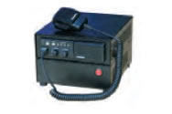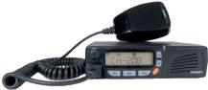
Figure 35: Talkback PMR equipment
To when constant carrier is requied a more robust system would normally be used:
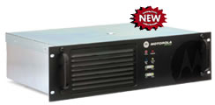
Figure 36: Rack mounted Talkback equipment
This type of unit can also be used as a repeater i.e. all mobiles or hand portables can hear each other sometimes referred to as “talk through”. When an OB vehicle or mobile studio is used space can be at a premium and built in 19” rack equipment is normally used.
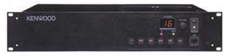
Figure 37: Talkback rack equipment
All systems will normally use a battery backup in case of primary power failure
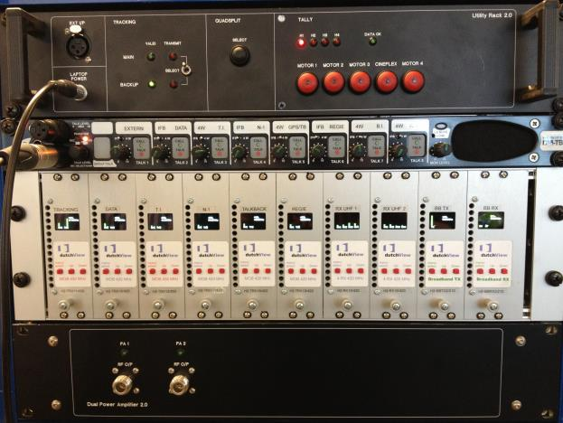
Figure 38: Talkback equipment

Hand Portable Transceiver Equipment
Normally conventional PMR units of between 1-5 watts are used.

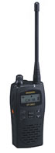
Figure 39: Hand Portable Receiver
Or more covert units with inductive earpiece are available as shown in the following figure.
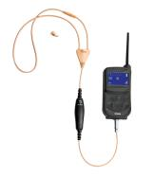
Figure 40: Inductive Earpiece
More complex systems are also available as shown in the following figure.
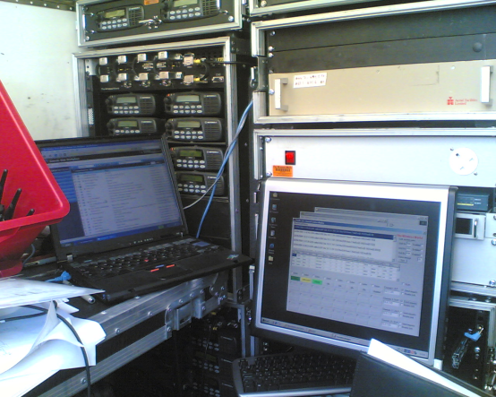
Figure 41: Portable trunked radio system base unit
For large talkback systems trunked radio MPT 1327 systems are often used which can use >200 handsets. Such handsets are conventional PMR handsets with the correct protocols loaded. These systems are spectrum efficient and provide communication for events such as conferences and major product launches where large number of attendees need to be marshalled or directed to various locations. Simple talkback systems and other PMSE equipment may also be present for the actual presentation or production.
All systems will use various accessories as shown in the following figure.

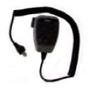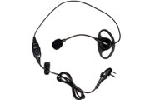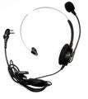

Figure 42: Remote microphone (on the left) headsets with a boom microphone
(centre and on the right)
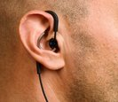
Figure 43: In ear microphone-receiver

Internal microphone employs voice intra-aural pick-up (VIP) technology to identify the user's speech signals inside the ear canal rather than via an external face microphone.
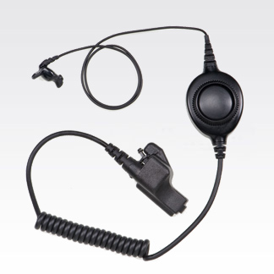
Figure 44: In ear bone conduction microphone-receiver
The streamlined Ear Microphone System picks up sound through bone vibrations in the ear canal, giving personnel the ability to hear and speak directly to others on the scene.
Any of these systems may also use various forms of Digital Signal Processing (DSP) in order to minimize external noise and increase clarity and comfort of hearing.
      - Receive Only Units
Systems can be based on 12.5-50 or 200 kHz bandwidth depending on model.
Whilst the PMR equipment can be used for “receive only” systems they are relatively large compared with in ear systems which are more suitable for those “in shot”:
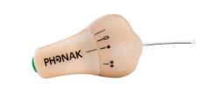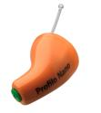
Figure 45: Receive only unit

The associated transmitter is shown in the following figure.

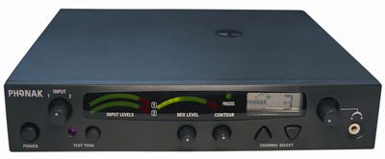
Figure 46: Associated transmitter (Photos curtsy of Phonak)

      - Wide Band Talkback: In Ear Monitors
Wide band systems can be used for the singer-artist listing to the audio output of the band or for choir coordination etc. (normally using a single channel (mono or stereo) per transmitter).

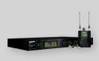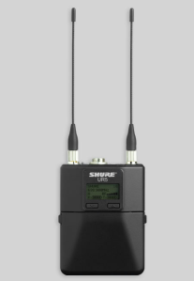
Figure 47: Wide Band Talkback: In Ear Monitors
      - Wide Band Talkback
Manufactured by a range of companies, provide full duplex talkback system, often with the ability to combine wired systems into the wireless system. Multiple channels can be selected. Similar characteristics to a radio microphone system i.e. 200 kHz bandwidth but a power output of up to 5W

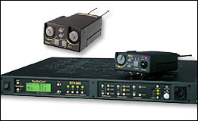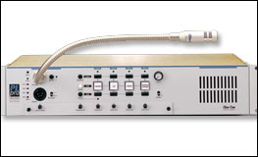
Figure 48: Wide Band Talkback
      - Video Assist
In film production, whether film or digital cinematography, an additional system of monitors, video matrices and recorders is often deployed to capture and display a lower resolution video reproduction of every shot. This allows the director and other production staff to view takes ‘as live’ or review them immediately afterwards. These systems can be cabled but often there is a requirement for handheld or remote viewing in which case wireless transmitters and receivers are used. Film cameras on the move or in remote locations may require wireless channels to relay a Video Assist feed to a central point. In television production too, either in studios or on location, directors use monitors to remotely view live or recorded images close to the action during rehearsal or while the scene is being shot. For flexibility and ease of implementation wireless channels can be used to relay these Video Assist images to remote monitors.

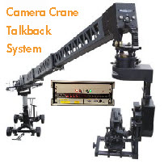
Figure 49: Video Assist

      - Control and Feedback Circuits
Many PMSE systems, both analogue and digital, use control or feedback links to allow information such as battery consumption and remaining life of battery to be sent to an engineer, increasingly remote adjustment of parameters can be achieved by these circuits. Examples of this would be remote iris control for cordless cameras and audio frequency response or change of frequency for radio microphones.
Currently most of these circuits use SRD or licenced PMR spectrum identified in section A3.3 of this Annex. As these circuits become critical to the successful operation of a PMSE system such as cognitive radio microphones, more protected spectrum will be required
  - Conclusions
The use of service links is fundamental to a successful production or event and should be considered when considering the overall spectrum requirements of events and productions. The use of critical control and feedback links for digital equipment should be kept under review.

- Economic and Social Values
It is difficult to clearly identify the specific financial and social advantages of PMSE as it is an enabling technology allowing other activities to take place. .
Current society trends will have a significant impact on the development of different PMSE sectors which include changes in:
- programming style and definition for TV;
- coverage style (i.e. multiple camera angles) and priorities for TV sport;
- musical theatre and all other forms of theatre and entrainment;
- production budgets and staffing levels.
PMSE is dynamic: producers continually seek new experiences for audiences, with consequential changes in demand for spectrum. Such requests need to be considered and balanced against the benefits to society and needs of other services including other PMSE applications.
  - Economic Value
A single figure is impossible to identify but the list below gives an overview of the major income streams.
It is reasonable to use the multiplier from the UK Wyndham report of the 1990s [21] that for every £1 spent on a theatre, concert or cinema ticket an additional £4 will be spent by tourists in the local economy.
Thus a venue having 1500 seats and charging £100 would result in a direct income of £1500, 00.00 and an indirect income of £600,000 per performance. The following list provides examples of areas where PMSE contribute to generate profit:
- Direct sales of PMSE and support equipment;
- Direct ticket sales of concerts, sport events and other venues;
- Direct ticket sales for pay TV;
- Direct revenues of rental companies on the PMSE and supporting equipment;
- The advertisement income from all the events using PMSE;
- The spin-off from these events (e.g. tourism, hotels, taxis, restaurant and catering industry);
- Indirect revenues from SMS services linked to events (European Song Contest, the Voice etc.);
- Indirect revenues of IMT providers on the traffic during events;
- Indirect revenues (sometimes lasting more than 10 years after the event) of recorded material of the events (DVD, Blue Ray, You Tube, Film Industry, etc.);
- Indirect revenues to IMT providers of streaming content to smartphones and tablets from various sources including the obligatory adverts.
  - Social Value
Discussing the social and benefit of Art, Culture and Creative Industry/Sector is difficult for various reasons:
- First: it is an achievement of our civilization that not everything has to have an economic value.
- Secondly, one has to describe which kind of Art, Culture and Creative Industry/Sector should be under examination. Due to the freedom of art, one has to be careful not to preclude developments which are not yet mainstream.
- Thirdly, collecting data, of any form, about the social and economic benefit of Art and Culture is not easy. This applies in particular when attempting to compare statistics from various countries, particularly when they are based on different assumptions or definitions.

As previously stated PMSE equipment is an “enabler” allowing artistic expression which has not been available to earlier generations of artists and musicians at both professional and amateur level.
In addition to the “artistic” use many other aspects of the social infrastructure rely heavily on the use of PMSE equipment, a few examples are:
- The ability in residential homes, hotels and village halls to provide announcements and entertainment;
- Use in schools to enhance the lives of hearing impaired children;
- Sports coaching using audio and video PMSE.
  - EXAMPLES FOR THE ECONOMIC POTENTIAL OF PMSE USE
This section provides indicative examples of the economic potential impact of PMSE use.
    - ESTIMATION OF THE GERMAN ECONOMIC POTENTIAL IN 2008
This estimation of the German economy potential generated in the professional event production by wireless production tools was collected by APWPT in 2008. A summary is available in document FM50(11)037 appendix 2 [34] :
Table 29: German Economy potential generated in the professional event production
(source: APWPT, 2008)
Category | Sales size | Explanation | Source
Sales volume of the enterprises of professional light, sound and event technology | 3.5 bn. € | The VPLT (10) has around 1.100 members with more than 10.000 employees. The rental companies of wireless radio systems are among others included | Association information of the VPLT (7)
Concert and event market | 3,873 bn. € | 79.4 million visitors | GFK study 2007 (3)
Total turnover of the event economy | 66.7 bn. €  of this 31.7 bn. € directly into the event- centres | - 2.8 m. organizing actions for more than 331 m. visitors.  - 6200 conference and event venues  - 1 m. jobs of the line of business generated  - 30.000 people directly employees of event centres indoor  - 3.000 trainees/a | Meeting and event barometer (4)
Classic advertising editions in result of fairs and events | 12.8 bn. € | These are 18% of the complete marketing charges of the economy. Altogether, the advertising market of Germany contains a complete volume of 71.6 bn. €. | Stage report 11.08 (9)
Culture and creative economy | 128 bn. €  (Estimate 1)  ------------------  60 bn. €  (Estimate 2) | - 227000 enterprises  - 1 m. employed person  --------------------------------  There are about 1 million people working for 210.000 enterprises in the culture and creative economy. | Initiative culture and creative economy (10)  --------------------------  Initiative of the representative for culture and media and the BMWT (6)
Theatre enterprise | 3 bn. € | Gives approx. 500 theatre enterprises including the free theatres in Germany. These employ 60.000 employees; have approx. 40 m visitors and generate a complete sales volume of almost 3 bn. € | Information of the German's Stage Association and the  Federal Association of the Theatres and Orchestras (5)
Hardware sale of  wireless microphones and  wireless instrument | 65 m. € | Since all market relevant suppliers take part in IMIS, this number corresponds 5% to the complete trade sales volume in Germany | IMIS (1), 2007
Total sales volume caused by trade mentioned above and its results (2)  (Minimum volume.) | 130 m. € | The SOMM (1) estimates five times of the trade sales for the events generated and the supplies needed for it | IMIS (1), 2007
Public broadcast | 2.68 bn. €  Gross value product in the  Year 2006 (8) |  | Goldmedia study 2008 (8)
Private broadcast | 2.75 bn. €  Gross value product in the  Year 2006 (8) | In the year 2006 (11):  - Annual sales volume approx. 8.3 bn. €  - 23.000 employee | Goldmedia study 2008 (8)

    - INFORMATION ABOUT WEST END THEATRES IN LONDON
The figures are collected by and are the property of the Society of London Theatres. At the time of writing the document, latest full set of figures available is for 2010
2010

Total Attendances: 14,152,230.
Total Box Office Revenue: £ 512,331,808.00.
Total number of performances given: 18,615.
Using the Wyndham multiplier of 4.4 this gives a total figure of £2,254,259,955.00 for the London economy

General

The Wyndham Report [21] (now out of print) was put together by Tony Travers of the London School of Economics (LSE) in 1998 and showed that an average of £4.4 was spent in the wider West End economy by theatregoers for every £1 they spent at the Box Office on tickets. There is no reason to suppose the overall ratios have changed.
Direct employment in West End theatres, including cast, musicians, technicians, administrators, front of house and catering staff and theatre specific trades amounted to circa 27.000 with a further 14.000 employed indirectly.
    - UKEMTS 2011 REPORT ON THE DEVELOPMENT OF THE BRITISH EVENT INDUSTRY
The 2011 report [22] is compiled from data supplied by a representative sample of 360 venues from across the UK, 10.3 per cent of the total of 3,500 venues used as the basis for research analysis.
Other key findings include:
- an estimated 99 million attendances at events in 2010 (an estimated 1.3 million events with an average attendance of 76 people);
- an average of 371 events per venue in 2010, down slightly on 2009 (an average of 379 events per venue);
- average daily delegate rates were £42 (Inc. VAT). The average 24-hour/residential rate was £120 (Inc. VAT). Rates were down on 2008 and 2009 levels, reflecting budgetary constraints and price sensitivity among buyers;
- a resurgence in corporate sector events which accounted for 51 per cent of all events staged (47 per cent in 2009);
- venues perceive ‘price’ and ‘value for money’ as the single most important selection criterion for buyers (scoring 87 per cent), followed by location (68 per cent), access (66 per cent) and quality of meeting facilities (60 per cent).
    - ECONOMIC IMPACT OF MAJOR EVENTS
Major events as Eurovision Song Contest, the Soccer World Championships and Olympic Games generate a huge revenue in relation to the deployed PMSE applications
Olympic Games 2008 Bejing: 4.7 billion viewers worldwide (approx. 70% of the world population)
2 out of 3 persons worldwide
World soccer champion ship 2010: 3.16 billion viewers. The in-home television coverage of the competition reached over 3.2 billion people around the world, or 46.4 per cent of the global population, based on viewers watching a minimum of over one minute of coverage

- Changes in the regulatory framework for pmse
  - Broadcast Agreements
PMSE equipment has been traditionally operated in the interleaved spectrum between broadcasting allotments/assignments on a secondary basis, e.g. on a non-interfering and non-protected basis with regard to the terrestrial broadcasting and other primary services. Therefore, revisions of broadcast agreements have an impact on the spectrum available for PMSE, especially in the UHF band (470-862 MHz) which is intensively used for PMSE devices.

The following broadcast agreements have been revised; new services have been allocated in these frequency ranges:
- GE06 Implementation of DVB-T in both VHF range 174-230 MHz and UHF range 470-862 MHz;
- WI95revCO07 Implementation of T-DAB in the VHF range 230-240 MHz;
- MA02revCO07 Implementation of T-DAB and other services in the band 1452-1492 MHz;
- ECC/DEC(03)02 S-DAB in the band 1479.5-1492.0 MHz (withdrawn in 2013).
  - Developments at World Radio Conferences related to PMSE frequency bands
At the World Radio Conference 2007, several frequency bands were allocated to IMT advanced. Therefore, following the WRC – 07 decision, LTE technology is expected to be deployed as implementation of IMT advanced.
- Bands in which LTE FDD is currently being deployed:
LTE band 3: 1710-1880 MHz;
LTE band 7: 2500-2690 MHz;
LTE band 20: 791-862 MHz.
- Candidate Bands in which LTE TDD could be deployed:
LTE band 40: 2300-2400 MHz;
LTE band 42: 3400-3600 MHz;
LTE band 43: 3600-3800 MHz.
It is anticipated that IMT technology will also deployed in the 900 MHz and 2.1 GHz band in the process of the revision of the existing allocations.
Moreover, Resolution 232 (WRC-12) [23] “Use of the frequency band 694-790 MHz by the mobile, except aeronautical mobile, service in Region 1 and related studies” was developed in order to consider additional requests for spectrum allocation for the Mobile Service were considered resulting in the development of
In this resolution, it is resolved
1.” that the band 694-790MHz will be allocated in Region 1 to the mobile, except aeronautical mobile, service on a co-primary basis with other services to which this band is allocated on a primary basis and to identify it for IMT”
2”that the allocation in resolves 1 is effective immediately after WRC-15”
This Resolution 232 will be considered in WRC-15 Agenda Item 1.2.
It should be noted, that WRC-12 recognized in Resolution 233 (WRC-12) [24] “that the advantages of the frequency bands below 1 GHz for wide coverage and those above 1 GHz for higher data rates with respect to use of IMT systems are noted in Resolutions 224 (Rev.WRC-12) and 223 (Rev.WRC-12), respectively”
This Resolution 233 will be considered at WRC-15 under agenda item 1.1.
In addition, in accordance with RR No. 5.296 a number of countries have deployments of applications ancillary to broadcasting (indirect expression of PMSE) operating on a secondary basis, which provide tools for the daily content production for the broadcast service.
- World Radio Conference 2015
Under Agenda Items 1.1 and 1.2, further frequency bands that are currently used by PMSE, are under consideration for a possible allocation to IMT.
It should be noted that PMSE can operate in the broadcast bands with TV and DAB transmissions which are “high tower high power systems” remote from audio PMSE installations and which are relatively well understood and rarely change their position or technical characters. The new allocations in comparison are for mobile use comprising of base stations and terminal units (phones or dongles) which will be located anywhere in the country and as such bring their transmissions physically closer to audio PMSE receivers which makes it impossible to use the interleaved spectrum as is the case with broadcasting stations. A combination of physical location, adjacent spectrum and modulation scheme are likely to provide a potential for interference to audio PMSE systems.

- Licensing of pmse
This annex provides a list of licensing issues for further consideration and will be relevant when considering the revision of ERC/REC 25-10 [3].

- Obtaining an application form: they are not always available on the web site of the national regulator. It may be difficult in some cases to identify or to contact the responsible person for providing license.
- Holder of a licence: in some cases, licenses are delivered only to residents of that country with a permanent address.
- Accepted communication means: it varies between administrations; some application forms must be faxed in some countries while they should be e-mailed or posted in others countries.
- Time Scales: the license processing delay varies from instant response to more than six weeks. It is unfortunately a fact of PMSE life that many jobs have a short or very short time scale for implementation. If a company does not receive a response by the shipping date of the equipment it will often use frequencies currently programmed into the equipment.
- Spectrum Allocation: with the introduction of semi cognitive programmable equipment individual frequency allocations (especially for audio PMSE) will often prevent the most spectrum efficient use. A licensing by “frequency block” could be considered.
- Payment for licence: In some cases an invoice for a licence can take many months to arrive, this creates accounting problems for the project which in many cases will either have an agreed budget or a separate company set up for that project. Late arrival of an invoice may not be paid due to the company or project having been closed and the personnel dispersed. This situation creates work and cost for an Administration.

Some of the items listed above could be addressed through a revision of ERC/REC 25-10 [3], also noting that in the past, the current form was not widely used. In addition, when addressing those points, administrations may consider using further “electronic” facilities (email, web site etc.) in order to facilitate the process.
It should be noted that in the framework of FM PT51, the ECO was tasked to implement a web page where the contact persons for PMSE licensing within each of the CEPT administrations are available (see http://www.cept.org/ecc/topics/programme-making-and-special-events-applications-pmse ).

- London 2012
  - Deployment of Links
Whilst events such as the Olympics are exceptional, they do provide both an indication of how PMSE use has expanded over the years and an indication of the complexity of these events. This section provides information relating to PMSE usage during the Olympic Games in London (2012).
Ofcom UK defined 13 “Products” for licensing. The total number of licences issued and frequency assignments made for the Games period is shown below
Table 30: Overview of the Licenses for London 2012
Product | Licences | Assignments
Wireless Camera | 452 | 631
Wireless Microphone | 1958 | 6052
Talkback | 946 | 3037
Land Mobile Radio | 1412 | 3026
Telemetry and Telecommand | 331 | 444
In Ear Monitor | 496 | 1468
Maritime Mobile Radio | 18 | 44
Microwave Mobile Link | 116 | 134
Fixed Link | 76 | 90
Permanent Earth Station | 20 | n/a
Transportable Earth Station | 28 | 1439
WCATV | 4 | 5
Games PMR Network (Apollo) | 1 | 206
Total Games | 5858 | 16576
Outside venue clearances in coordination zones | n/a | 13237
Total Frequencies Licensed |  | 29813

Nearly 6,000 licences were issued to more than 250 organisations occupying over 1 GHz of spectrum. 17.000 assignments were within the Games venues and 13.000 for applications outside the venues.
An example of the complexity of the licensing process was in providing coverage of the cycling and other road races. This involved assigning frequencies for high power video links for TV coverage from the air with their associated talkback and telemetry services. These links were essential to broadcasters’ coverage of the events and had to be resilient against interference and co-ordinated with other wireless camera use on the ground.
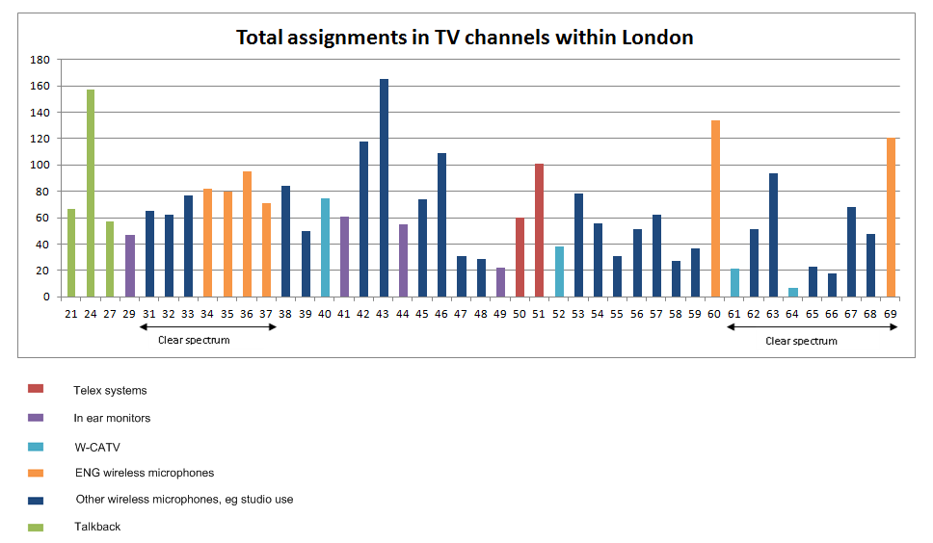
Note: Telex systems are a talkback system using 200 kHz bandwidth to EN 300422
Figure 50: Total assignment in TV channels within London (Ofcom presentation)
  - Audience Increase
The London 2012 Games was the most-watched Games ever, with over 51 million viewers in the UK watching at least 15 continuous minutes of Olympic coverage. This represented 20% more people aged 4+ than the Beijing Games and 14% more than the Athens Games. At 31 million people, the Paralympics attracted 141% more viewers than the Beijing Games and 193% more than the Athens Games.
Figure 51: Audience at the Olympic Games (source: Information courtesy Ofcom UK)
Both the opening and closing ceremonies for the Olympic Games 2012 attracted peak audiences of around 27 million viewers.
- Tour De france
The Tour de France is an annual event which now extends from France to other European countries and Islands.
Figure 52: Overview of the Tour de France 2011
During the Tour de France 2011, 794 frequencies were planned for walkie-talkies, HF cameras, talk back, etc.., 463 for wireless microphones (see figure below), which part has been assigned on site during the early stages, in the frequency band 470-862 MHz.
Figure 53: Number of radio microphones per UHF-TV channel in the Tour de France 2011
Furthermore, in 2013, the following deployment was done.
INCLUDEPICTURE "cid:image002.png@01CEA319.E7D4B5B0" \* MERGEFORMATINET INCLUDEPICTURE "cid:image002.png@01CEA319.E7D4B5B0" \* MERGEFORMATINET INCLUDEPICTURE "cid:image002.png@01CEA319.E7D4B5B0" \* MERGEFORMATINET INCLUDEPICTURE "cid:image002.png@01CEA319.E7D4B5B0" \* MERGEFORMATINET INCLUDEPICTURE "cid:image002.png@01CEA319.E7D4B5B0" \* MERGEFORMATINET INCLUDEPICTURE "cid:image002.png@01CEA319.E7D4B5B0" \* MERGEFORMATINET 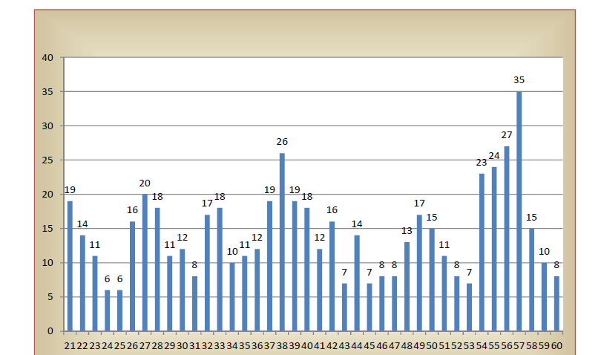
Figure 54: Number of radio microphones per UHF-TV channel in the Tour de France 2013

It should be noted that the demand for frequencies for wireless microphones (470-830 MHz band) is regularly increasing:
- 365 in 2007;
- 430 in 2009;
- 463 in 2011;
- 452 in 2012;
- 576 in 2013.

The number of frequencies for other uses has also increased:
- 287 in 2009;
- 319 in 2010 and
- 327 in 2011.

In 2011, in total, 1389 radio equipment (walkie-talkies, microphones and cameras HF, talk back, special equipment for runners and the caravan of the Tour etc.) have been checked by the technical services of the ANFR. In order to help the professionals, 41 frequencies have been authorized for temporary use during this event. Also, 12 interferences appeared and were solved.
27 frequencies have been authorized in Band III, 392 frequencies in the band 470-790 MHz and 75 frequencies between 790 MHz and 862 MHz for wireless microphones.
For video links, in 2011, 35 frequencies have been authorized between 1467 MHz and 3779 MHz operated by 14 companies.
Table 31: Overview of the Video Links for Tour de France
Event | Video Links
Event | 1 GHz | 2 GHz | 3 GHz | 4.5-6 GHz | 10 GHz | Above 20 GHz | Total Video Links
Tour de France 2010 | 4 | 20 | 4 | 0 | 0 | 0 | 28
Tour de France 2011 | 3 | 23 | 9 | 0 | 0 | 0 | 35
Tour de France 2012 | 4 | 17 | 11 | 0 | 0 | 0 | 32

For Satellite News Gathering, 104 transmission stations have been installed.
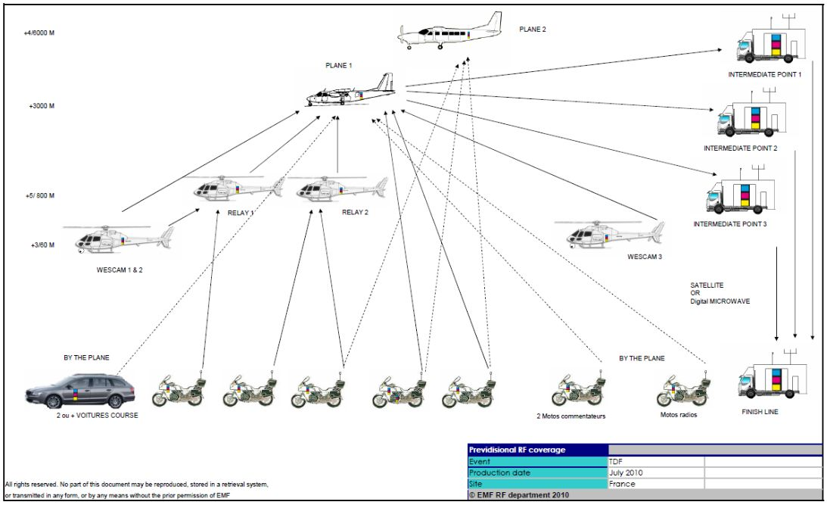
Figure 55: Overview of the links for Satellite News Gathering Video PMSE usage for
Tour de France, 2010 - 2012
The following table provides an overview of the video links deployed in 2010, 2011 and 2012 (see also CEPT Report 51 [14]).
Table 32: Video PMSE usage for Tour de France, 2010 - 2012
Note that the decrease of the number of video links between 2011 and 2012 was due to the withdrawal of German television in 2012.

The following figure provides an overview of the usage of the spectrum during Le Tour de France in 2013.

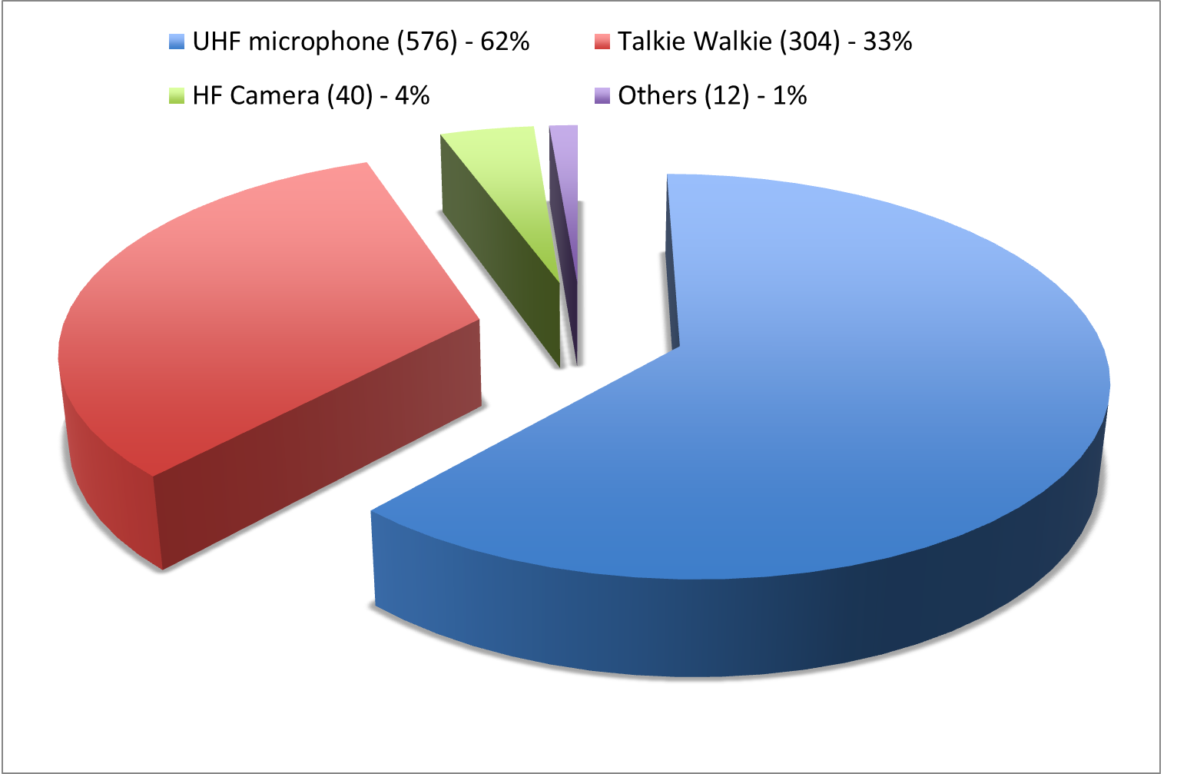
Figure 56: Overview of the spectrum usage during Le Tour de France 2013

- List of reference
- ECC Report 002: SAP/SAB (Incl. ENG/OB) spectrum use and future requirements
- Questionnaire to CEPT administrations on the regulatory procedures used by administrations in granting access to spectrum for PMSE (summary, full set of responses)
- ERC Recommendation 25-10: Frequency ranges for the use of temporary terrestrial audio and video SAP/SAB links (incl. ENG/OB)
- European competitiveness report 2010, http://bookshop.europa.eu/en/european-competitiveness-report-2010-pbNBAK10001/
- Creative Industries Economic Estimates, December 2011, Department for culture, media and sport, United Kingdom: https://www.gov.uk/government/uploads/system/uploads/attachment_data/file/77959/Creative-Industries-Economic-Estimates-Report-2011-update.pdf
- ERC Recommendation 70-03: Relating to the use of Short Range Devices (SRD)
- Decision 243/2012/EU of 14 March 2012 “on establishing a multiannual radio spectrum policy program”
- Decision 2010/267/EU “on harmonised technical conditions of use in the 790-862MHz frequency band for terrestrial systems capable of providing electronic communications services in the European Union”
Decision 128/1999/EC “on the coordinated introduction of a third-generation mobile and wireless communications system (UMTS) in the Community”
- ECC Report 159: Technical and operational requirements for the possible operation of cognitive radio systems in the ‘white spaces’ of the frequency band 470-790 MHz
- ECC Report 185: Complementary Report to ECC Report 159.Further definition of technical and operational requirements for the operation of white space devices in the band 470-790 MHz
- ECC Report 186: Technical and operational requirements for the operation of white space devices under geo-location approach
- EC Mandate to CEPT on technical conditions regarding spectrum harmonisation options for wireless radio microphones and cordless video-cameras (PMSE equipment)
- CEPT Report 50: Technical conditions for the use of the bands 821-832 MHz and 1785-1805 MHz for wireless radio microphones in the EU
- CEPT Report 51: Technical conditions for ensuring the sustainable operation of cordless video-cameras in the EU
- ECC Report 191: Adjacent band compatibility between MFCN and PMSE audio applications in the 1785-1805 MHz frequency range
- ECC Report 121: Compatibility studies between Professional Wireless Microphone Systems (PWMS) and other services/systems in the bands 1452-1492 MHz, 1492-1530 MHz, 1533-1559 MHz also considering the services/systems in the adjacent bands (below 1452 MHz and above 1559 MHz)
- ECC Report 44: Guidance for radio usage at special events
- Ofcom and the London 2012 Olympic and Paralympic Games, http://stakeholders.ofcom.org.uk/consultations/london2012/report-olympic-paralympic-2012/
- CEPT Report 32: Recommendation on the best approach to ensure the continuation of existing Program Making and Special Events (PMSE) services operating in the UHF (470-862 MHz)
- EBU Technical Report 001 Results of the EBU questionnaire on spectrum requirements for SAB/SAP & ENG/OB applications, http://tech.ebu.ch/docs/techreports/tr001.pdf
- The Wyndham report : the economic impact of London's West End theatre, 1998
- UKEMTS 2011 Report on the development of the British event industry
- Resolution 232 (WRC-12) “Use of the frequency band 694-790 MHz by the mobile, except aeronautical mobile, service in region 1 and related studies”
- Resolution 233 (WRC-12) “Studies on frequency-related matters on International Mobile Telecommunications and other terrestrial mobile broadband applications”
- ERC Report 38: Handbook on radio equipment and systems video links for ENG/OB use
- ERC Report 42: Handbook on radio equipment and systems radio microphones and simple wide band audio links
- European Commission Decision 2006/771/EC on harmonisation of the radio spectrum for use by short-range devices
- Presentations from C-PMSE workshop, 29 May 2013, http://cpmse.research-project.de/index.php/en/project/82-cpmsenewsen/119-demonstration-workshop
- ETSI EN 300 422: Harmonised European Standard for wireless microphones in the 25 MHz to 3 GHz frequency range
- Report for OFCOM from Analysys Mason: spectrum Planning for the London 2012 Olympic and Paralympic Games Link Link Part 2
- FM48#7-Info11-Direct-Air-to-Ground Demo Flight Event in October 2012
- ERC Report 25: The European table of frequency allocations and applications in the frequency range 9 kHz to 3000 GHz
- Audio Engineering Society Standard 42
- FM50(11)037 appendix 2 from APWPT: Economic potential of PMSE applications
- Report ITU-R BS 2161: Low delay audio coding for broadcasting applications

Programme Making includes the making of a programme for broadcast, the making of a film, presentation, advertisement or audio or video recordings, and the staging or performance of an entertainment, sporting or other public event.
A Special Event is an occurrence of limited duration, typically between one day and a few weeks, which take place on specifically defined locations. Examples include large cultural, sport, entertainment, religious and other festivals, conferences and trade fairs. In the entertainment industry, theatrical productions may run for considerably longer.
Other than possibly some spectrum in the duplex gaps.
Considering both the summer and winter Olympic Games.
The spectrum identified by each administration should be known by PMSE users in order that equipment is available
Please see Error: Reference source not found of this Annex for the London West End Hotspot
In many cases the figure given for Radio Microphones includes the number of IEM.
Many venues will not allow the use of multiple wired cameras or radio microphones due to the volume of cabling from even a small musical group
An LSA system comprises one or more incumbents, one or more LSA licensees, and the means to enable coordination between incumbents and LSA licensees, such that the latter may deploy their networks without harmful interference.
Please see Annex 3 (service link annex) for further information
Please see ERC Report 38 [25] for further details
The spectrum identified by each administration should be known by PMSE users in order that equipment is available.
Conditions of use are subject to a licence from the relevant administration, therefore no further comments or information will be provided on the operating conditions
In some cases separate licences were issued for Ceremonies, Olympic and Paralympic Games.
Duplex pairs counted as two frequency assignments.
For 2012, the decrease in the number of links is due to the fact that there was one TV operator less than in 2011.
In 2013, it was the 100th Tour de France, which may explain the increase in radio microphone and IEM assignments.

